

**Managing & Programming Database MCDA5540**

**Master of Science in Computing and Data Analytics**

**Team Project Bonus**

**Submitted by:**

Caner Adil Irfanoglu (A00425840)

Sunil Padikar (A00428089)

Vinay Govindan (A00429120)

Gaganpreet Singh (A00429660)

**Submitted to:**

TRISHLA SHAH

**Bonus Part: PERFORMANCE COMPARISONS**

Query 1-a: Running a full scan on MySQL local server

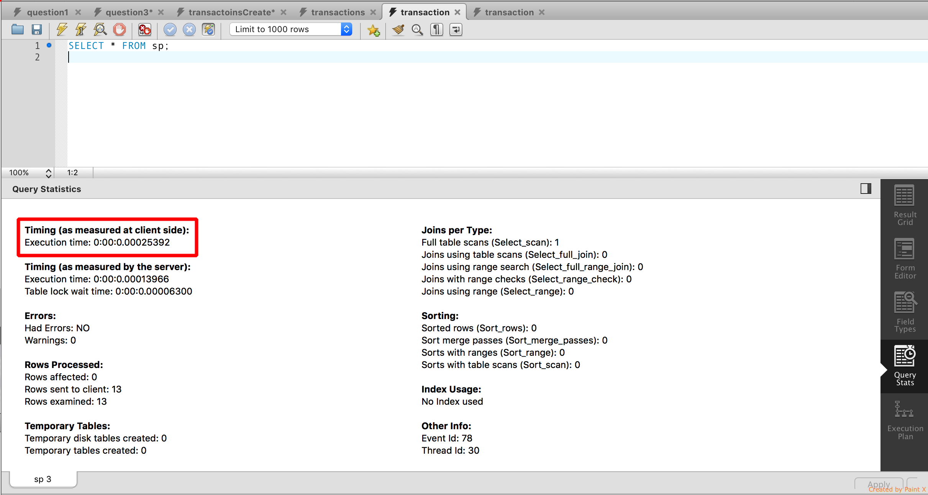



Figure 1 MySql Full table scan performance

Query 1-b: Running a full scan on IBM Db2 on Cloud

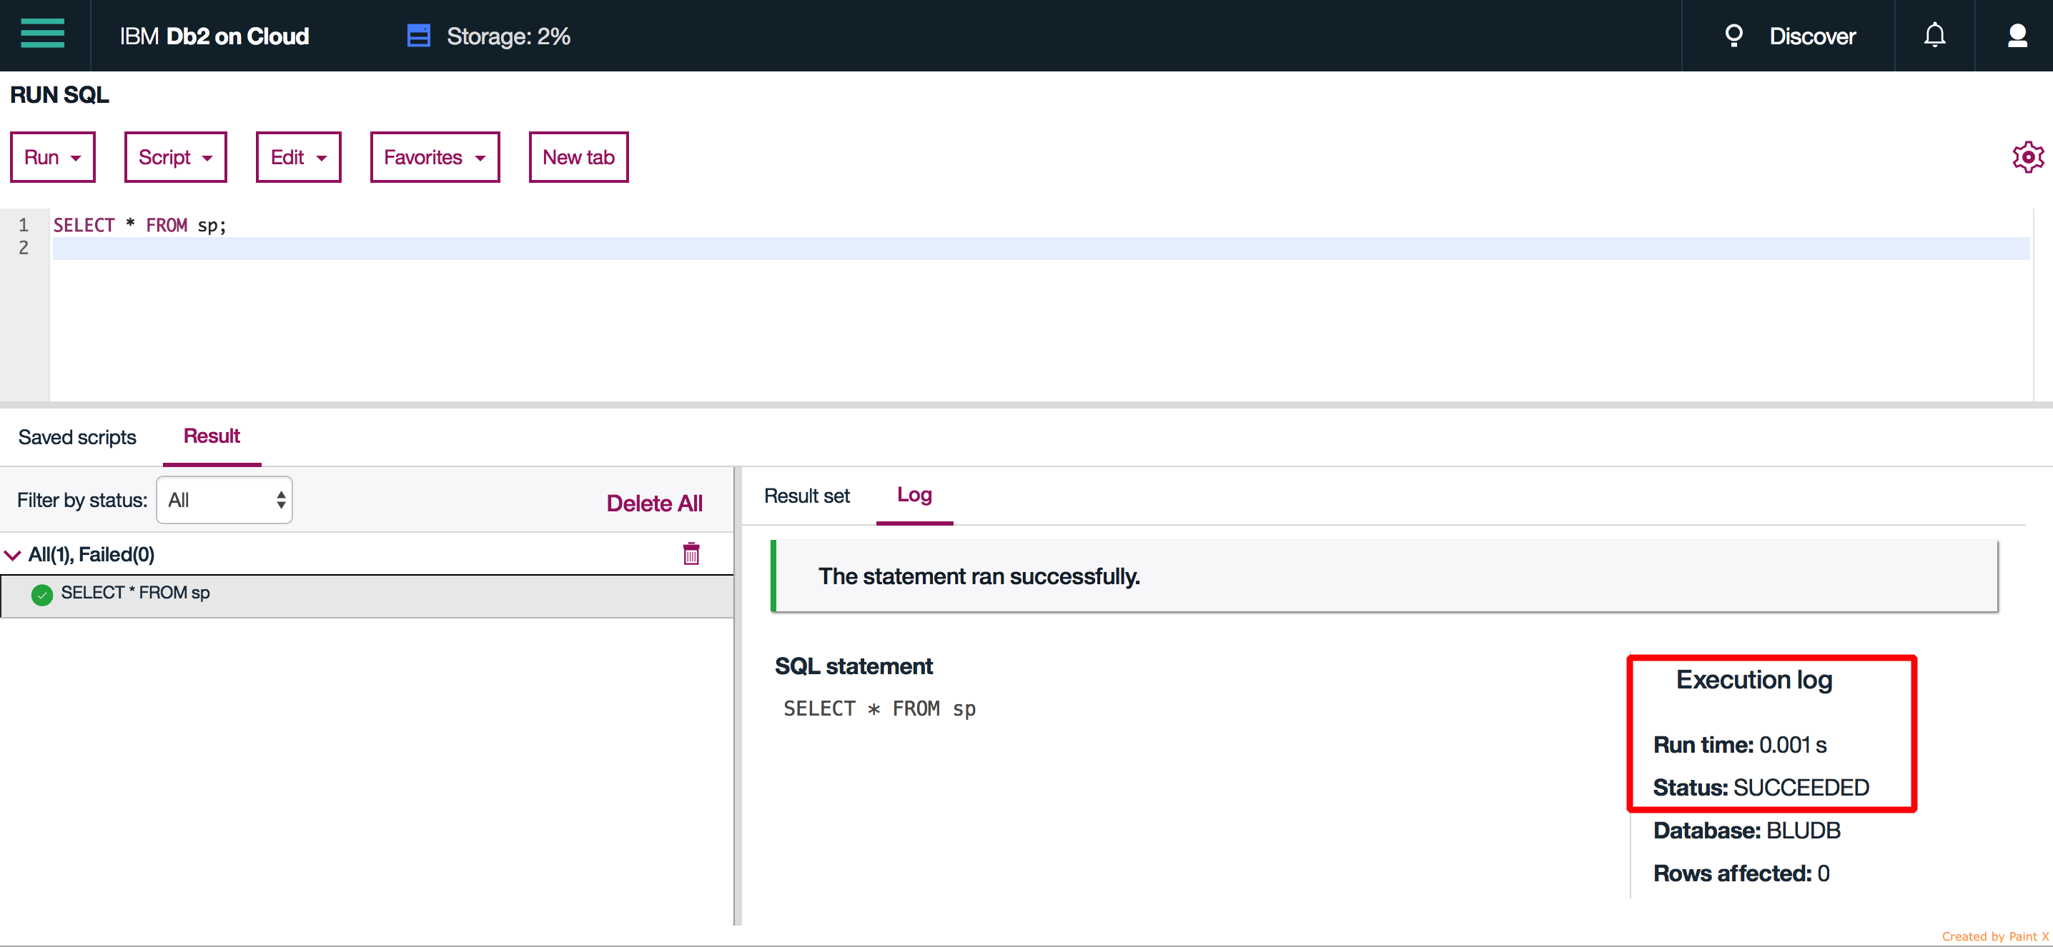

Figure 2 DB2 Full table scan performance

Query 2-a: Running a full scan + unique key look up on MySQL local server





Figure 3 MySql Full table scan + unique key lookup performance

Query 2-b: Running a full scan + unique key look up on IBM Db2 on Cloud

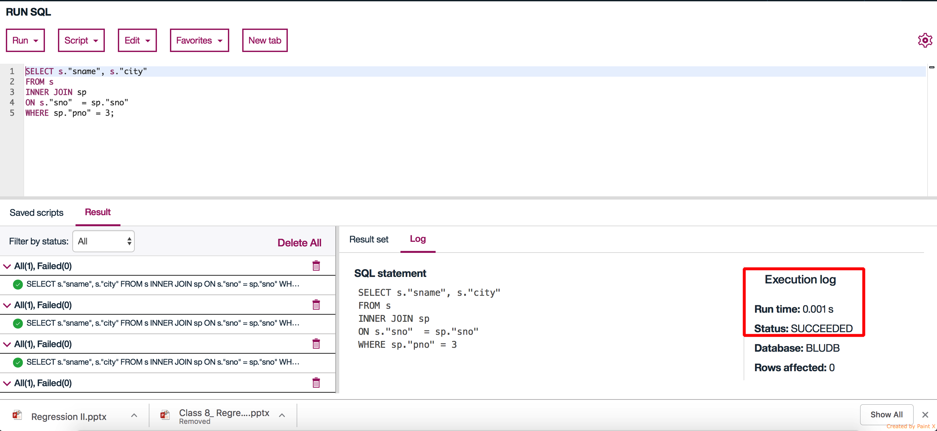

Figure 4 DB2 Full table scan + unique key lookup performance

Query 3-a: Running full scan + unique key look up + non-unique key look up on MySQL local server

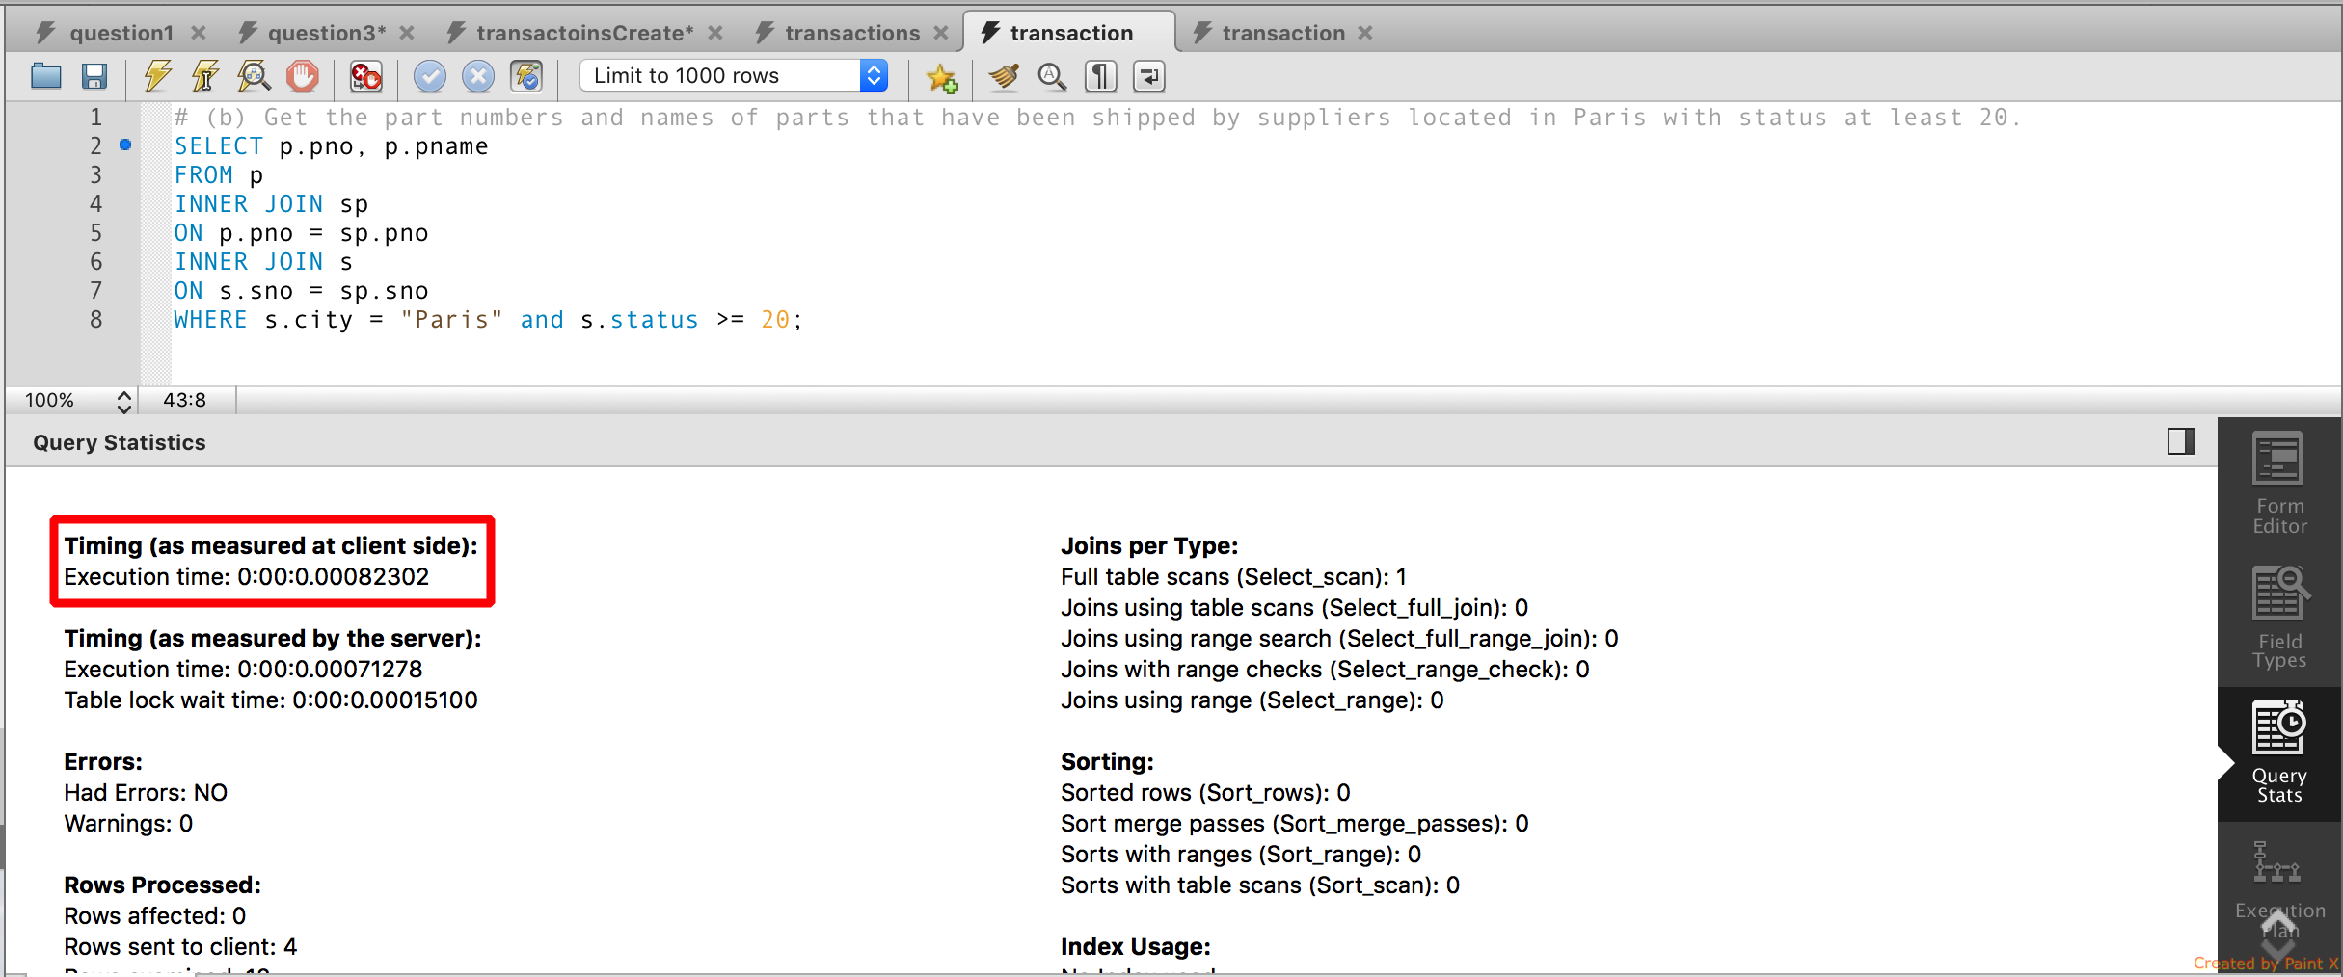



Figure 5 MySql Full table scan + unique + non unique key lookup performance

Query 3-b: Running full scan + unique key look up + non-unique key look up on IBM Db2 on Cloud

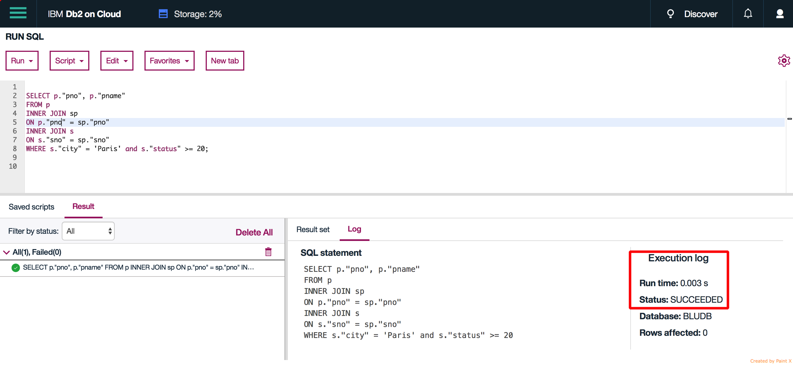

Figure 6 DB2 Full table scan + unique + non unique key lookup performance

Conclusion:

For full table scan results are ambiguous since Db2 only using 3 digits after decimal. The difference can be a rounding error.

For full table scan + unique key look up Db2 seems to perform better

For full table scan + unique key look + non-unique key look up MySQL seems to perform better.

Db2 might be performing better with unique key lookups whereas MySQL is superior for non-unique key look ups.

Reference:

1. Data for bonus point is taken from assignment-1.