

Caner Irfanoglu

Business Intelligence 5560

In Class Participation Open Refine

Date: Jan 24, 2019

Question 1: How many projects exist for the postal code M1G?

Answer: 119

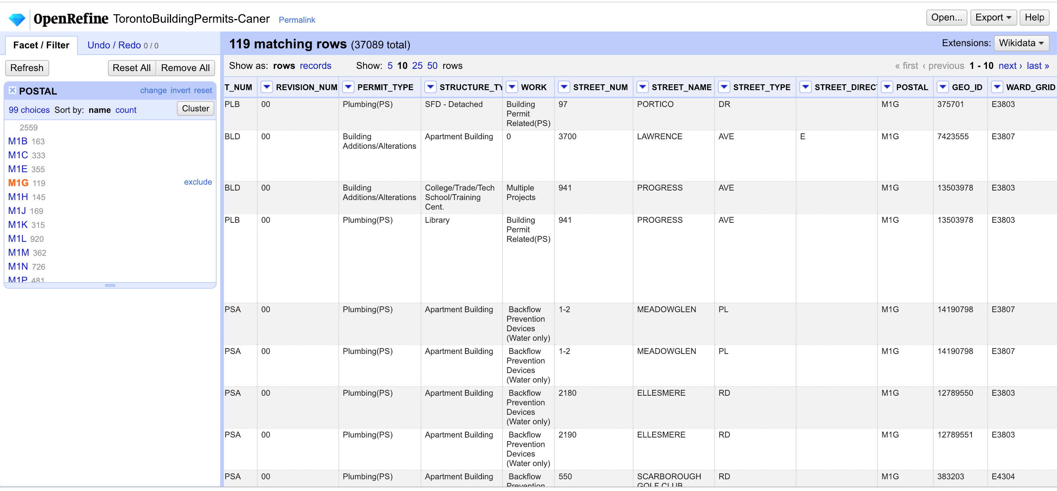

Question 2: In the postal code M1G, how many permits type are there for “Plumbing”?

Answer: 35

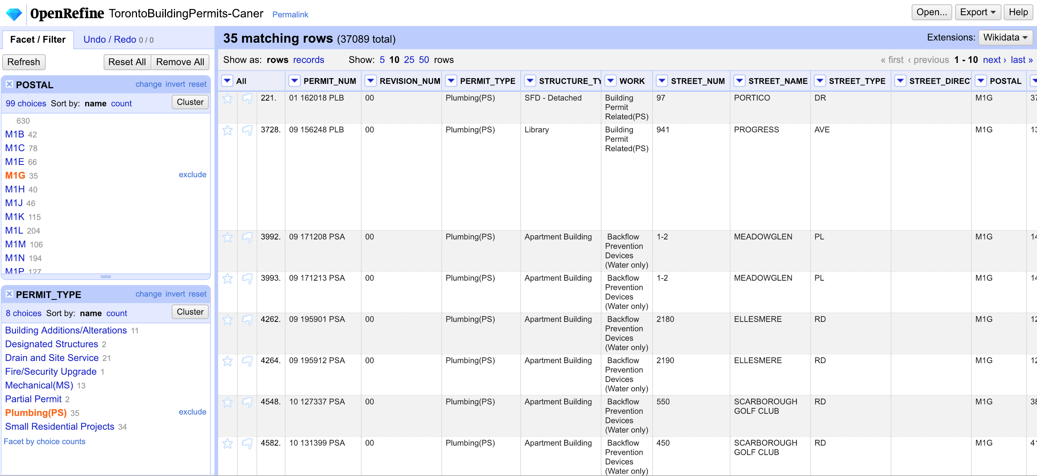

Question 3: How many conditional permit (permits type) have no structure type defined?

Answer: 177

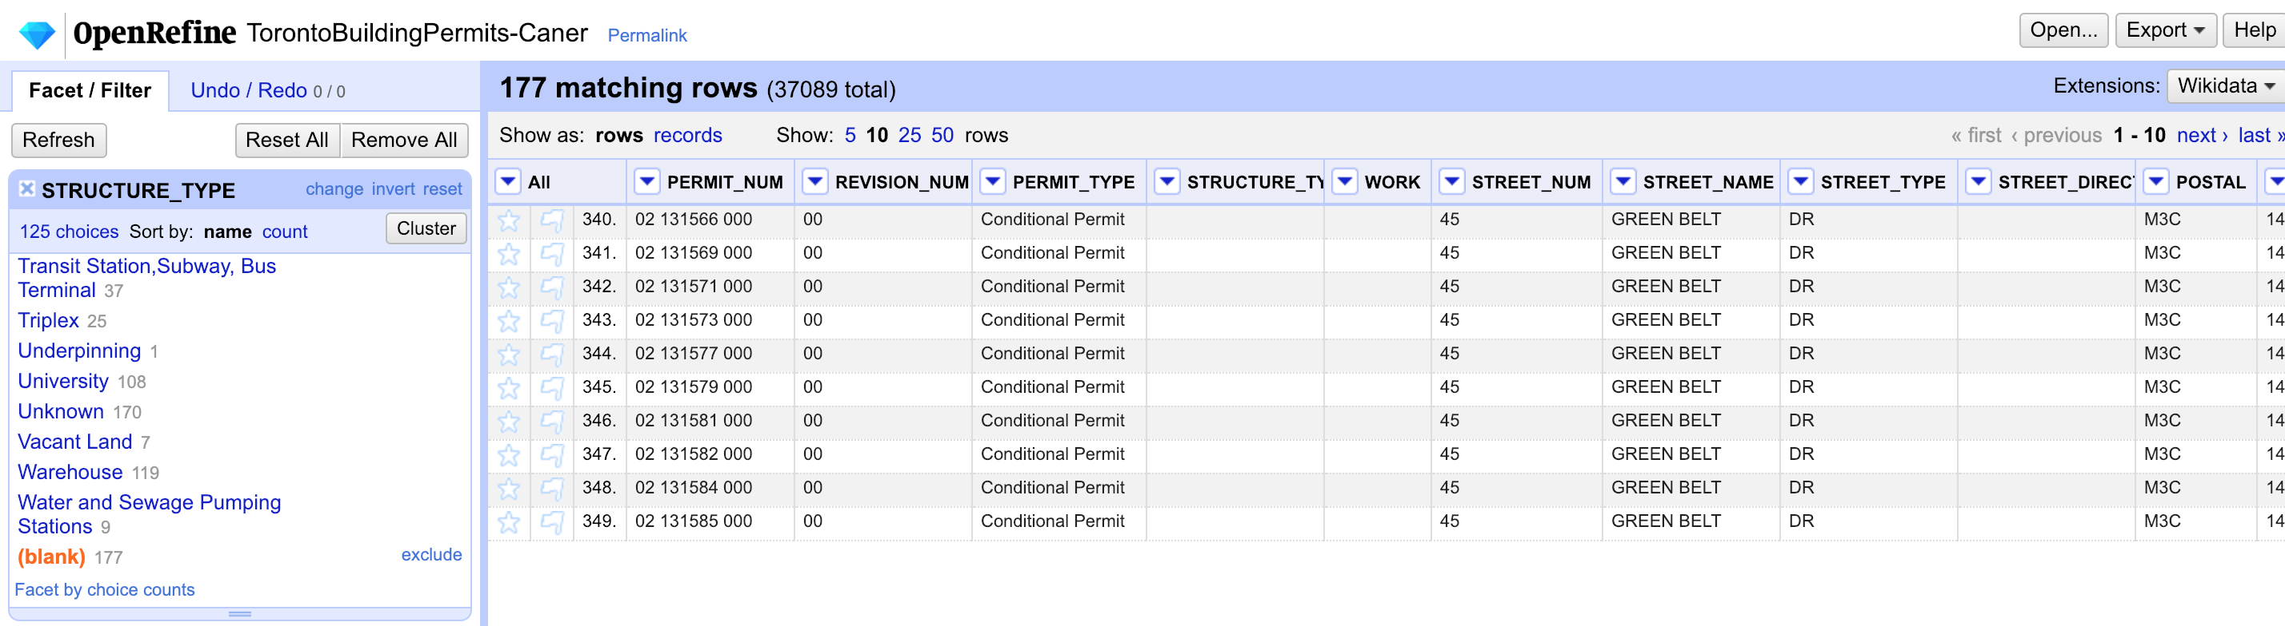

Question 4: How many unique permit numbers are there with more than 100 dwelling units?

Answer: 15

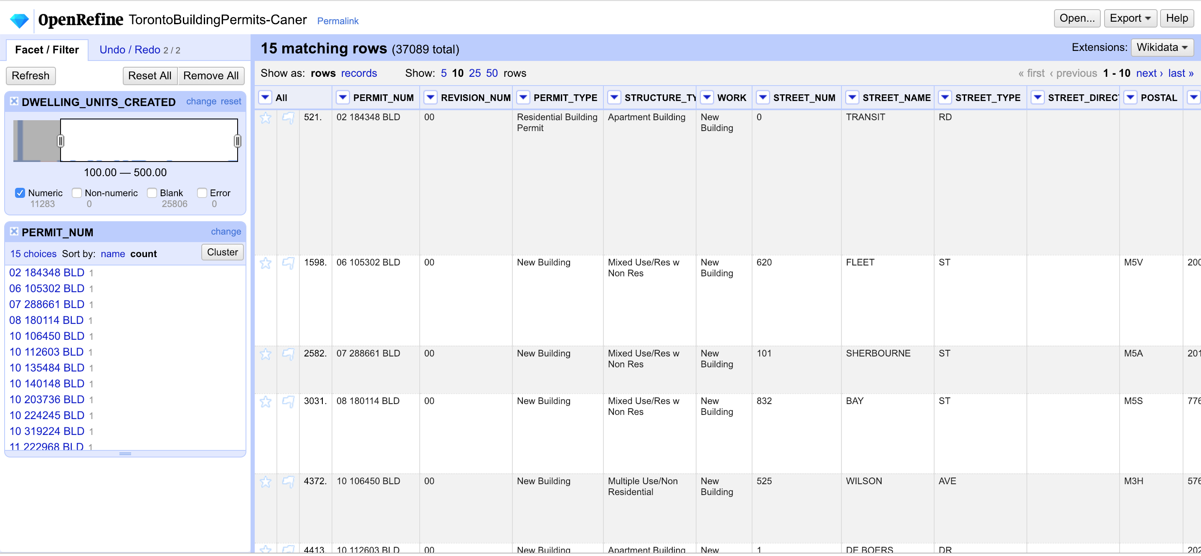

Question 5: How many applications did City of Toronto receive on October 09, 2012?

Answer: 313

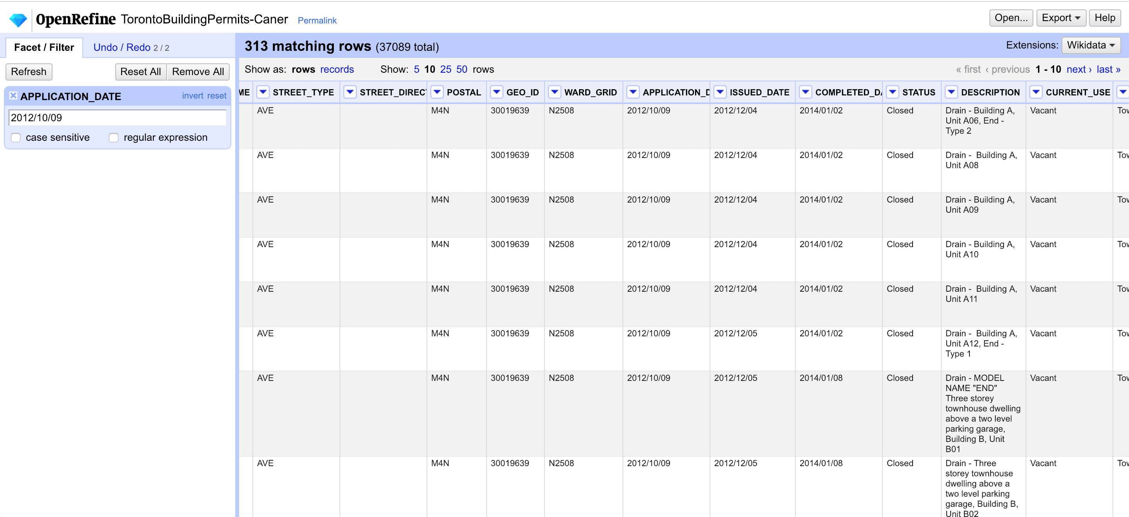

Question 6: When was the latest permit issued? (Format: YYYY-MM-DD)

Answer: 2014-12-31

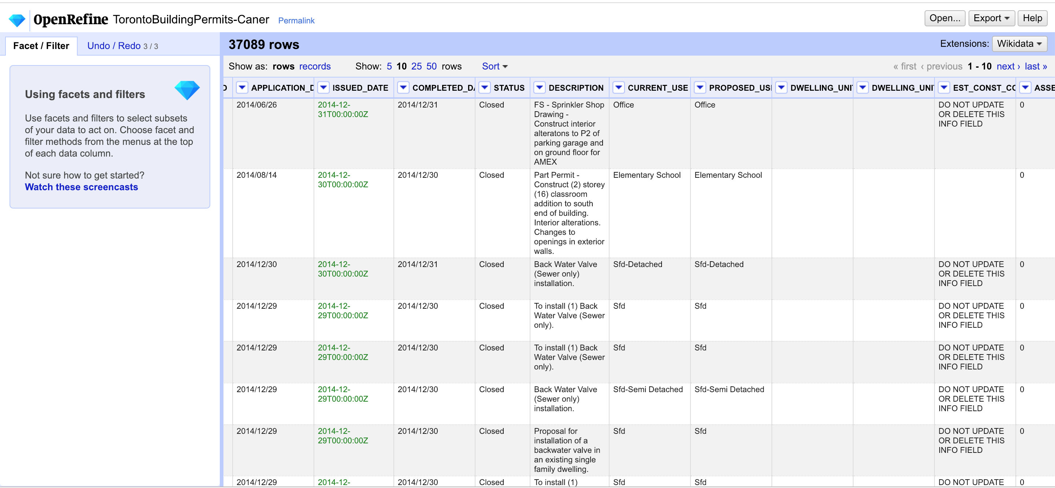

Question 7: See Question 4

Question 8: What is the permit number of the oldest application?

Answer: 86 251028 BL

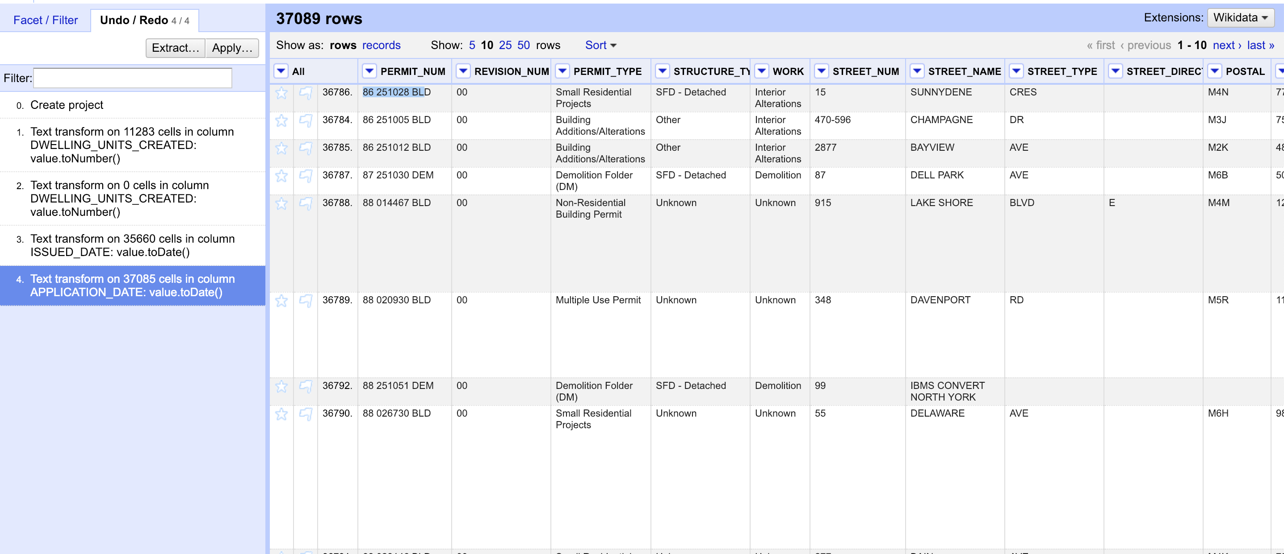

Question 9: See Question 7