**Mathematics**

Mathematics modeling

A device to release the problem of car wasting to much unneeded fuel(oil) when stuck in traffic.

problem

:the downtown of Beijing traffic flows are so slow that many citizens or visitors complain about it.

Known condition and assumption

1. car runs at a highest speed of 11.11m/s(40km/h)
2. Car has a average accelerated speed of 2.778m/s2.
3. Human has an average react time(both muscle and nerve)for 1.415s
4. Ultrasonic wave machine has an average react time for 0.01s
5. A car averagely consumes 0.61ml/s in a idling state .
6. Car has a length of 4m and the distance between two car is 0.5 m averagely.
7. 0.6214mile=1km
8. 6.78yuan=1dollar

Demonstrating and calculating

highway congestion around Beijing.

1. The road is 1687.5m on ave.
2. Double direction 4 roads (only one direction in congestion
3. There are 1687.5×4/4.5=1500 cars

1st time 1500cars waiting totally idling time 1500×1.405

2nd time 1499cars waiting totally idling time 1499×1.405

3rd time 1498cars waiting totally idling time 1498×1.405

........

1499th tim2 cars waiting totally idling time 2×1.405

1500th time 1cars waiting totally idling time 1×1.405

saving

:2170.5s=35.125min

:971.7L

for per driver:0.6478L the price of Beijing is 7.2yuan/L.

Oil cost for per driver 4.664yuan=0.7dollar

Traffic jam in Beijing downtown

PS:average length of congestion part road is 800m,the previous time is 75~100min.

Every red traffic light continues for 1minute.

There are totally 711cars on the road .

Following the algorithm bellow,

saving

=998.955s=16.64min

Add traffic light into consideration,

Actually,the saved =33.28min 437.795L

for per driver=0.6157L 4.43元。 the price of Beijing is 7.2yuan/L.

Oil cost for per driver4.43yuan=0.65dollar

Cost

Ultrasonic wave sender ~~~~25yuan

Ultrasonic wave receiver ~~~~26yuan

<https://www.1688.com/chanpin/-.html?spm=a261b.2187593.sea>

Chip and other staffs ~`··~·~~·~50yuan

Arduino display screen

Manual installtion fee ~~~`··`~20yuan

Totally cost 121 yuan=17.7dollars

Supposing every driver catches 3 traffic congestion everyday.

Everyday they save 0.65dollar,

Every month they save 19.5dollars

Every year they save 238 dollars!

|  |  |  |  |  |
| --- | --- | --- | --- | --- |
| **地区** | **92号汽油** | **95号汽油** | **98号汽油** | **0号柴油** |
| [北京](http://oil.usd-cny.com/beijing.htm) | 6.76 | 7.20 | 8.18 | 6.42 |
| [上海](http://oil.usd-cny.com/shanghai.htm) | 6.73 | 7.16 | 7.91 | 6.36 |
| [天津](http://oil.usd-cny.com/tianjin.htm) | 6.75 | 7.14 | 8.06 | 6.38 |
| [重庆](http://oil.usd-cny.com/chongqing.htm) | 6.84 | 7.22 | 8.14 | 6.46 |
| [福建](http://oil.usd-cny.com/fujian.htm) | 6.74 | 7.19 | 7.87 | 6.38 |
| [甘肃](http://oil.usd-cny.com/gansu.htm) | 6.66 | 7.12 | 7.57 | 6.29 |
| [广东](http://oil.usd-cny.com/guangdong.htm) | 6.79 | 7.35 | 8.23 | 6.39 |
| [广西](http://oil.usd-cny.com/guangxi.htm) | 6.83 | 7.38 | 8.10 | 6.44 |
| [贵州](http://oil.usd-cny.com/guizhou.htm) | 6.89 | 7.28 | 8.18 | 6.49 |
| [海南](http://oil.usd-cny.com/hainan.htm) | 7.88 | 8.36 | 9.45 | 6.47 |
| [河北](http://oil.usd-cny.com/hebei.htm) | 6.75 | 7.14 | 7.96 | 6.38 |
| [河南](http://oil.usd-cny.com/henan.htm) | 6.77 | 7.23 | 7.88 | 6.37 |
| [湖北](http://oil.usd-cny.com/hubei.htm) | 6.77 | 7.25 | 7.83 | 6.37 |
| [湖南](http://oil.usd-cny.com/hunan.htm) | 6.72 | 7.15 | 7.95 | 6.45 |
| [吉林](http://oil.usd-cny.com/jilin.htm) | 6.73 | 7.26 | 7.91 | 6.30 |
| [江苏](http://oil.usd-cny.com/jiangsu.htm) | 6.74 | 7.17 | 8.05 | 6.35 |
| [江西](http://oil.usd-cny.com/jiangxi.htm) | 6.73 | 7.23 | 8.23 | 6.43 |
| [辽宁](http://oil.usd-cny.com/liaoning.htm) | 6.74 | 7.18 | 7.83 | 6.30 |
| [内蒙古](http://oil.usd-cny.com/neimenggu.htm) | 6.72 | 7.21 | 7.94 | 6.21 |
| [安徽](http://oil.usd-cny.com/anhui.htm) | 6.73 | 7.22 | 8.05 | 6.49 |
| [宁夏](http://oil.usd-cny.com/ningxia.htm) | 6.67 | 7.05 | 8.07 | 6.28 |
| [青海](http://oil.usd-cny.com/qinghai.htm) | 6.72 | 7.20 | - | 6.32 |
| [山东](http://oil.usd-cny.com/shandong.htm) | 6.75 | 7.24 | 7.96 | 6.38 |
| [陕西](http://oil.usd-cny.com/shanxi-3.htm) | 6.66 | 7.04 | 7.85 | 6.29 |
| [山西](http://oil.usd-cny.com/shanxi.htm) | 6.72 | 7.26 | 7.96 | 6.44 |
| [四川](http://oil.usd-cny.com/sichuan.htm) | 6.80 | 7.33 | 7.97 | 6.48 |
| [西藏](http://oil.usd-cny.com/xizang.htm) | 7.65 | 8.09 | - | 6.94 |
| [黑龙江](http://oil.usd-cny.com/heilongjiang.htm) | 6.76 | 7.25 | 8.27 | 6.22 |
| [新疆](http://oil.usd-cny.com/xinjiang.htm) | 6.67 | 7.19 | 8.14 | 6.28 |
| [云南](http://oil.usd-cny.com/yunnan.htm) | 6.91 | 7.42 | 8.10 | 6.46 |
| [浙江](http://oil.usd-cny.com/zhejiang.htm) | 6.74 | 7.17 | 7.85 | 6.37 |
| [深圳](http://oil.usd-cny.com/shenzhen.htm) | 6.79 | 7.35 | 8.23 | 6.39 |

此汽油柴油价格表单位：人民币(元)/升，价格仅供参考使用，数据来源于各地网友提供的中石油、中石化、壳牌加油站最新价格. 本站对使用该油价数据导致的结果概不承担任何责任。

http://oil.usd-cny.com/

根據 Human Beachmark 的統計，人類的反應時間平均中位數為 215 毫秒，這個統計結果如下圖所示，是次數據共錄得 2949547 次測試（約300萬次）。   
  
  
圖片參考：<http://i204.photobucket.com/albums/bb175/EddieOR/reactiontime.png>  
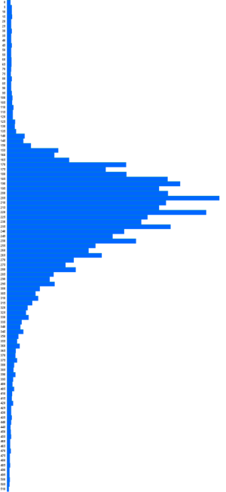

怠速就是发动机保持最低稳定运转速度的一种工作状况。一般发动机的怠速为600-1000转/分钟，缸数越多的发动机怠速转速越低。 比如最常见是四缸发动机怠速转速为850转/分钟左右，而六缸发动机怠速转速为700转/分钟左右，三缸发动机怠速转速为1000/分钟左右。

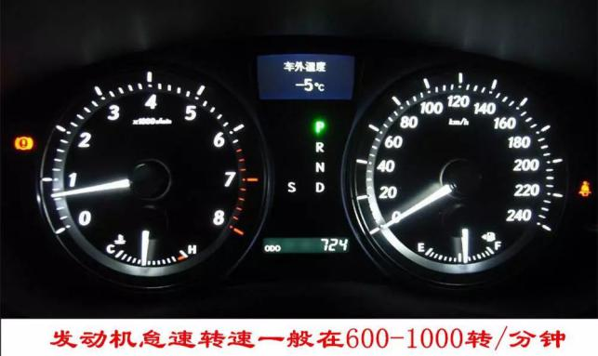

发动机怠速时，需要燃油供给系统提供浓而少的混合气。有实验表明，市面上主流排量的车型（1.4-2.5L）怠速时的油耗在1.5-3升/小时之间，排量越大怠速油耗越高。我们不妨取一个大致的平均数2.2升/小时来计算，看看每秒钟大约需要多少油。为了计算方便，我们以毫升/秒做单位。



即：大部分车型怠速时每一秒消耗的燃油大约是0.61毫升左右。

<https://detail.1688.com/offer/540890664152.html?spm=a261b.>