Detection function

This part will mainly discuss the detection function and its optimization. The detection function is of vital importance in the modeling because of the safety concerns. It will make the error adjustment much more quickly and improve the modeling efficiency. Therefore, the following text will cover the algorithm of the detection function and how it can be optimized.

According to the minimum safety distance mentioned in the Definition part, the distance between any two drones shouldn't be lower than this minimum value. First, our team utilize the Euclidean distance as part of the detection function. We calculate the Euclidean distance between every two drones at the same time by the following formulas

$$d\left(t\right)=\sqrt{{(x_{1}-x_{2})}^{2}+{(y_{1}-y_{2})}^{2}+{(z_{1}-z_{2})}^{2}}$$

among the formulas, x, y, z represent the coordinates of the drones. If the result of the formulas is lower than the minimum safety distance, then the program will send the error message. The program can calculate the total number of the error messages and report them to our tean members.

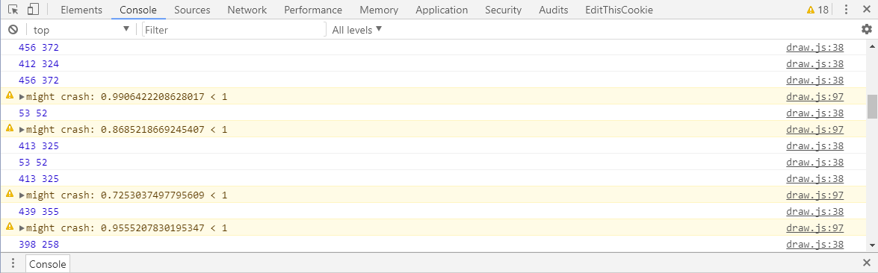

Then we improved the detection by using vectors. It can be applied to detect the minimal distance between two straight lines, but it doesn't use the time as independent variable, instead, it calculates the distance without the restrictions of time.

Suppose the starting and ending points of two drones are A（$x_{1},y_{1},z_{1}）$, B（$x_{2},y_{2},z_{2}）$, C（ $s_{1},t_{1},w_{1}）$ and D（$s_{2},t_{2},w_{2}）$. Then we can define the vector **n** as the following

**n**=**AB $×$ CD**

The vector **n** is perpendicular to both line AB and CD in the space. Then we calculate the minimal distance between two lines AB and CD by the following formula

$$d=\frac{n}{|n|}∙AC$$

Vector **AC** can be replaced by any vectors that starting point is on line AB and ending point is on line CD. The d in the formula means the vector **AC**'s projection on the vector **n**'s direction, which is the minimal, which equals to the minimal distance between the two lines. Then the program will judge the following situation, if d is lower than the minimal safety distance, then the program will further detect if two drones will possibly crash into one another.

The second algorithm can be used as a filter program and it can reduce the workload of the program by straining off the matches that certainly won't collide with one another.

