Audience's best viewing angle optimization

This part of the essay is going to discuss the best distance for viewing in order to let audiences better enjoy the visual feast.

Suppose the best horizontal distance is X. If the highest value of z-coordinate is A, the lowest value of z-coordinate is B, then we can calculate the best viewing angle  by using the following formulas



Then we calculate the derivative of  in order to find out its minimum value. We define ' as the derivative of  and it can be calculated by the following formula



When '=0,  has its minimum value, and we can calculate the value of X by the following



According to the z-coordinate of the first design, the Ferris wheel , the highest point of z-axis is approximately 200m and the lowest point of z-axis is approximately 50m. Therefore the best viewing distance is 100m.

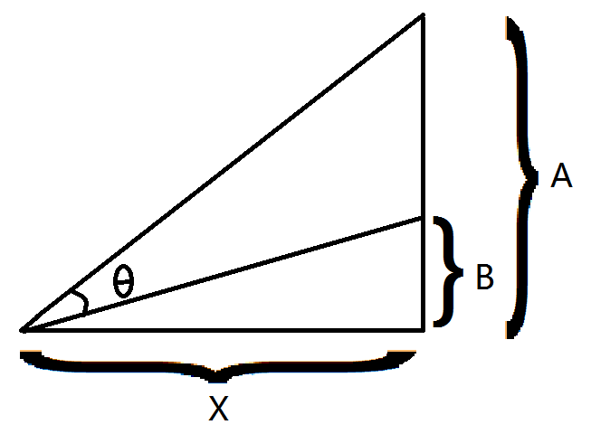

According to the z-coordinate of the second design, the dragon, the highest point of z-axis is approximately 200 and the lowest point of z-axis is approximately 50. Therefore the best viewing distance is 100m.

According to the z-coordinate of the first designs, the map of China, the highest point of z-axis is approximately 200 and the lowest point of z-axis is approximately 50. Therefore the best viewing distance is 100m.

Since audiences' viewing position is fixed, the three best distance above should be averaged in order to find the best horizontal distance for audiences to view the three patterns.

The average best distance is 100m+100m+100m/3=100m