DSE_Capstone_EDA_Canfield

Ryan Canfield

2024-11-10

## R Markdown

library(tidyverse) # For data manipulation.

## ── Attaching core tidyverse packages ──────────────────────── tidyverse 2.0.0 ──  
## ✔ dplyr 1.1.4 ✔ readr 2.1.5  
## ✔ forcats 1.0.0 ✔ stringr 1.5.1  
## ✔ ggplot2 3.5.1 ✔ tibble 3.2.1  
## ✔ lubridate 1.9.3 ✔ tidyr 1.3.1  
## ✔ purrr 1.0.2   
## ── Conflicts ────────────────────────────────────────── tidyverse_conflicts() ──  
## ✖ dplyr::filter() masks stats::filter()  
## ✖ dplyr::lag() masks stats::lag()  
## ℹ Use the conflicted package (<http://conflicted.r-lib.org/>) to force all conflicts to become errors

library(ggplot2) # For data visualizations.   
library(RColorBrewer) # For coloring visuals.

# Reading the CSV file into a data frame  
df <- read.csv("cleaned_data.csv")  
  
# Display a preview of the data frame.  
head(df)

# Visualizations:

## Frequency Bar Charts of Demographic Variables:

### This table will present frequencies and percentages of key demographic variables, such as country, age, gender, education, and online service preferences.

# Specify colors for each level   
country_colors <- c("red", "gold", "orange")   
age_colors <- c("navy", "darkorchid4", "deeppink3", "salmon")  
gender_colors <- c("pink", "skyblue")   
education_colors <- c("lightgoldenrod1", "springgreen3", "steelblue2", "slateblue3")   
OnlineS_colors <- c("darkred", "lightgreen")   
salary_colors <- c("deepskyblue", "darkolivegreen", "hotpink4", "firebrick3")  
  
  
  
par(mfrow=c(2,3))  
  
# Plot 1: Country   
barplot(table(df$Country),   
 col = country_colors,   
 xlab = "Country",   
 ylab = "Frequency",  
 main = "Customer Origins",   
 cex.names = 0.8)   
  
# Plot 2: Online Service Preference  
barplot(table(df$Online_Service_Preference),   
 col = OnlineS_colors,   
 xlab = "Online Shopping",   
 ylab = "Frequency",  
 main = "Do They Prefer Online Shopping",   
 cex.names = 0.8)  
  
# Plot 3: Gender   
barplot(table(df$Gender),   
 col = gender_colors,   
 xlab = "Gender",   
 ylab = "Frequency",  
 main = "Gender of Customer",   
 cex.names = 0.8)  
  
# Plot 4: Age   
barplot(table(df$Age),   
 col = age_colors,   
 xlab = "Age",   
 ylab = "Frequency",  
 main = "Age of Customers",   
 las = 2,   
 cex.names = 0.8)  
   
  
# Plot 5: Annual Salary   
barplot(table(df$Annual_Salary),   
 col = salary_colors,   
 xlab = "Salary",   
 ylab = "Frequency",  
 main = "Customers Salary",   
 las = 2,   
 cex.names = 0.8)

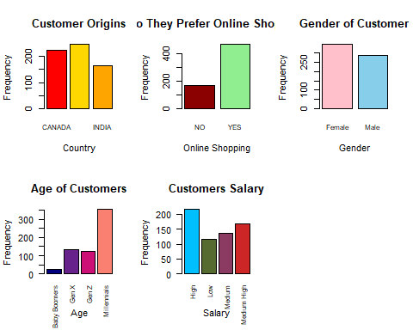

par(mar=c(5, 4, 4, 2) + 2.4) # Adjusts the bottom margin

# Plot 6: Education   
barplot(table(df$Education),   
 col = education_colors,   
 ylab = "Frequency",  
 main = "Education of Customers",   
 las = 2,   
 cex.names = 0.8)

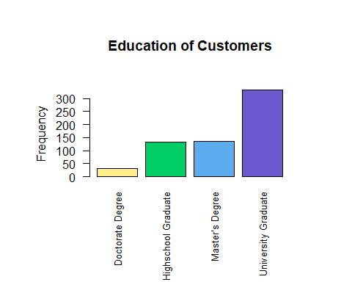

## Pie Charts of AI Tool Usage:

### These pie charts will show the proportion of customers in high, moderate, and low AI usage categories.

# Calculate the percentage of people who use AI  
AI_usage_percents <- df %>%  
 count(AI_Usage) %>%  
 mutate(Percentage = n / sum(n) * 100)  
  
# Create the pie chart using base R  
pie(AI_usage_percents$Percentage,   
 labels = paste0(AI_usage_percents$AI_Usage, ": ", round(AI_usage_percents$Percentage, 1), "%"),   
 col = c('darkred', 'steelblue2', '#28B463', 'goldenrod1'), # Customize colors  
 main = "The Proportion of the Usage Amount of AI from Customers")

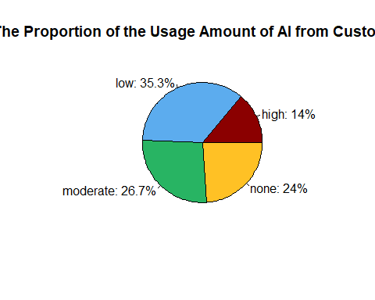

## Scatterplot of AI Trust vs. AI Satisfaction:

### This scatter plot will visualize the relationship between the newly created AI_Trust variable and AI satisfaction levels.

unique(df$AI_Trust)

## [1] "Moderate" "Low" "High"

unique(df$AI_Satisfaction)

## [1] "YES" "NO"

set.seed(3) # For repeated results  
  
# Function to generate random number based on category  
generate_random <- function(category) {  
 if (category == "Low") {  
 return(round(runif(1, min = 1, max = 3), 2)) # Random number between 1 and 3  
 } else if (category == "Moderate") {  
 return(round(runif(1, min = 4, max = 7), 2)) # Random number between 4 and 7  
 } else if (category == "High") {  
 return(round(runif(1, min = 8, max = 10), 2)) # Random number between 8 and 10  
 }  
}  
  
  
df$Random_Num_based_AITrust <- sapply(df$AI_Trust, generate_random)  
  
# View the result  
head(df)

df$Index <- seq_along(df$AI_Trust)  
  
  
ggplot(df, aes(x = Random_Num_based_AITrust, y = Index)) +  
 geom_point(aes(color = AI_Trust), size = 3) +  
 labs(  
 title = "Relationship Between AI Trust and AI Satisfaction",  
 x = "AI Trust Level",  
 y = "AI Satisfaction Count"  
 ) +  
 theme_minimal() +  
 theme(legend.title = element_blank())

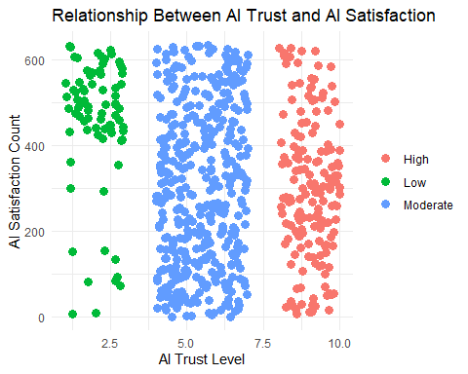

## Histogram of AI Usage Levels:

### This histogram will show the distribution of AI usage levels (high, moderate, low) across the dataset.

# Summarize the data to get frequencies  
data_summary <- df %>%  
 count(Country, AI_Usage)  
  
# Create the bar graph  
ggplot(data_summary, aes(x = Country, y = n, fill = AI_Usage)) +  
 geom_bar(stat = "identity", position = "dodge") +  
 labs(x = "Country", y = "Frequency of AI Usage", title = "AI Usage Frequency per Country") +  
 scale_fill_manual(values = c("high" = "dodgerblue2", "moderate" = "#28B463", "low" = "orange", "none" = "firebrick")) +  
 theme_minimal() +  
 theme(axis.text.x = element_text(angle = 45, hjust = 1),  
 panel.grid = element_blank())

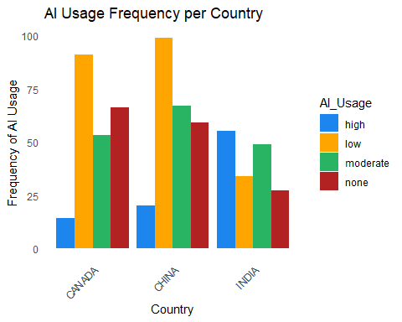

# Summarize the data to get frequencies  
data_summary <- df %>%  
 count(AI_Tools_Used_Chatbots, AI_Usage)  
  
# Create the bar graph  
ggplot(data_summary, aes(x = AI_Tools_Used_Chatbots, y = n, fill = AI_Usage)) +  
 geom_bar(stat = "identity", position = "dodge") +  
 labs(x = "Used Chatbot", y = "Frequency of AI Usage", title = "AI Sites that Used Chatbots") +  
 scale_fill_manual(values = c("high" = "royalblue", "moderate" = "springgreen3", "low" = "goldenrod1", "none" = "red2")) +  
 theme_minimal() +  
 theme(axis.text.x = element_text(angle = 45, hjust = 1),  
 panel.grid = element_blank())

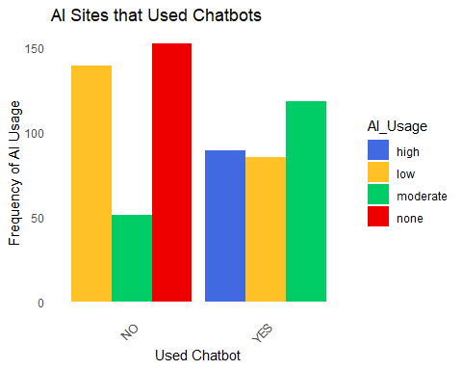

# Summarize the data to get frequencies  
data_summary <- df %>%  
 count(AI_Tools_Used_Virtual_Assistant, AI_Usage)  
  
# Create the bar graph  
ggplot(data_summary, aes(x = AI_Tools_Used_Virtual_Assistant, y = n, fill = AI_Usage)) +  
 geom_bar(stat = "identity", position = "dodge") +  
 labs(x = "Used Virtual Assistant", y = "Frequency of AI Usage", title = "AI Sites that Used Virtual Assistants") +  
 scale_fill_manual(values = c("high" = "slateblue", "moderate" = "darkgreen", "low" = "goldenrod3", "none" = "violetred")) +  
 theme_minimal() +  
 theme(axis.text.x = element_text(angle = 45, hjust = 1),  
 panel.grid = element_blank())

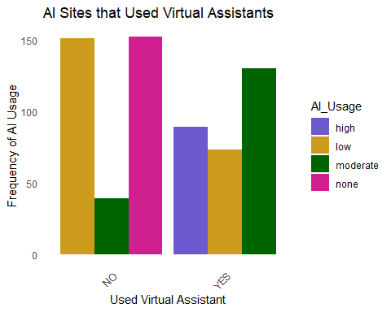

# Summarize the data to get frequencies  
data_summary <- df %>%  
 count(AI_Tools_Used_Voice_Photo, AI_Usage)  
  
# Create the bar graph  
ggplot(data_summary, aes(x = AI_Tools_Used_Voice_Photo, y = n, fill = AI_Usage)) +  
 geom_bar(stat = "identity", position = "dodge") +  
 labs(x = "Used Voice or Photo", y = "Frequency of AI Usage", title = "AI Sites that Used Photos or Voice") +  
 scale_fill_manual(values = c("high" = "turquoise2", "moderate" = "yellowgreen", "low" = "khaki", "none" = "tomato")) +  
 theme_minimal() +  
 theme(axis.text.x = element_text(angle = 45, hjust = 1),  
 panel.grid = element_blank())

