**COUNTRY SPECIFIC PROCESSING:**

* performance metrics by country(e.g., ridge_rmse and lasso_rmse).
* Feature Scaling by country
* split each country data into training (78%) and testing (22%) sets based on R code Professor Geist gave us:

* LDA for each country to predict AI_Satisfaction
* Ridge and Lasso Regression
* Validation Curves for Ridge and Lasso Regression
* LDA to reduce dimensionality and SMOTE to handle class imbalance
* GridSearchCV for Hyperparameter Tuning for Ridge Regression
* Learning Curve for Ridge Regression
* RMSE Comparison Plot

**FULL DATASET ANALYSIS**

* Feature scaling
* Test-train split with 78/22
* LDA – classification report and accuracy
* SMOTE - Oversampling to address class imbalance
* Ridge and Lasso Regression to handle overfitting
* Validation Curve
* Optimal Alpha
* Feature Importance (identify top 6 features based on subset selection in R)

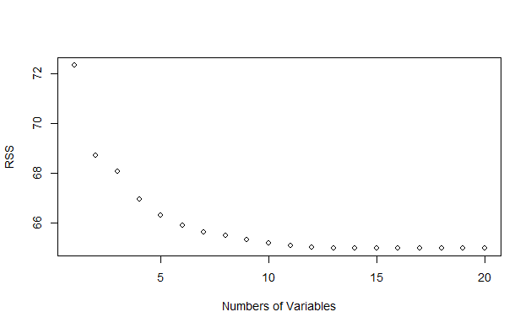

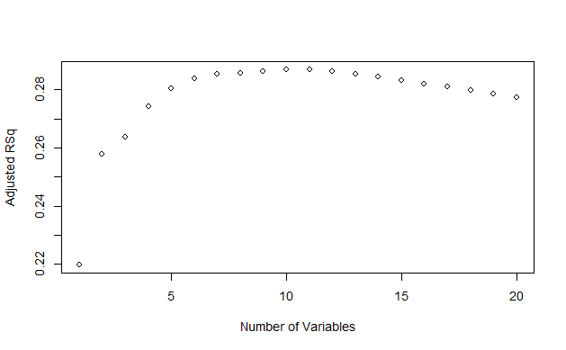

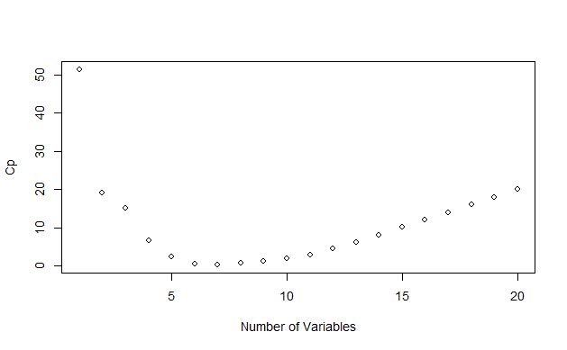

* Learning Curve for Ridge Regression