Alpha Surfaces logo

ALPHA SURFACES
Fabrication & Installation Manual
Version 1.0
March 2026
© Alpha Surfaces
[Cover Image – Alpha Surfaces Kitchen Installation]
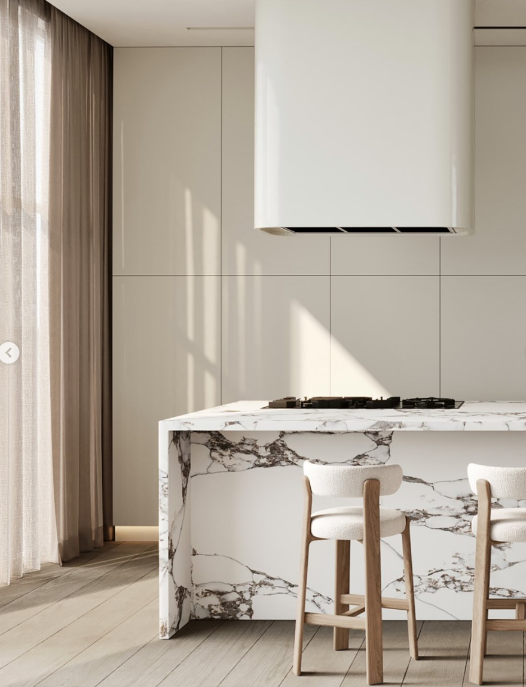

CONTENTS
- Introduction
- Product Overview
- Slab Information
- Product Inspection
- Storage & Handling
- Fabrication Equipment
- Safety Guidelines
- Templating
- Cabinet & Support Requirements
- Fabrication Procedures
- Edge Fabrication & Polishing
- Seaming
- Installation
- Wall Applications
- Care & Maintenance

1. INTRODUCTION
Alpha Surfaces represents the next generation of high-performance mineral surfaces. Developed using an advanced Zero Silica Formulation, Alpha Surfaces is engineered from premium minerals and recycled materials to deliver exceptional durability, enhanced translucency, and superior aesthetic performance - while prioritising fabrication safety and environmental responsibility.

2. PRODUCT OVERVIEW
The composition of Alpha Surfaces ensures high durability, structural stability and excellent resistance while completely eliminating crystalline silica.
Our surfaces offer classic engineered-stone aesthetics, including solid colours, natural stone tones, subtle patterns and mor dramatic veinng, produced using advanced moulding technology adapted from traditional quartz manufacturing but now reengineered for a silica-free formulation.
Aesthetic and functional performance
The zero-silica surfaces display remarkable depth and brightness, free from visible particulate grains and offering superior light reflection and colour clarity. Engineered to meet both residential and commercial requirements, the material delivers excellent hardness, stain resistance, low porosity and long-term durability.
These next-generation products redefine engineered stone by delivering full elimination of crystalline silica, high recycled content and advanced digital design technologies.
Alpha Surfaces are developed to provide a sustainable, high-performance surface suitable for residential and commercial applications.
Alpha Shield
Thanks to AlphaShield™ Technology, Alpha Surfaces provides a Lifetime Stain Resistance Guarantee on all surfaces when used in approved applications.
When properly installed and maintained according to the Alpha Surfaces Care & Maintenance Guidelines, Alpha Surfaces products will:
- Resist staining from common household substances
- Withstand exposure to substances with a pH range between 1 and 13
- Resist acid corrosion within this pH range
The warranty does not cover staining caused by substances exceeding pH13, harsh chemicals, misuse, or failure to follow the recommended care instructions.
  - SLAB INFORMATION
SIZE
Slab dimensions: 3200 mm × 1600 mm usable surface
THICKNESS
Available in 20 mm thickness
FINISH AVAILABLE
- Polished
- Matte
BACK LIGHTING
Available in some surfaces (refer website)

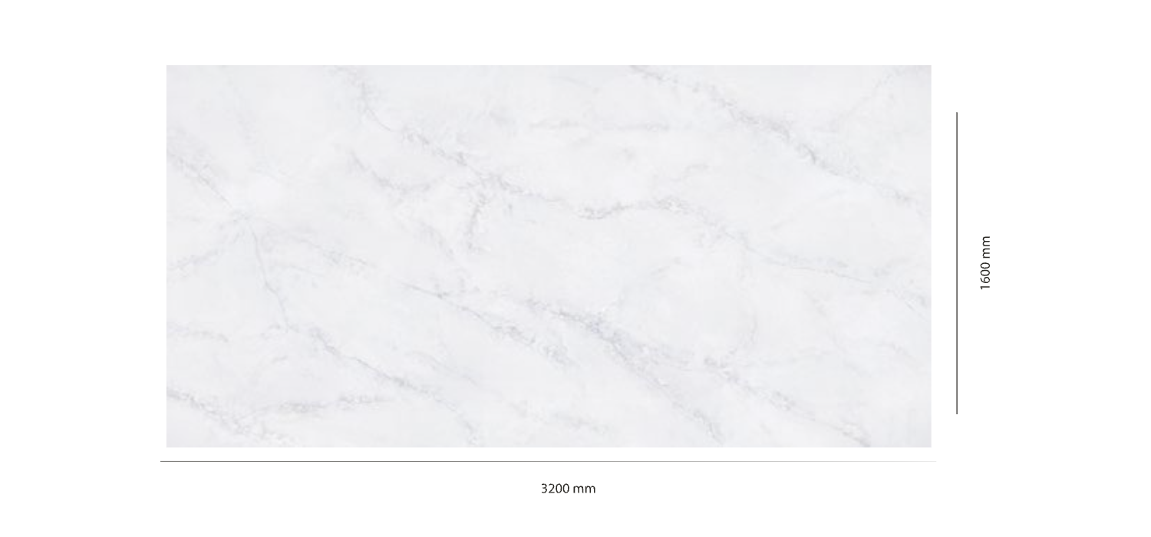
Slab Image indicating nominal slab size of 3200 x 1600mm

COMPLETE INSPECTION OF PRODUCT
VISUAL INSPECTION OF SLABS
A complete visual inspection for defects and colour consistency is essential when working with engineered stone. This inspection must be carried out before any cutting or fabrication begins.
Follow the steps below:
- Remove the protective film before inspection.
- Inspect both the front and back of the slab.
- Check for hairline cracks or structural defects.
- Confirm accurate colour matching between slabs before fabrication.
- Verify dimensions, warping, irregular spots, or other defects that may make the slab unsuitable for fabrication.
- Check the pattern flow and orientation for veined materials.
Important:
Once a fabricator has deemed a slab acceptable and it has been cut or machined in any way; the slab cannot be exchanged or refunded. The fabricator is responsible for ensuring the slab is suitable for fabrication before modification.
Alpha Surfaces will not accept claims once the slab has been modified, cut, or fabricated.
Alpha Surfaces replicates marble and features veined patterns that are non-directional. Vein distribution may vary throughout the slab and along its edges. As slabs are not book matched, fabricators must carefully plan the layout to achieve the best aesthetic outcome.
Slight colour variation between batches or production cycles is normal due to the blending of natural minerals and raw materials.
When using multiple slabs:
- Check the batch and shade numbers on the slab labels.
- Remove the protective plastic film.
- Visually inspect all slabs for colour consistency and defects before cutting.
- When planning the layout, ensure backsplashes match the countertop colour and vein pattern.

Standard Alpha Surfaces Labels on Slabs
Each slab includes two to three labels:
- Safety sticker
- Slab detail sticker
- Alpha Shield label
Slab Sticker Information
- Item name
- Item number
- Production batch
- Shade number
The item number, batch number, and shade number are also printed on the edge of the slab.
Please note: These slabs contain less than 1% crystalline silica.
Image of all labels

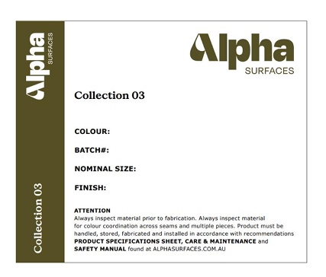
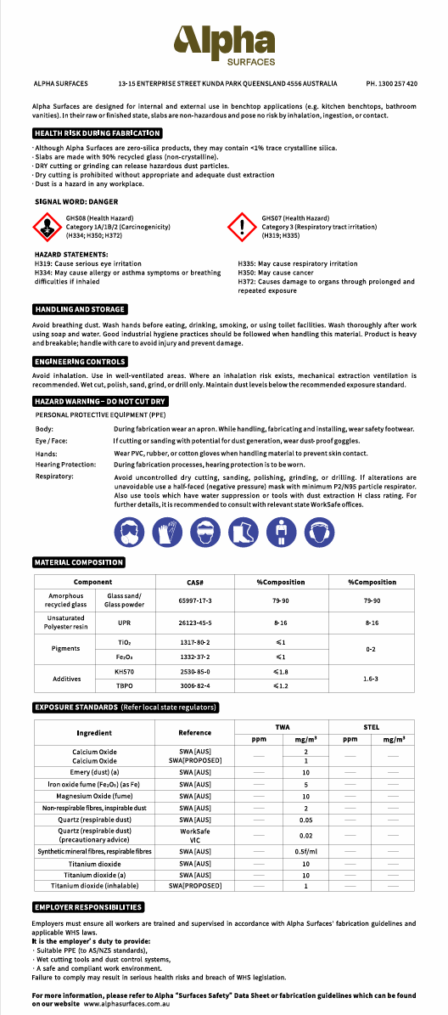
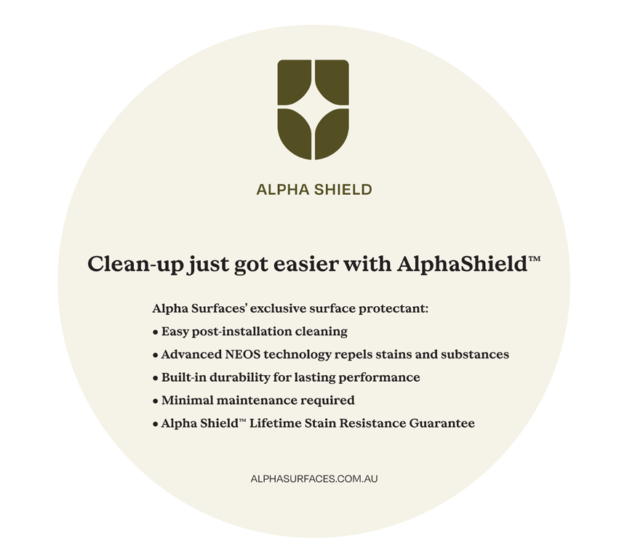

RECOMMENDATIONS FOR SLAB STORAGE IN FABRICATION SHOPS
A-FRAMES
The best way to store Alpha Surfaces slabs for fabrication or transport is on A-frame racks constructed from wood or metal.
These frames should ideally include forklift receivers for safe loading and transport.
Frame Image
Double A-frames must have equal numbers of slabs on each side for proper balance and safety.
Typical A-frame sizes:
Basic A-Frame
- 1500 mm (L) × 1510 mm (W) × 1600 mm (H)
- Capacity: 3,900 kg
- Weight: 54 kg
Large A-Frame
- 1830 mm (L) × 1830 mm (W) × 1624 mm (H)
- Capacity: 5,500 kg
- Weight: 68 kg
Single-sided A-frames may also be used according to the manufacturer’s specified capacity.
When storing slabs:
- Always strap slabs to the frame.
- Store slabs flat with no gaps between them.
- Place slabs face-to-face or back-to-back to protect polished surfaces.
Alpha Surfaces slabs must always be securely strapped when transported, whether inside the fabrication shop or on vehicles.
A-frames are suitable for temporary storage only, not long-term storage.
Image

VERTICAL STORAGE RACKS FOR SLABS
Vertical storage racks are recommended for long-term slab storage.
Racks should:
- Be steel constructed
- Be capacity rated
- Be designed specifically for stone slab storage
Most systems come in 1.5 m or 3 m sections with 50 mm × 50 mm uprights. Rubber-tipped uprights are recommended to prevent slab damage.
Typical capacities:
3 m Rack Systems
- Usually include 16 uprights
- Approximate capacity: 10,750 kg between uprights
- Approximate load per upright: 5,400 kg
1.5 m Rack Systems
- Usually include 8 uprights
- Capacity between uprights: 3,100 – 4,100 kg
- Load per upright: 1,450 – 2,000 kg
Actual capacities vary by manufacturer. Values in this guide are based on heavy-duty racking systems.
Slabs should always be stored:
- Face-to-face or back-to-back
- With the protective plastic film intact

RECOMMENDED FABRICATION EQUIPMENT & BASIC SAFETY EQUIPMENT
PROPER MATERIAL HANDLING OF ALPHA SURFACES
Alpha Surfaces slabs must never be transported horizontally. Horizontal handling places excessive stress on the slab and may cause hairline cracks or breakage.
Recommended handling equipment:
- Heavy-duty slab carts or dollies
- Slab booms and clamps for cranes or forklifts
- Pneumatic vacuum suction cups with white rubber pads. We recommend that all suction cups be used with white rubber to prevent dark rings from appearing on the slabs.
All countertop cutouts should be supported with 2" × 4" × 8' support rails during transportation.

BASIC DIAMOND TOOLING & POWER TOOLS
Minimum tooling required for fabrication includes:
- Wet diamond polishing pads (grits: 50, 100, 200, 400, 600, 800, 1500, 3000)
- Honed finish pads (100–600 grit)
- Diamond cup wheels
- Diamond core bits
- Diamond contour blades (sink cutouts)
- Diamond turbo blades (5" and 6")
- Diamond router bits (edge profiles)
- Diamond bridge saw blades
- Silicon carbide grinding wheels
- Back-up pads (rigid and flexible)
- Pneumatic polisher (0–4000 RPM)
- Variable speed grinder/polisher (2,800–11,000 RPM)
- Water supply systems for wet polishing

ADDITIONAL RECOMMENDED FABRICATION EQUIPMENT
Recommended equipment for professional fabrication shops:
- Bridge saw (20+ HP)
- CNC machine
- Automatic edge profiler
- Water jet cutting system
- Handheld edge profiler
- Forklift
- Overhead crane
- Fabrication tables
- Air compressor
- Water supply source
- Stone carts/dollies
- A-frames and storage racks
- Slab clamps
All bridge saws must use wet suppression methods in accordance with SafeWork Australia crystalline silica guidelines.

BASIC SAFETY EQUIPMENT
Alpha Surfaces must always be fabricated using wet cutting and polishing methods with proper ventilation.
Fabricators must wear:
- Respirators compliant with AS/NZS1716:2012
- Safety glasses
- Ear protection
- Waterproof steel-toe boots
- Solvent-resistant gloves
- Waterproof apron or rain suit
- Leather gloves (for slab handling)
All electric tools used in wet environments should be protected by Ground Fault Interrupters (GFI).


STANDARD SAFETY PRACTICES AND PROCEDURES FOR FABRICATORS
- Always wear appropriate protective clothing and PPE.
- Follow all SDS safety instructions for materials used in the shop.
- Follow manufacturers' guidelines for power tools and machinery.
- Always use eye and hearing protection.
- Ensure fabrication areas have proper drainage to prevent slip hazards.
- Clean trench drains regularly to remove stone slurry.
- Remove standing water using squeegees throughout the day.
- Use GFI-protected electrical connections in wet environments.
- Pneumatic tools are recommended wherever possible.
- Follow all local safety regulations and workplace safety standards.

TEMPLATING
JOB LAYOUT MEASUREMENT
Accurate templating ensures proper fabrication and installation.
DIGITAL TEMPLATING
Digital templating uses laser measuring systems, digital cameras, or point-to-point digitisers to capture precise dimensions.
Benefits include:
- Increased accuracy
- Faster measurement
- Direct integration with CNC machines, bridge saws, and water jets
MANUAL TEMPLATING
Manual templates are typically created using:
- Thin plywood
- Luan strips
- Cardboard
Templates should include detailed job drawings specifying:
- Sink centre lines
- Appliance cutouts
- Faucet locations
- Edge profiles
- Overhangs
All appliances and sinks should ideally be on site during templating.

INFORMATION TO GATHER FROM HOMEOWNER
- Alpha Surfaces colour selection
- Seam locations
- Edge profile selection
- Backsplash requirements
- Sink location
- Tap location
- Appliance locations
- Additional accessory locations (soap dispenser, sprayer, etc.)
Inside corners must have a minimum radius of 9.5 mm.

CABINET REQUIREMENTS
Before installation:
- Cabinets must be fully installed and level.
- Maximum allowable variation is 1.5 mm over 450 mm.
- Cabinets must be securely fixed to walls and adjoining cabinets.
- Additional support must be provided around dishwashers and cutouts.

SUPPORT REQUIREMENTS
Structures supported on four sides
No additional support is required for 20 mm material if:
- Depth is less than 660 mm
- Length is less than 3000 mm
If these dimensions are exceeded, support must be added every 914 mm.
Structures supported on three sides
Additional support required every 610 mm.

OVERHANG / CANTILEVER REQUIREMENTS
Maximum overhang: 300 mm
For 20 mm material:
- <300 mm: no additional support
- 300–500 mm: brackets at 600 mm intervals
- 500 mm: posts, legs, or structural supports required
No cutouts are permitted in unsupported overhang sections.

RECOMMENDED SUPPORT MATERIALS
Acceptable support materials include:
- Plywood
- Timber
- Medium density fibreboard
- Structural steel
Moisture-sensitive materials such as particle board or OSB are not recommended.
Failure to follow these guidelines may void the Alpha Surfaces warranty.

FABRICATING
LAYOUT
Before cutting slabs:
- Calculate required material dimensions
- Confirm slab batch and shade consistency
- Inspect for defects
- Plan seam locations carefully

DETERMINE SEAM LOCATIONS
Seams should not be located:
- Through the centre of sink cutouts
- In areas exposed to direct sunlight
- Directly above dishwashers
If a mitred edge is used on an L-shaped countertop, a field deck seam may be required.
IMAGE

PROPER CUTTING
All cutting equipment must use adequate water cooling.
Guidelines:
- First cut along the largest dimension of the slab
- Never plunge cut with a bridge saw
- Never create square inside corners
- Always use diamond core bits for internal radii
Minimum inside corner radius: 10 mm
Never cross-cut inside corners.
Resin in the slab may cause temporary warping. Cutting the slab into components typically releases tension and flattens the pieces.

CUTOUTS
Cutouts may be performed using:
- Bridge saws
- CNC machines
- Water jet systems
Requirements:
- Minimum 10 mm internal radius
- Allow 3 mm expansion clearance
- Maintain minimum 150 mm distance between seams and cutouts. This can be achieved during the layout process by making sure that all seams are at a cross member of the base cabinet; otherwise, additional cross members need to be added. Internal cutouts on all inside corners should have a 1cm radius at minimum.
Heat-producing appliances require 9-mil aluminium heat tape to prevent heat transfer.

PRE-FABRICATION
LAMINATIONS
When laminating:
- Use full-length lamination strips whenever possible
- Cut lamination joints at 45° angles to minimise stress
- Ensure lamination strips come from the same slab for colour consistency
- Butt joints are not recommended for veined slabs due to pattern interruption.
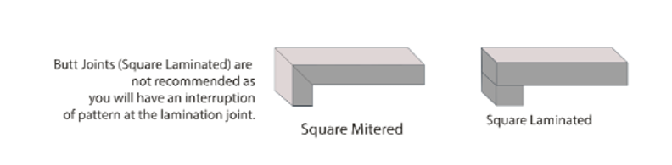

MITRED EDGE
A mitred edge forms a perfect 90° edge by joining two pieces cut at 45°.
Mitred edges greater than 100 mm height require additional support.
When clamping and gluing mitre joints, we recommend the use of Mitsubishi G-Tape or a tape of similar properties. For standard 38 mm mitred edge profiles, tape should be applied prior to glue every 203 mm to 254 mm. As edge profiles become taller (76 mm to 203 mm) tape will need to be applied more frequently to support the weight of the apron piece being attached. If mechanical clamping systems or jigs are being used to secure the mitre during the gluing process, be aware that both uneven clamp pressure, or clamp pressure higher than required can introduce warpage into the finished product.

ADHESIVES
Use colour-matched cartridge acrylic or epoxy adhesives designed for engineered stone.
These adhesives provide:
- Strong chemical bonding
- Minimal seam visibility
IMAGE ??

POLISHING / EDGE DETAIL
Use white resin polishing pads only to prevent colour transfer.
Polishing guidelines:
- Use wet polishing only
- Final polish should be 3000 grit
- Avoid final buffing pads designed for granite
Excessive heat can cause micro-fissures or discolouration.
Recommended polisher speed: 2,800–4,000 RPM.

SEAMS
Recommended seam width: 1.6 mm
Tolerance: ±0.8 mm
Seamed edges must be:
- Straight
- Level
- Properly supported
Always clean edges with denatured alcohol before applying adhesive.
Vacuum seam setters are recommended to ensure tight, level seams.

INSTALLATIONS
SINKS
Follow sink manufacturer guidelines.
Important rules:
- Sinks must have independent structural support
- Never screw or fasten directly into Alpha Surfaces
- Seal sinks using 100% silicone

SPLASHBACK MATERIALS
Standard backsplash height: 76 mm
Installation steps:
- Cut pieces from the same slab batch.
- Polish exposed edges.
- Dry-fit before installation.
- Apply 3.2 mm silicone bead to the base.
- Attach to wall with silicone dabs every 100–150 mm.
- Backsplashes should not be hard seamed to the countertop.
Alpha Surfaces can be installed as a splashback behind gas, electric, or induction cooktops, provided that both the appliance manufacturer’s installation instructions and relevant Australian and New Zealand standards are followed.
Careful attention must be given to required clearances and heat insulation. For gas cooktops, in accordance with AS/NZS 5601 Gas Installations Standard, there must be a minimum distance of 200 mm between the outer edge (periphery) of the gas burner and the Alpha Surfaces splashback.
For electric and induction cooktops, a minimum clearance of 50 mm is required from the back edge of the cooktop to the splashback. In corner installations such as L- or U-shaped benchtops, the cooktop must be positioned at least 25 mm away from the corner.
When installing a splashback behind a slide-in range or cooktop, all manufacturer requirements must be strictly followed; ovens that vent from the rear should not be installed directly against the splashback, and the use of a back guard is recommended to protect the surface. Additionally, operating an overhead exhaust or range hood during use is advised to help dissipate heat and maintain safe operating conditions.

WALL APPLICATIONS (VERTICAL)
Alpha Surfaces can be used for interior wall cladding.
Installation should consider:
- Structural load
- Local building codes
- Proper substrate preparation
Typical substrates include:
- Cement board
- Waterproof plywood
- Backer board
Allow 3.2 mm expansion joints between panels and seal with 100% silicone.
Bracing should remain in place for at least 24 hours until adhesive cures.

CARE AND MAINTENANCE
Alpha Surfaces is non-porous and requires minimal maintenance.
Routine cleaning only requires:
- Warm water
- Soft cloth
- pH-neutral cleaner

DAILY CLEANING
Wipe surfaces with:
- Damp cloth or paper towel
- pH-neutral stone cleaner
Alpha Surfaces is resistant to pH1–pH13 substances but always confirm cleaner pH levels.
Most granite cleaners are suitable if pH neutral.

PERIODIC CLEANING
For heavy-use areas:
- Perform deep cleaning once per month
- Use neutral intensive cleaners
When using cleaning machines:
- Use soft pads or brushes
- Avoid wax strippers

IMPORTANT MAINTENANCE NOTES
- Do not use acetone (may damage resin)
- Do not use bleach
- Do not apply waxes or sealants
- Use trivets or hot pads for hot cookware
Alpha Surfaces is heat and scratch resistant but not heat- or scratch-proof.

