A. Prepare Multiple Nodes on JD HDD Cloud without Jump Server

A.1. Create a VPC and a Subnet
Step 1: Click https://cns-console.jdcloud.com/network/vpc/list, create a VPC (20260721-VPC-again),
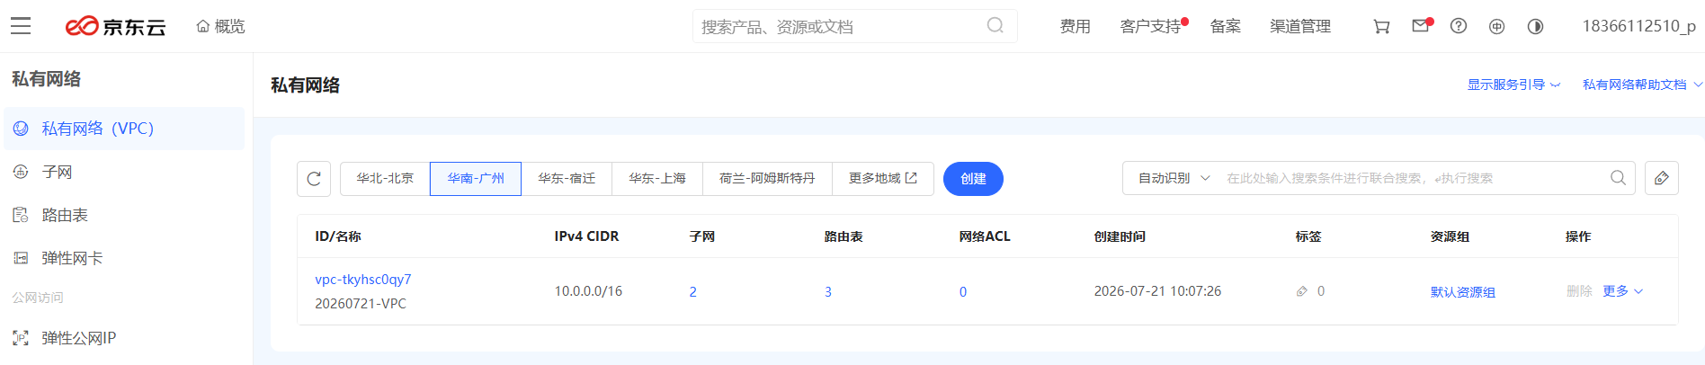

where the IPv4 CIDR is 10.0.0.0/17
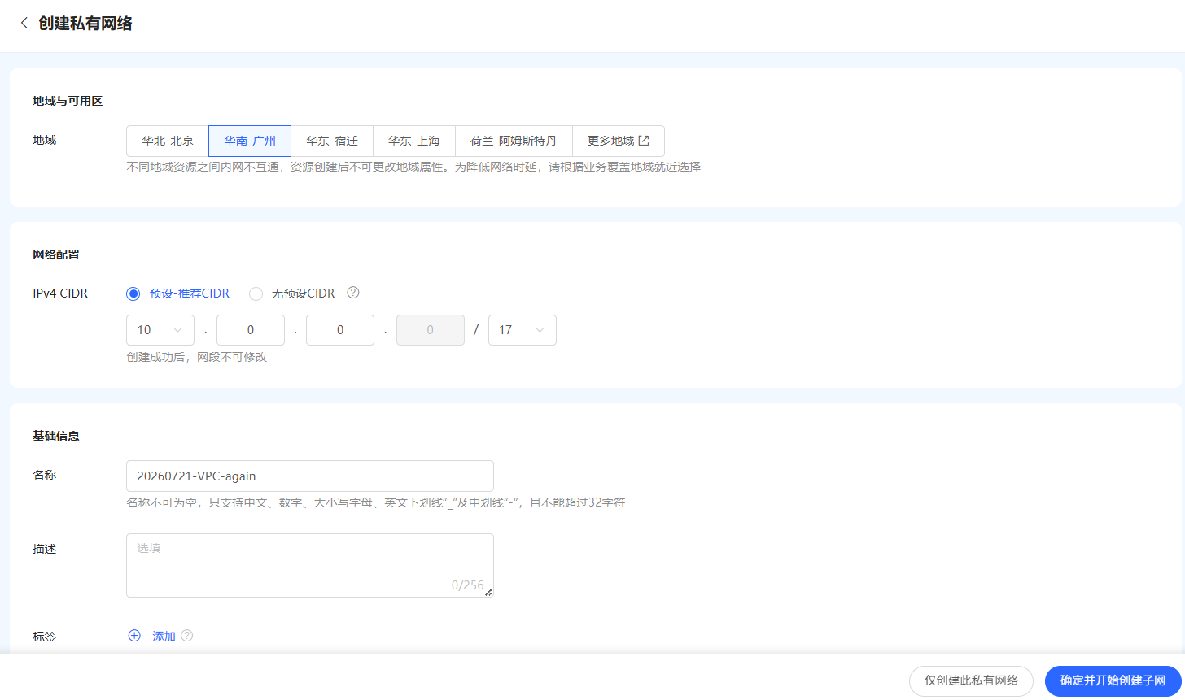

Then we create a subnet (20260721-SUBNET1-again), the IPv4 CIDR of the subnet is 10.0.1.0/26
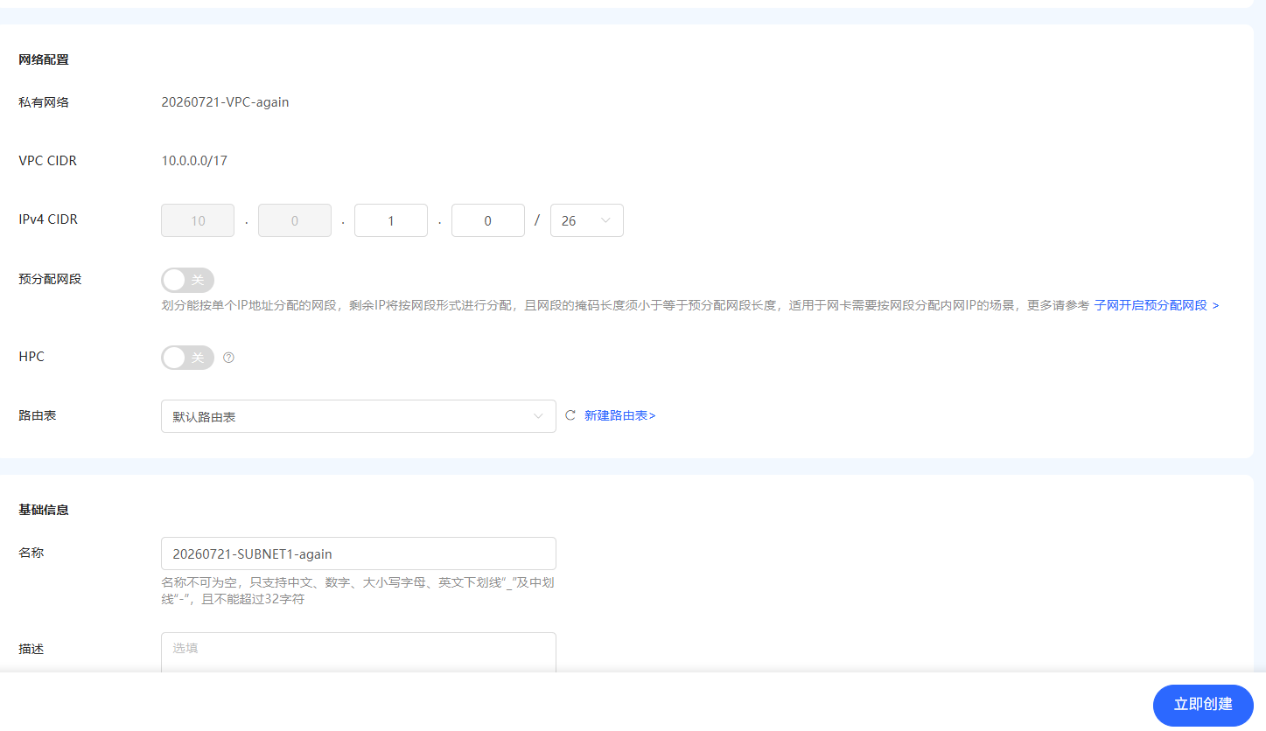

A.2. Create a Routing Table
Step 1: Click https://cns-console.jdcloud.com/host/routeTable/list, create a routing table, where the VPC is 20260721-VPC-again, the routing table is named as net-again,
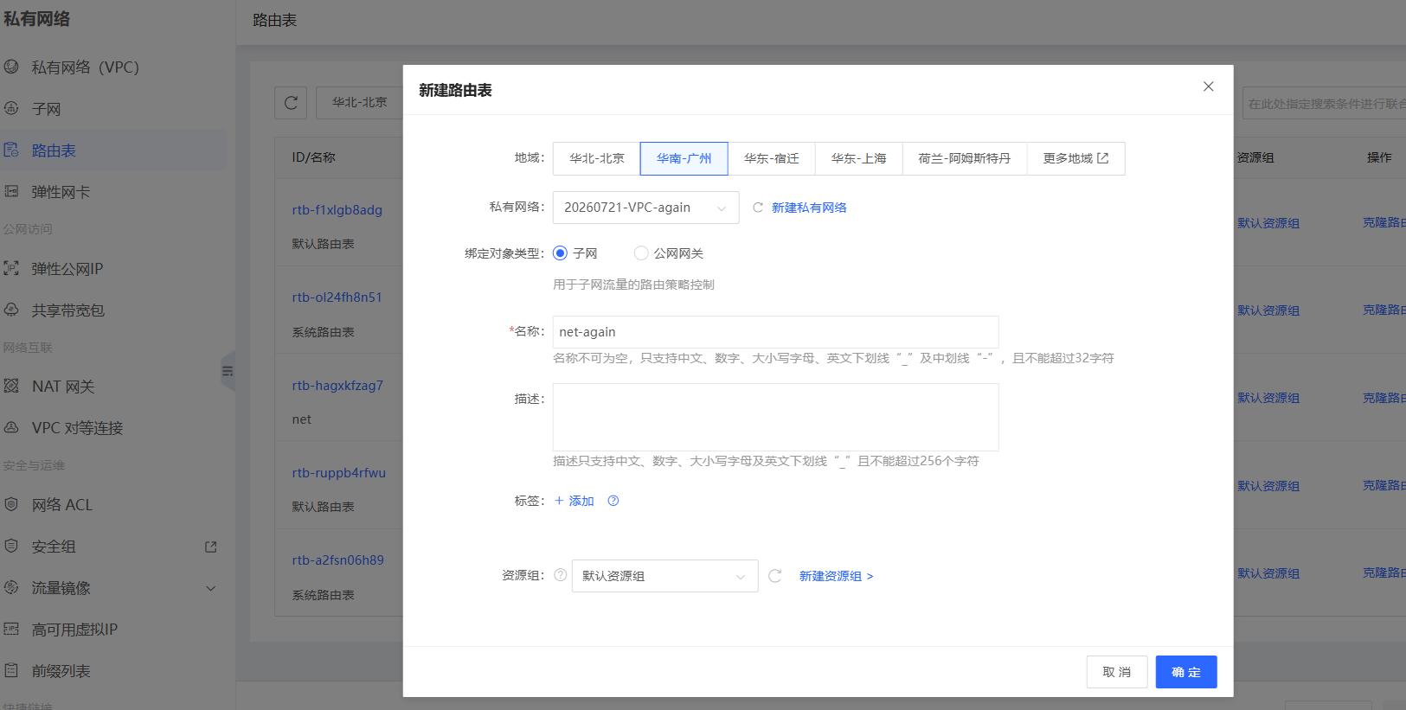
Step 2: Configure the routing table, click the routing strategy option of the routing table,
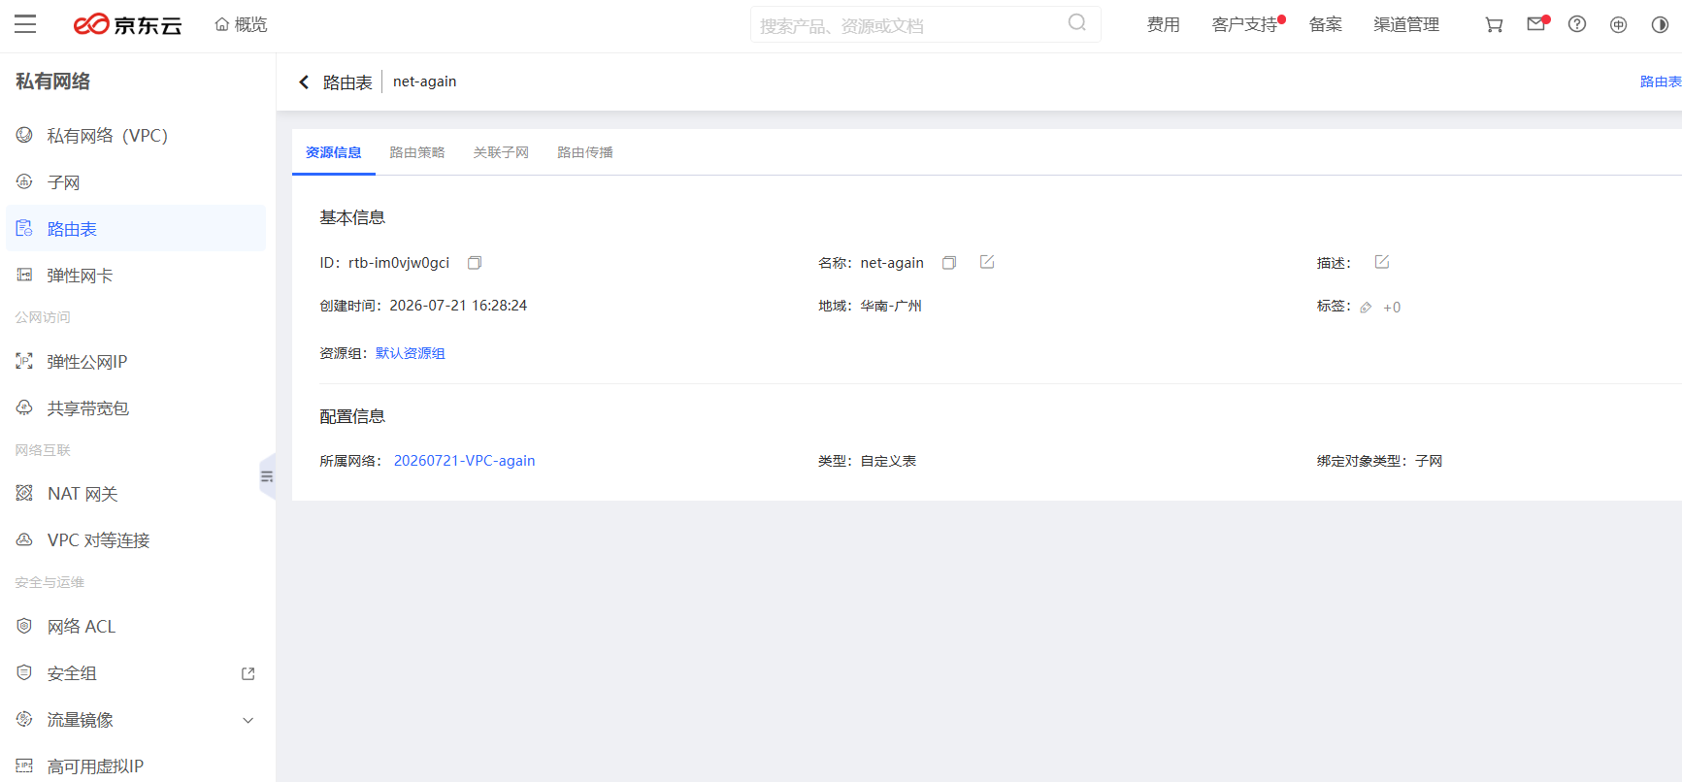

add a routing rule, and save it,
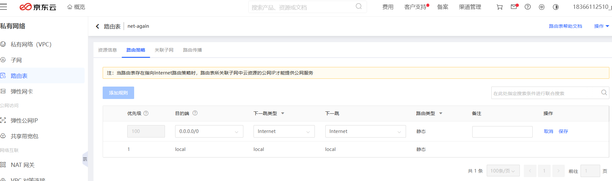

A.3. Configure subnet 1
Step 1: This step is optional, because we have already configured subnet 1 when we created VPC.

A.4. Configure subnet 2
Step 1: Click https://cns-console.jdcloud.com/host/subnet/list, and create subnet 2, where the VPC is 20260721-VPC-again,
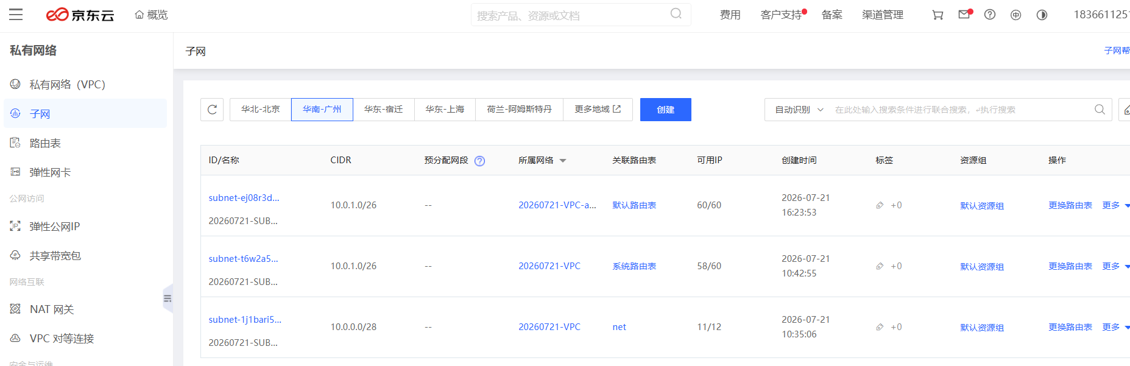
The IPv4 CIDR of the second subnet is 10.0.2.0/27, the name of the second subnet is 20260721-SUBNET2-again,
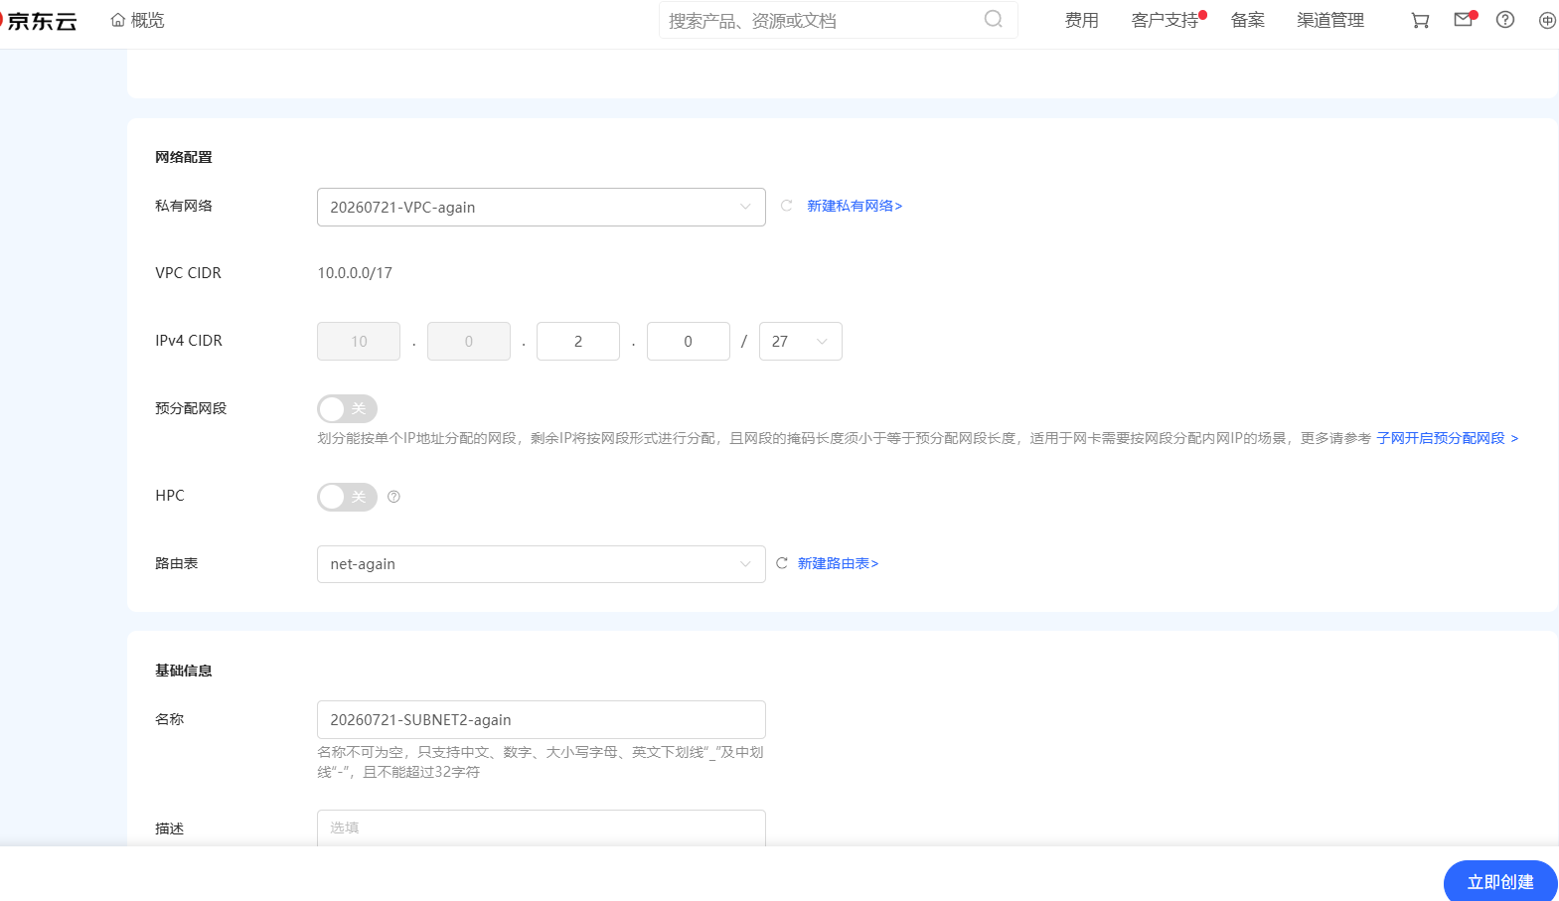
Now, we have one VPC and two subnets.

A.5. Change routing table of subnet 1
Step 1: The routing table of subnet 1 should be changed to net-again,
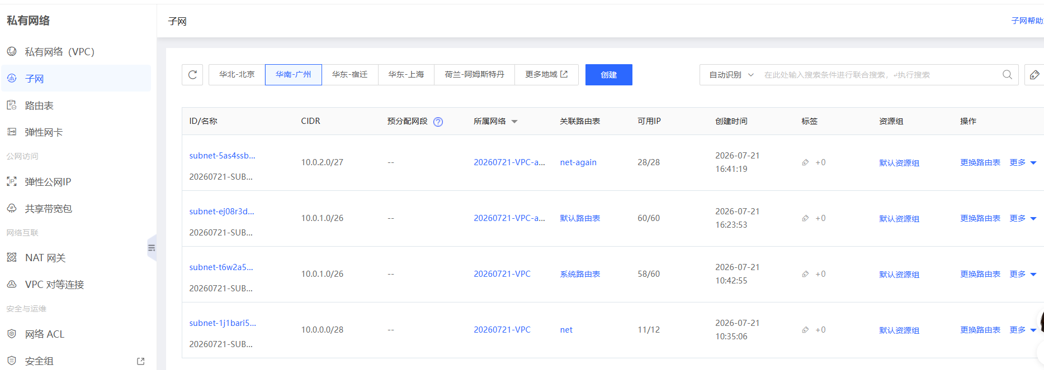
Click the routing table of subnet 1, and change it to net-again,
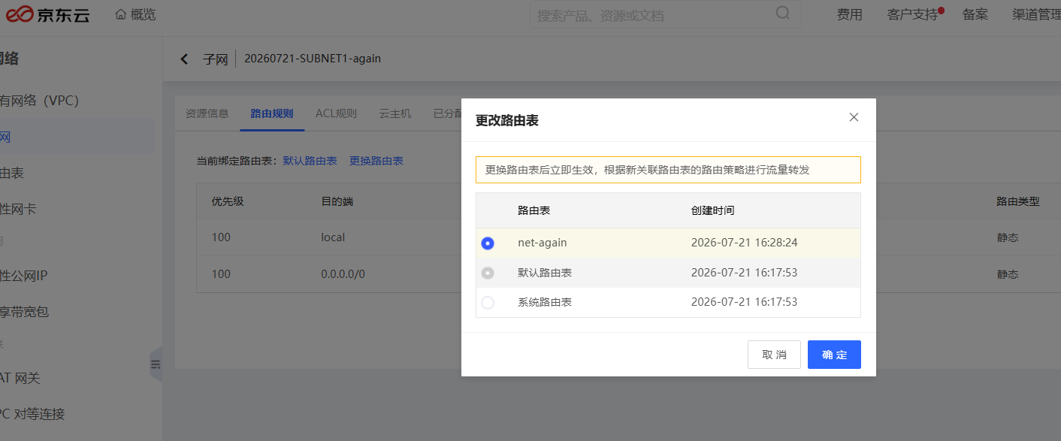

A.6. Change routing table of subnet 2
Step 1: The routing table of subnet 2 should be changed to system routing table,
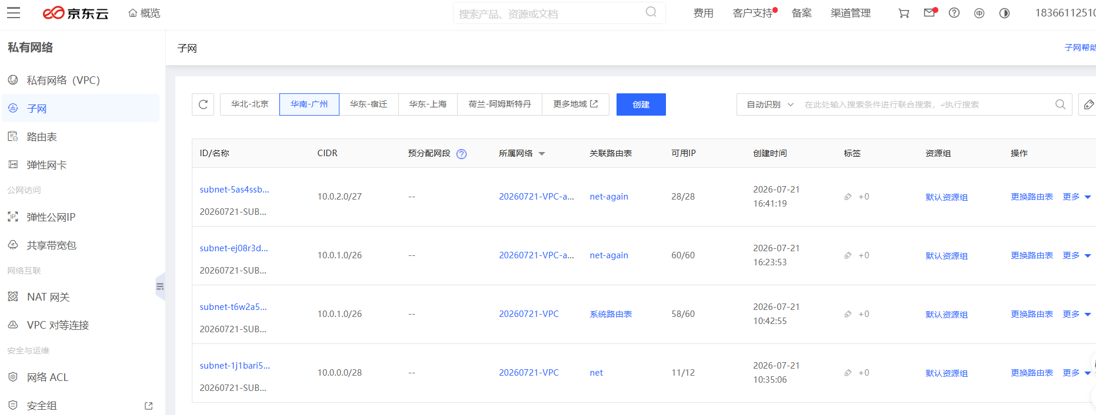
Click the routing table of subnet 2, and change it to system routing table,
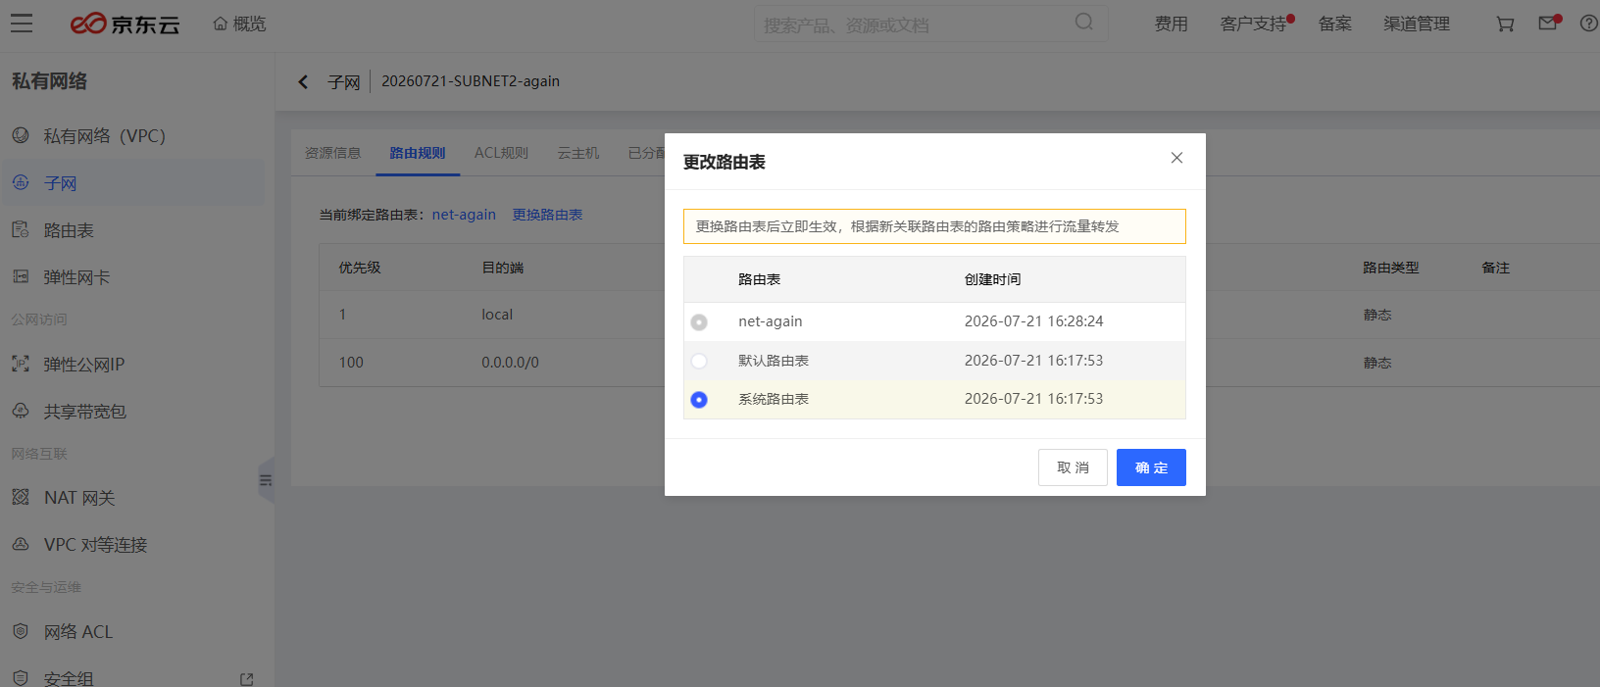

Step 2: Configure the system routing table,
The next hop type should be NAT gateway, the next hop should be NAT gateway address.
Now, hold on! We will go back and change it after configuring our NAT.
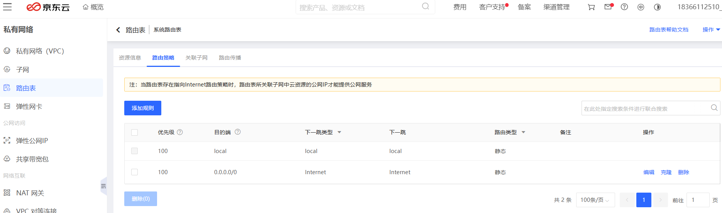

A.7. Create a NAT Gateway
Step 1: Click the link https://cns-console.jdcloud.com/network/natgateway/list, and create a NAT gateway,
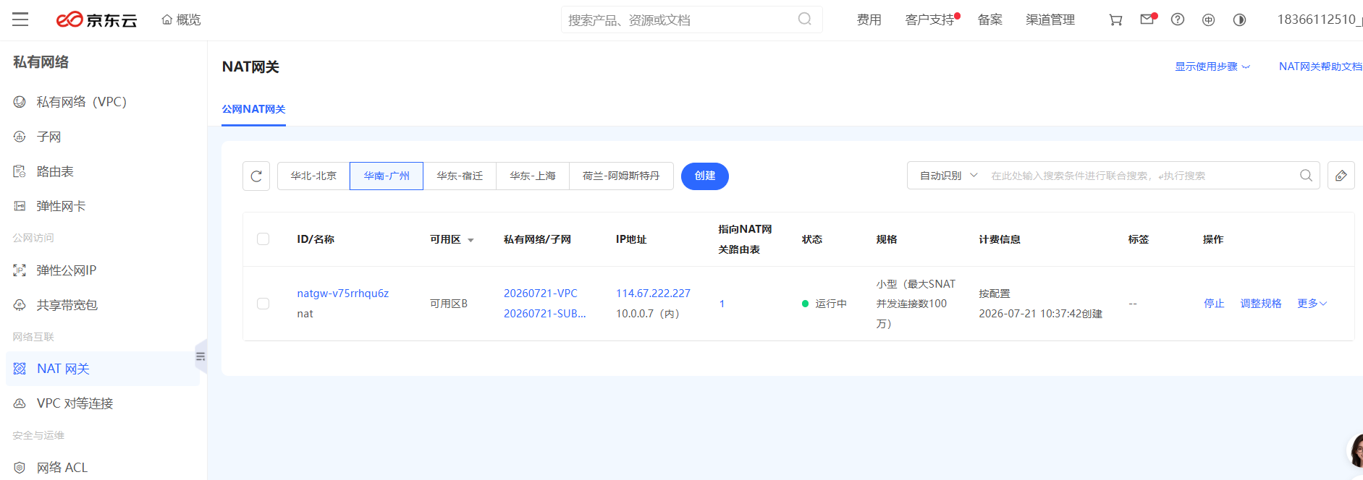
The name of the natgateway is nat-again, the VPC of the nat-gateway is 20260721-VPC-again, the subnet of the net-gateway is subnet1-again,
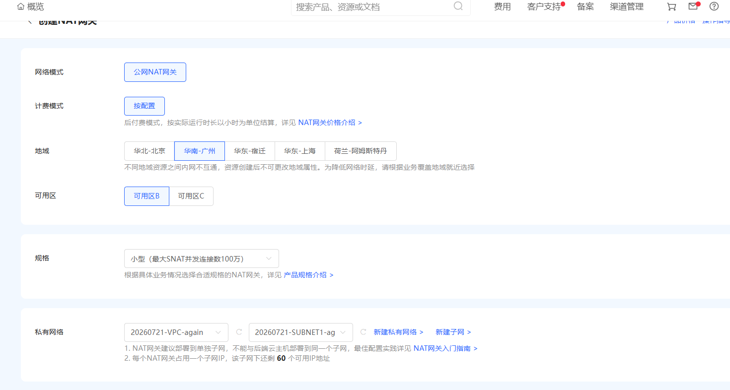

And the following information,
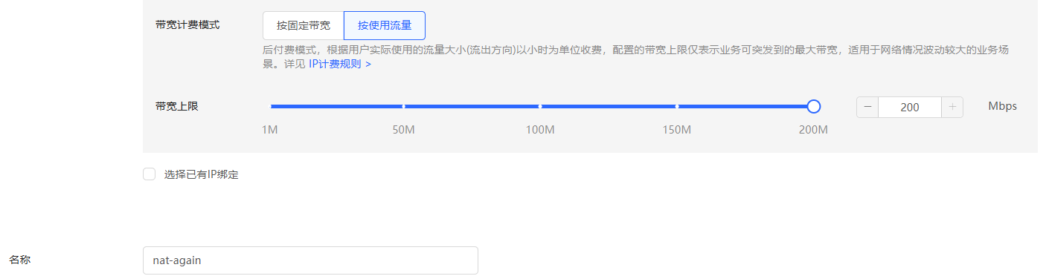
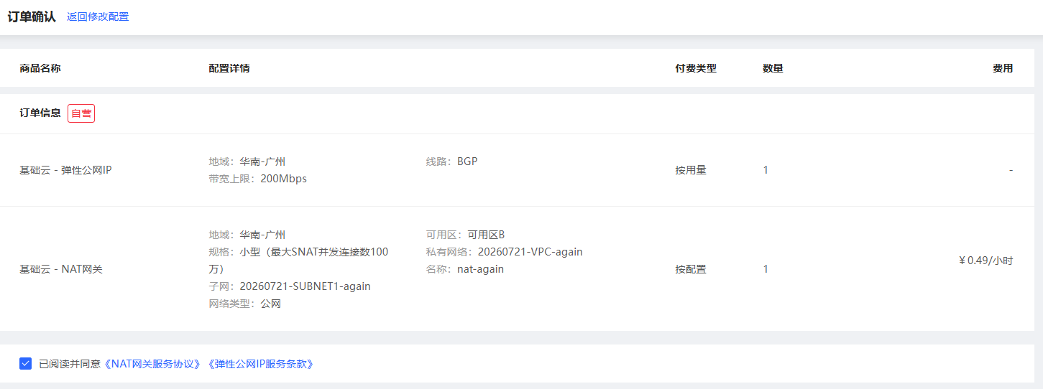
The natgateway is now under-config.
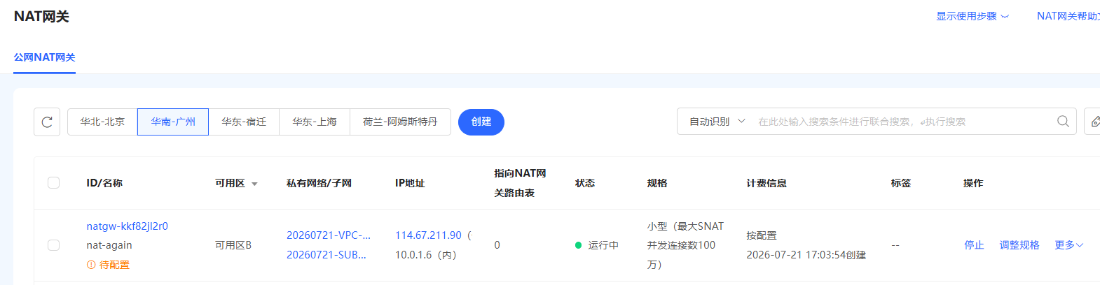
Next, we will configure the natgateway.

A.8. Config NAT gateway and routing rule of subnet 2
Step 1: Click https://cns-console.jdcloud.com/host/subnet/list, and go to routing table, i.e., system routing table of subnet 2,
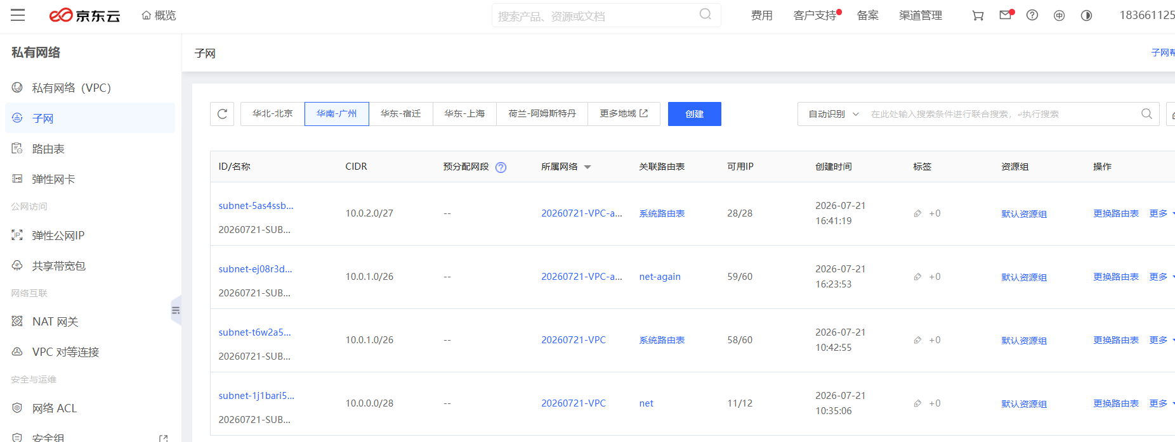
Click the routing table, i.e., system routing table,
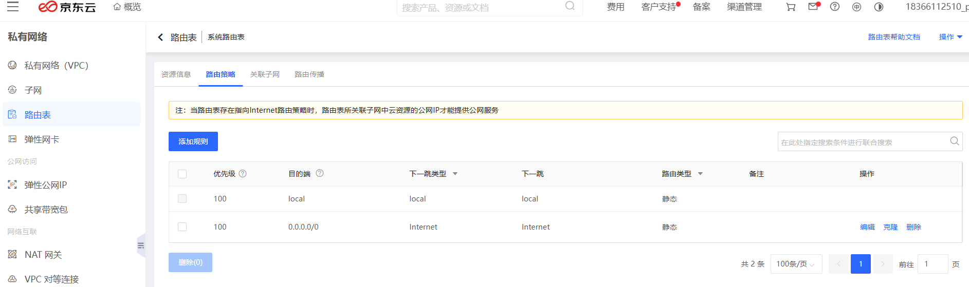
Change the next hop type to natgateway, and the next hop to natgateway address, save it,
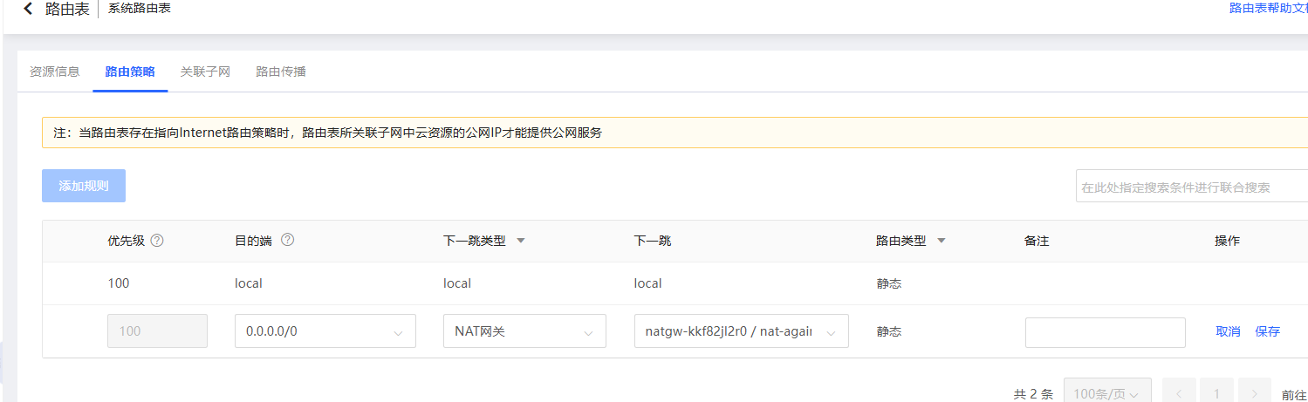

We confirm it,
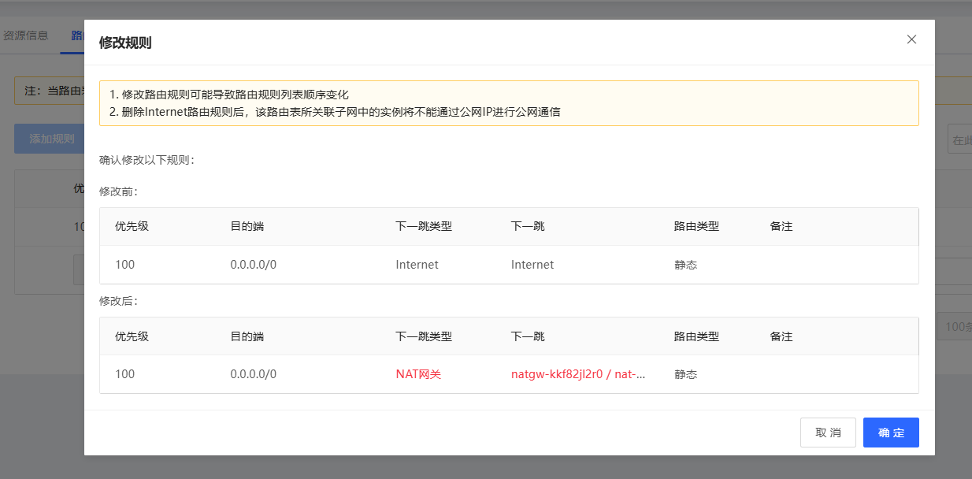

A.9. Confirm the status of the NAT gateway and add computing nodes
Step 1: Click the https://cns-console.jdcloud.com/network/natgateway/list, and go to the NAT gateway. The status of the NAT-gateway is running.
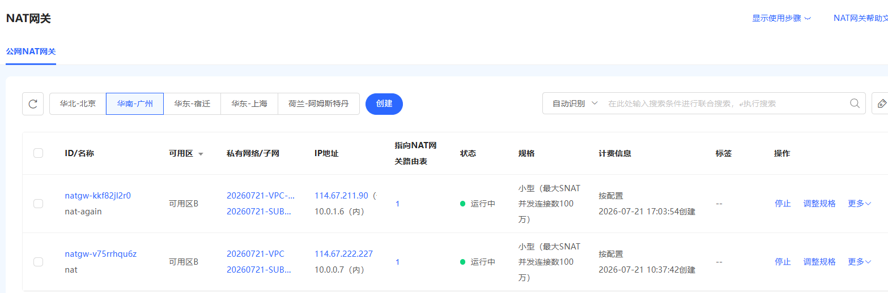
Step 2: Click https://cns-console.jdcloud.com/host/compute/list?dataCenter=cn-south-1, add computing nodes to subnet 2.
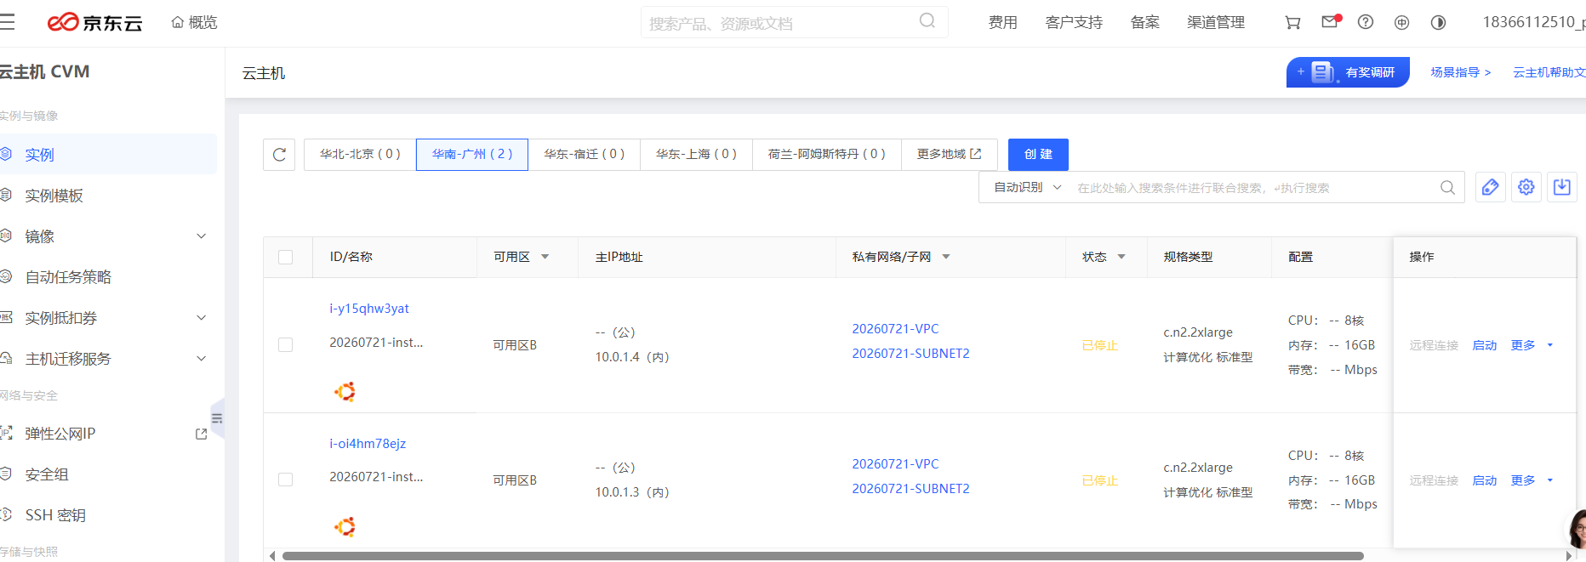

The details of the computing nodes are as follows,
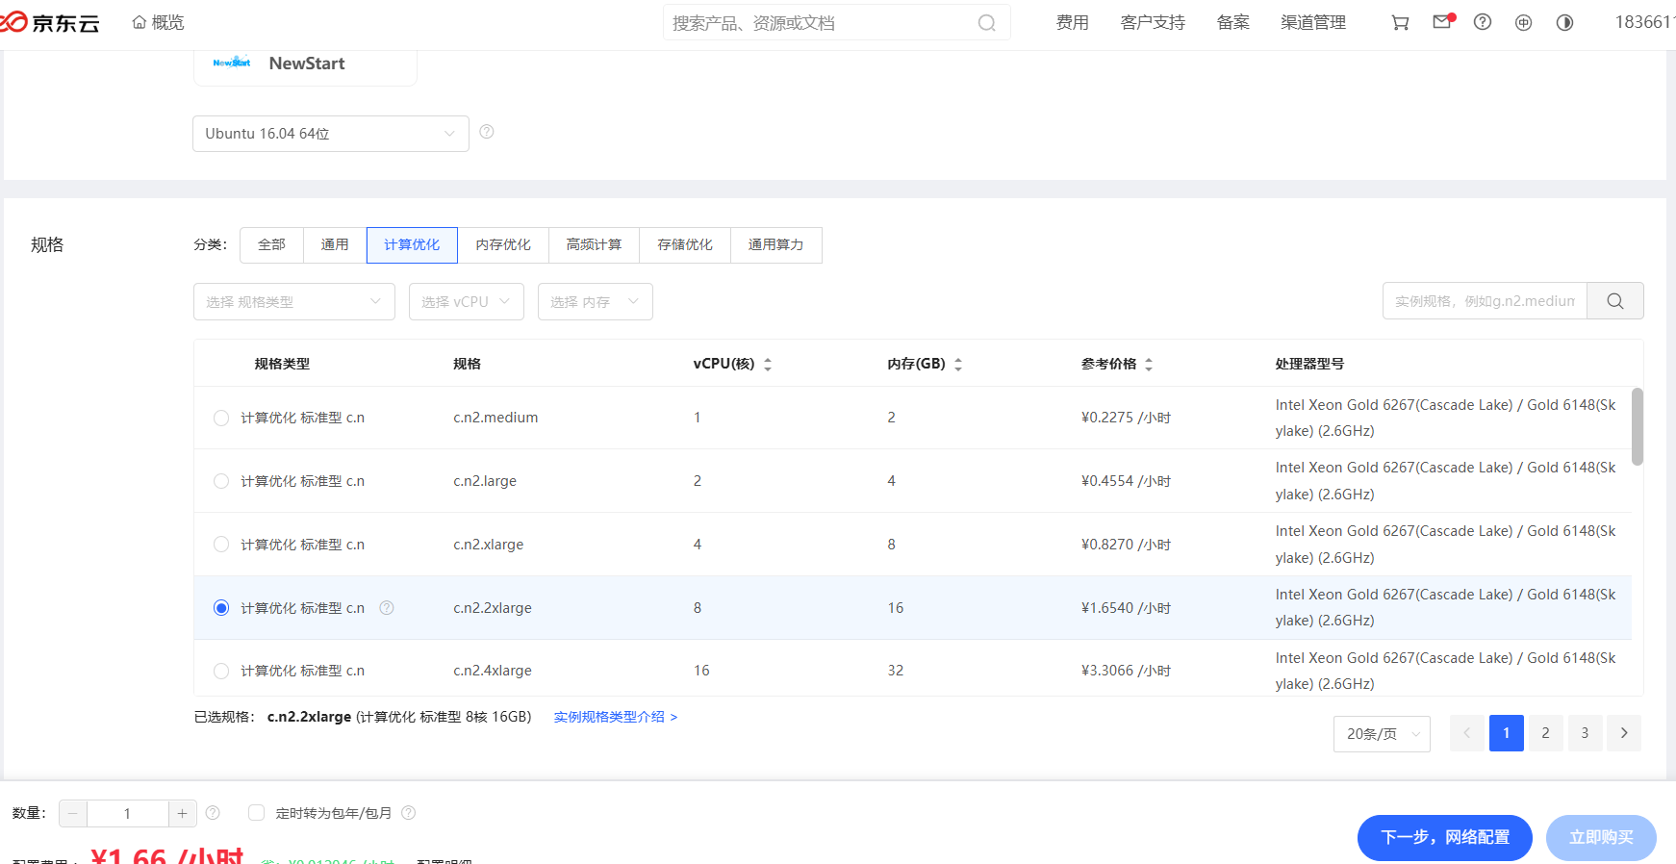
The corresponding HDD devices,
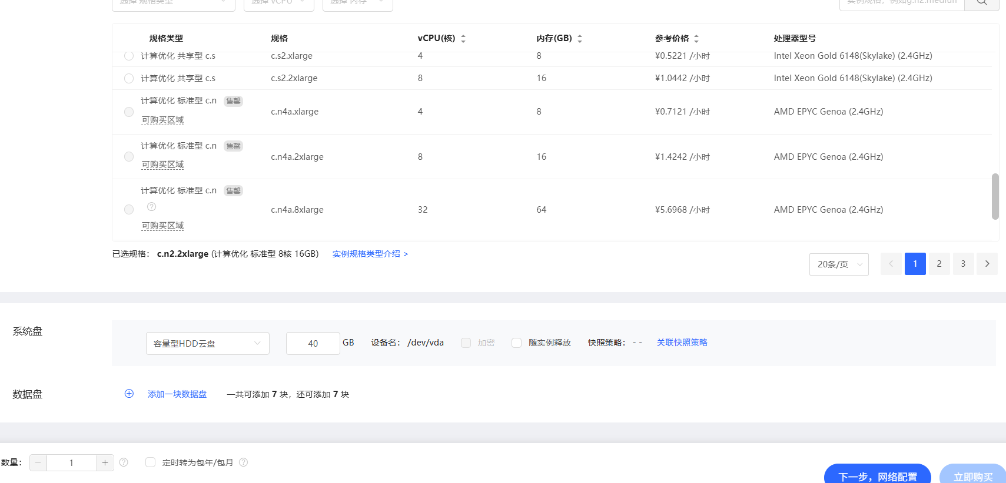

And the network configurations of the computing nodes are as follows. And the password of the JD cloud instance is Y0urpasswd.
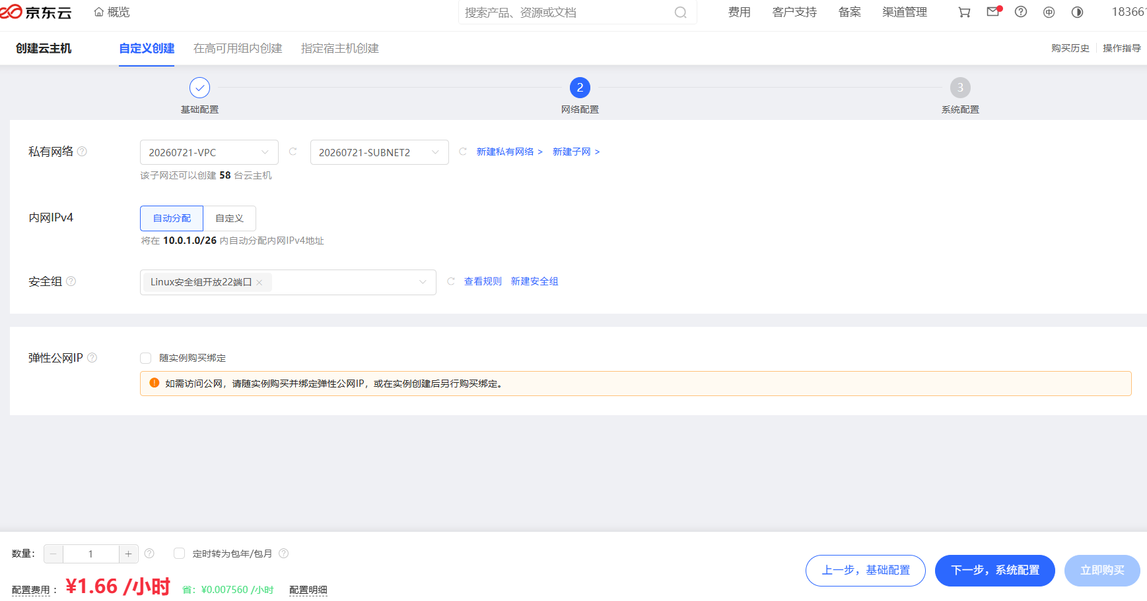

B. Prepare Multiple Nodes on JD HDD Cloud with Jump Server

B.1. Create a VPC and a Subnet
Step 1: Click https://cns-console.jdcloud.com/network/vpc/list, create a VPC (20260722-VPC-J),
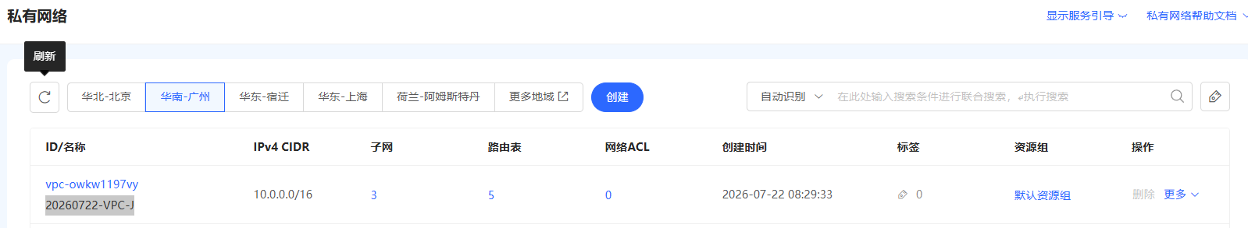
where the IPv4 CIDR is 10.0.0.0/16
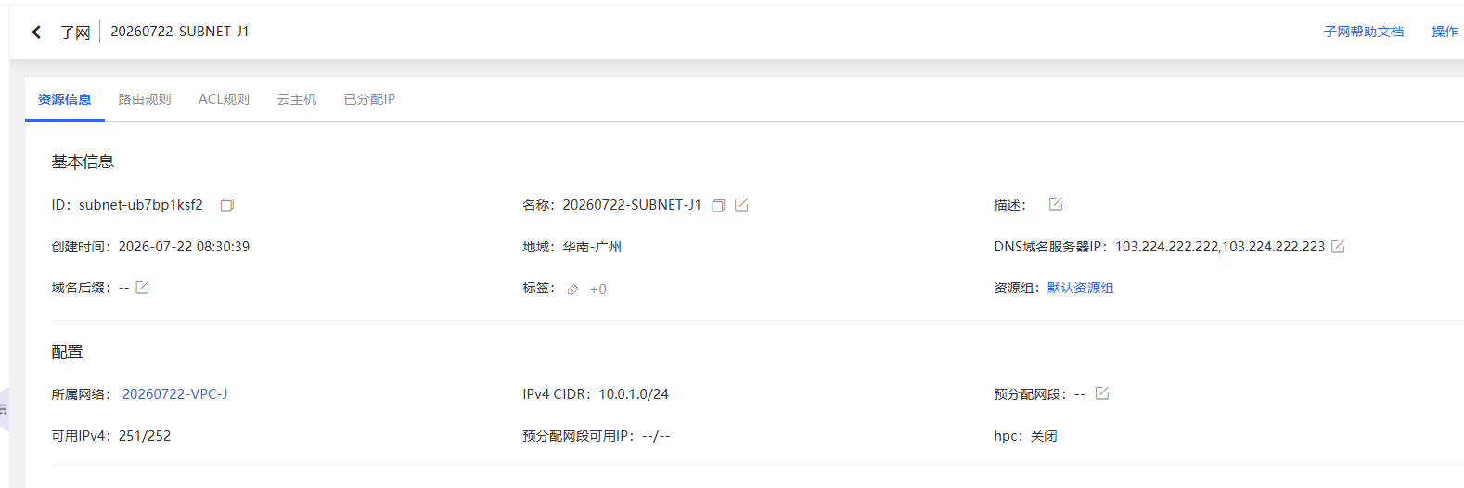
Then we create a subnet (20260722-SUBNET-J1), the IPv4 CIDR of the subnet is 10.0.1.0/24. The subnet is for jump server.


B.2. Create the Second Subnet for NAT Gateway
Step 1: Click https://cns-console.jdcloud.com/host/subnet/list, create the second subnet (20260722-SUBNET-J2) for NAT Gateway. The IPv4 CIDR for the second subnet is 10.0.0.2/24.

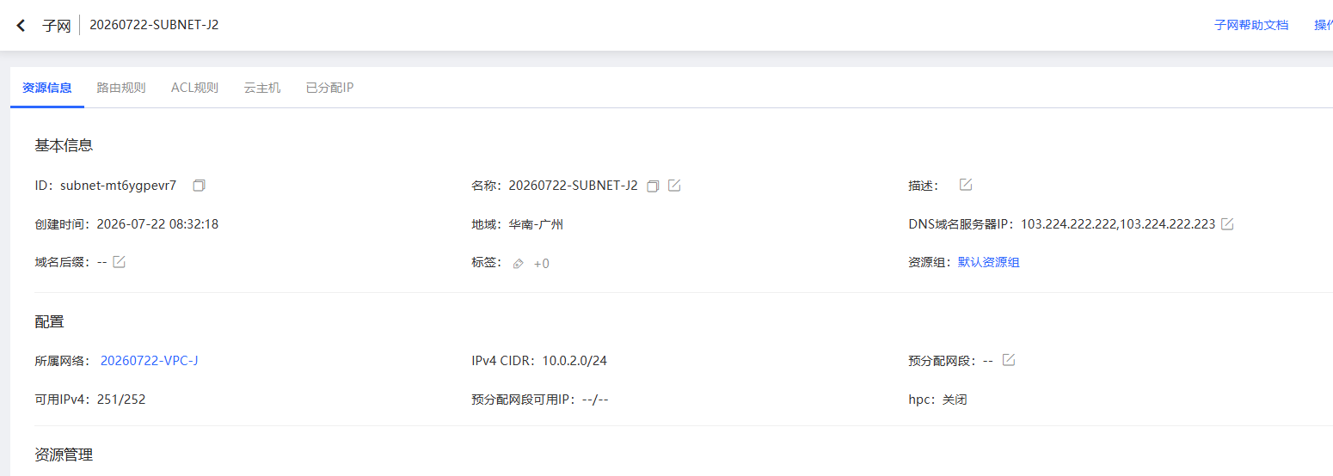

B.3. Create the Third Subnet for NAT Gateway
Step 1: Click https://cns-console.jdcloud.com/host/subnet/list, create the third subnet (20260722-SUBNET-J3) for Internal Computing Nodes. The IPv4 CIDR for the second subnet is 10.0.0.3/24.

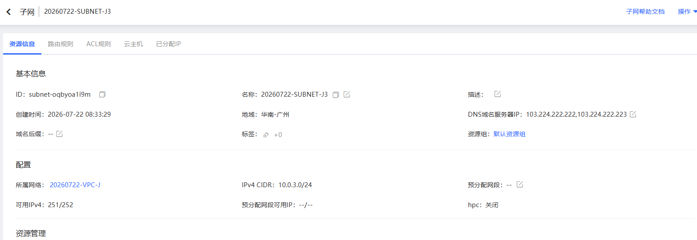

B.4. Create a NAT Gateway
Step 1: Click https://cns-console.jdcloud.com/network/natgateway/list, create a NAT gateway (NAT-J), where the NAT Gateway is in subnet 20260722-SUBNET-J2. And the NAT gateway has a public IP address.
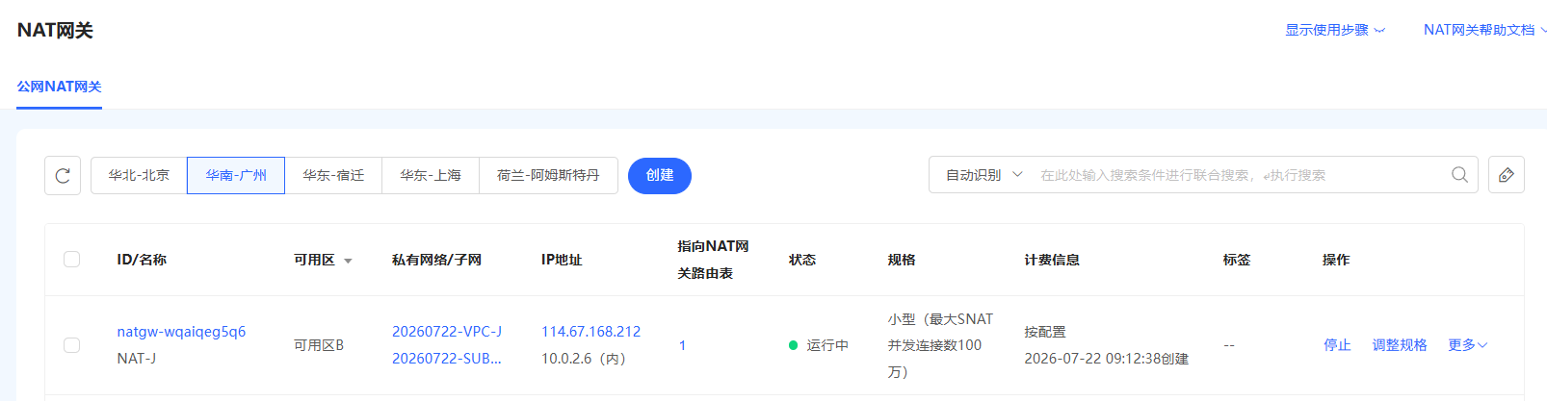
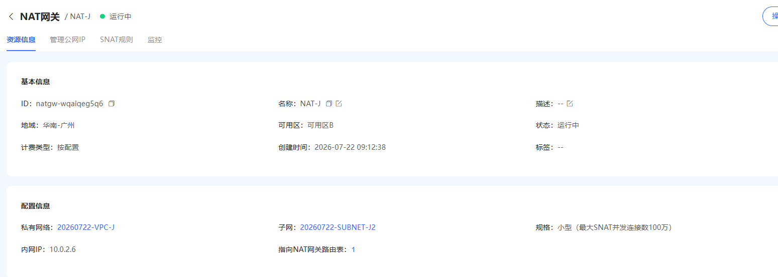

B.5. Create a Jump Server NAT
Step 1: Click https://cns-console.jdcloud.com/host/compute/list?dataCenter=cn-south-1, create a Jump Server. The jump server is in the first subnet. The jump server has a public IP address.
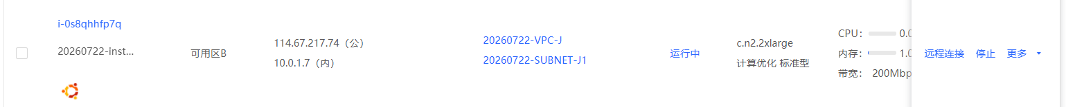

B.6. Configure Routing Table for the first Subnet
Step 1: Click https://cns-console.jdcloud.com/host/routeTable/list, config routing table for the first subnet. The first subnet uses routing table JUMP-RT,
The content of JUMP-RT is as follows,
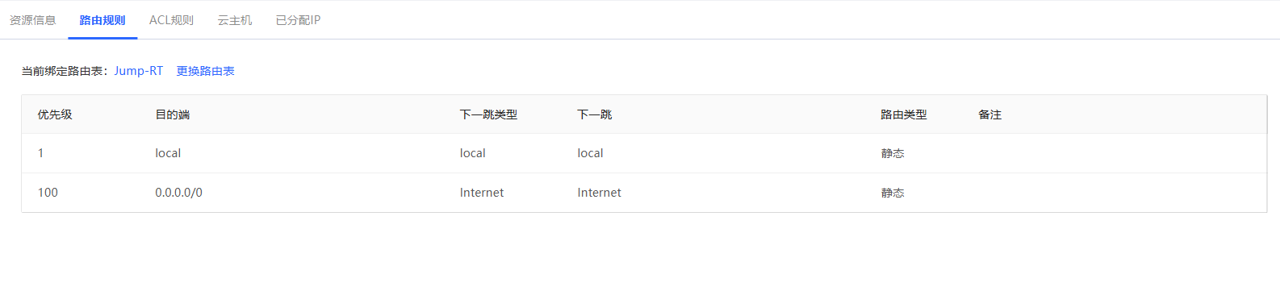

B.7. Configure Routing Table for the second Subnet
Step 1: Click https://cns-console.jdcloud.com/host/routeTable/list, config routing table for the second subnet. The second subnet uses routing table NAT-RT,
The content of NAT-RT is as follows,
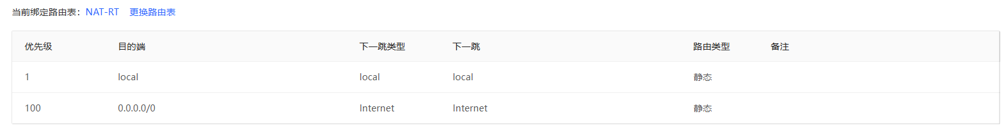

B.8. Configure Routing Table for the third Subnet
Step 1: Click https://cns-console.jdcloud.com/host/routeTable/list, config routing table for the third subnet. The third subnet uses routing table System Routing Table,

The content of System Routing Table is as follows,
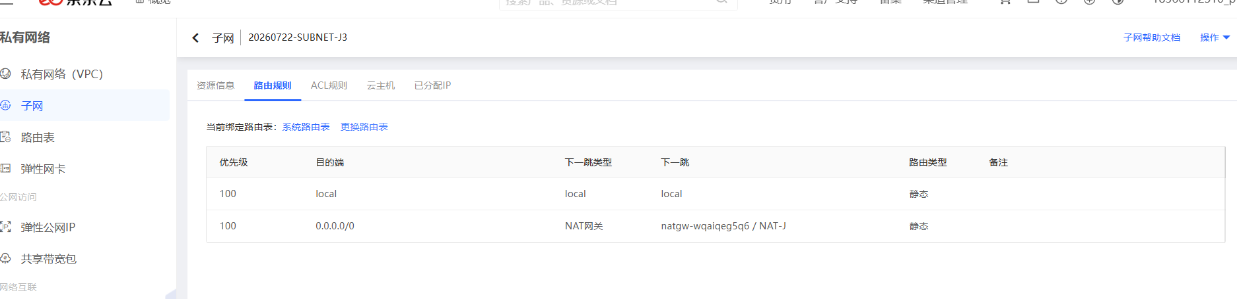

B.9. Add New Computing Nodes with no Public IP Address to the Third Subnet
Step 1: Click https://cns-console.jdcloud.com/host/compute/list?dataCenter=cn-south-1, add new computing nodes with no public IP address to the third Subnet,
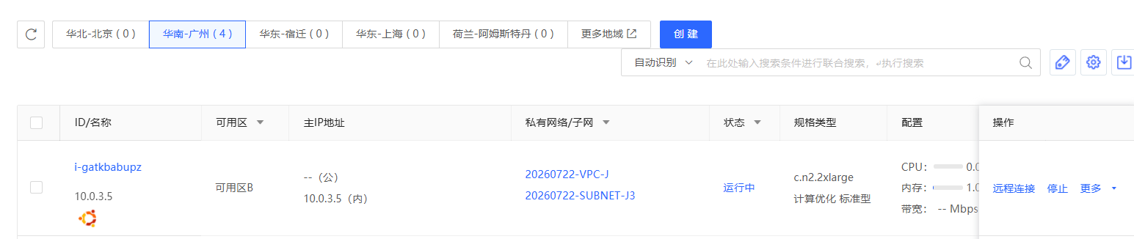

B.10. Connect New Computing Nodes with Jump Server
Step 1: Connect to the Jump server with Xshell,
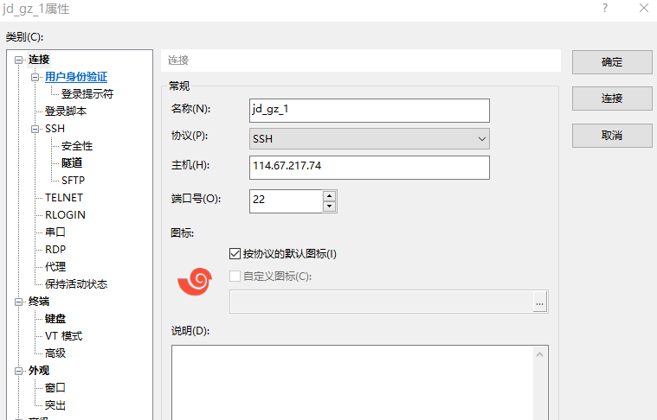
Step2: Connect to the internal computing nodes with the following commands,
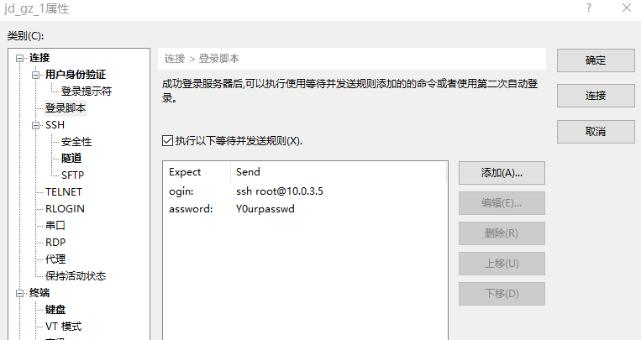

B.11. Password-Free SSH to Each Node
Step 1: The target is as follows,
Password-Free SSH from | To
10.0.3.5 // cli, z1 | 10.0.3.6 // z2
 | 10.0.3.9 // z3
 | … // z..
 | … // z..
 | 10.0.3.154 // z24
Step 2: Configure the 10.0.3.5 // cli, z1
// Generate Key
$ ssh-keygen

// Free Password
$ ssh root@10.0.3.6 'mkdir -p .ssh && cat > .ssh/authorized_keys' < ~/.ssh/id_rsa.pub // z2
$ ssh root@10.0.3.9 'mkdir -p .ssh && cat > .ssh/authorized_keys' < ~/.ssh/id_rsa.pub // z3
$ ssh root@10.0.3.10 'mkdir -p .ssh && cat > .ssh/authorized_keys' < ~/.ssh/id_rsa.pub // z4
$ ssh root@10.0.3.14 'mkdir -p .ssh && cat > .ssh/authorized_keys' < ~/.ssh/id_rsa.pub // z5
$ ssh root@10.0.3.16 'mkdir -p .ssh && cat > .ssh/authorized_keys' < ~/.ssh/id_rsa.pub // z6
$ ssh root@10.0.3.17 'mkdir -p .ssh && cat > .ssh/authorized_keys' < ~/.ssh/id_rsa.pub // z7
$ ssh root@10.0.3.19 'mkdir -p .ssh && cat > .ssh/authorized_keys' < ~/.ssh/id_rsa.pub // z8

$ ssh root@10.0.3.21 'mkdir -p .ssh && cat > .ssh/authorized_keys' < ~/.ssh/id_rsa.pub // z9

$ ssh root@10.0.3.23 'mkdir -p .ssh && cat > .ssh/authorized_keys' < ~/.ssh/id_rsa.pub // z10
$ ssh root@10.0.3.24 'mkdir -p .ssh && cat > .ssh/authorized_keys' < ~/.ssh/id_rsa.pub // z11
$ ssh root@10.0.3.25 'mkdir -p .ssh && cat > .ssh/authorized_keys' < ~/.ssh/id_rsa.pub // z12
$ ssh root@10.0.3.33 'mkdir -p .ssh && cat > .ssh/authorized_keys' < ~/.ssh/id_rsa.pub // z13
$ ssh root@10.0.3.40 'mkdir -p .ssh && cat > .ssh/authorized_keys' < ~/.ssh/id_rsa.pub // z14
$ ssh root@10.0.3.66 'mkdir -p .ssh && cat > .ssh/authorized_keys' < ~/.ssh/id_rsa.pub // z15
$ ssh root@10.0.3.72 'mkdir -p .ssh && cat > .ssh/authorized_keys' < ~/.ssh/id_rsa.pub // z16
$ ssh root@10.0.3.74 'mkdir -p .ssh && cat > .ssh/authorized_keys' < ~/.ssh/id_rsa.pub // z17
$ ssh root@10.0.3.76 'mkdir -p .ssh && cat > .ssh/authorized_keys' < ~/.ssh/id_rsa.pub // z18
$ ssh root@10.0.3.80 'mkdir -p .ssh && cat > .ssh/authorized_keys' < ~/.ssh/id_rsa.pub // z19
$ ssh root@10.0.3.103 'mkdir -p .ssh && cat > .ssh/authorized_keys' < ~/.ssh/id_rsa.pub // z20
$ ssh root@10.0.3.133 'mkdir -p .ssh && cat > .ssh/authorized_keys' < ~/.ssh/id_rsa.pub // z21
$ ssh root@10.0.3.147 'mkdir -p .ssh && cat > .ssh/authorized_keys' < ~/.ssh/id_rsa.pub // z22
$ ssh root@10.0.3.152 'mkdir -p .ssh && cat > .ssh/authorized_keys' < ~/.ssh/id_rsa.pub // z23
$ ssh root@10.0.3.154 'mkdir -p .ssh && cat > .ssh/authorized_keys' < ~/.ssh/id_rsa.pub // z24

// Verify
$ ssh root@10.0.3.6 "echo 'hi'" // z2
$ ssh root@10.0.3.9 "echo 'hi'" // z3
$ ssh root@10.0.3.10 "echo 'hi'" // z4
$ ssh root@10.0.3.14 "echo 'hi'" // z5
$ ssh root@10.0.3.16 "echo 'hi'" // z6
$ ssh root@10.0.3.17 "echo 'hi'" // z7
$ ssh root@10.0.3.19 "echo 'hi'" // z8

$ ssh root@10.0.3.21 "echo 'hi'" // z9

$ ssh root@10.0.3.23 "echo 'hi'" // z10
$ ssh root@10.0.3.24 "echo 'hi'" // z11
$ ssh root@10.0.3.25 "echo 'hi'" // z12
$ ssh root@10.0.3.33 "echo 'hi'" // z13
$ ssh root@10.0.3.40 "echo 'hi'" // z14
$ ssh root@10.0.3.66 "echo 'hi'" // z15
$ ssh root@10.0.3.72 "echo 'hi'" // z16
$ ssh root@10.0.3.74 "echo 'hi'" // z17
$ ssh root@10.0.3.76 "echo 'hi'" // z18
$ ssh root@10.0.3.80 "echo 'hi'" // z19
$ ssh root@10.0.3.103 "echo 'hi'" // z20
$ ssh root@10.0.3.133 "echo 'hi'" // z21
$ ssh root@10.0.3.147 "echo 'hi'" // z22
$ ssh root@10.0.3.152 "echo 'hi'" // z23
$ ssh root@10.0.3.154 "echo 'hi'" // z24

C. Run Single-Node Fabric

C.1. Configure Each Node
Step 1: Configure the host names,
# sudo vi /etc/hosts
:set paste
i

10.0.3.5 cli # CLI, z1

10.0.3.6 peer0.org1.example.com # Endorsing peer 1, z2
10.0.3.9 peer0.org2.example.com # Endorsing peer 2, z3
10.0.3.10 peer0.org3.example.com # Endorsing peer 3, z4
10.0.3.14 peer0.org4.example.com # Endorsing peer 4, z5
10.0.3.16 peer0.org5.example.com # Endorsing peer 5, z6
10.0.3.17 peer0.org6.example.com # Endorsing peer 6, z7
10.0.3.19 peer0.org7.example.com # Endorsing peer 7, z8

10.0.3.21 peer0.org8.example.com # A Non-Endorsing Peer, z9

10.0.3.23 orderer.example.com # Orderer 1, z10
10.0.3.24 orderer2.example.com # Orderer 2, z11
10.0.3.25 orderer3.example.com # Orderer 3, z12
10.0.3.33 orderer4.example.com # Orderer 4, z13
10.0.3.40 orderer5.example.com # Orderer 5, z14
10.0.3.66 orderer6.example.com # Orderer 6, z15
10.0.3.72 orderer7.example.com # Orderer 7, z16
10.0.3.74 orderer8.example.com # Orderer 8, z17
10.0.3.76 orderer9.example.com # Orderer 9, z18
10.0.3.80 orderer10.example.com # Orderer 10, z19
10.0.3.103 orderer11.example.com # Orderer 11, z20
10.0.3.133 orderer12.example.com # Orderer 12, z21
10.0.3.147 orderer13.example.com # Orderer 13, z22
10.0.3.152 orderer14.example.com # Orderer 14, z23
10.0.3.154 orderer15.example.com # Orderer 15, z24

C.2. Install Dependencies on Each Node
Step 1: Install the prerequisites on each node,
// Prerequisite: Git
$ sudo apt-get update
$ sudo apt purge -y git
$ sudo apt-get install -y git // =1:2.7.4-0ubuntu1.9
$ git version // 2.7.4
$ export PATH=$PATH:/usr/lib/git-core
$ echo 'export PATH=$PATH:/usr/lib/git-core' >> ~/.bashrc
$ source ~/.bashrc
Step 2: Install the cURL on each node,
// Prerequisite: cURL
$ sudo apt-get install -y curl
$ curl --version // 7.47.0
Step 3: Install the wget on each node,
// Prerequisite: wget
$ sudo apt-get install -y wget=1.17.1-1ubuntu1.5
Step 4: Install Docker on each node,
// Prerequisite: Docker 17.06.2-ce or greater: Docker 17.12.0-ce
$ sudo apt-get purge -y docker-ce docker-ce-cli
$ wget https://download.docker.com/linux/ubuntu/gpg
$ sudo apt-key add gpg
$ echo 'deb [arch=amd64] https://download.docker.com/linux/ubuntu xenial stable' | sudo tee /etc/apt/sources.list.d/docker.list
$ sudo apt-get update
$ apt-cache madison docker-ce
$ sudo apt-get install docker-ce=17.12.0~ce-0~ubuntu
$ sudo usermod -aG docker $USER
$ docker version
Step 5: (if outside the Great Wall) Install Docker Compose on each node,
// Prerequisite: Docker Compose 1.14.0 or greater: 1.21.0
$ sudo apt-get purge -y docker-compose
$ sudo curl -L https://github.com/docker/compose/releases/download/1.21.0/docker-compose-`uname -s`-`uname -m` -o /usr/local/bin/docker-compose
$ sudo chmod +x /usr/local/bin/docker-compose
$ docker-compose version
Step 5: (if within the Great Wall) Install Docker Compose on each node,
// Prerequisite: Docker Compose 1.14.0 or greater: 1.21.0
$ sudo apt-get purge -y docker-compose
$ mkdir downloads
$ cd $HOME/downloads
$ wget https://gitee.com/joe32065/fabric_2_2/releases/download/fabric-v2.2.0/docker-compose
// $ scp docker-compose root@10.0.3.6:$HOME/downloads
// $ scp docker-compose root@10.0.3.9:$HOME/downloads
// $ scp docker-compose root@10.0.3.10:$HOME/downloads
// $ scp docker-compose root@10.0.3.14:$HOME/downloads
// $ scp docker-compose root@10.0.3.16:$HOME/downloads
// $ scp docker-compose root@10.0.3.17:$HOME/downloads
// $ scp docker-compose root@10.0.3.19:$HOME/downloads
// $ scp docker-compose root@10.0.3.21:$HOME/downloads
// $ scp docker-compose root@10.0.3.23:$HOME/downloads
// $ scp docker-compose root@10.0.3.24:$HOME/downloads
// $ scp docker-compose root@10.0.3.25:$HOME/downloads
// $ scp docker-compose root@10.0.3.33:$HOME/downloads
// $ scp docker-compose root@10.0.3.40:$HOME/downloads
// $ scp docker-compose root@10.0.3.66:$HOME/downloads
// $ scp docker-compose root@10.0.3.72:$HOME/downloads
// $ scp docker-compose root@10.0.3.74:$HOME/downloads
// $ scp docker-compose root@10.0.3.76:$HOME/downloads
// $ scp docker-compose root@10.0.3.80:$HOME/downloads
// $ scp docker-compose root@10.0.3.103:$HOME/downloads
// $ scp docker-compose root@10.0.3.133:$HOME/downloads
// $ scp docker-compose root@10.0.3.147:$HOME/downloads
// $ scp docker-compose root@10.0.3.152:$HOME/downloads
// $ scp docker-compose root@10.0.3.154:$HOME/downloads

$ sudo chmod +x docker-compose
$ sudo mv docker-compose /usr/local/bin
$ docker-compose version
Step 6: (if outside the Great Wall) Install Golang on each node,
// Prerequisite: Go v1.14.8
$ cd $HOME/downloads
$ wget https://golang.org/dl/go1.14.8.linux-amd64.tar.gz
$ tar -xzf go1.14.8.linux-amd64.tar.gz
$ sudo rm -rf /usr/local/go
$ sudo mv go /usr/local
$ mkdir -p $HOME/go
$ echo 'export PATH=$PATH:/usr/local/go/bin' >> ~/.bashrc
$ echo 'export GOPATH=$HOME/go' >> ~/.bashrc
$ source ~/.bashrc
$ go version // go1.14.8 linux/amd64
Step 6: (if within the Great Wall) Install Golang on each node,
// Prerequisite: Go v1.14.8
$ cd $HOME/downloads
$ … // download go1.14.8.linux-amd64.tar.gz on node one, e.g., via winscp,
$ scp go1.14.8.linux-amd64.tar.gz root@10.0.3.6:$HOME/downloads
$ scp go1.14.8.linux-amd64.tar.gz root@10.0.3.9:$HOME/downloads
$ …
$ scp go1.14.8.linux-amd64.tar.gz root@10.0.3.154:$HOME/downloads

$ tar -xzf go1.14.8.linux-amd64.tar.gz
$ sudo mv go /usr/local
$ mkdir -p $HOME/go
$ echo 'export PATH=$PATH:/usr/local/go/bin' >> ~/.bashrc
$ echo 'export GOPATH=$HOME/go' >> ~/.bashrc
$ source ~/.bashrc
$ go version // go1.14.8 linux/amd64
Step 7: Install Node.js on each node,
// Prerequisite: Node.js v12.20.1 or higher
$ cd $HOME/downloads
$ curl -sL https://deb.nodesource.com/setup_12.x -o nodesource_setup.sh
$ sudo chmod +x nodesource_setup.sh
$ sudo bash nodesource_setup.sh
$ sudo apt-get install -y nodejs --allow-unauthenticated
$ nodejs -v // v12.22.12

$ curl -o- https://raw.githubusercontent.com/nvm-sh/nvm/v0.35.3/install.sh | bash
$ // close the terminals, and open the terminals again
$ cd $HOME/downloads
$ sudo npm -g install nvm
$ nvm ls available
$ nvm install 12.20.1
$ nvm use 12.20.1
Step 8: Install the NTP on each node,
$ sudo apt-get install ntp
$ sudo service ntp start

C.3. Install Fabric 2.2.0
Step 1: (if outside the Great Wall) Install Fabric 2.2.0, including Fabric Samples on each node,
$ cd $HOME
$ sudo rm -rf fabric-samples
$ curl -sSL https://bit.ly/2ysbOFE | bash -s -- 2.2.0
Step 1: (if within the Great Wall) Install Fabric 2.2.0, including Fabric Samples on each node,
$ cd $HOME
$ sudo rm -rf fabric-samples
$ sudo apt-get install unzip
$ cd $HOME
$ wget https://gitee.com/joe32065/fabric_2_2/releases/download/fabric-v2.2.0/fabric-v2.2.0.zip
$ unzip fabric-v2.2.0.zip
$ cd fabric-v2.2.0/scripts
In bootstrap.sh -> ”pullBinaries()”,
download "${BINARY_FILE}" "https://github.com/hyperledger/fabric/releases/download/v${VERSION}/${BINARY_FILE}"
download "${CA_BINARY_FILE}" "https://github.com/hyperledger/fabric-ca/releases/download/v${CA_VERSION}/${CA_BINARY_FILE}"
Replace with the two lines,
download "${BINARY_FILE}" "https://gitee.com/joe320653/fabric/attach_files/842230/download/${BINARY_FILE}"
download "${CA_BINARY_FILE}" "https://gitee.com/joe320653/fabric-ca/attach_files/842289/download/${CA_BINARY_FILE}"
In bootstrap.sh -> ” cloneSamplesRepo()”,
git clone -b master https://github.com/hyperledger/fabric-samples.git && cd fabric-samples && git checkout v${VERSION}
Replace with the two lines,
git clone -b master https://gitee.com/joe320653/fabric-samples.git && cd fabric-samples && git checkout v${VERSION}

Step 2: Install docker images and fabric-samples on each node,
$ cd $HOME/fabric-v2.2.0/scripts
$ chmod 777 *.sh

$ // configure the docker container service within the Great Wall
$ cd $HOME
$ sudo mkdir -p /etc/docker
$ sudo tee /etc/docker/daemon.json <<-'EOF'
{
"registry-mirrors": ["https://docker.1ms.run",
"https://docker.xuanyuan.me",
"https://docker.m.daocloud.io",
"https://docker.zhai.cm"
]
}
EOF
$ sudo systemctl daemon-reload
$ sudo systemctl restart docker

$ cd $HOME/fabric-v2.2.0/scripts
$ sudo ./bootstrap.sh
$ mv fabric-samples $HOME
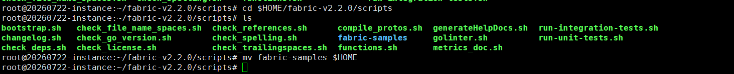

C.4. Run Test-Network
Step 1: (if outside the Great Wall) Run test network on each node,
$ cd $HOME/fabric-samples/test-network
$ ./network.sh up
$ ./network.sh createChannel
$ ./network.sh deployCC -ccn basic -ccp ../asset-transfer-basic/chaincode-go -ccl go
$ ./network.sh down

Step 1: (if within the Great Wall) Run test network on each node,
Set the Golang Proxy,
$ go env -w GOPROXY=https://goproxy.cn
Run the test network,
$ cd $HOME/fabric-samples/test-network
$ ./network.sh up
$ ./network.sh createChannel
$ ./network.sh deployCC -ccn basic -ccp ../asset-transfer-basic/chaincode-go -ccl go

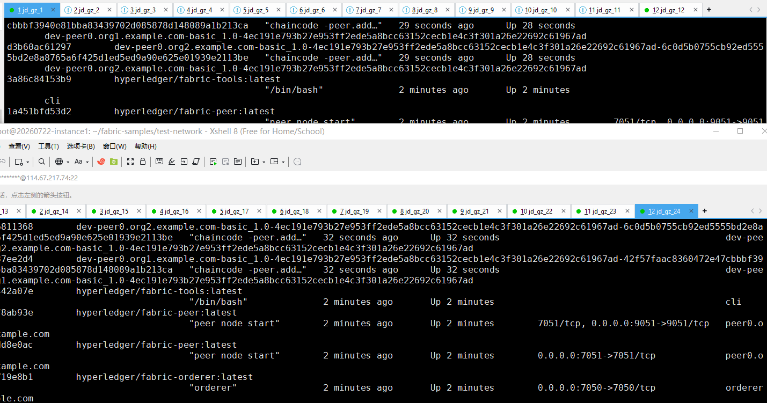

$ ./network.sh down
Where, we may need to scp docker images,
$ docker images

$ docker save -o busybox.tar busybox:latest

$ scp busybox.tar root@10.0.3.6:$HOME/downloads
$ scp busybox.tar root@10.0.3.9:$HOME/downloads
$ …
$ scp busybox.tar root@10.0.3.154:$HOME/downloads

$ cd $HOME/downloads
$ docker load -i busybox.tar

Run Multi-Nodes Fabric (Exp 1: 1 CLI + 2 Peers + 1 Orderer)

1.1. Prepare the Hosts

Step 1 (Prepare): All machines prepare the host names,
$ vi /etc/hosts

172.31.210.67 cli
172.31.210.70 peer0.org1.example.com
172.31.210.71 peer0.org2.example.com
172.31.210.72 orderer.example.com

Step 2 (Prepare): CLI prepares the Test-Network files,
$ cd $HOME/fabric-samples
$ mkdir demo-first
$ cd $HOME/fabric-samples/demo-first
$ vi crypto-config.yaml
$ vi configtx.yaml

$ vi peer0-org1.yaml
$ vi peer0-org2.yaml

$ vi orderer1.yaml

$ vi cli.yaml // (of peer0.org1)

$ vi $HOME/fabric-samples/chaincode/abstore/go/abstore.go // our proposed key-value chaincode
$ vi $HOME/fabric-samples/chaincode/abstore/go/go.mod

Step 2 (Prepare): All machines prepare the timestamp alignment,
$ date +%s // check the timestamp

$ sudo apt-get install ntpdate // align the timestamp
$ sudo ntpdate cn.pool.ntp.org
$ sudo hwclock –systohc

$ date +%s // check the timestamp again

Step 3 (Run): CLI runs the initial block generation,
$ cd $HOME/fabric-samples/demo-first
$ chmod +x *.sh
$ ./config.sh

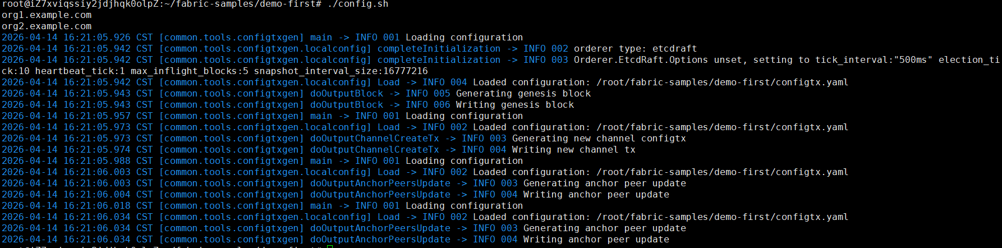

$ cd $HOME/fabric-samples/demo-first/workload/tls
$ chmod +x *.sh

$ cd $HOME/fabric-samples/demo-first/workload
$ chmod +x *.sh
$ wget https://gitee.com/joe32065/fabric_2_2/releases/download/fabric-v2.2.0/node_modules.zip
$ unzip node_modules.zip

$ cd $HOME/fabric-samples/demo-first/scripts
$ chmod +x *.sh

Step 4 (Run): CLI scp the contents to all machines including peers and orderers,
$ cd $HOME/fabric-samples/demo-first
$ ./scp.sh

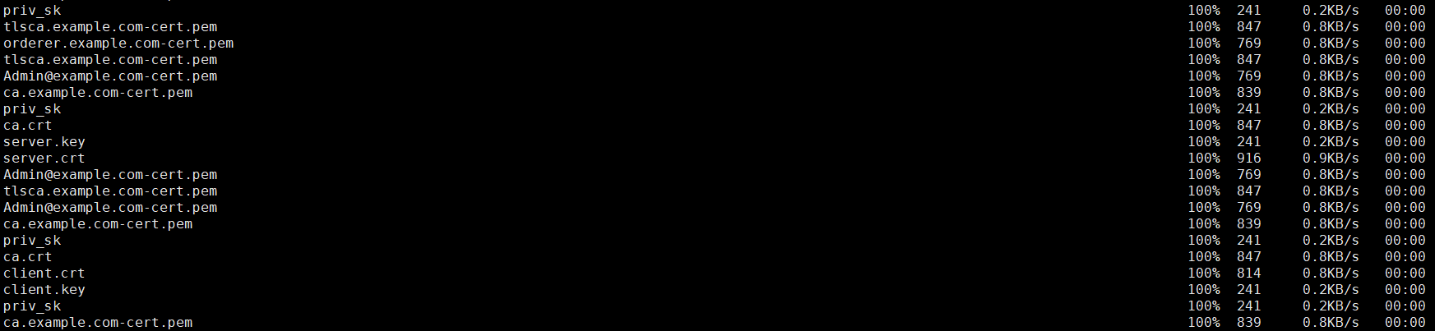

Step 5 (Run): Orderer1 sets up the Docker container,
$ cd $HOME/fabric-samples/demo-first
$ ./orderer1.sh

$ docker ps

Step 6 (Run): Peer1 sets up the Docker container,
$ cd $HOME/fabric-samples/demo-first
$ ./peer1.sh

$ docker ps

Step 7 (Run): Peer2 sets up the Docker container,
$ cd $HOME/fabric-samples/demo-first
$ ./peer2.sh

$ docker ps

Step 8 (Run): CLI sets up the Docker container,
$ cd $HOME/fabric-samples/demo-first
$ ./cli.sh

$ docker ps

1.2. Start the Network

Step 1 (Run): CLI connects to Peer0.org1.example.com:7051, creates a channel.block, and then all peers join the channel.block,
// CLI goes to `peer0.org1.example.com:7051`
$ docker exec -it cli bash

// Environment Configuration for `peer0.org1.example.com:7051`
# cd scripts
# ./step1.sh // All peers join the channel

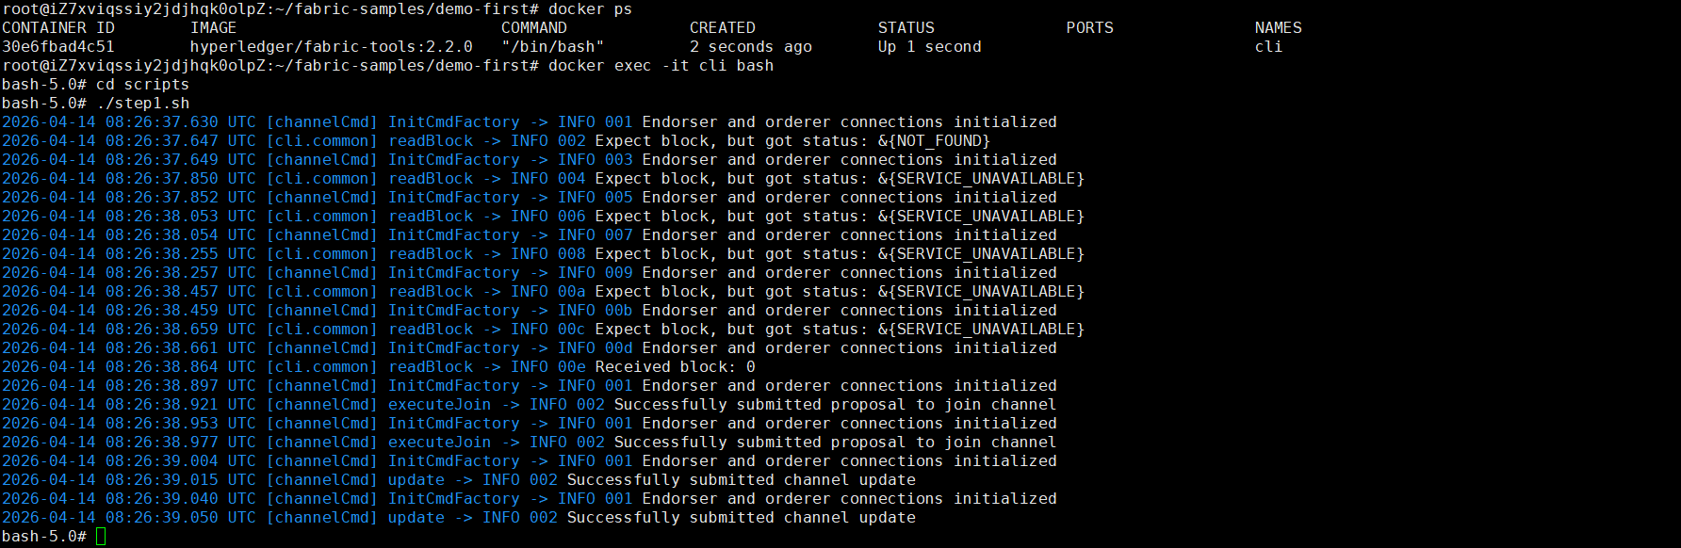

# ./step2.sh // All peers join the chaincode

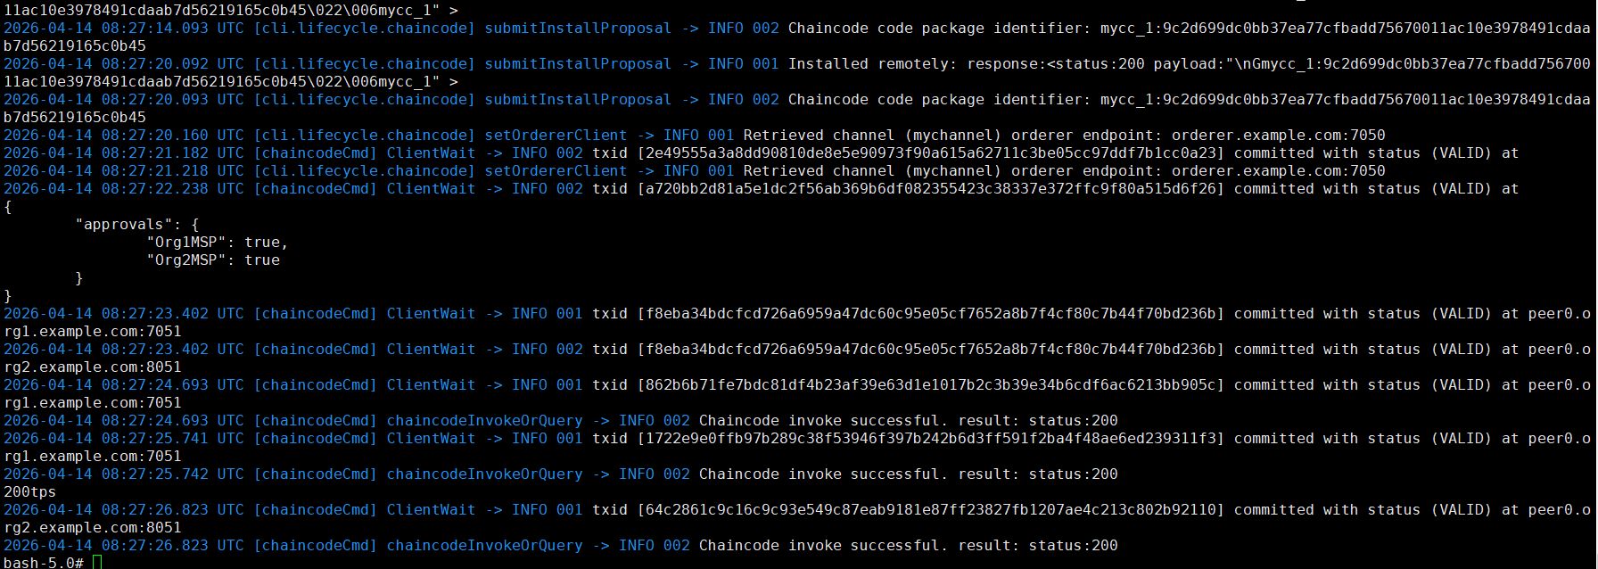

1.3. Start Nodejs SDK

Step 1 (Run): CLI configures the Node.js SDK folder and tls, wallet, and workload files for all peers,
# exit
$ mkdir -p $HOME/fabric-samples/demo-first/workload
$ mkdir -p $HOME/fabric-samples/demo-first/workload/tls
$ mkdir -p $HOME/fabric-samples/demo-first/workload/wallet
$ mkdir -p $HOME/fabric-samples/demo-first/workload/result

$ cd $HOME/fabric-samples/demo-first/workload/tls
$ vi read_pem.py
$ vi prepare_tls_peer0_org1.sh
$ vi prepare_tls_peer0_org2.sh
$ ./all.sh

$ cd $HOME/fabric-samples/demo-first/workload/wallet
$ vi prepare_wallet_user1_org1.py
$ vi prepare_wallet_user1_org2.py
$ ./all.sh

$ cd $HOME/fabric-samples/demo-first/workload
$ mkdir sdk-peer0-org1
$ mkdir sdk-peer0-org2
$ vi invoke.js
$ vi prepare_sdk_peer0_org1.sh
$ vi prepare_sdk_peer0_org2.sh
$ ./all.sh

Step 2 (Prepare): CLI prepares the Nodejs SDK dependencies on CLI. Note that you may pass this step by copying the compiled nodejs source code https://gitee.com/joe32065/fabric_2_2/releases/download/fabric-v2.2.0/node_modules.zip,
$ cd $HOME/fabric-samples/demo-first/workload
$ vi package.json
$ npm install
$ vi $HOME/fabric-samples/demo-first/workload/node_modules/fabric-network/lib/transaction.js

Step 3 (Run): Cli prepares wallets of User1@org1.example.com and User1@org2.example.com,
$ cd $HOME/fabric-samples/demo-first/workload/wallet
$ rm -rf *.id
$ python prepare_wallet_user1_org1.py
$ python prepare_wallet_user1_org2.py
$ ./all.sh

Step 4 (Run): CLI invokes and queries transactions via Node.js,
$ cd $HOME/fabric-samples/demo-first/workload
$ ./scp.sh // CLI copies files to all machines

$ ./ssh.sh > result/benchlog
$ ls result -l
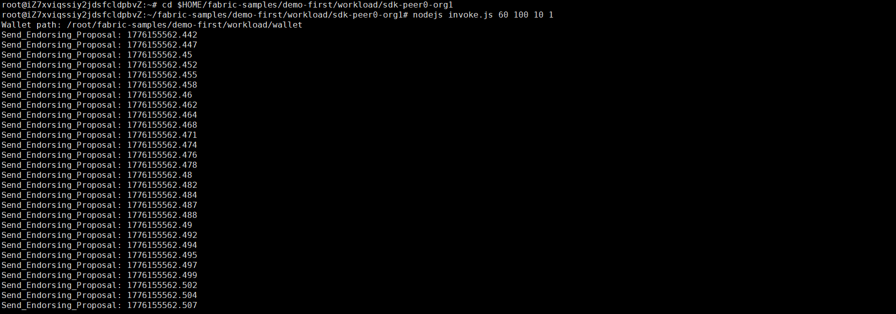

// $ node query.js
// $ node invoke.js 30 500 20 1

Step 5 (Run): Analyze the log,
// CLI analyzes the log
$ cd $HOME/fabric-samples/demo-first/workload/result
$ python readthroughput_p1.py // rate of sending endorsed txs

$ sudo apt-get install python-numpy
$ python readdelay_p1.py // delay of endorsing phase

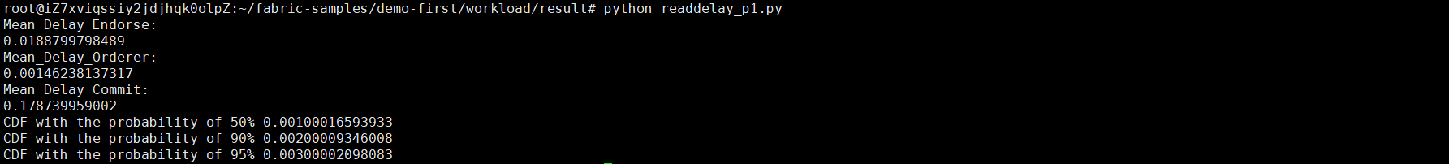

// Orderer analyzes the log
$ cd $HOME/fabric-samples/demo-first/workload/result
$ sudo apt-get install python-numpy
//$ docker logs containername >& ordererlog
$ docker logs $(docker ps -a | grep 'orderer'| awk '{print $1 }') >& ordererlog
// $ scp ordererlog chwang@1xx.1xx.7xx.1xx:/home/chwang
$ python readthroughput_p2.py // rate of generating blocks

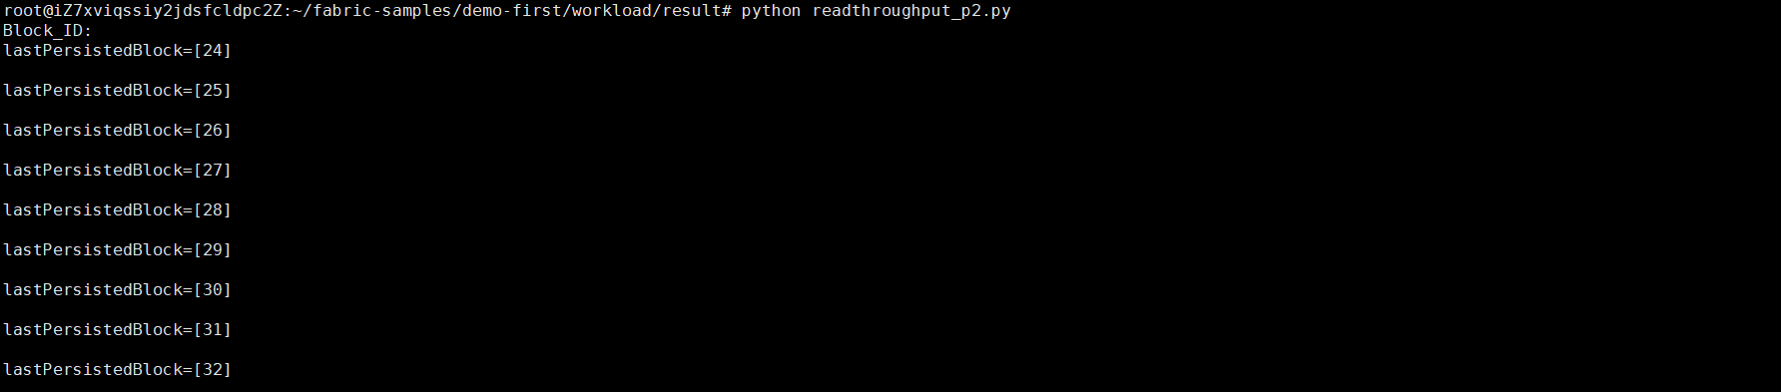

// Peer analyzes the log
$ cd $HOME/fabric-samples/demo-first/workload/result
$ sudo apt-get install python-numpy
//$ docker logs containername >& peerlog
$ docker logs $(docker ps -a | grep 'peer node start'| awk '{print $1 }') >& peerlog
// $ scp peerlog chwang@1xx.1xx.7xx.1xx:/home/chwang
$ python2 readthroughput_p3.py

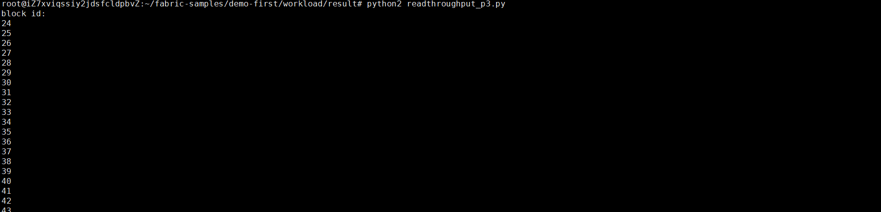

// Get block size
# peer channel fetch 2 last.block -o orderer.example.com:7050 -c mychannel --tls --cafile /opt/gopath/src/github.com/hyperledger/fabric/peer/crypto/ordererOrganizations/example.com/orderers/orderer.example.com/msp/tlscacerts/tlsca.example.com-cert.pem

Step 6 (Run): All nodes run the clean procedure,
$ cd $HOME/fabric-samples/demo-first
$ ./clean.sh

Run Multi-Nodes Fabric (Exp 2: 1 CLI + 2 Peers + 5 Orderers)

2.1. Prepare the Hosts

Step 1 (Prepare): All machines prepare the host names,
$ vi /etc/hosts

172.31.210.67 cli
172.31.210.70 peer0.org1.example.com
172.31.210.71 peer0.org2.example.com
172.31.210.72 orderer.example.com
172.31.210.73 orderer2.example.com
172.31.210.74 orderer3.example.com
172.31.210.75 orderer4.example.com
172.31.210.76 orderer5.example.com

Step 2 (Prepare): CLI prepares the Test-Network files,
$ cd $HOME/fabric-samples
$ mkdir demo-first
$ cd $HOME/fabric-samples/demo-first
$ vi crypto-config.yaml
$ vi configtx.yaml

$ vi peer0-org1.yaml
$ vi peer0-org2.yaml

$ vi orderer1.yaml
$ vi orderer2.yaml
$ vi orderer3.yaml
$ vi orderer4.yaml
$ vi orderer5.yaml

$ vi cli.yaml

Step 2 (Prepare): All machines prepare the timestamp alignment,
$ date +%s // check the timestamp

$ sudo apt-get install ntpdate // align the timestamp
$ sudo ntpdate cn.pool.ntp.org
$ sudo hwclock –systohc

$ date +%s // check the timestamp again

Step 3 (Run): CLI runs the initial block generation,
$ cd $HOME/fabric-samples/demo-first
$ chmod +x *.sh
$ ./config.sh

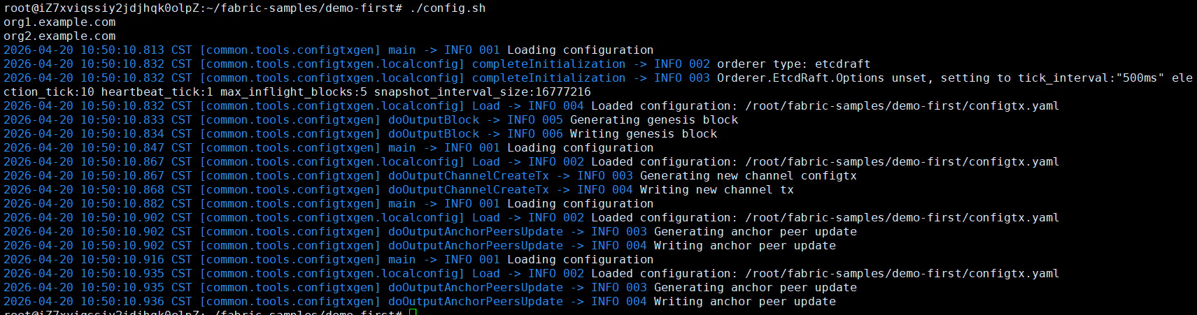

Step 4 (Run): CLI scp the contents to all machines including peers and orderers,
$ cd $HOME/fabric-samples/demo-first
$ ./scp.sh



Step 5 (Run): Orderers sets up the Docker container,
$ cd $HOME/fabric-samples/demo-first
$ ./orderer1.sh

$ ./orderer2.sh

$ ./orderer3.sh

$ ./orderer4.sh

$ ./orderer5.sh

$ docker ps

Step 6 (Run): Peer1 sets up the Docker container,
$ cd $HOME/fabric-samples/demo-first
$ ./peer1.sh

$ docker ps

Step 7 (Run): Peer2 sets up the Docker container,
$ cd $HOME/fabric-samples/demo-first
$ ./peer2.sh

$ docker ps

Step 8 (Run): CLI sets up the Docker container,
$ cd $HOME/fabric-samples/demo-first
$ ./cli.sh

$ docker ps

2.2. Start the Network

Step 1 (Run): CLI connects to Peer0.org1.example.com:7051, creates a channel.block, and then all peers join the channel.block,
// CLI goes to `peer0.org1.example.com:7051`
$ docker exec -it cli bash

// Environment Configuration for `peer0.org1.example.com:7051`
# cd scripts
# ./step1.sh // All peers join the channel

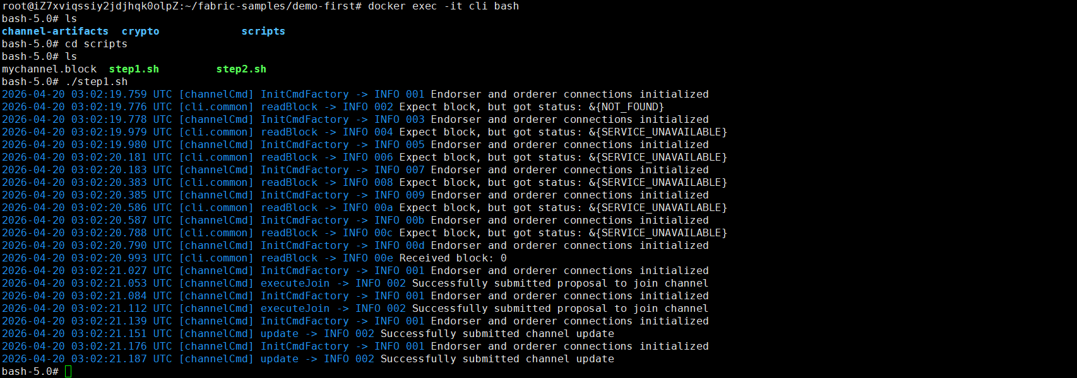

# ./step2.sh // All peers join the chaincode

2.3. Start Nodejs SDK

Step 1 (Run): CLI configures the Node.js SDK folder and tls, wallet, and workload files for all peers,
# exit
$ mkdir -p $HOME/fabric-samples/demo-first/workload
$ mkdir -p $HOME/fabric-samples/demo-first/workload/tls
$ mkdir -p $HOME/fabric-samples/demo-first/workload/wallet
$ mkdir -p $HOME/fabric-samples/demo-first/workload/result

$ cd $HOME/fabric-samples/demo-first/workload/tls
$ vi read_pem.py
$ vi prepare_tls_peer0_org1.sh
$ vi prepare_tls_peer0_org2.sh
$ ./all.sh

$ cd $HOME/fabric-samples/demo-first/workload/wallet
$ vi prepare_wallet_user1_org1.py
$ vi prepare_wallet_user1_org2.py
$ ./all.sh

$ cd $HOME/fabric-samples/demo-first/workload
$ mkdir sdk-peer0-org1
$ mkdir sdk-peer0-org2
$ vi invoke.js
$ vi prepare_sdk_peer0_org1.sh
$ vi prepare_sdk_peer0_org2.sh
$ ./all.sh

Step 2 (Prepare): -
Step 3 (Run): CLI prepares wallets of User1@org1.example.com and User1@org2.example.com,
$ cd $HOME/fabric-samples/demo-first/workload/wallet
$ python prepare_wallet_user1_org1.py
$ python prepare_wallet_user1_org2.py
$ ./all.sh

Step 4 (Run): CLI invokes and queries transactions via Node.js,
$ cd $HOME/fabric-samples/demo-first/workload
$ ./scp.sh // CLI copies files to all machines

$ ./ssh.sh > result/benchlog
$ ls result -l


// $ node query.js
// $ node invoke.js 30 500 20 1

Step 5 (Run): Analyze the log,
// CLI analyzes the log
$ cd $HOME/fabric-samples/demo-first/workload/result
$ python readthroughput_p1.py // rate of sending endorsed txs

$ sudo apt-get install python-numpy
$ python readdelay_p1.py // delay of endorsing phase



// Orderer analyzes the log
$ cd $HOME/fabric-samples/demo-first/workload/result
$ sudo apt-get install python-numpy
//$ docker logs containername >& ordererlog
$ docker logs $(docker ps -a | grep 'orderer'| awk '{print $1 }') >& ordererlog
// $ scp ordererlog chwang@1xx.1xx.7xx.1xx:/home/chwang
$ python readthroughput_p2.py // rate of generating blocks



// Peer analyzes the log
$ cd $HOME/fabric-samples/demo-first/workload/result
$ sudo apt-get install python-numpy
//$ docker logs containername >& peerlog
$ docker logs $(docker ps -a | grep 'peer node start'| awk '{print $1 }') >& peerlog
// $ scp peerlog chwang@1xx.1xx.7xx.1xx:/home/chwang
$ python2 readthroughput_p3.py



// Get block size
# peer channel fetch 228 last.block -o orderer.example.com:7050 -c mychannel --tls --cafile /opt/gopath/src/github.com/hyperledger/fabric/peer/crypto/ordererOrganizations/example.com/orderers/orderer.example.com/msp/tlscacerts/tlsca.example.com-cert.pem

Step 6 (Run): All nodes run the clean procedure,
$ cd $HOME/fabric-samples/demo-first
$ ./clean.sh

Run Multi-Nodes Fabric (Exp 3: 1 CLI + 5 Peers + 5 Orderers)

3.1. Prepare the Hosts

Step 1 (Prepare): All machines prepare the host names,
$ vi /etc/hosts

172.31.210.67 cli
172.31.210.70 peer0.org1.example.com
172.31.210.71 peer0.org2.example.com
172.31.210.72 orderer.example.com
172.31.210.73 orderer2.example.com
172.31.210.74 orderer3.example.com
172.31.210.75 orderer4.example.com
172.31.210.76 orderer5.example.com
172.31.210.77 peer0.org3.example.com
172.31.210.78 peer0.org4.example.com
172.31.210.79 peer0.org5.example.com

Step 2 (Prepare): CLI prepares the Test-Network files,
$ cd $HOME/fabric-samples
$ mkdir demo-first
$ cd $HOME/fabric-samples/demo-first
$ vi crypto-config.yaml
$ vi configtx.yaml

$ vi peer0-org1.yaml
$ vi peer0-org2.yaml
$ vi peer0-org3.yaml
$ vi peer0-org4.yaml
$ vi peer0-org5.yaml

$ vi orderer1.yaml
$ vi orderer2.yaml
$ vi orderer3.yaml
$ vi orderer4.yaml
$ vi orderer5.yaml

$ vi cli.yaml

Step 2 (Prepare): All machines prepare the timestamp alignment,
$ date +%s // check the timestamp

$ sudo apt-get install ntpdate // align the timestamp
$ sudo ntpdate cn.pool.ntp.org
$ sudo hwclock –systohc

$ date +%s // check the timestamp again

Step 3 (Run): CLI runs the initial block generation,
$ cd $HOME/fabric-samples/demo-first
$ chmod +x *.sh
$ ./config.sh



Step 4 (Run): CLI scp the contents to all machines including peers and orderers,
$ cd $HOME/fabric-samples/demo-first
$ ./scp.sh



Step 5 (Run): Orderers sets up the Docker container,
$ cd $HOME/fabric-samples/demo-first
$ ./orderer1.sh

$ ./orderer2.sh

$ ./orderer3.sh

$ ./orderer4.sh

$ ./orderer5.sh

$ docker ps

Step 6 (Run): Peer1 sets up the Docker container,
$ cd $HOME/fabric-samples/demo-first
$ ./peer1.sh

$ docker ps

Step 7 (Run): Other peers set up the Docker container,
$ cd $HOME/fabric-samples/demo-first
$ ./peer2.sh

$ ./peer3.sh

$ ./peer4.sh

$ ./peer5.sh

$ docker ps

Step 8 (Run): CLI sets up the docker container,
$ cd $HOME/fabric-samples/demo-first
$ ./cli.sh

$ docker ps

3.2. Start the Network

Step 1 (Run): CLI (of peer0.org1) connects to Peer0.org1.example.com:7051, creates a channel.block, and then all peers join the channel.block,
// CLI goes to `peer0.org1.example.com:7051`
$ docker exec -it cli bash

// Environment Configuration for `peer0.org1.example.com:7051`
# cd scripts
# ./step1.sh // All peers join the channel



# ./step2.sh // All peers join the chaincode

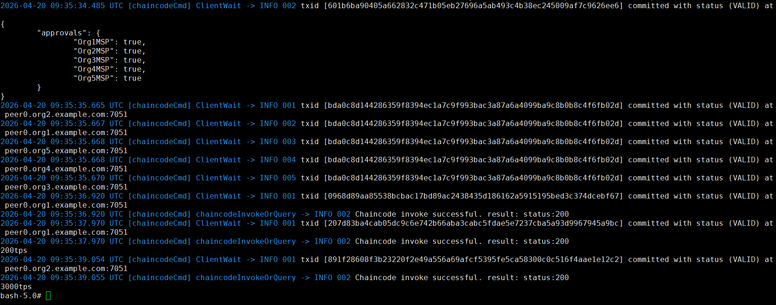

3.3. Start Nodejs SDK

Step 1 (Run): CLI configures the Node.js SDK folder and tls, wallet, and workload files for all peers,
# exit
$ mkdir -p $HOME/fabric-samples/demo-first/workload
$ mkdir -p $HOME/fabric-samples/demo-first/workload/tls
$ mkdir -p $HOME/fabric-samples/demo-first/workload/wallet
$ mkdir -p $HOME/fabric-samples/demo-first/workload/result

$ cd $HOME/fabric-samples/demo-first/workload/tls
$ vi read_pem.py
$ vi prepare_tls_peer0_org1.sh
$ vi prepare_tls_peer0_org2.sh
$ vi prepare_tls_peer0_org3.sh
$ vi prepare_tls_peer0_org4.sh
$ vi prepare_tls_peer0_org5.sh
$ ./all.sh

$ cd $HOME/fabric-samples/demo-first/workload/wallet
$ vi prepare_wallet_user1_org1.py
$ vi prepare_wallet_user1_org2.py
$ vi prepare_wallet_user1_org3.py
$ vi prepare_wallet_user1_org4.py
$ vi prepare_wallet_user1_org5.py
$ ./all.sh

$ cd $HOME/fabric-samples/demo-first/workload
$ mkdir sdk-peer0-org1
$ mkdir sdk-peer0-org2
$ mkdir sdk-peer0-org3
$ mkdir sdk-peer0-org4
$ mkdir sdk-peer0-org5
$ vi invoke.js
$ vi prepare_sdk_peer0_org1.sh
$ vi prepare_sdk_peer0_org2.sh
$ vi prepare_sdk_peer0_org3.sh
$ vi prepare_sdk_peer0_org4.sh
$ vi prepare_sdk_peer0_org5.sh
$ ./all.sh

Step 2 (Prepare): -
Step 3 (Run): Cli prepares wallets of User1@org1.example.com, User1@org2.example.com, …, and User1@org5.example.com,
$ cd $HOME/fabric-samples/demo-first/workload/wallet
$ python prepare_wallet_user1_org1.py
$ python prepare_wallet_user1_org2.py
$ python prepare_wallet_user1_org3.py
$ python prepare_wallet_user1_org4.py
$ python prepare_wallet_user1_org5.py
$ ./all.sh

Step 4 (Run): CLI invokes and queries transactions via Node.js,
$ cd $HOME/fabric-samples/demo-first/workload
$ ./scp.sh // CLI copies files to all machines

$ ./ssh.sh > result/benchlog
$ ls result -l


// $ node query.js
// $ node invoke.js 30 500 20 1

Step 5 (Run): Analyze the log,
// CLI analyzes the log
$ cd $HOME/fabric-samples/demo-first/workload/result
$ python readthroughput_p1.py // rate of sending endorsed txs

$ sudo apt-get install python-numpy
$ python readdelay_p1.py // delay of endorsing phase



// Orderer analyzes the log
$ cd $HOME/fabric-samples/demo-first/workload/result
$ sudo apt-get install python-numpy
//$ docker logs containername >& ordererlog
$ docker logs $(docker ps -a | grep 'orderer'| awk '{print $1 }') >& ordererlog
// $ scp ordererlog chwang@1xx.1xx.7xx.1xx:/home/chwang
$ python readthroughput_p2.py // rate of generating blocks



// Peer analyzes the log
$ cd $HOME/fabric-samples/demo-first/workload/result
$ sudo apt-get install python-numpy
//$ docker logs containername >& peerlog
$ docker logs $(docker ps -a | grep 'peer node start'| awk '{print $1 }') >& peerlog
// $ scp peerlog chwang@1xx.1xx.7xx.1xx:/home/chwang
$ python2 readthroughput_p3.py



// Get block size
# peer channel fetch 228 last.block -o orderer.example.com:7050 -c mychannel --tls --cafile /opt/gopath/src/github.com/hyperledger/fabric/peer/crypto/ordererOrganizations/example.com/orderers/orderer.example.com/msp/tlscacerts/tlsca.example.com-cert.pem

Step 6 (Run): All nodes run the clean procedure,
$ cd $HOME/fabric-samples/demo-first
$ ./clean.sh

Run Multi-Nodes Fabric (Exp 4: 7 CLI + 1 Peers + 15 Orderers)

4.1. Prepare the Hosts

Step 1 (Prepare): All machines prepare the host names,
$ vi /etc/hosts

172.31.210.67 cli # CLI

172.31.210.70 peer0.org1.example.com # Endorsing peer 1
172.31.210.71 peer0.org2.example.com # Endorsing peer 2
172.31.210.77 peer0.org3.example.com # Endorsing peer 3
172.31.210.78 peer0.org4.example.com # Endorsing peer 4
172.31.210.79 peer0.org5.example.com # Endorsing peer 5
172.31.210.80 peer0.org6.example.com # Endorsing peer 6
172.31.210.81 peer0.org7.example.com # Endorsing peer 7

172.31.210.82 peer0.org8.example.com # A Non-Endorsing Peer

172.31.210.72 orderer.example.com # Orderer 1
172.31.210.73 orderer2.example.com # Orderer 2
172.31.210.74 orderer3.example.com # Orderer 3
172.31.210.75 orderer4.example.com # Orderer 4
172.31.210.76 orderer5.example.com # Orderer 5
172.31.210.83 orderer6.example.com # Orderer 6
172.31.210.84 orderer7.example.com # Orderer 7
172.31.210.85 orderer8.example.com # Orderer 8
172.31.210.86 orderer9.example.com # Orderer 9
172.31.210.87 orderer10.example.com # Orderer 10
172.31.210.88 orderer11.example.com # Orderer 11
172.31.210.89 orderer12.example.com # Orderer 12
172.31.210.90 orderer13.example.com # Orderer 13
172.31.210.91 orderer14.example.com # Orderer 14
172.31.210.92 orderer15.example.com # Orderer 15

Step 2 (Prepare): CLI prepares the Test-Network files,
$ cd $HOME/fabric-samples
$ mkdir demo-first
$ cd $HOME/fabric-samples/demo-first
$ vi crypto-config.yaml
$ vi configtx.yaml

$ vi peer0-org1.yaml
$ vi peer0-org2.yaml
$ vi peer0-org3.yaml
$ vi peer0-org4.yaml
$ vi peer0-org5.yaml
$ vi peer0-org6.yaml
$ vi peer0-org7.yaml
$ vi peer0-org8.yaml

$ vi orderer1.yaml
$ vi orderer2.yaml
$ vi orderer3.yaml
$ vi orderer4.yaml
$ vi orderer5.yaml
$ vi orderer6.yaml
$ vi orderer7.yaml
$ vi orderer8.yaml
$ vi orderer9.yaml
$ vi orderer10.yaml
$ vi orderer11.yaml
$ vi orderer12.yaml
$ vi orderer13.yaml
$ vi orderer14.yaml
$ vi orderer15.yaml

$ vi cli.yaml

Step 2 (Prepare): All machines prepare the timestamp alignment,
$ date +%s // check the timestamp

$ sudo apt-get install ntpdate // align the timestamp
$ sudo ntpdate cn.pool.ntp.org
$ sudo hwclock –systohc

$ date +%s // check the timestamp again

Step 3 (Run): CLI runs the initial block generation,
$ cd $HOME/fabric-samples/demo-first
$ chmod +x *.sh
$ ./config.sh



Step 4 (Run): CLI scp the contents to all machines including peers and orderers,
$ cd $HOME/fabric-samples/demo-first
$ ./scp.sh



Step 5 (Run): Orderers sets up the Docker container,
$ cd $HOME/fabric-samples/demo-first
$ ./orderer1.sh

$ ./orderer2.sh

$ ./orderer3.sh

$ ./orderer4.sh

$ ./orderer5.sh

$ ./orderer6.sh

$ ./orderer7.sh

$ ./orderer8.sh

$ ./orderer9.sh

$ ./orderer10.sh

$ ./orderer11.sh

$ ./orderer12.sh

$ ./orderer13.sh

$ ./orderer14.sh

$ ./orderer15.sh

$ docker ps

Step 6 (Run): Peer1 sets up the Docker container,
$ cd $HOME/fabric-samples/demo-first
$ ./peer1.sh

$ docker ps

Step 7 (Run): Other peers set up the Docker container,
$ cd $HOME/fabric-samples/demo-first
$ ./peer2.sh

$ ./peer3.sh

$ ./peer4.sh

$ ./peer5.sh

$ ./peer6.sh

$ ./peer7.sh

$ ./peer8.sh

$ docker ps

Step 8 (Run): CLI sets up the docker container,
$ cd $HOME/fabric-samples/demo-first
$ ./cli.sh

$ docker ps

4.2. Start the Network

Step 1 (Run): CLI (of peer0.org1) connects to Peer0.org1.example.com:7051, creates a channel.block, and then all peers join the channel.block,
// CLI goes to `peer0.org1.example.com:7051`
$ docker exec -it cli bash

// Environment Configuration for `peer0.org1.example.com:7051`
# cd scripts
# ./step1.sh // All peers join the channel



# ./step2.sh // All peers join the chaincode



4.3. Start Nodejs SDK

Step 1 (Run): CLI configures the Node.js SDK folder and tls, wallet, and workload files for all peers,
# exit
$ mkdir -p $HOME/fabric-samples/demo-first/workload
$ mkdir -p $HOME/fabric-samples/demo-first/workload/tls
$ mkdir -p $HOME/fabric-samples/demo-first/workload/wallet
$ mkdir -p $HOME/fabric-samples/demo-first/workload/result

$ cd $HOME/fabric-samples/demo-first/workload/tls
$ vi read_pem.py
$ vi prepare_tls_peer0_org1.sh
$ vi prepare_tls_peer0_org2.sh
$ vi prepare_tls_peer0_org3.sh
$ vi prepare_tls_peer0_org4.sh
$ vi prepare_tls_peer0_org5.sh
$ vi prepare_tls_peer0_org6.sh
$ vi prepare_tls_peer0_org7.sh
$ vi prepare_tls_peer0_org8.sh
$ ./all.sh

$ cd $HOME/fabric-samples/demo-first/workload/wallet
$ vi prepare_wallet_user1_org1.py
$ vi prepare_wallet_user1_org2.py
$ vi prepare_wallet_user1_org3.py
$ vi prepare_wallet_user1_org4.py
$ vi prepare_wallet_user1_org5.py
$ vi prepare_wallet_user1_org6.py
$ vi prepare_wallet_user1_org7.py
$ vi prepare_wallet_user1_org8.py
$ ./all.sh

$ cd $HOME/fabric-samples/demo-first/workload
$ mkdir sdk-peer0-org1
$ mkdir sdk-peer0-org2
$ mkdir sdk-peer0-org3
$ mkdir sdk-peer0-org4
$ mkdir sdk-peer0-org5
$ mkdir sdk-peer0-org6
$ mkdir sdk-peer0-org7
$ mkdir sdk-peer0-org8
$ vi invoke.js

$ vi prepare_sdk_peer0_org1.sh
$ vi prepare_sdk_peer0_org2.sh
$ vi prepare_sdk_peer0_org3.sh
$ vi prepare_sdk_peer0_org4.sh
$ vi prepare_sdk_peer0_org5.sh
$ vi prepare_sdk_peer0_org6.sh
$ vi prepare_sdk_peer0_org7.sh
$ vi prepare_sdk_peer0_org8.sh

$ ./all.sh

Step 2 (Prepare): -
Step 3 (Run): Cli prepares wallets of User1@org1.example.com, User1@org2.example.com, …, and User1@org5.example.com,
$ cd $HOME/fabric-samples/demo-first/workload/wallet
$ python prepare_wallet_user1_org1.py
$ python prepare_wallet_user1_org2.py
$ python prepare_wallet_user1_org3.py
$ python prepare_wallet_user1_org4.py
$ python prepare_wallet_user1_org5.py
$ python prepare_wallet_user1_org6.py
$ python prepare_wallet_user1_org7.py
$ python prepare_wallet_user1_org8.py

$ ./all.sh

Step 4 (Run): CLI invokes and queries transactions via Node.js,
$ cd $HOME/fabric-samples/demo-first/workload
$ ./scp.sh // CLI copies files to all machines

$ ./ssh.sh > result/benchlog
$ ls result -l


// $ node query.js
// $ node invoke.js 30 500 20 1

Step 5 (Run): Analyze the log,
// CLI analyzes the log
$ cd $HOME/fabric-samples/demo-first/workload/result
$ python readthroughput_p1.py // rate of sending endorsed txs

$ sudo apt-get install python-numpy
$ python readdelay_p1.py // delay of endorsing phase



// Orderer analyzes the log
$ cd $HOME/fabric-samples/demo-first/workload/result
$ sudo apt-get install python-numpy
//$ docker logs containername >& ordererlog
$ docker logs $(docker ps -a | grep 'orderer'| awk '{print $1 }') >& ordererlog
// $ scp ordererlog chwang@1xx.1xx.7xx.1xx:/home/chwang
$ python readthroughput_p2.py // rate of generating blocks



// Peer analyzes the log
$ cd $HOME/fabric-samples/demo-first/workload/result
$ sudo apt-get install python-numpy
//$ docker logs containername >& peerlog
$ docker logs $(docker ps -a | grep 'peer node start'| awk '{print $1 }') >& peerlog
// $ scp peerlog chwang@1xx.1xx.7xx.1xx:/home/chwang
$ python2 readthroughput_p3.py



// Get block size
# peer channel fetch 228 last.block -o orderer.example.com:7050 -c mychannel --tls --cafile /opt/gopath/src/github.com/hyperledger/fabric/peer/crypto/ordererOrganizations/example.com/orderers/orderer.example.com/msp/tlscacerts/tlsca.example.com-cert.pem

Step 6 (Run): All nodes run the clean procedure,
$ cd $HOME/fabric-samples/demo-first
$ ./clean.sh

Dynamic Adj on Single Orderer (Exp 5: 1 CLI + 2 Peers + 1 Orderer)

5.1. Prepare the Hosts

Step 1 (Prepare): All machines prepare the host names,
$ vi /etc/hosts

172.31.210.67 cli
172.31.210.70 peer0.org1.example.com
172.31.210.71 peer0.org2.example.com
172.31.210.72 orderer.example.com

Step 2 (Prepare): CLI prepares the Test-Network files,
$ cd $HOME/fabric-samples
$ mkdir demo-first
$ cd $HOME/fabric-samples/demo-first
$ vi crypto-config.yaml
$ vi configtx.yaml

$ vi peer0-org1.yaml
$ vi peer0-org2.yaml

$ vi orderer1.yaml

$ vi cli.yaml // (of peer0.org1)

$ vi $HOME/fabric-samples/chaincode/abstore/go/abstore.go // our proposed key-value chaincode
$ vi $HOME/fabric-samples/chaincode/abstore/go/go.mod

Step 2 (Prepare): All machines prepare the timestamp alignment,
$ date +%s // check the timestamp

$ sudo apt-get install ntpdate // align the timestamp
$ sudo ntpdate cn.pool.ntp.org
$ sudo hwclock –systohc

$ date +%s // check the timestamp again

Step 3 (Run): CLI runs the initial block generation,
$ cd $HOME/fabric-samples/demo-first
$ chmod +x *.sh
$ ./config.sh



$ cd $HOME/fabric-samples/demo-first/workload/tls
$ chmod +x *.sh

$ cd $HOME/fabric-samples/demo-first/workload
$ chmod +x *.sh
$ wget https://gitee.com/joe32065/fabric_2_2/releases/download/fabric-v2.2.0/node_modules.zip
$ unzip node_modules.zip

$ cd $HOME/fabric-samples/demo-first/scripts
$ chmod +x *.sh

Step 4 (Run): CLI scp the contents to all machines including peers and orderers,
$ cd $HOME/fabric-samples/demo-first
$ ./scp.sh



Step 5 (Run): Orderer1 sets up the Docker container,
$ cd $HOME/fabric-samples/demo-first
$ ./orderer1.sh

$ docker ps

Step 6 (Run): Peer1 sets up the Docker container,
$ cd $HOME/fabric-samples/demo-first
$ ./peer1.sh

$ docker ps

Step 7 (Run): Peer2 sets up the Docker container,
$ cd $HOME/fabric-samples/demo-first
$ ./peer2.sh

$ docker ps

Step 8 (Run): CLI sets up the Docker container,
$ cd $HOME/fabric-samples/demo-first
$ ./cli.sh

$ docker ps

5.2. Start the Network

Step 1 (Run): CLI connects to Peer0.org1.example.com:7051, creates a channel.block, and then all peers join the channel.block,
// CLI goes to `peer0.org1.example.com:7051`
$ docker exec -it cli bash

// Environment Configuration for `peer0.org1.example.com:7051`
# cd scripts
# ./step1.sh // All peers join the channel



# ./step2.sh // All peers join the chaincode



5.3. Start Nodejs SDK

Step 1 (Run): CLI configures the Node.js SDK folder and tls, wallet, and workload files for all peers,
# exit
$ mkdir -p $HOME/fabric-samples/demo-first/workload
$ mkdir -p $HOME/fabric-samples/demo-first/workload/tls
$ mkdir -p $HOME/fabric-samples/demo-first/workload/wallet
$ mkdir -p $HOME/fabric-samples/demo-first/workload/result

$ cd $HOME/fabric-samples/demo-first/workload/tls
$ vi read_pem.py
$ vi prepare_tls_peer0_org1.sh
$ vi prepare_tls_peer0_org2.sh
$ ./all.sh

$ cd $HOME/fabric-samples/demo-first/workload/wallet
$ vi prepare_wallet_user1_org1.py
$ vi prepare_wallet_user1_org2.py
$ ./all.sh

$ cd $HOME/fabric-samples/demo-first/workload
$ mkdir sdk-peer0-org1
$ mkdir sdk-peer0-org2
$ vi invoke.js
$ vi prepare_sdk_peer0_org1.sh
$ vi prepare_sdk_peer0_org2.sh
$ ./all.sh

Step 2 (Prepare): CLI prepares the Nodejs SDK dependencies on CLI. Note that you may pass this step by copying the compiled nodejs source code https://gitee.com/joe32065/fabric_2_2/releases/download/fabric-v2.2.0/node_modules.zip,
$ cd $HOME/fabric-samples/demo-first/workload
$ vi package.json
$ npm install
$ vi $HOME/fabric-samples/demo-first/workload/node_modules/fabric-network/lib/transaction.js

Step 3 (Run): Cli prepares wallets of User1@org1.example.com and User1@org2.example.com,
$ cd $HOME/fabric-samples/demo-first/workload/wallet
$ rm -rf *.id
$ python prepare_wallet_user1_org1.py
$ python prepare_wallet_user1_org2.py
$ ./all.sh

Step 4 (Run): CLI invokes and queries transactions via Node.js,
$ cd $HOME/fabric-samples/demo-first/workload
$ ./scp.sh // CLI copies files to all machines

$ ./ssh.sh > result/benchlog
$ ls result -l



// $ node query.js
// $ node invoke.js 30 500 20 1

Step 5 (Run): Analyze the log,
// CLI analyzes the log
$ cd $HOME/fabric-samples/demo-first/workload/result
$ python readthroughput_p1.py // rate of sending endorsed txs

$ sudo apt-get install python-numpy
$ python readdelay_p1.py // delay of endorsing phase



// Orderer analyzes the log
$ cd $HOME/fabric-samples/demo-first/workload/result
$ sudo apt-get install python-numpy
//$ docker logs containername >& ordererlog
$ docker logs $(docker ps -a | grep 'orderer'| awk '{print $1 }') >& ordererlog
// $ scp ordererlog chwang@1xx.1xx.7xx.1xx:/home/chwang
$ python readthroughput_p2.py // rate of generating blocks



// Peer analyzes the log
$ cd $HOME/fabric-samples/demo-first/workload/result
$ sudo apt-get install python-numpy
//$ docker logs containername >& peerlog
$ docker logs $(docker ps -a | grep 'peer node start'| awk '{print $1 }') >& peerlog
// $ scp peerlog chwang@1xx.1xx.7xx.1xx:/home/chwang
$ python2 readthroughput_p3.py



// For example, we can get block size
# peer channel fetch 2 last.block -o orderer.example.com:7050 -c mychannel --tls --cafile /opt/gopath/src/github.com/hyperledger/fabric/peer/crypto/ordererOrganizations/example.com/orderers/orderer.example.com/msp/tlscacerts/tlsca.example.com-cert.pem

5.4. Dynamic Adjust Block Parameters on Single OSN

Step 1 (Run): Orderer fetches the latest block configuration, where orderer pulls the channel configuration in protobuf format and create a file named config_block.pb, as follows,
$ docker exec -it cli bash
# CORE_PEER_MSPCONFIGPATH=/opt/gopath/src/github.com/hyperledger/fabric/peer/crypto/ordererOrganizations/example.com/users/Admin@example.com/msp CORE_PEER_ADDRESS=orderer.example.com:7050 CORE_PEER_LOCALMSPID="OrdererMSP" CORE_PEER_TLS_ROOTCERT_FILE=/opt/gopath/src/github.com/hyperledger/fabric/peer/crypto/ordererOrganizations/example.com/orderers/orderer.example.com/msp/tlscacerts/tlsca.example.com-cert.pem peer channel fetch config config_block.pb -o orderer.example.com:7050 -c mychannel --tls --cafile /opt/gopath/src/github.com/hyperledger/fabric/peer/crypto/ordererOrganizations/example.com/orderers/orderer.example.com/msp/tlscacerts/tlsca.example.com-cert.pem

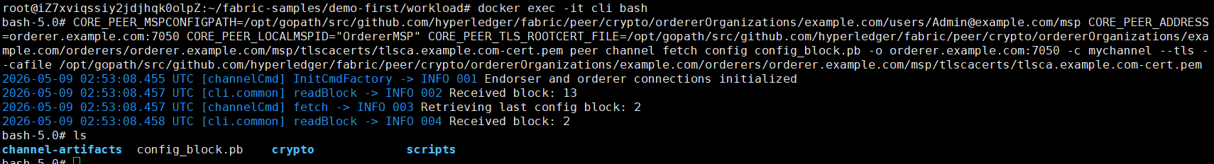

Step 2 (Run): We convert the configuration file named config_block.pb to JSON file named config.json, as follows,
# configtxlator proto_decode --input config_block.pb --type common.Block | jq .data.data[0].payload.data.config > config.json

We can check that the initial BatchSize is 60,

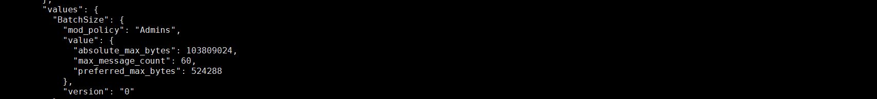

Step 3 (Run): We update the BatchSize value from 60 to 80, and save the modified json file as modified_config.json, as follows,
# BS=".channel_group.groups.Orderer.values.BatchSize.value.max_message_count"
# jq "$BS" config.json

# jq "$BS = 80" config.json > modified_config.json
# jq "$BS" modified_config.json

Step 4 (Run): We convert the initial config.json to config.pb and convert the modified_config.json to modified_config.pb, as follows,
# configtxlator proto_encode --input config.json --type common.Config --output config.pb
# configtxlator proto_encode --input modified_config.json --type common.Config --output modified_config.pb

Step 5 (Run): We calculate the difference between config.pb and modified_config.pb. The difference to be appended is named file_update.pb, as follows,
# configtxlator compute_update --channel_id mychannel --original config.pb --updated modified_config.pb --output final_update.pb

Step 6 (Run): We update the difference to the envelope, and append the changes to the config, as follows,
# configtxlator proto_decode --input final_update.pb --type common.ConfigUpdate | jq . > final_update.json
# echo "{\"payload\":{\"header\":{\"channel_header\":{\"channel_id\":\"mychannel\", \"type\":2}},\"data\":{\"config_update\":"$(cat final_update.json)"}}}" | jq . > header_in_envolope.json
# configtxlator proto_encode --input header_in_envolope.json --type common.Envelope --output final_update_in_envelope.pb

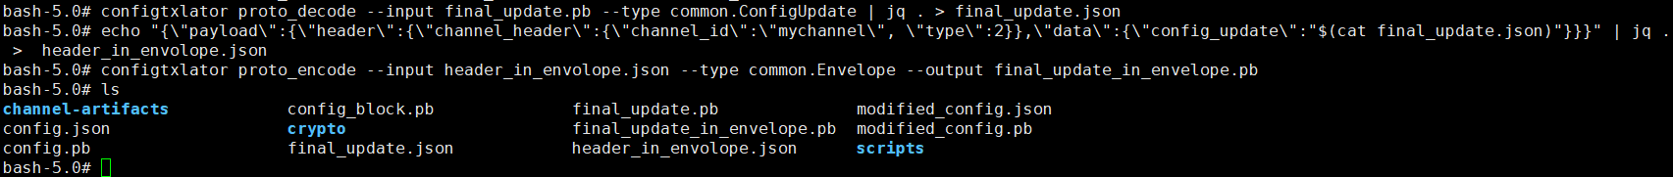

Step 7 (Run): All endorsing peers sign this update proto, as follows,
# CORE_PEER_MSPCONFIGPATH=/opt/gopath/src/github.com/hyperledger/fabric/peer/crypto/peerOrganizations/org1.example.com/users/Admin@org1.example.com/msp CORE_PEER_ADDRESS=peer0.org1.example.com:7051 CORE_PEER_LOCALMSPID="Org1MSP" CORE_PEER_TLS_ROOTCERT_FILE=/opt/gopath/src/github.com/hyperledger/fabric/peer/crypto/peerOrganizations/org1.example.com/peers/peer0.org1.example.com/tls/ca.crt peer channel signconfigtx -f final_update_in_envelope.pb

# CORE_PEER_MSPCONFIGPATH=/opt/gopath/src/github.com/hyperledger/fabric/peer/crypto/peerOrganizations/org2.example.com/users/Admin@org2.example.com/msp CORE_PEER_ADDRESS=peer0.org2.example.com:8051 CORE_PEER_LOCALMSPID="Org2MSP" CORE_PEER_TLS_ROOTCERT_FILE=/opt/gopath/src/github.com/hyperledger/fabric/peer/crypto/peerOrganizations/org2.example.com/peers/peer0.org2.example.com/tls/ca.crt peer channel signconfigtx -f final_update_in_envelope.pb

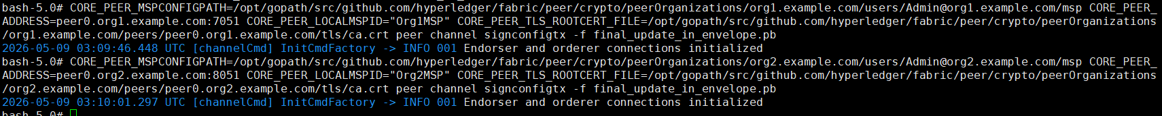

Step 7 (Run): Orderer update the channel as follows,
# CORE_PEER_MSPCONFIGPATH=/opt/gopath/src/github.com/hyperledger/fabric/peer/crypto/ordererOrganizations/example.com/users/Admin@example.com/msp CORE_PEER_ADDRESS=orderer.example.com:7050 CORE_PEER_LOCALMSPID="OrdererMSP" CORE_PEER_TLS_ROOTCERT_FILE=/opt/gopath/src/github.com/hyperledger/fabric/peer/crypto/ordererOrganizations/example.com/orderers/orderer.example.com/msp/tlscacerts/tlsca.example.com-cert.pem peer channel update -f final_update_in_envelope.pb -c mychannel -o orderer.example.com:7050 --tls --cafile /opt/gopath/src/github.com/hyperledger/fabric/peer/crypto/ordererOrganizations/example.com/orderers/orderer.example.com/msp/tlscacerts/tlsca.example.com-cert.pem

Step 8 (Validation): We can validate that the BatchSize is now from 60 to 80, as follows,
# CORE_PEER_MSPCONFIGPATH=/opt/gopath/src/github.com/hyperledger/fabric/peer/crypto/ordererOrganizations/example.com/users/Admin@example.com/msp CORE_PEER_ADDRESS=orderer.example.com:7050 CORE_PEER_LOCALMSPID="OrdererMSP" CORE_PEER_TLS_ROOTCERT_FILE=/opt/gopath/src/github.com/hyperledger/fabric/peer/crypto/ordererOrganizations/example.com/orderers/orderer.example.com/msp/tlscacerts/tlsca.example.com-cert.pem peer channel fetch config config_block.pb -o orderer.example.com:7050 -c mychannel --tls --cafile /opt/gopath/src/github.com/hyperledger/fabric/peer/crypto/ordererOrganizations/example.com/orderers/orderer.example.com/msp/tlscacerts/tlsca.example.com-cert.pem

# configtxlator proto_decode --input config_block.pb --type common.Block | jq .data.data[0].payload.data.config > config.json
# jq "$BS" config.json

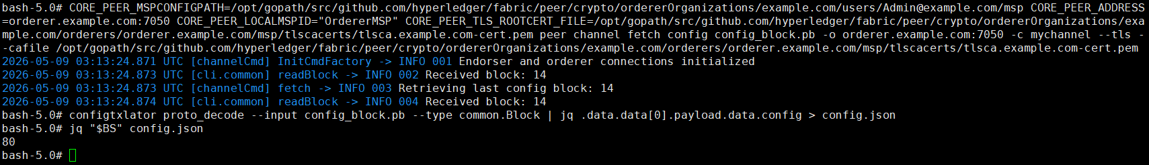

Step 9 (Run): Nodes run the clean procedure,
$ cd $HOME/fabric-samples/demo-first
$ ./clean.sh

Dynamic Adj on Multi Orderers (Exp 6: 1 CLI + 2 Peers + 5 Orderers)

6.1. Prepare the Hosts

Step 1 (Prepare): All machines prepare the host names,
$ vi /etc/hosts

172.31.210.67 cli
172.31.210.70 peer0.org1.example.com
172.31.210.71 peer0.org2.example.com
172.31.210.72 orderer.example.com
172.31.210.73 orderer2.example.com
172.31.210.74 orderer3.example.com
172.31.210.75 orderer4.example.com
172.31.210.76 orderer5.example.com

Step 2 (Prepare): CLI prepares the Test-Network files,
$ cd $HOME/fabric-samples
$ mkdir demo-first
$ cd $HOME/fabric-samples/demo-first
$ vi crypto-config.yaml
$ vi configtx.yaml

$ vi peer0-org1.yaml
$ vi peer0-org2.yaml

$ vi orderer1.yaml
$ vi orderer2.yaml
$ vi orderer3.yaml
$ vi orderer4.yaml
$ vi orderer5.yaml

$ vi cli.yaml

Step 2 (Prepare): All machines prepare the timestamp alignment,
$ date +%s // check the timestamp

$ sudo apt-get install ntpdate // align the timestamp
$ sudo ntpdate cn.pool.ntp.org
$ sudo hwclock –systohc

$ date +%s // check the timestamp again

Step 3 (Run): CLI runs the initial block generation,
$ cd $HOME/fabric-samples/demo-first
$ chmod +x *.sh
$ ./config.sh



Step 4 (Run): CLI scp the contents to all machines including peers and orderers,
$ cd $HOME/fabric-samples/demo-first
$ ./scp.sh



Step 5 (Run): Orderers sets up the Docker container,
$ cd $HOME/fabric-samples/demo-first
$ ./orderer1.sh

$ ./orderer2.sh

$ ./orderer3.sh

$ ./orderer4.sh

$ ./orderer5.sh

$ docker ps

Step 6 (Run): Peer1 sets up the Docker container,
$ cd $HOME/fabric-samples/demo-first
$ ./peer1.sh

$ docker ps

Step 7 (Run): Peer2 sets up the Docker container,
$ cd $HOME/fabric-samples/demo-first
$ ./peer2.sh

$ docker ps

Step 8 (Run): CLI sets up the Docker container,
$ cd $HOME/fabric-samples/demo-first
$ ./cli.sh

$ docker ps

6.2. Start the Network

Step 1 (Run): CLI connects to Peer0.org1.example.com:7051, creates a channel.block, and then all peers join the channel.block,
// CLI goes to `peer0.org1.example.com:7051`
$ docker exec -it cli bash

// Environment Configuration for `peer0.org1.example.com:7051`
# cd scripts
# ./step1.sh // All peers join the channel



# ./step2.sh // All peers join the chaincode

6.3. Start Nodejs SDK

Step 1 (Run): CLI configures the Node.js SDK folder and tls, wallet, and workload files for all peers,
# exit
$ mkdir -p $HOME/fabric-samples/demo-first/workload
$ mkdir -p $HOME/fabric-samples/demo-first/workload/tls
$ mkdir -p $HOME/fabric-samples/demo-first/workload/wallet
$ mkdir -p $HOME/fabric-samples/demo-first/workload/result

$ cd $HOME/fabric-samples/demo-first/workload/tls
$ vi read_pem.py
$ vi prepare_tls_peer0_org1.sh
$ vi prepare_tls_peer0_org2.sh
$ ./all.sh

$ cd $HOME/fabric-samples/demo-first/workload/wallet
$ vi prepare_wallet_user1_org1.py
$ vi prepare_wallet_user1_org2.py
$ ./all.sh

$ cd $HOME/fabric-samples/demo-first/workload
$ mkdir sdk-peer0-org1
$ mkdir sdk-peer0-org2
$ vi invoke.js
$ vi prepare_sdk_peer0_org1.sh
$ vi prepare_sdk_peer0_org2.sh
$ ./all.sh

Step 2 (Prepare): -
Step 3 (Run): CLI prepares wallets of User1@org1.example.com and User1@org2.example.com,
$ cd $HOME/fabric-samples/demo-first/workload/wallet
$ python prepare_wallet_user1_org1.py
$ python prepare_wallet_user1_org2.py
$ ./all.sh

Step 4 (Run): CLI invokes and queries transactions via Node.js,
$ cd $HOME/fabric-samples/demo-first/workload
$ ./scp.sh // CLI copies files to all machines

$ ./ssh.sh > result/benchlog
$ ls result -l


// $ node query.js
// $ node invoke.js 30 500 20 1

Step 5 (Run): Analyze the log,
// CLI analyzes the log
$ cd $HOME/fabric-samples/demo-first/workload/result
$ python readthroughput_p1.py // rate of sending endorsed txs

$ sudo apt-get install python-numpy
$ python readdelay_p1.py // delay of endorsing phase



// Orderer analyzes the log
$ cd $HOME/fabric-samples/demo-first/workload/result
$ sudo apt-get install python-numpy
//$ docker logs containername >& ordererlog
$ docker logs $(docker ps -a | grep 'orderer'| awk '{print $1 }') >& ordererlog
// $ scp ordererlog chwang@1xx.1xx.7xx.1xx:/home/chwang
$ python readthroughput_p2.py // rate of generating blocks



// Peer analyzes the log
$ cd $HOME/fabric-samples/demo-first/workload/result
$ sudo apt-get install python-numpy
//$ docker logs containername >& peerlog
$ docker logs $(docker ps -a | grep 'peer node start'| awk '{print $1 }') >& peerlog
// $ scp peerlog chwang@1xx.1xx.7xx.1xx:/home/chwang
$ python2 readthroughput_p3.py



// Get block size
# peer channel fetch 228 last.block -o orderer.example.com:7050 -c mychannel --tls --cafile /opt/gopath/src/github.com/hyperledger/fabric/peer/crypto/ordererOrganizations/example.com/orderers/orderer.example.com/msp/tlscacerts/tlsca.example.com-cert.pem

Step 6 (Run): All nodes run the clean procedure,
$ cd $HOME/fabric-samples/demo-first
$ ./clean.sh

6.4. Dynamic Adjust Block Parameters on Multiple OSNs

Step 1 (Run): Orderer 1 fetches the latest block configuration, where orderer pulls the channel configuration in protobuf format and create a file named config_block.pb, as follows,
$ docker exec -it cli bash
# CORE_PEER_MSPCONFIGPATH=/opt/gopath/src/github.com/hyperledger/fabric/peer/crypto/ordererOrganizations/example.com/users/Admin@example.com/msp CORE_PEER_ADDRESS=orderer.example.com:7050 CORE_PEER_LOCALMSPID="OrdererMSP" CORE_PEER_TLS_ROOTCERT_FILE=/opt/gopath/src/github.com/hyperledger/fabric/peer/crypto/ordererOrganizations/example.com/orderers/orderer.example.com/msp/tlscacerts/tlsca.example.com-cert.pem peer channel fetch config config_block.pb -o orderer.example.com:7050 -c mychannel --tls --cafile /opt/gopath/src/github.com/hyperledger/fabric/peer/crypto/ordererOrganizations/example.com/orderers/orderer.example.com/msp/tlscacerts/tlsca.example.com-cert.pem

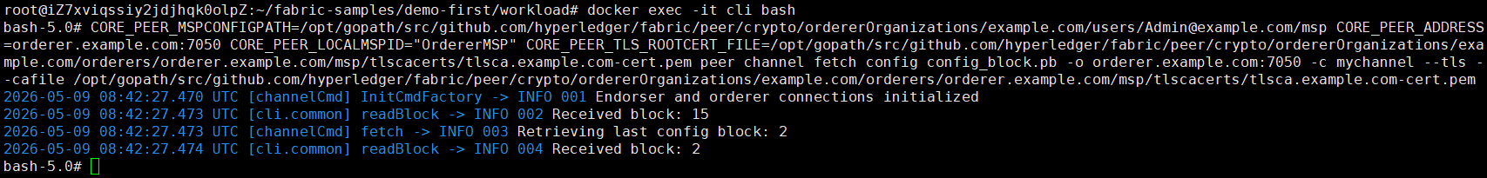

Step 2 (Run): We convert the configuration file named config_block.pb to JSON file named config.json, as follows,
# configtxlator proto_decode --input config_block.pb --type common.Block | jq .data.data[0].payload.data.config > config.json

Step 3 (Run): We update the BatchSize value from 30 to 80, and save the modified json file as modified_config.json, as follows,
# BS=".channel_group.groups.Orderer.values.BatchSize.value.max_message_count"
# jq "$BS" config.json

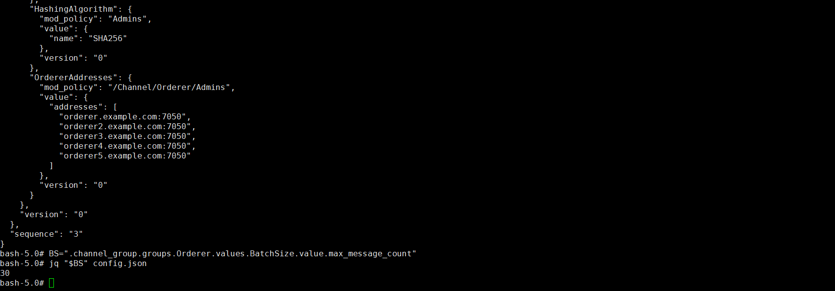

# jq "$BS = 80" config.json > modified_config.json
# jq "$BS" modified_config.json

Step 4 (Run): We convert the initial config.json to config.pb and convert the modified_config.json to modified_config.pb, as follows,
# configtxlator proto_encode --input config.json --type common.Config --output config.pb
# configtxlator proto_encode --input modified_config.json --type common.Config --output modified_config.pb

Step 5 (Run): We calculate the difference between config.pb and modified_config.pb. The difference to be appended is named file_update.pb, as follows,
# configtxlator compute_update --channel_id mychannel --original config.pb --updated modified_config.pb --output final_update.pb

Step 6 (Run): We update the difference to the envelope, and append the changes to the config, as follows,
# configtxlator proto_decode --input final_update.pb --type common.ConfigUpdate | jq . > final_update.json
# echo "{\"payload\":{\"header\":{\"channel_header\":{\"channel_id\":\"mychannel\", \"type\":2}},\"data\":{\"config_update\":"$(cat final_update.json)"}}}" | jq . > header_in_envolope.json
# configtxlator proto_encode --input header_in_envolope.json --type common.Envelope --output final_update_in_envelope.pb

Step 7 (Run): All endorsing peers sign this update proto, as follows,
# CORE_PEER_MSPCONFIGPATH=/opt/gopath/src/github.com/hyperledger/fabric/peer/crypto/peerOrganizations/org1.example.com/users/Admin@org1.example.com/msp CORE_PEER_ADDRESS=peer0.org1.example.com:7051 CORE_PEER_LOCALMSPID="Org1MSP" CORE_PEER_TLS_ROOTCERT_FILE=/opt/gopath/src/github.com/hyperledger/fabric/peer/crypto/peerOrganizations/org1.example.com/peers/peer0.org1.example.com/tls/ca.crt peer channel signconfigtx -f final_update_in_envelope.pb

# CORE_PEER_MSPCONFIGPATH=/opt/gopath/src/github.com/hyperledger/fabric/peer/crypto/peerOrganizations/org2.example.com/users/Admin@org2.example.com/msp CORE_PEER_ADDRESS=peer0.org2.example.com:8051 CORE_PEER_LOCALMSPID="Org2MSP" CORE_PEER_TLS_ROOTCERT_FILE=/opt/gopath/src/github.com/hyperledger/fabric/peer/crypto/peerOrganizations/org2.example.com/peers/peer0.org2.example.com/tls/ca.crt peer channel signconfigtx -f final_update_in_envelope.pb

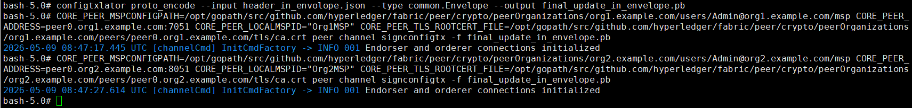

Step 7 (Run): Orderer 1 updates the channel as follows,
# CORE_PEER_MSPCONFIGPATH=/opt/gopath/src/github.com/hyperledger/fabric/peer/crypto/ordererOrganizations/example.com/users/Admin@example.com/msp CORE_PEER_ADDRESS=orderer.example.com:7050 CORE_PEER_LOCALMSPID="OrdererMSP" CORE_PEER_TLS_ROOTCERT_FILE=/opt/gopath/src/github.com/hyperledger/fabric/peer/crypto/ordererOrganizations/example.com/orderers/orderer.example.com/msp/tlscacerts/tlsca.example.com-cert.pem peer channel update -f final_update_in_envelope.pb -c mychannel -o orderer.example.com:7050 --tls --cafile /opt/gopath/src/github.com/hyperledger/fabric/peer/crypto/ordererOrganizations/example.com/orderers/orderer.example.com/msp/tlscacerts/tlsca.example.com-cert.pem

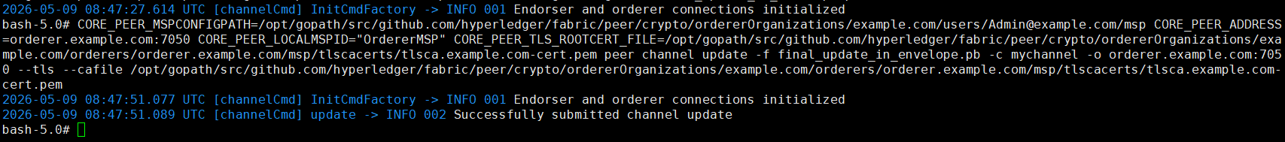

Step 8 (Validation): We can validate that the BatchSize is now from 60 to 80, as follows,
# CORE_PEER_MSPCONFIGPATH=/opt/gopath/src/github.com/hyperledger/fabric/peer/crypto/ordererOrganizations/example.com/users/Admin@example.com/msp CORE_PEER_ADDRESS=orderer.example.com:7050 CORE_PEER_LOCALMSPID="OrdererMSP" CORE_PEER_TLS_ROOTCERT_FILE=/opt/gopath/src/github.com/hyperledger/fabric/peer/crypto/ordererOrganizations/example.com/orderers/orderer.example.com/msp/tlscacerts/tlsca.example.com-cert.pem peer channel fetch config config_block.pb -o orderer.example.com:7050 -c mychannel --tls --cafile /opt/gopath/src/github.com/hyperledger/fabric/peer/crypto/ordererOrganizations/example.com/orderers/orderer.example.com/msp/tlscacerts/tlsca.example.com-cert.pem

# configtxlator proto_decode --input config_block.pb --type common.Block | jq .data.data[0].payload.data.config > config.json
# jq "$BS" config.json

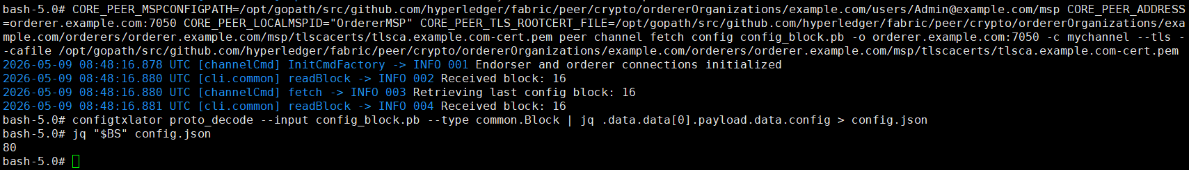

Step 9 (Run): Nodes run the clean procedure,
$ cd $HOME/fabric-samples/demo-first
$ ./clean.sh

Dynamic Adj on Single Peer (Exp 7: 1 CLI + 1 Peer + 1 Orderer)

7.1. Prepare the Hosts

Step 1 (Prepare): All machines prepare the host names,
$ vi /etc/hosts

172.31.210.67 cli
172.31.210.70 peer0.org1.example.com
172.31.210.72 orderer.example.com

Step 2 (Prepare): CLI prepares the Test-Network files,
$ cd $HOME/fabric-samples
$ mkdir demo-first
$ cd $HOME/fabric-samples/demo-first
$ vi crypto-config.yaml
$ vi configtx.yaml

$ vi peer0-org1.yaml

$ vi orderer1.yaml

$ vi cli.yaml // (of peer0.org1)

$ vi $HOME/fabric-samples/chaincode/abstore/go/abstore.go // our proposed key-value chaincode
$ vi $HOME/fabric-samples/chaincode/abstore/go/go.mod

Step 2 (Prepare): All machines prepare the timestamp alignment,
$ date +%s // check the timestamp

$ sudo apt-get install ntpdate // align the timestamp
$ sudo ntpdate cn.pool.ntp.org
$ sudo hwclock –systohc

$ date +%s // check the timestamp again

Step 3 (Run): CLI runs the initial block generation,
$ cd $HOME/fabric-samples/demo-first
$ chmod +x *.sh
$ ./config.sh



$ cd $HOME/fabric-samples/demo-first/workload/tls
$ chmod +x *.sh

$ cd $HOME/fabric-samples/demo-first/workload
$ chmod +x *.sh
$ wget https://gitee.com/joe32065/fabric_2_2/releases/download/fabric-v2.2.0/node_modules.zip
$ unzip node_modules.zip

$ cd $HOME/fabric-samples/demo-first/scripts
$ chmod +x *.sh

Step 4 (Run): CLI scp the contents to all machines including peers and orderers,
$ cd $HOME/fabric-samples/demo-first
$ ./scp.sh



Step 5 (Run): Orderer1 sets up the Docker container,
$ cd $HOME/fabric-samples/demo-first
$ ./orderer1.sh

$ docker ps

Step 6 (Run): Peer1 sets up the Docker container,
$ cd $HOME/fabric-samples/demo-first
$ ./peer1.sh

$ docker ps

Step 7 (Run): -,

Step 8 (Run): CLI sets up the Docker container,
$ cd $HOME/fabric-samples/demo-first
$ ./cli.sh

$ docker ps

7.2. Start the Network

Step 1 (Run): CLI connects to Peer0.org1.example.com:7051, creates a channel.block, and then all peers join the channel.block,
// CLI goes to `peer0.org1.example.com:7051`
$ docker exec -it cli bash

// Environment Configuration for `peer0.org1.example.com:7051`
# cd scripts
# ./step1.sh // All peers join the channel

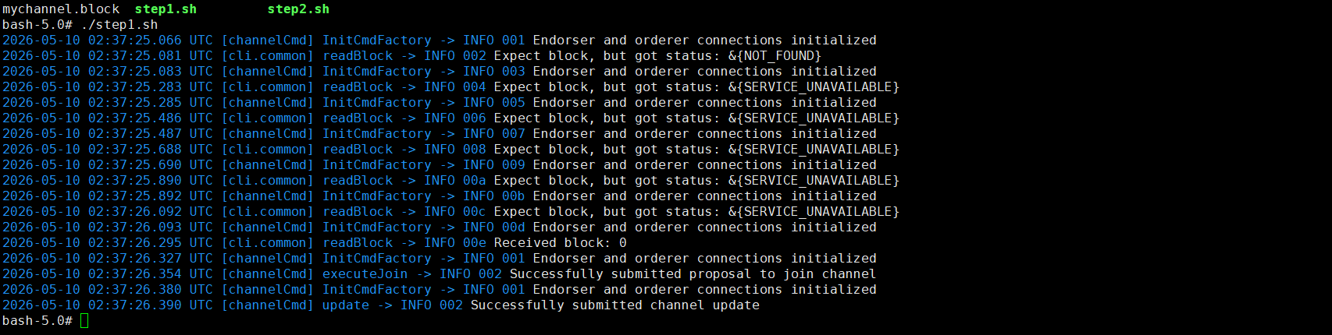

# ./step2.sh // All peers join the chaincode

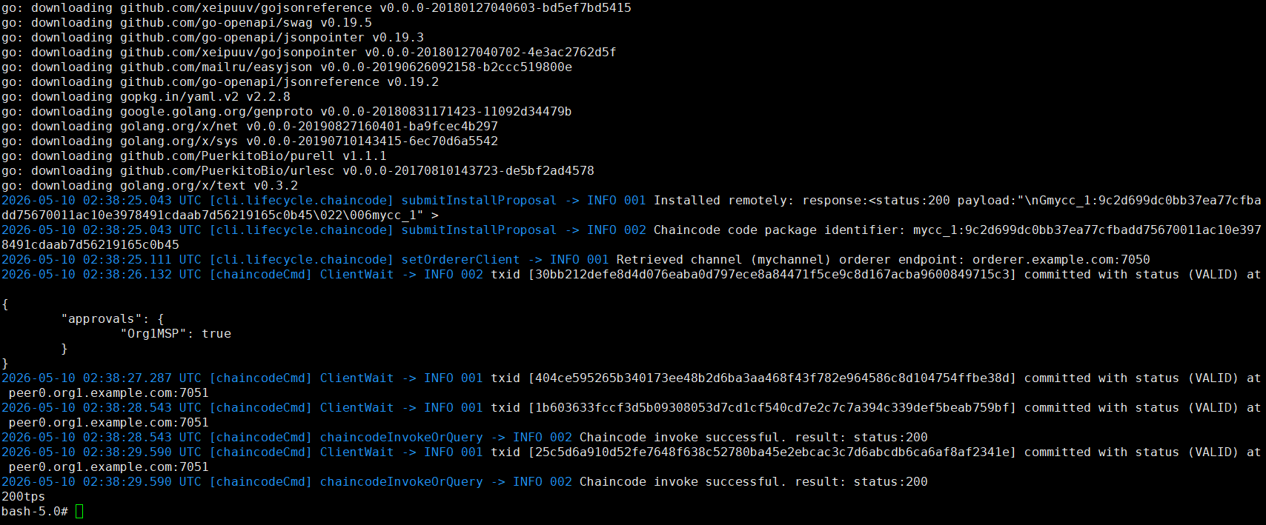

7.3. Start Nodejs SDK

Step 1 (Run): CLI configures the Node.js SDK folder and tls, wallet, and workload files for all peers,
# exit
$ mkdir -p $HOME/fabric-samples/demo-first/workload
$ mkdir -p $HOME/fabric-samples/demo-first/workload/tls
$ mkdir -p $HOME/fabric-samples/demo-first/workload/wallet
$ mkdir -p $HOME/fabric-samples/demo-first/workload/result

$ cd $HOME/fabric-samples/demo-first/workload/tls
$ vi read_pem.py
$ vi prepare_tls_peer0_org1.sh
$ vi prepare_tls_peer0_org2.sh
$ ./all.sh

$ cd $HOME/fabric-samples/demo-first/workload/wallet
$ vi prepare_wallet_user1_org1.py
$ vi prepare_wallet_user1_org2.py
$ ./all.sh

$ cd $HOME/fabric-samples/demo-first/workload
$ mkdir sdk-peer0-org1
$ mkdir sdk-peer0-org2
$ vi invoke.js
$ vi prepare_sdk_peer0_org1.sh
$ vi prepare_sdk_peer0_org2.sh
$ ./all.sh

Step 2 (Prepare): CLI prepares the Nodejs SDK dependencies on CLI. Note that you may pass this step by copying the compiled nodejs source code https://gitee.com/joe32065/fabric_2_2/releases/download/fabric-v2.2.0/node_modules.zip,
$ cd $HOME/fabric-samples/demo-first/workload
$ vi package.json
$ npm install
$ vi $HOME/fabric-samples/demo-first/workload/node_modules/fabric-network/lib/transaction.js

Step 3 (Run): Cli prepares wallets of User1@org1.example.com and User1@org2.example.com,
$ cd $HOME/fabric-samples/demo-first/workload/wallet
$ rm -rf *.id
$ python prepare_wallet_user1_org1.py
$ python prepare_wallet_user1_org2.py
$ ./all.sh

Step 4 (Run): CLI invokes and queries transactions via Node.js,
$ cd $HOME/fabric-samples/demo-first/workload
$ ./scp.sh // CLI copies files to all machines

$ ./ssh.sh > result/benchlog
$ ls result -l

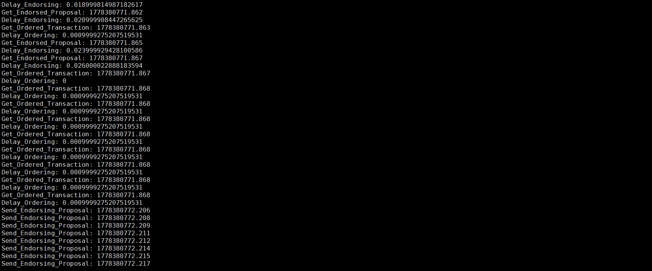

// $ node query.js
// $ node invoke.js 30 500 20 1

Step 5 (Run): Analyze the log,
// CLI analyzes the log
$ cd $HOME/fabric-samples/demo-first/workload/result
$ python readthroughput_p1.py // rate of sending endorsed txs

$ sudo apt-get install python-numpy
$ python readdelay_p1.py // delay of endorsing phase



// Orderer analyzes the log
$ cd $HOME/fabric-samples/demo-first/workload/result
$ sudo apt-get install python-numpy
//$ docker logs containername >& ordererlog
$ docker logs $(docker ps -a | grep 'orderer'| awk '{print $1 }') >& ordererlog
// $ scp ordererlog chwang@1xx.1xx.7xx.1xx:/home/chwang
$ python readthroughput_p2.py // rate of generating blocks

// Peer analyzes the log
$ cd $HOME/fabric-samples/demo-first/workload/result
$ sudo apt-get install python-numpy
//$ docker logs containername >& peerlog
$ docker logs $(docker ps -a | grep 'peer node start'| awk '{print $1 }') >& peerlog
// $ scp peerlog chwang@1xx.1xx.7xx.1xx:/home/chwang
$ python2 readthroughput_p3.py



// For example, we can get block size
# peer channel fetch 2 last.block -o orderer.example.com:7050 -c mychannel --tls --cafile /opt/gopath/src/github.com/hyperledger/fabric/peer/crypto/ordererOrganizations/example.com/orderers/orderer.example.com/msp/tlscacerts/tlsca.example.com-cert.pem

7.4. Dynamic Adjust Block Parameters on Single Peer

Step 1 (Run): Orderer fetches the latest block configuration, where orderer pulls the channel configuration in protobuf format and create a file named config_block.pb, as follows,
$ docker exec -it cli bash
# CORE_PEER_MSPCONFIGPATH=/opt/gopath/src/github.com/hyperledger/fabric/peer/crypto/ordererOrganizations/example.com/users/Admin@example.com/msp CORE_PEER_ADDRESS=orderer.example.com:7050 CORE_PEER_LOCALMSPID="OrdererMSP" CORE_PEER_TLS_ROOTCERT_FILE=/opt/gopath/src/github.com/hyperledger/fabric/peer/crypto/ordererOrganizations/example.com/orderers/orderer.example.com/msp/tlscacerts/tlsca.example.com-cert.pem peer channel fetch config config_block.pb -o orderer.example.com:7050 -c mychannel --tls --cafile /opt/gopath/src/github.com/hyperledger/fabric/peer/crypto/ordererOrganizations/example.com/orderers/orderer.example.com/msp/tlscacerts/tlsca.example.com-cert.pem

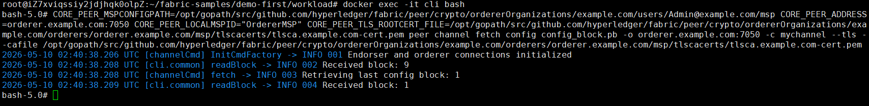

Step 2 (Run): We convert the configuration file named config_block.pb to JSON file named config.json, as follows,
# configtxlator proto_decode --input config_block.pb --type common.Block | jq .data.data[0].payload.data.config > config.json

We can check that the initial BatchSize is 60,

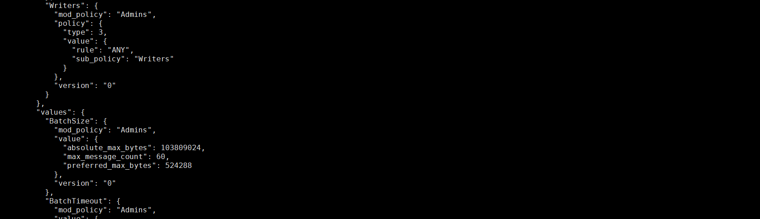

Step 3 (Run): We update the BatchSize value from 60 to 80, and save the modified json file as modified_config.json, as follows,
# BS=".channel_group.groups.Orderer.values.BatchSize.value.max_message_count"
# jq "$BS" config.json

# jq "$BS = 80" config.json > modified_config.json
# jq "$BS" modified_config.json

Step 4 (Run): We convert the initial config.json to config.pb and convert the modified_config.json to modified_config.pb, as follows,
# configtxlator proto_encode --input config.json --type common.Config --output config.pb
# configtxlator proto_encode --input modified_config.json --type common.Config --output modified_config.pb

Step 5 (Run): We calculate the difference between config.pb and modified_config.pb. The difference to be appended is named file_update.pb, as follows,
# configtxlator compute_update --channel_id mychannel --original config.pb --updated modified_config.pb --output final_update.pb

Step 6 (Run): We update the difference to the envelope, and append the changes to the config, as follows,
# configtxlator proto_decode --input final_update.pb --type common.ConfigUpdate | jq . > final_update.json
# echo "{\"payload\":{\"header\":{\"channel_header\":{\"channel_id\":\"mychannel\", \"type\":2}},\"data\":{\"config_update\":"$(cat final_update.json)"}}}" | jq . > header_in_envolope.json
# configtxlator proto_encode --input header_in_envolope.json --type common.Envelope --output final_update_in_envelope.pb



Step 7 (Run): All endorsing peers sign this update proto, as follows,
# CORE_PEER_MSPCONFIGPATH=/opt/gopath/src/github.com/hyperledger/fabric/peer/crypto/peerOrganizations/org1.example.com/users/Admin@org1.example.com/msp CORE_PEER_ADDRESS=peer0.org1.example.com:7051 CORE_PEER_LOCALMSPID="Org1MSP" CORE_PEER_TLS_ROOTCERT_FILE=/opt/gopath/src/github.com/hyperledger/fabric/peer/crypto/peerOrganizations/org1.example.com/peers/peer0.org1.example.com/tls/ca.crt peer channel signconfigtx -f final_update_in_envelope.pb

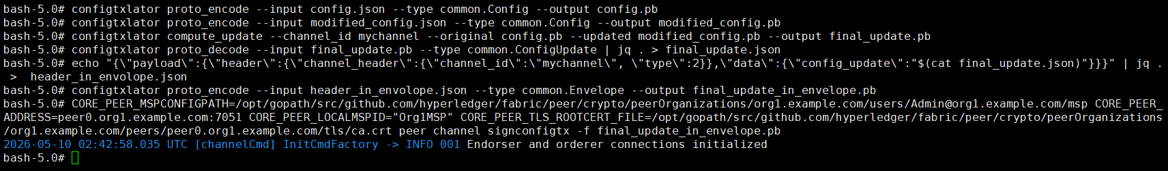

Step 7 (Run): Orderer update the channel as follows,
# CORE_PEER_MSPCONFIGPATH=/opt/gopath/src/github.com/hyperledger/fabric/peer/crypto/ordererOrganizations/example.com/users/Admin@example.com/msp CORE_PEER_ADDRESS=orderer.example.com:7050 CORE_PEER_LOCALMSPID="OrdererMSP" CORE_PEER_TLS_ROOTCERT_FILE=/opt/gopath/src/github.com/hyperledger/fabric/peer/crypto/ordererOrganizations/example.com/orderers/orderer.example.com/msp/tlscacerts/tlsca.example.com-cert.pem peer channel update -f final_update_in_envelope.pb -c mychannel -o orderer.example.com:7050 --tls --cafile /opt/gopath/src/github.com/hyperledger/fabric/peer/crypto/ordererOrganizations/example.com/orderers/orderer.example.com/msp/tlscacerts/tlsca.example.com-cert.pem

Step 8 (Validation): We can validate that the BatchSize is now from 60 to 80, as follows,
# CORE_PEER_MSPCONFIGPATH=/opt/gopath/src/github.com/hyperledger/fabric/peer/crypto/ordererOrganizations/example.com/users/Admin@example.com/msp CORE_PEER_ADDRESS=orderer.example.com:7050 CORE_PEER_LOCALMSPID="OrdererMSP" CORE_PEER_TLS_ROOTCERT_FILE=/opt/gopath/src/github.com/hyperledger/fabric/peer/crypto/ordererOrganizations/example.com/orderers/orderer.example.com/msp/tlscacerts/tlsca.example.com-cert.pem peer channel fetch config config_block.pb -o orderer.example.com:7050 -c mychannel --tls --cafile /opt/gopath/src/github.com/hyperledger/fabric/peer/crypto/ordererOrganizations/example.com/orderers/orderer.example.com/msp/tlscacerts/tlsca.example.com-cert.pem

# configtxlator proto_decode --input config_block.pb --type common.Block | jq .data.data[0].payload.data.config > config.json
# jq "$BS" config.json

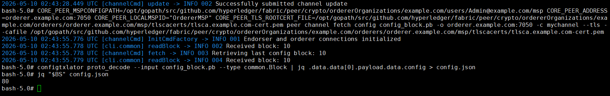

Step 9 (Run): Nodes run the clean procedure,
$ cd $HOME/fabric-samples/demo-first
$ ./clean.sh

Dynamic Adj on Multi Peers (Exp 8: 1 CLI + 2 Peers + 1 Orderer)

8.1. Prepare the Hosts

Step 1 (Prepare): All machines prepare the host names,
$ vi /etc/hosts

172.31.210.67 cli
172.31.210.70 peer0.org1.example.com
172.31.210.71 peer0.org2.example.com
172.31.210.72 orderer.example.com

Step 2 (Prepare): CLI prepares the Test-Network files,
$ cd $HOME/fabric-samples
$ mkdir demo-first
$ cd $HOME/fabric-samples/demo-first
$ vi crypto-config.yaml
$ vi configtx.yaml

$ vi peer0-org1.yaml
$ vi peer0-org2.yaml

$ vi orderer1.yaml

$ vi cli.yaml // (of peer0.org1)

$ vi $HOME/fabric-samples/chaincode/abstore/go/abstore.go // our proposed key-value chaincode
$ vi $HOME/fabric-samples/chaincode/abstore/go/go.mod

Step 2 (Prepare): All machines prepare the timestamp alignment,
$ date +%s // check the timestamp

$ sudo apt-get install ntpdate // align the timestamp
$ sudo ntpdate cn.pool.ntp.org
$ sudo hwclock –systohc

$ date +%s // check the timestamp again

Step 3 (Run): CLI runs the initial block generation,
$ cd $HOME/fabric-samples/demo-first
$ chmod +x *.sh
$ ./config.sh



$ cd $HOME/fabric-samples/demo-first/workload/tls
$ chmod +x *.sh

$ cd $HOME/fabric-samples/demo-first/workload
$ chmod +x *.sh
$ wget https://gitee.com/joe32065/fabric_2_2/releases/download/fabric-v2.2.0/node_modules.zip
$ unzip node_modules.zip

$ cd $HOME/fabric-samples/demo-first/scripts
$ chmod +x *.sh

Step 4 (Run): CLI scp the contents to all machines including peers and orderers,
$ cd $HOME/fabric-samples/demo-first
$ ./scp.sh



Step 5 (Run): Orderer1 sets up the Docker container,
$ cd $HOME/fabric-samples/demo-first
$ ./orderer1.sh

$ docker ps

Step 6 (Run): Peer1 sets up the Docker container,
$ cd $HOME/fabric-samples/demo-first
$ ./peer1.sh

$ docker ps

Step 7 (Run): Peer2 sets up the Docker container,
$ cd $HOME/fabric-samples/demo-first
$ ./peer2.sh

$ docker ps

Step 8 (Run): CLI sets up the Docker container,
$ cd $HOME/fabric-samples/demo-first
$ ./cli.sh

$ docker ps

8.2. Start the Network

Step 1 (Run): CLI connects to Peer0.org1.example.com:7051, creates a channel.block, and then all peers join the channel.block,
// CLI goes to `peer0.org1.example.com:7051`
$ docker exec -it cli bash

// Environment Configuration for `peer0.org1.example.com:7051`
# cd scripts
# ./step1.sh // All peers join the channel



# ./step2.sh // All peers join the chaincode



8.3. Start Nodejs SDK

Step 1 (Run): CLI configures the Node.js SDK folder and tls, wallet, and workload files for all peers,
# exit
$ mkdir -p $HOME/fabric-samples/demo-first/workload
$ mkdir -p $HOME/fabric-samples/demo-first/workload/tls
$ mkdir -p $HOME/fabric-samples/demo-first/workload/wallet
$ mkdir -p $HOME/fabric-samples/demo-first/workload/result

$ cd $HOME/fabric-samples/demo-first/workload/tls
$ vi read_pem.py
$ vi prepare_tls_peer0_org1.sh
$ vi prepare_tls_peer0_org2.sh
$ ./all.sh

$ cd $HOME/fabric-samples/demo-first/workload/wallet
$ vi prepare_wallet_user1_org1.py
$ vi prepare_wallet_user1_org2.py
$ ./all.sh

$ cd $HOME/fabric-samples/demo-first/workload
$ mkdir sdk-peer0-org1
$ mkdir sdk-peer0-org2
$ vi invoke.js
$ vi prepare_sdk_peer0_org1.sh
$ vi prepare_sdk_peer0_org2.sh
$ ./all.sh

Step 2 (Prepare): CLI prepares the Nodejs SDK dependencies on CLI. Note that you may pass this step by copying the compiled nodejs source code https://gitee.com/joe32065/fabric_2_2/releases/download/fabric-v2.2.0/node_modules.zip,
$ cd $HOME/fabric-samples/demo-first/workload
$ vi package.json
$ npm install
$ vi $HOME/fabric-samples/demo-first/workload/node_modules/fabric-network/lib/transaction.js

Step 3 (Run): Cli prepares wallets of User1@org1.example.com and User1@org2.example.com,
$ cd $HOME/fabric-samples/demo-first/workload/wallet
$ rm -rf *.id
$ python prepare_wallet_user1_org1.py
$ python prepare_wallet_user1_org2.py
$ ./all.sh

Step 4 (Run): CLI invokes and queries transactions via Node.js,
$ cd $HOME/fabric-samples/demo-first/workload
$ ./scp.sh // CLI copies files to all machines

$ ./ssh.sh > result/benchlog
$ ls result -l



// $ node query.js
// $ node invoke.js 30 500 20 1

Step 5 (Run): Analyze the log,
// CLI analyzes the log
$ cd $HOME/fabric-samples/demo-first/workload/result
$ python readthroughput_p1.py // rate of sending endorsed txs

$ sudo apt-get install python-numpy
$ python readdelay_p1.py // delay of endorsing phase



// Orderer analyzes the log
$ cd $HOME/fabric-samples/demo-first/workload/result
$ sudo apt-get install python-numpy
//$ docker logs containername >& ordererlog
$ docker logs $(docker ps -a | grep 'orderer'| awk '{print $1 }') >& ordererlog
// $ scp ordererlog chwang@1xx.1xx.7xx.1xx:/home/chwang
$ python readthroughput_p2.py // rate of generating blocks



// Peer analyzes the log
$ cd $HOME/fabric-samples/demo-first/workload/result
$ sudo apt-get install python-numpy
//$ docker logs containername >& peerlog
$ docker logs $(docker ps -a | grep 'peer node start'| awk '{print $1 }') >& peerlog
// $ scp peerlog chwang@1xx.1xx.7xx.1xx:/home/chwang
$ python2 readthroughput_p3.py



// For example, we can get block size
# peer channel fetch 2 last.block -o orderer.example.com:7050 -c mychannel --tls --cafile /opt/gopath/src/github.com/hyperledger/fabric/peer/crypto/ordererOrganizations/example.com/orderers/orderer.example.com/msp/tlscacerts/tlsca.example.com-cert.pem

8.4. Dynamic Adjust Block Parameters on Multiple Peers

Step 1 (Run): Orderer fetches the latest block configuration, where orderer pulls the channel configuration in protobuf format and create a file named config_block.pb, as follows,
$ docker exec -it cli bash
# CORE_PEER_MSPCONFIGPATH=/opt/gopath/src/github.com/hyperledger/fabric/peer/crypto/ordererOrganizations/example.com/users/Admin@example.com/msp CORE_PEER_ADDRESS=orderer.example.com:7050 CORE_PEER_LOCALMSPID="OrdererMSP" CORE_PEER_TLS_ROOTCERT_FILE=/opt/gopath/src/github.com/hyperledger/fabric/peer/crypto/ordererOrganizations/example.com/orderers/orderer.example.com/msp/tlscacerts/tlsca.example.com-cert.pem peer channel fetch config config_block.pb -o orderer.example.com:7050 -c mychannel --tls --cafile /opt/gopath/src/github.com/hyperledger/fabric/peer/crypto/ordererOrganizations/example.com/orderers/orderer.example.com/msp/tlscacerts/tlsca.example.com-cert.pem



Step 2 (Run): We convert the configuration file named config_block.pb to JSON file named config.json, as follows,
# configtxlator proto_decode --input config_block.pb --type common.Block | jq .data.data[0].payload.data.config > config.json

We can check that the initial BatchSize is 60,



Step 3 (Run): We update the BatchSize value from 60 to 80, and save the modified json file as modified_config.json, as follows,
# BS=".channel_group.groups.Orderer.values.BatchSize.value.max_message_count"
# jq "$BS" config.json

# jq "$BS = 80" config.json > modified_config.json
# jq "$BS" modified_config.json

Step 4 (Run): We convert the initial config.json to config.pb and convert the modified_config.json to modified_config.pb, as follows,
# configtxlator proto_encode --input config.json --type common.Config --output config.pb
# configtxlator proto_encode --input modified_config.json --type common.Config --output modified_config.pb

Step 5 (Run): We calculate the difference between config.pb and modified_config.pb. The difference to be appended is named file_update.pb, as follows,
# configtxlator compute_update --channel_id mychannel --original config.pb --updated modified_config.pb --output final_update.pb

Step 6 (Run): We update the difference to the envelope, and append the changes to the config, as follows,
# configtxlator proto_decode --input final_update.pb --type common.ConfigUpdate | jq . > final_update.json
# echo "{\"payload\":{\"header\":{\"channel_header\":{\"channel_id\":\"mychannel\", \"type\":2}},\"data\":{\"config_update\":"$(cat final_update.json)"}}}" | jq . > header_in_envolope.json
# configtxlator proto_encode --input header_in_envolope.json --type common.Envelope --output final_update_in_envelope.pb



Step 7 (Run): All endorsing peers sign this update proto, as follows,
# CORE_PEER_MSPCONFIGPATH=/opt/gopath/src/github.com/hyperledger/fabric/peer/crypto/peerOrganizations/org1.example.com/users/Admin@org1.example.com/msp CORE_PEER_ADDRESS=peer0.org1.example.com:7051 CORE_PEER_LOCALMSPID="Org1MSP" CORE_PEER_TLS_ROOTCERT_FILE=/opt/gopath/src/github.com/hyperledger/fabric/peer/crypto/peerOrganizations/org1.example.com/peers/peer0.org1.example.com/tls/ca.crt peer channel signconfigtx -f final_update_in_envelope.pb

# CORE_PEER_MSPCONFIGPATH=/opt/gopath/src/github.com/hyperledger/fabric/peer/crypto/peerOrganizations/org2.example.com/users/Admin@org2.example.com/msp CORE_PEER_ADDRESS=peer0.org2.example.com:8051 CORE_PEER_LOCALMSPID="Org2MSP" CORE_PEER_TLS_ROOTCERT_FILE=/opt/gopath/src/github.com/hyperledger/fabric/peer/crypto/peerOrganizations/org2.example.com/peers/peer0.org2.example.com/tls/ca.crt peer channel signconfigtx -f final_update_in_envelope.pb



Step 7 (Run): Orderer update the channel as follows,
# CORE_PEER_MSPCONFIGPATH=/opt/gopath/src/github.com/hyperledger/fabric/peer/crypto/ordererOrganizations/example.com/users/Admin@example.com/msp CORE_PEER_ADDRESS=orderer.example.com:7050 CORE_PEER_LOCALMSPID="OrdererMSP" CORE_PEER_TLS_ROOTCERT_FILE=/opt/gopath/src/github.com/hyperledger/fabric/peer/crypto/ordererOrganizations/example.com/orderers/orderer.example.com/msp/tlscacerts/tlsca.example.com-cert.pem peer channel update -f final_update_in_envelope.pb -c mychannel -o orderer.example.com:7050 --tls --cafile /opt/gopath/src/github.com/hyperledger/fabric/peer/crypto/ordererOrganizations/example.com/orderers/orderer.example.com/msp/tlscacerts/tlsca.example.com-cert.pem

Step 8 (Validation): We can validate that the BatchSize is now from 60 to 80, as follows,
# CORE_PEER_MSPCONFIGPATH=/opt/gopath/src/github.com/hyperledger/fabric/peer/crypto/ordererOrganizations/example.com/users/Admin@example.com/msp CORE_PEER_ADDRESS=orderer.example.com:7050 CORE_PEER_LOCALMSPID="OrdererMSP" CORE_PEER_TLS_ROOTCERT_FILE=/opt/gopath/src/github.com/hyperledger/fabric/peer/crypto/ordererOrganizations/example.com/orderers/orderer.example.com/msp/tlscacerts/tlsca.example.com-cert.pem peer channel fetch config config_block.pb -o orderer.example.com:7050 -c mychannel --tls --cafile /opt/gopath/src/github.com/hyperledger/fabric/peer/crypto/ordererOrganizations/example.com/orderers/orderer.example.com/msp/tlscacerts/tlsca.example.com-cert.pem

# configtxlator proto_decode --input config_block.pb --type common.Block | jq .data.data[0].payload.data.config > config.json
# jq "$BS" config.json



Step 9 (Run): Nodes run the clean procedure,
$ cd $HOME/fabric-samples/demo-first
$ ./clean.sh

Different Transaction Payoff Sizes (Exp 9: 1 CLI + 2 Peers + 1 Orderer)

9.1. Prepare the Hosts

Step 1 (Prepare): All machines prepare the host names,
$ vi /etc/hosts

172.31.210.67 cli
172.31.210.70 peer0.org1.example.com
172.31.210.71 peer0.org2.example.com
172.31.210.72 orderer.example.com

Step 2 (Prepare): CLI prepares the Test-Network files,
$ cd $HOME/fabric-samples
$ mkdir demo-first
$ cd $HOME/fabric-samples/demo-first
$ vi crypto-config.yaml
$ vi configtx.yaml

$ vi peer0-org1.yaml
$ vi peer0-org2.yaml

$ vi orderer1.yaml

$ vi cli.yaml // (of peer0.org1)

$ vi $HOME/fabric-samples/chaincode/abstore/go/abstore.go // our proposed key-value chaincode
$ vi $HOME/fabric-samples/chaincode/abstore/go/go.mod

Step 2 (Prepare): All machines prepare the timestamp alignment,
$ date +%s // check the timestamp

$ sudo apt-get install ntpdate // align the timestamp
$ sudo ntpdate cn.pool.ntp.org
$ sudo hwclock –systohc

$ date +%s // check the timestamp again

Step 3 (Run): CLI runs the initial block generation,
$ cd $HOME/fabric-samples/demo-first
$ chmod +x *.sh
$ ./config.sh



$ cd $HOME/fabric-samples/demo-first/workload/tls
$ chmod +x *.sh

$ cd $HOME/fabric-samples/demo-first/workload
$ chmod +x *.sh
$ wget https://gitee.com/joe32065/fabric_2_2/releases/download/fabric-v2.2.0/node_modules.zip
$ unzip node_modules.zip

$ cd $HOME/fabric-samples/demo-first/scripts
$ chmod +x *.sh

Step 4 (Run): CLI scp the contents to all machines including peers and orderers,
$ cd $HOME/fabric-samples/demo-first
$ ./scp.sh



Step 5 (Run): Orderer1 sets up the Docker container,
$ cd $HOME/fabric-samples/demo-first
$ ./orderer1.sh

$ docker ps

Step 6 (Run): Peer1 sets up the Docker container,
$ cd $HOME/fabric-samples/demo-first
$ ./peer1.sh

$ docker ps

Step 7 (Run): Peer2 sets up the Docker container,
$ cd $HOME/fabric-samples/demo-first
$ ./peer2.sh

$ docker ps

Step 8 (Run): CLI sets up the Docker container,
$ cd $HOME/fabric-samples/demo-first
$ ./cli.sh

$ docker ps

9.2. Start the Network

Step 1 (Run): CLI connects to Peer0.org1.example.com:7051, creates a channel.block, and then all peers join the channel.block,
// CLI goes to `peer0.org1.example.com:7051`
$ docker exec -it cli bash

// Environment Configuration for `peer0.org1.example.com:7051`
# cd scripts
# ./step1.sh // All peers join the channel



# ./step2.sh // All peers join the chaincode



9.3. Start Nodejs SDK

Step 1 (Run): CLI configures the Node.js SDK folder and tls, wallet, and workload files for all peers,
# exit
$ mkdir -p $HOME/fabric-samples/demo-first/workload
$ mkdir -p $HOME/fabric-samples/demo-first/workload/tls
$ mkdir -p $HOME/fabric-samples/demo-first/workload/wallet
$ mkdir -p $HOME/fabric-samples/demo-first/workload/result

$ cd $HOME/fabric-samples/demo-first/workload/tls
$ vi read_pem.py
$ vi prepare_tls_peer0_org1.sh
$ vi prepare_tls_peer0_org2.sh
$ ./all.sh

$ cd $HOME/fabric-samples/demo-first/workload/wallet
$ vi prepare_wallet_user1_org1.py
$ vi prepare_wallet_user1_org2.py
$ ./all.sh

$ cd $HOME/fabric-samples/demo-first/workload
$ mkdir sdk-peer0-org1
$ mkdir sdk-peer0-org2
$ vi invoke.js
$ vi prepare_sdk_peer0_org1.sh
$ vi prepare_sdk_peer0_org2.sh
$ ./all.sh

Step 2 (Prepare): CLI prepares the Nodejs SDK dependencies on CLI. Note that you may pass this step by copying the compiled nodejs source code https://gitee.com/joe32065/fabric_2_2/releases/download/fabric-v2.2.0/node_modules.zip,
$ cd $HOME/fabric-samples/demo-first/workload
$ vi package.json
$ npm install
$ vi $HOME/fabric-samples/demo-first/workload/node_modules/fabric-network/lib/transaction.js

Step 3 (Run): Cli prepares wallets of User1@org1.example.com and User1@org2.example.com,
$ cd $HOME/fabric-samples/demo-first/workload/wallet
$ rm -rf *.id
$ python prepare_wallet_user1_org1.py
$ python prepare_wallet_user1_org2.py
$ ./all.sh

Step 4 (Run): CLI invokes and queries transactions via Node.js,
$ cd $HOME/fabric-samples/demo-first/workload
$ ./scp.sh // CLI copies files to all machines

$ ./ssh.sh > result/benchlog
$ ls result -l



// $ node query.js
// $ node invoke.js 30 500 20 1

Step 5 (Run): Analyze the log,
// CLI analyzes the log
$ cd $HOME/fabric-samples/demo-first/workload/result
$ python readthroughput_p1.py // rate of sending endorsed txs

$ sudo apt-get install python-numpy
$ python readdelay_p1.py // delay of endorsing phase



// Orderer analyzes the log
$ cd $HOME/fabric-samples/demo-first/workload/result
$ sudo apt-get install python-numpy
//$ docker logs containername >& ordererlog
$ docker logs $(docker ps -a | grep 'orderer'| awk '{print $1 }') >& ordererlog
// $ scp ordererlog chwang@1xx.1xx.7xx.1xx:/home/chwang
$ python readthroughput_p2.py // rate of generating blocks



// Peer analyzes the log
$ cd $HOME/fabric-samples/demo-first/workload/result
$ sudo apt-get install python-numpy
//$ docker logs containername >& peerlog
$ docker logs $(docker ps -a | grep 'peer node start'| awk '{print $1 }') >& peerlog
// $ scp peerlog chwang@1xx.1xx.7xx.1xx:/home/chwang
$ python2 readthroughput_p3.py



// For example, we can get block size
# peer channel fetch 2 last.block -o orderer.example.com:7050 -c mychannel --tls --cafile /opt/gopath/src/github.com/hyperledger/fabric/peer/crypto/ordererOrganizations/example.com/orderers/orderer.example.com/msp/tlscacerts/tlsca.example.com-cert.pem

9.4. Different Transaction Payoff Sizes

Step 1 (Run): CLI invokes and queries transactions via Node.js,
$ cd $HOME/fabric-samples/demo-first/workload

$ ./ssh.sh > result/benchlog // Transaction payoff size: 1 byte
$ ls result -l

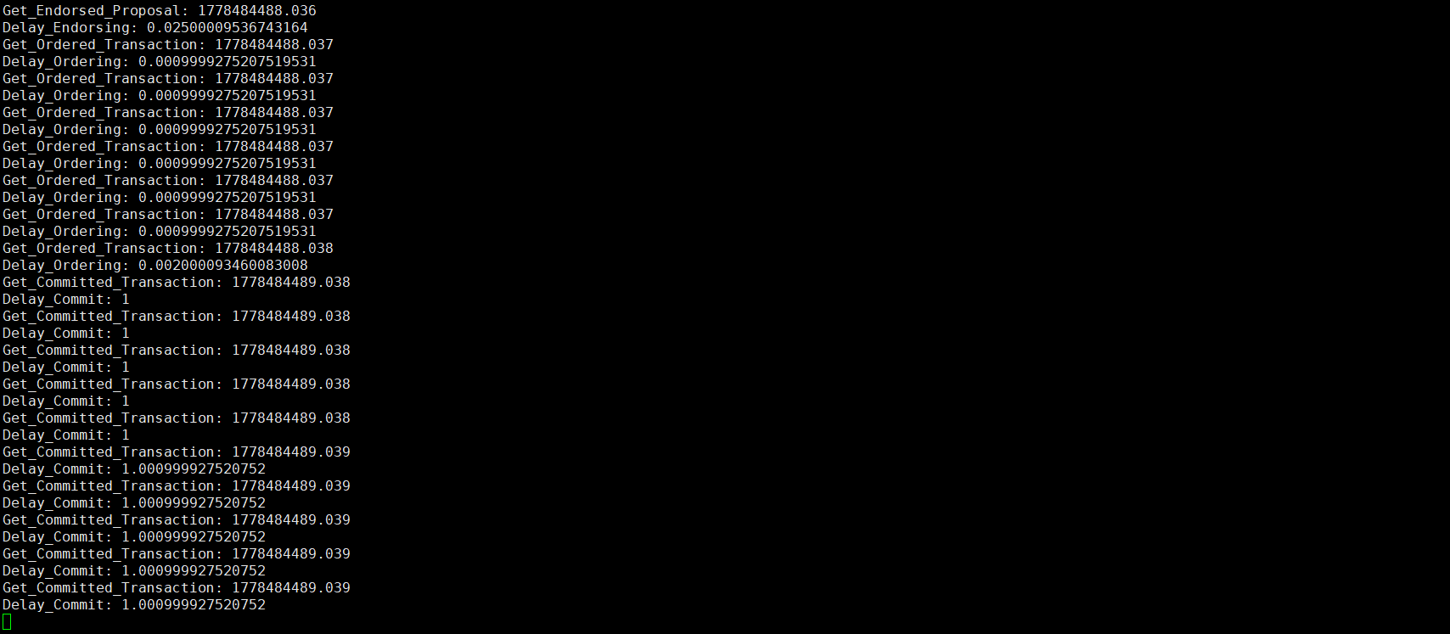

Step 2 (Run): CLI invokes and queries transactions via Node.js,
$ cd $HOME/fabric-samples/demo-first/workload

$ ./ssh.sh > result/benchlog // Transaction payoff size: 10 byte
$ ls result -l

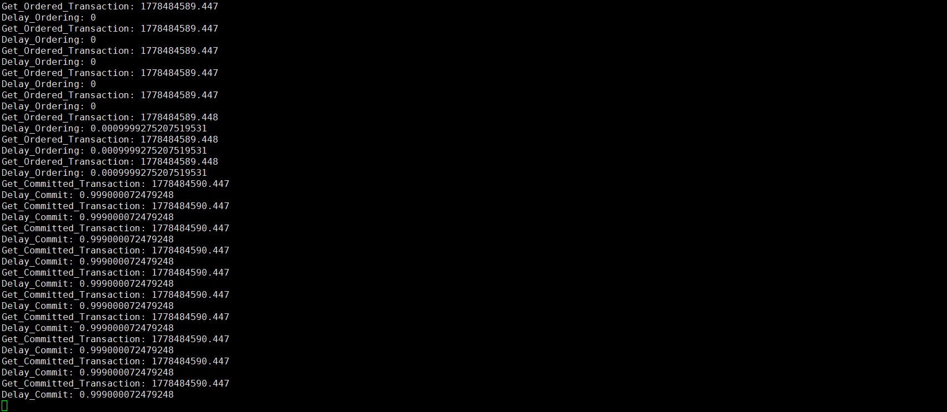

Step 3 (Run): CLI invokes and queries transactions via Node.js,
$ cd $HOME/fabric-samples/demo-first/workload

$ ./ssh.sh > result/benchlog // Transaction payoff size: 100 byte
$ ls result -l

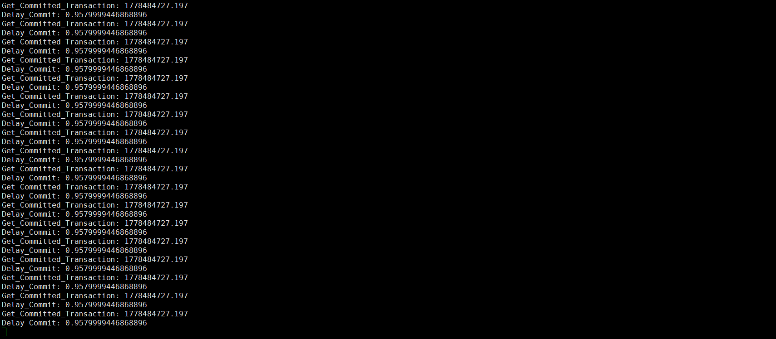

Different Chaincodes (Exp 10: 1 CLI + 2 Peers + 1 Orderer)

10.1. Prepare the Hosts

Step 1 (Prepare): All machines prepare the host names,
$ vi /etc/hosts

172.31.210.67 cli
172.31.210.70 peer0.org1.example.com
172.31.210.71 peer0.org2.example.com
172.31.210.72 orderer.example.com

Step 2 (Prepare): CLI prepares the Test-Network files,
$ cd $HOME/fabric-samples
$ mkdir demo-first
$ cd $HOME/fabric-samples/demo-first
$ vi crypto-config.yaml
$ vi configtx.yaml

$ vi peer0-org1.yaml
$ vi peer0-org2.yaml

$ vi orderer1.yaml

$ vi cli.yaml // (of peer0.org1)

$ vi $HOME/fabric-samples/chaincode/abstore/go/abstore.go // our proposed key-value chaincode
$ vi $HOME/fabric-samples/chaincode/abstore/go/go.mod

Step 2 (Prepare): All machines prepare the timestamp alignment,
$ date +%s // check the timestamp

$ sudo apt-get install ntpdate // align the timestamp
$ sudo ntpdate cn.pool.ntp.org
$ sudo hwclock –systohc

$ date +%s // check the timestamp again

Step 3 (Run): CLI runs the initial block generation,
$ cd $HOME/fabric-samples/demo-first
$ chmod +x *.sh
$ ./config.sh



$ cd $HOME/fabric-samples/demo-first/workload/tls
$ chmod +x *.sh

$ cd $HOME/fabric-samples/demo-first/workload
$ chmod +x *.sh
$ wget https://gitee.com/joe32065/fabric_2_2/releases/download/fabric-v2.2.0/node_modules.zip
$ unzip node_modules.zip

$ cd $HOME/fabric-samples/demo-first/scripts
$ chmod +x *.sh

Step 4 (Run): CLI scp the contents to all machines including peers and orderers,
$ cd $HOME/fabric-samples/demo-first
$ ./scp.sh



Step 5 (Run): Orderer1 sets up the Docker container,
$ cd $HOME/fabric-samples/demo-first
$ ./orderer1.sh

$ docker ps

Step 6 (Run): Peer1 sets up the Docker container,
$ cd $HOME/fabric-samples/demo-first
$ ./peer1.sh

$ docker ps

Step 7 (Run): Peer2 sets up the Docker container,
$ cd $HOME/fabric-samples/demo-first
$ ./peer2.sh

$ docker ps

Step 8 (Run): CLI sets up the Docker container,
$ cd $HOME/fabric-samples/demo-first
$ ./cli.sh

$ docker ps

10.2. Start the Network

Step 1 (Run): CLI connects to Peer0.org1.example.com:7051, creates a channel.block, and then all peers join the channel.block,
// CLI goes to `peer0.org1.example.com:7051`
$ docker exec -it cli bash

// Environment Configuration for `peer0.org1.example.com:7051`
# cd scripts
# ./step1.sh // All peers join the channel



# ./step2.sh // All peers join the chaincode



10.3. Start Nodejs SDK

Step 1 (Run): CLI configures the Node.js SDK folder and tls, wallet, and workload files for all peers,
# exit
$ mkdir -p $HOME/fabric-samples/demo-first/workload
$ mkdir -p $HOME/fabric-samples/demo-first/workload/tls
$ mkdir -p $HOME/fabric-samples/demo-first/workload/wallet
$ mkdir -p $HOME/fabric-samples/demo-first/workload/result

$ cd $HOME/fabric-samples/demo-first/workload/tls
$ vi read_pem.py
$ vi prepare_tls_peer0_org1.sh
$ vi prepare_tls_peer0_org2.sh
$ ./all.sh

$ cd $HOME/fabric-samples/demo-first/workload/wallet
$ vi prepare_wallet_user1_org1.py
$ vi prepare_wallet_user1_org2.py
$ ./all.sh

$ cd $HOME/fabric-samples/demo-first/workload
$ mkdir sdk-peer0-org1
$ mkdir sdk-peer0-org2
$ vi invoke.js
$ vi prepare_sdk_peer0_org1.sh
$ vi prepare_sdk_peer0_org2.sh
$ ./all.sh

Step 2 (Prepare): CLI prepares the Nodejs SDK dependencies on CLI. Note that you may pass this step by copying the compiled nodejs source code https://gitee.com/joe32065/fabric_2_2/releases/download/fabric-v2.2.0/node_modules.zip,
$ cd $HOME/fabric-samples/demo-first/workload
$ vi package.json
$ npm install
$ vi $HOME/fabric-samples/demo-first/workload/node_modules/fabric-network/lib/transaction.js

Step 3 (Run): Cli prepares wallets of User1@org1.example.com and User1@org2.example.com,
$ cd $HOME/fabric-samples/demo-first/workload/wallet
$ rm -rf *.id
$ python prepare_wallet_user1_org1.py
$ python prepare_wallet_user1_org2.py
$ ./all.sh

Step 4 (Run): CLI invokes and queries transactions via Node.js,
$ cd $HOME/fabric-samples/demo-first/workload
$ ./scp.sh // CLI copies files to all machines

$ ./ssh.sh > result/benchlog
$ ls result -l



// $ node query.js
// $ node invoke.js 30 500 20 1

Step 5 (Run): Analyze the log,
// CLI analyzes the log
$ cd $HOME/fabric-samples/demo-first/workload/result
$ python readthroughput_p1.py // rate of sending endorsed txs

$ sudo apt-get install python-numpy
$ python readdelay_p1.py // delay of endorsing phase



// Orderer analyzes the log
$ cd $HOME/fabric-samples/demo-first/workload/result
$ sudo apt-get install python-numpy
//$ docker logs containername >& ordererlog
$ docker logs $(docker ps -a | grep 'orderer'| awk '{print $1 }') >& ordererlog
// $ scp ordererlog chwang@1xx.1xx.7xx.1xx:/home/chwang
$ python readthroughput_p2.py // rate of generating blocks



// Peer analyzes the log
$ cd $HOME/fabric-samples/demo-first/workload/result
$ sudo apt-get install python-numpy
//$ docker logs containername >& peerlog
$ docker logs $(docker ps -a | grep 'peer node start'| awk '{print $1 }') >& peerlog
// $ scp peerlog chwang@1xx.1xx.7xx.1xx:/home/chwang
$ python2 readthroughput_p3.py



// For example, we can get block size
# peer channel fetch 2 last.block -o orderer.example.com:7050 -c mychannel --tls --cafile /opt/gopath/src/github.com/hyperledger/fabric/peer/crypto/ordererOrganizations/example.com/orderers/orderer.example.com/msp/tlscacerts/tlsca.example.com-cert.pem

10.4. Different Chaincodes

Step 1 (Run): CLI uses a different chaincode as follows,
$ cd $HOME/fabric-samples/chaincode/abstore/go
$ vi abstore.go
$ ls

Step 2 (Run): CLI compiles the chaincode in Go, and ensures that the chaincode in Go has no grammar errors, as follows,
$ go mod vendor
$ go build

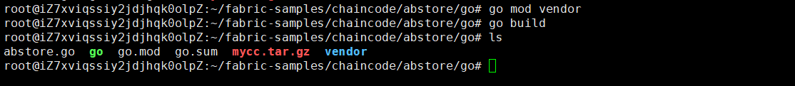

Step 3 (Run): CLI modifies the step2.sh, and ensures that the new chaincode can be initialized, as follows,
$ cd $HOME/fabric-samples/demo-first/scripts
$ vi step2.sh

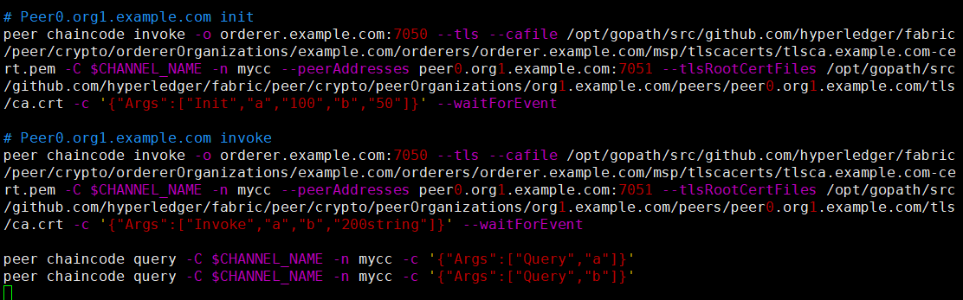

Step 4 (Run): CLI modifies all peers’ workload generator, as follows,
$ cd $HOME/fabric-samples/demo-first/workload
$ vi prepare_sdk_peer0_org1.sh

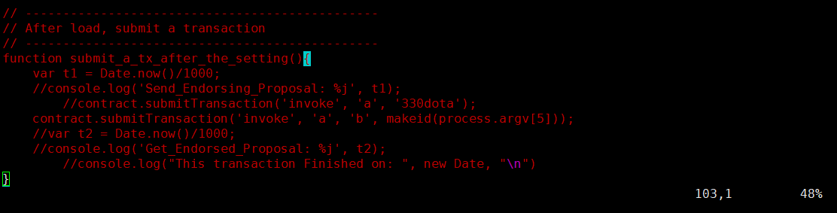

$ vi prepare_sdk_peer0_org2.sh

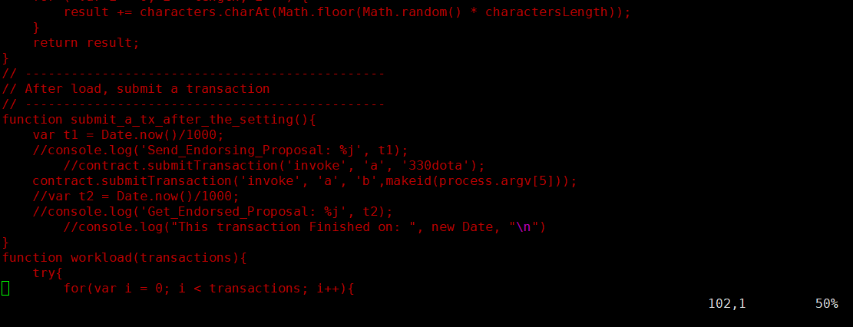

Step 5 (Run): CLI runs the initial block generation,
$ cd $HOME/fabric-samples/demo-first
$ chmod +x *.sh
$ ./config.sh

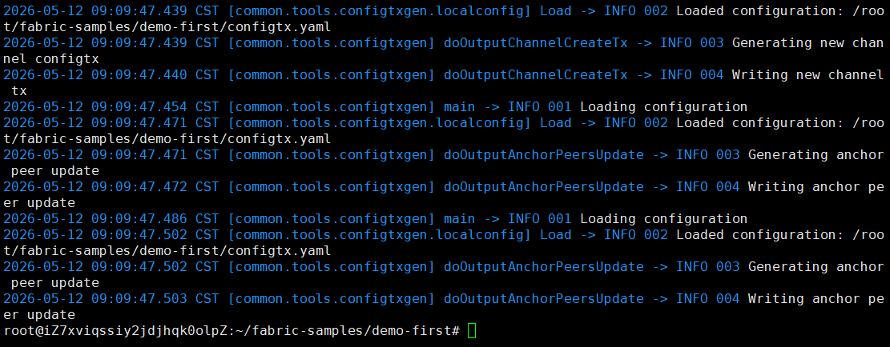

Step 6 (Run): CLI scp the contents to all machines including peers and orderers,
$ cd $HOME/fabric-samples/demo-first
$ ./scp.sh

Step 7 (Run): Set up all components as follows,
$ cd $HOME/fabric-samples/demo-first
$ ./orderer1.sh

$ cd $HOME/fabric-samples/demo-first
$ ./peer1.sh

$ cd $HOME/fabric-samples/demo-first
$ ./peer2.sh

$ cd $HOME/fabric-samples/demo-first
$ ./cli.sh

Step 8 (Run): CLI connects to Peer0.org1.example.com:7051, creates a channel.block, and then all peers join the channel.block,
// CLI goes to `peer0.org1.example.com:7051`
$ docker exec -it cli bash

// Environment Configuration for `peer0.org1.example.com:7051`
# cd scripts
# ./step1.sh // All peers join the channel

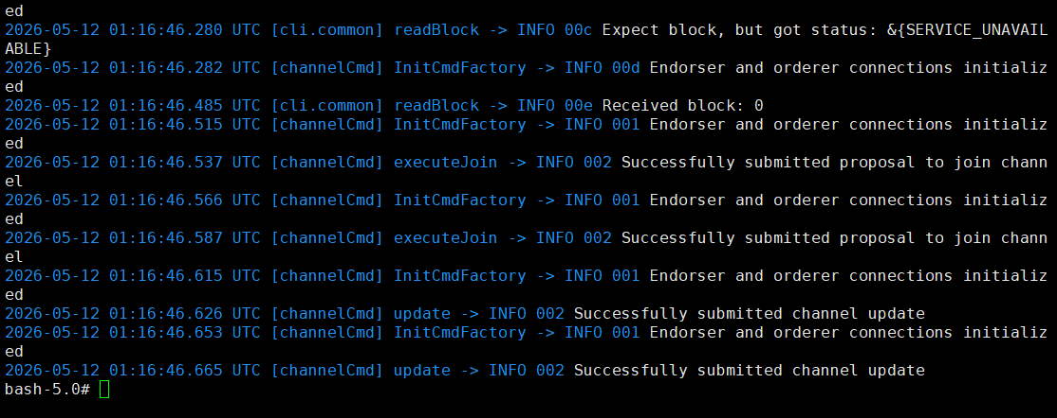

# ./step2.sh // All peers join the chaincode

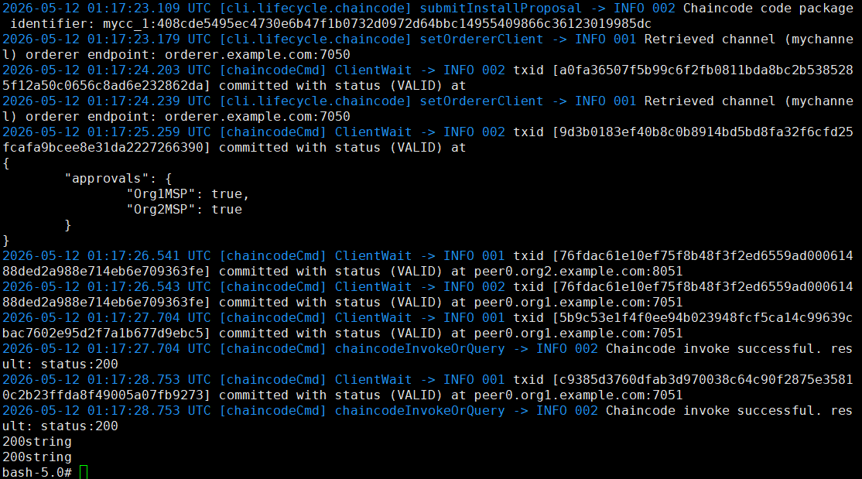

Step 9 (Run): CLI configures the Node.js SDK folder and tls, wallet, and workload files for all peers,
# exit

$ cd $HOME/fabric-samples/demo-first/workload/tls
$ ./all.sh

$ cd $HOME/fabric-samples/demo-first/workload/wallet
$ ./all.sh

$ cd $HOME/fabric-samples/demo-first/workload
$ ./all.sh

Step 10 (Run): CLI invokes and queries transactions via Node.js,
$ cd $HOME/fabric-samples/demo-first/workload
$ ./scp.sh // CLI copies files to all machines

$ ./ssh.sh > result/benchlog
$ ls result -l

