Prepare Multiple Nodes on Alibaba Cloud

1.1. Purchase Single Node on Alibaba Cloud
Step 1: Click https://homenew.console.aliyun.com/home/dashboard/ProductAndService, choose the ECS service,
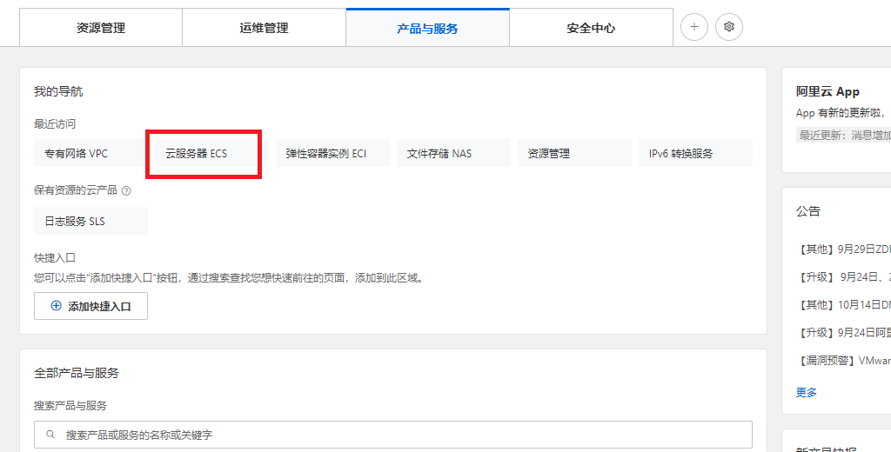
Step 2: Create a new instance, choose pay as you go, choose ecs.c7.2xlarge, choose Ubuntu 16.04 64 bits, choose ESSD, choose no IPv4 address, choose your password Y0urpassword,
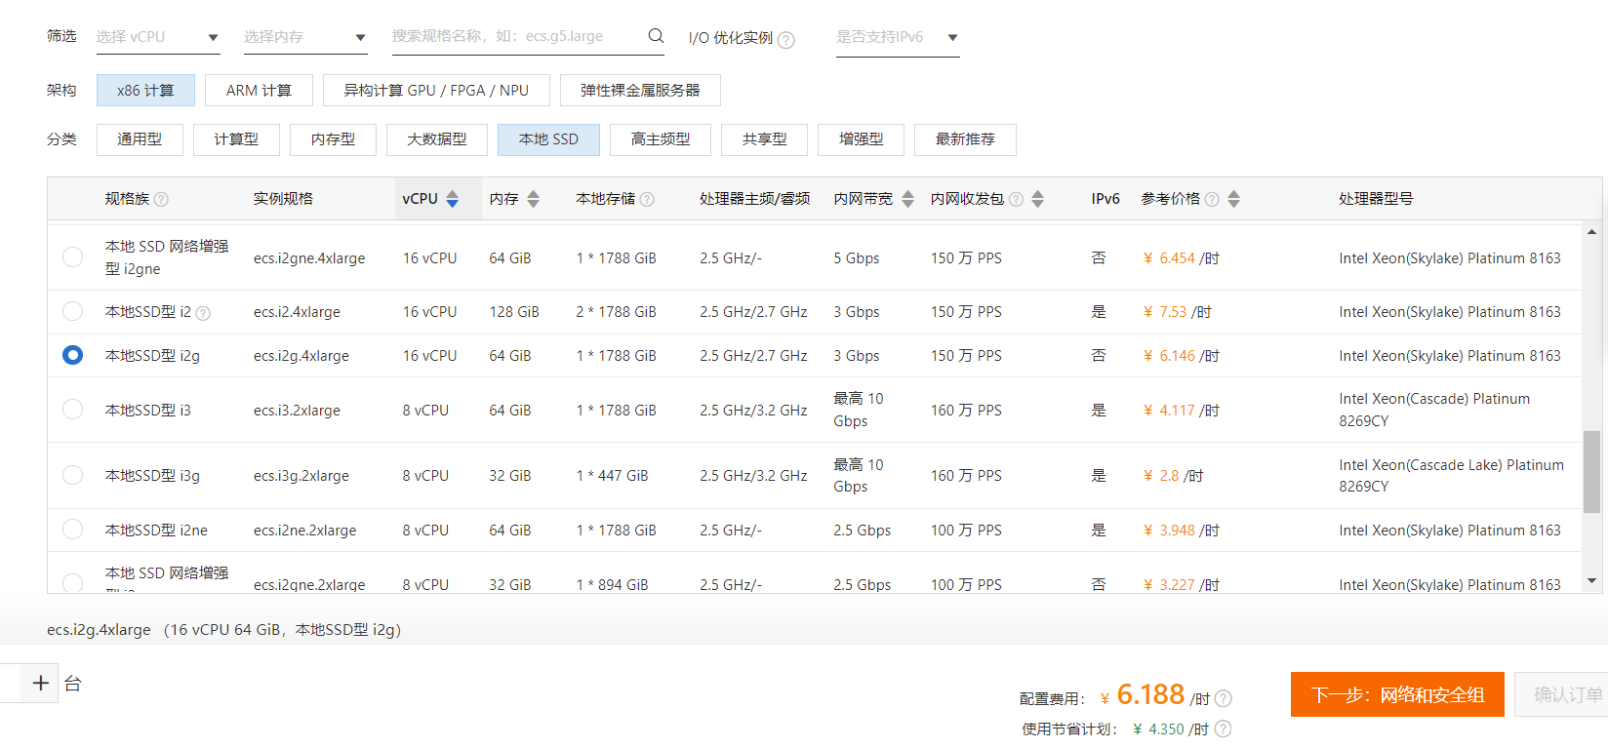
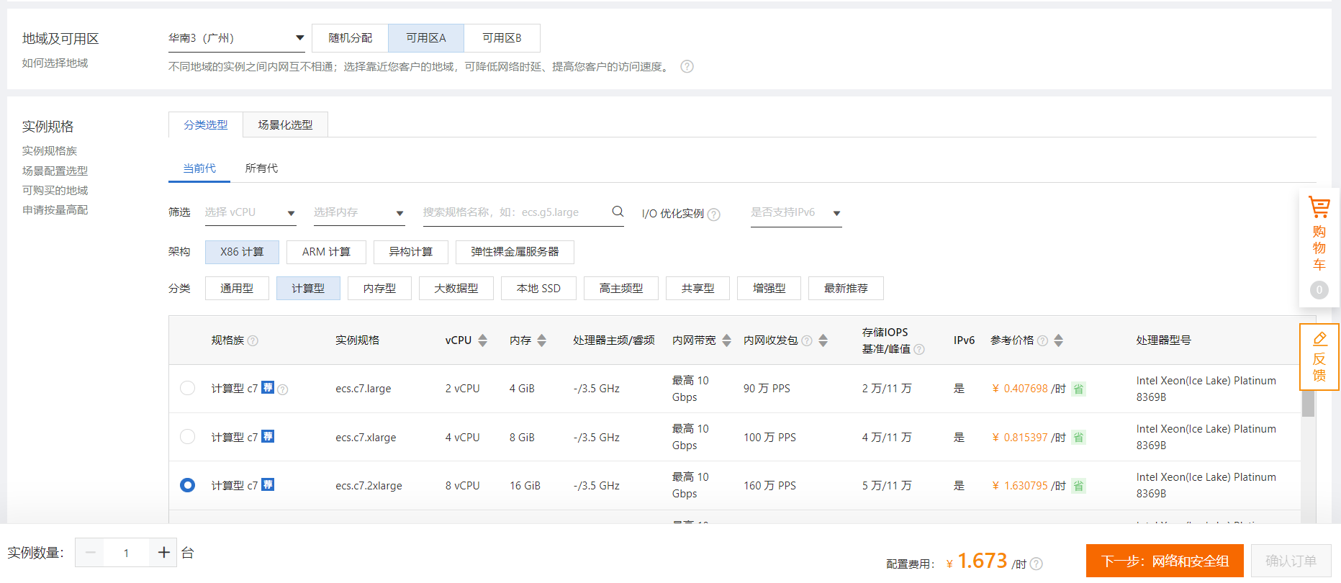
Step 3: Double-check the order,
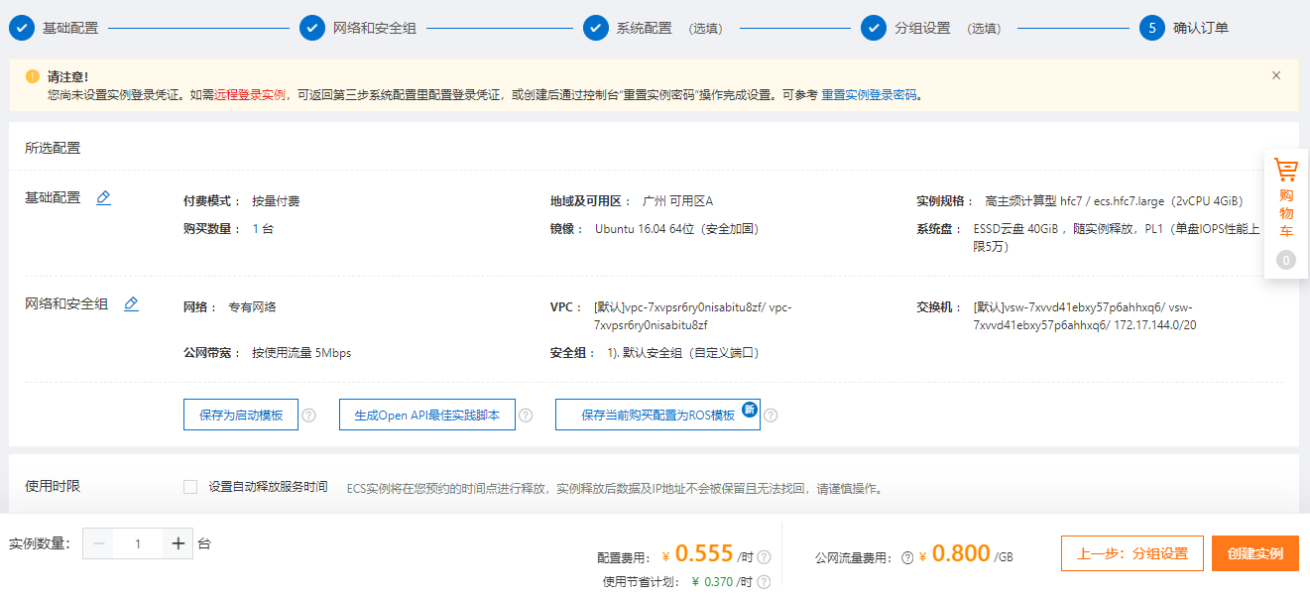

Step 4: Pay the order,
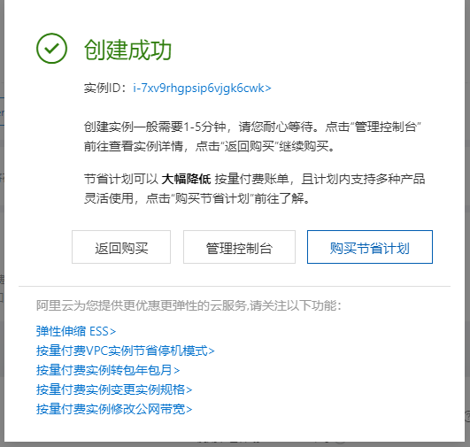
Step 5: Access the ECS instance via Alibaba Workbench, where the default username is root,
So far, the ECS instance cannot access the Internet because it has no IP address.

1.2. Purchase a NAT Gateway

Step 1: Click https://vpc.console.aliyun.com/nat/cn-guangzhou/nats, purchase 2 public IP addresses, create a NAT gateway,
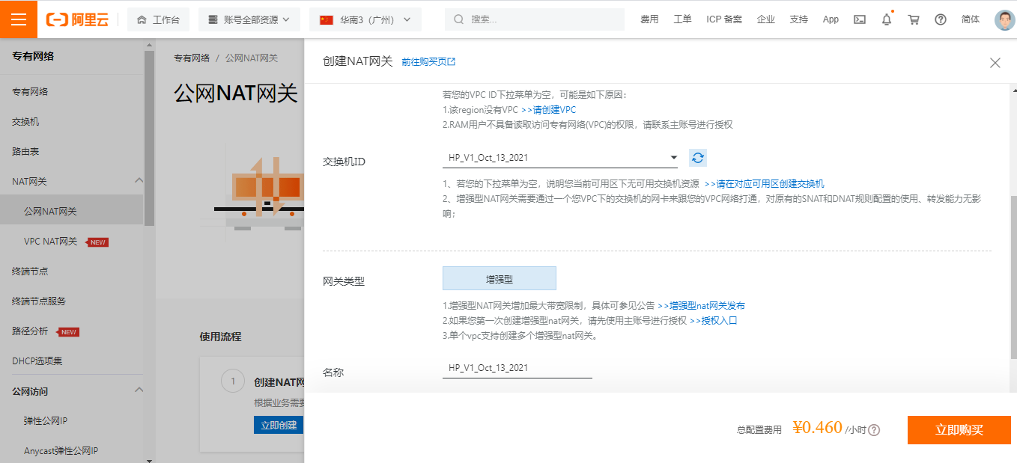

Step 2: After purchasing 2 public IP addresses, we have 8.163.56.8 and 8.138.164.210,
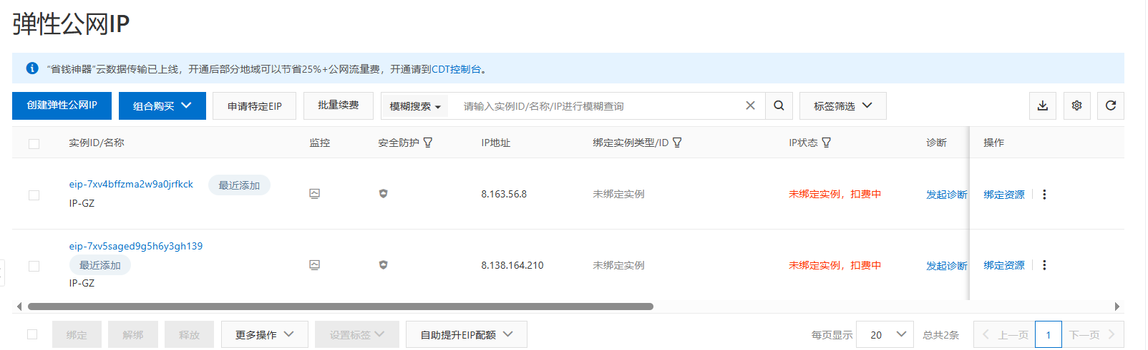

1.3. Purchase Multiple Nodes on Alibaba Cloud

Step 1: Click https://vpc.console.aliyun.com/vpc/cn-guangzhou/vpcs, purchase another 10 ECS nodes,
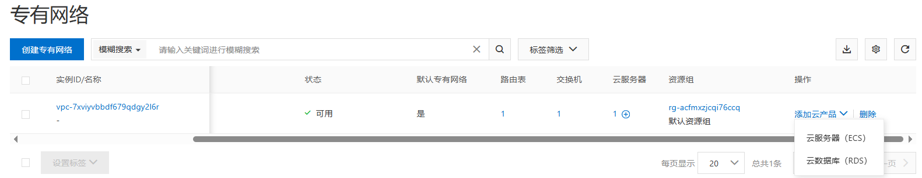

choose pay as you go, choose ecs.c7.2xlarge, choose Ubuntu 16.04 64 bits, choose ESSD, choose no IPv4 address, choose your password Y0urpassword,
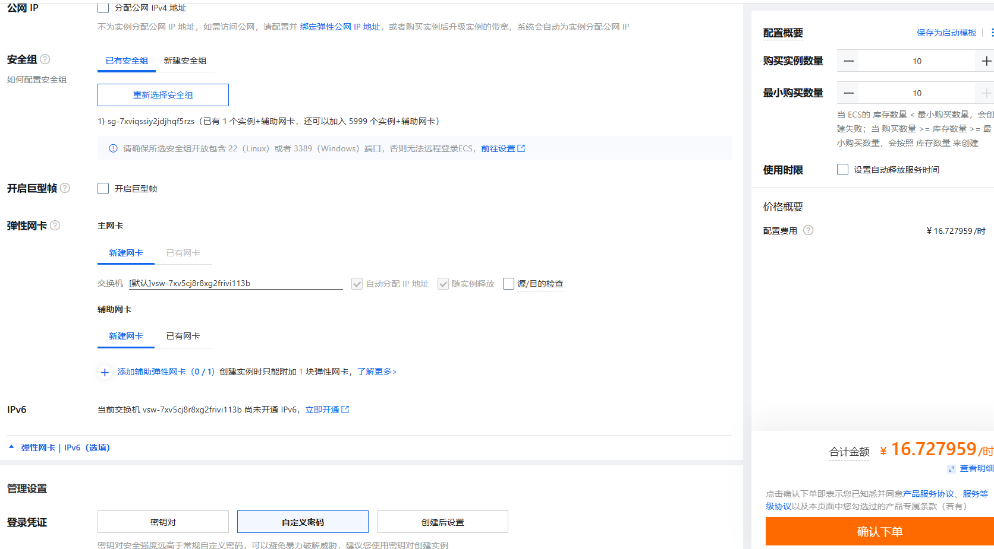

1.4. Configure the NAT Gateway

Step 1: Click https://vpc.console.aliyun.com/nat/cn-guangzhou/nats, configure the NAT gateway, where the IP address 8.163.56.8 for DNAT and 8.138.164.210 for SNAT (DNAT for Internet users and SNAT for VM inside). Currently, we have 1 NAT, 2 Public IP addresses, and 11 ECS, our target is as follows:
For NAT (Public IP):
SNAT | DNAT
8.138.164.210 | 8.163.56.8

For ECS maps (Inside IP):
SNAT | DNAT
- | 172.31.210.67
 | 172.31.210.70
 | 172.31.210.71
 | 172.31.210.72
 | 172.31.210.73
 | 172.31.210.74
 | 172.31.210.75
 | 172.31.210.76
 | 172.31.210.77
 | 172.31.210.78
 | 172.31.210.79

Step 2: Configure the SNAT,
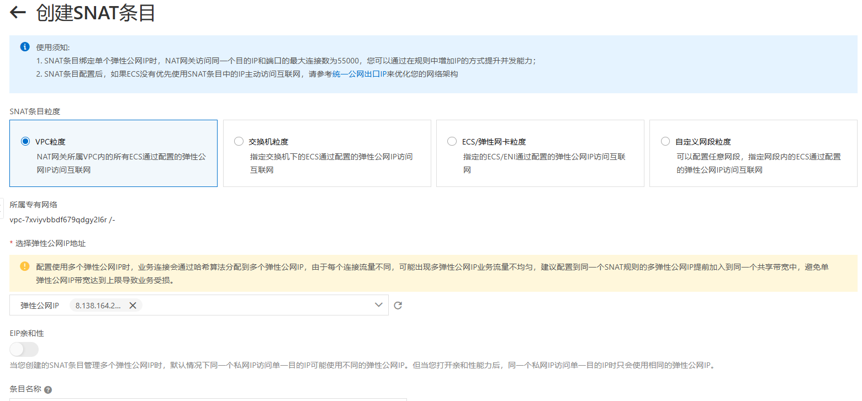

Step 3: Configure the DNAT,
ECS maps:
DNAT Public IP and Port Number | DNAT Inside IP
8.163.56.8:9999 | 172.31.210.67
8.163.56.8:10000 | 172.31.210.70
8.163.56.8:10001 | 172.31.210.71
8.163.56.8:10002 | 172.31.210.72
8.163.56.8:10003 | 172.31.210.73
8.163.56.8:10004 | 172.31.210.74
8.163.56.8:10005 | 172.31.210.75
8.163.56.8:10006 | 172.31.210.76
8.163.56.8:10007 | 172.31.210.77
8.163.56.8:10008 | 172.31.210.78
8.163.56.8:10009 | 172.31.210.79

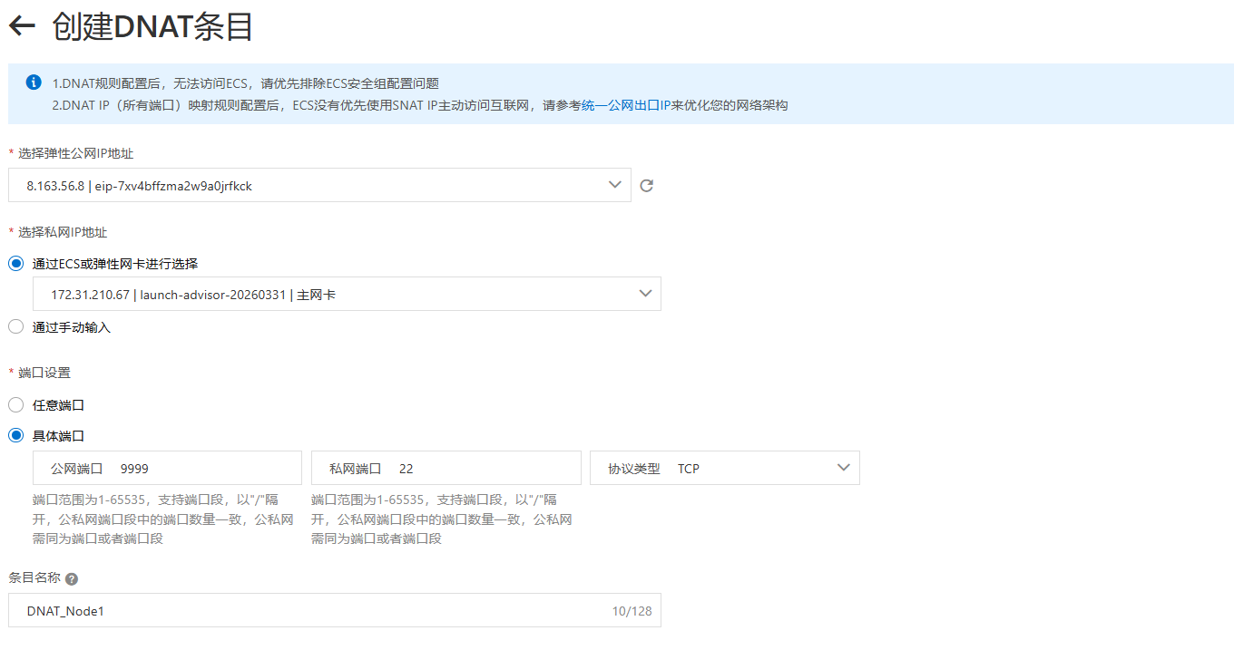
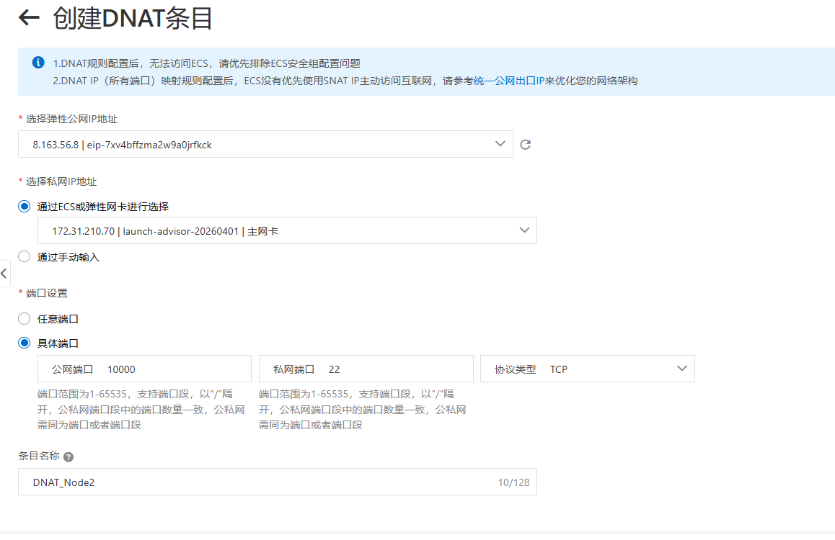
Access the inside IPs via Xshell,
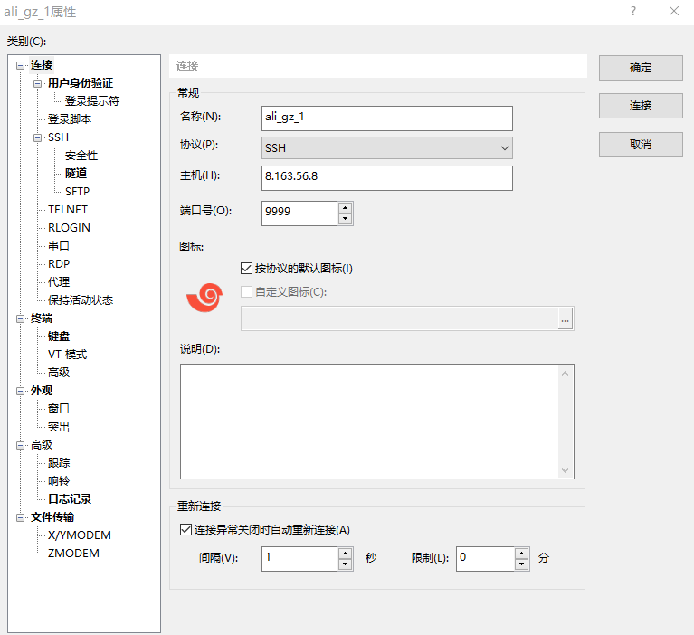
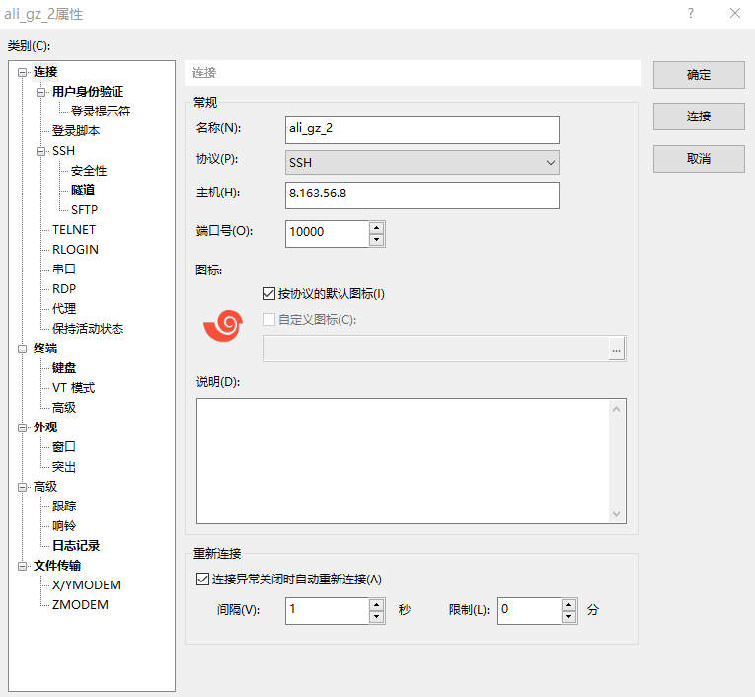

1.5. Configure the password-free SSH

Step 1: The target is as follows,
Host with free-password SSH to
172.31.210.67 | -
 | 172.31.210.70
 | 172.31.210.71
 | 172.31.210.72
 | 172.31.210.73
 | 172.31.210.74
 | 172.31.210.75
 | 172.31.210.76
 | 172.31.210.77
 | 172.31.210.78
 | 172.31.210.79

Step 2: Configure the 172.31.210.67,
$ ssh-keygen

$ ssh root@172.31.210.70 'mkdir -p .ssh && cat > .ssh/authorized_keys' < ~/.ssh/id_rsa.pub
$ ssh root@172.31.210.71 'mkdir -p .ssh && cat > .ssh/authorized_keys' < ~/.ssh/id_rsa.pub
$ ssh root@172.31.210.72 'mkdir -p .ssh && cat > .ssh/authorized_keys' < ~/.ssh/id_rsa.pub
$ ssh root@172.31.210.73 'mkdir -p .ssh && cat > .ssh/authorized_keys' < ~/.ssh/id_rsa.pub
$ ssh root@172.31.210.74 'mkdir -p .ssh && cat > .ssh/authorized_keys' < ~/.ssh/id_rsa.pub
$ ssh root@172.31.210.75 'mkdir -p .ssh && cat > .ssh/authorized_keys' < ~/.ssh/id_rsa.pub
$ ssh root@172.31.210.76 'mkdir -p .ssh && cat > .ssh/authorized_keys' < ~/.ssh/id_rsa.pub
$ ssh root@172.31.210.77 'mkdir -p .ssh && cat > .ssh/authorized_keys' < ~/.ssh/id_rsa.pub
$ ssh root@172.31.210.78 'mkdir -p .ssh && cat > .ssh/authorized_keys' < ~/.ssh/id_rsa.pub
$ ssh root@172.31.210.79 'mkdir -p .ssh && cat > .ssh/authorized_keys' < ~/.ssh/id_rsa.pub

$ ssh 172.31.210.70 "echo 'hi'"
$ ssh 172.31.210.71 "echo 'hi'"
$ ssh 172.31.210.72 "echo 'hi'"
$ ssh 172.31.210.73 "echo 'hi'"
$ ssh 172.31.210.74 "echo 'hi'"
$ ssh 172.31.210.75 "echo 'hi'"
$ ssh 172.31.210.76 "echo 'hi'"
$ ssh 172.31.210.77 "echo 'hi'"
$ ssh 172.31.210.78 "echo 'hi'"
$ ssh 172.31.210.79 "echo 'hi'"

1.6. Free the NAT Gateway
Step 1: Click https://vpc.console.aliyun.com/nat/cn-guangzhou/nats/ngw-7xv0l1e59yh41ve2vhc0g/snats, delete SNAT,
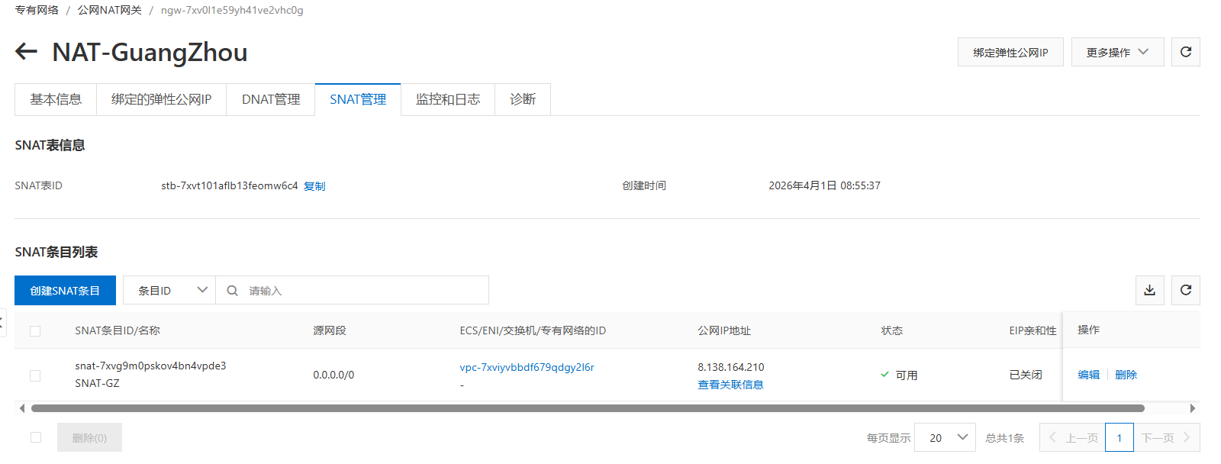
Step 2: Click https://vpc.console.aliyun.com/nat/cn-guangzhou/nats, unbind public IP, free public IP,
Step 3: Click https://homenew.console.aliyun.com/home/dashboard/ProductAndService, delete ECS,
Step 4: Click https://vpc.console.aliyun.com/nat/cn-guangzhou/nats, delete NAT

Run Single-Node Fabric

2.1. Configure Each Node
Step 1: Configure the host names,
# sudo vi /etc/hosts
:set paste
I

172.31.210.67 peer0.org1.example.com

172.31.210.70 client1.peer
172.31.210.71 client2.peer
172.31.210.72 client3.peer
172.31.210.73 client4.peer
172.31.210.74 client5.peer
172.31.210.75 client6.peer
172.31.210.76 client7.peer

172.31.210.77 order.example.com
172.31.210.78 order2.example.com
172.31.210.79 order3.example.com

2.2. Install Dependencies on Each Node
Step 1: Install the prerequisites on each node,
// Prerequisite: Git
$ sudo apt-get update
$ sudo apt purge -y git
$ sudo apt-get install -y git // =1:2.7.4-0ubuntu1.9
$ git version // 2.7.4
$ export PATH=$PATH:/usr/lib/git-core
$ echo 'export PATH=$PATH:/usr/lib/git-core' >> ~/.bashrc
$ source ~/.bashrc

Step 2: Install the cURL on each node,
// Prerequisite: cURL
$ sudo apt-get install -y curl
$ curl –version // 7.47.0

Step 3: Install the wget on each node,
// Prerequisite: wget
$ sudo apt-get install -y wget=1.17.1-1ubuntu1.5

Step 4: Install Docker on each node,
// Prerequisite: Docker 17.06.2-ce or greater: Docker 17.12.0-ce
$ sudo apt-get purge -y docker-ce docker-ce-cli
$ wget https://download.docker.com/linux/ubuntu/gpg
$ sudo apt-key add gpg
$ echo 'deb [arch=amd64] https://download.docker.com/linux/ubuntu xenial stable' | sudo tee /etc/apt/sources.list.d/docker.list
$ sudo apt-get update
$ apt-cache madison docker-ce
$ sudo apt-get install docker-ce=17.12.0~ce-0~ubuntu
$ sudo usermod -aG docker $USER
$ docker version

Step 5 (if outside the Great Wall): Install Docker Compose on each node,
// Prerequisite: Docker Compose 1.14.0 or greater: 1.21.0
$ sudo apt-get purge -y docker-compose
$ sudo curl -L https://github.com/docker/compose/releases/download/1.21.0/docker-compose-`uname -s`-`uname -m` -o /usr/local/bin/docker-compose
$ sudo chmod +x /usr/local/bin/docker-compose
$ docker-compose version

Step 5 (if within the Great Wall): Install Docker Compose on each node,
// Prerequisite: Docker Compose 1.14.0 or greater: 1.21.0
$ sudo apt-get purge -y docker-compose
$ mkdir downloads
$ cd $HOME/downloads
$ wget https://gitee.com/joe32065/fabric_2_2/releases/download/fabric-v2.2.0/docker-compose
$ sudo chmod +x docker-compose
$ sudo mv docker-compose /usr/local/bin
$ docker-compose version

Step 6 (if outside the Great Wall): Install Golang on each node,
// Prerequisite: Go v1.14.8
$ cd $HOME/downloads
$ wget https://golang.org/dl/go1.14.8.linux-amd64.tar.gz
$ tar -xzf go1.14.8.linux-amd64.tar.gz
$ sudo rm -rf /usr/local/go
$ sudo mv go /usr/local
$ mkdir -p $HOME/go
$ echo 'export PATH=$PATH:/usr/local/go/bin' >> ~/.bashrc
$ echo 'export GOPATH=$HOME/go' >> ~/.bashrc
$ source ~/.bashrc
$ go version // go1.14.8 linux/amd64

Step 6 (if within the Great Wall): Install the Golang on each node,
// Prerequisite: Go v1.14.8
$ cd $HOME/downloads
$ … // download go1.14.8.linux-amd64.tar.gz on node one, e.g., via winscp,
$ scp go1.14.8.linux-amd64.tar.gz root@172.31.210.70:$HOME/downloads
$ scp go1.14.8.linux-amd64.tar.gz root@172.31.210.71:$HOME/downloads
$ …
$ scp go1.14.8.linux-amd64.tar.gz root@172.31.210.79:$HOME/downloads

$ tar -xzf go1.14.8.linux-amd64.tar.gz
$ sudo mv go /usr/local
$ mkdir -p $HOME/go
$ echo 'export PATH=$PATH:/usr/local/go/bin' >> ~/.bashrc
$ echo 'export GOPATH=$HOME/go' >> ~/.bashrc
$ source ~/.bashrc
$ go version // go1.14.8 linux/amd64

Step 7: Install Node.js on each node,
// Prerequisite: Node.js v12.20.1 or higher
$ cd $HOME/downloads
$ curl -sL https://deb.nodesource.com/setup_12.x -o nodesource_setup.sh
$ sudo chmod +x nodesource_setup.sh
$ sudo bash nodesource_setup.sh
$ sudo apt-get install -y nodejs --allow-unauthenticated
$ nodejs -v // v12.22.12

$ curl -o- https://raw.githubusercontent.com/nvm-sh/nvm/v0.35.3/install.sh | bash
$ // close the terminals, and open the terminals again
$ cd $HOME/downloads
$ sudo npm -g install nvm
$ nvm ls available
$ nvm install 12.20.1
$ nvm use 12.20.1

Step 8: Install the NTP on each node,
$ sudo apt-get install ntp
$ sudo service ntp start

2.3. Install Fabric 2.2.0

Step 1 (if outside the Great Wall): Install Fabric 2.2.0, including Fabric Samples on each node,
$ cd $HOME
$ sudo rm -rf fabric-samples
$ curl -sSL https://bit.ly/2ysbOFE | bash -s -- 2.2.0

Step 1 (if within the Great Wall): Install Fabric 2.2.0, including Fabric Samples on each node,
$ cd $HOME
$ sudo rm -rf fabric-samples
$ sudo apt-get install unzip
$ cd $HOME
$ wget https://gitee.com/joe32065/fabric_2_2/releases/download/fabric-v2.2.0/fabric-v2.2.0.zip
$ unzip fabric-v2.2.0.zip
$ cd fabric-v2.2.0/scripts

In bootstrap.sh -> ”pullBinaries()”，
download "${BINARY_FILE}" "https://github.com/hyperledger/fabric/releases/download/v${VERSION}/${BINARY_FILE}"
download "${CA_BINARY_FILE}" "https://github.com/hyperledger/fabric-ca/releases/download/v${CA_VERSION}/${CA_BINARY_FILE}"

Replace with the two lines，
download "${BINARY_FILE}" "https://gitee.com/joe320653/fabric/attach_files/842230/download/${BINARY_FILE}"
download "${CA_BINARY_FILE}" "https://gitee.com/joe320653/fabric-ca/attach_files/842289/download/${CA_BINARY_FILE}"

In bootstrap.sh -> ” cloneSamplesRepo()”，
git clone -b master https://github.com/hyperledger/fabric-samples.git && cd fabric-samples && git checkout v${VERSION}

Replace with the two lines,
git clone -b master https://gitee.com/joe320653/fabric-samples.git && cd fabric-samples && git checkout v${VERSION}

Step 2: Install docker images and fabric-samples on each node,
$ cd $HOME/fabric-v2.2.0/scripts
$ chmod 777 *.sh

$ // configure the docker container service within the Great Wall
$ cd $HOME
$ sudo mkdir -p /etc/docker
$ sudo tee /etc/docker/daemon.json <<-'EOF'
{
"registry-mirrors": ["https://2htzxp9d.mirror.aliyuncs.com"]
}
EOF
$ sudo systemctl daemon-reload
$ sudo systemctl restart docker

$ cd $HOME/fabric-v2.2.0/scripts
$ sudo ./bootstrap.sh
$ mv fabric-samples $HOME

2.4. Run Test-Network

Step 1 (if outside the Great Wall): Run test network on each node,
$ cd $HOME/fabric-samples/test-network
$ ./network.sh up
$ ./network.sh createChannel
$ ./network.sh deployCC -ccn basic -ccp ../asset-transfer-basic/chaincode-go -ccl go
$ ./network.sh down

The success information is as follows,
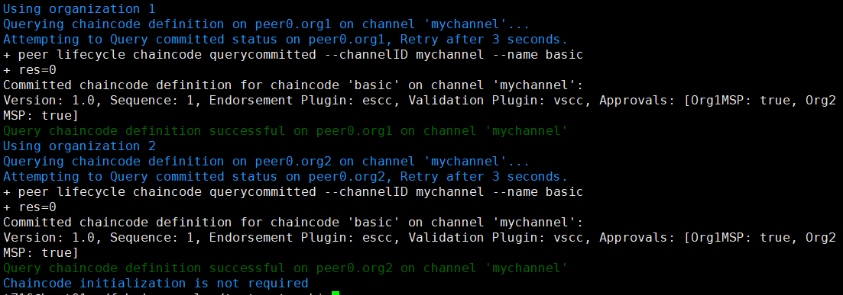

Step 1 (if within the Great Wall): Run test network on each node,
Set the Golang Proxy,
$ go env -w GOPROXY=https://goproxy.cn

Run the test network,
$ cd $HOME/fabric-samples/test-network
$ ./network.sh up
$ ./network.sh createChannel
$ ./network.sh deployCC -ccn basic -ccp ../asset-transfer-basic/chaincode-go -ccl go
$ ./network.sh down

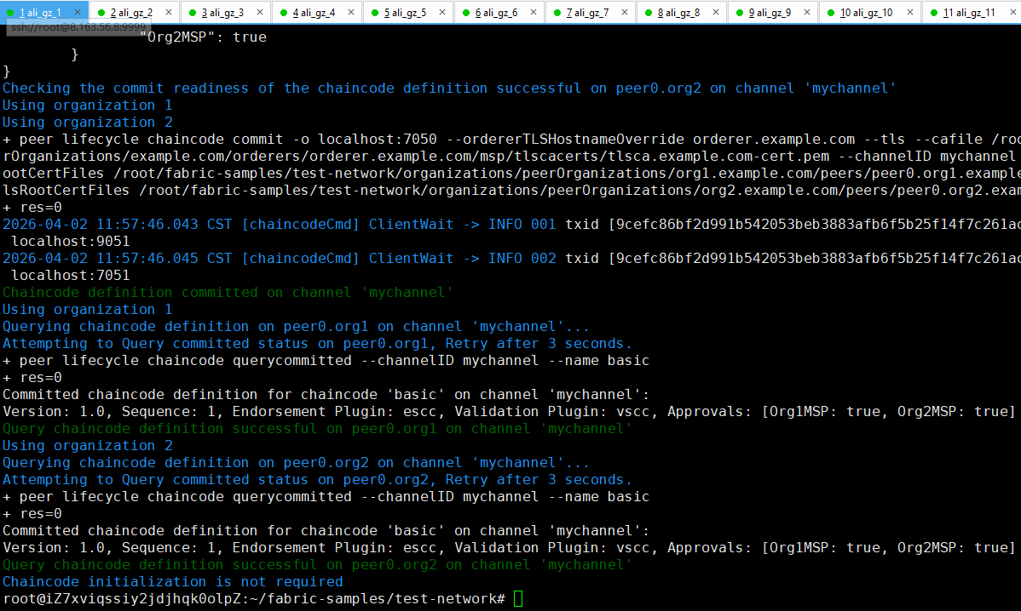

Run Multi-Nodes Fabric (Exp 1: 1 CLI + 2 Peers + 1 Orderer)

3.1. Prepare the Hosts

Step 1 (Prepare): All machines prepare the host names,
$ vi /etc/hosts

172.31.210.67 cli
172.31.210.70 peer0.org1.example.com
172.31.210.71 peer0.org2.example.com
172.31.210.72 orderer.example.com

Step 2 (Prepare): CLI prepares the Test-Network files,
$ cd $HOME/fabric-samples
$ mkdir demo-first
$ cd $HOME/fabric-samples/demo-first
$ vi crypto-config.yaml
$ vi configtx.yaml

$ vi peer0-org1.yaml
$ vi peer0-org2.yaml

$ vi orderer1.yaml

$ vi cli.yaml // (of peer0.org1)

$ vi $HOME/fabric-samples/chaincode/abstore/go/abstore.go // our proposed key-value chaincode
$ vi $HOME/fabric-samples/chaincode/abstore/go/go.mod

Step 2 (Prepare): All machines prepare the timestamp alignment,
$ date +%s // check the timestamp

$ sudo apt-get install ntpdate // align the timestamp
$ sudo ntpdate cn.pool.ntp.org
$ sudo hwclock –systohc

$ date +%s // check the timestamp again

Step 3 (Run): CLI runs the initial block generation,
$ cd $HOME/fabric-samples/demo-first
$ chmod +x *.sh
$ ./config.sh

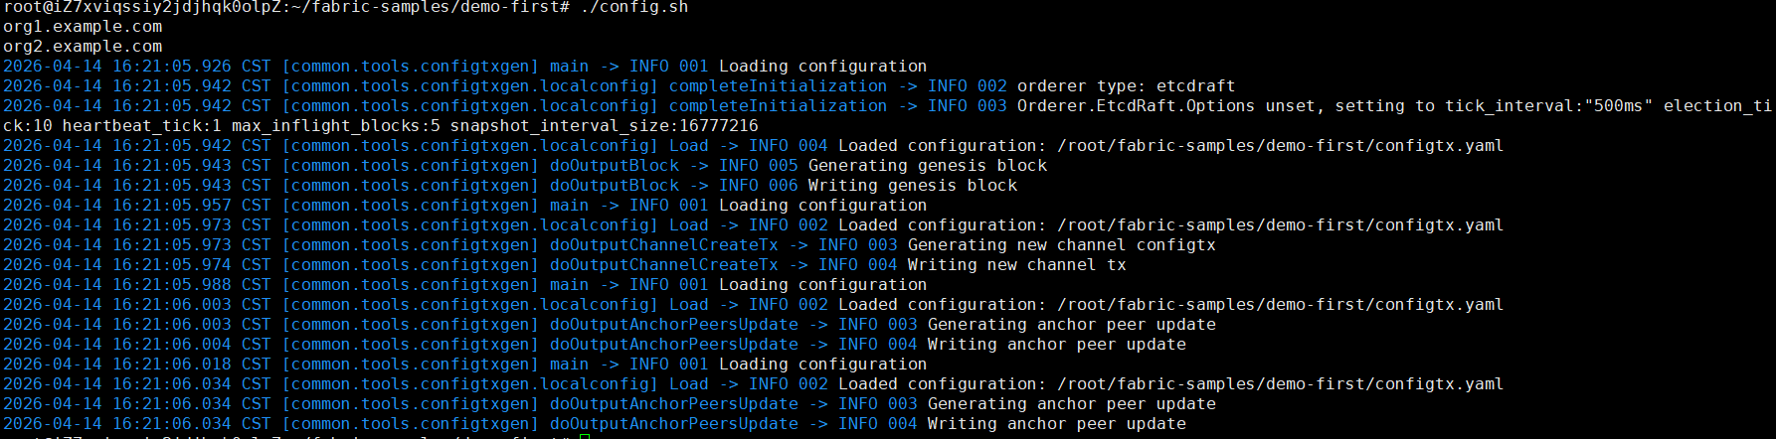

$ cd $HOME/fabric-samples/demo-first/workload/tls
$ chmod +x *.sh

$ cd $HOME/fabric-samples/demo-first/workload
$ chmod +x *.sh
$ wget https://gitee.com/joe32065/fabric_2_2/releases/download/fabric-v2.2.0/node_modules.zip
$ unzip node_modules.zip

$ cd $HOME/fabric-samples/demo-first/scripts
$ chmod +x *.sh

Step 4 (Run): CLI scp the contents to all machines including peers and orderers,
$ cd $HOME/fabric-samples/demo-first
$ ./scp.sh

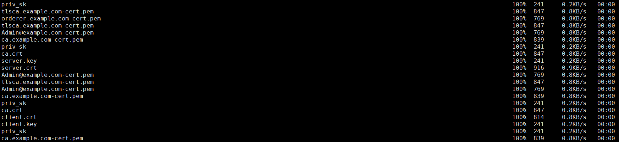

Step 5 (Run): Orderer1 sets up the Docker container,
$ cd $HOME/fabric-samples/demo-first
$ ./orderer1.sh

$ docker ps

Step 6 (Run): Peer1 sets up the Docker container,
$ cd $HOME/fabric-samples/demo-first
$ ./peer1.sh

$ docker ps

Step 7 (Run): Peer2 sets up the Docker container,
$ cd $HOME/fabric-samples/demo-first
$ ./peer2.sh

$ docker ps

Step 8 (Run): CLI sets up the Docker container,
$ cd $HOME/fabric-samples/demo-first
$ ./cli.sh

$ docker ps

3.2. Start the Network

Step 1 (Run): CLI connects to Peer0.org1.example.com:7051, creates a channel.block, and then all peers join the channel.block,
// CLI goes to `peer0.org1.example.com:7051`
$ docker exec -it cli bash

// Environment Configuration for `peer0.org1.example.com:7051`
# cd scripts
# ./step1.sh // All peers join the channel

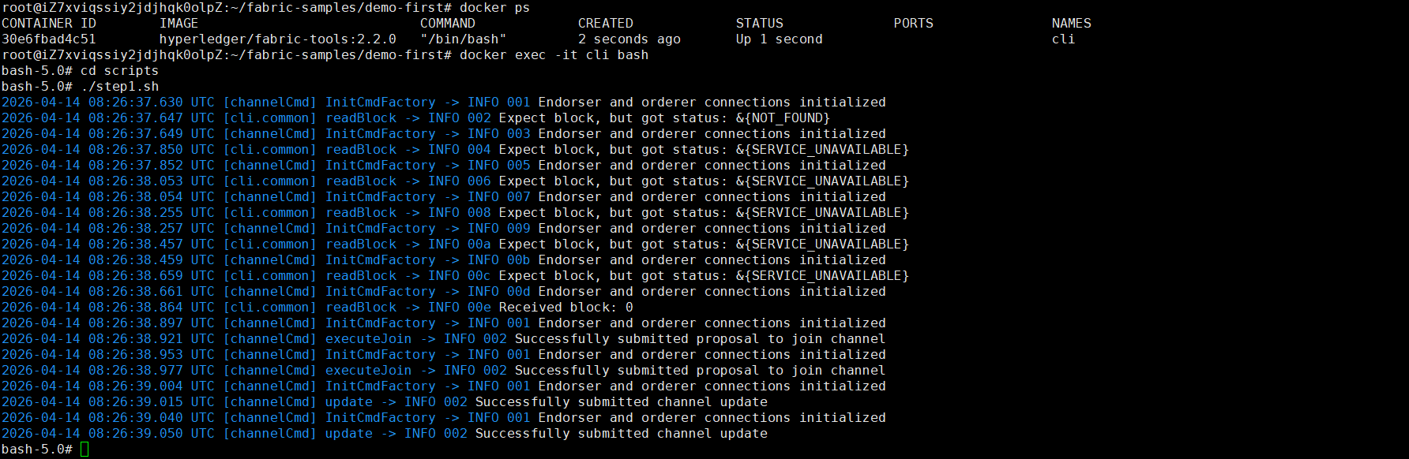

# ./step2.sh // All peers join the chaincode

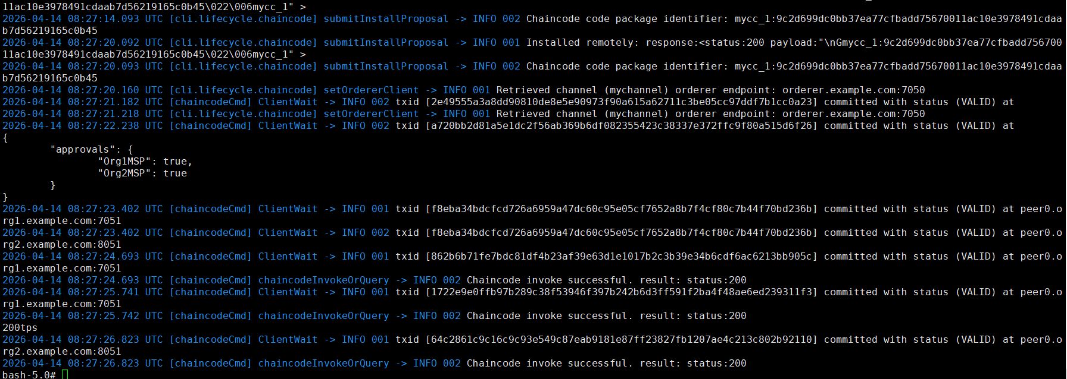

3.3. Start Nodejs SDK

Step 1 (Run): CLI configures the Node.js SDK folder and tls, wallet, and workload files for all peers,
# exit
$ mkdir -p $HOME/fabric-samples/demo-first/workload
$ mkdir -p $HOME/fabric-samples/demo-first/workload/tls
$ mkdir -p $HOME/fabric-samples/demo-first/workload/wallet
$ mkdir -p $HOME/fabric-samples/demo-first/workload/result

$ cd $HOME/fabric-samples/demo-first/workload/tls
$ vi read_pem.py
$ vi prepare_tls_peer0_org1.sh
$ vi prepare_tls_peer0_org2.sh
$ ./all.sh

$ cd $HOME/fabric-samples/demo-first/workload/wallet
$ vi prepare_wallet_user1_org1.py
$ vi prepare_wallet_user1_org2.py
$ ./all.sh

$ cd $HOME/fabric-samples/demo-first/workload
$ mkdir sdk-peer0-org1
$ mkdir sdk-peer0-org2
$ vi invoke.js
$ vi prepare_sdk_peer0_org1.sh
$ vi prepare_sdk_peer0_org2.sh
$ ./all.sh

Step 2 (Prepare): CLI prepares the Nodejs SDK dependencies on CLI. Note that you may pass this step by copying the compiled nodejs source code https://gitee.com/joe32065/fabric_2_2/releases/download/fabric-v2.2.0/node_modules.zip,
$ cd $HOME/fabric-samples/demo-first/workload
$ vi package.json
$ npm install
$ vi $HOME/fabric-samples/demo-first/workload/node_modules/fabric-network/lib/transaction.js

Step 3 (Run): Cli prepares wallets of User1@org1.example.com and User1@org2.example.com,
$ cd $HOME/fabric-samples/demo-first/workload/wallet
$ rm -rf *.id
$ python prepare_wallet_user1_org1.py
$ python prepare_wallet_user1_org2.py
$ ./all.sh

Step 4 (Run): CLI invokes and queries transactions via Node.js,
$ cd $HOME/fabric-samples/demo-first/workload
$ ./scp.sh // CLI copies files to all machines

$ ./ssh.sh > result/benchlog
$ ls result -l
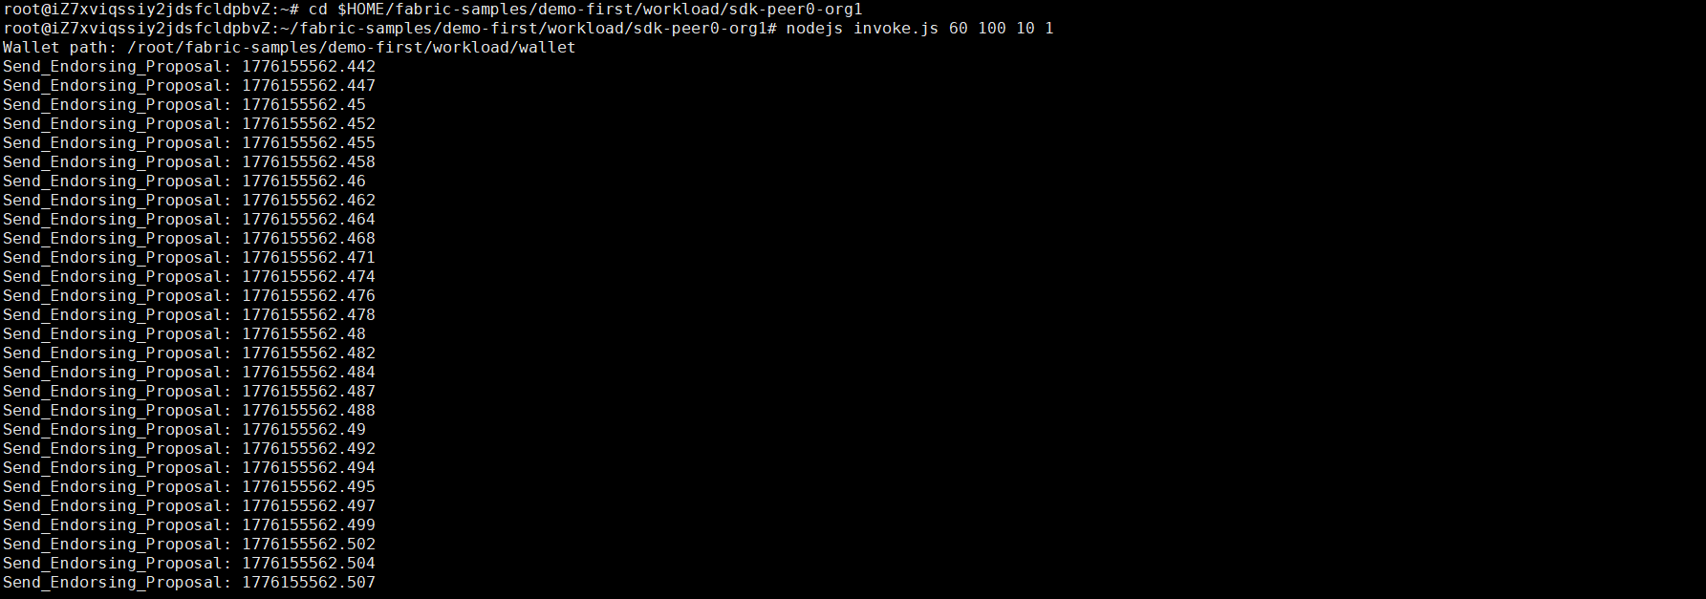

// $ node query.js
// $ node invoke.js 30 500 20 1

Step 5 (Run): Analyze the log,
// CLI analyzes the log
$ cd $HOME/fabric-samples/demo-first/workload/result
$ python readthroughput_p1.py // rate of sending endorsed txs

$ sudo apt-get install python-numpy
$ python readdelay_p1.py // delay of endorsing phase

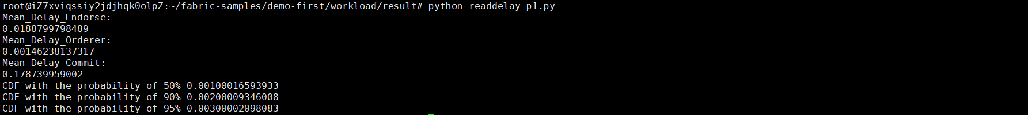

// Orderer analyzes the log
$ cd $HOME/fabric-samples/demo-first/workload/result
$ sudo apt-get install python-numpy
//$ docker logs containername >& ordererlog
$ docker logs $(docker ps -a | grep 'orderer'| awk '{print $1 }') >& ordererlog
// $ scp ordererlog chwang@1xx.1xx.7xx.1xx:/home/chwang
$ python readthroughput_p2.py // rate of generating blocks

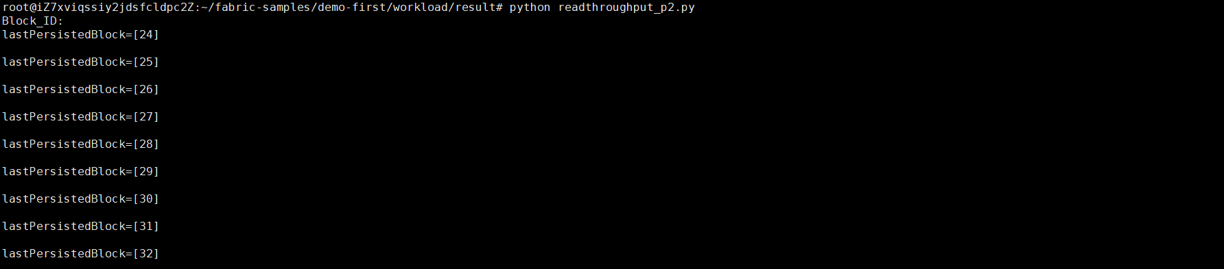

// Peer analyzes the log
$ cd $HOME/fabric-samples/demo-first/workload/result
$ sudo apt-get install python-numpy
//$ docker logs containername >& peerlog
$ docker logs $(docker ps -a | grep 'peer node start'| awk '{print $1 }') >& peerlog
// $ scp peerlog chwang@1xx.1xx.7xx.1xx:/home/chwang
$ python2 readthroughput_p3.py

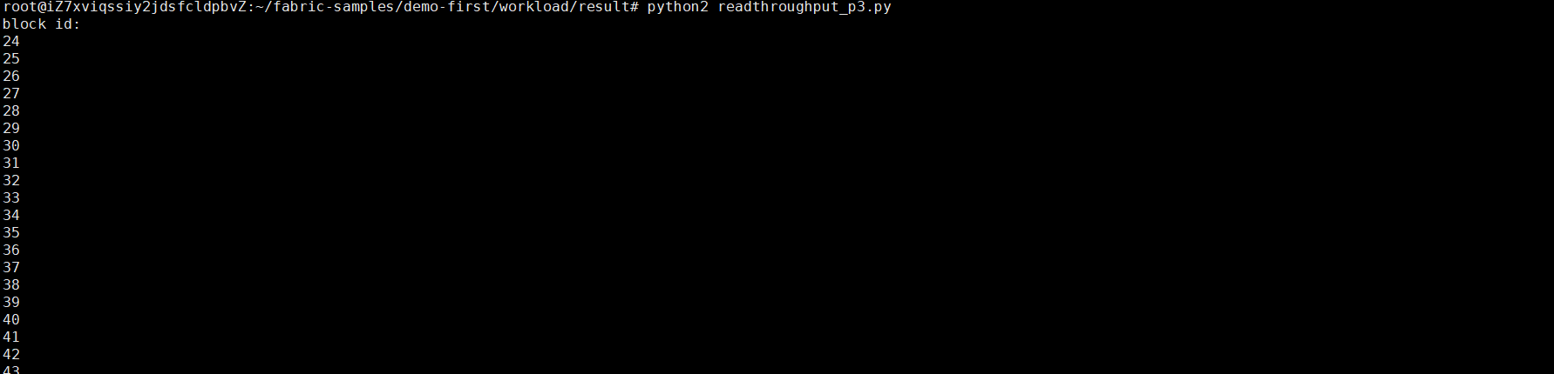

// Get block size
# peer channel fetch 2 last.block -o orderer.example.com:7050 -c mychannel --tls --cafile /opt/gopath/src/github.com/hyperledger/fabric/peer/crypto/ordererOrganizations/example.com/orderers/orderer.example.com/msp/tlscacerts/tlsca.example.com-cert.pem

Step 6 (Run): All nodes run the clean procedure,
$ cd $HOME/fabric-samples/demo-first
$ ./clean.sh

4. Run Multi-Nodes Fabric (Exp 2: 1 CLI + 2 Peers + 5 Orderers)

4.1. Prepare the Hosts

Step 1 (Prepare): All machines prepare the host names,
$ vi /etc/hosts

172.31.210.67 cli
172.31.210.70 peer0.org1.example.com
172.31.210.71 peer0.org2.example.com
172.31.210.72 orderer.example.com
172.31.210.73 orderer2.example.com
172.31.210.74 orderer3.example.com
172.31.210.75 orderer4.example.com
172.31.210.76 orderer5.example.com

Step 2 (Prepare): CLI prepares the Test-Network files,
$ cd $HOME/fabric-samples
$ mkdir demo-first
$ cd $HOME/fabric-samples/demo-first
$ vi crypto-config.yaml
$ vi configtx.yaml

$ vi peer0-org1.yaml
$ vi peer0-org2.yaml

$ vi orderer1.yaml
$ vi orderer2.yaml
$ vi orderer3.yaml
$ vi orderer4.yaml
$ vi orderer5.yaml

$ vi cli.yaml

Step 2 (Prepare): All machines prepare the timestamp alignment,
$ date +%s // check the timestamp

$ sudo apt-get install ntpdate // align the timestamp
$ sudo ntpdate cn.pool.ntp.org
$ sudo hwclock –systohc

$ date +%s // check the timestamp again

Step 3 (Run): CLI runs the initial block generation,
$ cd $HOME/fabric-samples/demo-first
$ chmod +x *.sh
$ ./config.sh

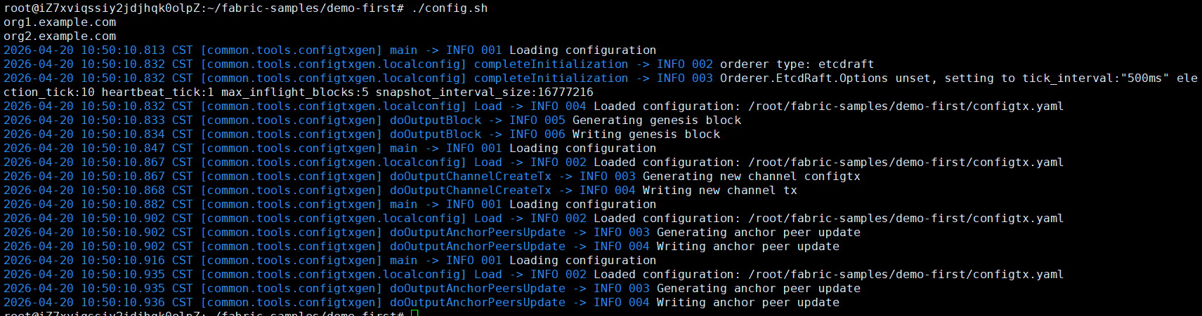

Step 4 (Run): CLI scp the contents to all machines including peers and orderers,
$ cd $HOME/fabric-samples/demo-first
$ ./scp.sh



Step 5 (Run): Orderers sets up the Docker container,
$ cd $HOME/fabric-samples/demo-first
$ ./orderer1.sh

$ ./orderer2.sh

$ ./orderer3.sh

$ ./orderer4.sh

$ ./orderer5.sh

$ docker ps

Step 6 (Run): Peer1 sets up the Docker container,
$ cd $HOME/fabric-samples/demo-first
$ ./peer1.sh

$ docker ps

Step 7 (Run): Peer2 sets up the Docker container,
$ cd $HOME/fabric-samples/demo-first
$ ./peer2.sh

$ docker ps

Step 8 (Run): CLI sets up the Docker container,
$ cd $HOME/fabric-samples/demo-first
$ ./cli.sh

$ docker ps

4.2. Start the Network

Step 1 (Run): CLI connects to Peer0.org1.example.com:7051, creates a channel.block, and then all peers join the channel.block,
// CLI goes to `peer0.org1.example.com:7051`
$ docker exec -it cli bash

// Environment Configuration for `peer0.org1.example.com:7051`
# cd scripts
# ./step1.sh // All peers join the channel

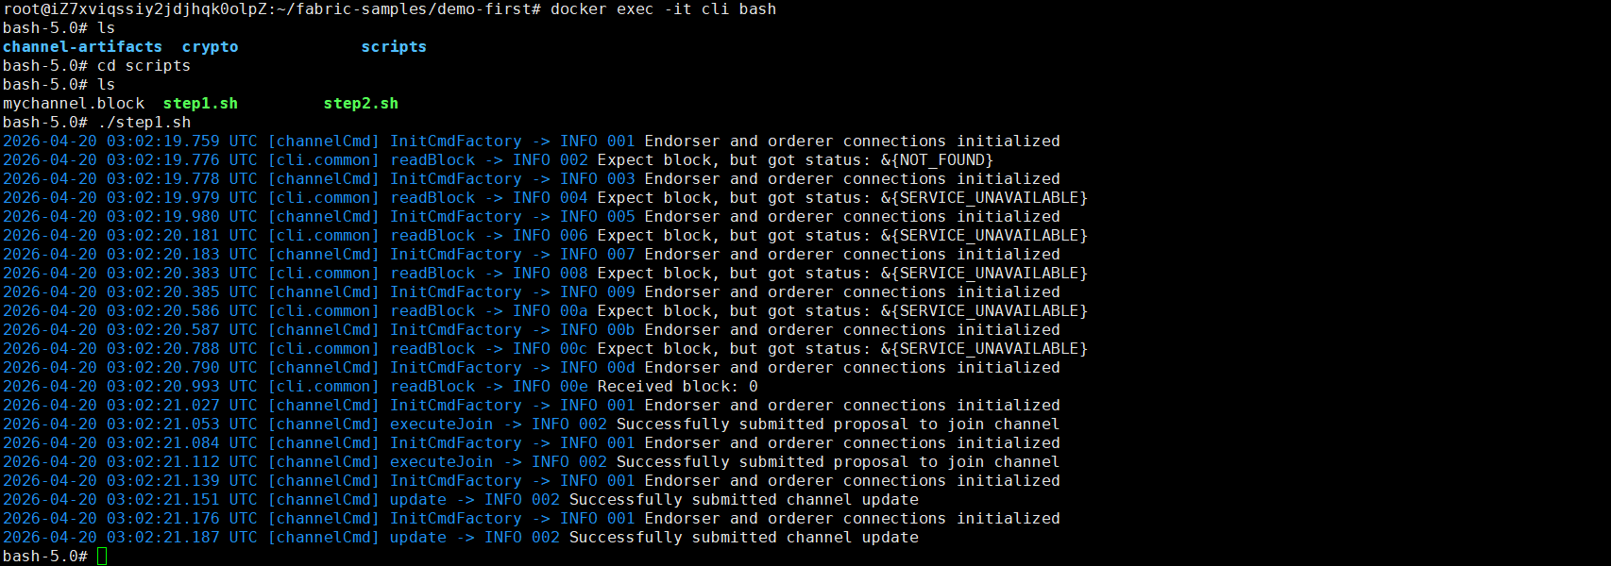

# ./step2.sh // All peers join the chaincode

4.3. Start Nodejs SDK

Step 1 (Run): CLI configures the Node.js SDK folder and tls, wallet, and workload files for all peers,
# exit
$ mkdir -p $HOME/fabric-samples/demo-first/workload
$ mkdir -p $HOME/fabric-samples/demo-first/workload/tls
$ mkdir -p $HOME/fabric-samples/demo-first/workload/wallet
$ mkdir -p $HOME/fabric-samples/demo-first/workload/result

$ cd $HOME/fabric-samples/demo-first/workload/tls
$ vi read_pem.py
$ vi prepare_tls_peer0_org1.sh
$ vi prepare_tls_peer0_org2.sh
$ ./all.sh

$ cd $HOME/fabric-samples/demo-first/workload/wallet
$ vi prepare_wallet_user1_org1.py
$ vi prepare_wallet_user1_org2.py
$ ./all.sh

$ cd $HOME/fabric-samples/demo-first/workload
$ mkdir sdk-peer0-org1
$ mkdir sdk-peer0-org2
$ vi invoke.js
$ vi prepare_sdk_peer0_org1.sh
$ vi prepare_sdk_peer0_org2.sh
$ ./all.sh

Step 2 (Prepare): -
Step 3 (Run): CLI prepares wallets of User1@org1.example.com and User1@org2.example.com,
$ cd $HOME/fabric-samples/demo-first/workload/wallet
$ python prepare_wallet_user1_org1.py
$ python prepare_wallet_user1_org2.py
$ ./all.sh

Step 4 (Run): CLI invokes and queries transactions via Node.js,
$ cd $HOME/fabric-samples/demo-first/workload
$ ./scp.sh // CLI copies files to all machines

$ ./ssh.sh > result/benchlog
$ ls result -l


// $ node query.js
// $ node invoke.js 30 500 20 1

Step 5 (Run): Analyze the log,
// CLI analyzes the log
$ cd $HOME/fabric-samples/demo-first/workload/result
$ python readthroughput_p1.py // rate of sending endorsed txs

$ sudo apt-get install python-numpy
$ python readdelay_p1.py // delay of endorsing phase



// Orderer analyzes the log
$ cd $HOME/fabric-samples/demo-first/workload/result
$ sudo apt-get install python-numpy
//$ docker logs containername >& ordererlog
$ docker logs $(docker ps -a | grep 'orderer'| awk '{print $1 }') >& ordererlog
// $ scp ordererlog chwang@1xx.1xx.7xx.1xx:/home/chwang
$ python readthroughput_p2.py // rate of generating blocks



// Peer analyzes the log
$ cd $HOME/fabric-samples/demo-first/workload/result
$ sudo apt-get install python-numpy
//$ docker logs containername >& peerlog
$ docker logs $(docker ps -a | grep 'peer node start'| awk '{print $1 }') >& peerlog
// $ scp peerlog chwang@1xx.1xx.7xx.1xx:/home/chwang
$ python2 readthroughput_p3.py



// Get block size
# peer channel fetch 228 last.block -o orderer.example.com:7050 -c mychannel --tls --cafile /opt/gopath/src/github.com/hyperledger/fabric/peer/crypto/ordererOrganizations/example.com/orderers/orderer.example.com/msp/tlscacerts/tlsca.example.com-cert.pem

Step 6 (Run): All nodes run the clean procedure,
$ cd $HOME/fabric-samples/demo-first
$ ./clean.sh

5. Run Multi-Nodes Fabric (Exp 3: 1 CLI + 5 Peers + 5 Orderers)

5.1. Prepare the Hosts

Step 1 (Prepare): All machines prepare the host names,
$ vi /etc/hosts

172.31.210.67 cli
172.31.210.70 peer0.org1.example.com
172.31.210.71 peer0.org2.example.com
172.31.210.72 orderer.example.com
172.31.210.73 orderer2.example.com
172.31.210.74 orderer3.example.com
172.31.210.75 orderer4.example.com
172.31.210.76 orderer5.example.com
172.31.210.77 peer0.org3.example.com
172.31.210.78 peer0.org4.example.com
172.31.210.79 peer0.org5.example.com

Step 2 (Prepare): CLI prepares the Test-Network files,
$ cd $HOME/fabric-samples
$ mkdir demo-first
$ cd $HOME/fabric-samples/demo-first
$ vi crypto-config.yaml
$ vi configtx.yaml

$ vi peer0-org1.yaml
$ vi peer0-org2.yaml
$ vi peer0-org3.yaml
$ vi peer0-org4.yaml
$ vi peer0-org5.yaml

$ vi orderer1.yaml
$ vi orderer2.yaml
$ vi orderer3.yaml
$ vi orderer4.yaml
$ vi orderer5.yaml

$ vi cli.yaml

Step 2 (Prepare): All machines prepare the timestamp alignment,
$ date +%s // check the timestamp

$ sudo apt-get install ntpdate // align the timestamp
$ sudo ntpdate cn.pool.ntp.org
$ sudo hwclock –systohc

$ date +%s // check the timestamp again

Step 3 (Run): CLI runs the initial block generation,
$ cd $HOME/fabric-samples/demo-first
$ chmod +x *.sh
$ ./config.sh



Step 4 (Run): CLI scp the contents to all machines including peers and orderers,
$ cd $HOME/fabric-samples/demo-first
$ ./scp.sh



Step 5 (Run): Orderers sets up the Docker container,
$ cd $HOME/fabric-samples/demo-first
$ ./orderer1.sh

$ ./orderer2.sh

$ ./orderer3.sh

$ ./orderer4.sh

$ ./orderer5.sh

$ docker ps

Step 6 (Run): Peer1 sets up the Docker container,
$ cd $HOME/fabric-samples/demo-first
$ ./peer1.sh

$ docker ps

Step 7 (Run): Other peers set up the Docker container,
$ cd $HOME/fabric-samples/demo-first
$ ./peer2.sh

$ ./peer3.sh

$ ./peer4.sh

$ ./peer5.sh

$ docker ps

Step 8 (Run): CLI sets up the docker container,
$ cd $HOME/fabric-samples/demo-first
$ ./cli.sh

$ docker ps

5.2. Start the Network

Step 1 (Run): CLI (of peer0.org1) connects to Peer0.org1.example.com:7051, creates a channel.block, and then all peers join the channel.block,
// CLI goes to `peer0.org1.example.com:7051`
$ docker exec -it cli bash

// Environment Configuration for `peer0.org1.example.com:7051`
# cd scripts
# ./step1.sh // All peers join the channel



# ./step2.sh // All peers join the chaincode

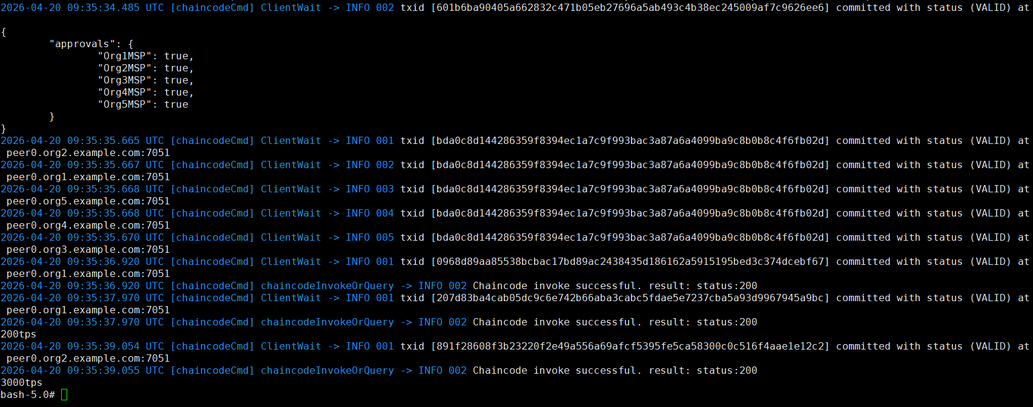

5.3. Start Nodejs SDK

Step 1 (Run): CLI configures the Node.js SDK folder and tls, wallet, and workload files for all peers,
# exit
$ mkdir -p $HOME/fabric-samples/demo-first/workload
$ mkdir -p $HOME/fabric-samples/demo-first/workload/tls
$ mkdir -p $HOME/fabric-samples/demo-first/workload/wallet
$ mkdir -p $HOME/fabric-samples/demo-first/workload/result

$ cd $HOME/fabric-samples/demo-first/workload/tls
$ vi read_pem.py
$ vi prepare_tls_peer0_org1.sh
$ vi prepare_tls_peer0_org2.sh
$ vi prepare_tls_peer0_org3.sh
$ vi prepare_tls_peer0_org4.sh
$ vi prepare_tls_peer0_org5.sh
$ ./all.sh

$ cd $HOME/fabric-samples/demo-first/workload/wallet
$ vi prepare_wallet_user1_org1.py
$ vi prepare_wallet_user1_org2.py
$ vi prepare_wallet_user1_org3.py
$ vi prepare_wallet_user1_org4.py
$ vi prepare_wallet_user1_org5.py
$ ./all.sh

$ cd $HOME/fabric-samples/demo-first/workload
$ mkdir sdk-peer0-org1
$ mkdir sdk-peer0-org2
$ mkdir sdk-peer0-org3
$ mkdir sdk-peer0-org4
$ mkdir sdk-peer0-org5
$ vi invoke.js
$ vi prepare_sdk_peer0_org1.sh
$ vi prepare_sdk_peer0_org2.sh
$ vi prepare_sdk_peer0_org3.sh
$ vi prepare_sdk_peer0_org4.sh
$ vi prepare_sdk_peer0_org5.sh
$ ./all.sh

Step 2 (Prepare): -
Step 3 (Run): Cli prepares wallets of User1@org1.example.com, User1@org2.example.com, …, and User1@org5.example.com,
$ cd $HOME/fabric-samples/demo-first/workload/wallet
$ python prepare_wallet_user1_org1.py
$ python prepare_wallet_user1_org2.py
$ python prepare_wallet_user1_org3.py
$ python prepare_wallet_user1_org4.py
$ python prepare_wallet_user1_org5.py
$ ./all.sh

Step 4 (Run): CLI invokes and queries transactions via Node.js,
$ cd $HOME/fabric-samples/demo-first/workload
$ ./scp.sh // CLI copies files to all machines

$ ./ssh.sh > result/benchlog
$ ls result -l


// $ node query.js
// $ node invoke.js 30 500 20 1

Step 5 (Run): Analyze the log,
// CLI analyzes the log
$ cd $HOME/fabric-samples/demo-first/workload/result
$ python readthroughput_p1.py // rate of sending endorsed txs

$ sudo apt-get install python-numpy
$ python readdelay_p1.py // delay of endorsing phase



// Orderer analyzes the log
$ cd $HOME/fabric-samples/demo-first/workload/result
$ sudo apt-get install python-numpy
//$ docker logs containername >& ordererlog
$ docker logs $(docker ps -a | grep 'orderer'| awk '{print $1 }') >& ordererlog
// $ scp ordererlog chwang@1xx.1xx.7xx.1xx:/home/chwang
$ python readthroughput_p2.py // rate of generating blocks



// Peer analyzes the log
$ cd $HOME/fabric-samples/demo-first/workload/result
$ sudo apt-get install python-numpy
//$ docker logs containername >& peerlog
$ docker logs $(docker ps -a | grep 'peer node start'| awk '{print $1 }') >& peerlog
// $ scp peerlog chwang@1xx.1xx.7xx.1xx:/home/chwang
$ python2 readthroughput_p3.py



// Get block size
# peer channel fetch 228 last.block -o orderer.example.com:7050 -c mychannel --tls --cafile /opt/gopath/src/github.com/hyperledger/fabric/peer/crypto/ordererOrganizations/example.com/orderers/orderer.example.com/msp/tlscacerts/tlsca.example.com-cert.pem

Step 6 (Run): All nodes run the clean procedure,
$ cd $HOME/fabric-samples/demo-first
$ ./clean.sh

6. Run Multi-Nodes Fabric (Exp 4: 7 CLI + 1 Peers + 15 Orderers)

6.1. Prepare the Hosts

Step 1 (Prepare): All machines prepare the host names,
$ vi /etc/hosts

172.31.210.67 cli # CLI

172.31.210.70 peer0.org1.example.com # Endorsing peer 1
172.31.210.71 peer0.org2.example.com # Endorsing peer 2
172.31.210.77 peer0.org3.example.com # Endorsing peer 3
172.31.210.78 peer0.org4.example.com # Endorsing peer 4
172.31.210.79 peer0.org5.example.com # Endorsing peer 5
172.31.210.80 peer0.org6.example.com # Endorsing peer 6
172.31.210.81 peer0.org7.example.com # Endorsing peer 7

172.31.210.82 peer0.org8.example.com # A Non-Endorsing Peer

172.31.210.72 orderer.example.com # Orderer 1
172.31.210.73 orderer2.example.com # Orderer 2
172.31.210.74 orderer3.example.com # Orderer 3
172.31.210.75 orderer4.example.com # Orderer 4
172.31.210.76 orderer5.example.com # Orderer 5
172.31.210.83 orderer6.example.com # Orderer 6
172.31.210.84 orderer7.example.com # Orderer 7
172.31.210.85 orderer8.example.com # Orderer 8
172.31.210.86 orderer9.example.com # Orderer 9
172.31.210.87 orderer10.example.com # Orderer 10
172.31.210.88 orderer11.example.com # Orderer 11
172.31.210.89 orderer12.example.com # Orderer 12
172.31.210.90 orderer13.example.com # Orderer 13
172.31.210.91 orderer14.example.com # Orderer 14
172.31.210.92 orderer15.example.com # Orderer 15

Step 2 (Prepare): CLI prepares the Test-Network files,
$ cd $HOME/fabric-samples
$ mkdir demo-first
$ cd $HOME/fabric-samples/demo-first
$ vi crypto-config.yaml
$ vi configtx.yaml

$ vi peer0-org1.yaml
$ vi peer0-org2.yaml
$ vi peer0-org3.yaml
$ vi peer0-org4.yaml
$ vi peer0-org5.yaml
$ vi peer0-org6.yaml
$ vi peer0-org7.yaml
$ vi peer0-org8.yaml

$ vi orderer1.yaml
$ vi orderer2.yaml
$ vi orderer3.yaml
$ vi orderer4.yaml
$ vi orderer5.yaml
$ vi orderer6.yaml
$ vi orderer7.yaml
$ vi orderer8.yaml
$ vi orderer9.yaml
$ vi orderer10.yaml
$ vi orderer11.yaml
$ vi orderer12.yaml
$ vi orderer13.yaml
$ vi orderer14.yaml
$ vi orderer15.yaml

$ vi cli.yaml

Step 2 (Prepare): All machines prepare the timestamp alignment,
$ date +%s // check the timestamp

$ sudo apt-get install ntpdate // align the timestamp
$ sudo ntpdate cn.pool.ntp.org
$ sudo hwclock –systohc

$ date +%s // check the timestamp again

Step 3 (Run): CLI runs the initial block generation,
$ cd $HOME/fabric-samples/demo-first
$ chmod +x *.sh
$ ./config.sh



Step 4 (Run): CLI scp the contents to all machines including peers and orderers,
$ cd $HOME/fabric-samples/demo-first
$ ./scp.sh



Step 5 (Run): Orderers sets up the Docker container,
$ cd $HOME/fabric-samples/demo-first
$ ./orderer1.sh

$ ./orderer2.sh

$ ./orderer3.sh

$ ./orderer4.sh

$ ./orderer5.sh

$ ./orderer6.sh

$ ./orderer7.sh

$ ./orderer8.sh

$ ./orderer9.sh

$ ./orderer10.sh

$ ./orderer11.sh

$ ./orderer12.sh

$ ./orderer13.sh

$ ./orderer14.sh

$ ./orderer15.sh

$ docker ps

Step 6 (Run): Peer1 sets up the Docker container,
$ cd $HOME/fabric-samples/demo-first
$ ./peer1.sh

$ docker ps

Step 7 (Run): Other peers set up the Docker container,
$ cd $HOME/fabric-samples/demo-first
$ ./peer2.sh

$ ./peer3.sh

$ ./peer4.sh

$ ./peer5.sh

$ ./peer6.sh

$ ./peer7.sh

$ ./peer8.sh

$ docker ps

Step 8 (Run): CLI sets up the docker container,
$ cd $HOME/fabric-samples/demo-first
$ ./cli.sh

$ docker ps

6.2. Start the Network

Step 1 (Run): CLI (of peer0.org1) connects to Peer0.org1.example.com:7051, creates a channel.block, and then all peers join the channel.block,
// CLI goes to `peer0.org1.example.com:7051`
$ docker exec -it cli bash

// Environment Configuration for `peer0.org1.example.com:7051`
# cd scripts
# ./step1.sh // All peers join the channel



# ./step2.sh // All peers join the chaincode



6.3. Start Nodejs SDK

Step 1 (Run): CLI configures the Node.js SDK folder and tls, wallet, and workload files for all peers,
# exit
$ mkdir -p $HOME/fabric-samples/demo-first/workload
$ mkdir -p $HOME/fabric-samples/demo-first/workload/tls
$ mkdir -p $HOME/fabric-samples/demo-first/workload/wallet
$ mkdir -p $HOME/fabric-samples/demo-first/workload/result

$ cd $HOME/fabric-samples/demo-first/workload/tls
$ vi read_pem.py
$ vi prepare_tls_peer0_org1.sh
$ vi prepare_tls_peer0_org2.sh
$ vi prepare_tls_peer0_org3.sh
$ vi prepare_tls_peer0_org4.sh
$ vi prepare_tls_peer0_org5.sh
$ vi prepare_tls_peer0_org6.sh
$ vi prepare_tls_peer0_org7.sh
$ vi prepare_tls_peer0_org8.sh
$ ./all.sh

$ cd $HOME/fabric-samples/demo-first/workload/wallet
$ vi prepare_wallet_user1_org1.py
$ vi prepare_wallet_user1_org2.py
$ vi prepare_wallet_user1_org3.py
$ vi prepare_wallet_user1_org4.py
$ vi prepare_wallet_user1_org5.py
$ vi prepare_wallet_user1_org6.py
$ vi prepare_wallet_user1_org7.py
$ vi prepare_wallet_user1_org8.py
$ ./all.sh

$ cd $HOME/fabric-samples/demo-first/workload
$ mkdir sdk-peer0-org1
$ mkdir sdk-peer0-org2
$ mkdir sdk-peer0-org3
$ mkdir sdk-peer0-org4
$ mkdir sdk-peer0-org5
$ mkdir sdk-peer0-org6
$ mkdir sdk-peer0-org7
$ mkdir sdk-peer0-org8
$ vi invoke.js

$ vi prepare_sdk_peer0_org1.sh
$ vi prepare_sdk_peer0_org2.sh
$ vi prepare_sdk_peer0_org3.sh
$ vi prepare_sdk_peer0_org4.sh
$ vi prepare_sdk_peer0_org5.sh
$ vi prepare_sdk_peer0_org6.sh
$ vi prepare_sdk_peer0_org7.sh
$ vi prepare_sdk_peer0_org8.sh

$ ./all.sh

Step 2 (Prepare): -
Step 3 (Run): Cli prepares wallets of User1@org1.example.com, User1@org2.example.com, …, and User1@org5.example.com,
$ cd $HOME/fabric-samples/demo-first/workload/wallet
$ python prepare_wallet_user1_org1.py
$ python prepare_wallet_user1_org2.py
$ python prepare_wallet_user1_org3.py
$ python prepare_wallet_user1_org4.py
$ python prepare_wallet_user1_org5.py
$ python prepare_wallet_user1_org6.py
$ python prepare_wallet_user1_org7.py
$ python prepare_wallet_user1_org8.py

$ ./all.sh

Step 4 (Run): CLI invokes and queries transactions via Node.js,
$ cd $HOME/fabric-samples/demo-first/workload
$ ./scp.sh // CLI copies files to all machines

$ ./ssh.sh > result/benchlog
$ ls result -l


// $ node query.js
// $ node invoke.js 30 500 20 1

Step 5 (Run): Analyze the log,
// CLI analyzes the log
$ cd $HOME/fabric-samples/demo-first/workload/result
$ python readthroughput_p1.py // rate of sending endorsed txs

$ sudo apt-get install python-numpy
$ python readdelay_p1.py // delay of endorsing phase



// Orderer analyzes the log
$ cd $HOME/fabric-samples/demo-first/workload/result
$ sudo apt-get install python-numpy
//$ docker logs containername >& ordererlog
$ docker logs $(docker ps -a | grep 'orderer'| awk '{print $1 }') >& ordererlog
// $ scp ordererlog chwang@1xx.1xx.7xx.1xx:/home/chwang
$ python readthroughput_p2.py // rate of generating blocks



// Peer analyzes the log
$ cd $HOME/fabric-samples/demo-first/workload/result
$ sudo apt-get install python-numpy
//$ docker logs containername >& peerlog
$ docker logs $(docker ps -a | grep 'peer node start'| awk '{print $1 }') >& peerlog
// $ scp peerlog chwang@1xx.1xx.7xx.1xx:/home/chwang
$ python2 readthroughput_p3.py



// Get block size
# peer channel fetch 228 last.block -o orderer.example.com:7050 -c mychannel --tls --cafile /opt/gopath/src/github.com/hyperledger/fabric/peer/crypto/ordererOrganizations/example.com/orderers/orderer.example.com/msp/tlscacerts/tlsca.example.com-cert.pem

Step 6 (Run): All nodes run the clean procedure,
$ cd $HOME/fabric-samples/demo-first
$ ./clean.sh

Run Multi-Nodes Fabric (Exp 1: 1 CLI + 2 Peers + 1 Orderer)

7.1. Prepare the Hosts

Step 1 (Prepare): All machines prepare the host names,
$ vi /etc/hosts

172.31.210.67 cli
172.31.210.70 peer0.org1.example.com
172.31.210.71 peer0.org2.example.com
172.31.210.72 orderer.example.com

Step 2 (Prepare): CLI prepares the Test-Network files,
$ cd $HOME/fabric-samples
$ mkdir demo-first
$ cd $HOME/fabric-samples/demo-first
$ vi crypto-config.yaml
$ vi configtx.yaml

$ vi peer0-org1.yaml
$ vi peer0-org2.yaml

$ vi orderer1.yaml

$ vi cli.yaml // (of peer0.org1)

$ vi $HOME/fabric-samples/chaincode/abstore/go/abstore.go // our proposed key-value chaincode
$ vi $HOME/fabric-samples/chaincode/abstore/go/go.mod

Step 2 (Prepare): All machines prepare the timestamp alignment,
$ date +%s // check the timestamp

$ sudo apt-get install ntpdate // align the timestamp
$ sudo ntpdate cn.pool.ntp.org
$ sudo hwclock –systohc

$ date +%s // check the timestamp again

Step 3 (Run): CLI runs the initial block generation,
$ cd $HOME/fabric-samples/demo-first
$ chmod +x *.sh
$ ./config.sh



$ cd $HOME/fabric-samples/demo-first/workload/tls
$ chmod +x *.sh

$ cd $HOME/fabric-samples/demo-first/workload
$ chmod +x *.sh
$ wget https://gitee.com/joe32065/fabric_2_2/releases/download/fabric-v2.2.0/node_modules.zip
$ unzip node_modules.zip

$ cd $HOME/fabric-samples/demo-first/scripts
$ chmod +x *.sh

Step 4 (Run): CLI scp the contents to all machines including peers and orderers,
$ cd $HOME/fabric-samples/demo-first
$ ./scp.sh



Step 5 (Run): Orderer1 sets up the Docker container,
$ cd $HOME/fabric-samples/demo-first
$ ./orderer1.sh

$ docker ps

Step 6 (Run): Peer1 sets up the Docker container,
$ cd $HOME/fabric-samples/demo-first
$ ./peer1.sh

$ docker ps

Step 7 (Run): Peer2 sets up the Docker container,
$ cd $HOME/fabric-samples/demo-first
$ ./peer2.sh

$ docker ps

Step 8 (Run): CLI sets up the Docker container,
$ cd $HOME/fabric-samples/demo-first
$ ./cli.sh

$ docker ps

7.2. Start the Network

Step 1 (Run): CLI connects to Peer0.org1.example.com:7051, creates a channel.block, and then all peers join the channel.block,
// CLI goes to `peer0.org1.example.com:7051`
$ docker exec -it cli bash

// Environment Configuration for `peer0.org1.example.com:7051`
# cd scripts
# ./step1.sh // All peers join the channel



# ./step2.sh // All peers join the chaincode



7.3. Start Nodejs SDK

Step 1 (Run): CLI configures the Node.js SDK folder and tls, wallet, and workload files for all peers,
# exit
$ mkdir -p $HOME/fabric-samples/demo-first/workload
$ mkdir -p $HOME/fabric-samples/demo-first/workload/tls
$ mkdir -p $HOME/fabric-samples/demo-first/workload/wallet
$ mkdir -p $HOME/fabric-samples/demo-first/workload/result

$ cd $HOME/fabric-samples/demo-first/workload/tls
$ vi read_pem.py
$ vi prepare_tls_peer0_org1.sh
$ vi prepare_tls_peer0_org2.sh
$ ./all.sh

$ cd $HOME/fabric-samples/demo-first/workload/wallet
$ vi prepare_wallet_user1_org1.py
$ vi prepare_wallet_user1_org2.py
$ ./all.sh

$ cd $HOME/fabric-samples/demo-first/workload
$ mkdir sdk-peer0-org1
$ mkdir sdk-peer0-org2
$ vi invoke.js
$ vi prepare_sdk_peer0_org1.sh
$ vi prepare_sdk_peer0_org2.sh
$ ./all.sh

Step 2 (Prepare): CLI prepares the Nodejs SDK dependencies on CLI. Note that you may pass this step by copying the compiled nodejs source code https://gitee.com/joe32065/fabric_2_2/releases/download/fabric-v2.2.0/node_modules.zip,
$ cd $HOME/fabric-samples/demo-first/workload
$ vi package.json
$ npm install
$ vi $HOME/fabric-samples/demo-first/workload/node_modules/fabric-network/lib/transaction.js

Step 3 (Run): Cli prepares wallets of User1@org1.example.com and User1@org2.example.com,
$ cd $HOME/fabric-samples/demo-first/workload/wallet
$ rm -rf *.id
$ python prepare_wallet_user1_org1.py
$ python prepare_wallet_user1_org2.py
$ ./all.sh

Step 4 (Run): CLI invokes and queries transactions via Node.js,
$ cd $HOME/fabric-samples/demo-first/workload
$ ./scp.sh // CLI copies files to all machines

$ ./ssh.sh > result/benchlog
$ ls result -l


// $ node query.js
// $ node invoke.js 30 500 20 1

Step 5 (Run): Analyze the log,
// CLI analyzes the log
$ cd $HOME/fabric-samples/demo-first/workload/result
$ python readthroughput_p1.py // rate of sending endorsed txs

$ sudo apt-get install python-numpy
$ python readdelay_p1.py // delay of endorsing phase



// Orderer analyzes the log
$ cd $HOME/fabric-samples/demo-first/workload/result
$ sudo apt-get install python-numpy
//$ docker logs containername >& ordererlog
$ docker logs $(docker ps -a | grep 'orderer'| awk '{print $1 }') >& ordererlog
// $ scp ordererlog chwang@1xx.1xx.7xx.1xx:/home/chwang
$ python readthroughput_p2.py // rate of generating blocks



// Peer analyzes the log
$ cd $HOME/fabric-samples/demo-first/workload/result
$ sudo apt-get install python-numpy
//$ docker logs containername >& peerlog
$ docker logs $(docker ps -a | grep 'peer node start'| awk '{print $1 }') >& peerlog
// $ scp peerlog chwang@1xx.1xx.7xx.1xx:/home/chwang
$ python2 readthroughput_p3.py



// For example, we can get block size
# peer channel fetch 2 last.block -o orderer.example.com:7050 -c mychannel --tls --cafile /opt/gopath/src/github.com/hyperledger/fabric/peer/crypto/ordererOrganizations/example.com/orderers/orderer.example.com/msp/tlscacerts/tlsca.example.com-cert.pem

// First, we fetch the latest configuration, where we will pull the channel configuration in protobuf format and create a file called config_block.pb as follows,
# peer channel fetch config config_block.pb -o orderer.example.com:7050 -c mychannel --tls --cafile /opt/gopath/src/github.com/hyperledger/fabric/peer/crypto/ordererOrganizations/example.com/orderers/orderer.example.com/msp/tlscacerts/tlsca.example.com-cert.pem

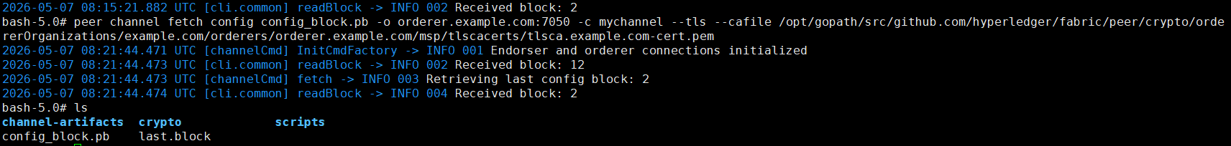

// Second, we convert the configuration file named config_block.pb to JSON file named config.json, as follows,
# configtxlator proto_decode --input config_block.pb --type common.Block | jq .data.data[0].payload.data.config > config.json

We can check that the initial BatchSize is 60, as follows,

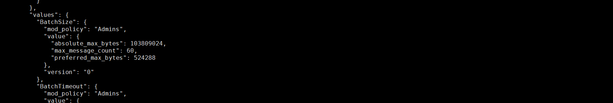

// Third, we will dynamic update the BatchSize value from 60 to 80, and save the modified json file as modified_config.json, we can check the modified BatchSize named modified_config.json as follows,
# MAXBATCHSIZEPATH=“.channel_group.groups.Orderer.values.BatchSize.value.max_message_count”
# jq “$MAXBATCHSIZEPATH” config.json
# jq “$MAXBATCHSIZEPATH = 20” config.json > modified_config.json
# jq “$MAXBATCHSIZEPATH” modified_config.json

We can check the modified BatchSize is 80, as follows,

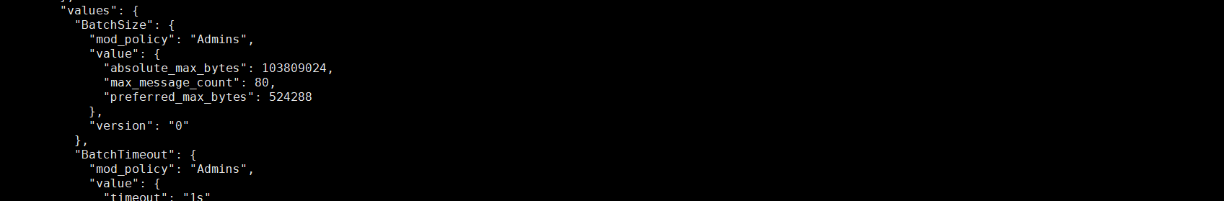

// Fourth, we convert the json to protobuf, where we convert the initial config.json to config.pb and convert the modified_config.json to modified_config.pb, as follows,
# configtxlator proto_encode --input config.json --type common.Config --output config.pb
# configtxlator proto_encode --input modified_config.json --type common.Config --output modified_config.pb

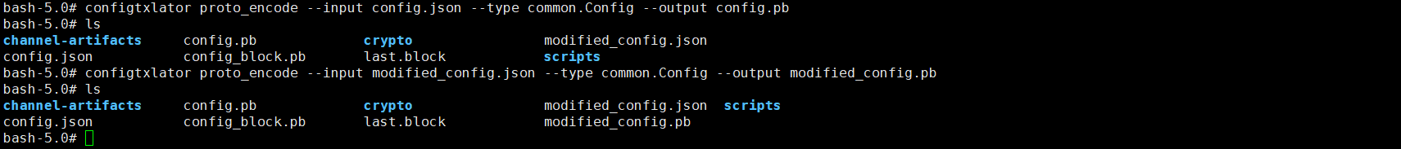

// Fifth, we calculate the difference between config.pb and modified_config.pb, and the difference is named final_update.pb, as follows,
# configtxlator compute_update --channel_id mychannel --original config.pb --updated modified_config.pb --output final_update.pb

// Sixth, we update the difference to the envelope, and apply the changes to the config, as follows,
# configtxlator proto_decode --input final_update.pb --type common.ConfigUpdate | jq . > final_update.json
# echo "{\"payload\":{\"header\":{\"channel_header\":{\"channel_id\":\"mychannel\", \"type\":2}},\"data\":{\"config_update\":"$(cat final_update.json)"}}}" | jq . > header_in_envolope.json
# configtxlator proto_encode --input header_in_envolope.json --type common.Envelope --output final_update_in_envelope.pb

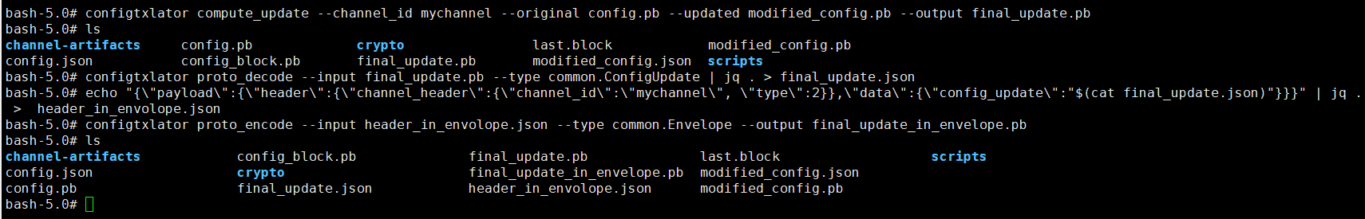

// Seventh, we sign this update proto as orderer, as follows,
# peer channel signconfigtx -f final_update_in_envelope.pb

// Eighth, we set some environment variables for orderer, as follows,
# peer channel update -f final_update_in_envelope.pb -c mychannel -o orderer.example.com:7050 --tls --cafile /opt/gopath/src/github.com/hyperledger/fabric/peer/crypto/ordererOrganizations/example.com/orderers/orderer.example.com/msp/tlscacerts/tlsca.example.com-cert.pem

# CORE_PEER_MSPCONFIGPATH=/opt/gopath/src/github.com/hyperledger/fabric/peer/crypto/peerOrganizations/org1.example.com/users/Admin@org1.example.com/msp CORE_PEER_ADDRESS=peer0.org1.example.com:7051 CORE_PEER_LOCALMSPID="Org1MSP" CORE_PEER_TLS_ROOTCERT_FILE=/opt/gopath/src/github.com/hyperledger/fabric/peer/crypto/peerOrganizations/org1.example.com/peers/peer0.org1.example.com/tls/ca.crt peer channel update -o orderer.example.com:7050 -c mychannel -f final_update_in_envelope.pb --tls --cafile /opt/gopath/src/github.com/hyperledger/fabric/peer/crypto/ordererOrganizations/example.com/orderers/orderer.example.com/msp/tlscacerts/tlsca.example.com-cert.pem

# peer channel update -f final_update_in_envelope.pb -c mychannel -o orderer.example.com:7050 --tls --cafile /opt/gopath/src/github.com/hyperledger/fabric/peer/crypto/ordererOrganizations/example.com/orderers/orderer.example.com/msp/tlscacerts/tlsca.example.com-cert.pem

Step 6 (Run): All nodes run the clean procedure,
$ cd $HOME/fabric-samples/demo-first
$ ./clean.sh

Ref: https://medium.com/coinmonks/modifying-the-batch-size-in-hyperledger-fabric-v2-2-3ec2dd779e2b
Ref: Updating a channel configuration — Hyperledger Fabric Docs main documentation

