1. Write at least an example of what you would test for each of the following types of testing:

**Component testing**

Example: [www.altex.ro](http://www.altex.ro)

Purpose: testing the web element in the header with the name altex

Descrition: I clicked on the web element with the name Altex

Expected result: redirection to the page with offers and promotions in different categories

Screenshot:

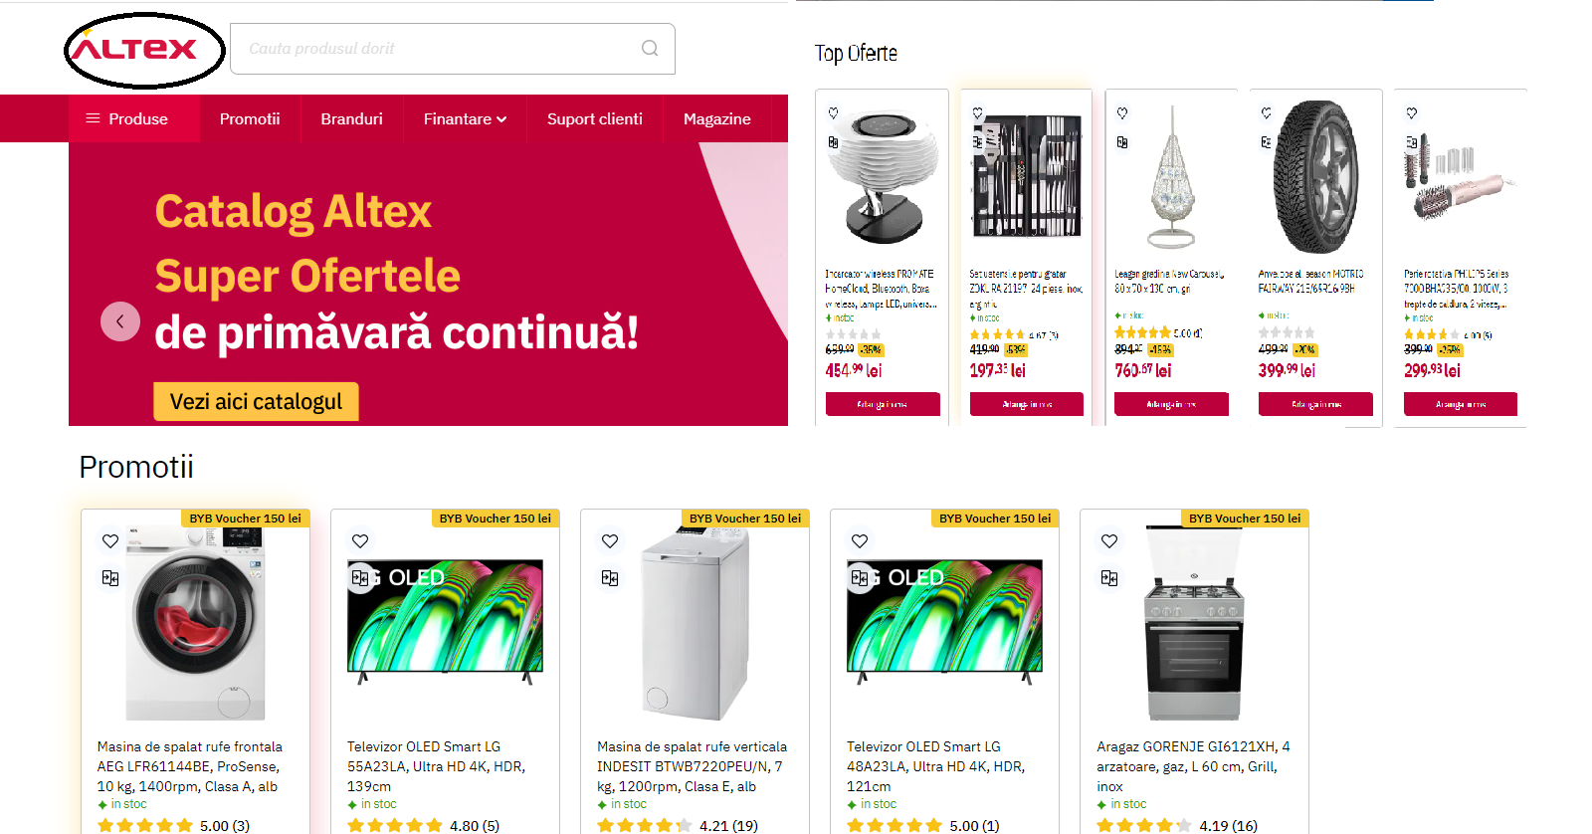

**Integration testing**

Example: Transporeon

Purpose: Check the process from accepting offers to assigned transport

Description: Choose the shipment on the left side, after that on the right side you have the option send the offer

Expected result: The selected transport will appear from the offers section to the unconfirmed transports section

Purpose: Check the process from the unconfirmed transports section to assigned transport

Description: Select the desired transport from unconfirmed routes and select the transport acceptance option, then assign the truck to the route

Expected result: The desired shipment should appear in assigned shipments

**System testing**

Example: [www.](http://www.zara.com)dedeman .ro

Purpose: Testing the browsing of the monthly catalog, choosing a product and opening it by clicking in the website's online store

Description: The main page opens, we have the image of the catalog, we click on it, we choose one of the products and once chosen, it should send us to the virtual space of the store where we can find details about the product

Expected result: it should send us to the virtual space of the store where we can find details about the product

Screenshot:

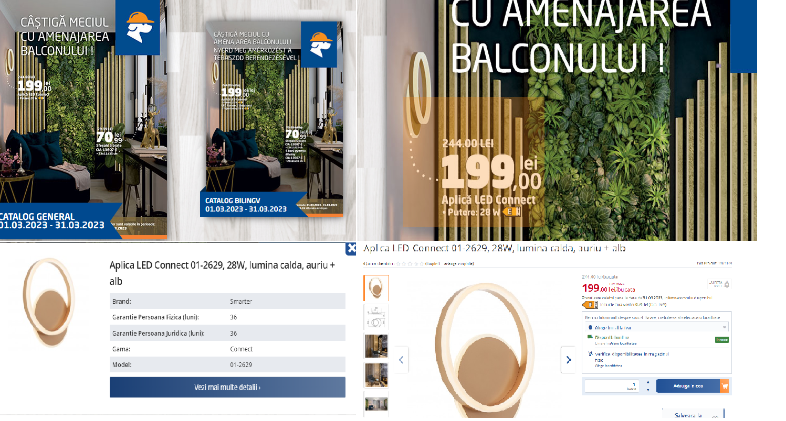

**Usability testing**

Example: App E-on My Line

Purpose: Testing if we can log in, how long it takes to log in with face ID and if we can pay several bills at the same time

Description: Enter the E-on MyLine , log in with face ID, choose two payment invoices from different months

Expected result: We expect the application to run quickly by choosing the make id method and to be able to choose to pay several bills at the same time

**Localisation testing**

Example: Setup date/hour desktop

Purpose: To test if the user can choose the time zone depending on the location

Description: Choose adjust date/time ( desktop)  and the status window opens, we have the time zone section

Expected resulted: To be able to choose time zones depending on the area

2. **UAT**

**Which is the purpose of WhatsApp? How would you test to see if the objective of this application has been met?**

* it is tested if it connects on whatsapp web
* it is tested if mobile messages are synchronized with those on the website
* it is tested if the read messages are marked with the two blue ticks
* it is tested if the audio call and video call option works
* it is tested if the emoticon options work
* it is tested the option to create groups
* it is tested the direct photo option from the application
* it is tested the option to publish short videos in the status option
* it is tested if the settings section complies with the requirements

3. **Smoke Testing**

**Which are the main components of the next two websites?**

The two sites being e-commerce, the most important components are:

- to create an account

- to be able to log in

-to be able to choose the desired products in the cart

- to be able to place the order

- to be able to pay through the given options

**What is the minimum number of tests you would run, within this type of testing, and what would they be?**

* Component Testing, Integration Testing and System Testing

