Group 3

Kirsten | Ate-jah | Mohan | James

Software Development Plan

Shannon’s organized planner

# **Group 3**

**Risk Mitigation Plan**

**Risk:**

Differing levels of programming ability/knowledge of team members.

**Probability:**

Probability is 100%. During group meetings, it has become apparent that some team members not as proficient computer programmers as others.

**Impact: 4**

If a team member is assigned a task that they are unable to complete, this will affect successfully meeting project deadlines. This could also result in delivering software that is not fully tested and possibly unstable.

**Mitigation:**

Assign software development tasks during early project phases. Tasks should also be assigned based on team members strengths.

**Risk:**

Client does not approve of finished product.

**Probability:**

Low. The group will meet with the client at least twice to discuss project requirements.

**Impact: 3**

If the client is not satisfied with the finished product, it will limit the usefulness of the software to the client. This may result in the client requesting the product be changed to meet their satisfaction. This would result in countless additional work hours to redesign the software.

**Mitigation:**

As previously stated, the group will meet the client at least twice to discuss design requirements. The group will use these opportunities to ensure both parties have an understanding of project requirements and what the final product features will look like. As well, if at any time during development, if the group feels they are missing data on certain features, the group can request to get in contact with the client through the course instructor to receive clarification.

**Risk:**

Client changes a project requirement.

**Probability:**

Low. The group will meet with the client at least twice and will thoroughly discuss project requirements.

**Impact: 2**

The group would have to redesign the software, possibly from scratch. This would add countless additional work hours and/or delay delivery of finished product.

**Mitigation:**

The group will use meeting times with the client to discuss thoroughly the project requirements, thereby reducing the possibility that the client will have additional requirements as work on the project progresses.

**Risk:**

Loss of work hours due to weather related calamities.

**Probability:**

Low. Hurricane season for HRM is nearing its end and winter weather should not adversely affect HRM until after project delivery.

**Impact: 2**

Hurricane or winter storms (with or without power outages) can result in lost productivity of the group and individuals. This may be due to missed group meetings, inability to contact group members for assistance on project requirements, or in ability to work on project due to power loss.

**Mitigation:**

Begin work on the project early, thereby avoiding last minute rush to complete the project, resulting in possibly missing project deadline if there is a weather-related loss of time.

**Risk:**

Missed meeting time due to client absence.

**Possibility:**

Unknown. Client is a resident of an assisted living community, and they possibility exists (as with anyone) that there may be unscheduled medical appointments.

**Impact: 1**

Loss of contact with the client during software developed period could result in a finished product that does not meet client requirements/expectations.

**Mitigation:**

Find extra time to make up for the meeting

|If a meeting time with the client is missed, the group will liaise with course instructor to arrange an alternate meeting time with the client.

**\* impact scale 1-5**

**Installation/Maintenance plan**

To install Shannon’s Organized Planner, you will need to create a MySQL database on the server. It will have two tables. Event; Id, title, start day, start time, end day, end time, reminder, notes. user; Id, username, email, password. Then upload the source files and the Calendar will function. To get an in-depth explanation visit the *Installation and Maintenance Guide*.

**Configuration management plan**

We will use local copies on our own pcs and then have a separate copy on the server. We will also use GitHub to manage project prototypes.

**GitHub**: <https://github.com/Caniscarica/Organized-Planner>

**Proposed standards, procedures, techniques, and tools**

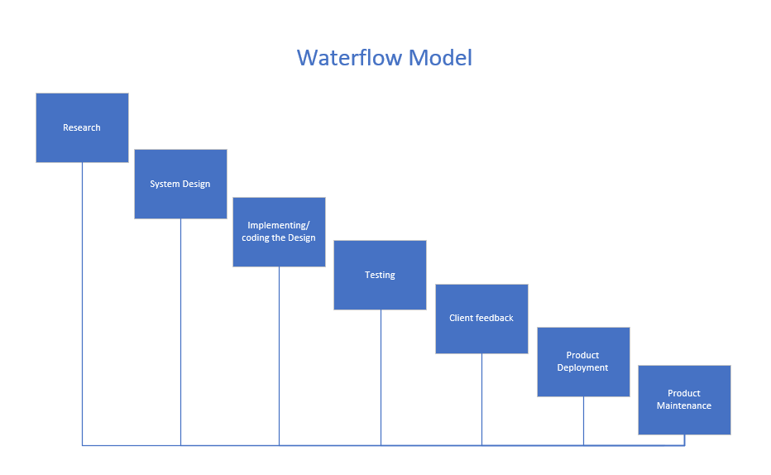

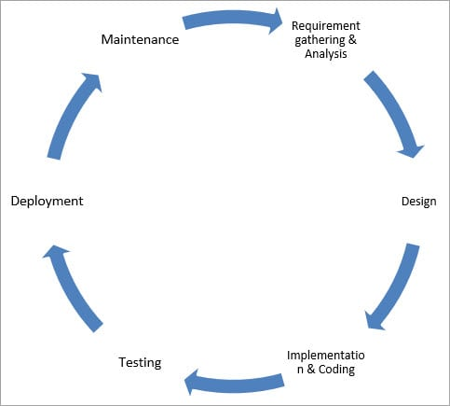

Operating system: Windows 10

Languages: PHP 7.2.24 (install), JavaScript 1.7, CSS, HTML5

Frameworks: Bootstrap 4.3.1, jQuery 3.4.1, ajax

Databases: MySQL 5.7.28

Tables in Database: Event, user

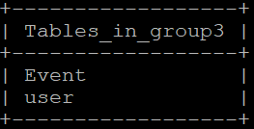

Event

Key: EventID

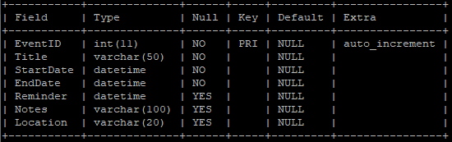

User

Key: id

