1.0 Purpose

This Software Requirements Specification document describes the behavior of the Login System for “Shannon’s Organized Planner”. It includes use case diagrams that describes the expected behavior between the user and the software. It describes the functional and non-functional requirements. As well as the design constraints and process constraints.

Requirement Functionality
2.1 Login Functionality:

2.1.1 The log in should take the input of the correct username and password then log the user into their respective calendars.
2.1.2 It allows user to connect using social networking account like Facebook, Twitter or Linkedin.
2.1.3 It is desirable that the user must be able to sign up. Signing up entails registering with the website. Allowing the database to have their information such as email, password and username.
2.1.4 It is essential that the user’s login username and password is stored.
2.1.5 It is essential that the program must store the login-state in the server session.
2.1.6 It is essential after logging in the user will be able to access their personal data.

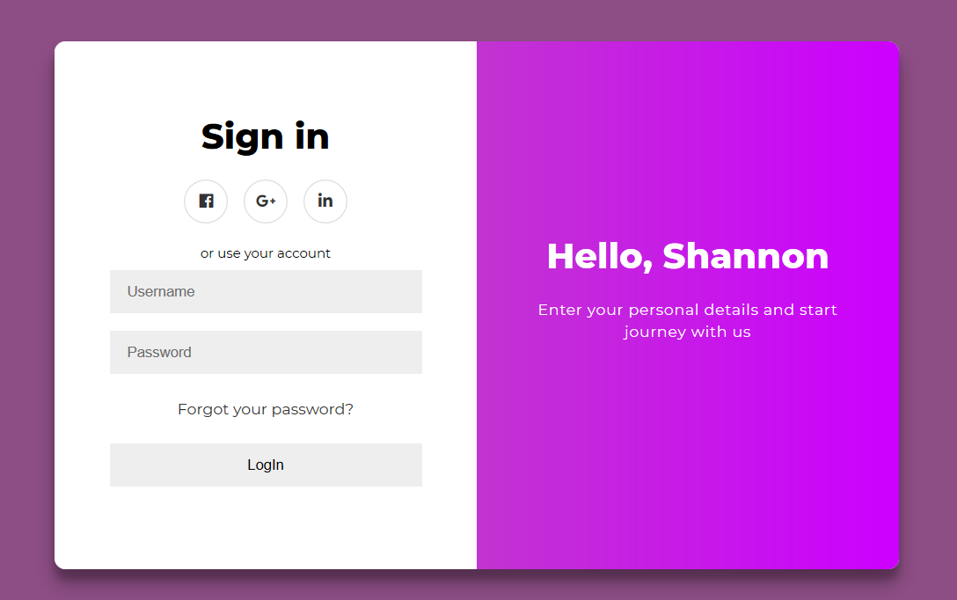

2.2 Logout Functionality:
2.2.1 After a Successful login on the home page top navigation bar on right-hand-side shall allow the user to logout.
2.2.2 After logout the user shall be taken back to the home page.
2.2.3 After logout all connection to server should be disconnected.

2.3 Add event Functionality
2.3.1 After a successful login on the home page user should be able to add events to a calendar.
2.3.2 The Add Event form shall appear when the Add Event button in the top right-hand corner is pressed as it appears in figure 3.
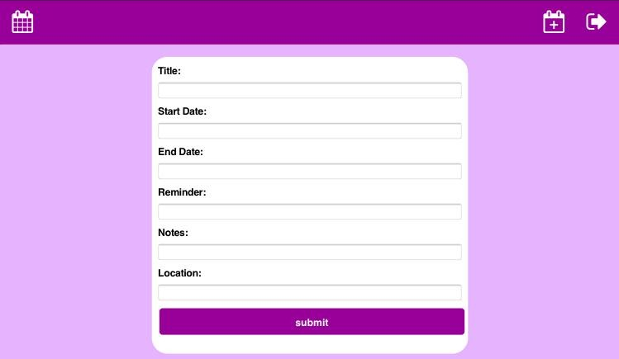Figure 3

2.3.3 The application shall not allow an event to be submitted without an event name or start date.
2.3.4 All fields in the Add Event form shall take user input, such as the title, start and end date, reminder, notes and location.
2.3.5 The Add Event form shall return to the Calendar View when a form is successfully.
2.3.6 Submitted events shall appear in the Calendar View and Day view submitted as it appears in figure 2.
2.3.7 Application should store and retrieve information for the event accurately as provided by the user

2.4 Delete event Functionality
2.4.1 After a successful login on the home page user should be able to add events to a calendar.
2.4.2 The Event should be deleted when the Delete Event button in the top right-hand corner is pressed.
2.4.3 Deleted event should be removed from a calendar view and Day View.

3.0 User Interface
The user interface will be accessible via any standard web browser.

3.0.1 Inputting sever link in a web browser shall launch the application.
3.0.2 The opening screen appears as in Figure 1.

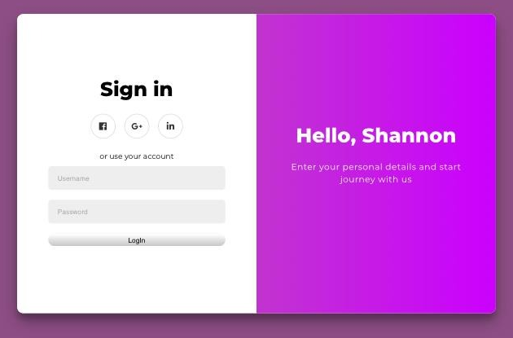
Figure 1

3.0.3 Placing the cursor into both input fields presents virtual keyboard (mobile device only).
3.0.4 Application shall generate error message if username and/or password is incorrect/missing. The error message states that the incorrect username and password combination was used.
3.0.5 Application permits user to successfully login if username and password are both correct.
3.0.6 Calendar View upon successful login appears as in Figure 2.


Figure 2.

Non-Functional Requirements
4.0 Low-Level Requirements.

4.0.1 Password field should not accept more than 15 characters.
4.0.2 Password field should not accept less than 6 characters.
4.0.3 Password entered should not be visible and only dots should be displayed.
4.0.4 Application shall generate error message if username and/or password is incorrect/missing.
4.0.5 Application shall not allow login if username and/or password are incorrect/missing.

4.1 Switch View
4.1.1 Application shall switch to Day view when in Calendar view by pressing Toggle view button at the top left-hand corner.
4.1.2 Application shall switch to Calendar view when in Day view by pressing Toggle view button at the top left-hand corner.

4.2 Background Notification.
4.2.1 Application should always be active and tracking time to throw a reminder as schedule by user.

5.0 Design Constraints

5.0.1 Hardware Limitations
5.0.1.1 Hardware limitations are defined by the limitations of web server and database server (SQL).
5.0.2 Software Limitations
5.0.2.1 Software limitations are defined by the limitations of the web server and the database.

