USER MANUEL FOR

SEARCH BY QUESTION PROJECT

1.SEARCH BY QUESTION ASKING HOMEPAGE

Query Homepage provide to enter the 5W 1H(What,Where,When,Why,Who,How) type questions. If the users want to ask the questions,user should select the question patterns. When users do not select any question type on the page, users can not enter the question to find their answers.In addition, Users select the possible question types under the “Alternative Possibilities” part thanks to Spell Checker if users enter the wrong questions. If users click “About us” link under the page, They can see Search By Question homepage to get more information.

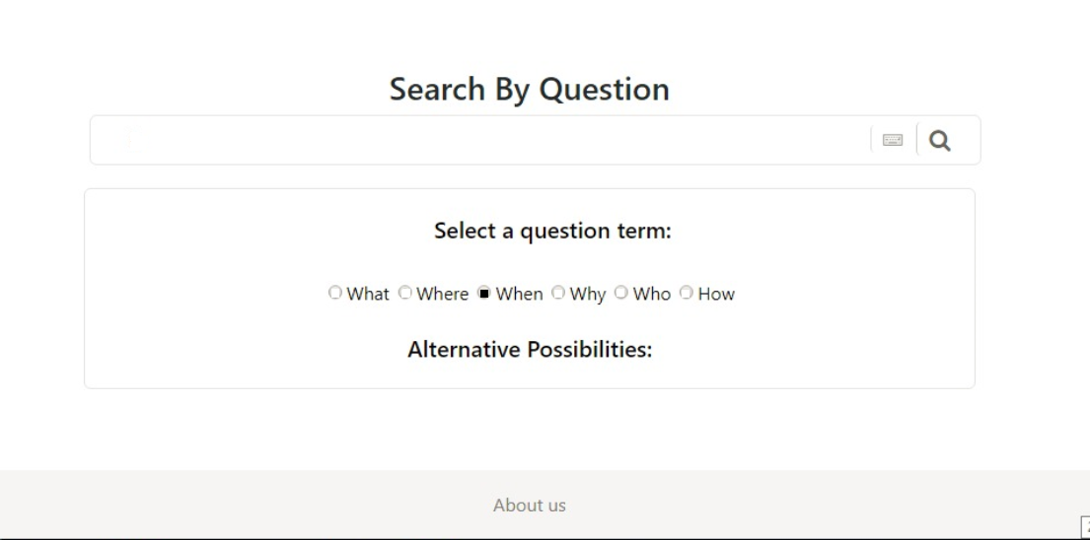

Figure 1.0 Search By Question Main Page

In addition, the main page has a virtual keyboard to right of the search box which is optional feature for the system. According to the figure 1.0, the user selected the “When” question type and we suppose the user enter the “When was Atatürk die?” as in the following figure 2.0.

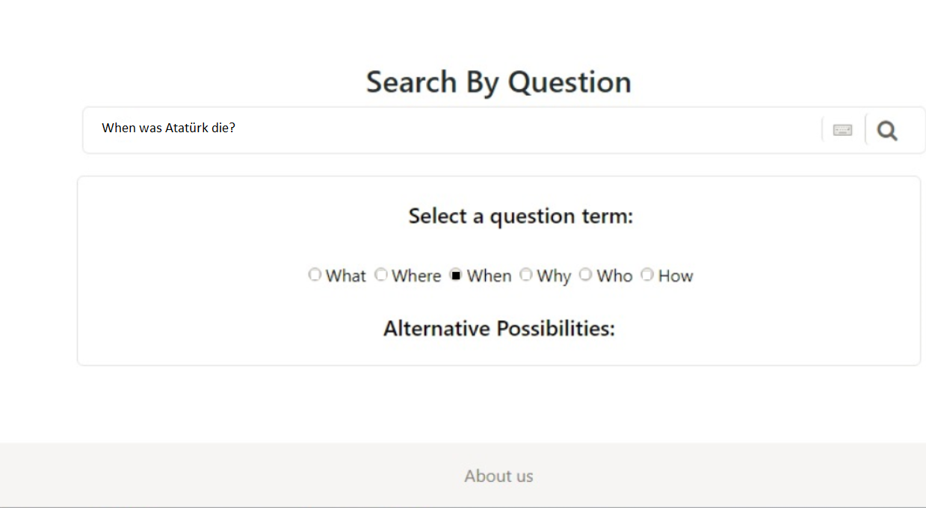

Figure 2.0 Asking Question on Search By Question Main Page

When the user click the search icon,the answer page becomes following figure3.0.

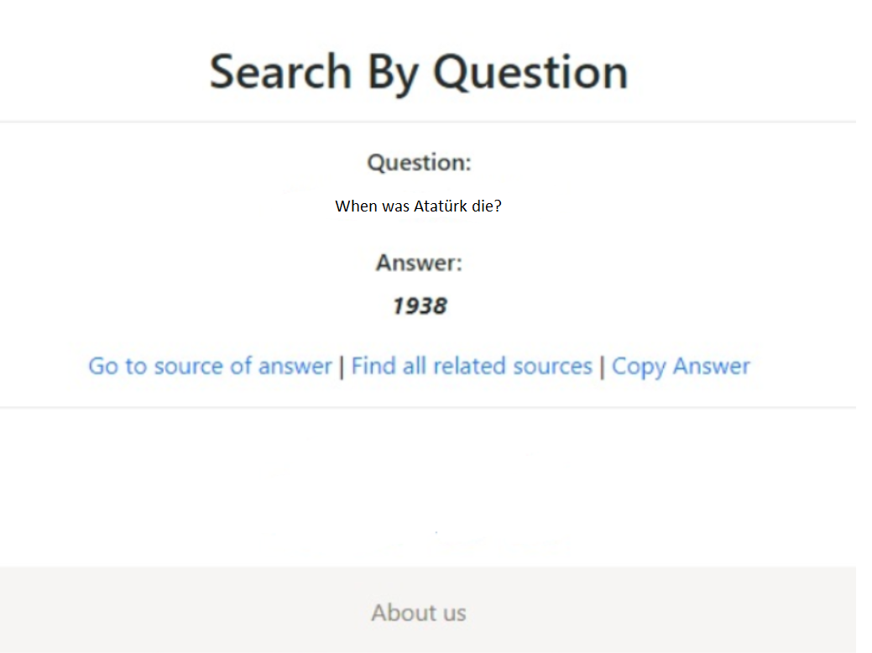

Figure3.0 Search By Question Result Page.

If user want to see source of answer,user should click the “ Go to source of answer” link under the page. There are many releated answer about of question topics.If user want to see all releated source, user should click the “Find all related sources” link undur the page.In additio, Result page has the Copy Answer link which is optional selection for users.When users need the their answers to copy,They should click the “Copy Answer” link on result page figure3.0.