**ÇANKAYA UNIVERSITY**

Software Requirements Specification

# Diet Plan Builder And Nutritional Value Counter

**Berke EREN-201311019, Burak ALIM-201211301, Furkan Elbasan-201611664**

**23.11.2018**

# Table of Contents

İçindekiler

Diet Plan Builder And Nutritional Value Counter 1

Table of Contents 1

1. INTRODUCTION 4

1.1 Purpose 4

1.2 Scope of Project 4

1.3 Glossary 5

1.4 References 5

1.5 Overview of the Document 5

2. OVERALLDESCRIPTION 6

2.1 Product Perspective 6

2.1.1 Development Methodology 6

2.2 User Characteristic 7

3.1.1 Participants 7

2.1.2 Admin 7

2.1.3 Expert 7

3. REQUIREMENTSSPECIFICATION 7

3.1 External Interface Requirements 7

3.1.1 User Interfaces 7

3.1.2 Hardware Interfaces 7

3.1.3 Software Interfaces 7

3.1.4 Communications Interfaces 7

3.2 Functional Requirements 8

3.2.1. Profile Management Use Case 8

3.2.2. User AndGuest Menu Use Case 9

3.2.3. ExpertLoginUse Case 10

3.3 Performance Requirement 12

3.4 Software System attributes 12

3.4.1. Portability 12

3.4.2. Performance 12

3.4.3. Usability 12

3.4.4. Adaptability 12

3.4.5. Scalability 12

3.5 Safety Requirement 13

4. REFERENCES 13

**List of Figures**

Figure 1 Structure of Waterfall

# INTRODUCTION

## Purpose

The purpose of this document is describing the application which is called Diet Plan Builder and Calorie Counter. Purpose of this application is to make a diet program with calculating calories of foods for people that wants to eat healthy. This document includes detailed information about requirements of the project. It reflects the identified constraints and proposed software functionalities. Moreover, the SRS document explains how participants interact with the application. This document explains how concerns of the stakeholders are met.

## Scope of Project

Nearly all human beings know that they should eat healthy things but they don’t know how to do it properly. Also, maybe they know what to eat but don’t know how much. In addition to these, generally in hospitals, doctors give diet program that wrote on a paper and sometimes this paper would lose. Applications solve lost diet program but there are not much of them to give solution to other problems. The project has become necessary to develop due to lack of these applications.

Diet Plan Builder and Calorie Counter aims to design “Making Diet Program with Calories of foods” as a standalone application. To reach more people we chose android operating systems instead of iOS operating system [1]. This operating system allows the participants to interact with application more easily. These interactions occurs by choosing making a diet planner in application or see nutritional values of foods using their fingers Apart from planning diet and seeing nutritional values of foods, this application also includes an expert page so doctors check the diet and make sure it is healthy. This project creates opportunities such as frequent repeating, easier access, efficient cost etc.

There are three actors in the application which are participant, expert and admin. Participant can choose Make a Diet or Nutritional Values tabs in application. Make a Diet section is going to using for making a diet with specifications. Nutritional Values section is for see nutritional values of foods. Another actor is expert. It can change diets. Last actor is admin. Admin have permission that can add or remove experts.

## Glossary

|  |  |
| --- | --- |
| **Term** | **Definition** |
| Participant | The user who interacts with the application. Generally persons that want to know nutritional values of foods and want to eat healthy. |
| Admin | Person that decide about experts. |
| Expert | Persons that check diet plans. Generally dieticians. |
| Stakeholders | Any person who has contribution in the project. |
| Android | Operating system that generally used for mobile phones.[1] |

## References

[1] Apple vs. Android. 2017. Apple vs. Android-A comparative study 2017. [ONLINE] Available at: <https://android.jlelse.eu/apple-vs-android-a-comparative-study-2017-c5799a0a1683>. [Accessed 21 November 2018]

## Overview of the Document

The second part of the document describes functionalities of the Diet Plan Builder and Calorie Counter. Informal requirements are described and it is a context for technical requirement specification in the Requirement Specification chapter.

Requirement Specification chapter is written for software developers and details of the functionality of the application are described in technical terms.

Both of the sections describe the functionalities of the same product. However, it is described differently because they are intended for different audiences.

# OVERALLDESCRIPTION

## Product Perspective

Diet Plan Builder and Calorie Counter is an application that has 2 purposes. They are making diet plan and show nutritional values of foods. The project divided into two parts: make a diet mode and nutritional values mode.

Make a diet mode had 2 segments. One of that is choosing category of food and the other one is choosing foods that participant doesn’t want to eat. Nutritional values mode has no segment. It just lists foods and their nutritional values.

### Development Methodology

**There are 12 development models;**

Waterfall Model Extreme Programming Methodology

Prototype Methodology Feature Driven Development

Agile Software Development Methodology Joint Application Development Methodology

Rapid Application Development Lean Development Methodology

Dynamic System Development Model Methodology Rational Unified Process Methodology

Spiral Model Scrum Development Methodology

Waterfall Model is very simple and easy to handle according to other development models, that’s why we planning to use Waterfall Model. Waterfall model based on doing the processes into a linear flow with a specified sequence. Also have very important advantages;

**1**. Easy to understand and functional

**2**. Simple enough to handle

**3**. Saves substantially amount of time

**4**. Permits easy testing and analysis

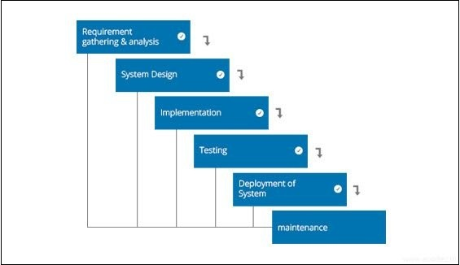

Figure 1 Structure of Waterfall Model

## User Characteristic

### Participants

* + - 1. Participant must read and understand Turkish language due to simulation language is Turkish.
      2. Participant must know how to use mobile phone with touch screen.



### Admin

* + - 1. Admin must read and understand Turkish language due to simulation language is Turkish.
      2. Admin must know how to use a computer.

### Expert

2.2.3.1. Expert must be a dietician.

2.2.3.2. Expert must read and understand English language due to application language is English.

2.3.3.3. Expert must to know how to use mobile phone with touch screen.

# REQUIREMENTSSPECIFICATION

## External Interface Requirements

### User Interfaces

The user interface will be worked on Android.

### Hardware Interfaces

The application needs a mobile phone that has touch screen.

### Software Interfaces

The application needs Android Studio and MySQL softwares.

### Communications Interfaces

There are no external communications interface requirements.

## Functional Requirements

### 3.2.1. Profile Management Use Case

**Use Case:**

* User Login
* Expert Login
* Guest Login
* Log Off
* Choose Language
* Sign Up

**Diagram:**

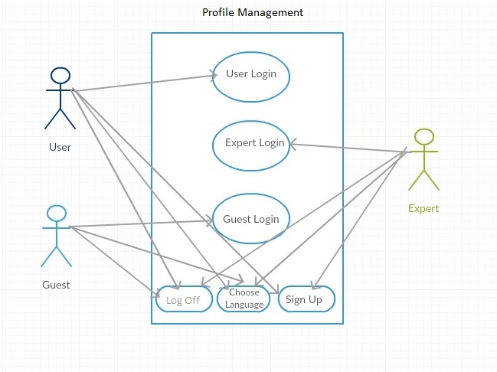

Figure 2 Profile Management Use Case

**Brief Description:**

In Profile Management diagram explains the basic operations which is related to entering system of user, guest and expert. User, Guest and Expert are able to use the following function: Log Off, Choose Language and Sign Up. Except those, User able to also use User Login function, Guest able to also use Guest Login function and Expert able to also use Expert Login function.When User, Guest or Expert choose to choose language, they can use different languages.

**Initial Step by Step Description:**

1. Guest would start system without login
2. User would start to the system with password
3. Expert would start to system with password.
4. Guest, User and Expert can choosel anguage.
5. Guest, User and Expert can exit from the system with Log Off.
6. Guest, User and Expert can choose languages.

### 3.2.2. User AndGuest Menu Use Case

**Use Case:**

* Choose Nutrition
* Choose Food
* Diet Plan
* Log Off
* Confirm

**Diagram:**

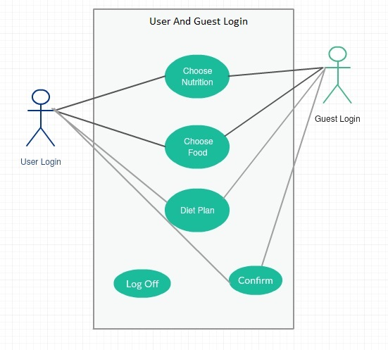

Figure 3 User And Guest Login Menu Use Case

**Brief Description:**

Figure shows User and Guest login menu use case diagram.When User and Guess entered choose nutrition, they choose the mode of nutrition. Then User and Guess can execute function of choose food. Once and for all, the diet plan created for user and guess.

**Initial Step by Step Description:**

1. User started system with password.
2. Guess started system without password.
3. User and Guest would choose nutrition.
4. User andGuess would choose food with the calories of meal.
5. User and Guess can view menü in diet plan.
6. User and Guess can confirm.

### 3.2.3. ExpertLoginUse Case

**Use Case:**

* Members List
* Log Off
* Check

**Diagram:**

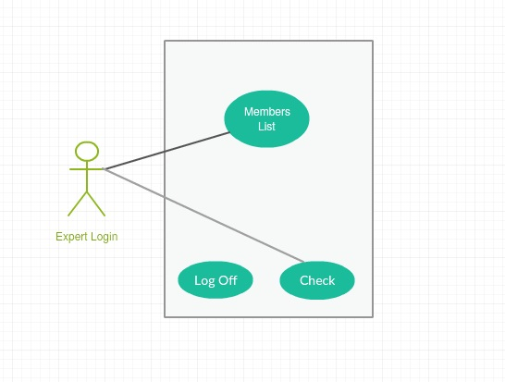

Figure 4 Expert Login Use Case

**Brief Description:**

Figure shows Expert login menu use case diagram. After User and Guest has approved the diet plan, expert can view diet plan on the members list. When expert view diet plan, she/he can reject or confirm. Once and for all, Expert can check the diet plans.

**Initial Step By StepDescription:**

1. Expert started system with password.
2. Expert view the diet menu in members list.
3. Expert can choose reject or confirm.
4. Expert can use check and log off.

## Performance Requirement

Program should run smoothly and stable in the device, The minimum system requirements are as following;

1. Android 2.3 or later
2. 512 MB of RAM
3. Also an Internet Connection is needed

## 3.4 Software System attributes

### 3.4.1. Portability

Program can be run in any android devices that provides the minimum system requirements. Also with the membership system, all information of the member is reachable by user with using username and password from any device.

### 3.4.2. Performance

Creating of a diet program can be done in seconds. It requires fast processing of dataset and fast synchronization with the programs interface.

### 3.4.3. Usability

Creation of the diet program be able to done according to be compatible with different nutritional styles like kethogenic etc...

### 3.4.4. Adaptability

Program should be able to handle the situation if user changes his/her mind and wants to change nutrition style that will be using in building of the diet program.

### 3.4.5. Scalability

Program will already process a huge dataset in seconds. There is an overloading situation cannot be come up.

## 3.5 Safety Requirement

Program provides an expert approval system to confirm the created diet plan. It saves users from the health problems that can be emerging from using an incompatible diet plan.

## REFERENCES