**ÇANKAYA UNIVERSITY**

Software Design Document

# Diet Plan Builder & Calorie Counter

**Berke EREN-201311019, Burak ALIM-201211301, Furkan Elbasan-201611664**

**23.11.2018**

# Table of Contents

Contents

Diet Plan Builder & Calorie Counter 1

Table of Contents 1

1. INTRODUCTION 3

1.1 Purpose 3

1.2 Scope of Project 4

1.3 Glossary 5

1.4 Overview of the Document 5

1.5 Motivation 5

2. ARCHITECTURE DESIGN 6

2.1. Program Design Approach 6

2.1.1 Class Diagram 7

2.2 Architecture Design of Application 8

2.2.1 Login System 8

2.2.2 Diet Plan Builder 8

2.2.3 Validation System 8

2.2.4 Choose Language 9

3. USE CASE REALIZATIONS 9

3.1 Brief Description of Figure 3 10

3.1.1 Sound Design 10

3.1.2 Gui Design 10

3.1.3 Database Design 10

4. References 10

**List of Figures**

Figure 1 Structure of Waterfall

Figure 2 Class Diagram

Figure 3 Project Component of Diet Plan Builder

# INTRODUCTION

## Purpose

The purpose of this Software Design Document is describing the application which is called Diet Plan Builder and Calorie Counter.

The target audience is people that want to eat healthy or want to know nutritional values of foods that they eat.

Diet Plan Builder and Calorie Counter aims to design “Making Diet Program with Calories of foods” as a standalone application. To reach more people we chose android operating systems instead of IPhone operating system [1]. This operating system allows the participants to interact with application more easily. These interactions occurs by choosing making a diet planner in application or see nutritional values of foods using their fingers Apart from planning diet and seeing nutritional values of foods, this application also includes an expert page so doctors check the diet and make sure it is healthy. This project creates opportunities such as frequent repeating, easier access, efficient cost, etc.

Android is used to extend approachability of this project. Android is operating system that used in smart phones so it includes managing touchscreen.

In order to provide a better comprehension, this SDD includes various diagrams such as UML diagram of the project, activity diagram and block diagram.

## Scope of Project

This document contains a complete description of the design of Diet Plan Builder and Calorie Counter.

Eclipse Software Development Kit (SDK) is open-source software that means is free under the terms of the Eclipse Public License. The Eclipse Software Development Kit (SDK) includes java development tools. Users can install plug-ins written for Eclipse Platform or write and contribute their own plug-in modules.

Scripting part of the project is occurred using Java scripts. Java is a general-purpose computer-programming language that is concurrent, class-based and object oriented. [3] The reason to choose this language is all members of our group have knowledge of Java or want to have knowledge about it and Java is one of the most important programming language that can be used in Android Studio.

There are three actors in the application which are participant, expert and admin. Participant can choose Make a Diet or Nutritional Values tabs in application. Make a Diet section is going to using for making a diet with specifications. Nutritional Values section is for see nutritional values of foods. Another actor is expert. It can change diets. Last actor is admin. Admin have permission that can add or remove experts.

## Glossary

|  |  |
| --- | --- |
| **Term** | **Definition** |
| Participant | The user who interacts with the application. Generally persons that want to know nutritional values of foods and want to eat healthy. |
| Admin | Person that decide about experts. |
| Expert | Persons that check diet plans. Generally dieticians. |
| Stakeholders | Any person who has contribution in the project. |
| Android | Operating system that generally used for mobile phones.[1] |

## Overview of the Document

The remaining chapters and their contents are listed below.

Section 2 is the Architectural Design which describes the project development phase. Also it contains class diagram of the system and architecture design of the simulation which describes actors, exceptions, basic sequences, priorities, pre-conditions and post conditions. Additionally, this section includes activity diagram of scenario generator.

Section 3 is Use Case Realization. In this section, a block diagram of the system, which is designed according to use cases in SRS document, is displayed and explained.



## Motivation

We are a group of senior students in computer engineering department. As a group, we are interested in android applications. We aimed to combine the fields of education and android technologies in this project. We have chosen Android Studio and for scripting we choose Java because they fit perfectly. We choose android environment which is most popular operating system for smartphones.

# ARCHITECTURE DESIGN

## 2.1. Program Design Approach

**There are 12 development models;**

Waterfall Model Extreme Programming Methodology

Prototype Methodology Feature Driven Development

Agile Software Development Methodology Joint Application Development Methodology

Rapid Application Development Lean Development Methodology

Dynamic System Development Model Methodology Rational Unified Process Methodology

Spiral Model Scrum Development Methodology

Waterfall Model is very simple and easy to handle according to other development models, that’s why we planning to use Waterfall Model. Waterfall model based on doing the processes into a linear flow with a specified sequence. Also have very important advantages;

**1**. Easy to understand and functional

**2**. Simple enough to handle

**3**. Saves substantially amount of time

**4**. Permits easy testing and analysis

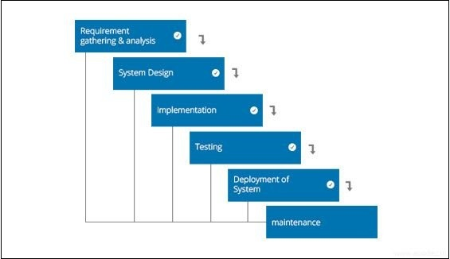

Figure 1 Structure of Waterfall Model

## 2.1.1 Class Diagram

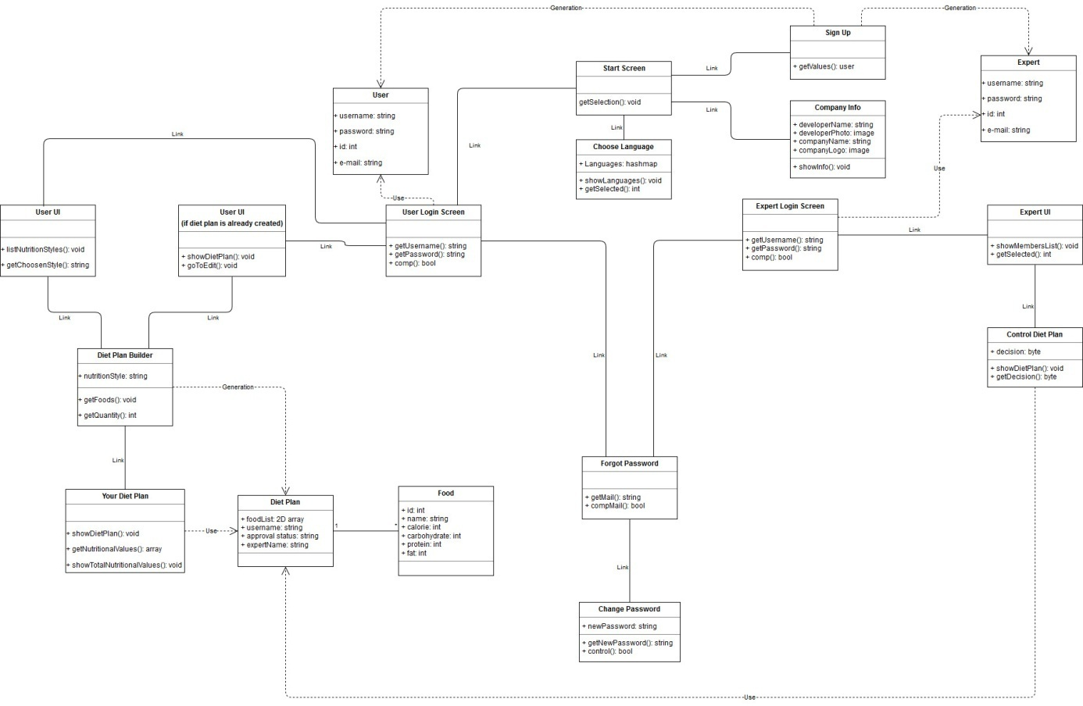

Figure 2 Class Diagram

When program starts “Start Screen” will display. In start screen user can change language by go to “Choose Language” screen, can sign up by go to “Sign Up” screen, can display the company info by go to “Company Info” screen and can log in as user or expert by go to “User Login Screen(If a diet plan was created before, program goes to User UI (if diet plan is already created) screen)” and “Expert Login Screen”, also user or expert can change password if forgot it by go to “Forgot Password”. In Forgot Password screen user can change password by go to “Change Password” screen by entering e-mail. In User UI screen user can create a diet plan by go to “Diet Plan Builder” or edit diet plan(If a diet plan was created before). After the diet plan created or edited program shows diet plan and its nutritional values by go to “Your Diet Plan” screen. In Expert UI screen expert can control diet plans created by users then can confirm or reject them.

## 2.2 Architecture Design of Application

## 2.2.1 Login System

Summary: This system is used by user, guest and admin. User can login and create diet plan and can edit it, also can reach from any device. Guest, also can create diet plan and can edit it but cannot reach from another devices. Expert can confirm or reject the diet plan of users.

Actor: User, Guest, Expert

Precondition: User and expert should create an account from sign up section.

## 2.2.2 Diet Plan Builder

Summary: Diet plan builder is used by user and guest. Information of user is store in local and in database in servers. But guest’s information is store only in the device.

Actor: User, Guest

Precondition: User and guest must be logged in.

## 2.2.3 Validation System

Summary: Validation System is used by expert. Expert can confirm or reject the diet plans that created by users.

Actor: Expert

Precondition: Expert must be logged in.

## 2.2.4 Choose Language

Summary: Choose language is used by user, guest and expert. Language of the program can changeable by user, guest and expert.

Actor: User, Guest, Expert

Precondition: User and guest must be logged in.

# USE CASE REALIZATIONS

**Simulacrum Project**

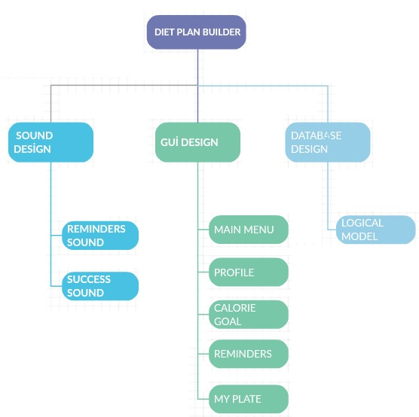

Figure 3 Project Component of Diet Plan Builder

## Brief Description of Figure 3

Components of the Diet Plan Builder Project are shown in the Figure 3. All designed systems of the simulation are displayed in the block diagram in the figure. There are three main components of the system which have their own sub-systems.

## 3.1.1 Sound Design

Sound design module is responsible for all audios which are used in simulation in order to increase the warning of the simulation especially for diet mode. This system includes Reminders Sound, Success Sound.

## 3.1.2 Gui Design

GUI design is responsible for interaction between the users and the system. There are five sub-systems in this design which are Main Menu, Profile, Calorie Goal, Reminders and My Plate. Main Menu is a start page, participant can register, login and log out from the system. There are two ways the reach profile. First of all, when you sign in profile page shows up and you can change the values for diet plan. Second way is that after created your diet you can tap the symbol of profile after that tap the edit profile. Calorie goal is a section that you decide how much calorie you want to take in a day. Reminders section is to remind times of nutrition with notification. My plate section is of how much calorie that we have for rest of the day.

## 3.1.3 Database Design

Database design section is to store datasets for our application.

# References

[1] Apple vs. Android. 2017. Apple vs. Android-A comparative study 2017. [ONLINE] Available at: <https://android.jlelse.eu/apple-vs-android-a-comparative-study-2017-c5799a0a1683>. [Accessed 21 November 2018]

[2] Eclipse (Software). [ONLINE] Available at: <http://www.wikizeroo.net/index.php?q=aHR0cHM6Ly9lbi53aWtpcGVkaWEub3JnL3dpa2kvRWNsaXBzZV8oc29mdHdhcmUp>. [Accessed 13 December 2018]

[3] Java (programming language). [ONLINE] Available at: <http://www.wikizeroo.net/index.php?q=aHR0cHM6Ly9lbi53aWtpcGVkaWEub3JnL3dpa2kvSmF2YV8ocHJvZ3JhbW1pbmdfbGFuZ3VhZ2Up>. [Accessed 13 December 2018]