ÇANKAYA UNIVERSITY

Software Design

Document

**Cook Hub: Cook Recipes and Virtual Fridge**

**Evrim Tugay MUTLU-201411039**

**Hasan Batuhan HASANOĞLU-201511030**

**Tolga TOLLUOĞLU-201511061**

**Didem ERDİVAN - 201511021**

**28/11/2019**

**List of Figures**

* **Figure 1** Glossary of SDD
* **Figure 2** Sequence Diagram
* **Figure 3** Activity Diagram
* **Figure 4** Class Diagram
* **Figure 5** Login Screen
* **Figure 6** Register Screen
* **Figure 7** Home Page
* **Figure 8** Search by Recipe
* **Figure 9** Search Screen
* **Figure 10** Search by Ingredient
* **Figure 11** Search by Tag
* **Figure 12** Shopping List
* **Figure 13** Virtual Fridge
* **Figure 14** Favourite Recipes
* **Figure 15** Block Diagram of System Components
* **Figure 16** Subsystem Decomposition Diagram

1. **INTRODUCTION**

# **1.1 Purpose**

The aim of this document is; delineate the Project which called Cook Hub. Cook Hub is a recipe recommendation Android application. You can create your virtual fridge which will be used for how to cook page. Also, you can find the recipes you are looking for. However, the app can also give you a recommendation. But it doesn't make the same suggestions to everyone. Instead, we offer personalized meals that meet certain conditions.

# **1.2 Scope**

This software system will be a cross-platform application for any people who want to use in their daily life. The system will be designed to help the user:

* Do we have the necessary ingredients to prepare recipes? To answer this question, we have created a virtual fridge in which we record the already existing food in the house.
* Search for cookable food according to virtual fridge data
* Create a Diet Plan
* Filter search by tags, ingredients or recipes
* Recommendation system according to users choices
* Create a Shopping List

# **1.3 Overview of the Document**

This section lists the contents of the rest of the document as follows: Part 2 explains this project's dilemma and discusses it's design along with the class architecture.Part 3 shows and describes the system block diagram, which is formulated in the SRS document according to use cases.

# **1.4 Glossary**

|  |  |
| --- | --- |
| **TERM** | **DEFINITION** |
| Database | Collection of all the information monitored by this system. |
| UML Diagram | It is a modeling language that is used in Software Engineering. |
| Block Diagram | Type of schema in which blocks represent the components in the system. |
| Activity Diagram | Describes activities and actions taking place in a system |
| Machine Learning | Machine learning is an application of artificial intelligence (AI) that provides systems the ability to automatically learn and improve from experience without being explicitly programmed. |
| Software Design Document (SDD) | A definition of software design (Software Design Specification) is a formal description of a software product written by a software designer to provide overall direction to the software project architecture to a software development team. |
| IOS | A mobile device operating system developed by Apple Inc. |
| Kivy Framework | Kivy is a free, open-source Python library with a natural user interface (NUI) for creating mobile apps and other multitouch application software. |
| Android | A mobile device operating system developed by Google Inc. |
| Spyder IDE | Spyder is an interface for Python written by and developed by scientists, developers, and data analysts in Python. [1] |

**Figure 1** Glossary of SDD

# **1.5 Motivation**

We are a group of senior students in the department of computer engineering who have an interest in mobile apps and machine learning. We aimed to create a program that offers recipes that are suitable for people, their tastes and their health. We choose Python language for development because Python is a high-level programming language commonly used in web development, app development, science and numerical data analysis and computation, desktop GUI design, and software development. Also, Python is a cut out for our recommender system. As a framework for the application, we choose the Kivy Framework. Kivy is a free, open-source Python library with a natural user interface (NUI) for creating mobile apps and other multitouch application software.Kivy released its stable version on 21 June 2019. Our database will be on MySQL. Our program development environment will be the Spyder IDE.

The target platform will be Android but our application will be cross-platform application and the development environment is Microsoft Visual Studio 2019.

1. **DESIGN OVERVIEW**

# **2.1 Problem Definition**

Nowadays, most people are in a hustle. They have a busy work tempo or other daily hassles. So they neglect themselves. They don't even think about their health when preparing or eating food. At the same time, with developing technology, people become lazy. Even when making plans, they use these high-tech machines. For example in the evening, they even get help with what to cook at home. There are applications suggesting recipes for this. According to research on people, nowadays, time is more important than their health.

* 1. **Architecture Design**

# **Simulation Design Approach**

# **2.2.1.1 Sequence Diagram**

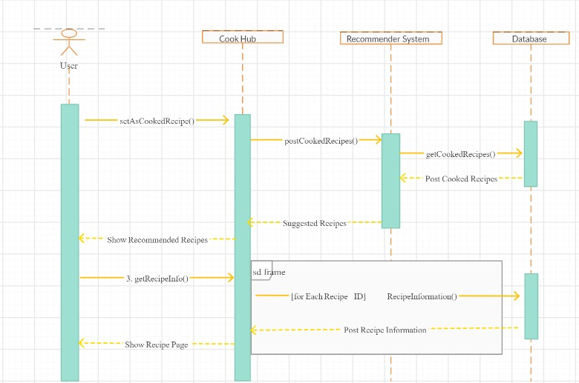

**Figure 2** Sequence Diagram

Figure 2 displays the sequence diagram. The user enters information about her/his taste and health. Recommend System creates recommendations to the user. Then the user chooses any recipe from recommends. If user cooked this recipe, s/he should mark the "I cooked it" button. With this method, the following recommendations will be even more accurate and personalized.

# **2.2.1.2 Activity Diagram**

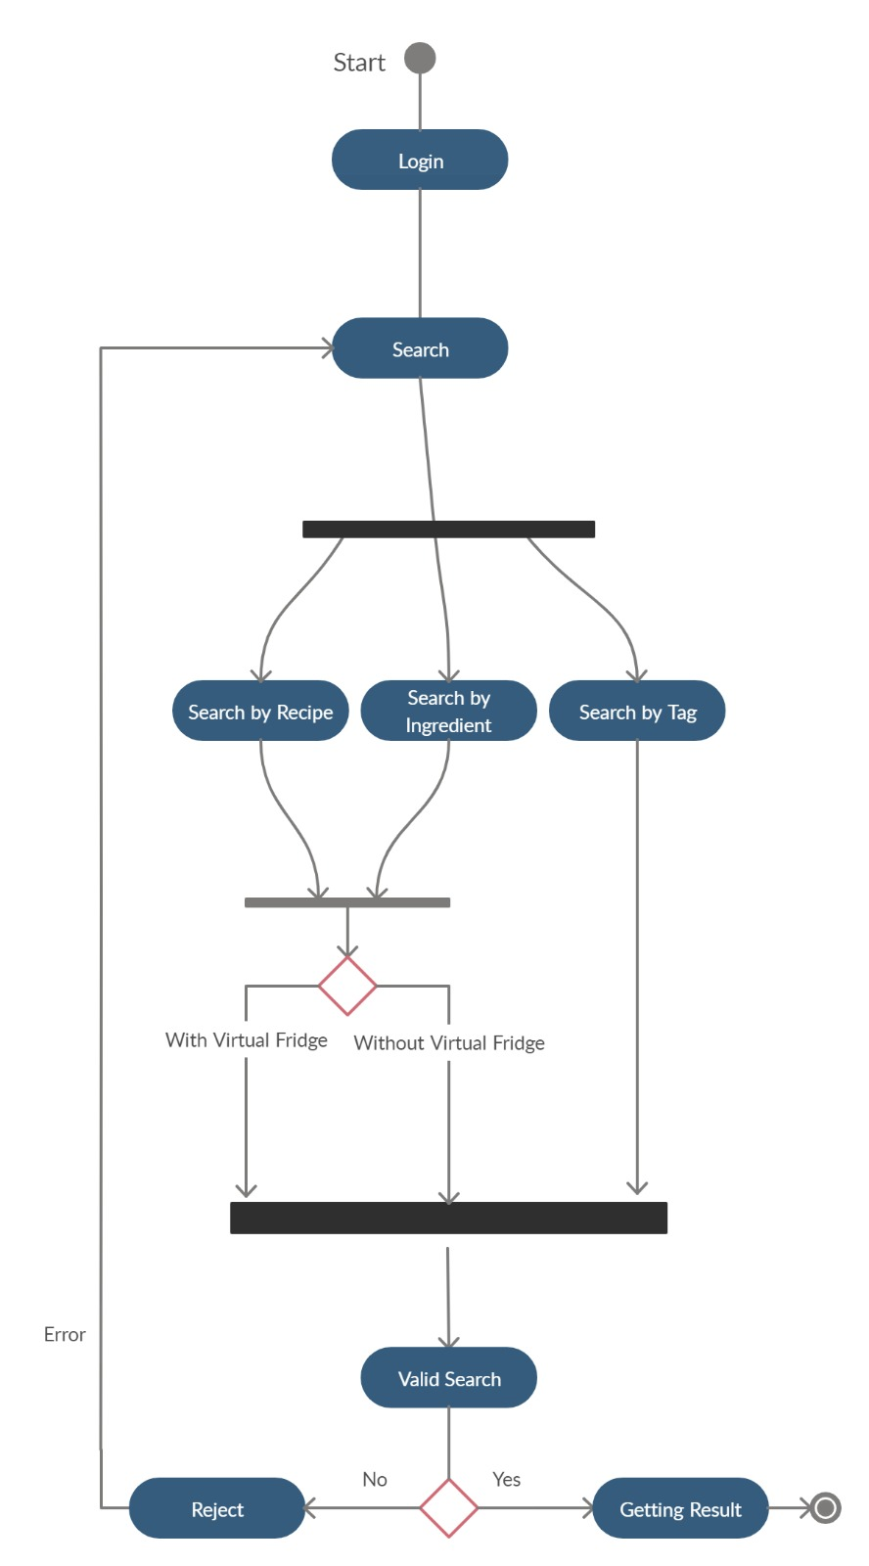

**Figure 3** Activity Diagram

Figure 3, shows how the scenario generation works as an activity diagram. When the user open to the application, she/he sees the home page of the application. If the user goes to the search page, they can find three searching methods; Search by Tag, Search by Ingredient, Search by Recipe. After searching, the user reaches the accurate recipes.

# **2.2.1.3 Class Diagram**

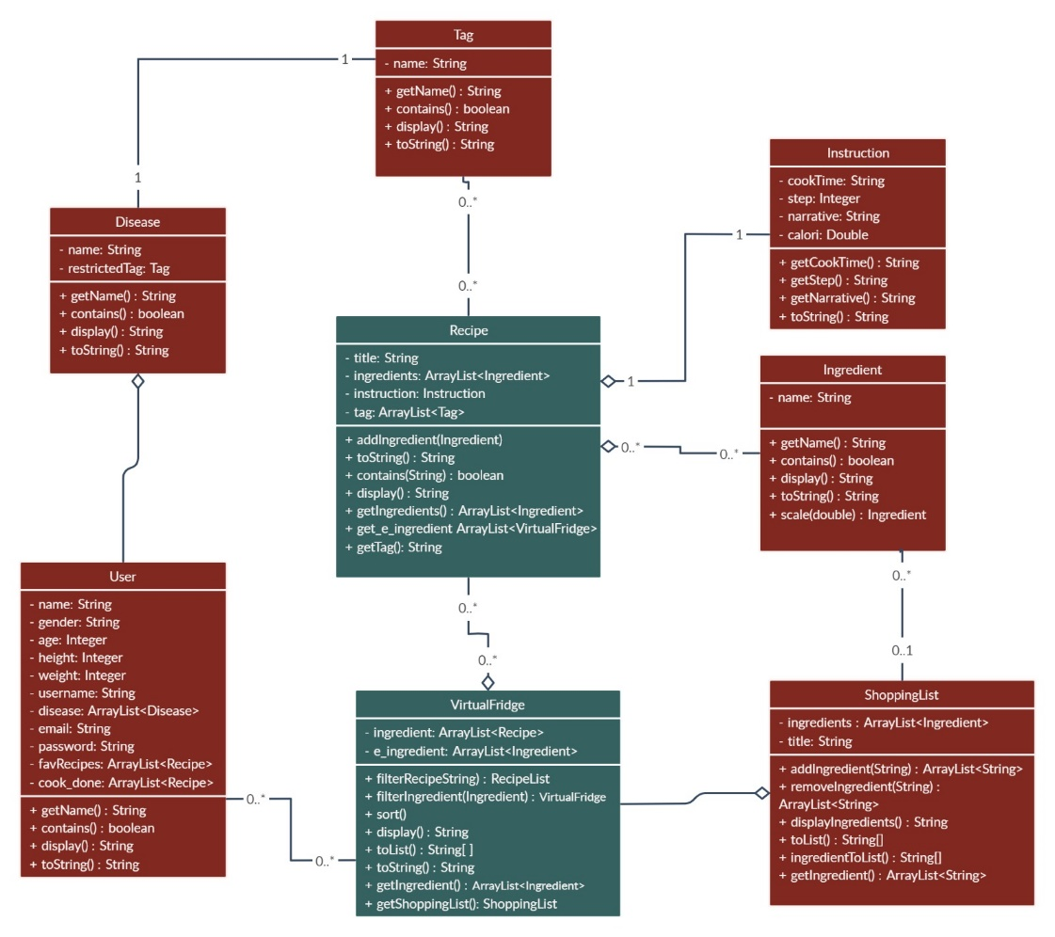

**Figure 4** Class Diagram

Figure 4 shows the main components of the system and its functions. Relationships between these tables are shown with links.

## **2.3 User Interfaces**

**1. Profile management**

**Summary**: Users can Register, Login, Edit profile. The information that has entered in register part will help the system to recommend customized recipes.

**Actor**: User

**Precondition**: Download Cook Hub Application from the app market.

**Basic Sequence:**

1. User must register if he/she doesn’t have an account.
2. User should specify the personal health information during registration.

3. The user shall log in to the system by entering his/her username and password.

4. Users can update his/her personal information by selecting the edit profile button from the user menu.

**Exception:** Database connection can be failed.

**Post Conditions:** None

**Priority:** Low

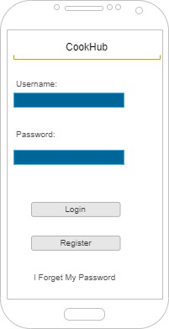 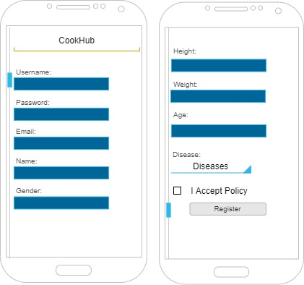

**Figure 5** Login Screen **Figure 6** Register Screen

**2. What should I cook? (Home Page)**

**Summary:** This system used by registered users. The Home Page will host several recipes that were recommended by the Cook Hub AI. Although users can search for food if they have wanted to. Users can search for food recipes in 3 ways; search by tag, search by ingredient, search by recipe.

**Actor**: User

**Precondition**: Log in the system

**Basic Sequence:**

1. User must log in if he/she has an account.
2. Users can see the ten most popular recipes (according to the user's personal information and tastes) on Home Page if s/he uses the application for the first time.

3. As the user chooses from the recipes s/he sees here, s/he will encounter even more personalized recipes each time.

4. Users can update his/her personal information by selecting the edit profile button from the user menu.

**Exception:** None

**Post Conditions:** None

**Priority:** High

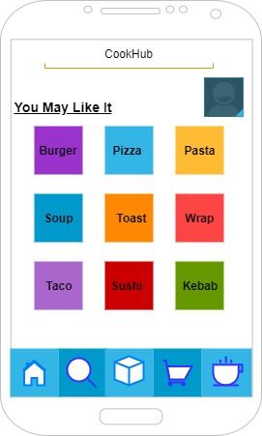

**Figure 7** Home Page

**3. Search Screen**

**Summary:** Users can manually search for recipes. They can search for food recipes in 3 ways; search by tag, search by ingredient, search by recipe. The recipes presented to them as a result of the search will again be limited according to their personal information.

**Actor**: User

**Precondition**: Click Search Button.

**Basic Sequence:**

1. If a user chooses the "Search by Recipe", with the name of the meal s/he can reach the recipe directly.
2. If a user chooses the "Search by Ingredient", users will encounter two search methods.
3. With the "Enter Ingredients" button the user will type the material name by hand. S/he will choose the materials s/he finds. Multisearch can be done here.
4. When the user clicks the "Virtual Fridge" button, a drop-down list will be opened below. This list shows the ingredients already exist in the refrigerator. Multisearch can be done here.
5. When users click "Search", these two methods will be combined.
6. If the user chooses the "Search by Tag", users will encounter an eye symbol. If the user clicks this eye, a pop up that shows all tags will appear on the screen. They can choose more than one tags by clicking.
7. Also if the user clicks the "Enter Tag", they can manually add tags. Recommended recipes will be include the intersection of these tags.

**Exception:** Database connection can be failed.

**Post Conditions:** None

**Priority:** Medium

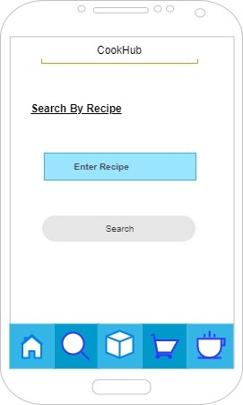 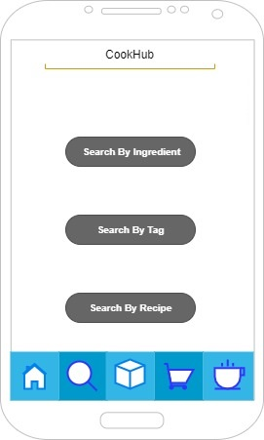

**Figure 8** Search by Recipe **Figure 9** Search Screen

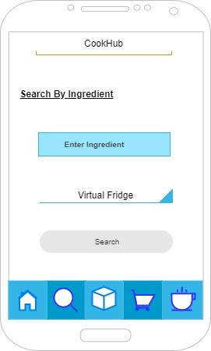 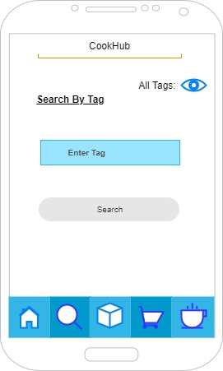

**Figure 10** Search by Ingredient **Figure 11** Search by Tag

**4. Virtual fridge and Shopping List**

**Summary:** After all the searching steps, finally the user finds and selects a recipe to prepare.

**Actor**: User

**Precondition**: Choose a recipe.

**Basic Sequence:**

1. The necessary ingredients in the recipe selected by the user are compared with the ingredients in your Virtual Fridge.
2. If there are no more than 2 missings, these are automatically added to the shopping list.
3. Also, the shopping list can be controlled manually. You can manipulate the list by adding something (marked with a tick) or delete something (unmark).
4. When the user buys the missing ingredients, then s/he should tick them from the shopping list. These ingredients will be included in Virtual Fridge anymore.
5. Users can create many shopping lists by clicking the plus sign above. Then a new list will be created as a new tab.

**Exception:** Database connection can be failed.

**Post Conditions:** None

**Priority:** Low

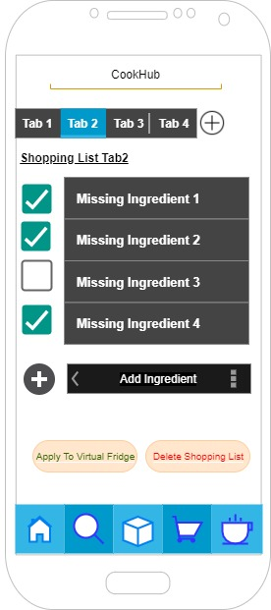 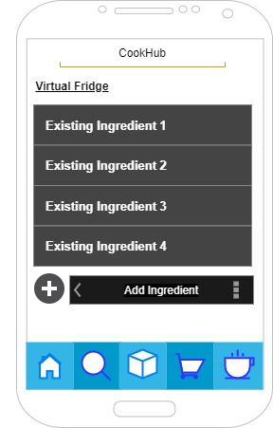

**Figure 12** Shopping List **Figure 13** Virtual Fridge

**5. Favorite Recipes**

**Summary:** Purpose of this page, the user can click the star sign when they are on the recipe screen. These starred recipes will be added to the favorite recipe list.

**Actor**: User

**Precondition**: Choose a recipe.

**Basic Sequence:**

1. Users can create many recipe lists by clicking the plus sign above. Then a new list will be created as a new tab.

**Exception:** None

**Post Conditions:** None

**Priority:** Low

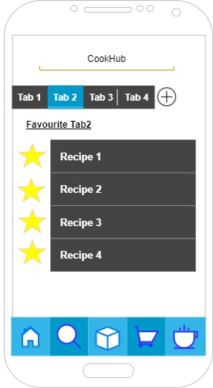

**Figure 14** Favourite Recipes

* 1. **Recommender System**

**Recommender System:** A recommender system refers to a system capable of predicting a user's future preference for a set of items, and recommending the top items.The system will use one of the three algorithms. These are Singular Value decomposition (SVD) - Jaccard Similarity Coefficient - Naive Bayes.

**Jaccard Similarity** - The Jaccard Similarity Index (sometimes called the Jaccard Similarity Coefficient) compares members for two sets to see which members are similar, and which members are different. For the two data sets, it is a correlation test, varying from 0 to 100 per cent. The higher the number, the more the two populations are identical.While simple to interpret, it is extremely sensitive to small sample sizes and may provide incorrect results, particularly with very small samples or data sets with missing observations.

**The Naive Bayes** - The Naive Bayes algorithm is a simple probabilistic classifier calculating a set of probabilities by counting the frequency and value combinations of a given set of data. The algorithm uses Bayes theorem which asserts that all attributes are equal given the value of the category function. This contingent presumption of liberty rarely occurs in real-world applications, hence the description as Naive yet the algorithm continues to do well and quickly learn in various supervised classification problems. Quality of classification algorithms is typically tested by testing the accuracy of the classification. Because classification is often a confusing issue, it may rely on the consumer for the correct answer. Standard methods of analyzing algorithms such as assessing overhead space and time may be used, but these strategies are typically secondary. Evaluating which is better is based on understanding the problem by the consumers.

**Singular Value decomposition** - SVD has used as collaborative filtering (CF) algorithm in the context of recommendation systems. Collaborative filtering is a method for predicting a user-item pair rating based on the user's history of ratings given to the item. Many CF algorithms are based on a matrix for the user-item rating where each row represents a user, each column is an item. The entries in this matrix are user-given ratings for items.

# **3. USE CASE REALIZATION**

## **3.1. Project Components**

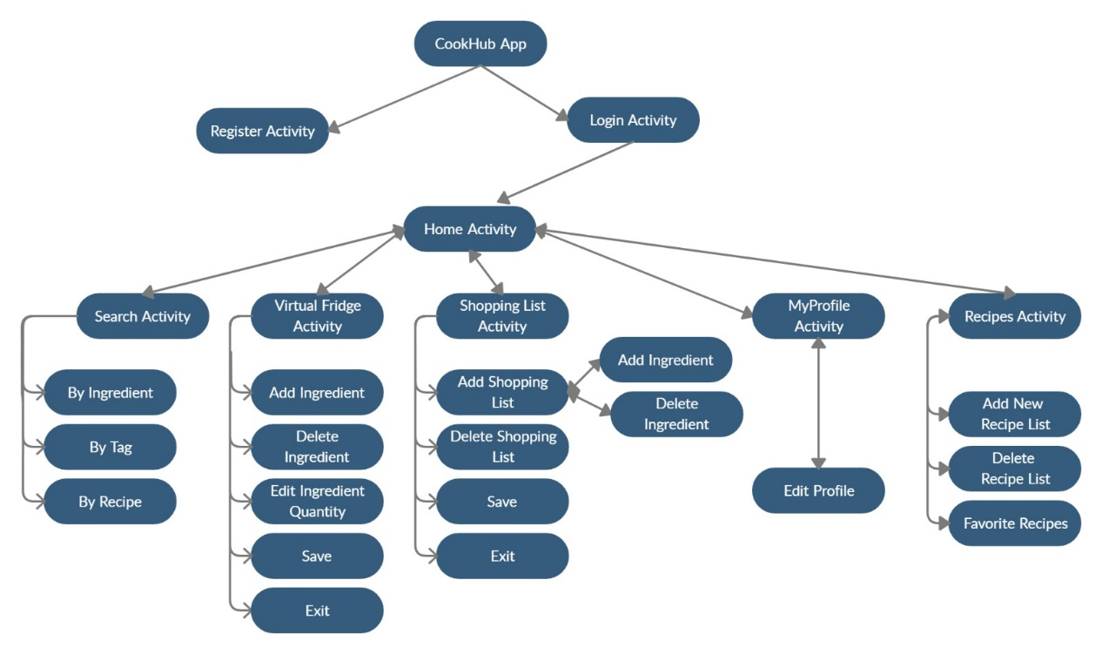

**Figure 15** Block Diagram of System Components

All of the system's designed structures are shown in the block diagram in the figure. The system has two main components that have its sub-systems.

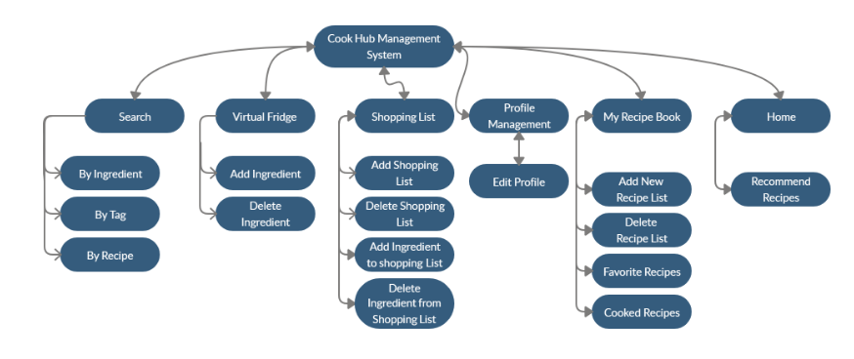

**Figure 16** Subsystem Decomposition Diagram

1. **References**

[1] <https://pandas.pydata.org/>

[2] <https://matplotlib.org/>

[3] <https://numpy.org/>

[4] The American Journal of Clinical Nutrition, Volume 103, Issue 5, May 2016, Pages 1193– 1194,

Available: <https://doi.org/10.3945/ajcn.116.134221>

[5] http: //www.google.com/insidesearch/ features / recipes /

[6] <http://microformats.org/wiki/> recipe formats

[7] <https://www.aclweb.org/anthology/W14-2407/>

[8] <http://citeseerx.ist.psu.edu/viewdoc/download?doi=10.1.1.666.1434&rep=rep1&type=pdf>

[9] <https://ieeexplore.ieee.org/abstract/document/7169757>

[10] <https://help.netflix.com/en/node/100639>

[11] The Effectiveness of a Smartphone Application on Modifying the Intakes of Macro and Micronutrients in Primary Care: A Randomized Controlled Trial. The EVIDENT II Study (10 October 2018)

[12] Steven S Coughlin, Mary S. Whitehead, Joyce Q Sheats, January 2016, Smartphone Applications for Promoting Healthy Diet and Nutrition: A Literature Review

[13] Kivy – A Framework for Rapid Creation of Innovative User Interfaces

Available: <https://www.semanticscholar.org/paper/Kivy-A-Framework-for-Rapid-Creation-of-Innovative-Virbel-Hansen/bae0df60195a86fa7fd12172b026b32ff7cfbe1b>

[14.1] Cookpad. <http://cookpad.com/> , (Accessed 20 October 2019)

[14.2] AllRecipes. <https://www.allrecipes.com/> , (Accessed 20 October 2019)

[14] M. Ueda, M. Takahata, and S. Nakajima. User’s food preference extraction for cooking recipe recommendation. In Proc. of the 2nd Workshop on Semantic Personalized Information Management: Retrieval and Recommendation, 2011

[15] Ulrich Sch¨afer, Frederik Arnold, Simon Ostermann, and Saskia Reifers, 2013, Ingredients and Recipe for a Robust Mobile Speech-Enabled Cooking Assistant for German

[16] <http://www.oaijse.com/VolumeArticles/FullTextPDF/224_40.BON_VIVANT_AN_ARTIFICIAL_INTELLIGENCE_COOKING_APP.pdf>

[17] <https://loco.yahoo.co.jp/gourmet/recipes/>

[18] <https://medium.com/cookpadteam/cookpad-the-story-behind-the-platform-used-by-100-million-people-7060f7fa4833>

[19] Brants, T.: TnT – A statistical part-of-speech tagger. In: Proc. of 6th ANLP, Seattle, Washington, pp. 224–231 (2000)Google Scholar Hamada, R., Okabe, J., Ide, I.: Cooking navi: Assistant for daily cooking in kitchen. In: Proc. of 13th ACM Int. Conf. on Multimedia, Singapore, pp. 371–374 (2005)Google Scholar

[20] Chouambe, L.C.: Dynamische Vokabularerweiterung für ein grammatikbasiertes Dialogsystem durch Online-Ressourcen, Studienarbeit, University of Karlsruhe (2006)Google Scholar

[21] Drozdzynski, W., Krieger, H.U., Piskorski, J., Schäfer, U., Xu, F.: Shallow processing with unification and typed feature structures — Foundations and applications. Künstliche Intelligenz 1, 17–23 (2004)Google Scholar

[22] Hamada, R., Okabe, J., Ide, I.: Cooking navi: Assistant for daily cooking in kitchen. In: Proc. of 13th ACM Int. Conf. on Multimedia, Singapore, pp. 371–374 (2005)Google Scholar

[23] Martins, F.M., Pardal, J.P., Franqueira, L., Arez, P., Mamede, N.J.: Starting to cook a tutoring dialogue system. In: SLT Workshop 2008, pp. 145–148. IEEE (2008)Google Scholar

[24] Petitpierre, D., Russell, G.: MMORPH – the Multext morphology program. Tech. rep., ISSCO, University of Geneva (1995)Google Scholar

[25] Ribeiro, R., Batista, F., Pardal, J.P., Mamede, N.J., Pinto, H.S.: Cooking an ontology. In: Euzenat, J., Domingue, J. (eds.) AIMSA 2006. LNCS (LNAI), vol. 4183, pp. 213–221. Springer, Heidelberg (2006)CrossRefGoogle Scholar

[26] Wasinger, R.: Dialog-based user interfaces featuring a home cooking assistant, University of Sydney, Australia (2001) (unpublished manuscript)Google Scholar

[27] [https://en.wikipedia.org](https://en.wikipedia.org/) › wiki › Data_set

[28] [https://en.m.wikipedia.org](https://en.m.wikipedia.org/) › wiki › Kaggle

[29] Pearson Correlation score [http://en.wikipedia.org/wiki/Pearson_productmoment_correlation_coefficient]