ÇANKAYA UNIVERSITY

Software Requirements

Specification

**Cook Hub: Cook Recipes and Virtual Fridge**

**Evrim Tugay MUTLU-201411039**

**Hasan Batuhan HASANOĞLU-201511030**

**Tolga TOLLUOĞLU-201511061**

**Didem ERDİVAN - 201511021**

**12/11/2019**

**List of Figures**

Figure1 Download Cook Hub Use Case Diagram

Figure 2 User Registration Use Case Diagram

Figure 3 Virtual Fridge Screen Use Case Diagram

Figure 4 Search a Recipe Use Case Diagram

Figure 5 Food Recommender System Use Case Diagram

Figure 6 Shopping List Use Case Diagram

1. **INTRODUCTION**

**1.1 Problem Definition**

Nowadays, most people are in a hustle. They have a busy work tempo or other daily hassles. So they neglect themselves. They don't even think about their health when preparing or eating food. At the same time, with developing technology, people become lazy. Even when making plans, they use these high-tech machines. For example in the evening, they even get help with what to cook at home. There are applications suggesting recipes for this. According to research on people, nowadays, time is more important than their health.

**1.2 Purpose**

The aim of this document is; delineate the Project which called Cook Hub. Cook Hub is a recipe recommendation Android application. You can create your virtual fridge which will be used for how to cook page. Also, you can find the recipes you are looking for. However, the app can also give you a recommendation. But it doesn't make the same suggestions to everyone. Instead, we offer personalized meals that meet certain conditions.

**1.3 Scope**

This software system will be a cross-platform application for any people who want to use in their daily life. The system will be designed to help the user:

* Do we have the necessary ingredients to prepare recipes? To answer this question, we have created a virtual fridge in which we record the already existing food in the house.
* Search for cookable food
* Create a Diet Plan
* Filter search by tags
* Recommendation system according to users choices
* Create a Shopping List

**1.4 Definitions, acronyms, and abbreviations**

|  |  |
| --- | --- |
| **TERM** | **DEFINITION** |
| Database | Collection of all the information monitored by this system. |
| User | Any person on the system. |
| Android | A mobile device operating system developed by Google Inc. |
| IOS | A mobile device operating system developed by Apple Inc. |
| Spyder IDE | Spyder is a powerful scientific environment written in Python, for Python, and designed by and for scientists, engineers and data analysts. [1] |
| Software Requirements Specification (SRS) | A document that completely describes all of the functions of a proposed system and the constraints under which it must operate. For example, this document. |

1. **OVERALL DESCRIPTION**

In this part, the system allows users to add or search any desired ingredient, food or tag. To do this, background information about the specific requirements of the system will be provided briefly. In **Cook Hub** the user can tag-based search, ingredient-based search, set timer, add an ingredient in the virtual fridge then the application will run along and communicate with a database server and running in between each part of the system.

**2.1 Product Perspective**

**Cook Hub** is a cross-platform mobile application with a database server to find a recipe or create a shopping list or create a diet plan. The mobile application will work on mobile Android or IOS devices. It will have functions as data managing, machine learning, and AI. When users run the application, they can use the functionalities of the device. All information will be kept on the database which can be accessed by users with or without login.

**2.2 Product Functions**

**Cook Hub** consists of these main tasks:

⮚ Authentication

⮚ Data Managing: We work with a very large data set. These data sets include recipes. We classified the characteristics of the recipe with short words that we call tag. We also use many different tags to describe the ingredients. Both of these information is stored in the data set.

To provide diversity in our application, we have presented thousands of recipes to the user. We have done long dataset research. A dataset is a collection of data. In the case of tabular data, a dataset corresponds to one or more database tables. Each column has a certain variable and each row has a specific record. [27] We first tried to answer that question: "Where can we find datasets?" Then we came across a lot of websites. Like "FiveThirtyEight, BuzzFeed News, Kaggle, Socrata, Awesome-Public-Datasets on GitHub, Google Public Datasets, UCI Machine Learning Repository, Data.gov”.

We chose to use “Kaggle”. Kaggle allows users to find and publish data sets, explore and build models in a web-based data-science environment, work with other data scientists and machine learning engineers, and enter competitions to solve data science challenges. [28] Most of the datasets are available to use. But it depends on the dataset. Some of the bigger companies have extra conditions that their data cannot be used without extra written permission.

The data set we use contains the following information; a step-by-step description of how to prepare and cook the food, ingredients in the food, calorie information, nutritional values, cooking time and so on.

⮚ Tag-based search: The user can search for food of his/her choice from a feature suggestion table that we provide him/her. These features are matched to the tags in the data set in the background. Thus, suggestions become more customized.

⮚ Ingredient based search: This type of search has the same logic with a tag-based search. The users see a list of all the materials. They mark what they want to remove from the list. Or vice versa, they mark what they want to use. They can also use this search method as follows; marking materials that already exist at their home. So that we can help them cook without leaving the house. Via Ingredients Tags, we recommend recipes with the ingredients they want.

⮚ Add ingredient in Virtual Fridge: The users can mark materials that already exist at their home. We will use it for two purposes. First, we will offer the user recipes that he/she can make with the ingredients s/he has. Or let's say the user chose a recipe. Via this virtual fridge, we will determine what is missing at home to prepare this recipe.

⮚ Create Diet Plan: At the register stage, we asked if the user had any significant health problems. We offer even more personalized recipes to the user if these health problems are associated with nutrition.

⮚ Create Shopping List: This is a task associated with the “Add ingredient in virtual Fridge” step. When you select a recipe, your virtual fridge and ingredients are compared. Then, this application creates a shopping list of missing materials in your home.

**2.3 Constraints, Assumptions and Dependencies**

Users of this application are any Android or IOS device users that load this application to their devices. All of the users are in the same class, only one type of user exits. The operating environment is, as just mentioned above, is an Android OS or IOS mobile device. An android or IOS device that can support basic dependencies of the application is expected for proper user experience. On the other hand, our database server and services can operate on any OS like Windows or Ubuntu that can supply the database server's fundamental dependencies and needs. One important constraint is privacy and security. Users should be accessing only the authenticated data.

1. **SPECIFIC REQUIREMENTS**

In this chapter and its sections, the requirements are explained.

**3.1 Interface Requirements**

There will be two interfaces in our system, one will be between user and system, and the other will be between system and database.

**3.2 Functional Requirements**

This section explains the use of cases.

* + 1. **Download Cook Hub Use Case**

**Use Case:**

* App Market
* Apple Store
* Google Play Store
* Download Cook Hub

**Diagram:**

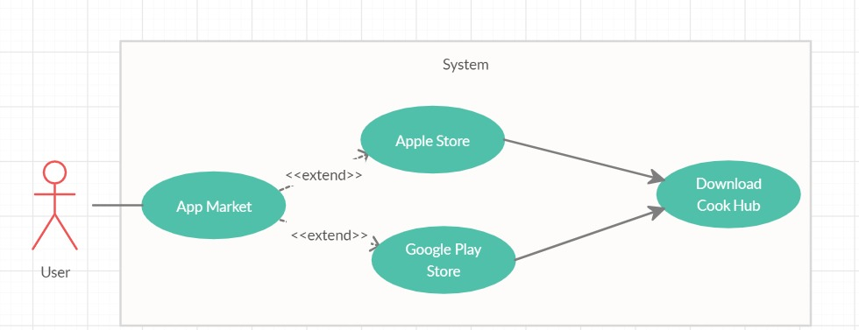

**Figure 1** Download Cook Hub Use Case

**Brief Description:**

Figure 1 shows participant Download Cook Hub Use Case diagram. When the user opens his current phone's market application, he/she can download Cook Hub and start to use it.

**Initial Step-By-Step Description:**

1. Users must have a smartphone to download and use the Cook Hub application.
2. The user must have select Cook Hub from his current phone's market application to download Cook Hub application.
   * 1. **User Registration Use Case**

**Use Case:**

* User Registration
* Agree with term and Conditions
* Check Previous Password and correctness
* Login
* Check Login Detail
* Confirm Login
* Login Failed
* Login Without Registration
* Mistyped Password

**Diagram:**

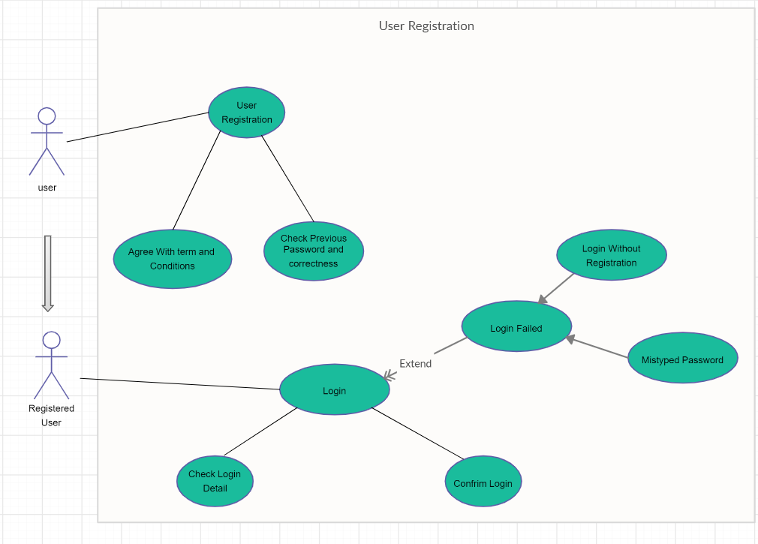

**Figure 2** User Registration Use Case

**Brief Description:**

Figure 2 shows the participant User Registration Use Case diagram. When the user opens the application he/she can log in the application if he/she has already an account. If he/she does not have an account, it can be registered using the button.

**Initial Step-By-Step Description:**

1. If the user has already an account (Registered User), he/she can log in to the application by selecting the Login button. The application will look for the password through the database and confirm if a user has written the password correctly.
2. If a user has not an account before he/she can create an account by using the Register button. Users must have, fill all the blanks with their personal information and their desired diet type to register the application and then must agree with terms and conditions to succeed in his account.
3. If the user, writes a password that is not matched with the account name or tried to login without registration, login will be failed.
   * 1. **Virtual Fridge Screen Use Case**

**Use Case:**

* Add Ingredient
* Delete Ingredient
* Edit Ingredient Quantity
* Save
* Exit

**Diagram:**

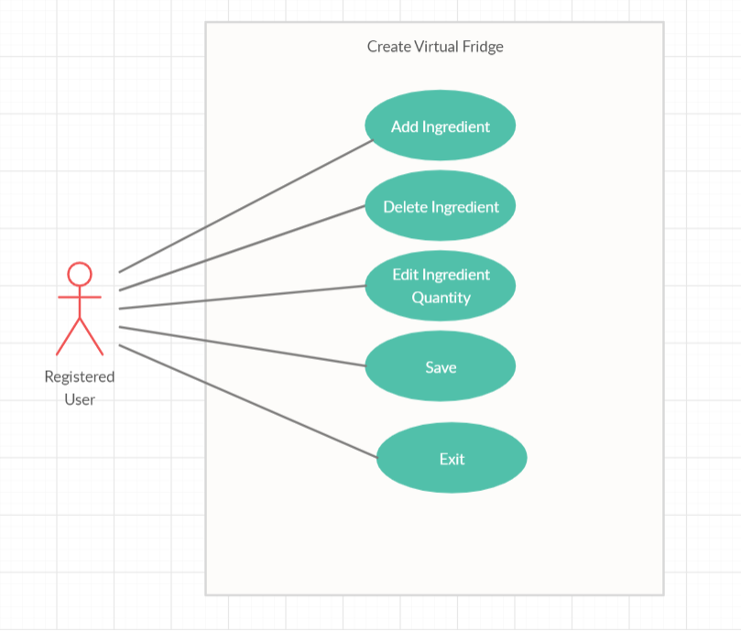

**Figure 3** Virtual Fridge Screen Use Case

**Brief Description:**

Figure 3 shows the participant Virtual Fridge screen use case diagram. Users can create their virtual fridge which will be used for how to cook page and online marketplace page. Users can select from the options which were Add Ingredient, Delete Ingredient, and Edit Ingredient Quantity, Save, Exit.

**Initial Step-By-Step Description:**

1. If the user selects Add Ingredient, the user will select or write the ingredients that he/she wanted to add to his virtual fridge.
2. If the user selects Delete Ingredient, the user will remove the unwanted ingredient from his Virtual Fridge.
3. If the user selects Save, the user allows the program to save changes.
4. If the user selects Exit, the user will be back for the main page.
   * 1. **Search a Recipe Use Case**

**Use Case:**

* Search
* Search by Recipe or Ingredient
* Search by Ingredient
* With Virtual Fridge
* Without Virtual Fridge
* Make Recommendation
* Results

**Diagram:**

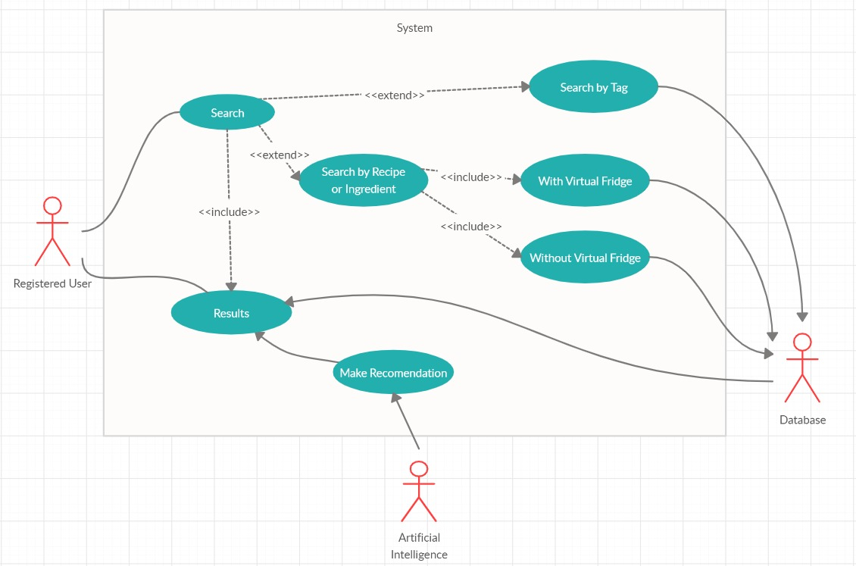

**Figure 4** Search a Recipe Use Case

**Brief Description:**

Figure 4 shows participant Search a Recipe Use Case Diagram. Users can search recipes in three ways which were; Search by Recipe or Ingredient, Search by Tag. After the user has been select from these options and fulfills the selected option's properties, he/she can review the result of the desired recipe/recipes.

**Initial Step-By-Step Description:**

1. The user will select one of three search options.
2. If the user selects Search by Recipe option, the user can review the recipes by typing their desired food and the application will display the desired food's recipe if that food's recipe exists on the application's database.
3. If user selects Search by Ingredient option, user can review the recipes from the application with two options which were; typing their desired ingredient by using auto-complete typing system by not using the virtual fridge or choosing ingredients by using multi-search selecting system from among the ingredients that has been saved before on the virtual fridge by the user.
4. If the user selects Search by Tag option, the user can review the recipes by selecting from search criteria by using the auto-complete typing system or multi search selecting the system.
5. After the user has select one of these options and uses it the application will display the desired recipe/recipes result concerning the Artificial Intelligence recommendation system.
   * 1. **Food Recommender System Use**

**Use Case:**

* Rate Recipe
* Rate Recommendations
* Make as Favourite Recipe
* Make as Favourite Tag
* Access Recommendations
* Search by Recipe, Tags or Ingredient
* Gather User data
* Calculate Similarity Scores
* Show Predictions

**Diagram:**

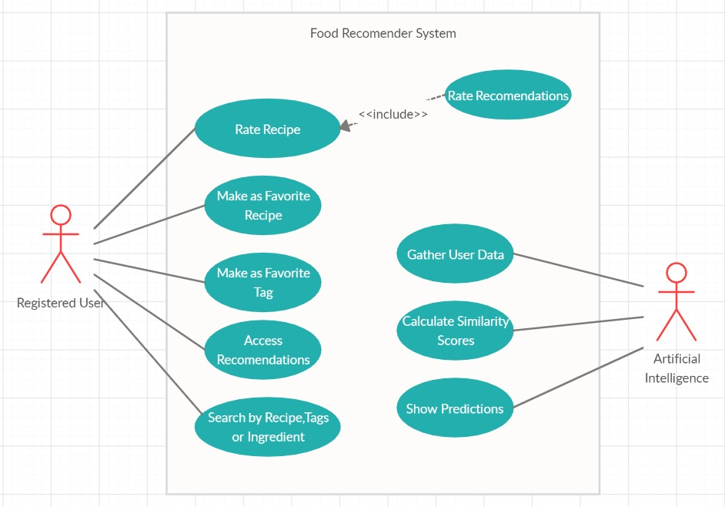

**Figure 5** Food Recommender System Use Case

**Brief Description:**

Figure 5 shows the participant Food Recommender System use case diagram. Users can rate the recipes that they choose to love their taste and they can rate the Cook Hub's Artificial Intelligence's recommended recipes if they have wanted to. Users can favorite the recipes or tags that they wanted, Access recommendations and can search for recipes with 3 sub search algorithms. While the user uses food recommender service Cook Hub's Artificial Intelligence at the back-end will gather the user data and calculate the similarity scores.

**Initial Step-By-Step Description:**

1. When the user uses the food recommender service he/she can search for recipes by using Search by Recipe, Tags, and Ingredient. Search by recipe let the user, their typed food comes to screen with its recipe, Search by Tag let the user, choose from different tags and system will display the fitted recipes that he/she has to choose before, Search by Ingredient let the user, choose the ingredients from its virtual fridge or by typing each ingredient and system will display the fitted recipes that he/she has to choose or typed before.
2. Users can favorite the recipes that they are enjoyed to eat it.
3. Users can favorite the tags that they are often used for their search criteria.
4. Users can rate the recipes that they have to want it by 1 to a maximum of 5. 1 means the user disliked the recipe while 5 means the user has enjoyed the recipe.
5. Users can rate the Cook Hub's Artificial Intelligence recommended recipe if they want it by 1 to a maximum of 5. 1 means user disliked the recipe while 5 means user has enjoyed the recipe
6. Cook Hub's Artificial Intelligence will store the user's data with log user activities, ingredient count in the virtual fridge, favorite food, etc. to give a better quality recommendation system.
7. Cook Hub's Artificial Intelligence will calculate similarities scores using Pearson correlation[2]
8. Cook Hub's Artificial Intelligence will show the prediction as a recommendation to the user due to calculated similarity scores.
   * 1. **Shopping List Use Case**

**Use Case:**

* Manipulate Shopping lists
* Add a new shopping list
* Delete a shopping list
* Save changes
* Manipulate content of shopping lists
* Add an item
* Delete an item/items
* Check off an item/items

**Diagram:**

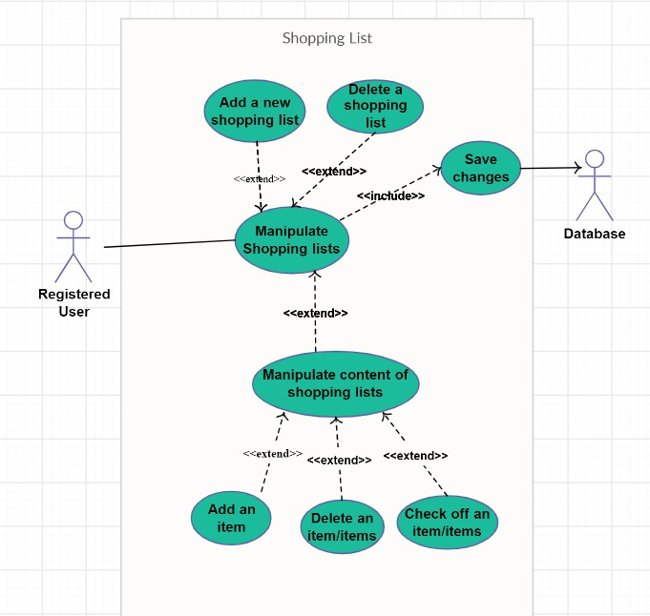

**Figure 6** Shopping List Screen Use Case

**Brief Description:**

Figure 6 shows the participant Shopping List use case diagram. Users can create one or more shopping lists which will help them reduce the time on their time during shopping. After the user has done the market shopping, they can select add to fridge option and all the ingredients in the list will be going to the virtual fridge automatically.

**Initial Step-By-Step Description:**

1. If the user wants to create one or more shopping lists he/she can create one that will help to reduce their shopping time.
2. Users can add or remove items in their current shopping list.
3. Users can check off an item if the selected items have already in the virtual fridge or not.
4. User can rename the shopping list that he/she has created.
5. User can switch between the shopping lists by choosing among the list names
6. Users can delete the shopping lists by choosing among the list names.
7. After the user has done and bought all of the shopping list items, he/she can use add to the fridge button that will instantly remove all the current shopping list items and add them to the user's virtual fridge.
   1. **Non-Functional Requirements**

* System recommendation will avoid suggesting a recipe that will trigger the user's disease or allergies that the user has specified before.
* When the user searches for any recipe system will load rapidly
* The system will recommend the recipe to the user at least %50 similarity as the taste of the user.
* The system will hold the calorie data of each meal user has eaten then calculate the average calorie of the user gain's from his meals in a day row then the system will primarily recommend foods with similar calories. To succeed with this a user must have specified all meals they have to eat at least for 7 days.
* The system will check the calorie values of the user's meals during the day then review the user's average calorie per day then primarily based on recommending the recipes which have calorie's close to the average calorie value.
* Whenever the user has searched for food that will exceed the average daily calorie value, the system will give a warning. User can skip the warning if he/she wanted to review the recipe.
  1. **Design Constraints**
* We will use the "agile method" and Object-Oriented Programming paradigm.
* We will use Python as a programming language. The Android version of the device should be 2.3 or higher. The system does not require an Internet connection.
  1. **Performance Requirements**

The Cook Hub project's respond and match system must run smoothly without delay. Because of the non-visual contents project do not need a high system. Any user that downloads the Cook Hub should be able to use the system at any time. The response time of the system should be 5 seconds at most.

* NETWORK : Technology GSM / HSPA / LTE/ WIFI
* DISPLAY: No minimum requirement
* PLATFORM: OS Android 4.4.2 (KitKat)
* Chipset: Qualcomm MSM8974AC Snapdragon 801
* CPU: Quad-core 2.5 GHz Krait 400
* MEMORY: 350MB
* RAM: 1GB
  1. **Software System Attributes**

**3.6.1 Portability**

* Cook Hub is intended for any kind of android OS mobile platform.
* After installation, there is no need for any internet connection to use the Cook Hub.

**3.6.2 Performance**

* Back-ground calculations work every time a recipe is cooked, does not stack

**3.6.3 Usability**

* Every recipe contains multiple tags
* Every recipe contains multiple ingredients
* Every recipe contains multiple levels of calorie

**3.6.4 Adaptability**

* Dataset is fetched by the data set since the dataset is internal at phone Android OS is required

**3.6.5 Scalability**

* Because of the offline working system every user’s information is stored at the internal storage. There is no scalability requirement.
  1. **Safety Requirements**

People have to consider and choose their diseases and allergies before they are searching for the food they liked otherwise they can take harm. While using the Cook Hub application users should have checked the oven and stove frequently and care for the timer at the application to avoid unexpected results.

1. **REFERENCES**

[1] <https://medium.com/cookpadteam/cookpad-the-story-behind-the-platform-used-by-100-million-people-7060f7fa4833>

[2] Pearson Correlation score [http://en.wikipedia.org/wiki/Pearson_productmoment_correlation_coefficient]

[3] [https://en.m.wikipedia.org](https://en.m.wikipedia.org/) › wiki › Kaggle

[4] <https://help.netflix.com/en/node/100639> The Effectiveness of a Smartphone Application on Modifying the Intakes of Macro and Micronutrients in Primary Care: A Randomized Controlled Trial. The EVIDENT II Study (10 October 2018)

[5] <http://cengproject.cankaya.edu.tr/wp-content/uploads/sites/10/2017/12/SRS-ieee-830-1998.pdf>

[6] <https://www.altexsoft.com/blog/business/functional-and-non-functional-requirements-specification-and-types/>

[7] <https://reqtest.com/requirements-blog/functional-vs-non-functional-requirements/>

[8] <http://user.ceng.metu.edu.tr/~e1679216/documents/SRS.pdf>

[9] Spyder: The Scientific Python Development Environment – Documentation <https://docs.spyder-ide.org/#spyder-the-scientific-python-development-environment-documentation>

[10] <https://www.draw.io/>

[11] [https://en.wikipedia.org](https://en.wikipedia.org/) › wiki › Use_case

[12] [https://en.wikipedia.org](https://en.wikipedia.org/) › wiki › Data_set