**A Review of the Machine Learning Literature Relating to Digital Cooking Recipe Recommendation Service**

Hasan Batuhan HASANOGLU, Didem ERDIVAN, Evrim Tugay MUTLU, Tolga TOLLUOGLU

[c1511030@student.cankaya.edu.tr](mailto:c1511030@student.cankaya.edu.tr) , [c1511021@student.cankaya.edu.tr](mailto:c1511021@student.cankaya.edu.tr) , [c1411039@student.cankaya.edu.tr](mailto:c1411039@student.cankaya.edu.tr) , [c1511061@student.cankaya.edu.tr](mailto:c1511061@student.cankaya.edu.tr)

Department of Computer Engineering, University of Cankaya

October 17, 2019, version 0.1

**Abstract**

Nowadays, most people are in a hustle. They have a busy work tempo or other daily hassle. So they neglect themselves. They don't even think about their health when preparing or eating food. At the same time, with the developing technology, people become lazy. Even when making plans, they use these high-tech machines. For examples in the evening, they even get help with what to cook at home. There are applications suggesting recipes for this. According to research on people, nowadays, time is more important than their health. Therefore, they prefer fast prepared meals like fastfood. And this threatens their health. Or let's say we cook at home. We can easily reach the recipes we want. The problem is that we don't know what should we eat for our health and body. At the same time, this recipe must comply with our taste. At this point, our application is created as a solution to these problems. CookHub is a recipe recommendation Android application. You can find the recipes you are looking for. However, the app can also give you suggestions. But it doesn't make the same suggestions to everyone. Instead , we offer personalized meals that meet certain conditions. For example, the health status of the person, taste, already existing materials in the house. While we were preparing this report, we reviewed the articles about Machine Learning, AI and Data Science. We also searched articles on health and diet to classify recipes that fit the health status of users.

**Keywords:** Health, Recipe Recommendation, Machine Learning, Data Science, Android Application, Big Data analysis, Matching Algorithms

1. **Introduction**

With the developing technology, people meet all their needs with technology. The most practical for this is the use of mobile applications. Nowadays, people care about their time and want to speed up their work. Therefore, they prefer to look at a recipe from applications rather than from a book. The data sets of the applications contain an incredible amount of data (millions of recipes). Users cannot decide which of these data to choose. CookHub is designed to help these people. We ask questions to these users at the register step. We learn their health conditions, body mass measurements, the flavors they like to eat (roughly sweet, bitter, salty, spicy, etc.) via these questions. We prepare our recommendations based on this initial information. Later, users can evaluate recipes. We now consider these evaluations as we prepare new recommendations. Of course, we teach the algorithm to do this to our machine (application).

In order to provide diversity in our application, we have presented thousands of recipes to the user. We have done long dataset research. A dataset is a collection of data. In the case of tabular data, a dataset corresponds to one or more database tables. Each column has a certain variable and each row has a specific record. [27] We first tried to answer that question: “Where can we find datasets?” Then we came across a lot of websites. Like “FiveThirtyEight, BuzzFeed News, Kaggle, Socrata, Awesome-Public-Datasets on GitHub, Google Public Datasets, UCI Machine Learning Repository, Data.gov”.

We chose to use “Kaggle”. Kaggle allows users to find and publish data sets, explore and build models in a web-based data-science environment, work with other data scientists and machine learning engineers, and enter competitions to solve data science challenges. [28] Most of the datasets are available to use. But it depends on the dataset. Some of the bigger companies have extra conditions that their data cannot be used without extra written permission.

The data set we use contains the following information; a step-by-step description of how to prepare and cook the food, ingredients in the food, calorie information, nutritional values, cooking time and so on.

We used MySQL to hold this large data set. We chose Python to use Machine Learning effectively. In addition, we will use Pandas, Mathplotlib, Numpy, which are important Python libraries for us. Pandas is a software library for the Python programming language. it is used in computer programming, data processing and analysis. First, it provides data structures and operations for modifying tables and time series. [1] Matplotlib is a Python 2D plotting library which produces publication quality figures in a variety of hardcopy formats and interactive environments across platforms. We can generate plots, histograms, power spectra, bar charts, error charts, scatterplots, etc [2] NumPy (Numerical Python) is a mathematical library that allows us to perform scientific calculations quickly. It is based on numpy arrays. [3]

We will use these libraries together. So we can process our large data set. When we recommend new recipes to users, we consider based on their previously preferred recipes and specified health status. We describe the characteristics of the recipes with short tags. For example, spicy, with eggs, lactose-free… We also keep these tags in the data set. With these tags are made from the best match to users. We scale the matching rate of the newly proposed recipe and user information with a term called “accuracy".

The most distinctive point of our application is to care about the health of the user while finding personalized recipes. For example, a user with a lactose allergy adds this to his / her information when registering. So we offer her recipes with the label "lactose-free" while we suggest recipe. We ask a lot of questions when registering for users who want to do diet. So we want to provide him with the most suitable diet. “Who should consume what? Who should avoid what? Who should take how many calories per day?” We aim to be a recipe app that can help you to answer questions such as.

Another feature of the application is a screen where you can click on the materials already available in your home. These materials of your choice will be matched to the tags in the data set in the background. And you will be offered what you can do with the materials in your home.

We also consider users' health conditions. We could not do this without using certain mathematical formulas and research on this topic. In order to get the best efficiency in calorie and diet, we examined similar applications that serve the same purpose. We found that all of them used a BMI Calculator. So we will use it.

Height and weight are an important variable in nutrition. Metrics that adjust weight for height, weight, and weight-related health risks and mortality. Ideal body weight (IBW) 2 was considered as “healthy” weight. The right conditions for BMI are:

1) Adult weight increases proportionally to height squared

2) BMI is a stature-independent measure of weight

3) BMI has a good correlation with fat mass (i.e., population studies the r values are ∼0.7) [4]

2**. Related Works**

A recommender system refers to a system that is capable of predicting the future preference of a set of items for a user, and recommend the top items. One key reason why we need a recommender system in modern society is that people have too much options to use from due to the prevalence of Internet. So we will use the three machine learning algorithms about reccomender system. These algorithms are Singular Value decomposition (SVD) - Jaccard Similartiy Coefficient - Naive Bayes.

The Jaccard Similarity Index (sometimes referred to as the Jaccard Similarity Coefficient) compares members for two sets to see which members are shared and which are separate. It is a test of correlation for the two data sets, varying from 0 per cent to 100 per cent. The higher the percentage, the more similar the two populations are. While simple to interpret, it is extremely sensitive to small sample sizes and may provide incorrect results, particularly with very small samples or data sets with missing observations.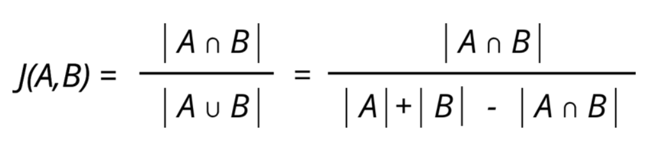

**Figure (a):** Jaccard similarity is computed using the following formula

The Naive Bayes algorithm is a simple probabilistic classifier that calculates a set of probabilities by counting a given data set's frequency and value combinations. The algorithm uses Bayes theorem which claims that, given the value of the category function, all attributes are equal. This contingent presumption of freedom seldom occurs to real-world applications, hence the description as Naive yet the algorithm continues to do well and learn quickly in various supervised classification problems. Classification algorithm performance is usually examined by evaluating the classification accuracy. Since classification is often a confusing issue, the correct answer can depend on the user. Standard analysis methods to algorithms such as evaluating the overhead space and time can be used, but these strategies are typically secondary. Evaluating which is better relies on consumers understanding the problem.

SVD is used as a collaborative filtering (CF) algorithm in the context of recommendation systems. Collaborative filtering is a method for predicting a user item pair rating based on the user's history of ratings given to the item. Most CF algorithms are based on a user-item rating matrix where each row represents a user, each column represents an item. The entries in this matrix are the ratings given to items by users.

Collaborative filtering(CF) is a technique that can be used by recommendation systems. Collaborative filtering in the newer, narrower sense is a form of automated predictions(filtering) concerning the user's desires by gathering tastes or taste data from many users(collaborating).

Cooking is an art and it has to be performed by rules to success. Also another important issue is the recipe of the food. These are the rules of the cooking a food. But how about health and taste? Not all foods are for all peoples taste and health. Why not to combine machine learning and cooking for the aim of health and perfect palatal delight.

There is already a lot of service to search for recipes. For example, Google Recipe Search [5], Yummly, Foodily and MyTaste… Good results can be achieved by using these services. Because these services have many search capabilities. This makes it easy to use them. For example, applications have search limits such as ingredients, species, cooking time, portions and nutritional values. Some of this information is clearly marked as machine-readable. [6]

Figure (a) is an easy-to-read flow chart. But the machine should have .csv file to understand the values ​​and data of the food recipe. [7]

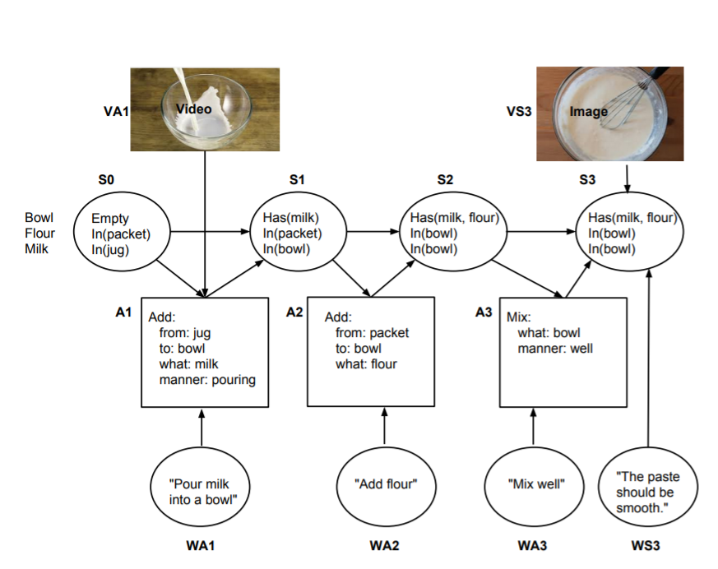

**Figure (b):** the actual steps of the recipe [7]

A machine can not recommend every food to every human group. Everybody has different concerns like health, gluten free, calorie level, taste. By this reason machine have to learn these issues about each user group interactively. By this machine learning system recommendation system works more successful as the groups uses the system. Taste, health concerns etc. are detected by tags of the data in a data. Furthermore, we help people to plan their meals without eating foods they don’t like while they are improving their health and life standards.

Despite technological advancement, people are still not implementing healthy diet programs. It is possible to find diet programs from books, websites and mobile applications. However, people prefer these programs to be personal. Finding such programs is not easy. So, the food mentioned in any diet program is not attractive. And users will not strictly follow the diet rules. In order to solve this problem, they create personalized meal plans suggestion systems. Studies on this subject have focused on general users. One of the main considerations when designing a proposal is that food and consumption are recurring. In fact, people eat at similar times a day and every day, and they plan their meals sequentially. A smart machine can help to pick healthy and tasty foods for them. [8]

The usage of the internet make peoples life easy in any ways. Especially in needs like food. Recipe recognition with large multimodal food dataset is very important because the main challenge is size of the data set. Food category classification is a key technology for many food-related applications such as monitoring healthy diet, computational cooking, food recommendation system, etc. In, a novel smart phone application to record daily meal activities by image retrieval technique is developed. Based on this personal dietary data log system, they were able to conduct further usage preference experiments and food nutrition balance estimation.

The Open Meal System aims to invent new intelligent cooking appliances. This is a Purdue University Technology Assisted Diet Assessment (TADA) project. The aim of the project is to develop a mobile food recorder. This device records diet information. The device plans this information on a daily basis. It considers daily nutritional intake. Food category classification should be in all these applications. [9]

Recommendation system is a relative concept. Netflix is a good example for recommendation system. Netflix, to date, has just over 100 million subscribers on its platform. But with each subscription having multiple profiles, the real number is double that. That's a lot of data, and with over 80% of TV shows being watched on the platform, it has its work cut out, to keep people engaged. But it doesn't have to do all the hard work.

Netflix effectively outsources some of the processes to you. Information on how you use the platform, how you rate content, and what you search for are all harvested and analyzed by Netflix to better improve your user experience.

When you access the Netflix service, a suggestion system is activated. The main purpose of the system is to show you the ideal show or film. We can think of Netflix as a film catalog. In this catalog, movies that you are likely to watch are presented according to the following factors:

* Your interactions with the Netflix service (such as your viewing history)
* Other members with similar preferences
* Types, categories, players, year of publication and so on. Information about topics

Netflix knows what to watch with these factors. It also looks at the following to personalize a similar and best suggestion:

* The time of day you watch
* The devices you are watching Netflix on
* How long you watch.

All of these factors mentioned above are kept as data. These data are the inputs of the Netflix algorithm. (The algorithm is the sequence of steps and processes followed to solve a problem.) Netflix does not take age and gender into consideration when deciding on the most appropriate recommendations. [10]

The Effectiveness of a Smartphone Application is an important concept for diet and healthy life. In 10 October 2018, José I Recio-Rodríguez and his team published an article about The Effectiveness of a Smartphone Application on Modifying the Intakes of Macro and Micronutrients in Primary Care. The objective of this study is to evaluate the long-term (12 months) effectiveness of adding a diet smartphone application to standard counseling to modify dietary composition (macro and micronutrients and food groups). According to this research consisting of nutritional counseling and a diet smartphone application, achieved better results than counseling alone in modifying the diet.[11]





**Figure (c):** Changes in macronutrients after randomization by group (repeated measures analysis). [11]

Rapid developments in technology have encouraged the use of smartphones in health promotion research and practice. Although many applications (apps) relating to diet and nutrition are available from major smartphone platforms, relatively few have been tested in research studies in order to determine their effectiveness in promoting health. In qualitative studies, participants preferred applications that were quick and easy to administer, and those that increase awareness of food intake and weight management. In randomized trials, the use of smartphone apps was associated with better dietary compliance for lower calorie, low fat, and high fiber foods, and higher physical activity levels which resulted in more weight loss.

Smartphone apps are likely to be a useful and low-cost intervention for improving diet and nutrition and addressing obesity in the general population. The accuracy of diet and nutrition measurements obtained using mobile devices has generally been found to be good. Participants prefer applications that are quick and easy to administer and those that increase awareness of food intake and weight management. [12]

The software toolkits and programming paradigms used by application developers have a large impact on the design of architecture and user interface of the applications they develop. Especially now, that technological advances are presenting us with affordable hardware that is capable of both sensing and displaying information with unprecedented accuracy, vividness, and bandwidth, there is an increased need to explore and develop tools that enable creative designers and developers to turn their ideas into reality. These tools must both allow for rapid prototyping to evaluate new ideas quickly, and be able to take advantage of the full computing power offered by cutting edge technology. Python Kivy framework is one them. [13]

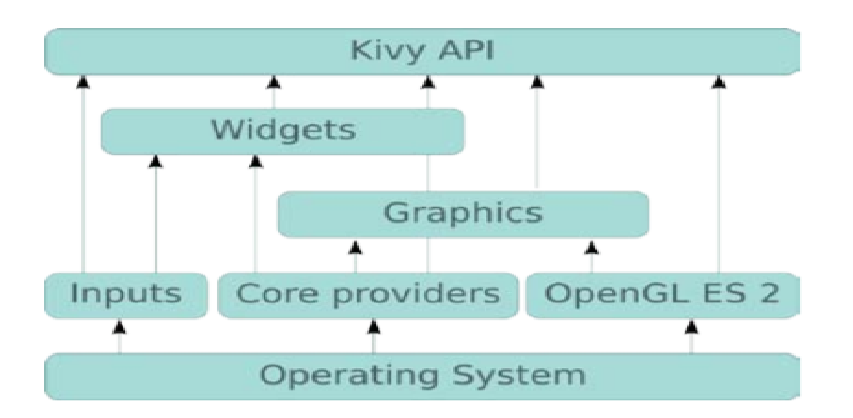

**Figure (d):** A general architecture of Kivy.[13]

As a result of the lifestyle-related disease epidemic, dietary life is now attracting attention. Good eating habits are important for maintaining a healthy life. However, menu planning requires one to take various factors into consideration, such as the nutritional value, food in stock, food preferences, and cost. Thus, people need to expand a lot of effort toward planning their daily menu. Against this background, a number of cooking websites comprising various food recipes have recently been launched, such as Cookpad[14.1] and AllRecipes[14.2]. Many people refer to these websites when planning their menu. Cookpad contains 900,000 recipes and has 10,000,000 monthly users. This data reflects the high demand for recipe-providing services. However, these websites do not reflect user’s preferences and conditions, although these two factors need to be considered if the goal is to provide high-satisfactory recipes.   
  
 In January 2011, Mayumi Ueda and her team published an article about this subject. In their paper, they presented a method for extracting the user’s food preferences for recipe recommendation. Their method estimates a user’s preferences from his/her past actions, such as through their recipe browsing and menu planning history. For extracting the preferences, their method breaks recipes down into their ingredients and scores the recipes using the frequency and specificity of ingredients. Since their method can estimate the preferences through their browsing and cooking history, the user convey his/her preferences to the system without having to carry out any particular operation. [14]

Another application that has parallel functions with us is Kochbot. Kochbot is a cooking assistant application for smartphones and tablet devices. This application allows you to search from a wide collection of recipes and explains cooking commands step by step. The most important feature of this application is that it is focused on speaking and listening. The main advantage of the application is that it has a hands-free scenario. and user satisfaction is quite high. [15]

Internet provides us many knowledge sharing facility and searching for any information from any corner of the world. Recipe websites are good examples of these knowledge sharings. People can find millions of recipes via using the internet.The manys recipes that internet provides is kind a diffucult for a person who just want to search a recipe fits in his taste. In the Internet the most of these websites are simple minded as not reliable on recommendation system which was recommends recipes based on rating and comment-based recipes in the site. In these cases a person who has been looking for a recipe for his taste can’t always happy about what they gets.

Bon Vivant is an interactive platform for discovering flavor mappings based on flavor compound analysis. It makes combinations of meals. It can match many factors, being able to do so. Eg ingredients, recipes, regional kitchens and aroma compounds. This platform enables the user to achieve a healthier lifestyle. Because it is based on nutritional requirements when making recommendations. [16]

Smart mobile phones, which have entered almost every home in our age, do many things to make our lives easier. Good eating habits are important for a healthy life. How-ever food planning requires consideration of different factors, such as nutritional value, food in stock, food preferences, and cost. . Additionally, people need to expand a lot of effort and time towards to planning their daily food cooking. For these subjects a various websites provides various food recipes have been published in worldwide such as Cookpad[14.1] and Yahoo! Recipe[17]. Many people refers to these websites for answer their “how to cook” question. Cookpad contains now almost 100 million people around the world use Cookpad every month and over 4 million recipes have been created on the platform. It’s available in almost 70 countries around the world in 23 languages. [18]

1. **Conclusion**

People are very busy in their daily lives. They want to get things done quickly. They even want speed while thinking. And, of course, when deciding. Sometimes they can't decide what to eat. They don't even know what should/shouldn’t eat. That’s why we decided to create an application that recommends both healthy and personalized recipes and shows you how to make it step by step. We have designed many algorithms to create this application. We have examined similar works from various articles. And we mentioned them in our report.

**4. References**

[1] <https://pandas.pydata.org/>

[2] <https://matplotlib.org/>

[3] <https://numpy.org/>

[4] The American Journal of Clinical Nutrition, Volume 103, Issue 5, May 2016, Pages 1193– 1194,

  Available: <https://doi.org/10.3945/ajcn.116.134221>

[5] http: //www.google.com/insidesearch/ features / recipes /

[6] http://microformats.org/wiki/ recipe formats

[7] <https://www.aclweb.org/anthology/W14-2407/>

[8] <http://citeseerx.ist.psu.edu/viewdoc/download?doi=10.1.1.666.1434&rep=rep1&type=pdf>

[9] <https://ieeexplore.ieee.org/abstract/document/7169757>

[10] <https://help.netflix.com/en/node/100639>

[11] The Effectiveness of a Smartphone Application on Modifying the Intakes of Macro and Micronutrients in Primary Care: A Randomized Controlled Trial. The EVIDENT II Study (10 October 2018)

[12] Steven S Coughlin, Mary S. Whitehead, Joyce Q Sheats, January 2016, Smartphone Applications for Promoting Healthy Diet and Nutrition: A Literature Review

[13] Kivy – A Framework for Rapid Creation of Innovative User Interfaces

Available: <https://www.semanticscholar.org/paper/Kivy-A-Framework-for-Rapid-Creation-of-Innovative-Virbel-Hansen/bae0df60195a86fa7fd12172b026b32ff7cfbe1b>

[14.1] Cookpad. <http://cookpad.com/> , (Accessed 20 October 2019)

[14.2] AllRecipes. <https://www.allrecipes.com/> , (Accessed 20 October 2019)

[14] M. Ueda, M. Takahata, and S. Nakajima. User’s food preference extraction for cooking recipe recommendation. In Proc. of the 2nd Workshop on Semantic Personalized Information Management: Retrieval and Recommendation, 2011

[15] Ulrich Sch¨afer, Frederik Arnold, Simon Ostermann, and Saskia Reifers, 2013, Ingredients and Recipe for a Robust Mobile Speech-Enabled Cooking Assistant for German

[16] <http://www.oaijse.com/VolumeArticles/FullTextPDF/224_40.BON_VIVANT_AN_ARTIFICIAL_INTELLIGENCE_COOKING_APP.pdf>

[17] <https://loco.yahoo.co.jp/gourmet/recipes/>

[18] <https://medium.com/cookpadteam/cookpad-the-story-behind-the-platform-used-by-100-million-people-7060f7fa4833>

[19] Brants, T.: TnT – A statistical part-of-speech tagger. In: Proc. of 6th ANLP, Seattle, Washington, pp. 224–231 (2000)Google Scholar Hamada, R., Okabe, J., Ide, I.: Cooking navi: Assistant for daily cooking in kitchen. In: Proc. of 13th ACM Int. Conf. on Multimedia, Singapore, pp. 371–374 (2005)Google Scholar

[20] Chouambe, L.C.: Dynamische Vokabularerweiterung für ein grammatikbasiertes Dialogsystem durch Online-Ressourcen, Studienarbeit, University of Karlsruhe (2006)Google Scholar

[21] Drozdzynski, W., Krieger, H.U., Piskorski, J., Schäfer, U., Xu, F.: Shallow processing with unification and typed feature structures — Foundations and applications. Künstliche Intelligenz 1, 17–23 (2004)Google Scholar

[22] Hamada, R., Okabe, J., Ide, I.: Cooking navi: Assistant for daily cooking in kitchen. In: Proc. of 13th ACM Int. Conf. on Multimedia, Singapore, pp. 371–374 (2005)Google Scholar

[23] Martins, F.M., Pardal, J.P., Franqueira, L., Arez, P., Mamede, N.J.: Starting to cook a tutoring dialogue system. In: SLT Workshop 2008, pp. 145–148. IEEE (2008)Google Scholar

[24] Petitpierre, D., Russell, G.: MMORPH – the Multext morphology program. Tech. rep., ISSCO, University of Geneva (1995)Google Scholar

[25] Ribeiro, R., Batista, F., Pardal, J.P., Mamede, N.J., Pinto, H.S.: Cooking an ontology. In: Euzenat, J., Domingue, J. (eds.) AIMSA 2006. LNCS (LNAI), vol. 4183, pp. 213–221. Springer, Heidelberg (2006)CrossRefGoogle Scholar

[26] Wasinger, R.: Dialog-based user interfaces featuring a home cooking assistant, University of Sydney, Australia (2001) (unpublished manuscript)Google Scholar

[27] https://en.wikipedia.org › wiki › Data_set

[28] https://en.m.wikipedia.org › wiki › Kaggle