

ÇANKAYA UNIVERSITY
FACULTY OF ENGINEERING
COMPUTER ENGINEERING DEPARTMENT

Project Report
Version 1

CENG 407 Innovative System Design and Development I

Cook Hub: Cook Recipes and Virtual Fridge

Evrim Tugay MUTLU-201411039
Hasan Batuhan HASANOĞLU-201511030
Tolga TOLLUOĞLU-201511061
Didem ERDİVAN - 201511021

Advisor: Roya CHOUPANI, Assist. Prof. Dr.

İçindekiler
List of Figures 4
Abstract 5
1. Introduction 6
1.1 Related Works 7
2. Software Requirements Specification 12
2.1 INTRODUCTION 12
2.1.1 Problem Definition 12
2.1.2 Purpose 13
2.1.3 Scope 13
2.1.4 Definitions, acronyms, and abbreviations 13
2.2 OVERALL DESCRIPTION 14
2.2.1 Product Perspective 14
2.2.2 Product Functions 14
2.2.3 Constraints, Assumptions and Dependencies 15
2.3 SPECIFIC REQUIREMENTS 16
2.3.1 Interface Requirements 16
2.3.2 Functional Requirements 16
2.3.2.1 Download Cook Hub Use Case 16
2.3.2.2 User Registration Use Case 17
2.3.2.3 Virtual Fridge Screen Use Case 18
2.3.2.4 Search a Recipe Use Case 19
2.3.2.5 Food Recommender System Use Case 21
2.3.2.6 Shopping List Use Case 22
2.3.3 Non-Functional Requirements 24
2.3.4 Design Constraints 24
2.3.5 Performance Requirements 24
2.3.6 Software System Attributes 25
2.3.6.1 Portability 25
2.3.6.2 Performance 25
2.3.6.3 Usability 25
2.3.6.4 Adaptability 25
2.3.6.5 Scalability 25
2.3.7 Safety Requirements 25
3. Software Design Description 25
3.1 Purpose 25
3.2 Scope 26
3.3 Overview of the Section 26
3.4 Glossary 26
3.6 Motivation 27
3.7 DESIGN OVERVIEW 28
3.7.1 Problem Definition 28
3.7.2 Architecture Design 28
3.7.3 Simulation Design Approach 28
3.7.3.1 Sequence Diagram 28
3.7.3.2 Activity Diagram 29
3.7.3.3 Class Diagram 30
3.7.4 User Interfaces 30
3.2.4.1 Profile management 30
3.7.4.2 What should I cook? (Home Page) 31
3.7.4.3 Search Screen 32
3.7.4.4 Virtual fridge and Shopping List 34
3.7.4.5 Favourite Recipes 35
3.8 Recommender System 36
3.9 USE CASE REALIZATION 37
3.9.1 Project Components 37
4. Conclusion 38
5. Acknowledgment 38
6. References 39

List of Figures
- Figure 1: Jaccard similarity is computed using the following formula
- Figure 2: the actual steps of the recipe
- Figure 3: Changes in macronutrients after randomization by group (repeated measures analysis)
- Figure 4: A general architecture of Kivy
- Figure 5: Download Cook Hub Use Case Diagram
- Figure 6: User Registration Use Case Diagram
- Figure 7: Virtual Fridge Screen Use Case Diagram
- Figure 8: Search a Recipe Use Case Diagram
- Figure 9: Food Recommender System Use Case Diagram
- Figure 10: Shopping List Use Case Diagram
- Figure 11: Glossary of SDD
- Figure 12: Sequence Diagram
- Figure 13: Activity Diagram
- Figure 14: Class Diagram
- Figure 15: Login Screen
- Figure 16: Register Screen
- Figure 17: Home Page
- Figure 18: Search by Recipe
- Figure 19: Search Screen
- Figure 20: Search by Ingredient
- Figure 21: Search by Tag
- Figure 22: Shopping List
- Figure 23: Virtual Fridge
- Figure 24: Favorite Recipes
- Figure 25: Block Diagram of System Components
- Figure 26: Subsystem Decomposition Diagram

Abstract

Nowadays, most people are in a hustle. They have a busy work tempo or other daily hassles. So they neglect themselves. They don't even think about their health when preparing or eating food. At the same time, with developing technology, people become lazy. Even when making plans, they use these high-tech machines. For example in the evening, they even get help with what to cook at home. There are applications suggesting recipes for this. According to research on people, nowadays, time is more important than their health. Therefore, they prefer fast prepared meals like fast food. And this threatens their health. Or let's say we cook at home. We can easily reach the recipes we want. The problem is that we don't know what should we eat for our health and body. At the same time, this recipe must comply with our taste. At this point, our application is created as a solution to these problems. CookHub is a recipe recommendation Android application. You can find the recipes you are looking for. However, the app can also give you suggestions. But it doesn't make the same suggestions to everyone. Instead, we offer personalized meals that meet certain conditions. For example, the health status of the person, taste, already existing materials in the house. While we were preparing this report, we reviewed the articles about Machine Learning, AI and Data Science. We also searched articles on health and diet to classify recipes that fit the health status of users.

Keywords: Health, Recipe Recommendation, Machine Learning, Data Science, Android Application, Big Data analysis, Matching Algorithms

1. Introduction
With developing technology, people meet all their needs with technology. The most practical for this is the use of mobile applications. Nowadays, people care about their time and want to speed up their work. Therefore, they prefer to look at a recipe from applications rather than from a book. The data sets of the applications contain an incredible amount of data (millions of recipes). Users cannot decide which of these data to choose. CookHub is designed to help these people. We ask questions to these users at the registration step. We learn their health conditions, body mass measurements, the flavors they like to eat (roughly sweet, bitter, salty, spicy, etc.) via these questions. We prepare our recommendations based on this initial information. Later, users can evaluate recipes. We now consider these evaluations as we prepare new recommendations. Of course, we teach the algorithm to do this to our machine (application).
To provide diversity in our application, we have presented thousands of recipes to the user. We have done long dataset research. A dataset is a collection of data. In the case of tabular data, a dataset corresponds to one or more database tables. Each column has a certain variable and each row has a specific record. [27] We first tried to answer that question: “Where can we find datasets?” Then we came across a lot of websites. Like “FiveThirtyEight, BuzzFeed News, Kaggle, Socrata, Awesome-Public-Datasets on GitHub, Google Public Datasets, UCI Machine Learning Repository, Data.gov”.
We chose to use “Kaggle”. Kaggle allows users to find and publish data sets, explore and build models in a web-based data-science environment, work with other data scientists and machine learning engineers, and enter competitions to solve data science challenges. [28] Most of the datasets are available to use. But it depends on the dataset. Some of the bigger companies have extra conditions that their data cannot be used without extra written permission.
The data set we use contains the following information; a step-by-step description of how to prepare and cook the food, ingredients in the food, calorie information, nutritional values, cooking time and so on.
We used MySQL to hold this large data set. We chose Python to use Machine Learning effectively. Besides, we will use Pandas, Mathplotlib, Numpy, which are important Python libraries for us. Pandas is a software library for the Python programming language. it is used in computer programming, data processing, and analysis. First, it provides data structures and operations for modifying tables and time series. [1] Matplotlib is a Python 2D plotting library which produces publication quality figures in a variety of hardcopy formats and interactive environments across platforms. We can generate plots, histograms, power spectra, bar charts, error charts, scatterplots, etc [2] NumPy (Numerical Python) is a mathematical library that allows us to perform scientific calculations quickly. It is based on numpy arrays. [3]
We will use these libraries together. So we can process our large data set. When we recommend new recipes to users, we consider based on their previously preferred recipes and specified health status. We describe the characteristics of the recipes with short tags. For example, spicy, with eggs, lactose-free… We also keep these tags in the data set. These tags are made from the best match to users. We scale the matching rate of the newly proposed recipe and user information with a term called "accuracy".
The most distinctive point of our application is to care about the health of the user while finding personalized recipes. For example, a user with a lactose allergy adds this to his / her information when registering. So we offer her recipes with the label "lactose-free" while we suggest a recipe. We ask a lot of questions when registering for users who want to do the diet. So we want to provide him with the most suitable diet. “Who should consume what? Who should avoid what? Who should take how many calories per day?” We aim to be a recipe app that can help you to answer questions such as.
Another feature of the application is a screen where you can click on the materials already available in your home. These materials of your choice will be matched to the tags in the data set in the background. And you will be offered what you can do with the materials in your home.
We also consider users' health conditions. We could not do this without using certain mathematical formulas and research on this topic. To get the best efficiency in calorie and diet, we examined similar applications that serve the same purpose. We found that all of them used a BMI Calculator. So we will use it.
Height and weight are an important variable in nutrition. Metrics that adjust the weight for height, weight, and weight-related health risks and mortality. Ideal body weight (IBW) 2 was considered a "healthy" weight. The right conditions for BMI are:
1) Adult weight increases proportionally to height squared
2) BMI is a stature-independent measure of weight
3) BMI has a good correlation with fat mass (i.e., population studies the r values are ∼0.7) [4]

1.1 Related Works
Recommender System
A recommender system refers to a system that is capable of predicting the future preference of a set of items for a user and recommend the top items. One key reason why we need a recommender system in modern society is that people have too many options to use due to the prevalence of the Internet. So we will use the three machine learning algorithms about the recommender system. These algorithms are Singular Value decomposition (SVD) - Jaccard Similarity Coefficient - Naive Bayes.
The Jaccard Similarity Index (sometimes referred to as the Jaccard Similarity Coefficient) compares members for two sets to see which members are shared and which are separate. It is a test of correlation for the two data sets, varying from 0 percent to 100 percent. The higher the percentage, the more similar the two populations are. While simple to interpret, it is extremely sensitive to small sample sizes and may provide incorrect results, particularly with very small samples or data sets with missing observations.

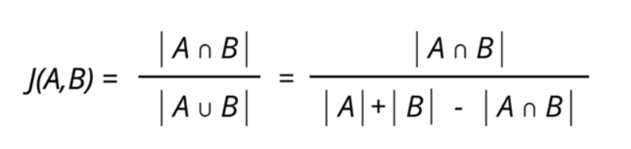
Figure 1: Jaccard similarity is computed using the following formula
The Naive Bayes algorithm is a simple probabilistic classifier that calculates a set of probabilities by counting a given data set's frequency and value combinations. The algorithm uses Bayes theorem which claims that, given the value of the category function, all attributes are equal. This contingent presumption of freedom seldom occurs to real-world applications, hence the description as Naive yet the algorithm continues to do well and learn quickly in various supervised classification problems.
Classification algorithm performance is usually examined by evaluating the classification accuracy. Since classification is often a confusing issue, the correct answer can depend on the user. Standard analysis methods to algorithms such as evaluating the overhead space and time can be used, but these strategies are typically secondary. Evaluating which is better relies on consumers understanding the problem.
SVD is used as collaborative filtering (CF) algorithm in the context of recommendation systems. Collaborative filtering is a method for predicting a user-item pair rating based on the user's history of ratings given to the item. Most CF algorithms are based on a user-item rating matrix where each row represents a user, each column represents an item. The entries in this matrix are the ratings given to items by users.
Collaborative filtering(CF) is a technique that can be used by recommendation systems. Collaborative filtering in the newer, narrower sense is a form of automated predictions(filtering) concerning the user's desires by gathering tastes or taste data from many users(collaborating).
Cooking is an art and it has to be performed by rules to success. Also, another important issue is the recipe for the food. These are the rules of cooking a portion of food. But how about health and taste? Not all foods are for all people's taste and health. Why not combine machine learning and cooking for the aim of health and perfect palatal delight.
There is already a lot of services to search for recipes. For example, Google Recipe Search [5], Yummly, Foodily, and MyTaste… Good results can be achieved by using these services. Because these services have many search capabilities. This makes it easy to use. For example, applications have search limits such as ingredients, species, cooking time, portions and nutritional values. Some of this information is marked as machine-readable. [6]
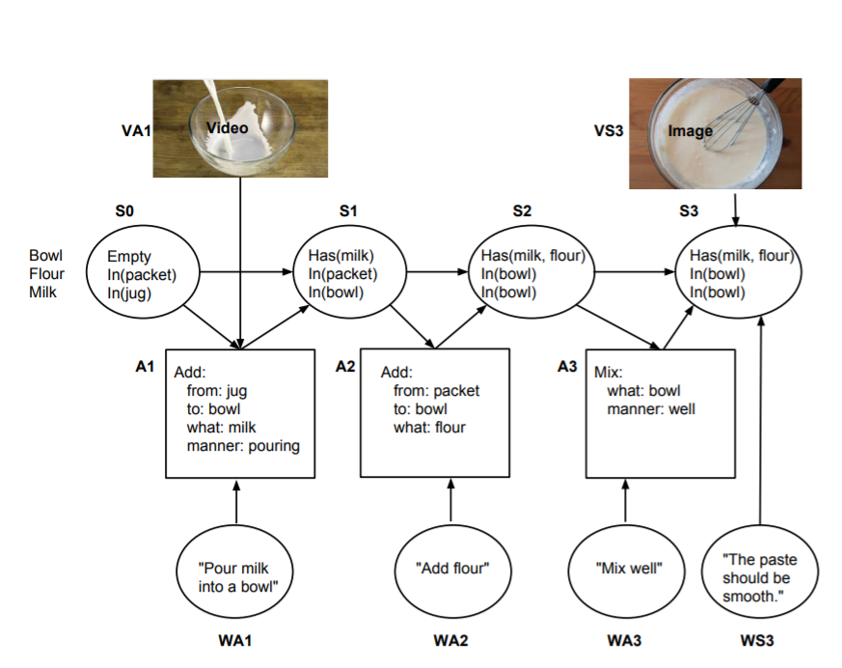

Figure 2: the actual steps of the recipe [7]

A machine can not recommend every food to every human group. Everybody has different concerns like health, gluten-free, calorie level, taste. For this reason, the machine has to learn these issues about each user group interactively. By this machine learning system recommendation system works more successful as the groups use the system. Taste, health concerns, etc. are detected by tags of the data in data. Furthermore, we help people to plan their meals without eating foods they don't like while they are improving their health and life standards.

Despite technological advancement, people are still not implementing healthy diet programs. It is possible to find diet programs from books, websites, and mobile applications. However, people prefer these programs to be personal. Finding such programs is not easy. So, the food mentioned in any diet program is not attractive. And users will not strictly follow the diet rules. To solve this problem, they create personalized meal plan suggestion systems. Studies on this subject have focused on general users. One of the main considerations when designing a proposal is that food and consumption are recurring. People eat at similar times a day and every day, and they plan their meals sequentially. A smart machine can help to pick healthy and tasty foods for them. [8]
The usage of the internet makes people's life easy in anyways. Especially in needs like food. Recipe recognition with a large multimodal food dataset is very important because the main challenge is the size of the data set. Food category classification is a key technology for many food-related applications such as monitoring a healthy diet, computational cooking, food recommendation system, etc. In, a novel smartphone application to record daily meal activities by image retrieval technique is developed. Based on this personal dietary data log system, they were able to conduct further usage preference experiments and food nutrition balance estimation.
The Open Meal System aims to invent new intelligent cooking appliances. This is a Purdue University Technology-Assisted Diet Assessment (TADA) project. The project aims to develop a mobile food recorder. This device records diet information. The device plans this information daily. It considers daily nutritional intake. The food category classification should be in all these applications. [9]
The recommendation system is a relative concept. Netflix is a good example of a recommendation system. Netflix, to date, has just over 100 million subscribers on its platform. But with each subscription having multiple profiles, the real number is double that. That's a lot of data, and with over 80% of TV shows being watched on the platform, it has its work cut out, to keep people engaged. But it doesn't have to do all the hard work.
Netflix effectively outsources some of the processes to you. Information on how you use the platform, how you rate content, and what you search for are all harvested and analyzed by Netflix to better improve your user experience.
When you access the Netflix service, a suggestion system is activated. The main purpose of the system is to show you the ideal show or film. We can think of Netflix as a film catalog. In this catalog, movies that you are likely to watch are presented according to the following factors:
- Your interactions with the Netflix service (such as your viewing history)
- Other members with similar preferences
- Types, categories, players, year of publication and so on. Information about topics

Netflix knows what to watch with these factors. It also looks at the following to personalize a similar and best suggestion:
- The time of day you watch
- The devices you are watching Netflix on
- How long you watch.
All of these factors mentioned above are kept as data. These data are the inputs of the Netflix algorithm. (The algorithm is the sequence of steps and processes followed to solve a problem.) Netflix does not take age and gender into consideration when deciding on the most appropriate recommendations. [10]

The Effectiveness of a Smartphone Application is an important concept for diet and a healthy life. On 10 October 2018, José I Recio-Rodríguez and his team published an article about The Effectiveness of a Smartphone Application on Modifying the Intakes of Macro and Micronutrients in Primary Care. The objective of this study is to evaluate the long-term (12 months) effectiveness of adding a diet smartphone application to standard counseling to modify dietary composition (macro and micronutrients and food groups). According to this research consisting of nutritional counseling and a diet smartphone application, achieved better results than counseling alone in modifying the diet. [11]
Figure 3: Changes in macronutrients after randomization by group (repeated measures analysis). [11]
Rapid developments in technology have encouraged the use of smartphones in health promotion research and practice. Although many applications (apps) relating to diet and nutrition are available from major smartphone platforms, relatively few have been tested in research studies in order to determine their effectiveness in promoting health. In qualitative studies, participants preferred applications that were quick and easy to administer and those that increase awareness of food intake and weight management. In randomized trials, the use of smartphone apps was associated with better dietary compliance for lower-calorie, low fat, and high fiber foods, and higher physical activity levels which resulted in more weight loss.
Smartphone apps are likely to be a useful and low-cost intervention for improving diet and nutrition and addressing obesity in the general population. The accuracy of diet and nutrition measurements obtained using mobile devices has generally been found to be good. Participants prefer applications that are quick and easy to administer and those that increase awareness of food intake and weight management. [12]
The software toolkits and programming paradigms used by application developers have a large impact on the design of architecture and the user interface of the applications they develop. Especially now, that technological advances are presenting us with affordable hardware that is capable of both sensing and displaying information with unprecedented accuracy, vividness, and bandwidth, there is an increased need to explore and develop tools that enable creative designers and developers to turn their ideas into reality. These tools must both allow for rapid prototyping to evaluate new ideas quickly and be able to take advantage of the full computing power offered by cutting edge technology. Python Kivy framework is one of them. [13]
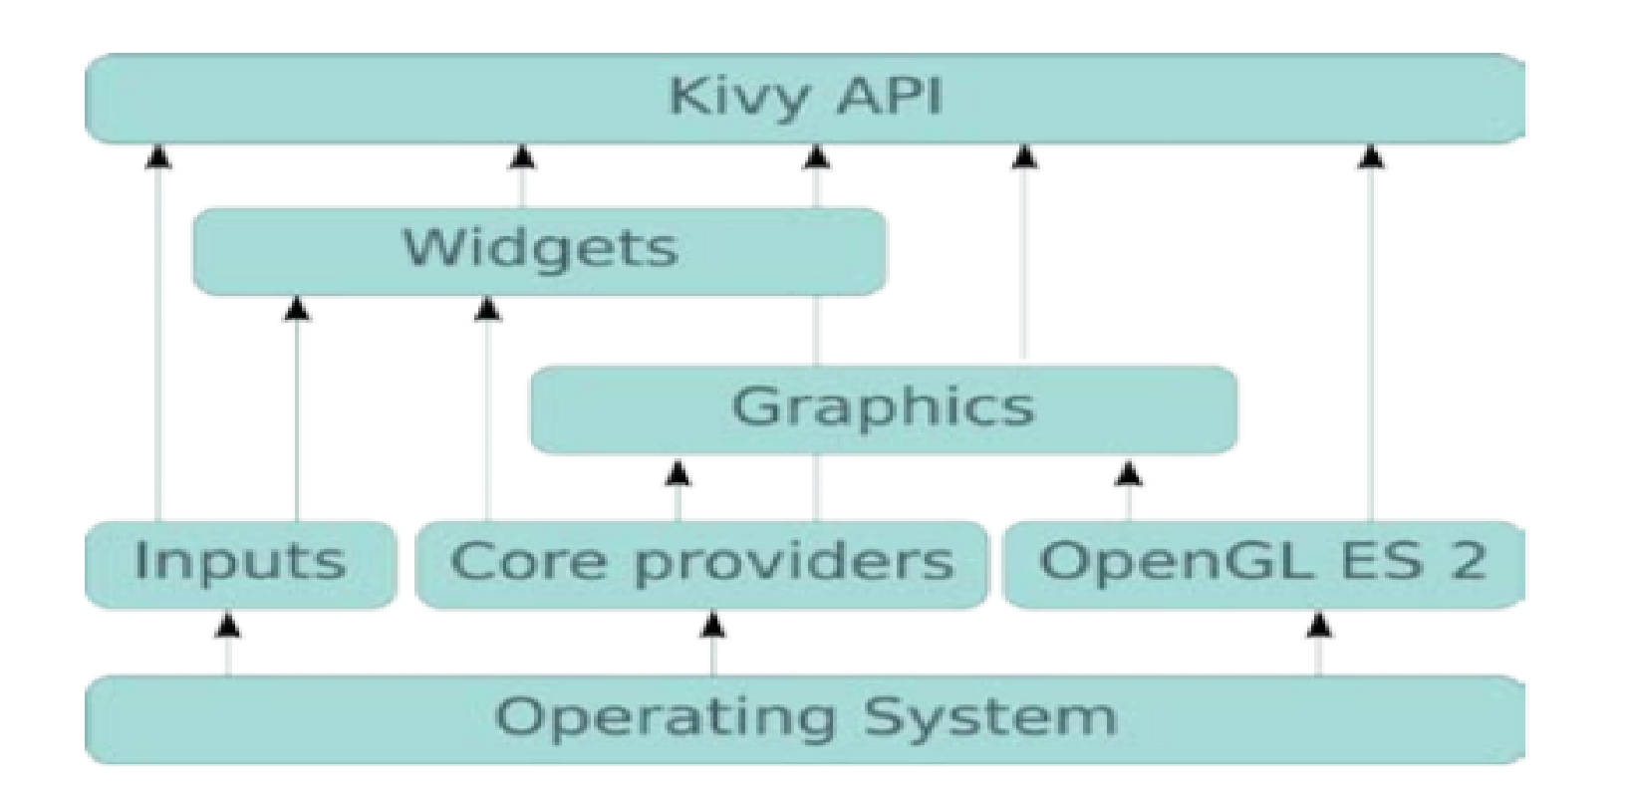
Figure 4: A general architecture of Kivy.[13]
As a result of the lifestyle-related disease epidemic, dietary life is now attracting attention. Good eating habits are important for maintaining a healthy life. However, menu planning requires one to consider various factors, such as the nutritional value, food in stock, food preferences, and cost. Thus, people need to expand a lot of effort toward planning their daily menu. Against this background, several cooking websites comprising various food recipes have recently been launched, such as Cookpad[14.1] and AllRecipes[14.2]. Many people refer to these websites when planning their menu. Cookpad contains 900,000 recipes and has 10,000,000 monthly users. This data reflects the high demand for recipe-providing services. However, these websites do not reflect the user's preferences and conditions, although these two factors need to be considered if the goal is to provide high-satisfactory recipes.
In January 2011, Mayumi Ueda and her team published an article about this subject. In their paper, they presented a method for extracting the user’s food preferences for recipe recommendation. Their method estimates a user’s preferences from his/her past actions, such as through their recipe browsing and menu planning history. For extracting the preferences, their method breaks recipes down into their ingredients and scores the recipes using the frequency and specificity of ingredients. Since their method can estimate the preferences through their browsing and cooking history, the user conveys his/her preferences to the system without having to carry out any particular operation. [14]
Another application that has parallel functions with us is Kochbot. Kochbot is a cooking assistant application for smartphones and tablet devices. This application allows you to search from a wide collection of recipes and explains cooking commands step by step. The most important feature of this application is that it is focused on speaking and listening. The main advantage of the application is that it has a hands-free scenario. and user satisfaction is quite high. [15]
The Internet provides us many knowledge-sharing facilities and searching for any information from any corner of the world. Recipe websites are good examples of this knowledge sharing. People can find millions of recipes using the internet. The many recipes that the internet provides are kinda difficult for a person who just want to search a recipe fits in his taste. On the Internet, most of these websites are simple-minded as not reliable on the recommendation system which was recommended recipes based on rating and comment-based recipes on the site. In these cases, a person who has been looking for a recipe for his taste can't always happy about what they get.
Bon Vivant is an interactive platform for discovering flavor mappings based on flavor compound analysis. It makes combinations of meals. It can match many factors, being able to do so. Eg ingredients, recipes, regional kitchens, and aroma compounds. This platform enables the user to achieve a healthier lifestyle. Because it is based on nutritional requirements when making recommendations. [16]
Smart mobile phones, which have entered almost every home in our age, do many things to make our lives easier. Good eating habits are important for a healthy life. How-ever food planning requires consideration of different factors, such as nutritional value, food in stock, food preferences, and cost. Additionally, people need to expand a lot of effort and time towards planning their daily food cooking. For these subjects, various websites provide various food recipes that have been published worldwide such as Cookpad[14.1] and Yahoo! Recipe[17]. Many people refer to these websites to answer their "how to cook" question. Cookpad contains now almost 100 million people around the world use Cookpad every month and over 4 million recipes have been created on the platform. It’s available in almost 70 countries around the world in 23 languages. [18]

2. Software Requirements Specification

2.1 INTRODUCTION

2.1.1 Problem Definition

Nowadays, most people are in a hustle. They have a busy work tempo or other daily hassles. So they neglect themselves. They don't even think about their health when preparing or eating food. At the same time, with developing technology, people become lazy. Even when making plans, they use these high-tech machines. For example in the evening, they even get help with what to cook at home. There are applications suggesting recipes for this. According to research on people, nowadays, time is more important than their health.

2.1.2 Purpose

The aim of this document is; delineate the Project which called Cook Hub. Cook Hub is a recipe recommendation Android application. You can create your virtual fridge which will be used for how to cook page. Also, you can find the recipes you are looking for. However, the app can also give you a recommendation. But it doesn't make the same suggestions to everyone. Instead, we offer personalized meals that meet certain conditions.

2.1.3 Scope

This software system will be a cross-platform application for any people who want to use in their daily life. The system will be designed to help the user:

- Do we have the necessary ingredients to prepare recipes? In order to answer this question, we have created a virtual fridge in which we record the already existing food in the house.
- Search for cookable food
- Create a Diet Plan

- Filter search by tags

- Recommendation system according to users choices

- Create a Shopping List

2.1.4 Definitions, acronyms, and abbreviations

TERM | DEFINITION
Database | Collection of all the information monitored by this system.
User | Any person on the system.
Android | A mobile device operating system developed by Google Inc.
IOS | A mobile device operating system developed by Apple Inc.
Spyder IDE | Spyder is a powerful scientific environment written in Python, for Python, and designed by and for scientists, engineers and data analysts. [1]
Software Requirements Specification (SRS) | A document that completely describes all of the functions of a proposed system and the constraints under which it must operate. For example, this document.

2.2 OVERALL DESCRIPTION

In this part, the system allows users to add or search any desired ingredient, food or tag. In order to do this, background information about the specific requirements of the system will be provided briefly. In Cook Hub the user can tag-based search, ingredient-based search, set timer, add an ingredient in the virtual fridge then the application will run along and communicate with a database server and running in between each part of the system.

2.2.1 Product Perspective

Cook Hub is a cross-platform mobile application with a database server in order to find a recipe or create a shopping list or create a diet plan. The mobile application will work on mobile Android or IOS devices. It will have functions as data managing, machine learning, and AI. When users run the application, they can use the functionalities of the device. All information will be kept on a database that can be accessed by users with or without login.

2.2.2 Product Functions

Cook Hub consists of these main tasks:

- Authentication
- Data Managing: We work with a very large data set. These data sets include recipes. We classified the characteristics of the recipe with short words that we call tag. We also use many different tags to describe the ingredients. Both of these information is stored in the data set.
- In order to provide diversity in our application, we have presented thousands of recipes to the user. We have done long dataset research. A dataset is a collection of data. In the case of tabular data, a dataset corresponds to one or more database tables. Each column has a certain variable and each row has a specific record. [27] We first tried to answer that question: “Where can we find datasets?” Then we came across a lot of websites. Like “FiveThirtyEight, BuzzFeed News, Kaggle, Socrata, Awesome-Public-Datasets on GitHub, Google Public Datasets, UCI Machine Learning Repository, Data.gov”.
- We chose to use “Kaggle”. Kaggle allows users to find and publish data sets, explore and build models in a web-based data-science environment, work with other data scientists and machine learning engineers, and enter competitions to solve data science challenges. [28] Most of the datasets are available to use. But it depends on the dataset. Some of the bigger companies have extra conditions that their data cannot be used without extra written permission.
- The data set we use contains the following information; a step-by-step description of how to prepare and cook the food, ingredients in the food, calorie information, nutritional values, cooking time and so on.
- Tag-based search: The user can search for food of his/her choice from a feature suggestion table that we provide him/her. These features are matched to the tags in the data set in the background. Thus, suggestions become more customized.
- Ingredient based search: This type of search has the same logic with a tag-based search. The users see a list of all the materials. They mark what they want to remove from the list. Or vice versa, they mark what they want to use. They can also use this search method as follows; marking materials that already exist at their home. So that we can help them cook without leaving the house. Via Ingredients Tags, we recommend recipes with the ingredients they want.
- Add ingredient in Virtual Fridge: The users can mark materials that already exist at their home. We will use it for two purposes. First, we will offer the user recipes that he/she can make with the ingredients s/he has. Or let's say the user chose a recipe. Via this virtual fridge, we will determine what is missing at home to prepare this recipe.
- Create a Diet Plan: At the register stage, we asked if the user had any significant health problems. We offer even more personalized recipes to the user if these health problems are associated with nutrition.
- Create Shopping List: This is a task associated with the "Add ingredient in virtual Fridge" step. When you select a recipe, your virtual fridge and ingredients are compared. Then, this application creates a shopping list of missing materials in your home.

2.2.3 Constraints, Assumptions and Dependencies

Users of this application are any Android or IOS device users that load this application to their devices. All of the users are in the same class, only one type of user exits. The operating environment is, as just mentioned above, is an Android OS or IOS mobile device. An android or IOS device that can support basic dependencies of the application is expected for proper user experience. On the other hand, our database server and services can operate on any OS like Windows or Ubuntu that can supply the database server's fundamental dependencies and needs. One important constraint is privacy and security. Users should be accessing only the authenticated data.

2.3 SPECIFIC REQUIREMENTS

In this chapter and its sections, the requirements are explained.

2.3.1 Interface Requirements

There will be two interfaces in our system, one will be between user and system, and the other will be between system and database.

2.3.2 Functional Requirements

This section explains the use of cases.

2.3.2.1 Download Cook Hub Use Case

Use Case:
- App Market
- Apple Store
- Google Play Store
- Download Cook Hub

Diagram:

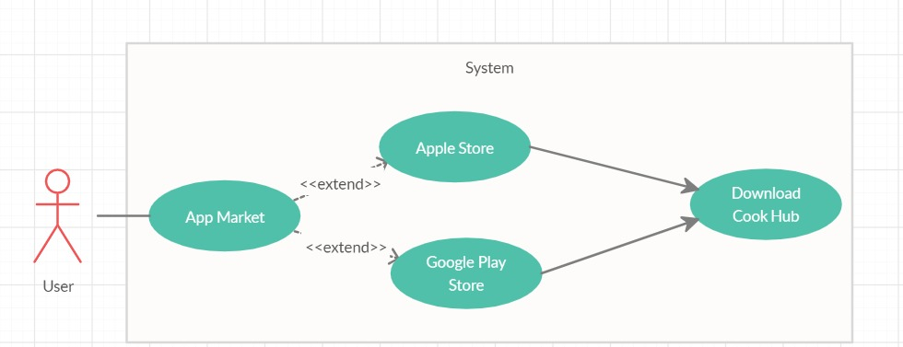

Figure 5 Download Cook Hub Use Case
Brief Description:
Figure 5 shows the participant Download Cook Hub Use Case diagram. When the user opens his current phone's market application, he/she can download Cook Hub and start to use it.
Initial Step-By-Step Description:
- Users must have a smartphone in order to download and use the Cook Hub application.
- The user must have select Cook Hub from his current phone's market application in order to download Cook Hub application.

2.3.2.2 User Registration Use Case

Use Case:
- User Registration
- Agree with term and Conditions
- Check Previous Password and correctness
- Login
- Check Login Detail
- Confirm Login
- Login Failed
- Login Without Registration
- Mistyped Password
Diagram:

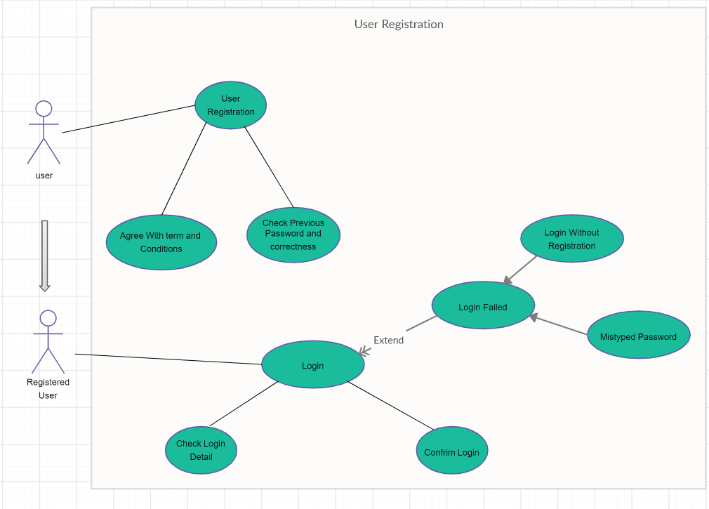
Figure 6: User Registration Use Case
Brief Description:
Figure 6 shows the participant User Registration Use Case diagram. When the user opens the application he/she can log in the application if he/she has already an account. If he/she does not have an account, it can be registered using the button.

Initial Step-By-Step Description:
- If the user has already an account (Registered User), he/she can log in to the application by selecting the Login button. The application will look for the password through the database and confirm if the user has written the password correctly.

- If the user has not an account before he/she can create an account by using the Register button. Users must have, fill all the blanks with their personal information and their desired diet type in order to register the application and then must agree with terms and conditions in order to succeed in his account.

- If the user, writes a password that is not matched with the account name or tried to login without registration, login will be failed.

2.3.2.3 Virtual Fridge Screen Use Case
Use Case:
- Add Ingredient
- Delete Ingredient
- Edit Ingredient Quantity
- Save
- Exit
Diagram:

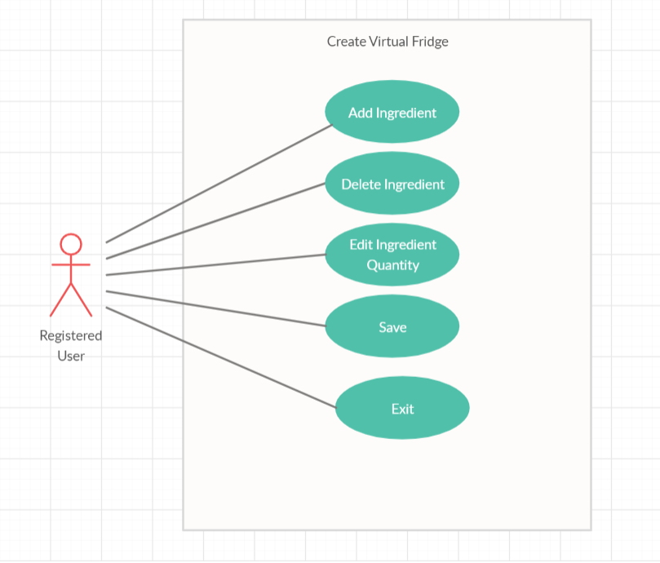
Figure 7 Virtual Fridge Screen Use Case
Brief Description:
Figure 7 shows a participant Virtual Fridge screen use case diagram. Users can create their own virtual fridge which will be used for how to cook page and online marketplace page. Users can select from the options which were Add Ingredient, Delete Ingredient, and Edit Ingredient Quantity, Save, Exit.

Initial Step-By-Step Description:
- If a user selects Add Ingredient, the user will select or write the ingredients that he/she wanted to add to his virtual fridge.
- If the user selects Delete Ingredient, the user will remove the unwanted ingredient from his own Virtual Fridge.
- If the user selects Save, the user allows the program to save changes.
- If the user selects Exit, the user will be back for the main page.

2.3.2.4 Search a Recipe Use Case

Use Case:
- Search
- Search by Recipe or Ingredient
- Search by Ingredient
- With Virtual Fridge
- Without Virtual Fridge
- Make Recommendation
- Results

Diagram:
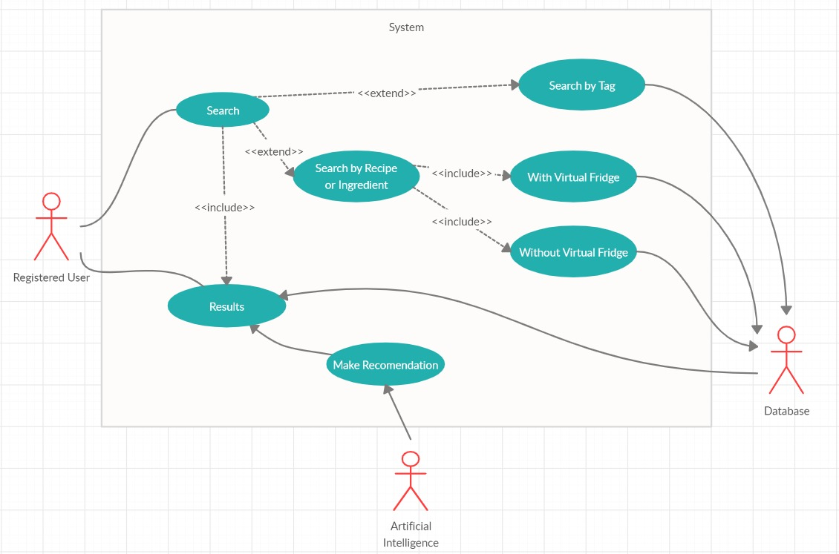
Figure 8 Search a Recipe Use Case

Brief Description:
Figure 8 shows participant Search a Recipe Use Case Diagram. Users can search recipes in three ways which were; Search by Recipe or Ingredient, Search by Tag. After the user has been select from this option and fulfills the selected option's properties, he/she can review the result of the desired recipe/recipes.

Initial Step-By-Step Description:
- The user will select one of three search options.
- If the user selects Search by Recipe option, the user can review the recipes by typing their desired food and the application will display the desired food's recipe if that food's recipe exists on the application's database.
- If user selects Search by Ingredient option, user can review the recipes from the application with two options which were; typing their desired ingredient by using auto-complete typing system by not using the virtual fridge or choosing ingredients by using multi-search selecting system from among the ingredients that has been saved before on the virtual fridge by the user.
- If the user selects Search by Tag option, the user can review the recipes by selecting from search criteria by using the auto-complete typing system or multi search selecting the system.
- After the user has select one of these options and uses it the application will display the desired recipe/recipes result concerning the Artificial Intelligence recommendation system.

2.3.2.5 Food Recommender System Use Case

Use Case:
- Rate Recipe
- Rate Recommendations
- Make as Favorite Recipe
- Make as Favorite Tag
- Access Recommendations
- Search by Recipe, Tags or Ingredient
- Gather User data
- Calculate Similarity Scores
- Show Predictions

Diagram:
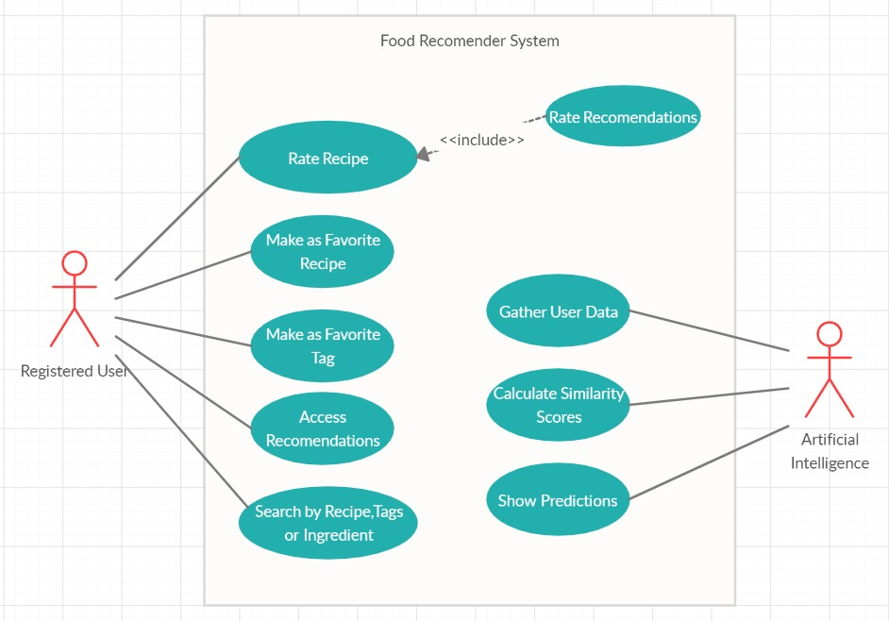
Figure 9 Food Recommender System Use Case

Brief Description:
Figure 9 shows the participant Food Recommender System use case diagram. Users can rate the recipes that they choose to love their taste and they can rate the Cook Hub's Artificial Intelligence's recommended recipes if they have wanted to. Users can favorite the recipes or tags that they wanted, Access recommendations and can search for recipes with 3 sub search algorithms. While the user uses food recommender service Cook Hub's Artificial Intelligence at the back-end will gather the user data and calculate the similarity scores.

Initial Step-By-Step Description:
- When the user uses the food recommender service he/she can search for recipes by using Search by Recipe, Tags, and Ingredient. Search by recipe let the user, their typed food comes to screen with its recipe, Search by Tag let the user, choose from different tags and system will display the fitted recipes that he/she has to choose before, Search by Ingredient let the user, choose the ingredients from its own virtual fridge or by typing each ingredient and system will display the fitted recipes that he/she has to choose or typed before.
- Users can favorite the recipes that they are enjoyed to eat it.
- Users can favorite the tags that they are often used for their search criteria.
- Users can rate the recipes that they have to want it by 1 to a maximum of 5. 1 means the user disliked the recipe while 5 means the user has enjoyed the recipe.
- Users can rate the Cook Hub's Artificial Intelligence recommended recipe if they want it by 1 to a maximum of 5. 1 means user disliked the recipe while 5 means user has enjoyed the recipe
- Cook Hub's Artificial Intelligence will store the user's data with log user activities, ingredient count in the virtual fridge, favorite food, etc. to give a better quality recommendation system.
- Cook Hub's Artificial Intelligence will calculate similarities scores using Pearson correlation[29]
- Cook Hub's Artificial Intelligence will show the prediction as a recommendation to the user due to calculated similarity scores.

2.3.2.6 Shopping List Use Case

Use Case:
- Manipulate Shopping lists
- Add a new shopping list
- Delete a shopping list
- Save changes
- Manipulate content of shopping lists
- Add an item
- Delete an item/items
- Check off an item/items
Diagram:
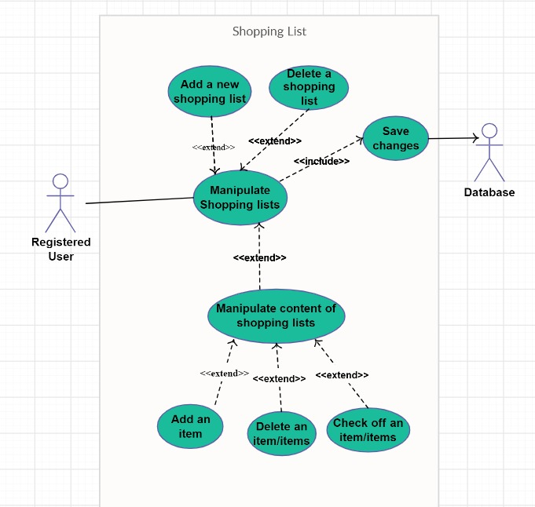
Figure 10 Shopping List Screen Use Case
Brief Description:
Figure 10 shows the participant Shopping List use case diagram. Users can create one or more shopping lists which will help them reduce the time on their time during shopping. After the user has done the market shopping, they can select add to fridge option and all the ingredients in the list will be going to the virtual fridge automatically.

Initial Step-By-Step Description:
- If a user wants to create one or more shopping lists he/she can create one that will help to reduce their shopping time.
- Users can add or remove items in their current shopping list.
- Users can check off an item if the selected items have already in the virtual fridge or not.
- User can rename the shopping list that he/she has created.
- User can switch between the shopping lists by choosing among the list names
- Users can delete the shopping lists by choosing among the list names.
- After a user has done and bought all of the shopping list items, he/she can use add to the fridge button that will instantly remove all the current shopping list items and add them to the user's own virtual fridge.

2.3.3 Non-Functional Requirements

- System recommendation will avoid suggesting a recipe that will trigger the user's disease or allergies that the user has specified before.
- When the user searches for any recipe system will load rapidly
- The system will recommend the recipe to the user at least %50 similarity as the taste of the user.
- The system will hold the calorie data of each meal user has eaten then calculate the average calorie of the user gain's from his meals in a day row then the system will primarily recommend foods with similar calories. To succeed with this a user must have specified all meals they have to eat at least for 7 days.
- The system will check the calorie values of the user's meals during the day then review the user's average calorie per day then primarily based on recommending the recipes which have calorie's close to the average calorie value.
- Whenever a user has searched for food that will exceed the average daily calorie value, the system will give a warning. User can skip the warning if he/she wanted to review the recipe.

2.3.4 Design Constraints

- We will use the "agile method" and Object-Oriented Programming paradigm.
- We will use Python as a programming language. The Android version of the device should be 2.3 or higher. The system does not require an Internet connection.

2.3.5 Performance Requirements
The Cook Hub project's respond and match system must run smoothly without delay. Because of the non-visual contents project do not need a high system. Any user that downloads the Cook Hub should be able to use the system at any time. The response time of the system should be 5 seconds at most.

- NETWORK : Technology GSM / HSPA / LTE/ WIFI
- DISPLAY: No minimum requirement
- PLATFORM: OS Android 4.4.2 (KitKat)
- Chipset: Qualcomm MSM8974AC Snapdragon 801
- CPU: Quad-core 2.5 GHz Krait 400
- MEMORY: 350MB
- RAM: 1GB

2.3.6 Software System Attributes

2.3.6.1 Portability
- Cook Hub is intended for any kind of android OS mobile platform.
- After installation, there is no need for any internet connection to use the Cook Hub.

2.3.6.2 Performance
- Back-ground calculations work every time a recipe is cooked, does not stack

2.3.6.3 Usability
- Every recipe contains multiple tags
- Every recipe contains multiple ingredients
- Every recipe contains multiple levels of calorie

2.3.6.4 Adaptability
- Dataset is fetched by the data set since the dataset is internal at phone Android OS is required

2.3.6.5 Scalability
- Because of the offline working system every user’s information is stored at the internal storage. There is no scalability requirement.

2.3.7 Safety Requirements

People have to consider and choose their diseases and allergies before they are searching for the food they liked otherwise they can take harm. While using the Cook Hub application users should have checked the oven and stove frequently and care for the timer at the application to avoid unexpected results.

3. Software Design Description

3.1 Purpose

The aim of this document is; delineate the Project which called Cook Hub. Cook Hub is a recipe recommendation Android application. You can create your own virtual fridge which will be used for how to cook page. This part will show the software design of the Cook Hub project.

3.2 Scope

This software system will be a cross-platform application for any people who want to use in their daily life. The system will be designed to help the user:

- Do we have the necessary ingredients to prepare recipes? In order to answer this question, we have created a virtual fridge in which we record the already existing food in the house.
- Search for cookable food according to virtual fridge data
- Create a Diet Plan

- Filter search by tags, ingredients or recipes

- Recommendation system according to users choices

- Create a Shopping List

3.3 Overview of the Section
This section provides information about the contents of the rest of the document as follows: Part 2 describes the problem and details the design of this project along with the class architecture. Part 3 displays and explains the block diagram of the system, which is designed according to use cases in the SRS document.

3.4 Glossary

TERM | DEFINITION
Database | Collection of all the information monitored by this system.
UML Diagram | It is a modeling language that is used in Software Engineering.
Block Diagram | The type of schema in which the components in the system are displayed in blocks.
Activity Diagram | Describes activities and actions taking place in a system
Machine Learning | Machine learning is an application of artificial intelligence (AI) that provides systems the ability to automatically learn and improve from experience without being explicitly programmed.
Software Design Document (SDD) | A software design description (a.k.a. software design document or SDD; just design document; also Software Design Specification) is a written description of a software product, that a software designer writes in order to give a software development team overall guidance to the architecture of the software project.
IOS | A mobile device operating system developed by Apple Inc.
Kivy Framework | Kivy is a free and open-source Python library for developing mobile apps and other multitouch application software with a natural user interface (NUI).
Android | A mobile device operating system developed by Google Inc.
Spyder IDE | Spyder is a powerful scientific environment written in Python, for Python, and designed by and for scientists, engineers and data analysts. [1]

Figure 11 Glossary of SDD

3.6 Motivation

We are a group of senior students in the computer engineering department who are interested in mobile application and machine learning. We aimed to create a program that offers recipes that are suitable for people, their tastes and their health. We choose Python language for development because Python is a high-level programming language that is widely used in web development, app development, analyzing and computing scientific and numeric data, creating desktop GUIs, and for software development. Also, Python is a cut out for our recommender system. As a framework for the application, we choose the Kivy Framework. Kivy is a free and open-source Python library for developing mobile apps and other multitouch application software with a natural user interface (NUI). Kivy released its stable version on 21 June 2019. Our database will be on MySQL. Our program development environment will be the Spyder IDE.
The target platform will be Android but our application will be cross-platform application and the development environment is Microsoft Visual Studio 2019.

3.7 DESIGN OVERVIEW

3.7.1 Problem Definition

Nowadays, most people are in a hustle. They have a busy work tempo or other daily hassles. So they neglect themselves. They don't even think about their health when preparing or eating food. At the same time, with developing technology, people become lazy. Even when making plans, they use these high-tech machines. For example in the evening, they even get help with what to cook at home. There are applications suggesting recipes for this. According to research on people, nowadays, time is more important than their health.

3.7.2 Architecture Design

3.7.3 Simulation Design Approach

3.7.3.1 Sequence Diagram

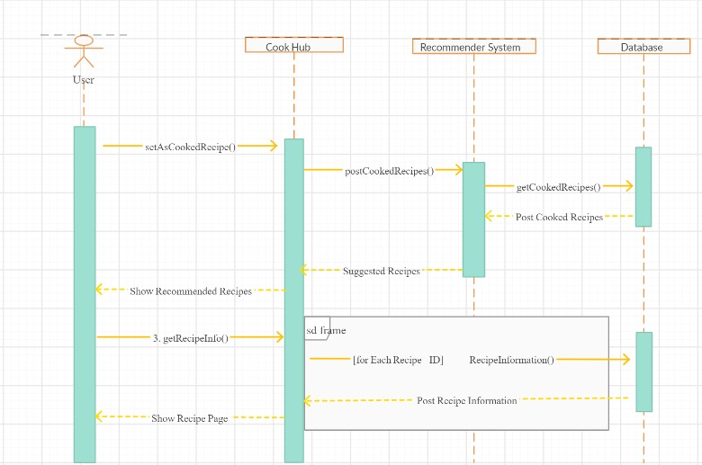
Figure 12 Sequence Diagram

Figure 12 displays a sequence diagram. The user enters information about her/his taste and health. Recommend System creates recommendations to the user. Then the user chooses any recipe from recommends. If the user cooked this recipe, s/he should mark the "I cooked it" button. With this method, the following recommendations will be even more accurate and personalized.

3.7.3.2 Activity Diagram

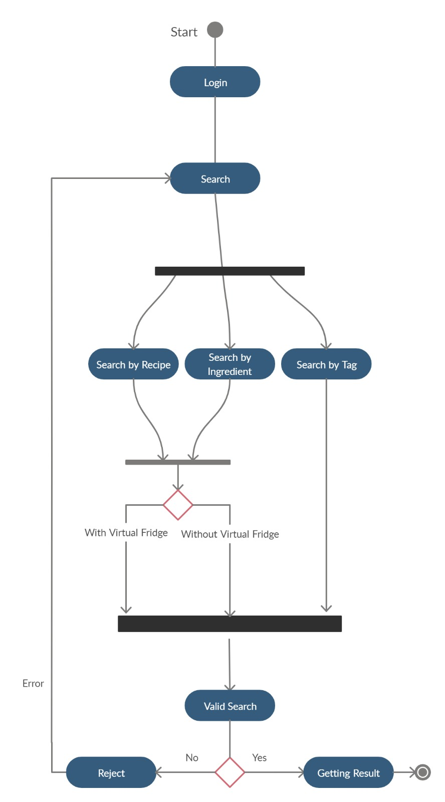

Figure 13 Activity Diagram
Figure 13, shows how scenario generation works as an activity diagram. When the user open to the application, she/he sees the home page of the application. If the user goes to the search page, they can find three searching methods; Search by Tag, Search by Ingredient, Search by Recipe. After searching, the user reaches the accurate recipes.

3.7.3.3 Class Diagram

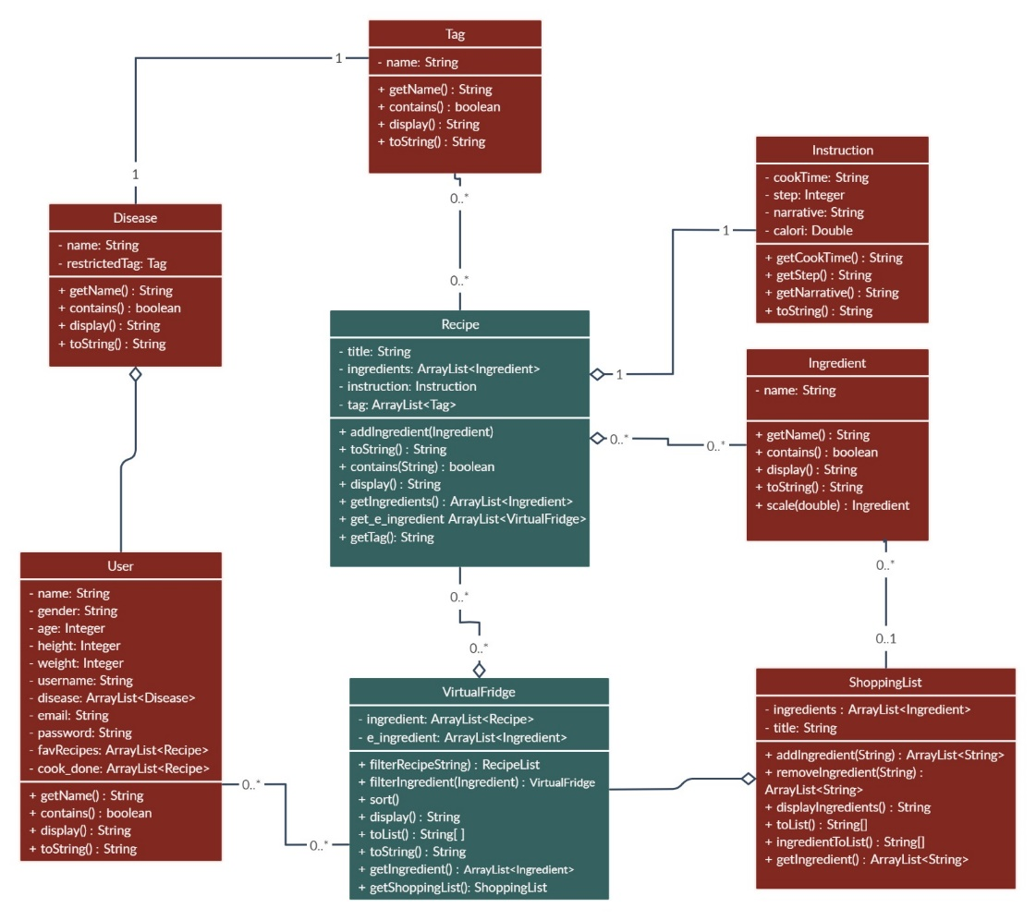
Figure 14 Class Diagram
Figure 14 shows the main components of the system and its functions. Relationships between these tables are shown with links.

3.7.4 User Interfaces

3.2.4.1 Profile management
Summary: Users can Register, Login, Edit profile. The information that has entered in register part will help the system to recommend customized recipes.
Actor: User
Precondition: Download Cook Hub Application from the app market.
Basic Sequence:
- User must register if he/she doesn’t have an account.
- User should specify the personal health information during registration.
3. The user shall log in to the system by entering his/her username and password.
4. Users can update his/her personal information by selecting an edit profile button from the user menu.
Exception: Database connection can be failed.
Post Conditions: None
Priority: Low

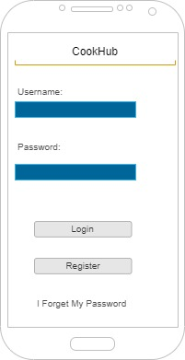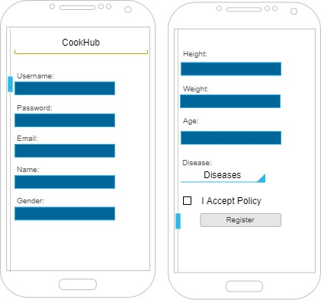
Figure 15 Login Screen Figure 16 Register Screen

3.7.4.2 What should I cook? (Home Page)

Summary: This system used by registered users. The Home Page will host several recipes that were recommended by the Cook Hub AI. Although users can search for food if they have wanted to. Users can search for food recipes in 3 ways; search by tag, search by ingredient, search by recipe.
Actor: User
Precondition: Log in the system
Basic Sequence:
- User must log in if he/she has an account.
- Users can see the ten most popular recipes (according to the user's personal information and tastes) on Home Page if s/he uses the application for the first time.
3. As the user chooses from the recipes s/he sees here, s/he will encounter even more personalized recipes each time.
4. Users can update his/her personal information by selecting an edit profile button from the user menu.
Exception: None
Post Conditions: None
Priority: High

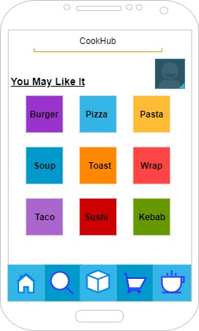
Figure 17 Home Page

3.7.4.3 Search Screen
Summary: Users can manually search for recipes. They can search for food recipes in 3 ways; search by tag, search by ingredient, search by recipe. The recipes presented to them as a result of the search will again be limited according to their personal information.
Actor: User
Precondition: Click Search Button.
Basic Sequence:
- If the user chooses the "Search by Recipe", with the name of the meal s/he can reach the recipe directly.
- If the user chooses the "Search by Ingredient", users will encounter two search methods.
- With the "Enter Ingredients" button the user will type the material name by hand. S/he will choose the materials s/he finds. Multisearch can be done here.
- When the user clicks the "Virtual Fridge" button, a drop-down list will be opened below. This list shows the ingredients already exist in the refrigerator. Multisearch can be done here.
- When users click "Search", these two methods will be combined.
- If the user chooses the "Search by Tag", users will encounter an eye symbol. If the user clicks this eye, a pop up that shows all tags will appear on the screen. They can choose more than one tags by clicking.
- Also if the user clicks the "Enter Tag", they can manually add tags. Recommended recipes will include the intersection of these tags.

Exception: Database connection can be failed.
Post Conditions: None
Priority: Medium

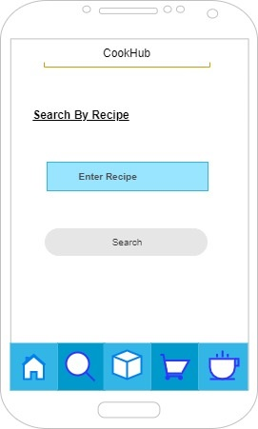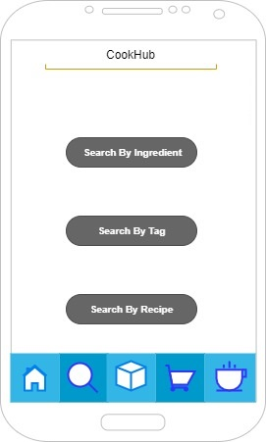

Figure 18 Search by Recipe Figure 19 Search Screen

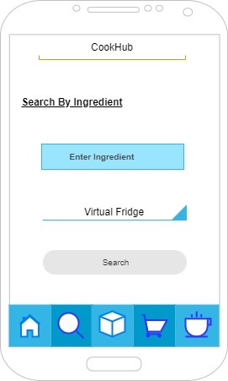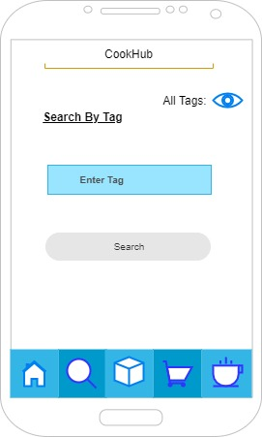
Figure 20 Search by Ingredient Figure 21 Search by Tag

3.7.4.4 Virtual fridge and Shopping List
Summary: After all the searching steps, finally the user finds and selects a recipe to prepare.
Actor: User
Precondition: Choose a recipe.
Basic Sequence:
- The necessary ingredients in the recipe selected by the user are compared with the ingredients in your Virtual Fridge.
- If there are no more than 2 missings, these are automatically added to the shopping list.
- Also, the shopping list can be controlled manually. You can manipulate the list by adding something (marked with a tick) or delete something (unmark).
- When the user buys the missing ingredients, then s/he should tick them from the shopping list. These ingredients will be included in Virtual Fridge anymore.
- Users can create many shopping lists by clicking the plus sign above. Then a new list will be created as a new tab.
Exception: Database connection can be failed.
Post Conditions: None
Priority: Low
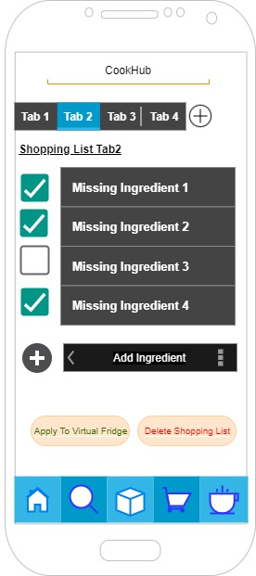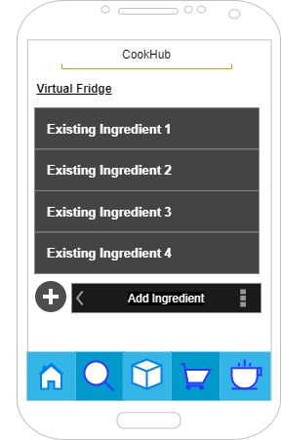
Figure 22 Shopping List Figure 23 Virtual Fridge

3.7.4.5 Favourite Recipes
Summary: Purpose of this page, the user can click the star sign when they are on the recipe screen. These starred recipes will be added to the favorite recipe list.
Actor: User
Precondition: Choose a recipe.
Basic Sequence:
- Users can create many recipe lists by clicking the plus sign above. Then a new list will be created as a new tab.

Exception: None
Post Conditions: None
Priority: Low
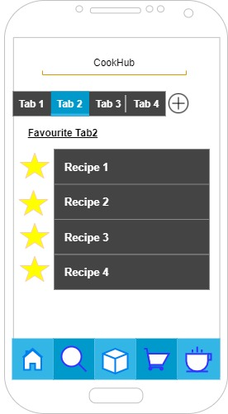
Figure 24 Favorite Recipes

3.8 Recommender System

Recommender System: A recommender system refers to a system that is capable of predicting the future preference of a set of items for a user and recommend the top items. The system will use one of the three algorithms. These are Singular Value decomposition (SVD) - Jaccard Similarity Coefficient - Naive Bayes.
Jaccard Similarity - The Jaccard Similarity Index (sometimes referred to as the Jaccard Similarity Coefficient) compares members for two sets to see which members are shared and which are separate. It is a test of correlation for the two data sets, varying from 0 percent to 100 percent. The higher the percentage, the more similar the two populations are. While simple to interpret, it is extremely sensitive to small sample sizes and may provide incorrect results, particularly with very small samples or data sets with missing observations.
The Naive Bayes - The Naive Bayes algorithm is a simple probabilistic classifier that calculates a set of probabilities by counting a given data set's frequency and value combinations. The algorithm uses Bayes theorem which claims that, given the value of the category function, all attributes are equal. This contingent presumption of freedom seldom occurs to real-world applications, hence the description as Naive yet the algorithm continues to do well and learn quickly in various supervised classification problems. Classification algorithm performance is usually examined by evaluating the classification accuracy. Since classification is often a confusing issue, the correct answer can depend on the user. Standard analysis methods to algorithms such as evaluating the overhead space and time can be used, but these strategies are typically secondary. Evaluating which is better relies on consumers understanding the problem.
Singular Value decomposition - SVD has used as collaborative filtering (CF) algorithm in the context of recommendation systems. Collaborative filtering is a method for predicting a user-item pair rating based on the user's history of ratings given to the item. Most CF algorithms are based on a user-item rating matrix where each row represents a user, each column represents an item. The entries in this matrix are the ratings given to items by users.

3.9 USE CASE REALIZATION

3.9.1 Project Components
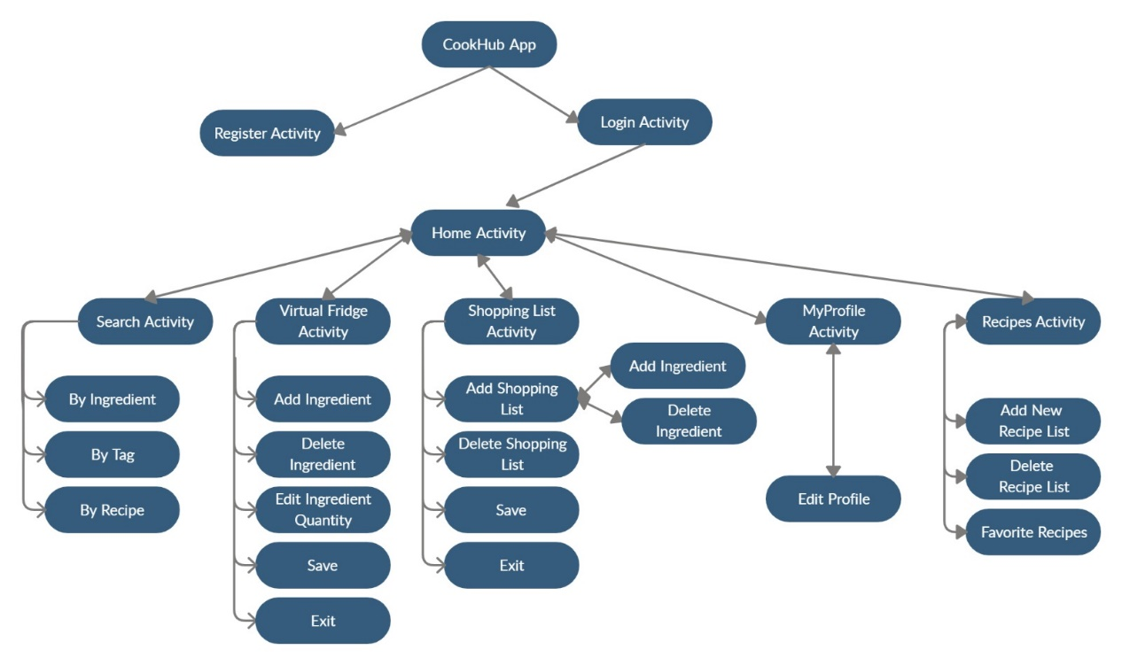
Figure 25 Block Diagram of System Components
All designed systems of the system are displayed in the block diagram in the figure. There are two main components of the system which have their own sub-systems.

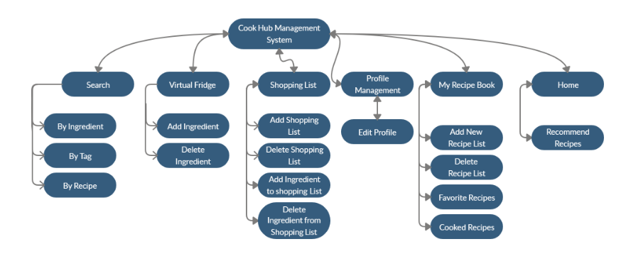

Figure 26 Subsystem Decomposition Diagram

4. Conclusion
People are very busy in their daily lives. They want to get things done quickly. They even want speed while thinking. And, of course, when deciding. Sometimes they can't decide what to eat. They don't even know what should/shouldn’t eat. That’s why we decided to create an application that recommends both healthy and personalized recipes and shows you how to make it step by step. We have designed many algorithms to create this application. We have examined similar works from various articles. And we mentioned them in our report.

5. Acknowledgment
We are grateful for the guidance we have received from Assist. Prof. Dr. Roya Choupani. The help we received from them was a great asset to improve this project and ourselves.

6. References

[1] https://pandas.pydata.org/
[2] https://matplotlib.org/
[3] https://numpy.org/
[4] The American Journal of Clinical Nutrition, Volume 103, Issue 5, May 2016, Pages 1193– 1194,
Available: https://doi.org/10.3945/ajcn.116.134221
[5] HTTP: //www.google.com/insidesearch/ features / recipes /
[6] http://microformats.org/wiki/ recipe formats
[7] https://www.aclweb.org/anthology/W14-2407/
[8] http://citeseerx.ist.psu.edu/viewdoc/download?doi=10.1.1.666.1434&rep=rep1&type=pdf
[9] https://ieeexplore.ieee.org/abstract/document/7169757
[10] https://help.netflix.com/en/node/100639
[11] The Effectiveness of a Smartphone Application on Modifying the Intakes of Macro and Micronutrients in Primary Care: A Randomized Controlled Trial. The EVIDENT II Study (10 October 2018)
[12] Steven S Coughlin, Mary S. Whitehead, Joyce Q Sheats, January 2016, Smartphone Applications for Promoting Healthy Diet and Nutrition: A Literature Review
[13] Kivy – A Framework for Rapid Creation of Innovative User Interfaces
Available: https://www.semanticscholar.org/paper/Kivy-A-Framework-for-Rapid-Creation-of-Innovative-Virbel-Hansen/bae0df60195a86fa7fd12172b026b32ff7cfbe1b
[14.1] Cookpad. http://cookpad.com/, (Accessed 20 October 2019)
[14.2] AllRecipes. https://www.allrecipes.com/, (Accessed 20 October 2019)
[14] M. Ueda, M. Takahata, and S. Nakajima. User’s food preference extraction for cooking recipe recommendation. In Proc. of the 2nd Workshop on Semantic Personalized Information Management: Retrieval and Recommendation, 2011
[15] Ulrich Sch¨afer, Frederik Arnold, Simon Ostermann, and Saskia Reifers, 2013, Ingredients and Recipe for a Robust Mobile Speech-Enabled Cooking Assistant for German
[16] http://www.oaijse.com/VolumeArticles/FullTextPDF/224_40.BON_VIVANT_AN_ARTIFICIAL_INTELLIGENCE_COOKING_APP.pdf
[17] https://loco.yahoo.co.jp/gourmet/recipes/
[18] https://medium.com/cookpadteam/cookpad-the-story-behind-the-platform-used-by-100-million-people-7060f7fa4833
[19] Brants, T.: TnT – A statistical part-of-speech tagger. In: Proc. of 6th ANLP, Seattle, Washington, pp. 224–231 (2000)Google Scholar Hamada, R., Okabe, J., Ide, I.: Cooking navi: Assistant for daily cooking in kitchen. In: Proc. of 13th ACM Int. Conf. on Multimedia, Singapore, pp. 371–374 (2005)Google Scholar
[20] Chouambe, L.C.: Dynamische Vokabularerweiterung für ein grammatikbasiertes Dialogsystem durch Online-Ressourcen, Studienarbeit, University of Karlsruhe (2006)Google Scholar
[21] Drozdzynski, W., Krieger, H.U., Piskorski, J., Schäfer, U., Xu, F.: Shallow processing with unification and typed feature structures — Foundations and applications. Künstliche Intelligenz 1, 17–23 (2004)Google Scholar
[22] Hamada, R., Okabe, J., Ide, I.: Cooking navi: Assistant for daily cooking in kitchen. In: Proc. of 13th ACM Int. Conf. on Multimedia, Singapore, pp. 371–374 (2005)Google Scholar
[23] Martins, F.M., Pardal, J.P., Franqueira, L., Arez, P., Mamede, N.J.: Starting to cook a tutoring dialogue system. In: SLT Workshop 2008, pp. 145–148. IEEE (2008)Google Scholar
[24] Petitpierre, D., Russell, G.: MMORPH – the Multext morphology program. Tech. rep., ISSCO, University of Geneva (1995)Google Scholar
[25] Ribeiro, R., Batista, F., Pardal, J.P., Mamede, N.J., Pinto, H.S.: Cooking an ontology. In: Euzenat, J., Domingue, J. (eds.) AIMSA 2006. LNCS (LNAI), vol. 4183, pp. 213–221. Springer, Heidelberg (2006)CrossRefGoogle Scholar
[26] Wasinger, R.: Dialog-based user interfaces featuring a home cooking assistant, University of Sydney, Australia (2001) (unpublished manuscript)Google Scholar
[27] https://en.wikipedia.org › wiki › Data_set
[28] https://en.m.wikipedia.org › wiki › Kaggle
[29] Pearson Correlation score [http://en.wikipedia.org/wiki/Pearson_productmoment_correlation_coefficient]

