

**ÇANKAYA UNIVERSITY**

**FACULTY OF ENGINEERING**

**COMPUTER ENGINEERING DEPARTMENT**

**Project Report**

**Version 1**

**CENG 407**

Innovative System Design and Development I

***MOVIE RECOMMENDATION SYSTEM***

*Doruk Gürsey*

*201511029*

*Kaan Önder*

*201511044*

*Kemal Berke Saka*

*201411051*

*Önen Emre Can*

*201511008*

Advisor: *Abdül Kadir Görür*

Abstract

1. Introduction

1.1 What is a Recommendation System?

1.2 Recommendation System Algorithms

1.3 Content Based Filtering Systems

1.4 Collaborative Filtering Systems

1.5 Popularity Based Recommendation Systems

1.6 Hybrid Recommendation Systems

2. Who Uses Recommendation Systems?

2.1 Netflix

2.2 Amazon

2.3 Spotify

3. Software Requirements Specification

3.1 Introduction

3.1.1 Purpose

3.1.2 Scope of Project

3.1.3 Glossary

3.2 Overall Description

3.2.1 Product Perspective

3.2.2 Development Methodology

3.2.3 Product Functions

3.2.4 Constraints

3.2.5 User Characteristics

3.2.6 Use Case Diagram

3.3 Requirements Specification

3.3.1 External Interface Requirements

3.3.2 Performance Requirements

3.3.3 Software system attributes

4. Conclusion For SRS

5. Software Design Description

5.1 Introduction

5.1.1 Purpose

5.1.2 Scope

5.1.3 Glossary

5.1.4 Overview of document

5.2 Architecture design

5.2.1 Architecture Design Approach

5.2.2 Technologies Used

5.2.3 Architecture Design Of Movie Recommendation System

5.3 Class Diagram

5.4 Use case realizations

5.4.1 Movie Recommendation System Components

5.4.2 UI Design Description

5.5 Interface Design

5.6 Conclusion

5.7 References

# Abstract

The aim of this project is to develop a system that can offer movie advice to people looking for movies they like or looking for similar ones they love. In this document, we will present to you what is our project will be look like, what are the algorithms that we may use and which softwares, systems uses these algorithms.

# Introduction

Over the past 5 years, watching movies and series on digital platforms is now a part of our lives. While the film industry is slowly losing its influence, watching movies on the Internet and paying less for it is becoming a better and easier method for everyone. With the increase in our internet speeds, we are now able to watch movies or series from various platforms very comfortably. Some companies that foreseen this development have increased their investments in this field and have become the pioneers of this sector[1].

As we can see from the Figure 1, the internet movie watching sector has increased over the years and will continue to increase at the same speed.

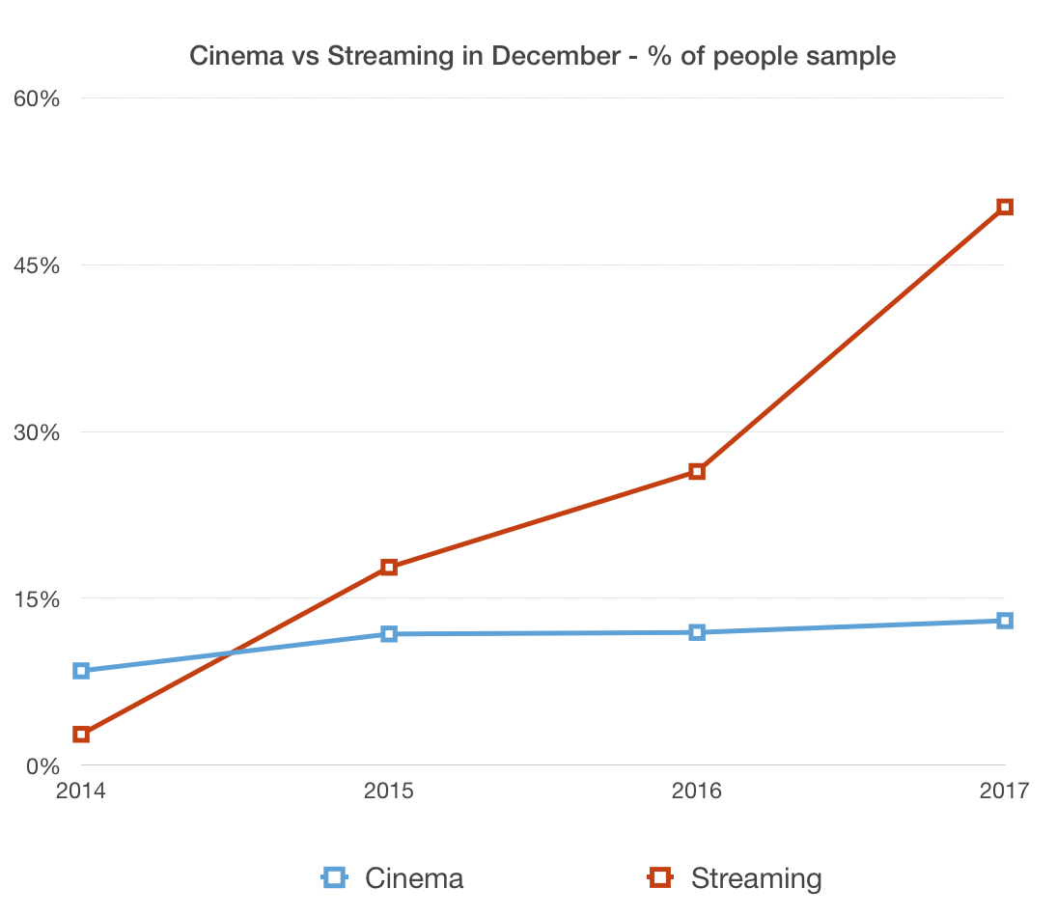

**Figure 1**

## What is a Recommendation System?

State the problem to be solved. Why are you doing this work and what significance does it have in the relevant literature? Even if your project is applied (as opposed to research-oriented), you are building a system because a problem, requiring a solution in the form of a computer program, exists.

## Recommendation System Algorithms

There are basically 4 important recommendation systems.

* Content-Based Filtering Systems
* Collaborative Filtering Systems
* Popularity Based Recommendation Systems
* Hybrid Recommendation Systems

## Content Based Filtering Systems

This method is based on the users' preferred options and the content of those options. It attempts to recommend products that are similar to the products the user has liked in the past. So it works as follows; "If you like product A, you like product B" [3].

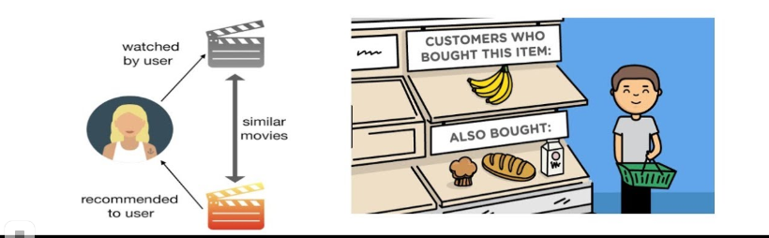

**Figure 2**

## Collaborative Filtering Systems

This method is based on analyzing the user's activities, behaviors or preferences and gathering information about them. Its most important feature is that it combines the information it collects and analyzes, based on its similarity with other users, to predict what they will love. The underlying theory is; It is assumed that individuals who have similar preferences in the past will make the same choices in the future[4].

If they want to understand better, let me think you an example. User1 chose A,B,C and User2 choose B,C,D. It is obvious that User1 will prefer D and User2 will prefer A in the future. This is exactly what the system does.

*There are 2 types of Collaborative Filtering Systems* :

* User-Based Collaborative Filtering

This algorithm is based on associating similar customers. It works quite well but takes a long time to work. It is difficult to implement this algorithm for large platforms.

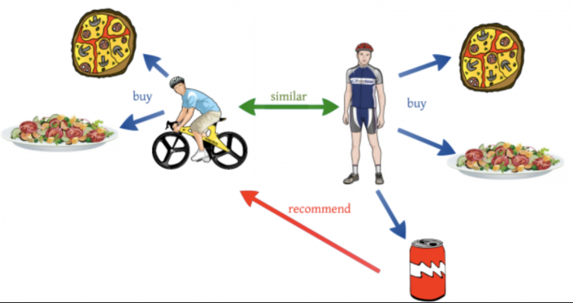

**Figure 3**

* Item Based Collaborative Filtering

So instead of finding the similarity among users, we focus on product similarity. With this algorithm, we can easily recommend similar items to the customer who purchases any item. It works faster than User-User Collaborative Filtering and easy to implement to the platforms.

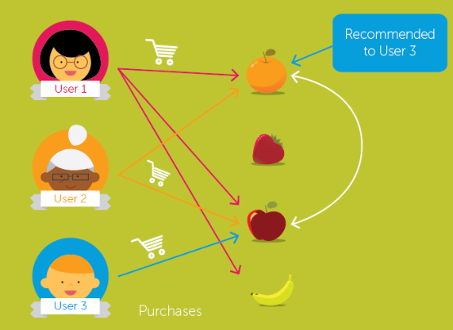

**Figure 4**

## Popularity Based Recommendation Systems

Works based on popularity. Current products that are instant trending are used. For example, if 90% of newly registered members have purchased A, this product may be offered to the other newly registered user.

## Hybrid Recommendation Systems

As a result of recent researches, it has been found that combining Collaborative Filtering Systems and Content-Based Filtering Systems will be more effective. It is not very common yet.

# Who Uses Recommendation Systems?

## Netflix

Netflix, according to the Statista report, reached approximately 150 million available in the first quarter of 2019. What Netflix does is it makes predictions based on users' viewing histories and the scores they have given to movies. Taking advantage of big data and artificial intelligence, Netflix; analyzing the monitoring activities of millions of users every day; yet you can really guess what you want to watch, even when you don't even know what you want to watch. Its most important innovation in recent years is; while offering a film to users with different picture covers[5]. If User1 likes romantic movies, they recommend an action film with a romantic picture cover. The cover pictures of the films are made by AI Models, not physically from the employees [6].

## Amazon

Amazon is one of the companies that do Recommendation System best and earn the best money from it. 35% of this company's revenue comes from the Recommendation Systems. Because the existing algorithms are too hard to perform in a huge data like Amazons', They have developed their own algorithms. How Amazon's algorithm works are still unknown. This algorithm based on the Item Based Collaborative Filtering[7].

## Spotify

Spotify is also at the top of the music industry. It gives each audience a personalized listening experience. It has more than 100 million users. Each week, Spotify presents a list of songs that users are likely to like, called _Weekly Discover_. It uses Collaborative Filtering in order to recommend a song to the people. Also, they use Natural Language Processing for analyzing the lyrics of the songs in order to good suggestions [8].

# Software Requirements Specification

## Introduction

### Purpose

This document describes the Movie Recommendation System which is a web app that uses various prediction algorithms to propose their users' new movies according to their movie tastes. In addition to that, the system also proposes new movies to its users based on their friends' movie preferences. Also, the app will be compatible with mobile devices too. In this document, our main goal is to explain our project's requirements and functionalities. The purpose of this project is to help people to find new movies to watch and share their movie interests with other people and with their friends.

### Scope of Project

People used to have a hard time finding a movie that suits them. Because until 10 years ago, how could we set up a fast algorithm when our computers were not running fast? Even though people found such algorithms, we couldn't implement them because our calculations powers were slow. With the development of technology, such algorithms that could work fast began to be developed. Even though we don't realize this, they offer something every day.

The aim of this project is to propose movies using specific algorithms according to the movies people like. Recently, similar systems have been used by large companies such as Amazon, Netflix, and Spotify. Netflix uses a system similar to this, but only for movies on its own platform. IMBD also uses this system and they have large datasets of movies, but they offer to a movie by looking at the movie user write to the system and give the movie name that similar to user wrote. This is a user-based system. In our project, we aim that use both User Based and Item Based.

User will have 2 choices:

* Find movies similar to the movie he writes to the system
* If the movies recommended to a friend are the same as those proposed to you, your friend's movie taste may be similar to you. The system can show you the movies your friend watched.

### Glossary

| **Term** | **Definitions** |
| --- | --- |
| User | The person who uses and interacts with the system. |
| Guest User | The person who can interact with the system, but can not use all of its functionalities. |
| Registered User | The person who can interact with the system and also can use all of its functionalities. |
| Django | A Python-based open-source web framework developed by Django Software Foundation. |
| MTV | Model-Template-View architectural pattern that the Django framework uses. |

## Overall Description

### Product Perspective

Movie Recommendation System is a website that recommends movies to people. Users registered can see the similar movies they watched and also see which people's tastes are similar to them. They can easily find the movies they want and watch from other platforms.

### Development Methodology

For developing the project, we have planned to use the scrum method. Scrum is a term used by people who are considered to be the development method of an application and who are working on software development. With Scrum, it will be beneficial to ensure that the observer, who possesses the characteristics aimed at developing the main objective, has a developmental structure, and to obtain a repetitive infrastructure in this process and to pay attention to the development of a modern system.

### Product Functions

Movie Recommendation System is going to have different product functions. Those product functions explained one by one in the below sections.

#### HomePage

* Users can use the system even if they don't register or log in to the system.
* If they write the name of the movie they watch and enjoy, the system will give them similar movies with the percentage of similarity.
* With the register button, they can register to the system from the register page.
* If the user already has an account he/she can log in with the login button from the login page.

#### Add Friend Page

* Users who registered can use this page.
* Users can add a friend and see their similarities in movie tastes.
* Users can also see their friend's movie that they watched and liked.

#### Movie Page

* Users can display the information of the selected movie.
* Registered users can rate and make comments about the movie.

#### Profile Page

* Users can update their pieces of information from this page.

### Constraints

* The movie Recommendation system is designed for users from all around the world. So our system will support only the English language.

### User Characteristics

* Our system's language is English. So, users should understand English if they want to use the system.

### Use Case Diagram

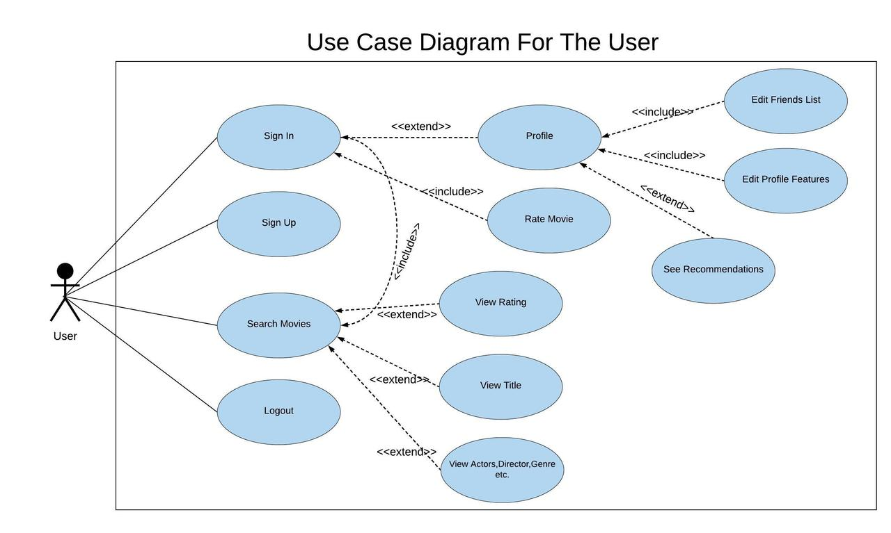

**Figure 5 User Use Case Diagram**

## Requirements Specification

### External Interface Requirements

#### User interfaces

Movie Recommendation System is a web-based project. We will use bootstrap for better User Interface.

#### Hardware interfaces

Users that want to use the Recommendation System must have :

* At least 1 GB of Ram
* Minimum 1 CPU
* Internet Connection

#### Software interfaces

Any device that can access the internet can use our system. We recommend using Google Chrome while using the system.

#### Communications interfaces

User needs to have an internet connection and a web browser.

### Performance Requirements

Internet connection speed is not so important to use our system. Having a connection is the most important thing.

### Software system attributes

#### Portability

In Movie Recommendation System, we will use Django, Vue.js, and Bootstrap. Users can access our web-based application from their devices both mobile or stationary.

#### Performance

Performance is based on the server density and internet connection.

#### Adaptability

Users can use our system from the time they log in to our website. Registered users will have more features available.

#### Safety Reqirements

There is no big deal for safety because users will not share all their pieces of information to the system. They just want to get recommended movies.

# Conclusion For SRS

This software document contains more details about the project. The software we will use, the movements of the users who will use the system, which team member is responsible for which task are stated in this document. Thanks to this document, it will be easier for us to do the project, and when we forget something or want to remember, we will be able to go back and continue the project by looking at this documentation.

# Software Design Description

## Introduction

### Purpose

The aim of this document is to test the behavior of a Movie Recommendation System and more details. At first, our target users are the ones who find movies that are closer to their movie tastes. Our biggest goal is to help people after successfully setting up our algorithm. We think we will change the way people view movies. There will be a dataset for our system to use effectively. Users can enter their information into the system and keep them in a database. The best part is that we will keep the movies recommended to the users in a database so that we can find out which users enjoy the same movie tastes. Users have to sign up if they want to look at users who enjoy the movies closer to them.

On the other hand, our system is also free to use without registering. If you do not register, you can only see movies that are similar to your own taste, not the others.

### Scope

We are going to use Python and its frameworks for this project because Python is a programming language that works very well in machine learning algorithms and has a very good interface within websites. Python is one of the easiest languages to learn and process. Clear definition of syntax; its simple interface makes it easier to read.

Another advantage of Python is its ability to access standard libraries. UNIX can be moved to platforms such as Windows and Macintosh without requiring interface changes. Python's source code is easy to maintain and allows the use of interactive modes. Another reason why Python is so popular is its wide range of operations, including data mining and deep learning.

### Glossary

| **Term** | **Definitions** |
| --- | --- |
| Django | A Python-based open-source web framework developed by Django Software Foundation. |
| MVT | Model-View-Template architectural pattern that the Django framework uses. |
| PostgreSQL | A general-purpose object-relational database management system. |
| SCRUM | An agile software development methodology based on iterative and incremental approach. |

### Overview of document

More detailed information of the rest of the content is clarified in the below sections. Section 2.1. is the "Architecture Design Approach" which contains information about the development methodology of the project. Section 2.2 contains information about which technologies will our project have and how will we use them. Section 2.3 is the Class diagram that represents the structure of a system by showing the system's classes, their attributes, operations, and the relationships among objects. Section 2.4 contains information about the different roles of the system's architectural components. Such as "Admin Operations", "User Operations", "Prediction System ". Section 2.5 contains the activity diagram of the project that represents the workflows of activities and actions.

## Architecture design

### Architecture Design Approach

For developing the project, we have planned to use the scrum method. Scrum is a term used by people who are considered to be the development method of an application and who are working on software development. With Scrum, it will be beneficial to ensure that the observer, who possesses the characteristics aimed at developing the main objective, has a developmental structure, and to obtain a repetitive infrastructure in this process and to pay attention to the development of a modern system.

It will be possible to try to reduce this complex order as one of the most important factors will be the thought or assumption that it will be difficult to ensure that all stages are planned in a planned manner. At this point, it would be useful to evaluate the following three main items. The roles in the scrum process basically start as interaction, the product owner. The Scrum administrator is determined and the work is started considering the user or the masses of users. A system focuses on systems of interaction with managers and teams, taking into account the risk of abuse of roles.

### Technologies Used

We have planned to use Django Framework. The main purpose of the Django Framework is to facilitate the use of complex web applications. Django is designed with a policy of reusability, modularity and rapid development process. Django also provides a dynamic management panel that incorporates the basic record insertion, deletion, editing and update functions for each project.

A convenient web framework for those who want to get rid of complex databases. Django is an open-source web framework that uses an MVT architect structure written in Python programming language. The structure we call MVT is Model, View, and Template. It shows us that Django was coded in the development stage by paying attention to this structure. Also, we think to use PostgreSQL or SQLite for database design. We will decide while developing the project. The database has a very important place here because the application runs completely through the database. Thanks to the database we will be able to collect information about users and give them the information they want. For the background, we are thinking of using HTML, CSS, and javascript.

### Architecture Design Of Movie Recommendation System

| **Position** | **Registered User** |
| --- | --- |
| Login Page | The user can log in to the system |
| User Profile Page | The user registered to the system can update his / her profile information from the Home Page |
| Home Page | The user can list the movies that are similar to the desired movie with the details. |
| Home Page | The user can add a friend |
| Home Page | The user can see his / her friends list |
| Home Page | The user can select the movies they watched for the background of User-User recommendation |
| Home Page | The user can see their friend's movie that movies tastes are similar to his / her movie taste which is performed by the machine learning algorithm |

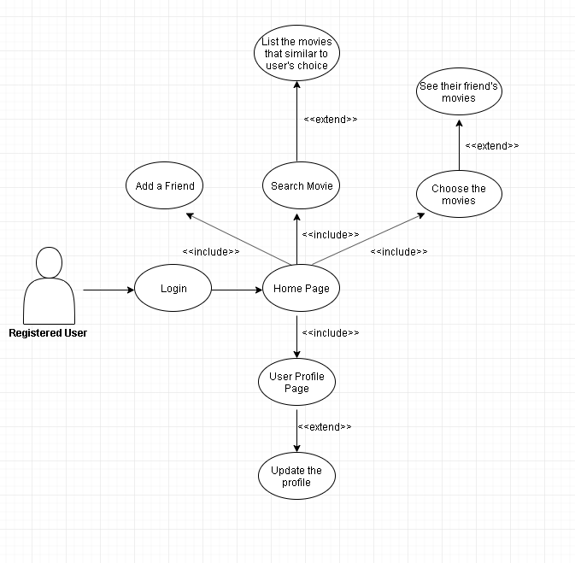

**Figure 6 Registered User Use Case**

| **Position** | **Unregistered User** |
| --- | --- |
| Login Page | The user can log in to the system |
| Register Page | The user can register to the system |
| Home Page | The user can list the movies that are similar to the movie they declare to the system with fewer details than the registered users. |

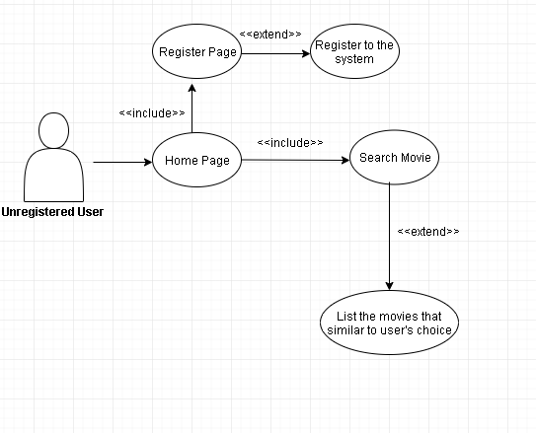

**Figure 7 Unregistered User Use case**

| **Position** | **Admin** |
| --- | --- |
| Panel | The admin can update the algorithm and dataset for better recommendations |
| Home Page | The admin can delete users |

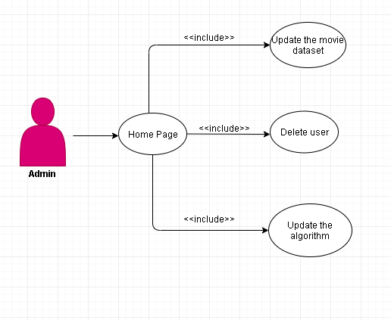

**Figure 8 Admin Use Case**

## Class Diagram

**Figure 1 Class Diagram**

**Figure 9 Class Diagram**

## Use case realizations

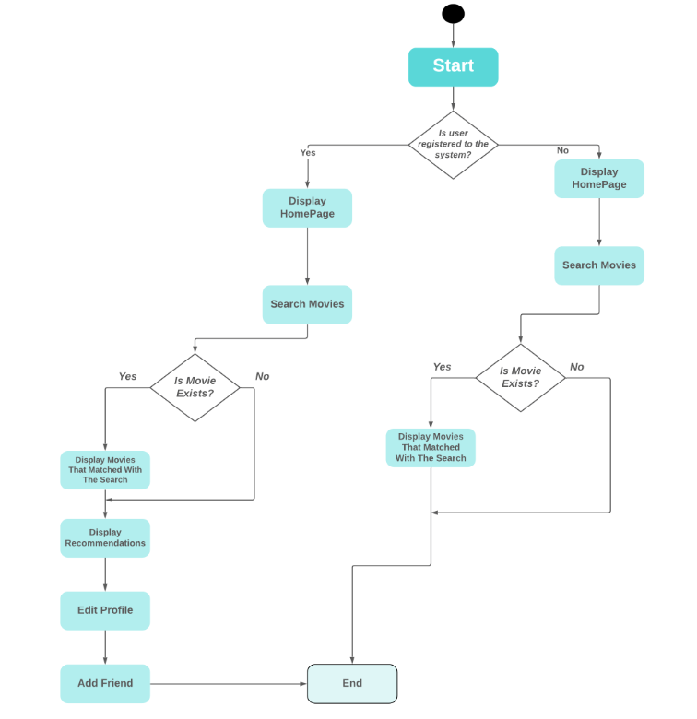

Figure 10 System Activity Diagram

### Movie Recommendation System Components

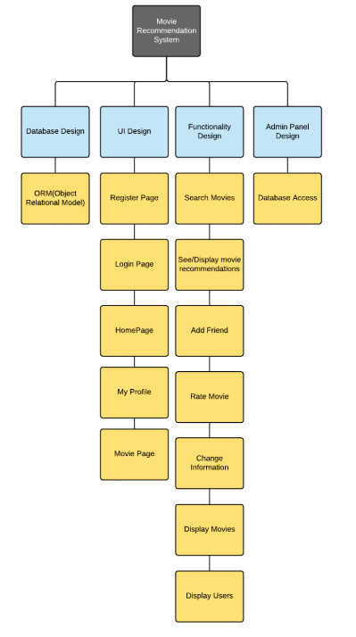

Figure 11 System Components Diagram

### UI Design Description

Our project's UI (User Interface) Design will contain 5 different user interactable sub-parts. They are all explained below.

1. **Login Page:** Registered users logs in to the system by validating their own username and password.(Figure 2)
2. **Register Page:** Users register to the system by entering their information. After this process, the system saves the user to the database as a registered user. (Figure 1)
3. **Home Page:** The system redirects registered or unregistered users to this page. Most of the system's functionalities can be accessed from this page. (Figure 3)
4. **User Profile:** Registered users can change their information from this page. Also, they can add or remove friends from this page.
5. **Movie Page:** Registered or unregistered users can access this type of page by selecting any movie they want and can examine the information about the movie. Registered users can rate movies and receive suggestions from the system based on their decisions.

## Interface Design

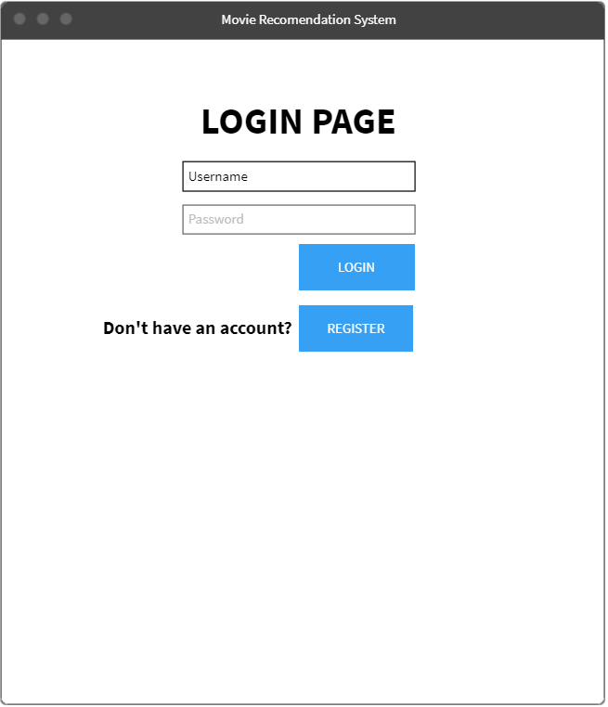

**Figure 12 Login Page Design**

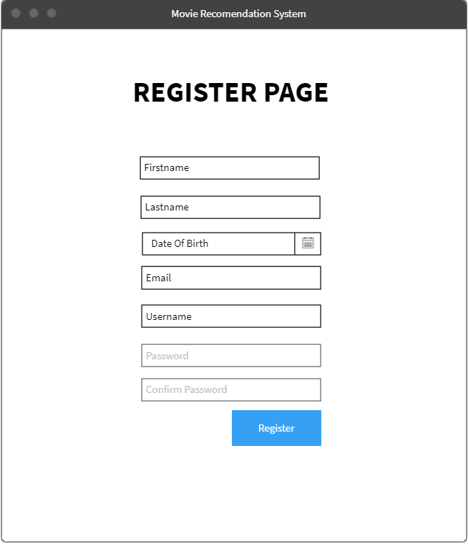

**Figure 13 Register Page Design**

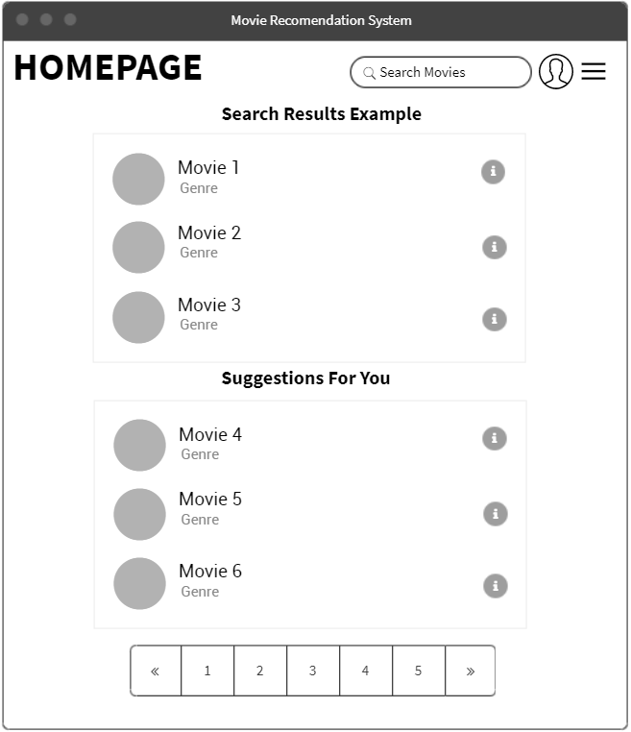

**Figure 14 Home Page Design**

## Conclusion

What our project will look like has begun to emerge more or less. The user interface designs are not yet complete, but will be similar to the images we use in the document. We think that the simple and easy-to-use interface can appeal to a larger audience. This document also shows the features of being registered in the system and what advantages it has over unregistered users. In the end, we hope that our project will help people to find movies in a more comfortable and enjoyable way.

## References

* [1] https://www.sheffieldav.com/education/how-internet-changing-filmmaking-industry
* [2] https://towardsdatascience.com/introduction-to-recommender-systems-6c66cf15ada
* [3] https://medium.com/@cfpinela/content-based-recommender-systems-a68c2aee2235
* [4] https://realpython.com/build-recommendation-engine-collaborative-filtering/
* [5] https://help.netflix.com/tr/node/100639
* [6] https://www.wired.co.uk/article/netflix-data-personalisation-watching
* [7] https://aws.amazon.com/tr/blogs/big-data/building-and-running-a-recommendation-engine-at-any-scale/
* [8] https://medium.com/@ericboam/i-decoded-the-spotify-recommendation-algorithm-heres-what-i-found-4b0f3654035b
* https://link.springer.com/article/10.1007/s11257-019-09231-w
* http://rejoiner.com/resources/amazon-recommendations-secret-selling-online/
* https://towardsdatascience.com/intro-to-recommender-system-collaborative-filtering-64a238194a26