

**ÇANKAYA UNIVERSITY**

**FACULTY OF ENGINEERING**

**COMPUTER ENGINEERING DEPARTMENT**

**Project Report**

**Version 1**

**CENG 407**

Innovative System Design and Development I

**appDermis**

*Elif Başak Koç 201611038*

*Merve Talakacı 201511056*

*İlayda Selin Türk 201511062*

*Deniz Çınar 201511062*

Advisor: *Gül Tokdemir*

Table of Contents

Table of Contents 1

Abstract 3

Skin Cancer, Artificial Intelligence, Mobile Application, Machine Learning, Image Processing, Melanoma, CNN, Time Schedule, CAD, Incidence, Melanoma Detection, Dermoscopy Images, Automatic Segmentation, Deep Learning. 3

Özet: 3

1. Introduction 1

1.1 Problem Statement 1

1.2 Background or Related Work 1

1.3 Solution Statement 1

1.4 Contribution 2

2. Literature Search 3

2.1 Abstract 3

2.2 Introduction 3

2.3 Image Acquisition 4

2.4 Pre-processing 4

2.5 Image Segmentation 5

2.5.1 Otsu's Method 5

2.6 Feature Extraction 6

2.6.1 Gray level co-occurrence matrix (GLCM) 6

2.6.2 ABCD scale 6

2.7 Classification 6

2.7.1 Convolutional Neural Networks (CNNs): 6

2.7.2 Support Vector Machine (SVM): 7

2.8 Conclusion 7

2.9 References 8

3. Software Requirements Specification 10

3.1 Introduction 10

3.1.1 Purpose 10

3.1.2 Scope of Project 10

3.1.3 Glossary 11

3.1.4 References 11

3.1.5 Overview of Document 12

3.2 Overall Description 12

3.2.1 Product Perspective 12

3.2.2 Development Methodology 13

3.2.3 Product Functions 13

3.2.4 Constraints 14

3.2.5 Assumptions and Dependencies 14

3.3 Requirements Specification 15

3.3.1 External Interface Requirements 15

3.3.2 Functional Requirements 16

3.3.3 Performance Requirements 21

3.3.4 Non-functional Requirements 21

4. Software Design Description 21

4.1 Overview 21

4.1.1 Scope 21

4.1.2 Purpose 22

4.1.3 Intended Audience 22

4.2 Definitions 22

4.3 Conceptual Model For Software Design Descriptions 23

4.3.1 Software Design In Context 23

4.3.2 Software Design Descriptions Within The Life Cycle 23

4.4 Design Description Information Content 24

4.4.1 Introduction 24

4.4.2 SDD Identification 24

4.4.3 Design Stakeholders And Their Concerns 24

4.4.4 Design Views 24

4.4.5 Design Viewpoints 25

4.4.6 Design Elements 25

4.4.7 Design Overlays 25

4.4.8 Design Rationale 25

4.4.9 Design Languages 26

4.5 Design Viewpoints 26

4.5.1 Introduction 26

4.5.2 Context Viewpoint 27

4.5.3 Composition Viewpoint 37

4.5.4 Logical Viewpoints 37

4.5.5 Dependency Viewpoint 41

4.5.6 Information Viewpoint 41

4.5.7 Patterns User Viewpoint 42

4.5.8 Interface Viewpoint 42

4.5.9 Interaction Viewpoint 47

4.5.10 State Dynamics Viewpoint 47

4.5.11 Algorithm Viewpoint 48

4.5.12 Resource Viewpoint 48

5. Conclusions 59

Acknowledgement 59

References 59

# Abstract

With a rapid enhancement rate of melanoma skin cancer, there is a demand for decision support systems to perceive it in its early phases, which would lead to better decisions in cleanse it successfully. Nevertheless, growing such systems is yet a challenging task for researchers. Several Computer Aided Diagnosis (CAD) systems have been recommend in the last two decades to increase the correctness of melanoma detection. What we want to do in this project is mainly develop an application for the people who want to follow-up their moles when they think there is a risk. The application will collect images of skin regularly and periodically send notifications to the user to scan his or her skin. Each time a new photo is added, application will compare with previous photos. If there is a change in mole’s shape, colour, borders, asymmetry or size it will analyse it. With the personal gallery, users have the option to compare pictures over time and easily share their images with a doctor. It won’t make any diagnosis.

**Key words:**

# Skin Cancer, Artificial Intelligence, Mobile Application, Machine Learning, Image Processing, Melanoma, CNN, Time Schedule, CAD, Incidence, Melanoma Detection, Dermoscopy Images, Automatic Segmentation, Deep Learning.

# Özet:

Bir cilt kanseri tipi olan melanomun hızla artma oranı, kanser teşhisine karar vermede yardımcı olan sistemler tarafından erken evrelerde keşfedilmesi için talep vardır, bu da hızlı bir iyileşmede daha iyi kararlar alınmasına yol açacaktır. Bununla birlikte, bu tür sistemleri geliştirmek araştırmacılar için henüz zor bir konudur. Melanom tespitinin doğruluğunu arttırmak için son yirmi yılda birçok Bilgisayar Destekli Tanı (CAD) sistemi önerilmiştir. Bu projede yapmak istediğimiz, esas olarak benlerinde bir risk olduğunu düşündüklerinde benlerini takip etmek isteyen insanlar için bir uygulama geliştirmektir. Uygulama düzenli olarak cilt görüntülerini toplayacak ve periyodik olarak kullanıcıya cildini taramak için bildirim gönderecektir. Her yeni fotoğraf eklendiğinde, uygulama önceki fotoğraflarla karşılaştırır Benlerin şekli, rengi, sınırları, asimetrisi veya boyutunda bir değişiklik varsa, onu analiz edecektir. Kişisel galeri ile kullanıcılar zaman içinde resimleri karşılaştırma ve resimlerini bir doktorla kolayca paylaşma seçeneğine sahiptir. Teşhis koymaz.

**Anahtar Kelimeler:**

Cilt Kanseri, Yapay Zeka, Mobil Uygulama, Makine Öğrenmesi, Görüntü İşleme, Melanom, CNN, Zaman Çizelgesi, CAD, İnsidans, Melanom Saptama, Dermoskopi Görüntüleri, Otomatik Segmentasyon, Derin Öğrenme.

# Introduction

## Problem Statement

Many health systems around the world have fund seriously in the cure of different illness, but they yet fall behind when it comes to exploring ways to get ahead of them.

Melanoma is one of the fieriest tumors for humans and it might be deadly, if not diagnosed on time. The rate of melanoma amongst whole dermatologic cancers is 4%, while melanoma-induced death rate accounts for around 80% of deaths from skin cancer; only 14% of patients with metastatic melanoma survive for five years. Over and above, malignant melanoma has a treatment rate of more than 95% if detected at an early phase.

Even if people are in doubt of melanoma, they are afraid to go to the hospital or postpone going to the hospital. In this way, they prevent early detection and cause delay of treatment.

AppDermis provides it possible to perceive skin cancer in early phase when it’s most treatable and has less costly cure options.

## Background or Related Work

There are not many applications similar to the appDermis. Some of them are MoleMapper, UMSkinCheck, MoleScope, SkinVision. Most of these applications require a full fee to provide full service, while others do not work at all and are out of date.

## Solution Statement

Early detection of melanoma might be importantly decrease both morbidity and death rate. The risk of death from the illness is straightly interested with the deepness of the cancer, that is directly related to the amount of time it has been accelerating unobserved. Therefore, earlier finding leads to thinner cancers and rescues lives. Luckily, dissimilar to most other cancers, skin cancers available on the skin are most frequently easily can be seen to the patient and the examiner.

AppDermis allows you to control your skin moles for symptoms of skin cancer within seconds. It enables you for record photos to keep in track of alters over time, assisting you to observe your health in the long-range period. The effective and simple-to-use solution will available for Android and assists to make skin monitoring a basic routine.

Our goal is to increase of awareness of the significance of the early detection of skin cancer by let you to being aware of peoples own skin, discover a mole potentially hazardous early, and follow-up and monitor your skin in a long period.

## Contribution

State how your solution builds upon and extends current technology.

Sometimes, the introduction can be split into subsections or more than one section including the following parts: Background, Related Work and Motivation.

# Literature Search

While working on our project we made literature review about artificial intelligence based skin cancer mobile applications and researches for the last 5 years.

## Abstract

Skin cancers account for more than 40% of all malignancies all over the world, and the incidence continues to rise. Melanoma is considered the most dangerous type of skin cancer. There is a necessity to make decision support systems to detect it while it is still in early phases. Nevertheless, growing such kind of systems are challenging and complicated subject for researchers. Many Computer Aided- Diagnosis (CAD) systems have been recommended in the past two ten years to increment the correctness of melanoma finding. In this paper, we survey broad the Skin Cancer Detection literature. We identify more than 15 works determined by using PubMed, Google Scholar search tool, IEEE Xplore Digital Library conferences and journals.

**Keywords**: **Skin Cancer, Mobile Aplication, Classification, Melanoma, Feature Extracion, Segmentation**

## Introduction

According to the American Cancer Society [7], the rates of melanoma have been increasing during the last 30 years. For years, different projects and applications have been developed for early detection of skin cancer. Some projects developed as mobile application and some projects are just machine learning algorithms to classify the type of lesion as melanoma or non-melanoma. But no studies done in this field in Turkey. We will develop a mobile application that users can follow up themselves when they think there is a risk of skin cancer.The application will scan the lesion and tell the user if the situation is risky. At the same time, users can create their own archives in the application so, application will tell the difference between the present and the past, it will make comparisons. It won’t make any diagnosis. We have made researches covering the last five years for the steps we will follow while developing our application. We have examined many data sets and tried to find the most useful one. In the rest of this article, we explained which methods work better and which algorithms we should use. Five fundamental steps were mentioned; image acquisition, image pre-processing, image segmentation, feature extraction and image classification.

## Image Acquisition

Image acquisition can be defined as the action of retrieving an image from some source, generally it can be a camera picture, so it can be passed through whatever processes need to occur afterward. Performing image acquisition in image processing is always the first step in the workflow sequence because, without an image, no processing is possible.

## Pre-processing

The main purpose of image pre-processing is to increase readability of images and decrease undesirable distortions such as hair and artifacts. Also pre-processing is used to improve visibility of feature of interest. Therefore, various algorithms enhanced so as to improve performance.

**2.4.1 Grayscale Conversion**

Grayscale image is 8 bit image and each pixel includes 256 shades of gray combination. Grayscale images are more easy and more faster to process than coloured images[1]. Due to this reason, entire pre-procesing methods are applied on grayscale images.

**2.4.2 Hair Removal Methods**

* **Median Filter**

In the literature[1] [4] [5] [14], Median Filter is used to remove hair and noise from an image. One of the non-linear digital filtering technique is median filter. The esential aim is used to improve results of afterward processing tecniques. Median filters works like this; entire image pixels are considered by median filter. It specifies whether or not it is representative of its region and it is replaced region's pixel values with median value. Median filter is the most proper technique for medical images.

* **DullRazor Software**

In the literature[5][16], DullRazor is used by authors. The software uses to aim remove unwanted noise from an image. DullRazor Software consists of 3 steps.

* 1. Noise such as hair is defined by grayscale morphological closing operations.
  2. It confirms shape of noise pixels and replaced confirmed pixels. Bilinear interpolation is used for this step.
  3. The DullRazor Software smooths replaced noise pixels by adaptive median filter.

**2.4.3 Contrast Enhancement**

Contrast enhancement is a technique to improve the visualization of images[5]. Original image with low contrast does not give better results so image visibility is increased by contrast enhancement. One of the contrast enhancement algorithm is Contrast Limited Adaptive Histogram Equalization (CLAHE). Contrast Limited Adaptive Histogram Equalization is applied on the image to get a contrast enhanced image, from which accurate features can be derived [14]. Every pixel of image is processed and the image contrast is improved. The output image is highly suitable for other process precisely.

**2.4.4 Other Image Enhancement Methods**

Gaussian filter [15], is used to reduce noise from an image. Also it used to smooth and blur images. Karhunen-loeve Transformation, Corner Space Transformation and Luminance Transformation [13] and Image Uneven Illumination Correction [16],Corner Detection[16] are used for increase quality of image.

## Image Segmentation

Segmentation is the process of parting an image into significant specks, like the needed zone is segmented, from that can infer the essential information for upward processing.It simplifies description of an image so it makes easier to analyze.Image segmentation is the operation of partition or gathering an image into several pieces.

### Otsu's Method

OTSU algorithm is an automatic threshold election region-based segmentation technique. It is commonly used because of its simplicity and effect and expected in finding the optimum value for the universal threshold.It is based principally over the image histogram, looking at the values of pixel and the zones to segment out, fairly than the image edges. It tries segmenting it by exercising the variance on each of the least classes. The process suits fine with images with two pixels classes, following a bi-modal histogram distribution.[2][4][3][14][9]

## Feature Extraction

The feature extraction phase might be noted as data compression that extracts extra and disinterested information while protecting suitable information. Features selected in order to the calculation of detected skin moles are based on the information and experimentation regarding to the properties and variations in look among the benign and malignant skin lesions. However, to discover the most necessary and efficent features, it extracts a large number of initial features.

### Gray level co-occurrence matrix (GLCM)

The GLCM is a tabulation of how frequently several combinations of pixel luminance values (grey levels) be formed in a certain pixel pairing of image. Using a two-dimensional gray-level co-occurrence matrix is mostly and widely used in the area of texture analysis for finding the locative dependence of brightness (gray-level) values, that helps to find worthy information about the neighboring pixels in an image. The features extracted based on GLCM are: contrast, energy, homogeneity, correlation along with other statistical parameters such as mean, skewness, and kurtosis[7][10][15][16].

### ABCD scale

The ABCD (Asymmetry, Border irregularities, Color variation and Diameter) criteria is used by medical doctors for diagnosing.Every criterias are multiplied with a dedicated weight factor to product Total Dermoscopy Score (TDS). TDS values smaller than 4.75 shows benign melanocytic lesion, values between 4.8 and 5.45 shows a doubtful lesion, and values of 5.45 or larger are extremely possible of melanoma.Formula for TDS: [(A score x 1.3) + (B score x 0.1) + (C score x 0.5) + (D score x 0.5)].

## Classification

After the feature extraction step, finally, we will use image classification to decide the lesion is cancerous or noncancerous. Last five years, most of the research showed machine learning and deep learning algorithms are the best way to detect skin cancer. After researching, classification algorithms with the highest accuracy value will be used in our mobile application. Every research has a different number of and type of classes.

### Convolutional Neural Networks (CNNs):

Deep learning, particularly the convolutional neural network (CNN), has been widely applied to unravel several issues in computer vision [6]. There are different CNN architectures and they all have different results. AlexNet, GoogLeNet, VGG, ResNet are the most popular ones. Some of these architectures (e.g. GoogLeNet, ResNet) are available as pre-trained models also which were initially trained on approximately 1.28 million natural images from the dataset ImageNet. Thus, architectures can use the weights and biases from these pre-trained models. That is, if we fine-tune all the layers of these models by going on with the backpropagation using our data, they can be applied to our specific classification task, as well. Other architectures as AlexNet and VGGNet are initialized so that their weights and biases are not influenced by visual information which may differ from skin images [17].

### Support Vector Machine (SVM):

SVM is a supervised learning model. SVM is also a binary classification algorithm. Which means, the result can only belong to one of the two classes. In our case, classes will be cancerous and noncancerous. The purpose of SVM is to create hyperplane that separates two classes with a maximum gap between them [1]. Support Vector Machine requires training data in the form of instances called feature vectors and data output instances called labels [2]. Like the other algorithms, data is divided into two parts: training and test. The SVM algorithm is useful for noisy data and big data sets. For better CPU performance with large data sets, we can also use Linear SVM. In some cases, SVM is biased toward the class with a greater population [16].

## Conclusion

We identify more than 15 works in this literature review and we selected "top papers" as shown in table. According to the table, these algorithms and methods are highly convenient to use for detection of skin cancer.

| **Reference** | **Pre-Processing Methods** | **Feature Extraction** | **Classification** | **Accuracy** |
| --- | --- | --- | --- | --- |
| [1] | Median Filter | GLCM | SVM | 95% |
| [14] | Clahe&Median Filter | GLCM | SVM | 90.44% |
| [7] | Resizing | GLCM | ANN | 88% |

## References

**[1]** Uzma Bano Ansari, Tanuja Sarode “Skin Cancer Detection Using Image Processing”, International Research Journal of Engineering and Technology , Vol. 4, Issue 4, April 2017.

**[2]** Hiam Alquran, Isam Abu Qasmieh , et al. “The Melanoma Skin Cancer Detection and Classification using Support Vector Machine”, 2017 IEEE Jordan Conference on Applied Electrical Engineering and Computing Technologies, 2017

**[3]** Pratik Dubal, Sankirtan Bhatt, Chaitanya Joglekar and Dr. Sonali Patil “Skin Cancer Detection and Classification”, 2017 6th International Conference on Electrical Engineering Informatics, 2017

**[4]** Akila Victor and Muhammad Rukunuddin Ghalib “Automatic Detection and Classification of Skin Cancer”,International Journal of Intelligent Engineering and Systems, June 2017

**[5]** Enakshi Jana, Dr.Ravi Subban , S. Saraswathi “Research on Skin Cancer Cell Detection using Image Processing”, 2017 IEEE International Conference on Computational Intelligence and Computing Research (ICCIC), 2017

**[6]** Abeer Mohamed, Wael A.Mohamed, and Abdel Halim Zekry “Deep Learning Can Improve Early Skin Cancer Detection”, INTL JOURNAL OF ELECTRONICS AND TELECOMMUNICATIONS, 2019, VOL. 65, NO. 3, PP. 507-512

**[7]** Santosh Achakanallı, G. Sadashivappa “Statistical Analysis Of Skin Cancer Image” International Journal of Electronics and Communication Engineering (IJECE), Vol. 3, Issue 3, 2014

**[8]** Shivangi Jain, Vandana jagtap, Nitin Pise “Computer Aided Melanoma Skin Cancer Detection Using Image Processing”, International Conference on Intelligent Computing, Communication & Convergence (ICCC), 2015

**[9]** Omar Abuzaghleh, Buket D. Barkana and Miad Faezipour “Automated Skin Lesion Analysis Based on Color and Shape Geometry Feature Set for Melanoma Early Detection and Prevention”, IEEE, 2014

**[10]** Miss Pooja Koli, Prof. S. S. Ingaleshwar, Nagraj V. Dharwadkar ”Computer Aided Melanoma Detection Using GLCM matrix Analysis”, International Conference on Advancements in Computing & Management (ICACM) ,2019

**[11]** A.P. Kassianos, J.D. Emery, P. Murchie and F.M. Walter “Smartphone Applications For Melanoma Detection By Community, Patient And Generalist Clinician Users: A Review”, British Journal of Dermatology (2015) 172, 2015

**[12]** T. Maier, D. Kulichova, K. Schotten, R. Astrid, T. Ruzicka, C. Berking, A. Udrea “Accuracy of a Smartphone Application Using Fractal Image Analysis of Pigmented Moles Compared to Clinical Diagnosis and Histological Result”,European Academy of Dermatology and Venereology(JEADV), 2014

**[13]** N. Durga Rao et al. Int. Journal of Engineering Research and Application,’’Skin Cancer Detection’’ 2016

**[14]** Novel Approaches for Diagnosing Melanoma Skin Lesions Through Supervised and Deep Learning Algorithms (J. Premaladha & K. S. Ravichandran), 2016

**[15]** Computer-Aided Diagnosis of Micro-Malignant Melanoma Lesions Applying Support Vector Machines (Joanna Jaworek-Korjakowska), 2016

**[16]** Melanoma Recognition in Dermoscopy Images Using Lesion’s Peripheral Region Information (Neda Zamani Tajeddin , Babak Mohammadzadeh Asl), 2018

**[17]** Skin lesion classification with ensembles of deep convolutional neural networks (Balazs Harangi), 2018

# Software Requirements Specification

## Introduction

### Purpose

The main purpose of this document is to give a elaborate explanation of the requirements for the “AppDermis” app. It will define the purpose and fulfil representation for the progress of system. It will additionally clarify system limitations, interfaces. This document is mainly designed to be proposed to the stakeholders and the developers of the system.

### Scope of Project

This app will provide help for a people who have suspicious of melanoma. AppDermis intends to give a struggle towards one of the most mortal illness, skin cancer. The application will scan the lesion and tell if the situation is in risky or not. Nevertheless , users can create their own records in the application thus, it will notify the difference among the current and the previous situation of mole, it will make comparisons. The app classes each photo as either high or low risk. However, AppDermis is not a diagnostic tool and shall not be taken as the final judgment, as pointed out by the disclaimer at the end of every skin spot evaluation.

Furthermore, the app needs Internet connection for fetch and display results. Whole system information is maintained in a database, which is located on a cloud.The application also has the detailed information about the what is melanoma.

### Glossary

| **Term** | **Definition** |
| --- | --- |
| User | Someone who interacts with the mobile phone application. |
| Database | Collection of all the information monitored for this application. |
| Application | A mobile application, most commonly referred to as an app, is a type of application software designed to run on a mobile device, such as a smartphone or tablet computer.[1] |
| Software Requirements Specification | A document that entirely defines whole functions of a proposed system and the limitations under which it must operate. Of an example, this document. |
| Stakeholder | Any person with an interest for the project. |
| GLCM | The Gray Level Co-occurrence Matrix(GLCM) and associated texture feature calculations are image analysis techniques. Given an image composed of pixels each with an intensity (a specific gray level), the GLCM is a tabulation of how often different combinations of gray levels co-occur in an image or image section.[2] |

### References

**[1]** IEEE. “IEEE Std 830- 19 98 IEEE Recommended Practice for Software Requirements Specifications”. IEEE Computer Society. October 20, 1998.

**[2]** P. Mohanaiah*, P. Sathyanarayana**, L. GuruKumar “Image Texture Feature Extraction Using GLCM Approach”, 2013

### Overview of Document

The rest of this document contains two chapters. The second chapter, the Overall Description section, of this document gives an overview of the functionality of the application. It defines the informal requirements and is used to establish a context for the technical requirements description in chapter.The third chapter, Requirements Specification section, of this document is written mainly for the developers and explaines in technical expressions the details of the functionality of the application.

## Overall Description

### Product Perspective

Appdermis project is a mobile application aimed at early detection of skin cancer. Users can get information about skin cancer risk by taking a picture of their moles or adding pictures from the gallery.

#### User Interfaces

This mobile application is developed for everyone who want use. Users can download mobile application from mobile application store. After downloading the mobile application, users should be register to the system. After login to the mobile application, the main menu appears. The main menu is divided into sub-parts such as adding a new mole picture, adding mole picture from the gallery, updating personal information.

#### Hardware Interfaces

The application will work on mobile devices.

#### Software Interfaces

The application will work on Android, hence there will be no need another software interfaces.

#### Communication Interfaces

There is an internet connection is required to run this software.

#### Memory

Our application's minimum system requirements: 50 Mb or more memory 1.4 GHz Cpu – Quad Core or above 2 GB or more RAM Android 6.0 (Marshmallow) or above Operating System Stable Internet Connection.

### Development Methodology

We will be using agile development methodology, scrum method. There will be daily scrum meetings and 1-4 weeks sprint meetings.

### Product Functions

#### Sign-up

Sign-up: People who want to use this application, have to give information to agree to become involved. These informations are name, surname, e-mail, password, date of birth and skin color.

#### Sign In

Sign In: After user completes his/her registration to system, they can enter by e-mail and password.

#### Sign Out

Sign Out: If a user wants to sign out from system. They can do this operation by clicking the sign out button.

#### Take a Photo of Lesion:

Took Photo of Lesion: User clicks camera button and takes a photo of suspicious lesions. Photo analyzed for skin cancer risk and saved in the album.

#### Add Photo to Album

User clicks gallery button and add new photo from gallery for analyzing skin cancer risk. Every lesion has its own album to analyze and compare.

#### Edit Profile

User clicks his/her profile and can change the informations.

#### Analyze

User clicks the analyze tab. The user chooses an album to analyze the improvement of the lesion. Or the user can analyze the only one lesion.

#### Check for results

User clicks the results tab. The user chooses an results to see. Results will be shown in graphs and diagrams. Also there will be a written detailed report about results. And if there is a risky situation application will send a notification to the user.

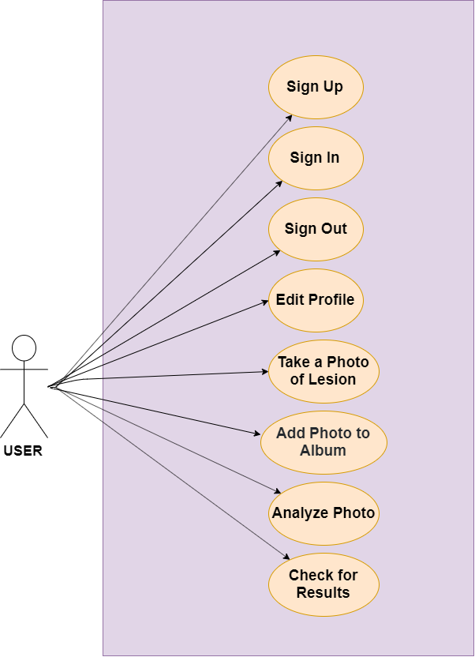

### Constraints

Appdermis mobile application has some constraints such as reliability, safety and security. Wrong risk analyze due to wrong taking photo is an important constraint for Appdermis Mobile Application. In addition to this, since the user information is stored in a database and this database can be hacked and user information will be no longer private to the user. So this is an important constraints for security.

### Assumptions and Dependencies

During the use of the application, user add or take a picture with obeying the rules. The mobile application with the android operating system correctly analyzes the skin cancer according to the picture and sends it to the application. The mobile application algorithm works correctly and displays rate of skin cancer risk's.

## Requirements Specification

### External Interface Requirements

#### User interfaces

This mobile application is developed for everyone who want use. Users can download mobile application from mobile application store. After downloading the mobile application, users should be register to the system. After login to the mobile application, the main menu appears. The main menu is divided into sub-parts such as adding a new mole picture, adding mole picture from the gallery, updating personal information.

#### Hardware interfaces

The application will work on mobile devices.

#### Software interfaces

The application will work on Android, hence there will be no need another software interfaces.

#### Communications interfaces

There is an internet connection is required to run this software.

### Functional Requirements

#### Sign Up

| **Use Case Name** | **Sign Up** |
| --- | --- |
| Trigger | User enters the application and pushes the sign up button. |
| Precondition | No preconditions |
| Basic Path | 1.User enters the application. 2. User pushes the sign up button. 3. User enters his/her informations. 4. User saves the informations. |
| Post Condition | No post conditions. |
| Alternative Path | 1. The user enters an invalid email form or leaves a blank space in form. 2. The application gives an error. |
| Other | None. |

#### Sign In

| **Use Case Name** | **Sign In Use Case** |
| --- | --- |
| Trigger | User assesses the application with sign in button. |
| Precondition | User has signed up system. |
| Basic Path | 1. User enters email and password to login to the system. 2. If the password is valid for the user email, user enters the system. Otherwise user should re-login. |
| Post Condition | After a successful login operation user is directed to the Main Menu. |
| Other | None. |

#### Sign Out

| **Use Case Name** | **Sign Out Use Case** |
| --- | --- |
| Trigger | User exits system with sign out button. |
| Precondition | User has signed in the system. |
| Basic Path | 1. User clicks sign out button and exits from the system. |
| Post Condition | No post conditions. |
| Other | None. |

#### Edit Profile

| **Use Case Name** | **Edit Profile** |
| --- | --- |
| Trigger | User enters the profile tab. |
| Precondition | User must sign in before trying to edit his/her profile. |
| Basic Path | 1. User will sign in to the system. 2. User shall enter his/her profile. 3.User will change the profile info. 4. User will enter 'Edit Profile' button. |
| Post Condition | No post conditions. |
| Other | None. |

#### Take Photo of Lesion

| **Use Case Name** | **Take Photo of Lesion Case** |
| --- | --- |
| Trigger | User takes a picture of lesion with camera. |
| Precondition | The user has accessed the camera with main screen. |
| Basic Path | 1. User clicks button and camera opens. 2.The user takes a photo of suspicious lesions. 3.Photo is saved in the album. 4. System calculates the cancer risk of the lesion. |
| Post Condition | The database is updated and rate of risk is showed. |
| Other | None. |

#### Add Photo to Album

| **Use Case Name** | **Add Photo to Album** |
| --- | --- |
| Trigger | User assesses with camera. |
| Precondition | User has taken picture of lesion with camera. |
| Basic Path | 1. User clicks button and camera opens. 2.The user takes a photo of suspicious lesions. 3.Photo is saved in the album. 4. System calculates the cancer risk of the lesion. |
| Post Condition | The database is updated and photo is added album part. |
| Other | None. |

#### Analyze Lesion

| **Use Case Name** | **Analyze Lesions** |
| --- | --- |
| Trigger | User enters the analyze tab and selects an album to analyze or the moment user user takes the photo, analyzes the photo. |
| Precondition | User must have an account and must sign in. If user wants to make a comparison, user must have previous photos of the lesion in the album or must take a photo to analyze. |
| Basic Path | 1.User sign in. 2. User enters analyze tab. 3. User chooses an album to analyze. 4. User pushes the analyze button. 5.Analyze results will be saved to albums tab for each album. |
| Alternative Path | 1.User enters the camera. 2. User takes a photo. 3. User can analyze the photo at that moment. |
| Post Condition | No post conditions. |
| Other | None. |

#### Check For Results

| **Use Case Name** | **Check For Results** |
| --- | --- |
| Trigger | User enters the check for results tab. |
| Precondition | The user must have more than one results of photos. |
| Basic Path | 1. User selects check for results tab. 2. The system compares other results. 3. The result is showed on screen. |
| Post Condition | No post condition. |
| Other | None. |

### Performance Requirements

Our application appDermis will be working on android mobile devices. In normal workload, appDermis will use less than %30 of the CPU. Changing between pages will take 1 second.

### Non-functional Requirements

appDermis will be on a mobil application server with high speed internet capability. The speed of the user's connection will depend on the hardware. appDermis will run on the user's smart phone and android operating system. The only one user uses the system at a time so there is no scalability requirement.

# Software Design Description

## Overview

This document ensures the software design descriptions for the purpose of AppDermis application project. This document is prepared according to the “IEEE Standard for Information Technology – Systems Design – Software Design Descriptions – IEEE 1016 –2009”. This software design document provides the details of how the AppDermis software should have been done. The further particulars are offered by using graphical notations such as viewpoints, use case models, sequence diagrams, class diagrams, object behavior models and alternative supporting design knowledges.

### Scope

Software Design Document (SDD) is for a ground level system which will work as a evidence of notion for the usege of building a system the supplies a ground level of functionality to represent applicability for wide scale production usege. Software Design is centered on the ground level system and crucial sections of the system. For this certain Software Design Document, the center is placed on generation of the documents and changes of the documents. The system will be used in association by other pre-actual systems and will be formed usually of a document interplay appearance that abstracts document interactions and usage of the document objects.

### Purpose

Software Design Document (SDD) is for a ground level system which will work as a evidence of notion for the usege of building a system the supplies a ground level of functionality to represent applicability for wide scale production usege. Software Design is centered on the ground level system and crucial sections of the system. For this certain Software Design Document, the center is placed on generation of the documents and changes of the documents. The system will be used in association by other pre-actual systems and will be formed usually of a document interplay appearance that abstracts document interactions and usage of the document objects.

### Intended Audience

In contradicton of the Software Requirements Specification (that is written for the purpose of client and user), most of this Software Design Description is written for engineers and designers or researchers who want to change and/or extend the existing reference implementation. In this way the Client is not going to be among the intended audience for this document, which is:

* Team
* Supervisor
* Auditors and Reviewers

## Definitions

| **Term** | **Definition** |
| --- | --- |
| User | Someone who interacts with the mobile phone application |
| Database | Collection of all the information monitored for this application |
| SDD | Software Design Description |
| SRS | A document that entirely defines whole functions of a proposed system and the limitations under which it must operate |
| Class Diagram | Describes the structure of a system |
| Use-case Diagrams | Illustrates the relationships between use cases |
| UML | Standardized modeling language enabling developers to specify, visualize, construct and document artifacts of a software system |
| Function | Identifies data elements that form part of the internal entity |
| Application | An application, or application program, is a software program that runs on your computer or phone |
| IEEE | Institution of Electrical Engineers |

## Conceptual Model For Software Design Descriptions

In this document, we will use a conceptual model for the SDD. Conceptual model mainly explains the context in which SDD is prepared and how it will be used. We planned to use multi-layered system architecture. Thus it will be easier to implement the project and add possible future features.

### Software Design In Context

We planned to use object oriented approach and multi-layered system architecture. Thus we will increase to project implementation, adaptability and portability. Layers will help modularity, security and adaptability of the software. Using object oriented design and multi­layered architecture will be improved portability and integrality between components.

### Software Design Descriptions Within The Life Cycle

The key software life cycle product that drives this software design is the SRS we have prepared. The requirements in the SRS document (interface, functional, non­functional and logical database requirements) specify the design of the project.

## Design Description Information Content

### Introduction

Software Design Description of the AppDermis gives information about how AppDermis will be designed and implemented. This section will include information about SDD identification, identified design stakeholders and design concerns, selected design viewpoints with their type definitions of its allowed design elements and design languages, design views, desig overlays and design rationale.

### SDD Identification

This document is a first version of System Design Description for this project. This SDD report prepared based on created using Github. Draw.io and Github's markdown is used for drawing diagrams. In the first section an overview of SDD is given. Scope of the SDD report refers to the section 1.1, Purpose of the SDD report refers to section 1.2 and Intended Audience of this document refers to section 1.3. For design conceptual model for software design descriptions refer to the section 3. Lastly, for the design viewpoints including context, composition, logical, information, patterns use, interface, interaction, state dynamics and resource viewpoints refer to the section 5.

### Design Stakeholders And Their Concerns

In AppDermis, design stakeholders are the developer team of AppDermis and their advisors. Our design stakeholders are the people who know and understand software development and our stakeholders are the part of the development. Our stakeholders’ concerns are listed below:

* The implementation should be safe, secure, maintainability and open to future changes.
* The interface shall be easy to read and use.
* The desired results should be obtained from the developed system.
* Database should be simple and efficient.
* New features will be adapted into AppDermis, so software must be proper for it.

### Design Views

In this SDD, for representing the diagrams of view, UML is used. Design views are design rational, contextual, composition, interface, logical and interaction views. These design views a are explained in chapter 5.

### Design Viewpoints

There are three viewpoints that are used in this project which are context, composition and interaction viewpoints. These viewpoints are explained detailly with UML diagrams in section 5.

* Context viewpoint defines the relationships, dependencies, and interactions between the system and its environment (the users, systems etc ).
* Composition viewpoint describes the way the design subject is structured into constituent parts and establishes the roles of those parts.
* Interaction viewpoint defines strategies for interaction among entities, regarding why, where, how, and at what level actions occur.

### Design Elements

The main design elements are entities, attributes and some other member associated with communication and relations between modules and user of our project. These main design elements are defined inside the related viewpoints in detail in chapter 5.

### Design Overlays

The essential factors to explain design choices in appdermis is simplicity and sustainability. The features will add in the future so appDermis is designed with this vision. appDermis developers document process of development so new developers can understand and modify or add features easiliy.

### Design Rationale

The software has to be designed in a way that future models and features can be added and current models can be changed and updated independently. The object oriented design helps to classify the objects of the software so that a new object can easily be added to design or an existing component can be easily deleted. Developers of the system has to use comments in their code frequently, so that in the future other developers may understand code and the structure of the system. Also, while writing the code, function and variable names are intentionally chosen to specify what they do. Thus, their functionalities can be understood easily in future. While designing the database of the system, tables are created according to both ER Diagram and class diagram, shown in Section 5, in order to synchronize the database and models.

### Design Languages

In this project, Unified Modeling Language (UML) is selected as a part of design viewpoint and it will be used for clarifying design viewpoints.

## Design Viewpoints

### Introduction

In this chapter, the viewpoints of the appDermis is explained in detail. UML diagrams will be used (Use case Diagrams, Class Diagrams, Sequence Diagrams, State Diagrams etc.). There is 13 viewpoints for our projects.

* Context viewpoint
* Composition viewpoint
* Logical viewpoint
* Dependency viewpoint
* Information viewpoint
* Patterns use viewpoint
* Interface viewpoint
* Structure viewpoint
* Interaction viewpoint
* State dynamics viewpoint
* Algorithm viewpoint
* Resource viewpoint

### Context Viewpoint

#### Design Concerns

The main service category releated to system which is User. Users are people who will use the application.

#### Design Elements

User and actions are design entities for application. As you can see, use case diagram is showed with whole functions.

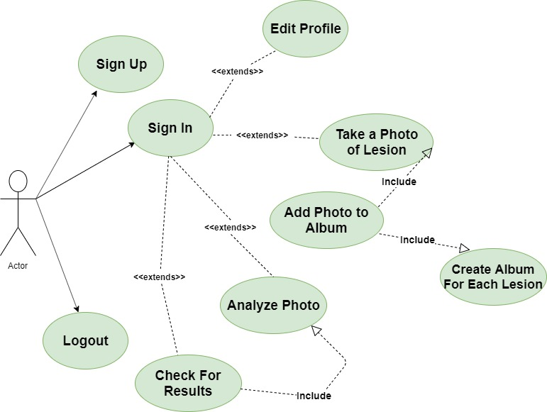

**4.5.2.2.1 Sign In**

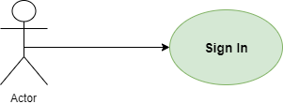

| **Use Case Number** | **1** |
| --- | --- |
| **Use Case** | Sign In |
| **Summary** | User can sign in to the application. |
| **Actor** | User |
| **Trigger** | Sign In Button |
| **Primary Scenario** | User will enter the appplication. If user didn't sign in before, opening page will be SignIn page. After entering email and password, user will be redirected to profile page. |
| **Alternative Scenario** | No alternative scenarios. |
| **Exceptional Scenario** | Wrong e-mail and password combination or wrong e-mail format. |
| **Pre-Conditions** | User must register before trying to signing in to the system. |
| **Post-Conditions** | User will be redirected to her/his profile. User can use every function of the system after signing in. |
| **Assumptions** | User must be connected to the internet. |

**4.5.2.2.2 Sign Up**

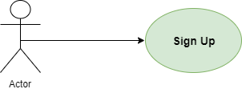

| **Use Case Number** | **2** |
| --- | --- |
| **Use Case** | Sign Up |
| **Summary** | User can sign up to the application |
| **Actor** | User |
| **Trigger** | Sign Up Button |
| **Primary Scenario** | User will enter the application. In the sign in page there will be a button for sign up page. After filling his/her information, user can sign up if he/she didn't sign up before. |
| **Alternative Scenario** | No alternative scenarios. |
| **Exceptional Scenario** | Email address is already taken or password dosen't meet the standards. |
| **Pre-Conditions** | No pre-conditions. |
| **Post-Conditions** | User can sign in to the application. |
| **Assumptions** | Valid e-mail address. |

**4.5.2.2.3 Logout**

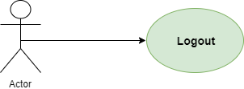

| **Use Case Number** | **3** |
| --- | --- |
| **Use Case** | Logout |
| **Summary** | User can logout from the application. |
| **Actor** | User |
| **Trigger** | Logout button in the Profile. |
| **Primary Scenario** | After signing in, user can log out from her/his profile. |
| **Alternative Scenario** | No alternative scenarios. |
| **Exceptional Scenario** | No exceptional scenarios. |
| **Pre-Conditions** | User must sign in to the system. |
| **Post-Conditions** | User will be redirected to Sign In page. |
| **Assumptions** | User has sign in to the system. |

**4.5.2.2.4 Edit Profile**

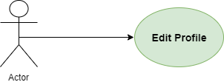

| **Use Case Number** | **4** |
| --- | --- |
| **Use Case** | Edit Profile |
| **Summary** | User can edit his/her informations. |
| **Actor** | User |
| **Trigger** | Edit button |
| **Primary Scenario** | User must register then login to system. |
| **Alternative Scenario** | None. |
| **Exceptional Scenario** | 1. Not registered user. |
| **Pre-Conditions** | User must login to the system. |
| **Post-Conditions** | User will edit the information. User Profile will be updated. |
| **Asumptions** | User must be connected to the internet. |

**4.5.2.2.5 Take Photo of Lesion**

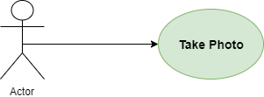

| **Use Case Number** | **5** |
| --- | --- |
| **Use Case** | Take Photo of Lesion |
| **Summary** | User can take photo of suspicious lesion then see the risk range about lesion. |
| **Actor** | User |
| **Trigger** | Camera button |
| **Primary Scenario** | User must login to system. |
| **Alternative Scenario** | None. |
| **Exceptional Scenario** | 1. Not entered user. |
| **Pre-Conditions** | User must login to the system and push camera button. |
| **Post-Conditions** | Photo is saved in the album then system calculates the cancer risk of the lesion. |
| **Asumptions** | None |

**4.5.2.2.6 Add Photo To Album**

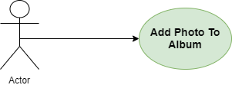

| **Use Case Number** | **6** |
| --- | --- |
| **Use Case** | Add Photo To Album |
| **Summary** | Every lesion has its own album. User can photos to album. |
| **Actor** | User |
| **Trigger** | Add To The Album button appears when a new photo is taken. |
| **Primary Scenario** | User signs in to the application. Every lesion has its own album. After taking a new photo, user can add photo to its album. |
| **Alternative Scenario** | No alternative scenarios. |
| **Exceptional Scenario** | No albums was created before for that lesion. In this case application will create a new album. |
| **Pre-Conditions** | User must take the photo of the lesion. There must be an album to save the photo. |
| **Post-Conditions** | User will be redirected to the camera. |
| **Assumptions** | User added right photo to right album. |

**4.5.2.2.7 Analyze Lesions**

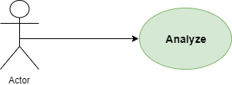

| **Use Case Number** | **7** |
| --- | --- |
| **Use Case** | Analyze Lesions |
| **Summary** | If user wants to make a comparison, user must have previous photos of the lesion in the album or must take a new photo to analyze. |
| **Actor** | User |
| **Trigger** | Analyze button |
| **Primary Scenario** | User must take photo or have previous photos. |
| **Alternative Scenario** | User accesses the album then select a photo to analyze. |
| **Exceptional Scenario** | None. |
| **Pre-Conditions** | 1. Login is required. 2. User must access analyze lesion part by button. |
| **Post-Conditions** | None. |
| **Asumptions** | None. |

**4.5.2.2.8 Check For Results**

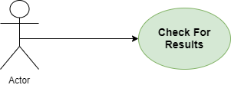

| **Use Case Number** | **8** |
| --- | --- |
| **Use Case** | Check For Results |
| **Summary** | User can check for analyze results. |
| **Actor** | User |
| **Trigger** | User enters the check for results tab and enters the check for results button. |
| **Primary Scenario** | User enters the check for results tab. Results will be showed in 2 different ways. User can check for album results to see the development of a lesion or check for only one photo results. Also user can see the history of album. |
| **Alternative Scenario** | No alternative scenarios. |
| **Exceptional Scenario** | If no analysis done before,user can not check for any result. |
| **Pre-Conditions** | Analyze |
| **Post-Conditions** | No post conditions. |
| **Assumptions** | User analyzed at least 1 photo to check for results. |

**4.5.2.2.9 Create Album For Each Lesion**

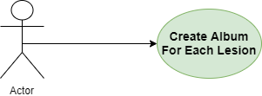

| **Use Case Number** | **9** |
| --- | --- |
| **Use Case** | Create Album For Each Lesion |
| **Summary** | User must create an album for each lesion to see the development of that lesion. |
| **Actor** | User |
| **Trigger** | Create an album button at the Albums tab. |
| **Primary Scenario** | User enters the Albums tab. Pushes the Create an Album button. |
| **Alternative Scenario** | User can create a new album for a new photo after taking the photo if there is no album created for that lesion. |
| **Exceptional Scenario** | No exceptional scenarios. |
| **Pre-Conditions** | User must login. |
| **Post-Conditions** | After creating the album, user can add photos to the album. |
| **Assumptions** | Individual albums created for same lesion's photos. |

### Composition Viewpoint

#### Design Concerns

In this part, composition viewpoint will assist software process easily. There are three essential components in this software as you can see 5.3.2 Design Elements Part.

#### Design Elements

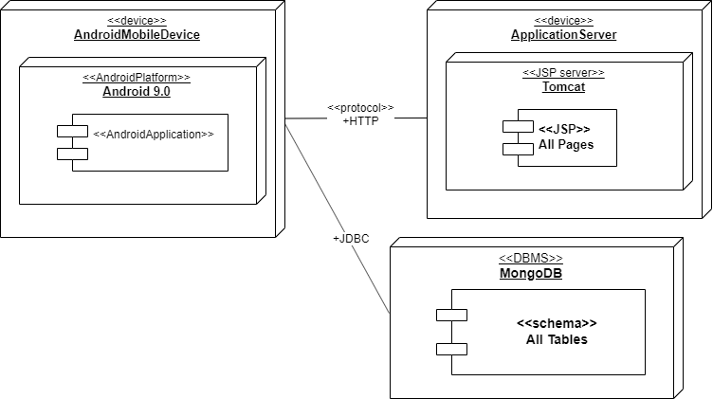

* Design Entities: The main components in system; database, application server and android application.
* Application Server: Establishing connection between application and database.
* Design Attributes will discuss next chapters.

### Logical Viewpoints

#### Design Concerns

In this part, enire classes and relations are identified in detail. The main purpose is to explain and clarify appDermis system design. Complete class diagram includes classes and their relations. Entire classes and methods/fields are explained.

#### Design Elements

* **5.4.2.1 Class Relations**

There are four classes; user, photo, analyze and album and they are related to each other. The class diagram includes only essential classes, on the other hand there are trivial classes. However these classes are not shown because of clarity.

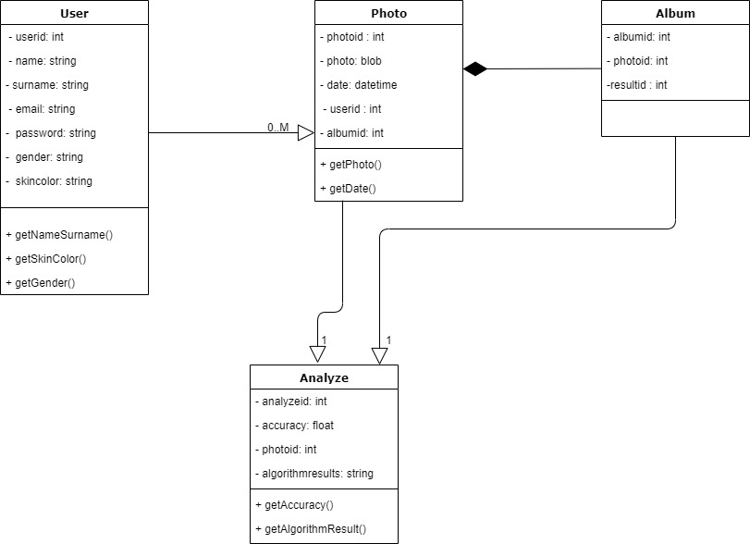

**4.5.4.2.2 User Class**

| **Method/Field** | **Definition** |
| --- | --- |
| **int userid** | Unique id for each user. |
| **string name** | User's name. |
| **string surname** | User's surname. |
| **string email** | Email of the user. |
| **string gender** | Gender of the user. |
| **string skincolor** | User's skin color. |
| **date birthdate** | Birthdate of the user. |
| **string getNameSurname()** | Returns name and surname |
| **string getSkinColor()** | Returns the skin color |
| **string getGender()** | Returns the gender. |

**4.5.4.2.3 Photo Class**

| **Method/Field** | **Definition** |
| --- | --- |
| **int photoid** | Unique id for each photo |
| **blob photo** | Photo of a lesion. |
| **date datetime** | Date of the photo. |
| **int userid** | Photo belongs to this user. |
| **int albumid** | Photo belongs to this album. |
| **blob getPhoto()** | Returns the photo. |
| **date getDate()** | Returns the date for that photo. |

**4.5.4.2.4 Analyze Class**

| **Method/Field** | **Definition** |
| --- | --- |
| **int resultid** | Unique id for each result |
| **float accuracy** | Accuracy of the results |
| **int photoid** | Results are belong to this photo |
| **string algorithmresults** | When the all machine learning algorithms run, results will be here. |
| **string getAlgorithmResult()** | Returns the results. |
| **float getAccuracy()** | Returns the accuracy. |

**4.5.4.2.5 Album Class**

| **Method/Field** | **Definition** |
| --- | --- |
| **int albumid** | Unique id for each album |
| **int photoid** | Photo id of the photo that belongs to this album |
| **int resultid** | Result id of the result that belongs to this album |

### Dependency Viewpoint

Dependency viewpoint explains dependencies and relationships between system design component.

#### Design Concerns

Defining dependencies of application and determining which subsystems are depends on other subsystems. It helps deciding the priorities in design entities.

#### Design Elements

Design Entities: Application server, database server and the client. Design Relationships: Each entities are related each other, application server is between the database and client.

#### Example Languages

You can see the diagram in section 5.3.2.

### Information Viewpoint

#### Design Concerns

In this section, data management of the application and data structure will be shown. ER diagram is used. Design entities in this diagram are our tables. There are data types, data items, and extra information about data in every table. Design relationships are displayed with connections. Connections between tables show us how these tables are related to each other (one to one or one to many).

#### Design Elements

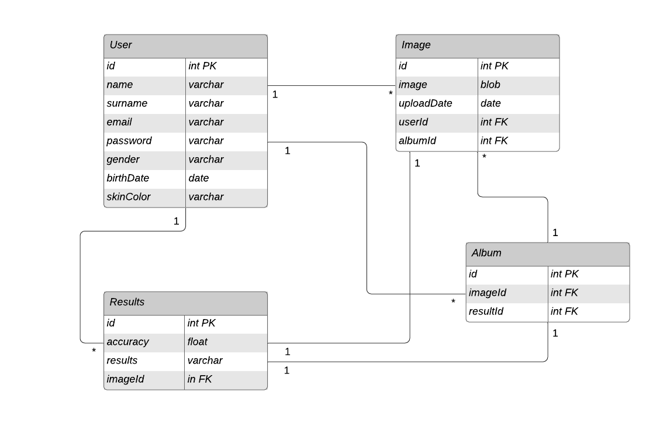

### Patterns User Viewpoint

In appDermis server-client design pattern is used so the software reusable. The server-client design pattern is consisted two component client and server. The server listens to request from client and provide services.

### Interface Viewpoint

#### Design Concerns

This viewpoint shows users how to use appDermis application. Every interface of the application has its own prototype and description. This will be very helpful for users and developers.

#### Design Elements

**4.5.8.2.1 Welcome Page**

After downloading and entering the application, the user will see this tab first. This page will consists of information about the application. And for the users who want to use the application, there will be 2 options: Sign up and Sign in. It will be redirected to the next page, depending on the user's choice.

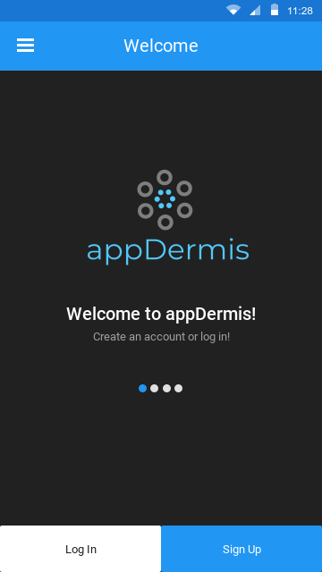

**4.5.8.2.2 Sign Up Page**

In this page, the user can sign up to the system by entering some personal information. After signing up, the user can edit, change or add information to his/her profile page.

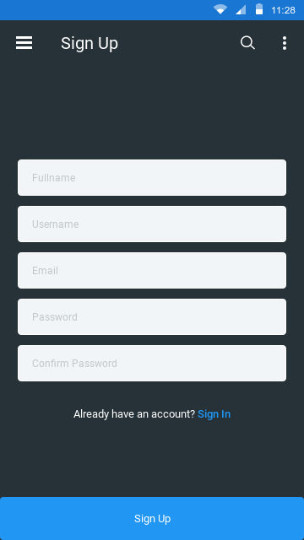

**4.5.8.2.3 Sign In Page**

In this page, the user can enter the application by entering his/her information if she/he is already signed up.

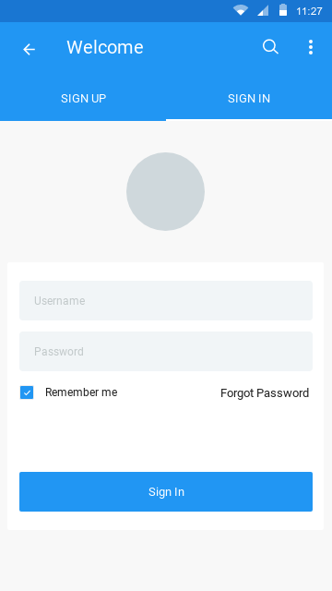

**4.5.8.2.4 Profile**

In this page, the user can see personal information, edit information or add more information to make our analysis better. Also, there will be an analysis history for the user's lesions.

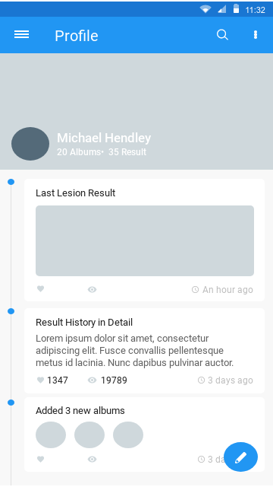

**4.5.8.2.5 Camera**

The user will take his/lesion photos in this page. The camera will be activated when the user wants to take a new lesion photo. After every photo is taken, the application will ask user which album to save it.

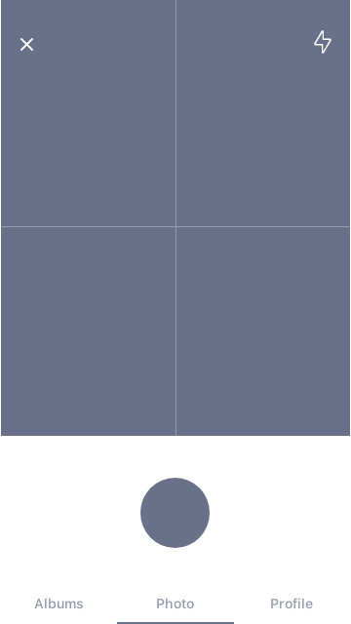

**4.5.8.2.6 Albums**

Every lesion will have a specific album. So we can check how much it has changed. And every album will store statistical information about the lesion. When you click the album, you will be able to see information and lesion photos.

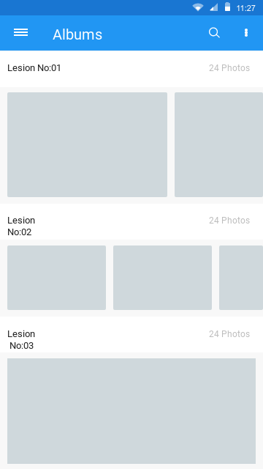

**4.5.8.2.7 Analysis**

In this page, users can choose one of the albums or one of the lesion photos and analyze them. After clicking the analyze button, user will be redirected to the results page.

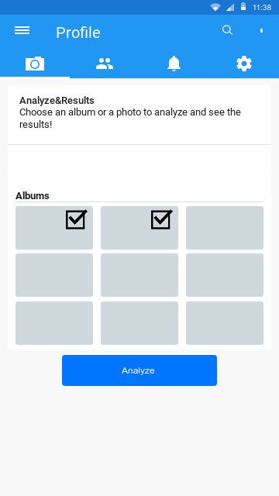

**4.5.8.2.8 Check For Results**

This page contains information about all analyzed albums and lesions. Results will be showed in graphs, diagrams and also there will be a written explanation. If there is a risky situation, the application will notify the user for a doctor appointment.

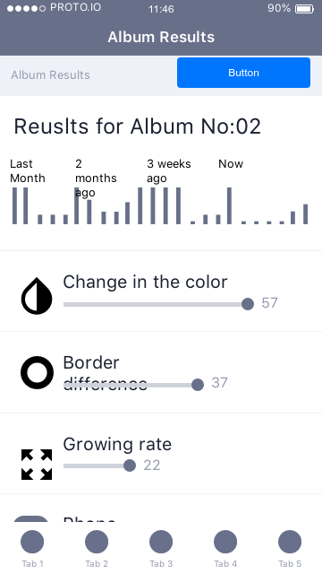

### Interaction Viewpoint

#### Design Concerns

Sequence Diagram is used to show communication between objects.

#### Design Elements

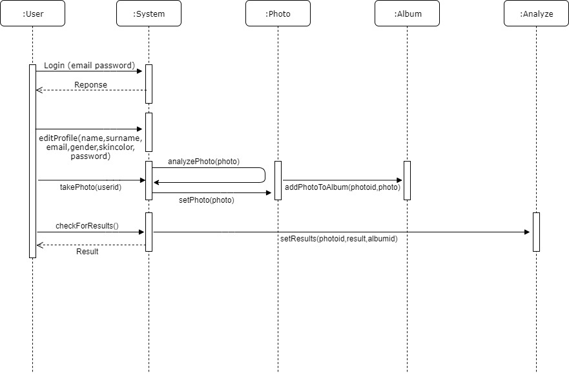

### State Dynamics Viewpoint

#### Design Concern

The user starts the application, user is redirected sign up page. User can sign up if he/she has an account. When the user signs up the application, he/she can reach various feature of application.

#### Design Elements

Design entities and design relationships are observed with the state transition diagram particularly in the section bellow.

#### Example Languages

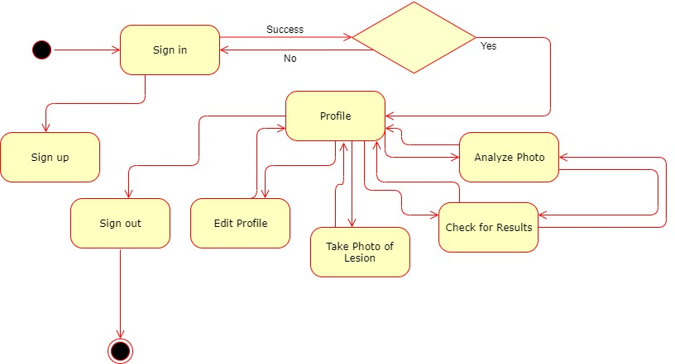

### Algorithm Viewpoint

Algorithm viewpoint is not available.

### Resource Viewpoint

Resource viewpoint is not available.

# Conclusions

State what you learned from your work. Sometimes this section is labeled Conclusion, Summary or Concluding Remarks. In this section:

* Summarize what you did. This can be viewed as the evidence.
* State what you learned (the actual conclusions that you a drawing).
* State future work and directions, and then list any open problems.

List the advantages and disadvantages of your work. In what ways is your solution deficient or lacking? You are not divulging a weakness in your work when you state problems that still remain. You may also have a separate section for future work.

# Acknowledgement

Acknowledge any individuals who have helped you during the course of the project, including your project advisor. If you have been supported by a company or a scholarship, then this should also be gratefully acknowledged.

# References

All senior projects, especially research-oriented projects, should include at least a few references to the literature. You can choose any style, but be consistent and complete in your reference list. You should pick a particular style such as one promoted by a technical society (ACM, IEEE, SPIE, API, or AIP).

# Appendices

Include brief code fragments, and illustrations of results that are too verbose for the body of your report. Reference these in the body of your report. If you have a lot of raw data that you think might be interesting, you can place examples of that here as well.