CANKAYA UNIVERSITY

Software Design

Description

**System Resource Monitoring**

**and Visualization**

**Füsun Funda AKAY-201511001**

**İbrahim Arda ACAR-201611003**

**Mustafa AYDEMİR-201211007**

Table of Contents

1. Introduction 3

1.1. Purpose 3

1.2. Scope 3

1.3. Definitions, Abbreviations, Acronyms 3

1.4. Overview 3

2. Design Considerations 4

2.1. Aproach 4

2.2. Tools Used 4

2.2.1. For Website Software 4

2.2.2. Server-Side 4

2.2.3. For Visual Machine 4

2.3. Constrains 4

2.4. Assumptions and Dependencies 5

3. Architecture 5

3.1. Software Architecture 5

3.2. Hardware Architecture 6

4. System Interfaces 6

4.1. External System Interfaces 6

5. User Interface Design 7

5.1. Navigation 7

5.2. Screen Definitions 8

5.2.1. Home Page 8

5.2.2. Register Page 8

5.2.3. Forgot Password 9

5.2.4. Reset Password 9

5.2.5. After Login Home Page 10

5.2.6. Dark After Login Home Page 10

6. Process Design 11

6.1. Use Case 11

6.2. Sequence Diagram 11

7. Database Design 12

7.1. User Database 12

7.2. Virtual Machine Database 12

8. References 12

# Introduction

Software Design Descriptions (SDD) provides documentation to use to assist. This document is a document that explains and graphically illustrates the software design. This document has been prepared to better explain what to do to System Resource Monitoring and Visualization(SRMV) developers. SDD is prepared according to the application of design methods and design documentation recommended in IEEE Std 1016-1987 is described [1].

## Purpose

The purpose of System Resource Monitoring and Visualization (SRMV) is to show the system data of a virtual machine by using graphics and charts in a website interface. Virtual machine can be run from the website if desired. In this website authentication will be carried out.

## Scope

This software is based on showing the data of a virtual machine with the help of graphs and charts in a website. Virtual machines data samples can be processor spending, ram spending, how many user are available in the operating system, what are the IP addresses of the users, how many hours has it been open..etc. In this website authentication will be carried out. After logging in to the website, users can see the status of the virtual machine on the website and start it if they wish. Users can edit their own profiles on the website.

## Definitions, Abbreviations, Acronyms

|  |  |
| --- | --- |
| TERM | DEFINITIONS |
| User | Right to login to the website. |
| SDD | Software Design Description |
| IEEE | Institute of Electrical and Electronics Engineers |
| SRMV | System Resource Monitoring and Visualization |

## 

## Overview

* Chapter1 Introduction
* Chapter2 Design Considerations
* Chapter3 Architecture
* Chapter4 System Interfaces
* Chapter5 User Interface Design
* Chapter6 Process Design
* Chapter7 Database Design

# Design Considerations

## Aproach

Controlling virtual machines connected to a server is related to the number of virtual machines connected to that server. In other words, the more virtual machines there are, the more difficult it will be to control them. The SRMV project is about controlling these virtual machines and aims to present the system data of each one in a more readable way.

## Tools Used

### For Website Software

|  |  |
| --- | --- |
| FRONT-END | BACK-END |
| HTML5 | PHP(To be determined) |
| CSS3 | Python(To be determined) |
| Javascript | Laravel |
| jQuery | Laravel Telescope |
| Vue.js | Laravel Horizon |
| ApexCharts Addition |  |

### Server-Side

* Nginx (Web Server)
* MySQL (For database)
* Redis (For cache database)
* Supervisor (For background operations)

### For Visual Machine

* Windows Operating System.

## Constrains

* User information must be known in order to enter the web interface.
* Virtual machines for which system data will be retrieved must use the windows operating system.
* User can switch between dark mode and light mode according to his/her wishes.

## Assumptions and Dependencies

* The systems in the tools used section must be up to date.
* Virtual machines whose data will be read must have a windows operating system.
* If only the data will be displayed (no installation will be made on the system), it is important that the systems of the ipad, mobile phone or computer to be used are up-to-date.
* Internet must be active for communication.

# Architecture

## Software Architecture

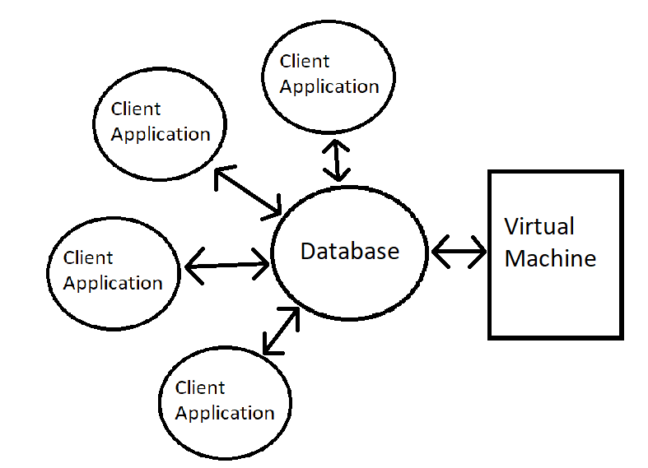

SRMV will have a data-centric software architecture.

## Hardware Architecture

SRMV project will use client-server architecture. Client-server architecture describes how a server provides services to its clients. Clients can be one or more. TCP / IP protocol will be used to establish a client connection with the server.

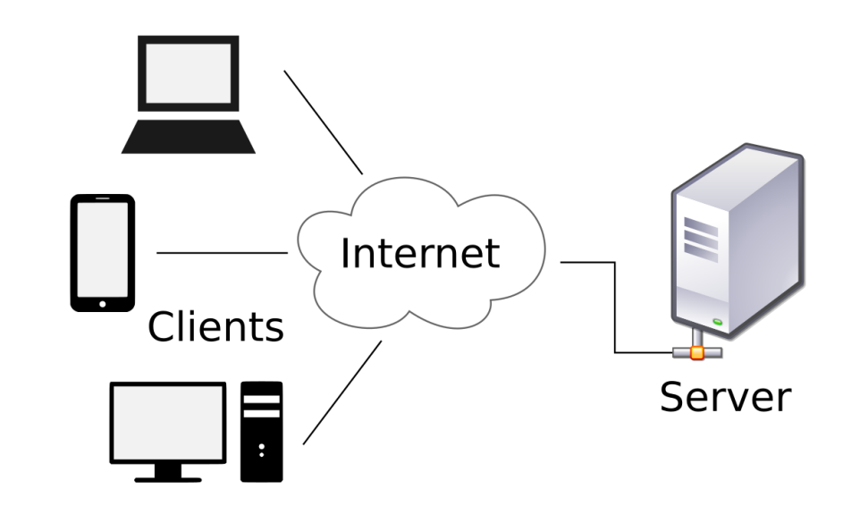

# System Interfaces

## External System Interfaces

Mysql will be used for the database. There will be two or more different tables in the database, virtual machine data and user data. Virtual machine must have windows operating system. At certain times, the data of the virtual machine (processor spending, ram spending, how many users are available in the operating system, what are the IP addresses of the users, how many hours has it been open..etc.) Will be pulled into the database's virtual machine table will be recorded. The data of the virtual machine will be pull with the Virtual Machine Introspection (VMI) technique [2]. The table containing the data of the virtual machine in the database has to work dynamically with the website.

# User Interface Design

## Navigation

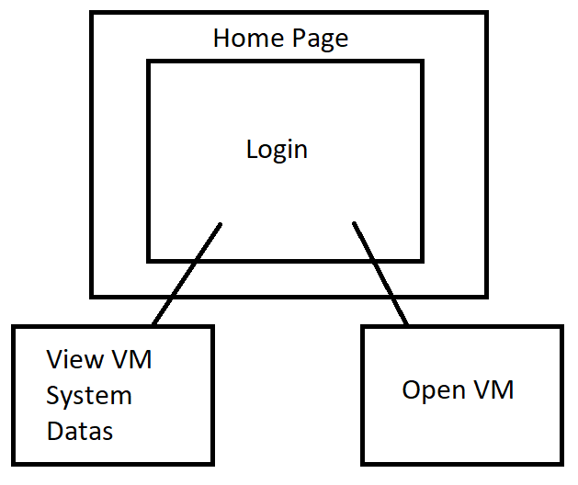

* When users connect to the site, they are directed to the "Home page" page and have to login.
* After logging in, they can both see the virtual machine data on their servers and start the virtual machine from the "Open VM" button if they wish.

## Screen Definitions

### Home Page

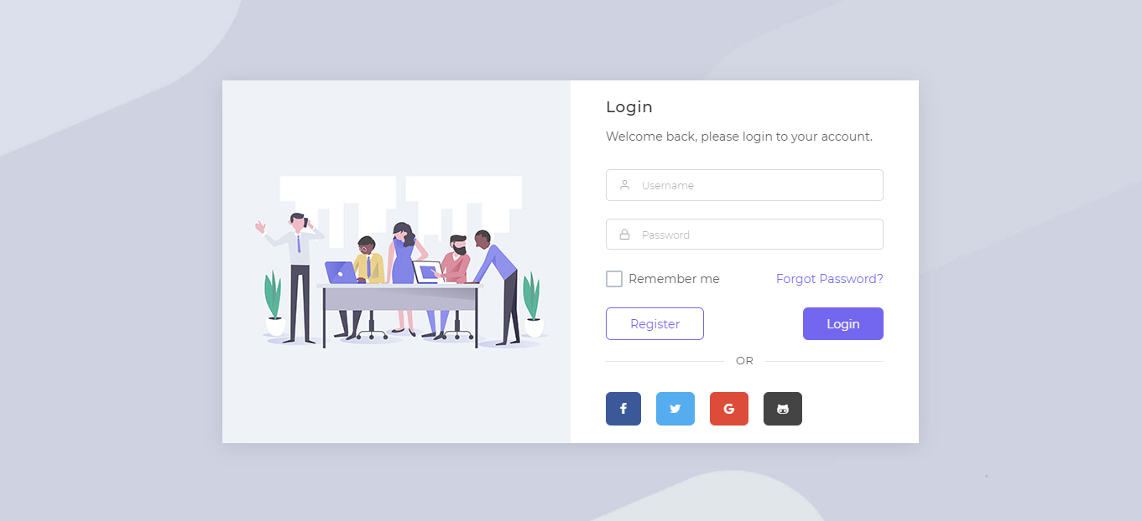

* Input: User's email and password.
* Output: Error (The user's username or password are incorrect) or login.

### Register Page

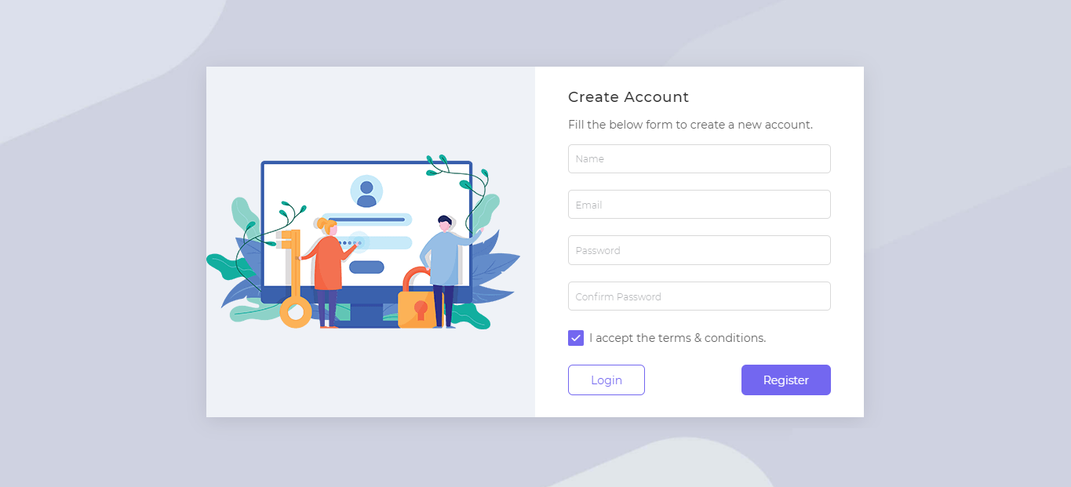

* Input: User’s email, password, user’s name and private question.
* Output: Error (Underfilled / passwords are not the same) or create.

### Forgot Password

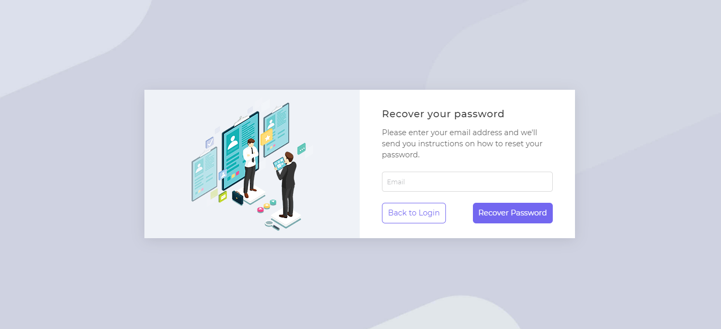

* Input: User’s email(If it true), private question.
* Output: Error (User’s email or admin's private question is wrong) or create password.

### Reset Password

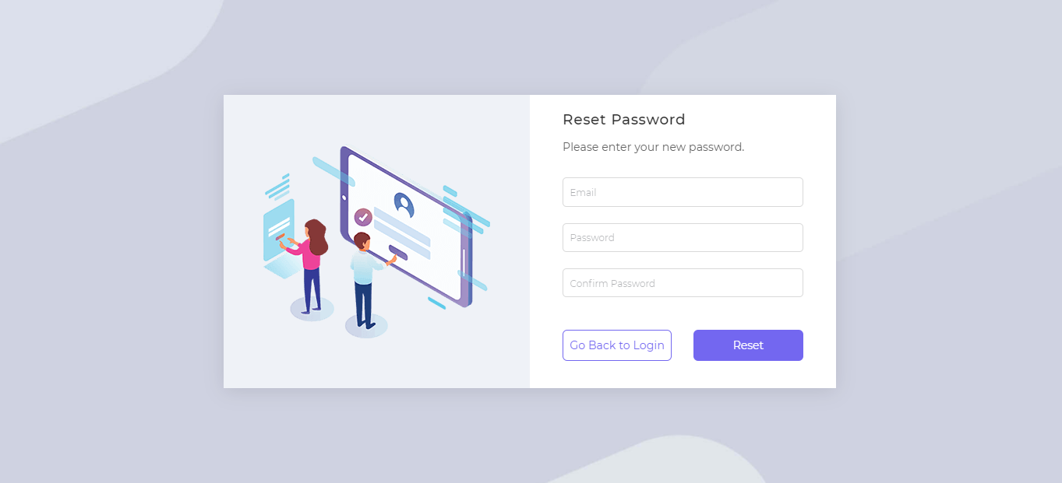

* Input: Email, User’s new password(x2).
* Output:Error (The new passwords are not the same or the old password is wrong) or change.

### After Login Home Page

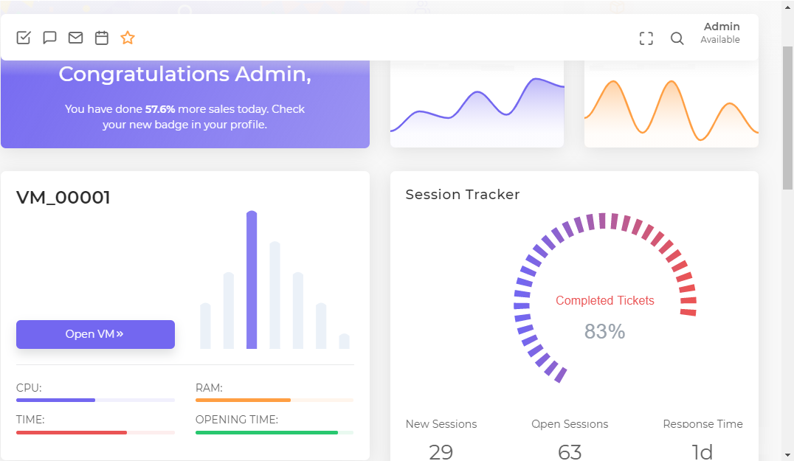

* VM data can be viewed.
* The virtual machine can be opened using the "Open VM" button.

### Dark After Login Home Page

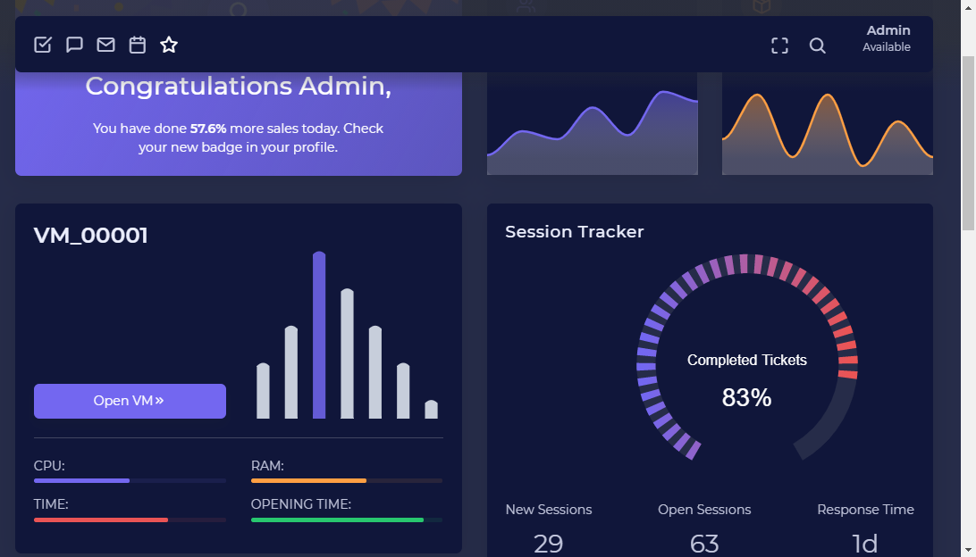

* VM data can be viewed.
* The virtual machine can be opened using the "Open VM" button.

# Process Design

## Use Case

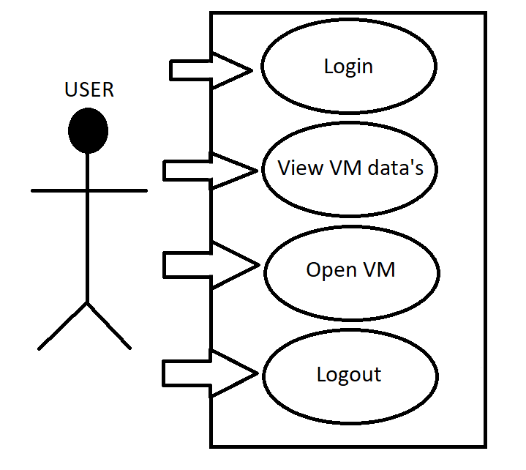

## Sequence Diagram

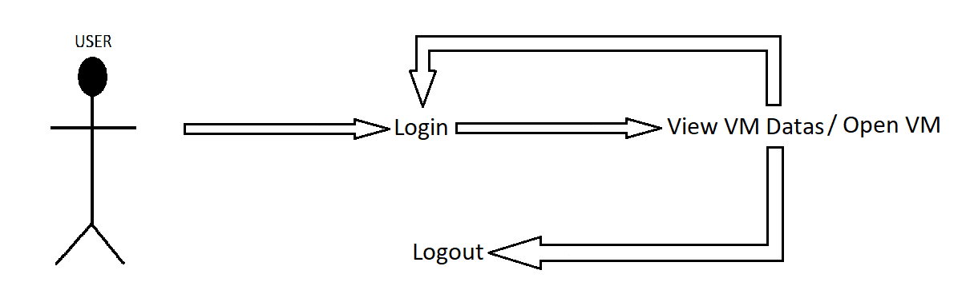

# Database Design

## User Database

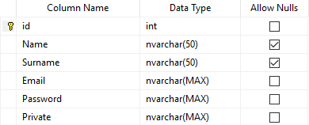

## Virtual Machine Database

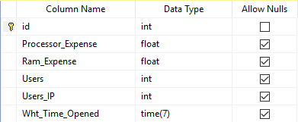

# References

[1] <https://standards.ieee.org/standard/1016-1998.html>

[2].Y. Hebbal, S. Laniepce, Jean-Marc Menaud, **Virtual Machine Introspection: Techniques and Applications,** **IEEExplore,** **24-27 Aug. 2015, DOI:** [10.1109/ARES.2015.43](https://doi.org/10.1109/ARES.2015.43) , <https://ieeexplore.ieee.org/document/7299979>