

**ÇANKAYA UNIVERSITY**

**FACULTY OF ENGINEERING**

**COMPUTER ENGINEERING DEPARTMENT**

**Project Report**

**Version 1**

**CENG 407**

Innovative System Design and Development I

**22**

**Creating A Website With Bootstrap**

*Füsun Funda Akay*

*201511001*

*İbrahim Arda ACAR*

*201611003*

Advisor: *Asst. Prof. Sibel Tarıyan Özyer*

Table of Contents

Abstract 3

Özet: 3

1. Introduction 4

1.1 Motivation 4

1.2 Problem Statement 4

1.3 Solution Statement 4

1.4 Contribution 4

2. Literature Search 4

2.1 Front End Coding Using Bootstrap 4

3. Summary 4

3.1 Summary of Conceptual Solution 4

3.2 Technology Used 5

4. Software Requirements Specification 5

4.1 Introduction 5

4.1.1 Purpose 5

4.1.2 Scope of the Project 5

4.1.3 Referances 5

4.2 OVERAL DESCRIPTION 5

4.2.1 Product Perspective 5

4.2.2 Assumptions and Depencies 5

4.3 REQUIREMENTS SPECIFICATION 5

4.3.1 External Interface Requirements 5

4.3.2 Functional Requirements 6

4.4 Software System Attributes 6

4.4.1 Portability 6

4.4.2 Usability 6

4.4.3 Adaptability 6

4.4.4 Scalability 7

5 Software Design Description 7

5.1 INTRODUCTION 7

5.1.1 Purpose 7

The purpose of this document is to describe the details of the "building a website with bootstrap" project. 7

5.1.2 Scope 7

5.1.3 Glossary 7

5.1.4 Motivation 7

5.2 ARCHITECTURE DESIGN 7

5.2.1 Aproach 7

5.2.2 Tools Used 7

5.2.3 Constraints 7

5.2.4 Assumptions and Depencies 8

5.3 ARCHITECTURE 8

5.3.1 Software Architecture 8

5.3.2 Hardware Architecture 8

5.4 SYSTEM INTERFACES 9

5.4.1 External System Interfaces 9

5.5 USER INTERFACE DESIGN 9

5.5.1 Navigation 9

5.5.2 Screen Definitions 9

5.6 DATABASE DESIGN 10

5.6.1 Table Definitions 10

5.7 REFERENCES 10

# Abstract

With the developing technology, data has also improved, data has become difficult to understand. This project is designed for admins to better understand the data. Admin will be able to see her data clearly by entering the website. The project does not only keep the data as numbers, but also displays the data through charts and graphs. All admins within the same company can view and browse this data.

# Özet:

Gelişen teknoloji ile veriler de gelişti, verilerin anlaşılması zorlaştı. Bu proje, yöneticilerin verileri daha iyi anlaması için tasarlanmıştır. Yönetici, web sitesine girerek verilerini net bir şekilde görebilecektir. Proje verileri sadece sayı olarak tutmakla kalmaz, aynı zamanda verileri çizelge ve grafiklerle de gösterir. Aynı şirketteki tüm yöneticiler bu verileri görüntüleyebilir ve bunlara göz atabilir.

# Introduction

## Motivation

We are last class computer engineering students who are learning to make a more beautiful website using Bootstrap technology. In our project called "Create a website with Bootstrap", we aimed to free the data from complexity and to observe it in a more visual way.

## Problem Statement

Understanding data is a big problem. If the data is misunderstood, it can be difficult to undo this mistake. Companies, schools, governments, markets, hospitals, etc. All institutions generally do their work based on data. This project will present the data with graphs and charts, reducing the difficulty of understanding the data.

## Solution Statement

Data will be dynamically extracted from the database, and graphs and charts will be created for the data. These charts will show the parts the user considers important in color. As soon as something changes in the database, a graphic according to it will be displayed on the website. All administrators of the institution will be able to log into the website and see the graphics.

## Contribution

In this solution, users will not have to calculate their data separately. The website will make all of the data calculations and present it to the user. The user will see how important or insignificant data he / she owns by browsing through this data provided by the website.

# Literature Search

## Front End Coding Using Bootstrap

Bootstrap is an open source front end framework. A website designed with Bootstrap can work on all screen sizes. The reason for using the Bootstrap framework is that the websites look better and shorten the creation time.

# Summary

## Summary of Conceptual Solution

Presenting data in charts and tables in order to remove the complexity of understanding data.

## Technology Used

* Asp.Net Core 3.1
* Mssql
* Mysql

# Software Requirements Specification

## Introduction

### Purpose

The purpose of this document is to describe a simulation called Simulacrum: Building a Website with Bootstrap. This website will be Admin panel simulation. The manager will be able to view the data in visual design.

### Scope of the Project

Dealing with data is normally difficult. You get a headache when you work hard with numbers. This website will be an Admin panel simulation. The administrator will be able to log into the website, view the data more visually, understand the course of the data more easily and edit his own profile if he wants.

### Referances

IEEE Std 830-1998, IEEE Recommended Practice for Software Requirements Specifications,

<http://cengproject.cankaya.edu.tr/wpcontent/uploads/sites/10/2017/10/SRS_Simulacrum_2ndEd.pdf>

## OVERAL DESCRIPTION

## Product Perspective

Creating an extremely simple to use Admin page that can better describe the data with charts and graphs.

### Assumptions and Depencies

* A new admin record can be created.
* If the admin has forgotten his/her password, he/she can get the new a password.
* If the admin wants, he/she can view her profile.

## REQUIREMENTS SPECIFICATION

### External Interface Requirements

For this website, mysql or mssql will be used. There will be two tables in the database for both admin input data and for recording data to be observed. Angular CLI, Asp.Net Core Mvc3.1 or Asp.Net will be used in software development. Database -> Theme -> Database Architecture will be based.

### Functional Requirements

#### Login Function

* Input: Admin's email and password.
* Output: Error(The admin's email or password is incorrect.) or login.

#### 4.3.2.2 Register Function

* Input: Admin’s email, password, admin’s name, private question.
* Output: Error(If there is space left to fill.) or create.

#### 4.3.2.3 Forgot Password

* Input: Admin’s email, private question.
* Output: Error(Admin's email or admin's private question is wrong.) or create password.

#### Reset Password

* Input: Admin’s old password, Admin’s new password(x2).
* Output:Error(The new passwords are not the same or the old password is wrong.) or change.

## Software System Attributes

## Portability

* This website can be run on localhost or on a remote computer.
* C #, javascript, typescript libraries required for the operation of the website must be installed.
* Mysql or Mssql must be installed to communicate with the database.

## Usability

* After logging into the website, the current status of the data can be viewed from the charts and graphs on the home page.
* After logging into the website, the profile can be changed from the login screen if desired.

## Adaptability

* Since the data are received from the moment the website is run, the data will be adaptable.

## Scalability

* There is no scalability requirement as admins will see the same data graphics when they log in.

# Software Design Description

## INTRODUCTION

### Purpose

## The purpose of this document is to describe the details of the "building a website with bootstrap" project.

### Scope

The main purpose of the "Create a website with bootstrap" project is to help company administrators understand the data.

### Glossary

|  |  |
| --- | --- |
| **TERM** | **DEFINITION** |
| **Admin** | It is the administrator and monitor of the system. |

### Motivation

We are last class computer engineering students who are learning to make a more beautiful website using Bootstrap technology. In our project called "Create a website with Bootstrap", we aimed to free the data from complexity and to observe it in a more visual way.

## ARCHITECTURE DESIGN

### Aproach

This project aims to observe complex data in the best explanatory way. Visual communication is aimed between the manager and the data. It has a user-friendly interface. It is open to discussion in meetings, as all managers will see the same data sheet. The administrator will access the site on the internet.

### Tools Used

* MSSQL
* Visual Studio
* Visual Studio Code

### Constraints

Complex data will be made readable.

### Assumptions and Depencies

When there is any connection problem, data may be missing / not at all.

## ARCHITECTURE

### Software Architecture

This Project have a data-centering software architecture.

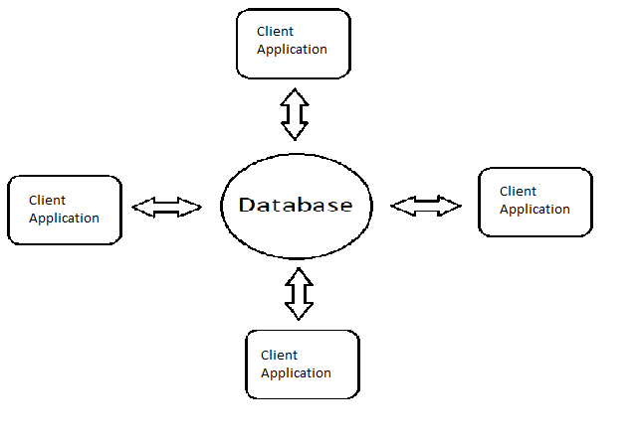

### Hardware Architecture

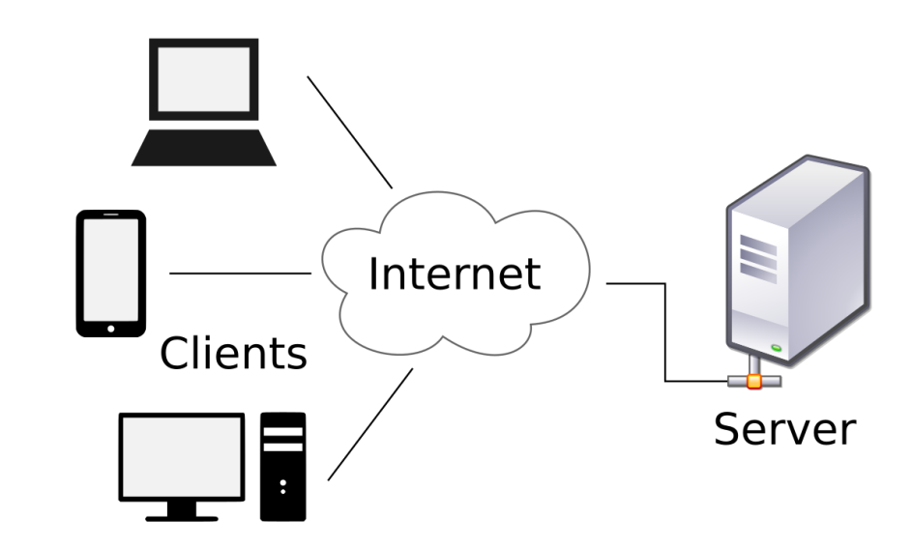

## SYSTEM INTERFACES

### External System Interfaces

External system interface is not used in this project.

## USER INTERFACE DESIGN

### Navigation

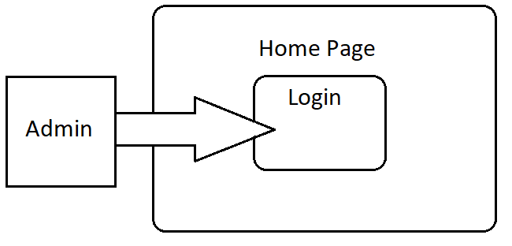

* The first place users will encounter on the website is the login screen.
* No user can view the data without logging in.
* If the session is successful, data can be viewed.

### Screen Definitions

#### Home Page

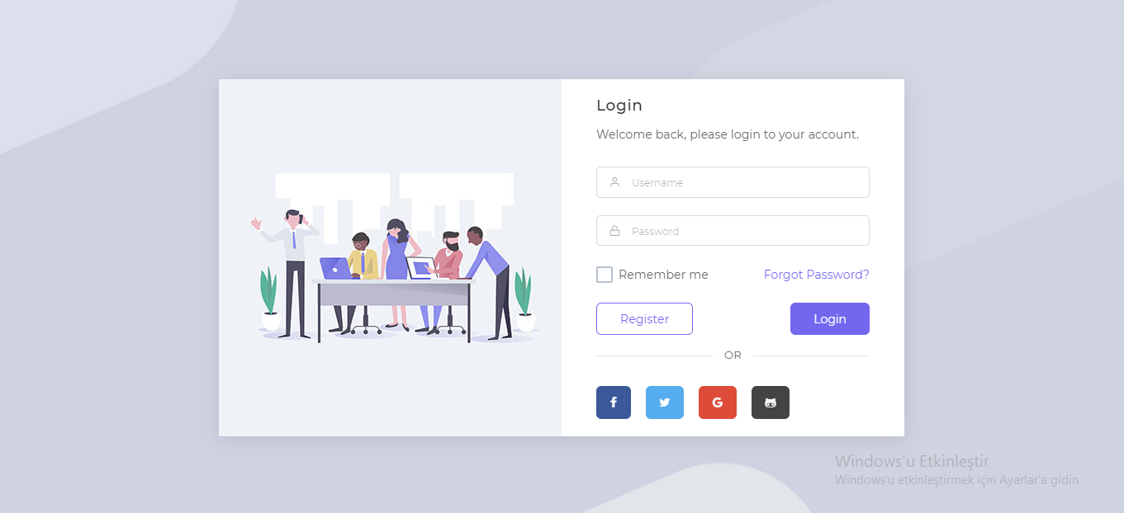

This page is the home page of the application. If the login is successful, the admin page is passed.

#### Admin Page

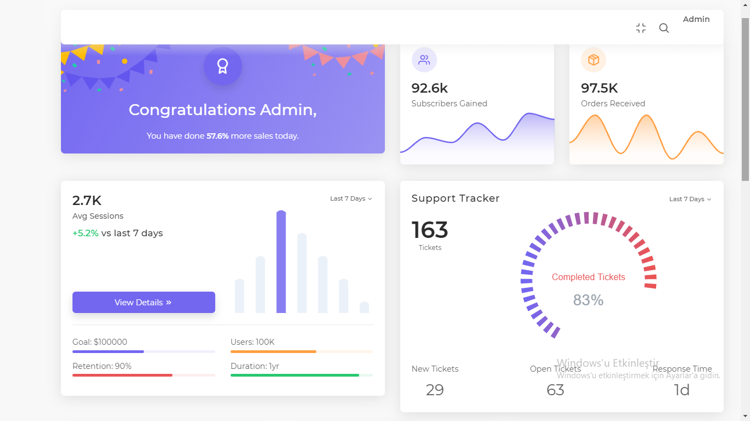

On this page, admin can view the data.

## DATABASE DESIGN

### Table Definitions

#### Admin Table

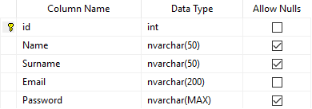

#### Data Table

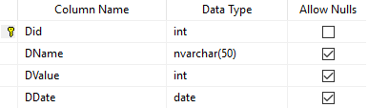

## REFERENCES

http://cengproject.cankaya.edu.tr/wp-content/uploads/sites/10/2017/12/SDD-ieee-1016-2009.pdf