CANKAYA UNIVERSITY

Software Design

Document

**Simulacrum: Creating a Website with Bootstrap**

**Füsun Funda AKAY-201511001, İbrahim Arda ACAR-201611003**

**03/12/2020**

Table of Content

1. INTRODUCTION 2

1.1 Purpose 2

1.2 Scope 2

1.3 Glossary 2

1.4 Motivation 2

2. ARCHITECTURE DESIGN 2

2.1 Aproach 2

2.2 Tools Used 2

2.3 Constraints 2

2.4 Assumptions and Depencies 3

3. ARCHITECTURE 3

3.1 Software Architecture 3

3.2 Hardware Architecture 3

4. SYSTEM INTERFACES 4

4.1 External System Interfaces 4

5. USER INTERFACE DESIGN 4

5.1 Navigation 4

5.2 Screen Definitions 4

5.2.1 Home Page 4

5.2.2 Admin Page 5

6. DATABASE DESIGN 5

6.1 Table Definitions 5

6.1.1 Admin Table 5

6.1.2 Data Table 5

7. REFERENCES 5

# INTRODUCTION

## Purpose

## The purpose of this document is to describe the details of the "building a website with bootstrap" project.

## 1.2 Scope

The main purpose of the "Create a website with bootstrap" project is to help company administrators understand the data.

### 1.3 Glossary

|  |  |
| --- | --- |
| **TERM** | **DEFINITION** |
| **Admin** | It is the administrator and monitor of the system. |

## 1.4 Motivation

We are last class computer engineering students who are learning to make a more beautiful website using Bootstrap technology. In our project called "Create a website with Bootstrap", we aimed to free the data from complexity and to observe it in a more visual way.

# ARCHITECTURE DESIGN

## Aproach

This project aims to observe complex data in the best explanatory way. Visual communication is aimed between the manager and the data. It has a user-friendly interface. It is open to discussion in meetings, as all managers will see the same data sheet. The administrator will access the site on the internet.

## Tools Used

* MSSQL
* Visual Studio
* Visual Studio Code

## Constraints

Complex data will be made readable.

## Assumptions and Depencies

When there is any connection problem, data may be missing / not at all.

# ARCHITECTURE

## Software Architecture

This Project have a data-centering software architecture.

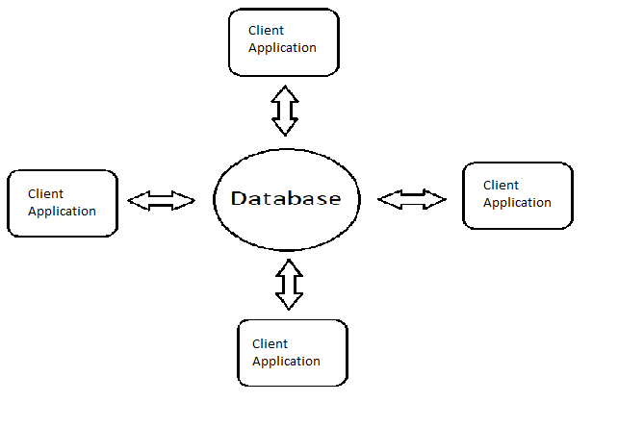

## Hardware Architecture

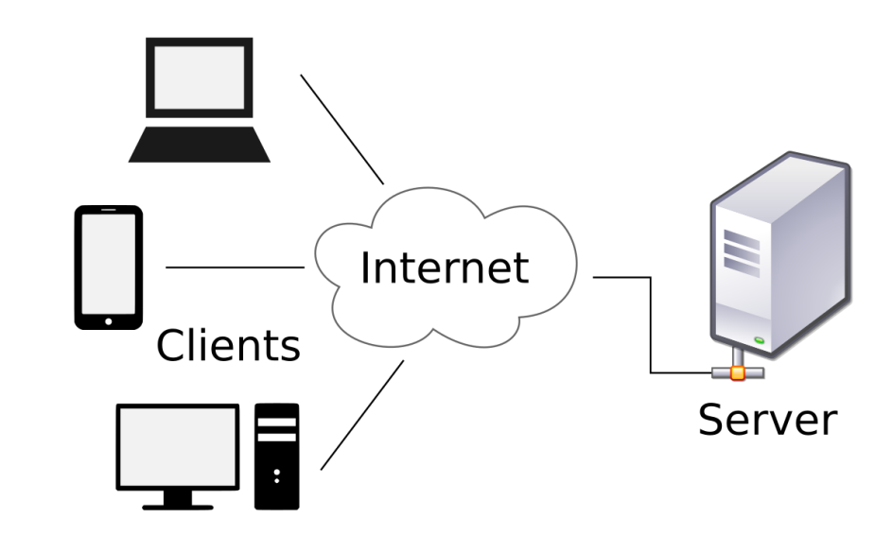

# SYSTEM INTERFACES

## External System Interfaces

External system interface is not used in this project.

# USER INTERFACE DESIGN

## Navigation

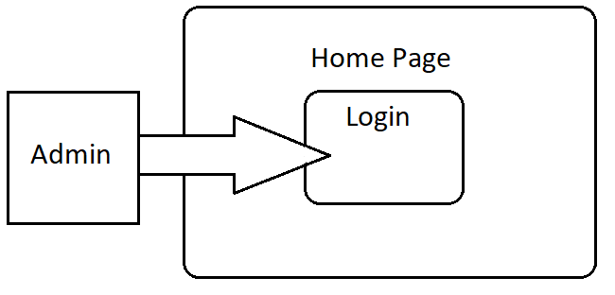

* The first place users will encounter on the website is the login screen.
* No user can view the data without logging in.
* If the session is successful, data can be viewed.

## Screen Definitions

### Home Page

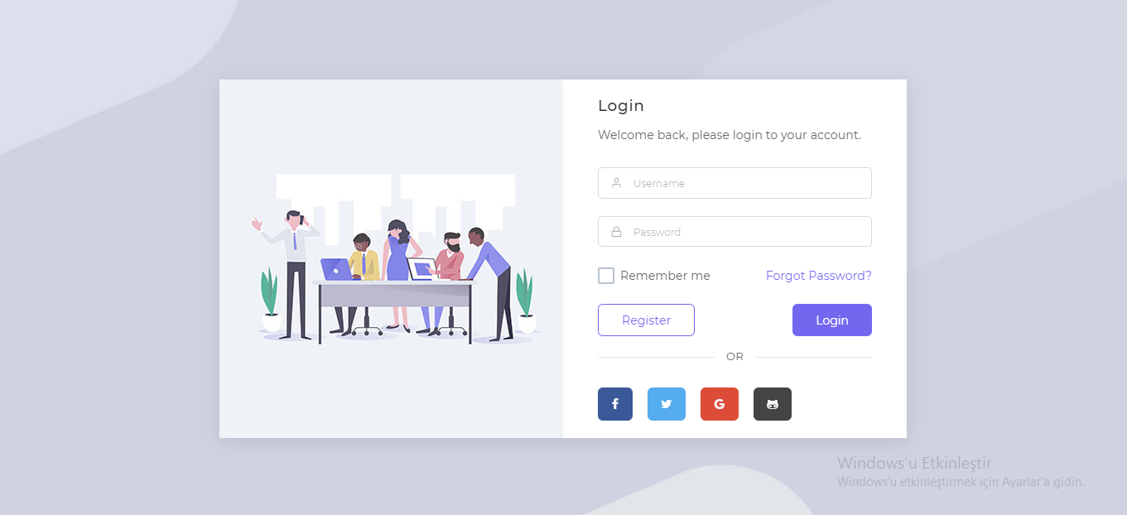

This page is the home page of the application. If the login is successful, the admin page is passed.

### Admin Page

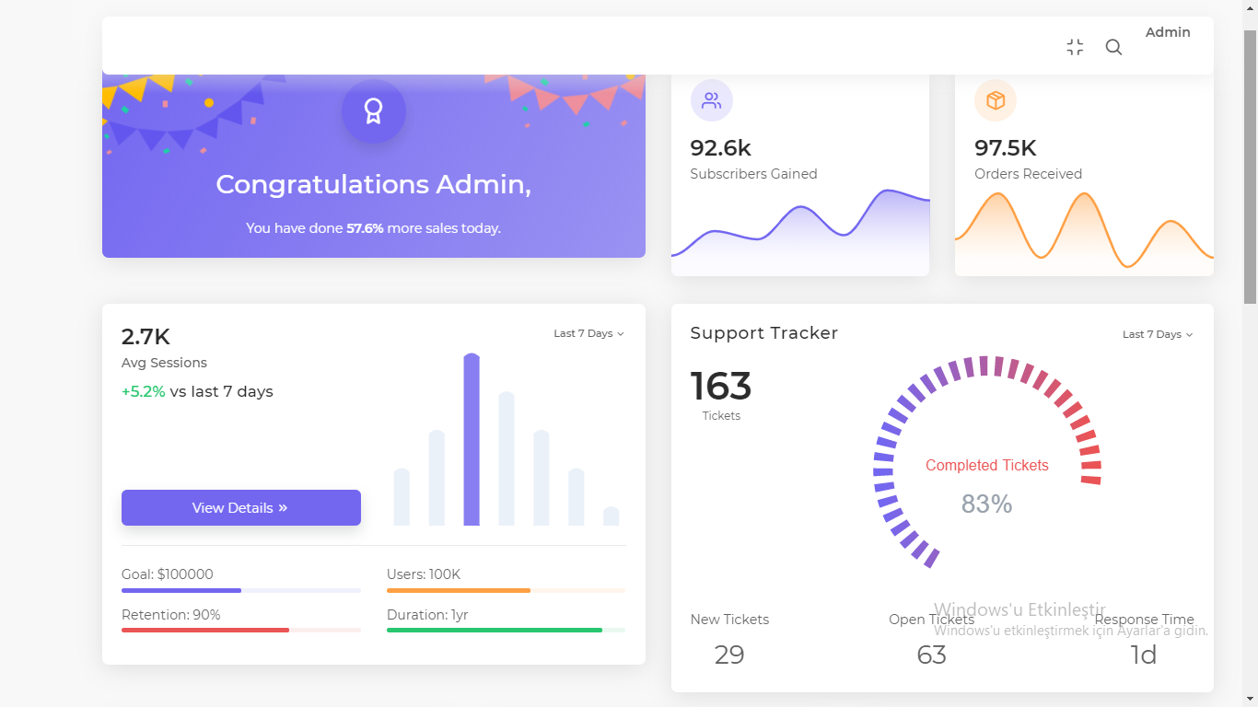

On this page, admin can view the data.

# DATABASE DESIGN

## Table Definitions

### Admin Table

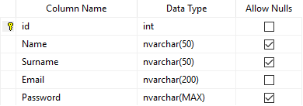

### Data Table

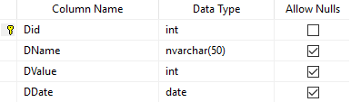

# REFERENCES

http://cengproject.cankaya.edu.tr/wp-content/uploads/sites/10/2017/12/SDD-ieee-1016-2009.pdf