SOFTWARE REQUIREMENTS SPECIFICATION

* Nadir Suhan İLTER 201611029
* Can OZAL 201611043
* Muhammed Talha ZAMBAK 201611043

Integrating Digital Queue Line Order Screens Into Phone Application (Express)

SEGMENTS OF CONTENTS

1.0 INTRODUCTION

1.1 What is Express?

1.2 Scope

1.3 Glossary

1.4 Overview of Document

2.0 OVERALL DESCRIPTION

2.1 Product Perspective

2.2. Devolopment Methodology

2.3 User Characteristic

3.0 REQUIREMENT SPECIFICATIONS

3.1 External Interface Specifications

3.2 Functional Requirements

3.2.1 Profile Management Use Case

3.2.2 User Use Case

3.2.3 Admin Use Case

3.3 Performance Requirements

3.4 Software System Attributes

3.4.1 Reliability

3.4.2 Availability

3.4.3 Security

3.4.4 Maintainability

3.4.5 Ease Of Use

1. INTRODUCTION
   1. What is Express?

This project is will available on both mobile application systems which is IOS and Android. It will be also available as Web Application for terminal  
usage which targeted other side of users. The main purpose of project is to reduce the time needed for giving an order from queue to restaurants and  
eliminating any possible health risks which can spread by interaction with people and restaurant menus which like COVID-19, Influenza, Sars etc.

Technology of QR will be allow us to reach that goal by simply scanning qr code on the designated areas such as restaurant tables or anywhere close to  
the restaurant which user wants to order from. It will also help to restaurants side as reducing time for taking orders and reducing resources by using menus etc.

This project also can get implement for places which has high queue on it like hospitals, banks for make users relax by simply allow them to  
track their current line in queue and notify them when their turn comes.

1.2 Scope

This project has two side to use which is customer and terminal side. Customer side will be available on both IOS and Android side. Anyone wants to use that service will be available to easily download the app from App Store and Google Play without paying any price. On the other side, terminal will be written with different technology to service any information that they need by making available them to track their order queue easily. Terminal side will be available as a website which will make it usable from any device that has consistent network connection. This can be a computer, television, phones and even smart weareable technology. These things make our product

easy to get and easy to use for potential 2 billion user around the world.

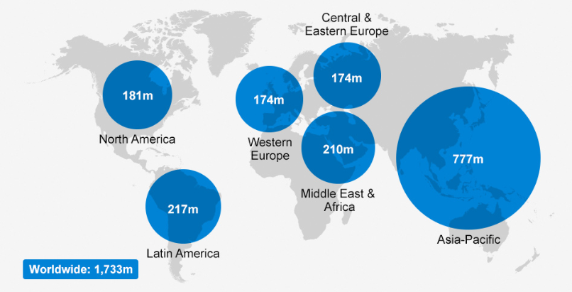

1.3 Glossary

QR (Quick Response): QR code (abbreviated from Quick Response code) is a type of [matrix barcode](https://en.wikipedia.org/wiki/Barcode#Matrix_(2D)_barcodes) (or two-dimensional barcode) first designed in 1994 for the automotive industry in Japan. A barcode is a machine-readable optical label that contains information about the item to which it is attached. In practice, QR codes often contain data for a locator, identifier, or [tracker](https://en.wikipedia.org/wiki/Website_visitor_tracking) that points to a website or application. A QR code uses four standardized encoding modes (numeric, alphanumeric, byte/binary, and [kanji](https://en.wikipedia.org/wiki/Kanji)) to store data efficiently; extensions may also be used.



Database: A database is an organized collection of [data](https://en.wikipedia.org/wiki/Data_(computing)), generally stored and accessed electronically from a computer system. Where databases are more complex they are often developed using formal [design and modeling](https://en.wikipedia.org/wiki/Database#Design_and_modeling) techniques.

The [database management system](https://en.wikipedia.org/wiki/Database#Database_management_system) (DBMS) is the [software](https://en.wikipedia.org/wiki/Software) that interacts with [end users](https://en.wikipedia.org/wiki/End_user), applications, and the database itself to capture and analyze the data. The DBMS software additionally encompasses the core facilities provided to administer the database. The sum total of the database, the DBMS and the associated applications can be referred to as a "database system". Often the term "database" is also used to loosely refer to any of the DBMS, the database system or an application associated with the database.

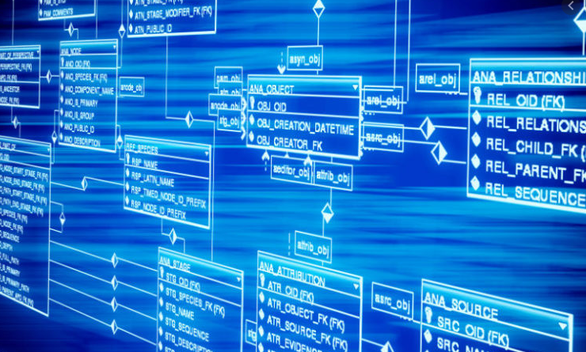

Server: Web server is [server software](https://en.wikipedia.org/wiki/Server_software), or [hardware](https://en.wikipedia.org/wiki/Computer_hardware) dedicated to running this software, that can satisfy [client](https://en.wikipedia.org/wiki/Client_(computing)) requests on the [World Wide Web](https://en.wikipedia.org/wiki/World_Wide_Web). A web server can, in general, contain one or more [websites](https://en.wikipedia.org/wiki/Website). A web server processes incoming [network](https://en.wikipedia.org/wiki/Computer_network) requests over [HTTP](https://en.wikipedia.org/wiki/Hypertext_Transfer_Protocol) and several other related [protocols](https://en.wikipedia.org/wiki/Communication_protocol).

The primary function of a web server is to store, process and deliver [web pages](https://en.wikipedia.org/wiki/Web_page) to clients.[[1]](https://en.wikipedia.org/wiki/Web_server#cite_note-1) The communication between client and server takes place using the [Hypertext Transfer Protocol (HTTP)](https://en.wikipedia.org/wiki/Hypertext_Transfer_Protocol). Pages delivered are most frequently [HTML documents](https://en.wikipedia.org/wiki/HTML), which may include [images](https://en.wikipedia.org/wiki/Image), [style sheets](https://en.wikipedia.org/wiki/Style_sheet_(web_development)) and [scripts](https://en.wikipedia.org/wiki/JavaScript) in addition to the text content.

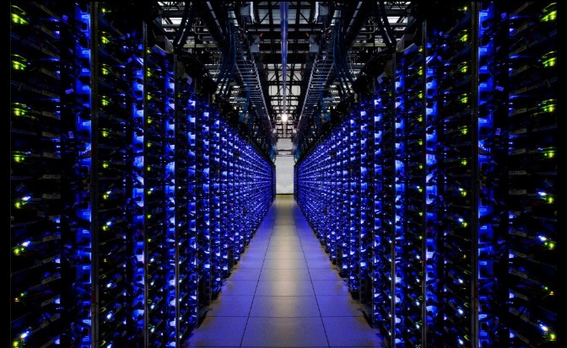

Application (APP): Application software (app for short) is a [program](https://en.wikipedia.org/wiki/Computer_program) or group of programs designed for end-users. Examples of an application include a [word processor](https://en.wikipedia.org/wiki/Word_processor), a [spreadsheet](https://en.wikipedia.org/wiki/Spreadsheet), an [accounting application](https://en.wikipedia.org/wiki/Accounting_software), a [web browser](https://en.wikipedia.org/wiki/Web_browser), an [email client](https://en.wikipedia.org/wiki/Email_client), a [media player](https://en.wikipedia.org/wiki/Media_player_(software)), a [file viewer](https://en.wikipedia.org/wiki/File_viewer), [simulators](https://en.wikipedia.org/wiki/Simulators), a [console game](https://en.wikipedia.org/wiki/Console_game), or a [photo editor](https://en.wikipedia.org/wiki/Raster_graphics_editor). The [collective noun](https://en.wikipedia.org/wiki/Collective_noun) applicationsoftware refers to all applications collectively. This contrasts with [system software](https://en.wikipedia.org/wiki/System_software), which is mainly involved with running the computer.

Applications may be [bundled](https://en.wikipedia.org/wiki/Product_bundling) with the computer and its system software or published separately and may be coded as [proprietary](https://en.wikipedia.org/wiki/Proprietary_software), [open-source](https://en.wikipedia.org/wiki/Open-source_model), or university projects.[[2]](https://en.wikipedia.org/wiki/Application_software#cite_note-2) Apps built for mobile platforms are called [mobile apps](https://en.wikipedia.org/wiki/Mobile_app).



1.4 Overview Of Document

Remaining segments will give inform about all the aspects due to software requirements and reflections.With all the calculated aspects of usage, there will be explanation for every single of them to explain our product better and simplier. There will be a diagrams and sub-segments to divide subject to sub-elements for better experience.

2. OVERALL DESCRIPTION

2.1 Product Perspective

The main purpose of project is to reduce the time needed for giving an order from queue to restaurants and eliminating any possible health risks which can spread by interaction with people and restaurant menus which like COVID-19, Influenza, Sars etc.

The project was divided into two important parts: ordering food part and social media part. In food ordering part, thanks to the qr feature of our application on their phones, they can access the menus of the restaurants by reading the qr code. The qr code that the user will read can be on the table in the restaurant or it can be in a place determined by the restaurant. After the user has finished her meal, they will be able to rate the restaurant on different criteria. This will be a preliminary idea for the user who wants to go to this next restaurant. In social media part, users will be able to comment on restaurants or meals or share photos. They will be able to follow each other. Users will be able to see the shares of the users they follow on the main screen. According to the friends, users follow, users may come across a restaurant or meal suggestion.

2.2 Development Methodology

We decided to use the Rapid Application Development (RAD) method in the project. The reason we chose this method is that we, as a software developer, also put ourselves in the customer position. After the work we do, we constantly ask about the work we do with our group friends and get feedback. Since we will examine the code we write at every stage of the code we write, we will greatly reduce the security risk in the code. We can change places that we don't like and thus we try to make the best product we can.

2.3 User Characteristic

2.3.1.1 Customers

2.3.1.2 Customers must have a consistent network connection,

2.2.1.3 Customers must have credit cards to order,

2.2.1.4 Customers must be in places where they can read the qr code on the phone.

2.3.2.1 Restaurants;

2.3.2.2 The restaurant should have a place to serve its customers,

2.3.2.3 The restaurant must deliver their promised meals on time,

2.3.2.4 Restaurant must put QR code their own place or other places for customers can read on the phone.

3.0 REQUIREMENTS SPECIFICATION

3.1 External Interface Requirements

3.1.1 User interfaces

The user interface will be worked on phones with an android or ios operating system.

3.1.2 Hardware interfaces

Since we will use react native in our application, our application may target iOS 10.0 and Android 4.1 (API 16) or newer. It depends on which component we will use in the project.

3.1.3 Software interfaces

There are no external software interface requirements.

3.1.4 Communications interfaces

There are no external communications interface requirements.

* 1. Functional Requirements

### 3.2.1 Profile Management Use Case

### Use Case:

* Login
* Sign Up
* Validation
* Exit

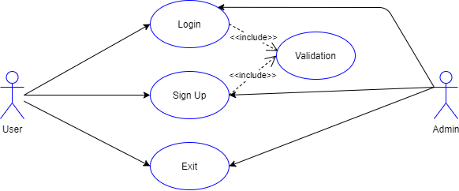

FIGURE I - Profile Management Use Case

#### Brief Description:

Figure I show profile management use case diagram. When user and admin first entered within the system, they come across the authentication menu. Admin and user can use the functions that are Sign Up, Login and Exit.

#### Initial Step by Step Description:

1. Users and admin must login the system;

If the username and password is invalid that should re-login.

1. Users and admin can exit from the system.

### 3.2.2 User Use Case

#### Use Case:

* Menu
* Reservation
* Comments
* Order
* Most Preferred
* Add Order
* Show
* Add
* Delete
* Confirmed

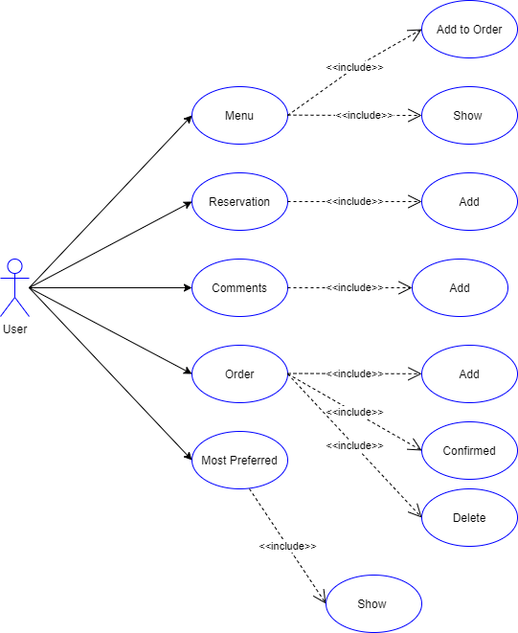

FIGURE II- User Use Case

#### Brief Description:

In user diagram (Figure II) defines what type of action the user can perform on the system. User is able to use the following function: Add to Order , Show, Add , Confirmed, Delete with this function the user can see the most preferred list or see the menu and add to users order or delete and also sees the comments and make reservation on the restaurants.

#### Initial Step by Step Description:

1. If the users select Menu, the system will show the list of menus in the restaurant and the users can add some think to the users order from menu.
2. If the users select Reservation, the system will show the restaurants vacant places and times and the user can make a reservation with add function.
3. If the users select Comments the users can comment the filling of the restaurant.
4. If the users select Order the users make an order with add or delete the order and confirmed it here.
5. If the users select Most Preferred the user will see which products more preferred.

### 3.2.3 Admin Use Case

#### Use Case:

* Add
* Delete
* Change
* Confirm
* Show
* Answer Comments
* Menu
* Reservation
* Comments
* Order
* Most Preferred

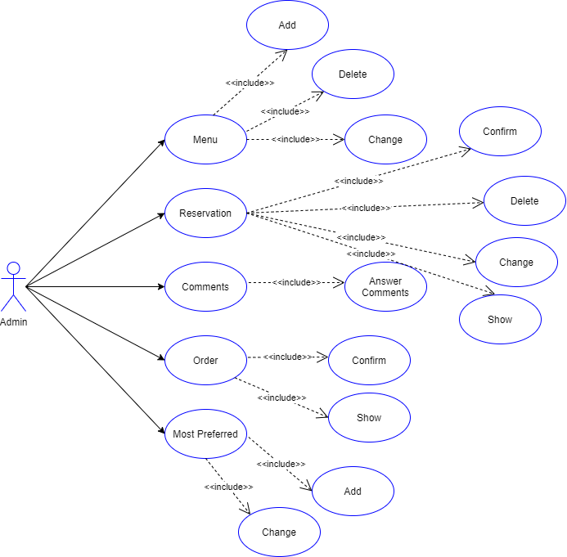 F FIGURE III - Admin Use Case

#### Brief Description:

The admin is authorized to intervene in the system. Figure III is admin use case diagram that explains admin's privileges.

#### Initial Step by Step Description:

1. Admin can add and delete or change the menu in the system.
2. Admin can see the reservation on the system and change, delete and confirm in the system.
3. Admin can see the comments and answer the comments.
4. Admin can view the order and confirm.
5. Admin can change or add to the most preferred list.

## 3.3 Performance Requirements

The minimum system requirements for the computer to be used are as follows:

* Processors: Any device that can open a web browser from pc or mobile.
* Disk space: 99,9 MB
* Operating systems: Linux, macOS, Windows 7, Android or İOS

## 3.4 Software System Attributes

### 3.4.1 Reliability

### 3.4.2 Availability

The system will work on all operating systems.

### 3.4.3 Security

### Before receiving the data from the user, indicated that will only be used for system.

### 3.4.4 Maintainability

To increase the stability of the software, the training and test files of the software will be updated once a week or worst a month by the administrator.

### 3.4.5 Ease of Use

Since the developed application is a user-oriented project, it should provide simple usage to the user. Therefore, the interface we will prepare will be understandable and user oriented.

REFERENCES

Pathogen Persistence in Restaurant Menus: Comparison between Materials Martín Gámez N, Mengual Lombar M, Carcedo I, Lopez M.A and Álava J.I.*

[*https://www.longdom.org/open-access/pathogen-*](https://www.longdom.org/open-access/pathogen-) *persistence-in- restaurant-menus-comparison- between-materials-jfmsh-1000104.pdf*

Alsallaiy, Ibtehal, "BACTERIAL RECOVERY, TRANSFER TO HANDS AND SURVIVAL ON RESTAURANT MENUS" (2013). All Theses. 1616.

https://tigerprints.clemson.edu/all_theses/1616

# Survival of Enterococci and Staphylococci on Hospital Fabrics and Plastic (2000) Alice N. Neely and Matthew P.Maley

# https://www.ncbi.nlm.nih.gov/pmc/articles/PMC86187/

# The European Union summary report on trends and sources of zoonoses, zoonotic agents and food-borne outbreaks in 2013

# https://www.efsa.europa.eu/en/efsajournal/pub/3991

# Persistence of Salmonella and E. coli on the surface of restaurant menus (2013) Sujata A. Sirsat, Jin-Kyung K. Choi, Barbara A. Almanza and Jack A. Neal

# https://pubmed.ncbi.nlm.nih.gov/23505769/

# Survival of bacterial pathogens on paper and bacterial retrieval from paper to hands: preliminary results (2011) Nils-Olaf Hübner, Claudia Hübner, Axel Kramer and Ojan Assadian.

# https://pubmed.ncbi.nlm.nih.gov/22082498/

# QR Codes: Innovative Technology for Libraries in Electronic Environment (2018) Anil Kumar Jharotia

# <https://www.researchgate.net/publication/332187538_> QR_Codes_Inno vative_Technology_for_Libraries_in_Electronic_Enviro nment

# A Mobile QR Code Application for an Article: QR-ticle (2020) Esra Eroğlu and Esma Ergüner Özkoç

# <https://www.researchgate.net/publication/342531476_> A_Mobile_QR_C ode_Application_for_an_Article_QR- ticle

Chang, J. H. (2014). An introduction to using QR codes in scholarly journals. Science Editing, 1(2), 113-117.

https://doi.org/10.6087/kcse.2014.1.113

Liu, C., Shi, L., Xu, X., Li, H., Xing, H., Liang, D & Chen, S. (2012). DNA barcode goes two-dimensions:

DNA QR code web server. PloS one, 7(5), e35146.

https://doi.org/10.1371/journal.pone.0035146

Shin, D. H., Jung, J., & Chang, B. H. (2012). The psychology behind QR codes: User experience perspective.

Computers in Human Behavior, 28(4), 1417-1426.

https://doi.org/10.1016/j.chb.2012.03.004

# SERVICE SPEED AND PATRONAGE OF QUICK-SERVICE RESTAURANTS IN PORT-HARCOURT.

# <https://www.researchgate.net/publication/317492964_> SERVICE_SPEE D_AND_PATRONAGE_OF_QUICK- SERVICE_RESTAURANTS_IN_PORT-HARCOURT

# The influence of the quality of the physical environment, food, and service on restaurant image, customer perceived value, customer satisfaction, and behavioral intentions (2012) Kisang Ryu, Hye-Rin Lee and Woo Gon Kim

# https://www.researchgate.net/publication/235316810_The_influence_o f_the_quality_of_the_physical_environment_food_and_service_on_res taurant_image_customer_perceived_value_customer_satisfaction_and _behavioral_intentions

# Guest Satisfaction and Restaurant Performance (2007) Sachin Gupta

# <https://www.researchgate.net/publication/247274257_> Guest_Satisfacti on_and_Restaurant_Performance

# Customer Restaurant Choice: An Empirical Analysis of Restaurant Types and Eating-out Occasions

# <https://www.researchgate.net/publication/343960966_Customer_Resta> urant_Choice_An_Empirical_Analysis_of_Restaurant_Types_and_Eatin g-out_Occasions

Xiang, Z.; Gretzel, U. Role of social media in online travel information search. Tour. Manag. 2010, 31, 179–

188,

doi:10.1016/j.tourman.2009.02.016.

Ye, Q.; Law, R.; Gu, B. The impact of online user reviews on hotel room sales. Int. J. Hosp. Manag. 2009, 28,

180–182,

doi:10.1016/j.ijhm.2008.06.011.

Dellarocas, C. Reputation mechanisms. In Handbook on Information Systems and Economics; Hendershott, T.,

Ed.; Elsevier Publishing: Amsterdam, The Netherlands, 2006; pp. 629– 660.

Dowling, G. Creating Corporate Reputations; Oxford University Press: Oxford, UK, 2001.

Fombrun, C.J. Indices of corporate reputation: An analysis of media rankings and social monitors’ratings. Corp. Reput. Rev. 1998, 1, 327–340,

doi:10.1057/palgrave.crr.1540055.

Foroudi, P. Influence of brand signature, brand awareness, brand attitude, brand reputation on hotel industry’s brand performance. Int. J. Hosp. Manag. 2019, 76, 271–285,

doi:10.1016/j.ijhm.2018.05.016.

Loureiro, S.M.C.; Kastenholz, E. Corporate reputation, satisfaction, delight, and loyalty towards rural lodging units in Portugal. Int. J. Hosp. Manag. 2011, 30, 575–583,

doi:10.1016/j.ijhm.2010.10.007.

Su, L.; Swanson, S.R.; Chinchanachokchai, S.; Hsu, M.K.; Chen, X. Reputation and intentions: The role of satisfaction, identification, and commitment. J. Bus. Res.2016, 69, 3261–3269,

doi:10.1016/j.jbusres.2016.02.023.

Chang, K.-C. How reputation creates loyalty in the restaurant sector. Int. J. Contemp. Hosp. Manag. 2013,

25, 536–557,

doi:10.1108/09596111311322916.

Han, S.H.; Nguyen, B.; Lee, T.J. Consumer-based chain restaurant brand equity, brand reputation, and brand trust. Int. J. Hosp. Manag. 2015, 50, 84–93,

doi:10.1016/j.ijhm.2015.06.010.