**

ÇANKAYA UNIVERSITY

Software Requirements Specification

For

***MyFM: Adaptive music player with personalized playlist generation***

*(Version 1.0)*

*Prepared By:*

***Group ID:* 202019**

*Orkun Güneri-201611025*

*Erenalp Kesici-201811406*

*Necati Anıl Gökkaya-201511025*

*4/12/2020*

**Change History**

This document is the first version Software Requirements Specification document of the project named *MyFM: Adaptive music player with personalized playlist generation*. It was created on December 4, 2020.

Table of Contents

1.Introduction 5

1.1 Purpose 5

1.2 Scope of the Project 5

1.3 Glossary 5

1.4 References 5

1.5 Overview of the Document 6

2. Overall Description 6

2.1 Product Perspective 6

2.1.1 Development Methodology 6

2.1.2 User Interface 6

2.2 User Characteristic 6

2.3 Product Functions 7

3. Requirements Specifications 7

3.1 External Interface Requirements 7

3.1.1. User Interface 7

3.1.2 Hardware Interface 7

3.1.3. Software interfaces 7

3.1.4. Communications interfaces 8

3.2 Functional requirements 8

3.3 Software System Attributes 8

3.3.1 Portability 8

3.3.2 Availability 8

3.3.3 Security 8

3.3.4 Adaptability 8

3.3.5 Usability 8

3.3.6 Safety Requirements 8

# 1.Introduction

## Purpose

The main objective of this document is to explain the adaptive music player with personalized playlist generation called MyFm. This music player aims to generate personalized playlists for the user after examining a pattern in the user’s music taste. This application is for people that would like to be able to listen to songs that are in close proximity to what they have listened to before[1].

## Scope of the Project

MyFm is a music player that allows for the generation of personalized playlists. The aim of this application is to satisfy the user with songs that they would enjoy listening to by finding the right recommendations.

## Glossary

|  |  |
| --- | --- |
| UI | User Interface |
| SRS | Software Requirements Specification |
| OS | Operating System |

## 1.4 References

|  |  |
| --- | --- |
| [1] | [Online]. Available: https://en.wikipedia.org/wiki/Media_player_software. [Accessed 3 12 2020]. |

## Overview of the Document

The second part of this SRS document explains the functionalities of the MyFM: Adaptive

music player with personalized playlist generation.

The third part introduces the requirements that come with using this application.

# 2. Overall Description

## 2.1 Product Perspective

MyFm is a self-contained, music player that will provide the user with personal playlists that will continually adapt to user’s listening history. It will look at many fields including metadata etc. in achieving its goal.

### 2.1.1 Development Methodology

For developing the project, we chose Android Studio as our development platform, because this platform fits our goals for this project and makes it easy to maintain its functions.

### 2.1.2 User Interface

One of the most crucial part of MyFm project is its ease of use with the correct placements of certain UI fields (play/pause buttons, previous/next buttons etc.), its goal is to be made as user friendly as possible.

## 2.2 User Characteristic

The user should know the basics of how to operate smart phones.

## 2.3 Product Functions

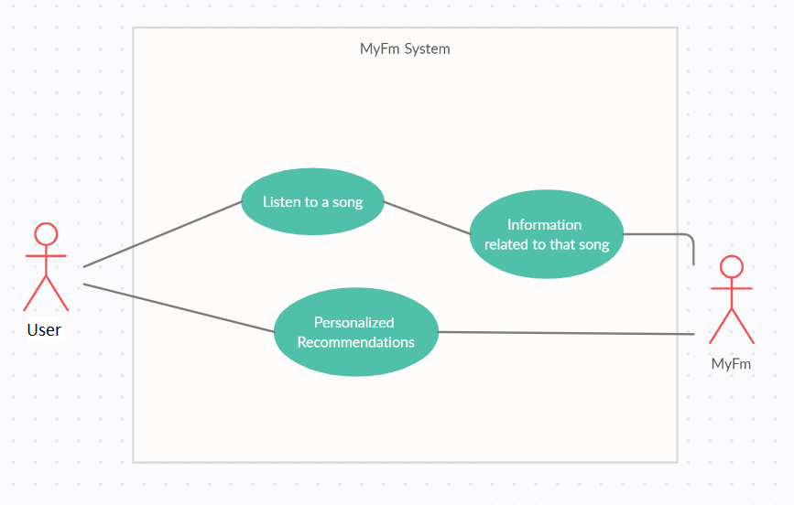

# 3. Requirements Specifications

## 3.1 External Interface Requirements

### 3.1.1. User Interface

The user interface requires to be run on Android platforms.

### 3.1.2 Hardware Interface

There are no strict hardware requirements other than that it is required for the user to have a smart phone with Android OS installed on it.

### 3.1.3. Software interfaces

This application will need a minimum of Android version 4.1(Jelly Bean) or higher to be run.

### 3.1.4. Communications interfaces

Wireless or wired internet connection is required for listening to the songs and using the application.

## 3.2 Functional requirements

Some data will need to be collected to fulfill the goal of the application and ensure accurate recommendations delivered to the user.

## 3.3 Software System Attributes

### 3.3.1 Portability

The system was designed and coded in Android Studio thus it will be available exclusively on Android devices.

### 3.3.2 Availability

The system will be usable as long as there is an active internet connection.

### 3.3.3 Security

By using a number of secure network protocol techniques, it will be made as secure of an application as possible.

### 3.3.4 Adaptability

Since some data is being collected when using the application, it will be highly adaptive to user inputs.

### 3.3.5 Usability

The MyFm system will be easy to use thanks to its heavy emphasis on the simplicity of its UI mechanics.

### 3.3.6 Safety Requirements

Listening to music at a high volume for a long time can cause long-term damage to user’s ears.