

ÇANKAYA UNIVERSITY

DEPARTMENT OF  
COMPUTER  
ENGINEERING

**Cryptocurrency Price Change Predictor**

CENG 408  
INNOVATIVE ENGINEERING ANALYSIS AND DESIGN  
PROJECT REPORT

**Group ID:** 202122

**Group Members:**

Ece PULAT 201726061

Gamze Nur Dağdelen 201711017

Türkan Simge İŞPAK 201726038

Kadir Berke ÇINAR 201711016

**Advisor:**

Dr. Uğur SOPAOĞLU

**Table of Contents**

1. Abstract……………………………………………………………2
2. Introduction………………………………………………………..2
3. Related Work ……………………………………………………..3
4. Proposed System ………………………………………………….3
5. Cryptocurrency Price Predictor Application ……………………...4
6. Software Requirements Specification …………………………….6
7. Software Design Description ……………………………………...9
8. Test Plan ……………………………………….………….……...23
9. Installation Manual…………………………………….................32
10. User Manual……………………………………………………...35
11. References ………………………………………………………..37
12. **Abstract**

The aim of "Cryptocurrency Price Change Predictor" project is to design an application which can predict decrease and increase on cryptocurrency by using candlestick, technical indicators and machine learning algorithms. Different machine learning algorithms and hybrid models will be studied to develop an accurate prediction algorithm. Afterwards, a mobile and/or a web application will be developed to provide prediction information by means of data visualization. Application user will be able to see the time-based prediction graph of a selected cryptocurrency as well as the prediction’s accuracy. As a result, this project aims to yield a cryptocurrency price increase and decrease prediction application which can help users make more informed decisions concerning the market.

**Key Words:** Cryptocurrency, Bitcoin, Technical Indicators, Machine Learning.

1. **Introduction**

In 2021, the cryptocurrency market is worth over 3 trillion dollars with around 6000 different types of crypto coins. Ever since the first decentralized cryptocurrency, Bitcoin, emerged in 2009 the cryptocurrency market had an extremely volatile but nonetheless increasing growth. First transaction with a cryptocurrency was swapping two pizzas for 10000 Bitcoins which is now worth more than 100 million dollars. People did not really think that an invention such as this would have such magnitude in the world of economy.

Prediction of stock prices to maximize investment return holds an important place in finance. There are different discussions on the matter whether or not price prediction is possible. Behavioral Finance, which is a newly emerging Economics subfield state that it is possible to predict prices based on the study of the influence of psychology on the behavior of investors. Indeed, new research emerge everyday about price prediction and forecasting. Machine learning algorithms are able to detect patterns with generalization power thus, they can be used in cryptocurrency price prediction with varying algorithms. Some of these algorithms are Recurrent Neural Network (RNN), MultiLayer Perceptron (MLP), Bayesian Regression, Random Forest, Long Short-Term Memory (LSTM) and its extension Gated Recurrent Unit (GRU), Hidden Markov Model (HMM) each having different advantages and disadvantages when it comes to price prediction in a volatile market.

In this project, aforementioned machine learning algorithms will be tested and compared using Coinmarketcap and Kaggle Cryptocurrency datasets using libraries such as Scikit-learn, Tensorflow and Keras. Ensamble methods, which is a machine learning technique that aims to utilize numerous base models to obtain an optimal prediction model, will also be studied. After determining their advantages and disadvantages in a volatile market such as the cryptocurrency market, an application will be developed using Flutter and React.js tools which have powerful data visualization capabilities. This mobile and/or web application will allow user to see cryptocurrency price predictions and estimated prediction accuracy. Proposed methods and system will be tested using evaluation methods such as precision parameter, confusion matrix, autocorrelation function, augmented Dickey-Fuller test for machine learning algorithms and usability testing methods for the developed application. As a result, proposed system will help users make more informed decisions concerning the volatile cryptocurrency market.

1. **Related Work**
   1. **Predicting Price Changes in Ethereum**

This research paper [1] compares different machine learning models such as Recurrent Neural Network, Naive Bayes, Support Vector Machines, Random Forest and ARIMA to find the most efficient and highest accuracy model which predicts Bitcoin price changes. For this study, features are generated by sequencing data points, which are closing prices of the Ether cryptocurrency, in which each point is separated from its neighbors by one hour. Five closing prices in a group are used to determine the change direction prediction of the sixth sample which indicates the prediction of price change direction concerning the next day. Research concludes that all methods achieved above 50% accuracy whereas Auto Regressive Integrated Moving Average (ARIMA) model showed best performance which is related to its suitability to time-series data.

* 1. **Machine Learning Models Comparison for Bitcoin Price Prediction**

This research paper [2] compares different machine learning models such as LSTM, Theil-Sen Regression, Huber Regression and GRU to find the most efficient and highest accuracy model which predicts Bitcoin prices. 1-minute interval data from Bitcoin exchange website “Bitstamp” are used as datasets. As a result, it has been shown that GRU and LSTM outperform Theil-Sen and Huber regressions where GRU is best in terms of accuracy but it is very slow. The authors also make it a point to explain that selected features may not be enough to give an accurate price prediction since Cryptocurrency market is affected greatly by various external factors such as politics and social media. In conclusion, this research narrowed the scope of this project in terms of machine learning algorithms used and it made an important point about proper feature selection.

* 1. **Deep Neural Networks for Cryptocurrencies Price Prediction**

This thesis [3] presents how neural networks, especially LSTM, are useful tools for trend predictions with high prediction accuracy. After explaining basics of recurrent neural networks as a nonlinear method for sequence learning, MLP, RNN, LSTM architectures and the deep learning methodology, the authors tune different hyper-parameters of the model with the trial-and-error methodology in order to obtain best prediction results. It is strongly emphasized that hyper-parameter tuning always improves the prediction accuracy of the model for all models. Overall, the topics covered in this paper guides our project greatly in the stage of literature review.

* 1. **Forecasting Bitcoin Prices**

This thesis [4] presents the accuracy performance comparison of two Bitcoin price prediction algorithms namely as ARIMA and LSTM forecasts for a daily time-series of bitcoin prices. The author states that LSTM predictions have better precision with respect to the ARIMA model.

1. **Proposed System**

The Cryptocurrency Price Change Predictor project will consist of two parts. The first part will be responsible predicting the cryptocurrency prices using machine learning, based on the dataset. The second part will be responsible for providing prediction information by means of data visualization on an application.

* 1. **Dataset**

The primary dataset consists of the price of Bitcoin sampled for the time period of November 2015 to present day which is May 2022, with daily updates of OHLC (Open, High, Low, Close) and Trending Technical Indicators more specifically as Simple Moving Average (SMA), Exponential Moving Average (EMA) and Average Directional Movement (ADX). The dataset is obtained from Yahoo Finance's Python module yfinance daily. This section covers the models, tools and frameworks which will be used for predicting cryptocurrency prices.

* 1. **Cryptocurrency Price Prediction**

This section covers the models, tools and frameworks which will be used for predicting cryptocurrency prices.

* + 1. **Adaptive Boosting (ADB)**

Adaptive Boosting is a boosting or decrease bias algorithm which are types of ensemble methods that combine several base algorithms to form one optimized predictive algorithm. AdaBoost has advantages such as ease of use, being less prone to overfitting and requiring less parameter adjustment compared to Support Vector Machine classifier algorithms. Among disadvantages of AdaBoost are that it very sensitive to outliers and noise in data and it uses a progressively learning boosting technique which means it requires high-quality data.

* + 1. **Support Vector Machine (SVM)**

Support Vector Machine or SVM for short, is a supervised machine learning algorithm which is most commonly used for classification challanges. SVM has advantage with a clear margin of separation among the data and it is effective in high dimensional spaces. On the other hand, SVM does not perform well when with large data sets because required training time increases as data size increases.

* + 1. **Extreme Gradient Boosting (XGB)**

XGBoost is a distributed gradient-boosted decision tree (GBDT) ensemble method which means it uses different feature selection methods with the same data. XGBoost has good performance on not too large data with subgroups and structured datasets with not too many features and it can handle over-fitting. Because of this, XGB has the best performance in real-world problems that involve classification and regression. XGBoost has poor performance on unstructured data and sensitive to outliers.

* 1. **Tools and Frameworks**

For this project, we decided to use the Python programming language for implementing machine learning algorithms. For the machine learning framework, we will use scikit-learn and/or TensorFlow.

1. **Cryptocurrency Price Predictor Application**
   1. **Tools and Frameworks**
      1. **Visualization**

We're working on a project called "Cryptocurrency Price Change Predictor" to create an app that can forecast cryptocurrency values. The user will have access to a time-based forecast of the price of a chosen cryptocurrency thanks to an accurate forecasting system. We utilize Data Visualization to help people understand the data more clearly. Complex data is made more accessible, intelligible, and usable through data visualization. Users will be able to compare and comprehend the accuracy of the forecasts by looking at the cryptocurrency's time-based price prediction graph. With colors and lines, we want to make it easy for the user to make judgments. Our objective is to provide consumers with information that is both clear and efficient. The user will be able to simply track the graphical currency of the selected cryptocurrency in this manner. As a result, users will be able to use a bitcoin price estimator tool more effectively, allowing them to make more educated market judgments.

For data visualization, we will utilize the Recat.js package.React.js is an open-source JavaScript library that is simple to use. React and React-Native may also be used to create mobile apps.React.js is a multi-purpose library. It saves time, it's a fantasy mobile app, it's high, and it's unemployed. It is faster and has a more current user base. This is how we decided on this library for data visualization.

* + 1. **Android Studio**

Android Studio is an open source mobile application development application developed by Google. It includes an interface creation and editing ecosystem in itself. With this interface tool, you can create your own custom interfaces, add existing or external media tools and icons. Android Studio, which also includes a device emulator in itself, greatly accelerates real-time debug and execution processes. The emulator feature, which includes many brands and models on the market, offers you everything you can do on a physical phone, from camera to screen rotation. It also provides 100% support for test-driven development with the already available test codes and rapid test facilities. Using java as the primary language, android studio supports many software languages ​​supported by the android operating system with various tools. Even if an iOS application cannot be developed with android studio, the transition to iOS platform can be very fast and comfortable as it contains many features with iOS’ own language swift.

1. **Software Requirements Specification**

# Introduction

## Purpose

The purpose of this document is to describe the application which is called CryptoCast. This application aims to provide predictions on Bitcoin's price status under three possibilities as predicted increase, predicted decrease and predicted stability. This application has been prepared for users who want to get information about predicted future price directions of Bitcoin. The user will be able to register and build profile in which they can track multiple types of cryptocoins.

## Scope

This software system will be a Cryptocurrency Price Change Predictor System for potential investors who may gain insight on a future price of a selected cryptocurrency generated using machine learning algorithms. This system will be designed to try and maximize the return on investment (ROI) by providing a platform which has enhanced visualization services. The platform will be implemented on a web application and a native android application to predict cryptocoin prices using ensemble classfier algorithms namely as Support Vector Machine (SVM), Adaptive Boosting (ADB) and Exreme Gradient Boosting (XGB).

* 1. **General Description**
     1. **Glossary**

|  |  |
| --- | --- |
| **Term** | **Definition** |
| API | Application Programming Interface |
| CUDA | Compute Unified Device Architecture |
| GPU | Graphics Processing Unit |
| HTML | Hypertext Markup Language |
| IEEE | Institute of Electrical and Electronics Engineers |
| ML | Machine Learning |
| OS | Operating System |
| REST | Representational State Transfer |
| SQL | Structured Query Language |

* + 1. **User Characteristic**
       1. **User**

Users must have a browser installed on their personal computer (PC) or another smart device with a browser in order to utilize the Cryptocurrency Price Predictor platform as a web application. The application must be mobile-friendly. It must be able to connect to devices running the Android or iOS operating systems in order to do so. In order to utilize the applications, users must have internet connectivity and other essential gadgets. The ability to use a web browser is required of all users.

* + - 1. **Administrator**

The administrator must have a browser on a personal computer (PC) or another smart device with a browser to use the Cryptocurrency Price Predictor platform as a web application. The program should be accessible via a mobile device for administrators. It must be able to connect to devices running on the Android or iOS operating systems in order to accomplish this. The administrator must have internet connectivity as well as the other devices needed to run the applications. A web browser is required of the administrator.

* + 1. **Product Perspective**

The app will use a web-based app or/and an iOS mobile app, and an Android mobile app. The application runs in the latest version of Chrome or Firefox browser on Windows, Linux, and Mac. In addition, access will be provided from mobile devices. So, it will be compatible with iOS and Androids. These applications will connect to a REST API built with .NET Core to store and retrieve data from a Microsoft SQL database.

* 1. **Overview**

This document obeys the requirements stated in IEEE Std 1016-2009, IEEE Recommended Practice for Software Requirements Specifications.

* 1. **Interface Requirements**
     1. **User Interface**

There will be two different user interfaces for different types of users. The types are the administrator and standard user.

In standard user interface type, the user will be able to see the value movements of the cryptocurrency they want. Users can manage their subscriptions and create new subscriptions. He/She will be able to determine the time range of crypto currency movements. Users will be able to compare cryptocurrency charts and add various metrics. Also users will be able to set alarms and reminders for the values of the cryptocurrencies it subscribes to.

Users with admin authority can only see the membership information of standard users in the interface that is specific to admin authority. Admins can also update the subscription fees for cryptocurrencies. Admins can stop predictions and subscriptions of any cryptocurrency when there is a problem. Admins can also prepare and publish announcements.

* + 1. **Hardware Interfaces**

Users do not need high hardware to run this program, because all predict operations will be done by the server and the application. Users only need a hardware that can connect to the internet.

For the server and application, a CUDA capable GPU is needed to make predictions as quickly as possible.

* + 1. **Software Interfaces**
       1. **Server Side**

The background data must be updated and quickly obtained from a provider and given to the model. The results of the model should be graphed together with the visualization tool and reflected in the application.

* + - 1. **Client Side**

The web and mobile application developed will be accessible over any browsers that run on any OS, supporting at least HTML version 5 and having Java enabled.

* + 1. **Communication Interfaces**

The default communication protocol for data transmission between server and the client is Transmission Control Protocol/ Internet Protocol (TCP/IP). At the upper-level HyperText Transfer Protocol (HTTP, default port=80) will be used for communication between the web server and client.

* 1. **Functional Requirements**
     1. **Main Page**

The first page will welcome the user to the application and display widget for bitcoin price values and predicted price change direction for the day.

* + 1. **Login Page**

The login page should provide two text fields, one for username and one for password. In the case of mismatch between username and password system should notify the user. Users that have not yet registered cannot log in. They must use register page to create an account for the application. If the user forgot their password, they should use forgot password button which redirects to password reset page.

* + 1. **Register Page**

The user registers to the system by filling the required information which is designated as email address, username, and password. After entering this information, the user clicks the register button to continue to the application.

* + 1. **Password Reset Page**

In this page the user will enter their registered email. Then they the system will send a password reset email link which will direct to this change password page.

* + 1. **Coin Summary Page**

This page uses visualization tools to provide time versus predicted price graph of selected cryptocoin. The time axis of the graph can be selected to display prediction values ranging between 1 hour and 1 month. Actual price and previously predicted price may be displayed as an overlay graph to inform the user about the prediction accuracy.

* + 1. **Profile Page**

The profile page will display account information such as name and e-mail. In addition to this user can create and manage collections which contains their favorite/selected cryptocoins.

1. **Software Design Description**
   1. **Introduction**
      1. **Purpose**

The purpose of this document is to describe the Cryptocurrency Price Change Predictor System application which is named “CryptoCast”. Main purpose of this application is to provide classification or regression for a selected cryptocurrency. Therefore, “CryptoCast” application is developed for users who want to get predicted price change information about of cryptocoins. The user will also be able to register and build profile in which they can track multiple types of cryptocoins and discuss topics based on the current cryptocoin market.

* + 1. **Scope**

The scope of this document is to provide in-depth details about the essential components of the Cryptocurrency Price Change Predictor System. This documents consists of Cryptocurrency Price Change Predictor System design principles and its specifications, application functionalities and meanings. This document will adhere to definitions declared in SRS document.

* + 1. **Glossary**

| **Term** | **Definition** |
| --- | --- |
| ROI | Return On Investment |
| RNN | Recurrent Neural Network |
| LSTM | Long Short-Term Memory |
| GRU | Gated Recurrent Unit |
| HMM | Hidden Markov Models |
| GUI | Graphical User Interface |
| API | Application Programming Interface |
| CUDA | Compute Unified Device Architecture |
| GUI | Graphical User Interface |
| GPU | Graphics Processing Unit |
| HTML | Hypertext Markup Language |
| IEEE | Institute of Electrical and Electronics Engineers |
| ML | Machine Learning |
| OS | Operating System |
| REST | Representational State Transfer |
| ROI | Return On Investment |
| SQL | Structured Query Language |
| SVM | Support Vector Machine |

* + 1. **Overview**
* “Design Considerations” section covers the tools used for this project and explains the motive behind their selection.
* “Architecture” subsection presents software and hardware architecture diagrams which describes the project.
* “System Interfaces” subsection gives information about the database and application framework.
* “User Interface Design” subsection presents figures and comments about GUI design used in the project.
* “Process Design” subsection explains use cases and sequence diagrams for each type of user.
* “Database Design” subsection presents an ER diagram of the database and table of field explanations which gives a more detailed information about the database relations used in this project.
  1. **Design Considerations**
     1. **Approach**

• The data is separated into time intervals ranging from one hour to one month.

• Each sample of data will be saved in the database.

• The data is available in.csv format.

• Using libraries such as Scikit-learn, Pandas, and Seaborn, machine learning methods will be evaluated and compared using Coinmarketcap and Kaggle Cryptocurrency datasets and market data will be downloaded from YahooFinance daily.

• Ensemble techniques will be investigated, which is a machine learning methodology that seeks to use many base models to build an ideal prediction model.

• If there is an issue, administrators can halt any cryptocurrency projections.

• After studying comparable projects and research publications, the precise ML method to be utilized will be determined.

• For estimate, the ML with the best training and accuracy will be utilized.

• An anticipated price chart of the selected currency vs time is generated using visualization tools. The user may see the actual price and the previously anticipated price as an overlay graph to see how accurate the forecast was.

• For the created application, evaluation methods such as accuracy parameter, confusion matrix, autocorrelation function, enhanced Dickey-Fuller test for machine learning algorithms, and usability testing methods will be used to test the proposed methods and systems.

* + 1. **Tools Used**

• The system will use classifications methods such as AdaBoost, XGBoost, and Support Vector Machine(SVM) to anticipate utilizing a web application and a native Android application .

• A CUDA competent GPU is required for the server and application to produce predictions as rapidly as feasible.

• Any browser that supports HTML 5 and is Java-enabled will be able to use the program.

• TCP/IP stands for Transmission Control Protocol/Internet Protocol. HyperText Transfer Protocol (HTTP, default port=80) will be used for communication between the web server and the client at the highest level.

• We'll use the Recat.js library for data visualization.

* + 1. **Constraints**

There is no constriction.

* + 1. **Assumptions and Dependencies**

There is no system for CryptoCast design.

* 1. **Architecture**
     1. **Hardware Architecture**

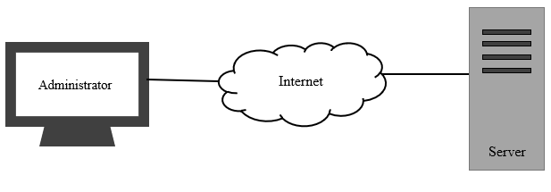

* + 1. **Software Architecture**

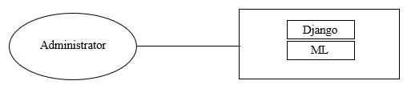

* 1. **System Interfaces**

To store and retrieve data from a Microsoft SQL database, the system will connect to a REST API created with.NET Core. Transmission Control Protocol/Internet Protocol (TCP/IP) is the default communication protocol for data transmission between the server and the client. HyperText Transfer Protocol (HTTP, default port=80) will be used for communication between the web server and the client at the highest level. At least HTML version 5 is required, as well as Java.

* + 1. **External System Interfaces**

There are no external system interfaces needed.

* 1. **User Interface Design**

Cryptocurrency Price Predictor System is a mobile-based cryptocurrency price prediction system which serves three different types of user. These users are Guest, Registered User and Admin. Based on these user types, system will include seven different interfaces:

* “Main Page” interface consisting of price prediction data display for Guest and Registered Users to see.
* “Login Page” interface consisting of username and password fields which Registered Users use to access their personalized profiles.
* “Register Page” interface consisting of email address, username, and password fields which allow Guest users to become Registered Users.
* “Password Reset Page” interface consisting of verification code and new password fields which allow Registered Users to change their existing password.
* “Coin Summary Page” interface consisting of visualization tools to display personalized time versus predicted price graph of selected cryptocurrencies for only Registered Users to see.
* “Profile Page” interface consisting of name, email and collections sections for only Registered Users to see.
  + 1. **Screen Definitions**
       1. **Main Page**

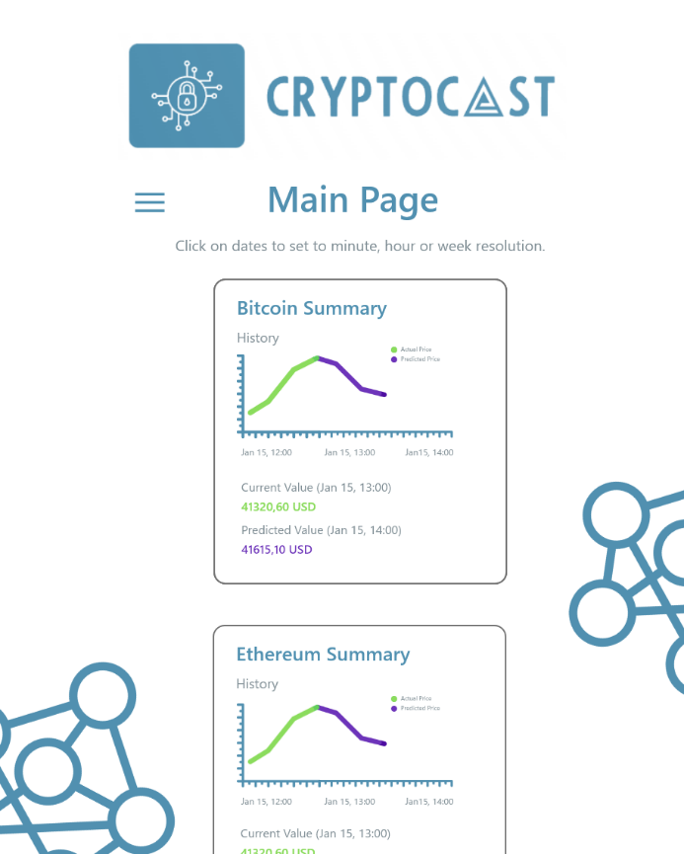

Figure 7.5.1.1: Main Page

The Cryptocurrency Price Predictor System logo "CryptoCast" is displayed at the top of the page. Guest and Registered users see this page first. There are three box designs which contain Current Value, Predicted Value and Combined Current/Predicted Value Graph for three of the most popular cryptocoins such as Bitcoin, Etherium and XRP. Each value display and graph show dates which are clickable buttons that can be set to hours, days and weeks if desired. Lastly, there is a "≡" button which the users can click to be redirected to Login, Register, Coin Summary, and Profile pages.

* + - 1. **Login Page**

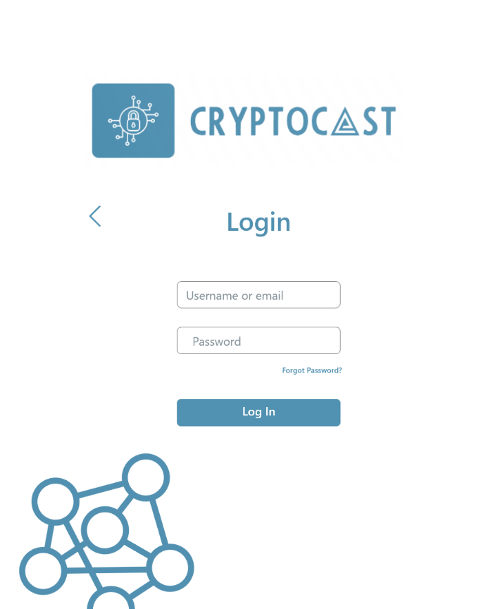

Figure 7.5.1.2: LoginPage

The Cryptocurrency Price Predictor System logo "CryptoCast" is displayed at the top of the page. Registered users can log in to Cryptocurrency Price Predictor System using a username and password. There are two text input areas for username and password and a button to log in. There are also two other buttons which the Registered user can click to be directed to Password Reset page if they forgot their password and Guest user can click to be directed to Register Page if they want to create an account. Lastly, there is a "<" button which the users can click to be directed to the Main page.

* + - 1. **Password Reset Page**

**metin içeren bir resim

Açıklama otomatik olarak oluşturuldu**

Figure 7.5.3.1: Password Reset Page

The Cryptocurrency Price Predictor System logo "CryptoCast" is displayed at the top of the page. Password Reset page is designed for Registered users who do not have access to their Profile page. There is one text input area for username or email and a button to submit input which sends a password reset link to registered email. There is also one other button which the Guest user can click to be directed to Register Page if they want to create an account. Lastly, there is a "<" button which the users can click to be directed to the Main page.

* + - 1. **Register Page**

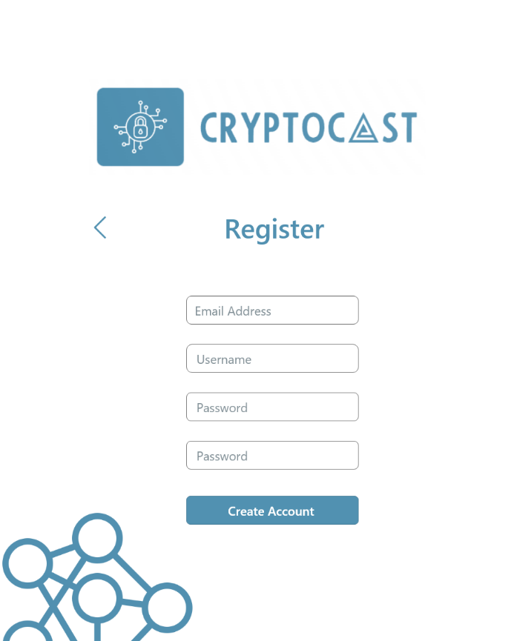

Figure 7.5.1.5: Register Page

The Cryptocurrency Price Predictor System logo "CryptoCast" is displayed at the top of the page. Guest users can create a new account to log in to Cryptocurrency Price Predictor System using an email address, username and password. There are four text input areas for email, username, and two password areas which are used for verification purposes. There is a button to create account and a "<" button which the users can click to be directed to the Main page.

* + - 1. **Profile Page**

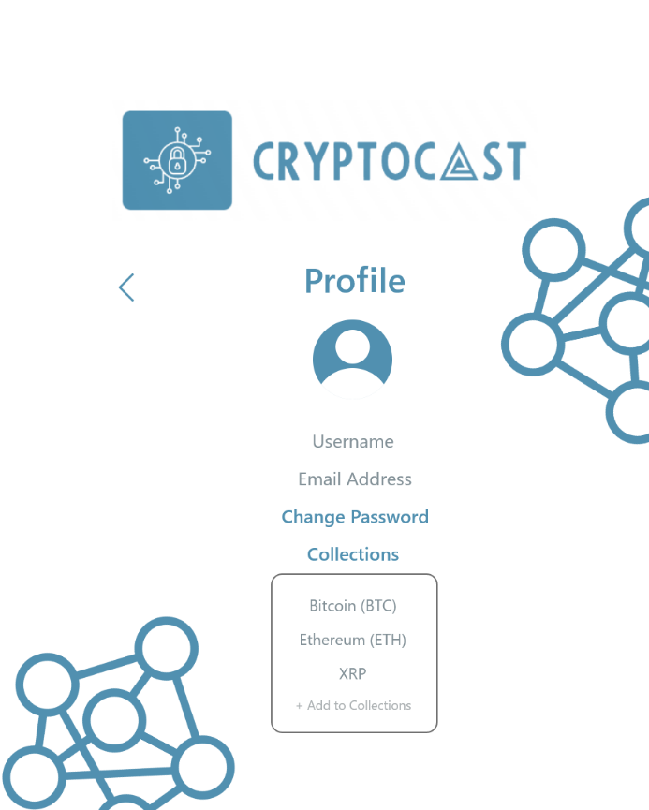

Figure 7.5.1.6: Profile Page

The Cryptocurrency Price Predictor System logo "CryptoCast" is displayed at the top of the page. Registered users can see their account details such as username and email information. There is a button to change password which the users can click to be directed to the Change Password page, a collections button which the users can click to be directed to the Collections page and a Prefferred Currency dropdown menu which the users can click to select desired currency type displayed in the application. Lastly there is a "<" button which the users can click to be directed to the Main page.

* + - 1. **Coin Summary Page**

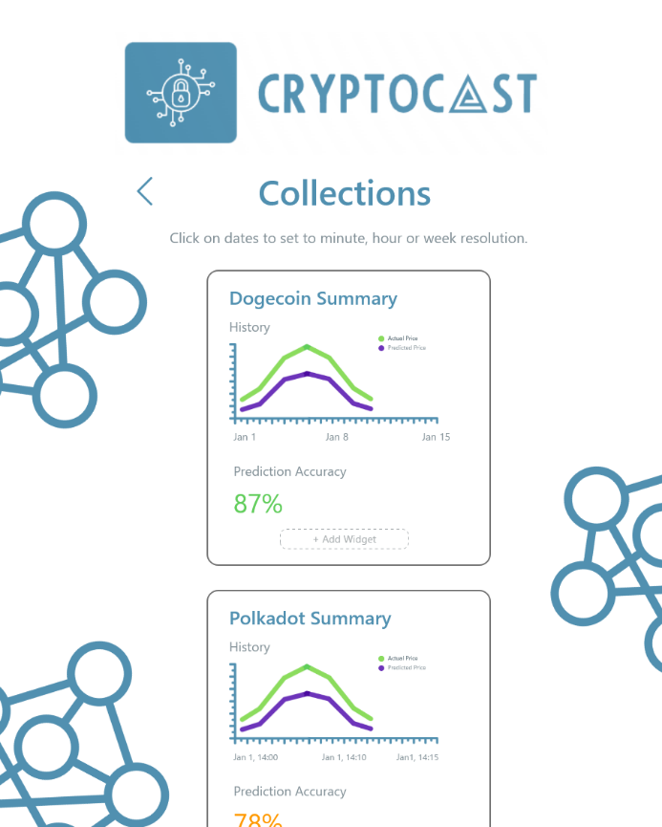

Figure 7.5.1.7: Coin Summary Page

The Cryptocurrency Price Predictor System logo "CryptoCast" is displayed at the top of the page. Coin Summary Page is only accessible to Registered users and it is very similar to Main page design in the sense that there can be a number of box designs which contain Current Value, Predicted Value and Combined Current/Predicted Value Graph for any selected cryptocurrency. Each value display and graph show dates which are clickable buttons that can be set to hours, days and weeks if desired. These box designs are also expandable, by clicking “+Add Widget” button, the user can choose to personalize their selected cryptocurrency box by adding features such as prediction accuracy or Actual vs. Predicted Price Overlay Graph. Lastly there is a "<" button which the users can click to be directed to the Main page.

* 1. **Process Design**
     1. **Use Cases**
        1. **Administrator Use Cases**

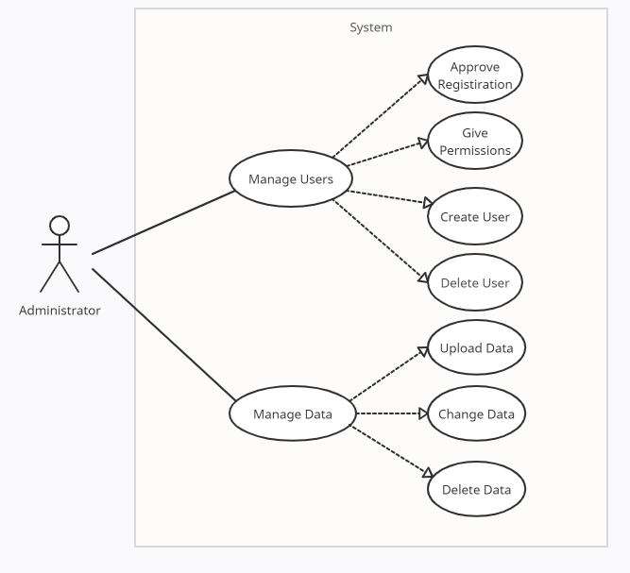

Figure 7.6.1.1: Administrator Use Case Diagram

|  |
| --- |
| Use Case Name: Manage Users |
| Use Case Number: 1 |
| Actors: Administrator |
| Overview: This use case captures the process of creating, deleting, and managing users within the system. |
| Typical Flow Description:  1. After the registration is completed, the Administrator approves the registrations through the system.  2. The Administrator can give users specific permissions and prohibitions.  3. The Administrator can delete user.  4. A confirmation e-mail is sent to user by the system. |
| Precondition:  1. The User must not use an existing account email. |
| Postcondition:  1. A confirmation e-mail is sent to user by the system. |
| Alternative Flow Description:   1. The user can not register the system. 2. The administrator can create user |

|  |
| --- |
| Use Case Name: Manage Data |
| Use Case Number: 2 |
| Actors: Administrator |
| Overview: This use case captures the process of creating, updating and deleting data within the system in order to make predictions. |
| Typical Flow Description:  1. The Administrator can upload new coin data to system.  2. The Administrator can change the existing coin data.  3. The Administrator can delete coin data.  4. The Administrator saves the changes in database |
| Precondition:  1. The data must not duplicate. |
| Postcondition:  1. The result of the data entry must affect the system behavior positively. |
| Alternative Flow Description:   1. The data is duplicated. 2. The Administrator finds and deletes the duplicate data. 3. The Administrator saves the changes in database. |

* + - 1. **User Use Cases**

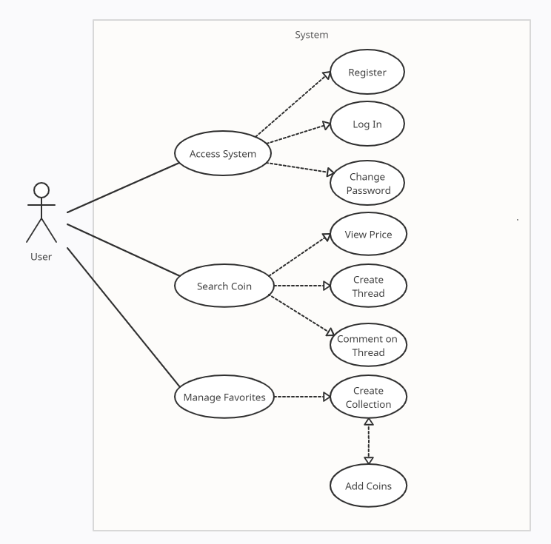

Figure 7.6.1.2: User Use Case Diagram

|  |
| --- |
| Use Case Name: Access System |
| Use Case Number: 3 |
| Actors: User |
| Overview: This use case captures the process of registering, logging in, changing password and other base actions the User can take within the system. |
| Typical Flow Description:  1. The User registers to system.  2. A confirmation email is sent to User.  3. The User can log in the system after confirming the email.  4. The User can change password. |
| Precondition:  1. The User must not use an existing account email. |
| Postcondition:  1. The User should access all pages within his/her permissions and navigate in system without any problem. |
| Alternative Flow Description:   1. The user has already had an account. 2. The can directly log in to system. |

|  |
| --- |
| Use Case Name: Search Coin |
| Use Case Number: 4 |
| Actors: User |
| Overview: This use case captures the process of searching and navigating through coin information within the system. |
| Typical Flow Description:  1.The User is in Coin Summary Page.  2. The User can see the details about the searched coin.  3. The User can view predicted price graphs about the searched coin  3. The User can jump to Coin Discussion page.  4. The User can create thread about the coin.  5. The user can comment on an existing thread. |
| Precondition:  1. The User must be registered. |
| Postcondition:  1. The User can display the information. |
| Alternative Flow Description:   1. The User searches a coin. 2. The coin information does not exist within the system. 3. The User can make a request about a new coin. |

|  |
| --- |
| Use Case Name: Manage Favorites |
| Use Case Number: 5 |
| Actors: User |
| Overview: This use case captures the process of managing the system profile according to preferences. |
| Typical Flow Description:  1. The User is in Profile page.  2. The User can create a collection.  3. The User can add coins to the created collection.  4. The System considers the coins within the collection as favorized.  5. The System makes suggestions according to coins in the collection. |
| Precondition:  1. The User must be registered. |
| Postcondition:  1. The User should be notified about the coins in the collection. |

* 1. **Database Design**

There are 3 tables in the planned database of the system. The tables are User, Reading, Location and Reading Type. Their content is explained in their respective table definition sections.

* + 1. **Table Definitions**
       1. **User**

| Field | Type | Decription |
| --- | --- | --- |
| ID | Integer | Auto generated positive integer id for table entry |
| UserName | CharField | Username of the user |
| Password | CharField | Password of the user |
| Email | EmailField | Email of the user |
| Name | CharField | First name of the user |
| Surname | CharField | Last name of the user |
| AuthorityLevel | Integer | Level of moderation authortiy of user (0 for regular user) |

* + - 1. **Message**

| Field | Type | Decription |
| --- | --- | --- |
| ID | Integer | Auto generated positive integer id for messages |
| SenderId | Integer | Message's sender id number |
| Date | DateTimeField | Messages's send date |
| Topic | CharField | Message's topic |
| Body | CharField | Body of message |

* + - 1. **Coin**

| Field | Type | Decription |
| --- | --- | --- |
| ID | Integer | Auto generated positive integer id for coins |
| Name | CharField | Coin name |
| Price | Float | Price of the coin on the specified date |
| Volume | Float | Volume of the coin on the specified date |
| Change | Float | Change of the coin on the last 24 hours (with %) |
| Date | DateTimeField | Messages's send date |

1. **Test Plan**
   1. **Introduction**
      1. **Version Control**

|  |  |  |
| --- | --- | --- |
| **Version Number** | **Description of Changes** | **Date** |
| 1.0 | First Version | May 2022 |

* + 1. **Overview**

The use case of Crypto Currency Price Predictor users namely participant and admin which has been determined in SRS document will be tested.

* + 1. **Scope**

This document encapsulates the test plan of the use cases, test design specifications and the test cases correspond to test plan.

* + 1. **Terminology**

This document encapsulates the test plan of the use cases, test design specifications and the test cases correspond to test plan.

|  |  |
| --- | --- |
| **Acronym** | **Definition** |
| GUI | Graphical User Interface (GUI) |

* 1. **Features to Be Tested**

This section lists and gives a brief description of all the major features to be tested. For each major feature there will be a Test Design Specification added at the end of this document.

* + 1. **Graphical User Interface (GUI)**

In this project, graphical user interface components are used. The GUI has three major parts. Login/Register interfaces, crypto currencys’ values and movements and finally prediction display interfaces.

* + 1. **Price Change Prediction Process**

In this project, machine learning algorithms shall be used for price change direction process. Time and Accuracy performance evaluation metrics described at the end of Test Design Specification.

* 1. **Item Pass/Fail Criteria**
     1. **Exit Criteria**
* 100% of the test cases are executed
* 100% of the test cases passed
* All High and Medium Priority test cases passed
  1. **Test Design Specifications**
     1. **Graphical User Interface (GUI)**
        1. **Register Page**

Register to the system by entering Username, Mail and password.

* + - 1. **Login Page**

Login to the system with Username or Email and password. Do you have any account? redirect the user who is not a member of my site before to the regisater page.

* + - 1. **Forgot Password**

A password with at least 8 characters, one uppercase, one lowercase, at least 1 symbol and number is determined. There is a confirmation box for users who want to learn their daily rise or fall forecasts by e-mail.

* + - 1. **Crypto Currency Graph**

Find out the open close high low values by moving your mouse over the green or red candles.

* + - 1. **Predicted Stability**

Find the daily up/down predict values by hovering over the green/red arrow with your mouse.

* + - 1. **Crypto Currency List**

List of crypto currencies and their values. It is also button connect to Crypto Currency Graph as seen in 1.4.

* + - 1. **Test Cases**

List of all related test cases for given features are presented here.

|  |  |  |  |
| --- | --- | --- | --- |
| **TC ID** | **Requirements** | **Priority** | **Scenario Description** |
| 3.1.1 |  | M | Select the “Sign In ” option. The button redirects the user to the “Login” page. |
| 3.1.2 |  | M | Select the “Log In ” option. The button redirects the user to the “Index” page. |
| 3.1.2 |  | M | Select the “Do you have any account? ” option. The button redirects the user to the “Register” page. |
| 3.1.3 |  | L | Select the “Forgot Password ” option to change password. |
| 3.1.3 |  | M | Select the “I want to receive notification mail. ” option to receive daily notification. |
| 3.1.4 |  | H | Find out the OHLC values by moving your mouse over the green and red candles. |
| 3.1.5 |  | H | Find the daily up/down values by hovering over the green/red arrow with your mouse. |
| 3.1.6 |  | M | List of crypto currencies and their values. It is also button connect to Crypto Currency Graph as seen in 1.4. |

* + 1. **Price Change Prediction Process**
       1. **Performance Evaluation Accuracy Metric**

System tests the accuracy value for price change prediction accuracy with total number of two correct predictions (TP + TN) divided by the total number of a dataset (P + N).

* + - 1. **Performance Evaluation Time Metric**

Model shall be trained everyday with updated windows at 3:00 AM Istanbul (GMT+03). Training shall be completed within 15 minutes.

* + - 1. **Test Cases**

List of all related test cases for given features are presented here.

|  |  |  |  |
| --- | --- | --- | --- |
| **TC ID** | **Requirements** | **Priority** | **Scenario Description** |
| 4.2.1 |  | M | After the prediction process accuracy value is computed. |
| 4.2.2 |  | H | Prediction process runs at local host at exactly 3:00 AM Istanbul (GMT+03). |
| 4.2.2 |  | L | Recorded prediction process runtime is recorded to be under 15 minutes. |

* 1. **Detailed Test Cases**

|  |  |
| --- | --- |
| **ID** | **3.1.1** |
| Purpose | Register into the system. |
| Requirements | - |
| Priority | M |
| Estimated Time Needed | 1 min |
| Dependency | A valid user account. |
| Setup | Register into system. |
| Procedure | Enter valid username, mail and password. |
| Clean Up | - |

|  |  |
| --- | --- |
| **ID** | **3.1.2** |
| Purpose | Login into the system. |
| Requirements | - |
| Priority | M |
| Estimated Time Needed | 1 min |
| Dependency | User account should exist. |
| Setup | Sign into system. |
| Procedure | Enter valid and matched username, e-mail and password. |
| Clean Up | - |

|  |  |
| --- | --- |
| **ID** | **3.1.2** |
| Purpose | Login into the system. |
| Requirements | - |
| Priority | M |
| Estimated Time Needed | 1 min |
| Dependency | User account should exist. |
| Setup | Sign into system. |
| Procedure | Enter valid and matched username, e-mail and password. |
| Clean Up | - |

|  |  |
| --- | --- |
| **ID** | **3.1.3** |
| Purpose | Reset password. |
| Requirements | - |
| Priority | L |
| Estimated Time Needed | 1 min |
| Dependency | E-mail or username entered by user should exist and valid. |
| Setup | Reset password. |
| Procedure | User will fill “e-mail or username” part and click reset password button. |
| Clean Up | - |

|  |  |
| --- | --- |
| **ID** | **3.1.4** |
| Purpose | Display crypto currencies’ OHCL values with candles. |
| Requirements | - |
| Priority | H |
| Estimated Time Needed | 1 min |
| Dependency | - |
| Setup | Display OHCL values. |
| Procedure | Application should have internet connection. |
| Clean Up | - |

|  |  |
| --- | --- |
| **ID** | **3.1.5** |
| Purpose | Display prediction arrows. |
| Requirements | - |
| Priority | H |
| Estimated Time Needed | 1 min |
| Dependency | Application should have internet connection. |
| Setup | Display predict result with green and red arrows. |
| Procedure | - |
| Clean Up | - |

|  |  |
| --- | --- |
| **ID** | **3.1.6** |
| Purpose | List of crypto currencies. |
| Requirements | - |
| Priority | M |
| Estimated Time Needed | 1 min |
| Dependency | Application should have internet connection. |
| Setup | Display crypto currencies’ values and dates. |
| Procedure | - |
| Clean Up | - |

|  |  |
| --- | --- |
| **ID** | **4.1.1** |
| Purpose | Compute Accuracy. |
| Requirements | - |
| Priority | M |
| Estimated Time Needed | 10 seconds |
| Dependency | Model should be trained. |
| Setup | Train model and calculate accuracy by dividing (TP + TN) by the total number of a dataset (P + N) |
| Procedure | - |
| Clean Up | - |

|  |  |
| --- | --- |
| **ID** | **4.1.2** |
| Purpose | Periodically train model. |
| Requirements | - |
| Priority | H |
| Estimated Time Needed | 24 Hours |
| Dependency | Application should have internet connection. |
| Setup | Prediction process runs at local host at exactly 3:00 AM Istanbul (GMT+03) every day. |
| Procedure | - |
| Clean Up | - |

|  |  |
| --- | --- |
| **ID** | **4.1.3** |
| Purpose | Check prediction process runtime. |
| Requirements | - |
| Priority | L |
| Estimated Time Needed | 30 seconds |
| Dependency | Model should be trained. |
| Setup | Model traning and prediction is obtained at 3:00 AM. |
| Procedure | - |
| Clean Up | - |

|  |  |  |  |
| --- | --- | --- | --- |
| **ID** | **Priority** | **Date Run** | **Explanation** |
| 3.1.1 | M | 25.05.2022 | Pass |
| 3.1.2 | M | 25.05.2022 | Pass |
| 3.1.3 | L | 25.05.2022 | Pass |
| 3.1.4 | H | 25.05.2022 | Pass |
| 3.1.5 | H | 25.05.2022 | Pass |
| 3.1.6 | M | 25.05.2022 | Pass |
| 3.2.1 | M | 25.05.2022 | Pass |
| 3.2.2 | H | 25.05.2022 | Pass |
| 3.2.3 | L | 25.05.2022 | Pass |
| 4.1.1 | M | 25.05.2022 | Pass |
| 4.1.2 | H | 24.05.2022 | Pass |
| 4.1.3 | L | 25.05.2022 | Pass |

* 1. **Summary of Test Result**

|  |  |  |  |
| --- | --- | --- | --- |
| **Priority** | **Numbers of TC’s** | **Executed** | **Passed** |
| H | 3 | 3 | 3 |
| M | 4 | 4 | 4 |

1. **User Manual**

Two pages are presented below.

* 1. **User Manual Crypto Currency List Page**

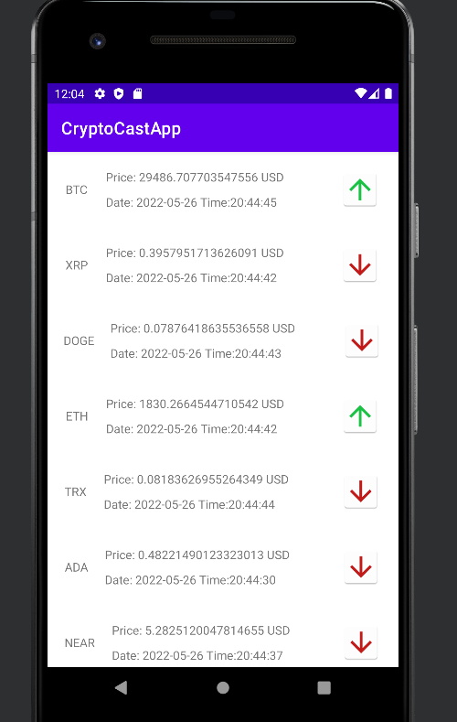

Figure 9.1.1: User Manual Crypto Currency List Page

Users can see all coins;

* Name of crypto currency
* Date
* Current Price
* Our ML based prediction

User can touch on any crypto currency and see charts.

* 1. **Crypto Currency Chart Page**

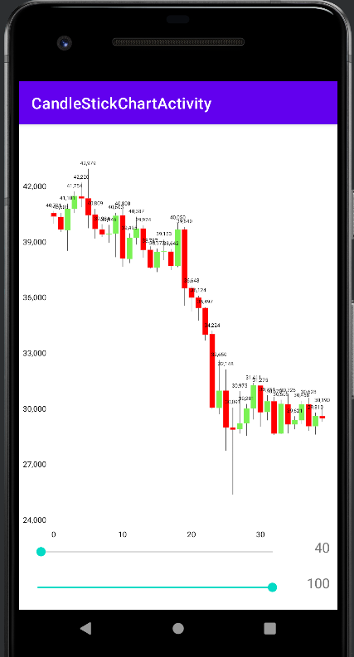

Figure 9.1.2: User Manual Crypto Currency List Page

Users can see candle data day by day; user can see next day price change predictions.

1. **Installation Manual**
   1. **Installation of API and Server Part**
2. Install Visual Studio 2022 or higher version for maintain and update API application.
3. Install .NET6 Run Time
4. Hosting Bundle For .NET6
5. Install Windows Server 2012 or Kestrel(for Linux)
6. Internet Information Service IIS(for Windows)
7. Install MsSQL(optional)
   1. **Preparation of Online API on IIS**
8. Open IIS, in Connections part which on left In IIS expand “Connections” and “Application Pools” and Create a new Application Pool.
9. Create Web Pages folder under the Connections tab.
10. Create a Web Page under Web Pages folder
11. Right click on web page you created before and click Explore
12. Paste documents you will take from API with using Visual Studio 2022 Publish option. We will explain that in after step.
    1. **API Installation**
13. You should open API project in Visual Studio 2022
14. open “appsettings.json”
15. Enter information like;

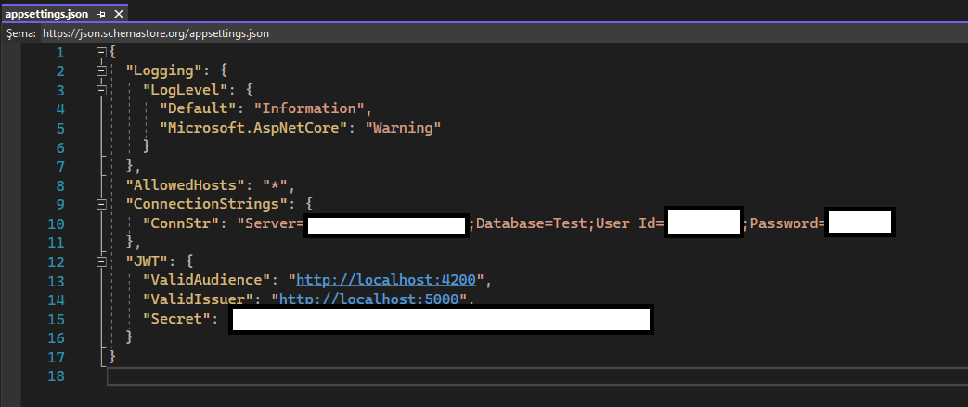

1. This code has a code-first data base, so you don’t need any data base in server computer.
2. After DB integration you should publish the API. Right click on solution which has a name the project in solution explorer.
3. Click the “Publish…” button and copy all things from the opened window.
   1. **ML Model Installation**

* Download Python 3.10 https://www.python.org/downloads/
* Download pip for Windows
* Open Command Prompt: ** curl https://bootstrap.pypa.io/get-pip.py -o get-pip.py python get-pip.py
* To run PIP from any location, you need to add it to Windows environment variables to avoid getting the "not on PATH" error. To do so, follow the steps outlined below:

1. Open the System and Security window by searching for it in the Control Plane.
2. Navigate to System settings.

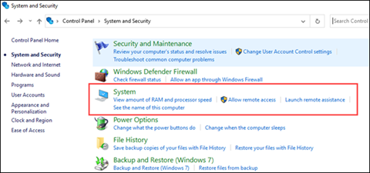

1. Then, select Advanced system settings.

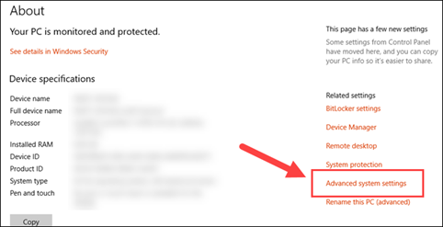

1. Open the Environment Variables and double-click on the Path variable in the System Variables.

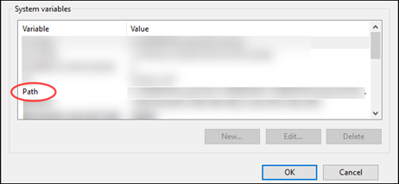

1. Next, select New and add the directory where you installed PIP.
2. Click OK to save the changes.
   * 1. **Install Libraries**

* pip install numpy
* pip install matplotlib
* pip install seaborn
* pip install pandas
* pip install scikit-learn
* pip install yfinance

To download Ta-lib library for indicators:

1. Go to the following page: https://www.lfd.uci.edu/~gohlke/pythonlibs/#ta-lib • Choose your version of python: cp35 means Python 3.5 (64 bit for example) (In our case TA_Lib 0.4.24 cp310 cp310 win_amd64.whl)
2. Download the package and unzip in ...\Python\Python35\Scripts
3. Go on cmd and in the same directory (...\Python\Python35\Scripts) execute the following command: ** pip install TA_Lib-0.4.17-cp35-cp35m-win_amd64.whl
   * 1. **Run The Script**

* Save the script under the same directory you install the libraries (for ex C:\User\uname)
* Open command prompt and enter:
* python run.py

1. **References**

[1] Chen, Narwal & Schultz. Predicting Price Changes in Ethereum. Stanford University.

[2] Phaladisailoed, T., & Numnonda, T. (2018, July). Machine learning models comparison for bitcoin price prediction. In 2018 10th International Conference on Information Technology and Electrical Engineering (ICITEE) (pp. 506-511). IEEE.

[3] Spilak, Bruno. (2018). Deep Neural Networks for Cryptocurrencies Price prediction.

[4] FORECASTING BITCOIN PRICES, João Filipe Batista Mendes. FORECASTING BITCOIN PRICES. Repositório do ISCTE-IUL. <https://repositorio.iscte-iul.pt/bitstream/10071/19724/1/Master_Joao_Batista_Mendes.pdf>

[5] Flutter FAQ URL:<https://github.com/hemanthrajv/fludex> Accessed March 03, 2018

[6] Allocation Profile URL:<https://dart-lang.github.io/observatory/allocation-profile.html> Accessed September 03, 2017

[6] What’s Revolutionary about Flutter URL:<https://hackernoon.com/whats-revolutionary-about-flutter-946915b09514> Accessed September 03, 2017