

*Project Report submitted to*

*The Departmant of Computer Engineering of Çankaya University*

*in fullfillment of requirements for*

*CENG 407 Innovative System Design and Development I*

CENG-407 PROEJECT REPORT FOR

#### ThinCloud Cloud Computing Client Project Mobile Application Stage

*By*

|  |  |
| --- | --- |
| 201711035 | Betül HAYKIR |
| 201711020 | Batuhan DEMİRBAĞ |
| 201711408 | Cem GÜVENBAŞ |
| 201711070 | Burak YAVUZ |

*Advisor: Prof. Dr. Ahmet COŞAR*

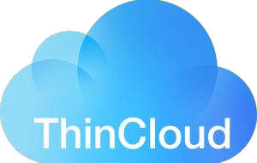

*Çankaya University*

*Department of Computer Engineering 2021 FALL*

TABLE OF CONTENTS

Table of Contents 2

Abstract 3

Öz 3

1. INTRODUCTION 4
2. LITERATURE REVIEW 5
   1. MAIN FINDINGS 5
   2. THE PLATFORMS SIMILAR TO THINCLOUD PROJECT 9
3. SOFTWARE REQUIREMENTS SPECIFICATIONS 11
   1. INTRODUCTION 11
   2. OVERALL DESCRIPTION 12
   3. REQIREMENTS SPECIFICATIONS 14
   4. SOFTWARE SYSTEM ATTRIBUTES 19
4. SOFTWARE DESIGN DESCRIPTION 21
   1. INTRODUCTION 21
   2. ARCHITECTURAL DESIGN 22
   3. REQUIREMENTS MATRIX 33
5. CONCLUSION 34
6. REFERENCES 35
7. TASK DISTRUBUTION 36

## Abstract

*ThinCloud, as the next cloud-connected and integrated system of the existing 'Thin-Client' and 'Zero-Client' systems, is an advanced step and project in this technology. For this purpose, it is essential for our country to have quality and performance-oriented software, both as the only platform and project in this field, and especially as the only project on virtualization infrastructures (Hypervisors). ThinCloud Cloud Computing Client Project gathers computer systems (Desktop, Mobile, Laptop) that can exist in an organization in a single cloud-based center. It enables organizations to access the entire information architecture over the Remote Data Center with just a network client card (ThinCloud) without purchasing a computer and server system. It aims to manage all its operations through this system. This document details the Mobile Application Phase of the ThinCloud Cloud Computing Client Project. With this project, organizations will be able to minimize their IT expenditures and IT systems maintenance and management costs.*

## Öz

*ThinCloud, sektörde var olan ‘Thin-Client’ ve ‘Zero-Client’ sistemlerin bir sonraki bulut ile bağlı ve bütünleşik sistemi olarak, bu teknoloji içerisinde gelişmiş bir adım ve proje olarak karşımıza çıkmaktadır. Bu amaç ile, hem ülkemizin bu alandaki tek platformu ve projesi, hem de özellikle sanallaştırma altyapıları (Hypervisors) konusunda tek proje olarak, kalite ve performans odaklı yazılımlara sahip olabilmesi elzemdir. ThinCloud Bulut Bilişim İstemcisi Projesi, bir kuruluşta var olabilecek bilgisayar sistemlerini (Desktop, Mobile, Laptop) bulut tabanlı tek bir merkezde merkezileştirerek; kuruluşların bir bilgisayar ve server sistemi satın almadan, sadece bir ağ istemci devre kartı (ThinCloud) ile tüm bilişim mimarisine uzak veri merkezi üzerinden erişebilmesini ve tüm operasyonlarını bu sistem üzerinden yönetebilmesini amaçlar. Bu belgede, ThinCloud Bulut Bilişim İstemcisi Projesi'nin Mobil Uygulama Basamağı’nın detaylarına yer verilmektedir. Bu proje kuruluşların, bilişim harcamasını ve bilişim sistemleri bakım ve yönetim masraflarını minimuma çekmesini sağlayacaktır.*

# INTRODUCTION

Today, corporate organizations and small-medium-sized businesses actively use computer systems. Although these systems are sometimes only desktop,laptop computer systemsor phones and tablets, many organizations have started to install server systems in-house for hosting websites, configuring mail systems, common file sharing and common business tracking platforms. It is difficult and expensive for corporate organizations to set up, operate and maintain these information systems on their own, even now. Especially in Turkey, which is behind the world in system engineering, system installation and maintenance technicians, such systems are still expensive, even though they are perceived as a vital necessity. New businesses allocate high financial resources to implement these systems, which are mandatory for entering the world digital order and market, and they have difficulty in allocating these resources at the first entry into the business. It is possible that the difficulties and costs will increase with the development of technology and the increase in the need for technology.

ThinCloud Cloud Computing Client consolidates all computer systems in an organization into a single cloud-based center. It enables organizations to access the entire information architecture over a remote data center with just a network client board (ThinCloud). Thus, it allows to manage all computing operations over the cloud system without purchasing a computer and server system. It removes hardware dependency, prevents cable clutter and completely .ThinCloud Cloud Computing Client with a size of 7-8 cm is introduced as the World's Smallest Cloud Computing Client. This project, which provides the opportunity to work over the internet, works with 'cloud' technology as in the telephone sector. With the transfer of the world's smallest cloud computing client to mobile, the ease of use will increase even more. Users will be able to access the entire information architecture with a simple mobile application via the cloud-based remote data center, and thus it will be possible to use them from devices such as phones and tablets.

1. **LITERATURE REVIEW**

# MAIN FINDINGS

## Traditional Computing Technologies

Traditionally, organizations have implemented applications by installing software for the application on one or more physical servers. In this traditional model, servers are considered as a single, functional unit that encompasses the hardware, operating system, application, utilities, and storage for the application. When the capacity of the server is exceeded, additional hardware or storage must be added to the physical machine. It is possible to set up clusters of servers, all of which are configured exactly the same, to ensure greater fault tolerance. This helps protect the organization from the undesirable consequences of a server hardware failure.

## Virtual Computing Technologies (Hypervisor or Virtual Machine Manager)

In a virtual server model, a different type of operating system runs on the physical hardware. This operating system is specialized and designed to run other operating systems as applications.By doing this, the traditional server environment can be encapsulated in an environment which provides a layer of isolation from the underlying hardware.

A hypervisor can run multiple operating system environments and their associated applications in individual virtual machines, each of which runs on a single physical machine. Each virtual machine is presented with an environmental context that makes it appear as if they were running natively as the only machine on the physical hardware. In most virtual server implementations, several virtual machines are assigned to a single physical server based on the assumption that none of the virtual machines will need the entire computing power of the physical server. It is the job of the hypervisor to simulate, emulate, or enable all of the functionality necessary for the virtual machine to operate normally and with all of its functionality.

## Cloud Computing Technologies

It is used by large organizations such as companies, universities. Using this technology reduces the load on personal computers. The word cloud refers to the location where the files are provided. All operations and storages are provided by the cloud system. Hosting all our data on the internet in cloud storage on the virtual machine enables us to access this data with any device connected to the internet.

### Mobile Cloud Computing Technologies

Mobile cloud computing uses cloud computing to deliver applications to mobile devices. These mobile apps can be deployed remotely using speed and flexibility and development tools. Mobile cloud applications can be built or revised quickly using cloud services. They can be delivered to many different devices with different operating systems, computing tasks, and data storage. Thus, users can access applications that could not otherwise be supported.

## Thick-Client

A thick client is a type of client device in client-server architecture that has most hardware resources on board to perform computation operations, run applications and perform other functions independently. Although a thick client can perform most operations, it still needs to be connected to the primary server to download programs and data, and to update the operating system.

Thick clients are generally implemented in computing environments when the primary server has low network speeds, limited computing and storage capacity to facilitate client machines, and/or there is a need to work offline.

## Thin-Client

Thin Client technology is widely regarded as an effective virtual desktop computing model. This is because it is a secure device where programs, applications, memory, and sensitive information are stored securely in a data center instead of the device itself. As a result, Thin Clients are viable alternatives to regular PCs for businesses that demand flexibility, energy efficiency, improved data security, and longer IT infrastructure lifespan. The advantages of a Thin Client are

* Centralized IT
* Easy manageability
* Enhanced security
* Improved productivity
* Cost savings
* Remote Work Solution

Thin clients can work within a shared terminal service, desktop virtualization or within a browser- based approach. In a shared terminal service, all clients share a server-based operating system and applications. With desktop virtualization, each desktop is a virtual machine that is partitioned form a central server. This way of creating thin clients will have the central server partition resources to the appropriate clients. Even though the operating system and applications are not shared resources in this instance, they are still stored in the central server.The browser-based approach is different from a normal thin client system in that the client will have function execute from within a web browser, instead of on a central server. Data processing is done on the thin client. This form focuses on retrieving software and data that is held on a network.

## Zero-Client

Zero client, also known as ultrathin client, is a server-based computing model in which the end user's computing device has no local storage. A zero client can be contrasted with a thin client, which retains the operating system and each device's specific configuration settings in flash memory.

A typical zero client product is a small box that serves to connect a keyboard, mouse, monitor and Ethernet connection to a remote server. The server, which hosts the client's operating system (OS) and software applications, can be accessed wirelessly or with cable. Zero clients are often used in a virtual desktop infrastructure (VDI) environment. This makes them ideal for remote work situations or distributed work environments.

Zero clients don't use an operating system and instead use firmware to connect to a remote device. No data is stored on zero clients, because there is no local storage. Therefore all applications are provisioned and managed on a server in a remote data center, and served to the zero client device using its protocol.

## Mobile Developement

Mobile app development is the act or process by which a mobile app is developed for mobile devices, such as personal digital assistants, enterprise digital assistants or mobile phones. These software applications are designed to run on mobile devices, such as a smartphone or tablet computer.Cross- Platform development is one of the sub-branches of mobile app development.

### What does Cross-platform mobile app developement mean?

*Cross-platform development is the practice of developing software products or services for multiple platforms or software environments.Cross-platform development aims at creating a single application that runs identically on several platforms. It uses platform-agnostic technologies such as HTML and CSS and helps businesses cover many end devices at lower costs.*

*The idea of cross-platform development is that a software application or product should work well in more than one specific digital habitat. This capability is typically pursued in order to sell software for more than one proprietary operating system, such as to accommodate use on both Microsoft and Apple platforms. With the development of mobile devices and other kinds of platforms, as well as the proliferation of open-source technologies like Linux, more kinds of cross-platform development have emerged.*

*Some of the fundamental strategies for cross-platform development include compiling different versions of the same program for different operating systems, or in other cases, the use of sub-tree files to apply or fit the product to different operating systems. Another major approach is to make the program abstract at certain levels in order to accommodate different software environments. Software like this can be said to be "platform agnostic" in that it doesn't value or support one platform over another. Developers can also use application programming interfaces (APIs) to adjust a piece of software to a specific platform.*

### Some Elements Used in Mobile Application Development

#### Figma

Figma is a cloud-based design and prototyping tool for digital projects. It is made so that users can work on projects collaboratively and almost anywhere. You can design, prototype and transfer developers with one tool.Figma works on any operating system running a web browser and is the only design tool that works on every platform. So, when using Mac or Windows operating system, there is no problem sharing files or switching to different platforms as it is cloud-based.

#### Flutter

Flutter is a free and open source mobile UI framework that you can use to develop mobile, web and desktop apps created by Google and released in May 2017. Flutter is a cross platform, you can develop both IOS and Android based applications using the same infrastructure. Flutter consists of two main parts;

* SDK (Software Development Kit): It offers many tools to help you develop your applications more easily. The SDK allows you to compile the code you wrote for both IOS and Android.
* Framework (Many UIs and libraries): It offers many UI components (buttons, text inputs, etc.) used while developing software. You can customize these components according to your projects. A programming language called Dart is used to develop software with Flutter. The language was created by Google in October 2011, and has continued on its way by improving itself every year.

#### 2.1.7.2.3.1 Dart

Dart is an open source programming language first developed by Google and later standardized by Ecma. Thanks to the Google-supported Flutter SDK, you can now develop both iOS and Android applications using the Dart language. Apart from mobile applications, you can develop applications for web, server and IoT devices with Dart programming language. The Dart language is class-based, single-inherited, in short, object-oriented, similar to the code sequence of the C programming language. It can be translated into JavaScript or the native language on the system it works on. It supports Interfaces, Abstracts, generic type and optional types.

#### 2.1.7.2.4 React

React is a library developed by Facebook in 2011 for creating user interfaces. It was born as a solution to the developers' need to write compelling and long Javascript code every time. It is used to create SPA (Single Page Application).

## THE PLATFORMS SIMILAR TO THINCLOUD PROJECT

* + 1. **Vagon**

Vagon is a site that provides cloud-based supercomputer service.Vagon is your personal high- performance computer on the cloud. You can use the program you want from any device by using the Vagon. Vagon utilizes the power of cloud computers for your creative tasks. No technical experience is required.

## Digital Ocean

DigitalOcean is one of the world's largest cloud server providers, positioning itself as a cloud-based infrastructure provider, meeting many needs such as development, version control and test environments.

## Amazon Web Services

Amazon Web Services (AWS) is a subsidiary of Amazon that provides on-demand cloud computing platforms and application programming interfaces. Established in July 2002, it provides cloud computing web services, a variety of core intangible technical infrastructure and distributed computing building blocks and tools to individuals, companies, and governments on a pay-as-you-go basis. The virtual computer version of AWS emulates many of the attributes of a real computer, including hardware central processing units and graphics processing units for rendering.

## Microsoft Azure

Azure Services Platform is an application platform in the cloud that enables applications to be hosted and run in Microsoft data centers. It provides a cloud operating system called Windows Azure that serves as a runtime for applications, and provides a set of services that enable the development, management, and hosting of indoor land applications.All Azure Services and applications are built using Windows Azure in addition to running them.

## Vultr

Vultr is a specialist cloud hosting provider that stands out for its high performance service and easy scalability. It offers everything from cloud computing and memory block to bare metal and dedicated servers. You can choose from 16 different server locations around the world.Founded in 2014, Vultr has continuously improved itself over the past five years. It currently works with a team of 50 engineers and developers and serves over 100,000 customers from 150 countries with 22 million instances of cloud servers.

## Oracle Cloud

Oracle Cloud is a cloud computing service offered by Oracle Corporation providing servers, storage, network, applications and services through a global network of Oracle Corporation managed data centers. The company allows these services to be provisioned on demand over the Internet. Oracle Cloud provides Infrastructure as a Service (IaaS), Platform as a Service (PaaS), Software as a Service (SaaS), and Data as a Service (DaaS). These services are used to build, deploy, integrate, and extend applications in the cloud. This platform supports numerous open standards (SQL, HTML5, REST, etc.), open-source applications (Kubernetes, Spark, Hadoop, Kafka, MySQL, Terraform, etc.), and a variety of programming languages, databases, tools, and frameworks including Oracle-specific, Open Source, and third-party software and systems.

## IBM Cloud

IBM offers three hardware platforms for cloud computing.These platforms offer built-in support for virtualization. For virtualization IBM offers IBM Websphere application infrastructure that supports programming models and open standards for virtualization.

The management layer of the IBM cloud framework includes IBM Tivoli middleware.Management tools provide capabilities to regulate images with automated provisioning and de-provisioning, monitor operations and meter usage while tracking costs and allocating billing. The last layer of the framework provides integrated workload tools.Workloads for cloud computing are services or instances of code that can be executed to meet specific business needs. IBM offers tools for cloud based collaboration, development and test, application development, analytics, business-to-business integration, and security.

## Google Cloud

Google Cloud is a cloud information platform where Google offers the server infrastructure services used by sites such as Google search engine and Youtube to the end user. Various types of software, from simple websites to complex applications, can be developed over Google Cloud. Google Cloud Platform is part of Google's enterprise solutions suite that works with and offers cloud-based services along with server development tools. Examples include server and computing, cloud storage, data storage, translation APIs, and prediction APIs.

# SOFTWARE REQUIREMENTS SPECIFICATION

## INTRODUCTION

* + 1. **Purpose of Project**

The purpose of the Software Requirements Document is to determine the requirements of the outputs targeted by the ThinCloud Project, to understand and make sense of the requirements in the best way, and to determine the studies and strategies that will ensure that appropriate actions can be taken. these requirements.

Within the ThinCloud ecosystem, there are software that serve many different purposes. These are software that helps ecosystem users to individually provide the operations they need. In order to provide these software and the relationships between them in the best way, the software requirements must be determined and defined.

The mobile application step of the Thincloud system, the software running on the ThinCloud Client, the Cloud Over Management Platform Software that provides ThinCloud management, the ThinCloud Mobile Interface Software that allows the ThinClouds to be managed independently of the device, and the ThinCloud, which allows this process to be done on local computers and to serve the systems on independent or local servers Hypervisor systems include ThinCloud HV Software. These software are systems that allow users to run and manage computer architecture and processes directly from the cloud.For this reason, it is necessary to plan and determine the requirements for each software separately and take action according to these requirements.

## Scope of Project

The scope of this document is to explain the requirements the UI design and software requirements in my mobile app development step of the Thincloud project, to collect the necessary information in this sense, to compile this information and to determine the requirements.

Performance, clean coding, fast interaction and security factors lie behind the software requirements and the ThinCloud ecosystem to interact with the user in the most efficient way. Within these elements, software requirement analysis was defined and studies were carried out in this context.

## Glossary

Client: The client takes part on the client side in information transfers provided by the server or host. If it is explained with an example scenario, when the client tries to log in to a website, it reaches the main web server and requests information from this server.

Interface: Interface is the borderline software and/or hardware unit that allows two systems to interact with each other or a user with a system.

SDD: A software design document is a representation of a software design that is to be used for recording design information, addressing various design concerns, and communicating that information to the design’s stakeholders.

Server: Servers actually; These are digital systems where software, programs are installed and run, allowing multiple users to share data. Servers, which are much stronger than a normal computer, are configured to manage multiple tasks simultaneously and faster.

## References

Reference is made to “IEEE Std 830-1998: IEEE Recommended Practice for Software

Requirements Specifications” for this document template.

### Overview of the Document

This document is the requirements specification document in the mobile application stage of the “ThinCloud Cloud Computing Client” project. The document has been prepared in order to indicate what will be done in the system, as a reflection of the requirements determination discussions of the system and the software. The general structure of the document is divided into sections and explained below.

Part 1 – Introduction: The introduction of the system and the document is explained.

Part 2 – Overview: General factors affecting the software product and its requirements are defined under the headings of product overview, product functions, user features, constraints, assumptions and dependencies.

Part 3 – Special Requirements: In this section, the features desired in the system to be developed are explained by dividing them into sections. Within the system are the capabilities of the system (requirements that are functional) and requirements that are not functional but must be met.

# OVERALL DESCRIPTION

ThinCloud, as the next cloud-connected and integrated system of the existing 'Thin-Client' and 'Zero-Client' systems, is an advanced step and project in this technology. For this purpose, it is essential for our country to have quality and performance-oriented software, both as the only platform and project in this field, and especially as the only project on virtualization infrastructures (Hypervisors). ThinCloud Cloud Computing Client Project gathers computer systems (Desktop, Mobile, Laptop) that can exist in an organization in a single cloud-based center. It enables organizations to access the entire information architecture over the Remote Data Center with just a network client card (ThinCloud) without purchasing a computer and server system. It aims to manage all its operations through this system. This document details the Mobile Application Phase of the ThinCloud Cloud Computing Client Project. With this project, organizations will be able to minimize their IT expenditures and IT systems maintenance and management costs.

## Product Perspective

ThinCloud centralizes the computer systems (Desktop, Mobile, Laptop) that may exist in an organization in a single cloud-based center, enabling organizations to access the entire information architecture via a remote data center with just a network client board (ThinCloud) without purchasing a computer and server system. and it aims to manage all its operations through this system. This will enable organizations to minimize their IT expenditure and IT systems maintenance and management costs.

As a group, we take part in the design of the mobile part of this project. The mobile application will work on mobile Android and IOS devices. The mobile application will have many tabs such as Login, Register, Create An Account, Settings. It will also contain many functional features such as information about the computers that the person is connected to, adding a new computer, payment information. When users run the application, they can use the functionalities the device. All information will be kept on database which can be accessed by users with or without login.

### Development Methodology

It is planned to use the Waterfall software development model in the development process of this project. The Waterfall Model is the first Process Model introduced. It is also called the linear sequential lifecycle model. It is very simple to understand and use. In a waterfall model, each phase must be completed before the next phase can begin, and there is no overlap in phases. The waterfall model is the oldest software development lifecycle approach used for software development. The waterfall model shows the software development process in a linear sequential flow. This means that any stage in the development process will only begin when the previous stage is completed. In this waterfall model, the phases do not overlap. The main advantages of the Waterfall Model can be summarized as follows; Simple planning and control possibilities, a simple and understandable model, clear demarcation of stages. Considering these facts, the waterfall Model is the most suitable methodology for the project. Figure 1 shows the steps of the waterfall development modeL.

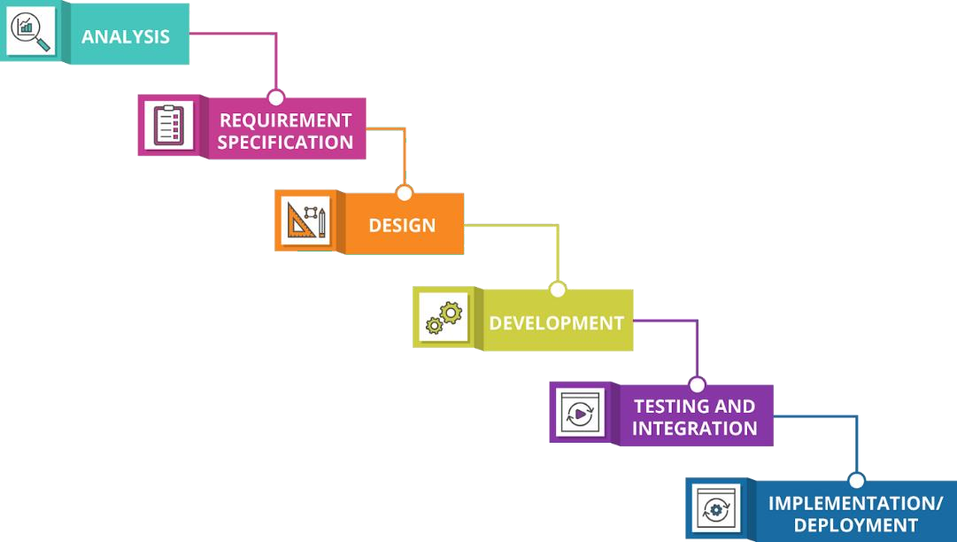

Figure 1 Waterfall Model

### User Characteristic

* + - 1. **Users**
* ThinCloud users must have internet access and have any mobile device to use the application.
* ThinCloud users should be entry, intermediate, upper and professional level users who have mobile device usage skills and have received adequate training in this field, are familiar with mobile device usage and working principles, have sufficient level of mobile device settings and features.
  + - 1. **Admin**
* Admins must have internet access and have any mobile device to use the application.
* The admin must know how use a ThinCloud Mobile Application.

## REQUIREMENTS SPECIFICATIONS

### Functional Requirements

* + - 1. **Use Case Diagram**

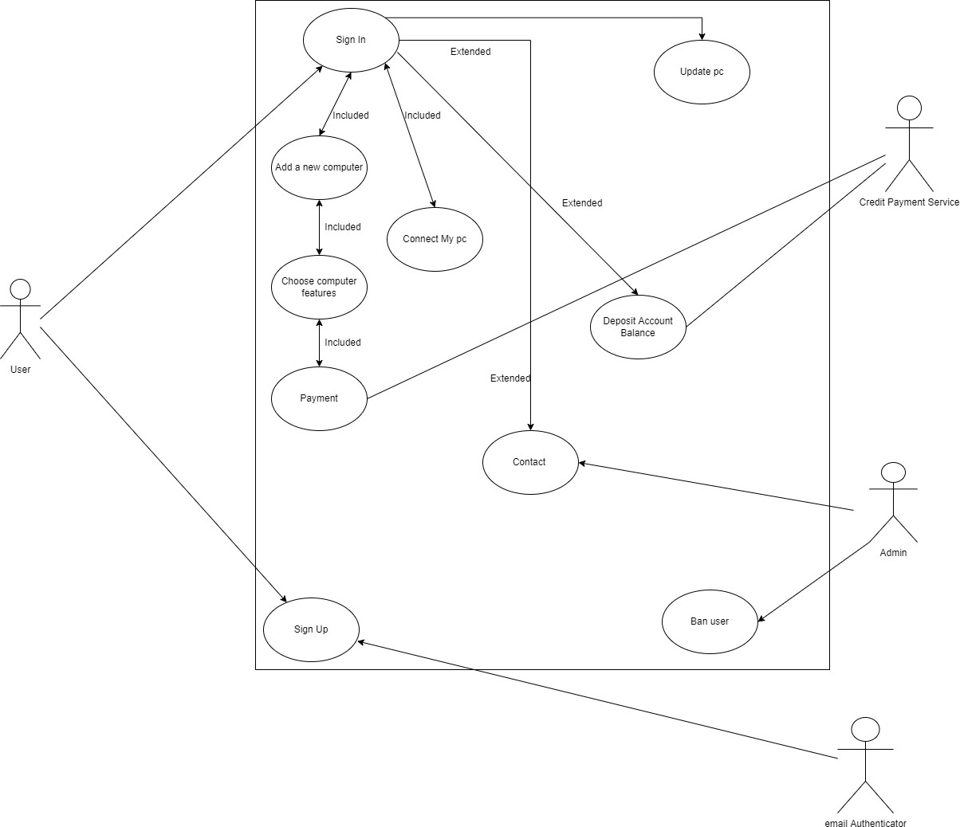

* + - 1. **Use Case Tables**

*USE CASE 1*

|  |  |  |  |
| --- | --- | --- | --- |
| USE CASE NAME | | Sign In | |
| USE CASE NUMBER | | UC 1.0.0 | |
| CREATED BY | Thin Cloud | DATE | 08/12/2021 |
| ACTOR | | Primary Actor: User | |
| PRECONDITIONS | | *PRE_1. Visitor should use Thincloud Mobile Application.*  *PRE_2.Visitor has an active internet connection.* | |
| DESCRIPTION | | Function that allows the user to log into the system. | |
| TRIGGER | | User clicked on the “*Sign In”* button. | |
| RELATED USE CASES | | - | |
| STEPS | | 1. The user enters their own information. 2. User clicks the “*Sign In”* button. | |
| POST CONDITIONS | | POST_1. If the registered user clicks to  POST_2. If the registered user clicks to | |
| EXCEPTIONS | | 1. Connection errors occured during this function. 2. The user enters their information incorrectly. | |

*USE CASE 2*

|  |  |  |  |
| --- | --- | --- | --- |
| USE CASE NAME | | Add a new computer | |
| USE CASE NUMBER | | UC 1.1.0 | |
| CREATED  BY | Thin  Cloud | DATE | 08/12/2021 |
| ACTOR | | Primary Actor: User | |
| PRECONDITIONS | | PRE_1. The user must be logged into the application. | |
| DESCRIPTION | | Function to use to define a new virtual computer for its account. | |
| TRIGGER | | User clicked on *“Add a new computer”* button. | |
| RELATED USE CASES | | UC 1.0.0, UC 1.1.1, UC 1.1.2 | |
| STEPS | | 1. User decided to add a new computer. 2. The user makes a choice according to the characteristics of the computers. UC 1.1.1 3. The user pays to purchase the desired computer. UC 1.1.2 | |
| POST CONDITIONS | | *POST_1. User will be directed to UC 1.1.1 if wants to continue this process.* | |
| EXCEPTIONS | | 1. Connection errors occured during this function. | |

*USE CASE 3*

|  |  |  |  |
| --- | --- | --- | --- |
| USE CASE NAME | | Choose computer features | |
| USE CASE NUMBER | | UC 1.1.1 | |
| CREATED  BY | Thin  Cloud | DATE | 08/12/2021 |
| ACTOR | | Primary Actor: User | |
| PRECONDITIONS | | PRE_1. User clicked on *“Add a new computer”* button. | |
| DESCRIPTION | | Function to use to add a new virtual computer for its account. | |
| TRIGGER | | User clicked on *“Choose”* button. | |
| RELATED USE CASES | | UC 1.0.0, UC 1.1.0, UC 1.1.2 | |
| STEPS | | 1. The user makes a choice according to the characteristics of the computers. UC 1.1.1  3. The user pays to purchase the desired computer. UC 1.1.2 | |
| POST CONDITIONS | | *POST_1. User will be directed to UC 1.1.2 if wants to continue this*  *process.* | |
| EXCEPTIONS | | 1. Connection errors occured during this function. | |

*USE CASE 4*

|  |  |  |  |
| --- | --- | --- | --- |
| USE CASE NAME | | Payment | |
| USE CASE NUMBER | | UC 1.1.2 | |
| CREATED  BY | Thin  Cloud | DATE | 08/12/2021 |
| ACTOR | | Primary Actors: User and Credit Payment Service | |
| PRECONDITIONS | | PRE_1. User clicked on *“Add a new computer”* button.  PRE_2. User choose computer features. | |
| DESCRIPTION | | After completing the UC 1.1.0 and UC 1.1.1 functions, the user enters the payment information to make the payment and makes the payment with  the credit payment service. | |
| TRIGGER | | User clicks *"Pay"* button | |
| RELATED USE CASES | | UC 1.0.0, UC 1.1.0, UC 1.1.1 | |
| STEPS | | 1. User enters payment information after clicking "*pay"* button. 2. Credit payment service confirms the transaction. 3. After the payment is confirmed, the computer with the features selected   by the user is defined to the user's account. | |
| POST CONDITIONS | | *-* | |
| EXCEPTIONS | | 1. Connection errors occured during this function. 2. The payment method may be invalid. | |

*USE CASE 5*

|  |  |  |  |
| --- | --- | --- | --- |
| USE CASE NAME | | Connect My PC | |
| USE CASE NUMBER | | UC 1.2.0 | |
| CREATED BY | Thin Cloud | DATE | 08/12/2021 |
| ACTOR | | Primary Actors: User | |
| PRECONDITIONS | | *PRE_1.* The user must be logged into the application. | |
| DESCRIPTION | | Function prepared to use previously purchased computers. | |
| TRIGGER | | User clicks *"Connect My PC"* button. | |
| RELATED USE CASES | | UC 1.0.0 | |
| STEPS | | 1. The user chooses one of the computers he owns 2. Click the "Connect My PC" button to open the selected computer. | |
| POST CONDITIONS | | *POST_1. The user performs operations on the computer.* | |
| EXCEPTIONS | | 1. Connection errors occured during this function. 2. The user may not have purchased the computer. | |

*USE CASE 6*

|  |  |  |  |
| --- | --- | --- | --- |
| USE CASE NAME | | Contact | |
| USE CASE NUMBER | | UC 1.3.0 | |
| CREATED  BY | Thin  Cloud | DATE | 08/12/2021 |
| ACTOR | | Primary Actors: User, Admin | |
| PRECONDITIONS | | *PRE_1.* The user must be logged into the application. | |
| DESCRIPTION | | This function allows users who want to contact to contact the support  team. | |
| TRIGGER | | User clicks *"Contact"* button. | |
| RELATED USE CASES | | UC 1.0.0 | |
| STEPS | | 1. The user chooses the topic related to the problem and makes the relevant explanation. Then user presses the "submit" button. 2. Admin sees this topic and replies to the user | |
| POST CONDITIONS | | - | |
| EXCEPTIONS | | 1. Connection errors occured during this function. 2. User may be spamming. | |

*USE CASE 7*

|  |  |  |  |
| --- | --- | --- | --- |
| USE CASE NAME | | Update features of pc | |
| USE CASE NUMBER | | UC 1.4.0 | |
| CREATED  BY | Thin  Cloud | DATE | 08/12/2021 |
| ACTOR | | Primary Actors: User | |
| PRECONDITIONS | | *PRE_1.* The user must be logged into the application. | |
| DESCRIPTION | | This function allows the user to update the features of the computer they  hold within the price difference. | |
| TRIGGER | | User clicks *"Update"* button. | |
| RELATED USE CASES | | UC 1.0.0 | |
| STEPS | | 1. The user selects the computer they want to update and clicks the "update" button. 2. User selects the features it wants to change . 3. The price difference appears on the interface. The user accepts and approves them. | |
| POST CONDITIONS | | - | |
| EXCEPTIONS | | 1. Connection errors occured during this function. 2. The user's balance may be insufficient. | |

*USE CASE 8*

|  |  |  |  |
| --- | --- | --- | --- |
| USE CASE NAME | | Deposit Account Balance | |
| USE CASE NUMBER | | UC 1.5.0 | |
| CREATED  BY | Thin  Cloud | DATE | 08/12/2021 |
| ACTOR | | Primary Actors: User, Credit Payment Service | |
| PRECONDITIONS | | *PRE_1.* The user must be logged into the application. | |
| DESCRIPTION | | User uses this function when she wants to add money to account  balance. | |
| TRIGGER | | User clicks *"Deposit"* button. | |
| RELATED USE CASES | | UC 1.0.0 | |
| STEPS | | 1. The user clicked the "deposit" button to add money to the account balance. 2. The user chooses how much they want to add to their balance. 3. User completes the payment transaction via "Credit Payment Service" | |
| POST CONDITIONS | | - | |
| EXCEPTIONS | | 1. Connection errors occured during this function. 2. The user's payment method may be invalid. | |

*USE CASE 9*

|  |  |  |  |
| --- | --- | --- | --- |
| USE CASE NAME | | Sign Up | |
| USE CASE NUMBER | | UC 2.0.0 | |
| CREATED  BY | Thin  Cloud | DATE | 08/12/2021 |
| ACTOR | | Primary Actors: User,eMail Authenticator | |
| PRECONDITIONS | | *PRE_1. Visitor should use Thincloud Mobile Application.*  *PRE_2.Visitor has an active internet connection.* | |
| DESCRIPTION | | The function that the user uses to register to the system. | |
| TRIGGER | | User clicks “Sign Up” button. | |
| RELATED USE CASES | | - | |
| STEPS | | 1. The user clicks the "sign up" button to register in the system. 2. The user enters information such as id, password, email on the sign up interface. 3. The user's identity is authenticated through the eMail Authenticator. | |
| POST CONDITIONS | | - | |
| EXCEPTIONS | | 1. Connection errors occured during this function. 2. The user may have entered information that the system does not accept. 3. The user may not have approved the e-mail. | |

## SOFTWARE SYSTEM ATTRIBUTES

Our quality features and understanding for the ThinCloud Ecosystem and Software are designed to provide the best service to the user of the system and devices. Quality characteristics are examined under the following headings.

### Reliability

The system is planned to be a reliable ecosystem and quality. With this purpose, it is aimed that the ThinCloud system should be reliable in terms of use, security, system software and compatibility.

System crash frequency and severity, mean time between two crashes (“MTTF: mean time to

failure”), mean time to repair (“MTTR: mean time to repair”), error or defect rate, maximum error or

defect rate are defined.

### Availability

In order to improve the usability features of the ThinCloud system, studies were carried out together with effective compatibility and usability methods.

The percentage of software available for use (“% of time available=MTTF/(MTTF+MTTR)”) was

calculated and the usage percentage was increased to 89% by subtracting it in this way.

### Security

ThinCloud system, software and ecosystem perform transactions by performing data and packet encryption with high-bit encryption algorithms. It is aimed to securely communicate outgoing and incoming data by using VPN and packet encryption systems, especially in the stages of exiting and entering the unsecured networks. The use of certain encryption and cryptographic techniques is expressed by keeping purpose-specific records (“logs”) or historical data, assigning certain functions to different modules/users, restricting communication between parts of the program, and checking data integrity for critical variables. Apart from these, the datacenter systems, where the entire ThinCloud ecosystem is hosted, and especially the ThinCloud virtual machines are hosted, the network is secured from the very beginning with the Unified-Thread-Management (UTM) devices that act as a high-performance firewall with Zero-Day protection feature. Thus, the data of the ThinCloud ecosystem users, the packets and data they send and receive to the network, each information retrieved from the network, the common file areas and storage unit systems in the data center, as well as all kinds of virtualized systems, switchers and virtual machines created, are operated with high encryption and security.

### Maintainability

In order to ensure efficient and fast maintenance of software and hardware in the ThinCloud ecosystem, they must meet the following requirements;

* They must be remotely accessible at subnet layers and non-sub-user interface systems.
* It should be able to allocate its own bandwidth, memory and processing power in the areas of

update, maintenance, development and data collection.

* They must have a main mechanism by which maintenance processes can be managed and

reported.

* In order to measure the quality of maintenance processes, they should be detailed and opinions

should be taken in interaction with the user.

### Portability

Although the ThinCloud ecosystem and software are successful in migration and portability, especially virtualization systems are low in portability due to the many associated technologies they contain.

### Usability

Easy use, efficient functions and performance of ThinCloud software and hardware are the most important usage scenarios. For this reason, the usage scenarios, user interfaces and systems should be planned and operated in order to maximize the “Usability” of the users. These can be generalized as follows;

* ThinCloud Network Client Device with Easy to Use and Setup
* ThinCloud Hypervisor with Easy-to-Use and Setup Features
* ThinCloud Softwares with Easy Manageability Features
* Easily Configurable, Expandable and Customizable Virtual Machines

# SOFTWARE DESIGN DESCRIPTION

## INTRODUCTION

### Purpose

This document aims to shed light on the architectural design created and explain the expected/desired graphics of each interface. It includes the Thincloud Mobile Application step requirements.

### Scope

The scope of this document aims to shed light on the architectural design required for the Mobile Application Step of the ThinCloud System to work and to explain the expected/desired graphics of each interface.

### Glossary

**Client:** The client takes part on the client side in information transfers provided by the server or host. If it is explained with an example scenario, when the client tries to log in to a website, it reaches the main web server and requests information from this server.

**Interface:** Interface is the borderline software and/or hardware unit that allows two systems to interact with each other or a user with a system.

**SDD:** A software design document is a representation of a software design that is to be used for recording design information, addressing various design concerns, and communicating that

information to the design’s stakeholders.

**Server:** Servers actually; These are digital systems where software, programs are installed and run, allowing multiple users to share data. Servers, which are much stronger than a normal computer, are configured to manage multiple tasks simultaneously and faster.

### Overview

* + - 1. **Overview of Document**

This document is organized to show the system design, architectural design, decomposition description, user interfaces and the requirements matrix in the given order and describe each of them explicitly. In addition, the components of the software and hardware environments, the relations of the components with the classes.and what requirements are needed for them to work together, architectural views,collaboration, state and activity diagrams of architectural requirements are included.This document describes the created interface for “Thincloud Computing Client Project Mobile Application Stage”.

### Overview of Project

This Project centralizes the computer systems (Desktop, Mobile, Laptop) that may exist in an organization in a single cloud-based center; It aims to enable organizations to access the entire information architecture via a remote data center with only a network client board (ThinCloud) without purchasing a computer and server system, and to manage all their operations over this system. For this project there are many needed interfaces which all belonging designs are included in this document. The system aims to provide the visitor with the option to register and provide basic information about the project about the login interface. The interface will change depending on whether the user is registered or not.

There will also be an interface related to pricing and sessions options. Apart from these, there will also be an interface where we can see the hardware features of the computer we are currently using and increase or decrease these features.

### Motivation

We are a group of senior students working in the field of mobile applications in the computer engineering department. As a group, a mobile application works with 'Thin Client' and 'Client Zero' cloud systems. This project is both the only platform and project of our country in this field, as well as the only project in the field of virtualization infrastructures (Hypervisors). Our aim is to develop this project. ThinCloud Informatics Project, centralization of computer systems (Desktop, Mobile, Laptop, etc.) that may exist in an organization in a single cloud-based center; It aims to enable organizations to access all information architecture and manage all their transactions over a remote data center with only a network client card (ThinCloud) without purchasing a computer and server system. In this project, we aim to develop the mobile application so that it can be easily accessed by more audiences. This document details the Mobile Application Phase of the ThinCloud Cloud Computing Client Project.

## ARCHITECTURAL DESING

### Architecture Design Approach

ThinCloud Cloud Computing Client Project is an internet-based system that provides computing resources for computers and other devices that can be used at any time and shared among users.The architecture of the project was designed with the aim of establishing and developing a system that brings users together with maximum capacity and performance.The functionality of the system is carried out by focusing on user interfaces and communication between client and server. The user interfaces are designed with simplicity, user experiences, effectiveness and intelligibility in mind. It is also important to understand user satisfaction for performance tracking. In the following sections, the designs are explained in detail.

### Class Diagram

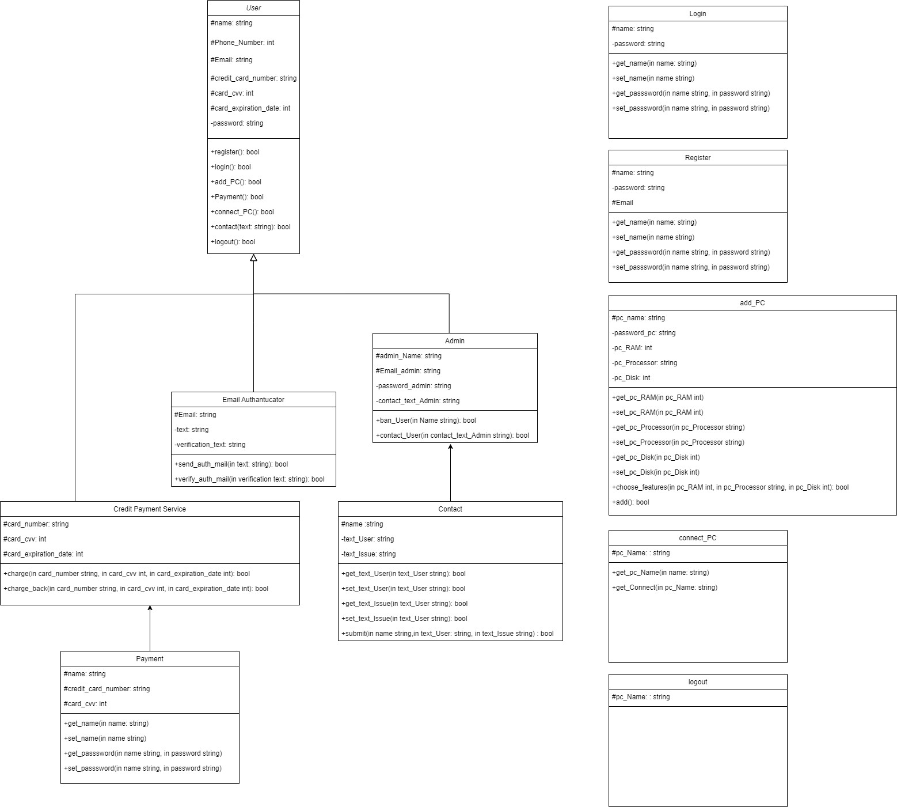

* + 1. **Architecture Design of Application**

#### 4.2.2.1.1 Register Page

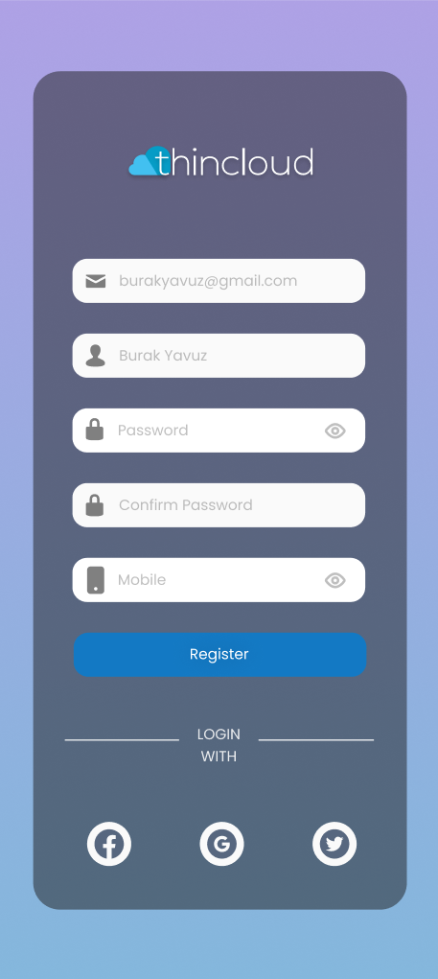

**Summary:** User can login, register, update personal information and exit the system.

**Actor:** User and Administrator

**Trigger:** Record button

**Precondition:** The user must run the application.

#### Basic Sequence:

1. If the user does not have an account, they must be registered.
2. The user enters the user name and password into the system.
3. User can change update button from user.

Exception: The e-mail address may have already been taken or the password does not meet the standards.

1. The administrator can delete a user account by selecting the delete button from the administrator menu.
2. The administrator can approve a newly registered user account by selecting confirm from the administrator menu.
3. The administrator can add a new administrator by selecting the add new administrator button from the administrator menu.
4. The user can exit the system by selecting the exit button.

**Exception:** Database connection failed.

#### Post Condition: None

**Priority:** Low

#### 4.2.2.1.2 Login Page

#### 

**Summary:** Members and admins can log in to the application.

**Actor:** Users & admins

**Trigger:** Login button

Precondition: Member and all admins must register before trying to log in into the application.

#### Basic Sequence:

1. Member and all admins shall open the application.
2. If the member and all admins did not log in before, the opening page will be the Login page.
3. Member and all admins shall log in to the application by entering their e- mail and password.
4. After the login operation, the member and all admins will be directed to the Create a Profile page if they are logging in for the first time. Further logins will direct them to the Feed page.

**Exception:** Member and all admins can enter the wrong e-mail and password combination or wrong e-mail format.

**Post Condition:** Member and all admins will be redirected to the Create a Profile page if they are logging in for the first time. Further logins will direct them to the Feed page.

**Priority:** High

**Assumptions:** Member and all admins must be connected to the internet.

* + **4.2.2.1.3 My Computer Page Summary:** Users select a computer with the

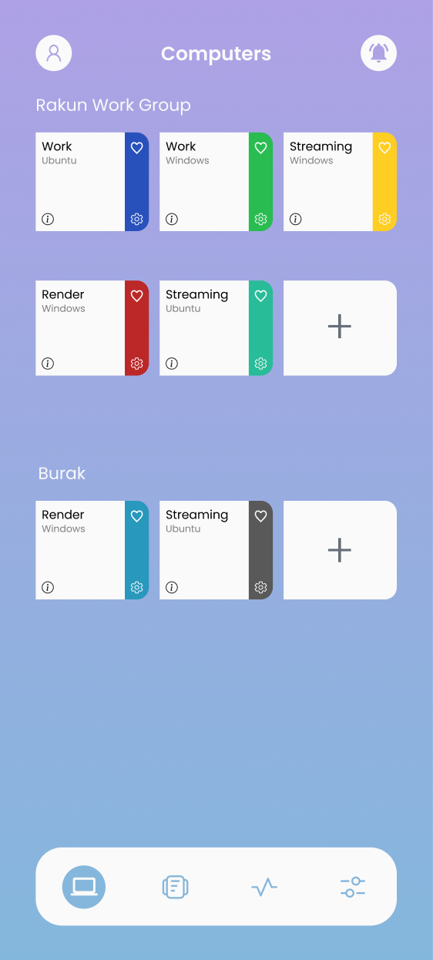features they need through the application and allow them to connect to the computer with the features they choose.(The user can change the properties of the selected computer system)

**Actor:** All users

**Trigger:** My computer,My payment,Connect computer,Upgrade,Add New Computer,Digital Art,Motion&Video,Engineering,Other

#### Precondition:

* 1. The user sees the features of the computer to be designed on the My Computer screen.
  2. Selects the computer to be designed according to the Performance and RAM Storage features.(The user can change the previously selected features from the Upgrade button)
  3. In the Connection section, it checks that the connection is successful.
  4. By pressing the Connect Computer button, it sends a request to connect to the computer.

Exception: It may not click on Digital Art, Motion&Video, Engineering, Other buttons.

**Priority:** High

**Assumptions:** Member and all admins must be connected to the internet.

#### 4.2.2.1.4 Add New Computer Page

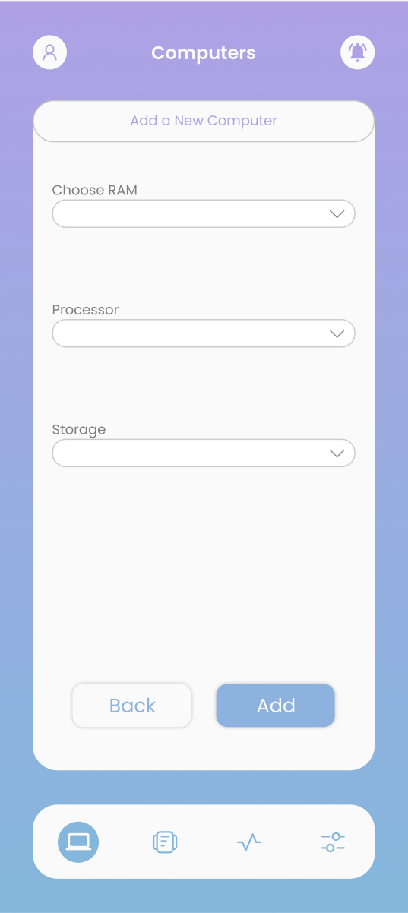

**Summary:** Users select a computer with the features they need through the application, see the features they choose and pay.

**Actor:** All users

**Trigger:** Add New Computer,payment buttons,Continue to payment

#### Precondition:

1. The user sees the properties of the computer to be designed on the My Computer screen.
2. The user must pay to purchase the system, which is formed according to the features he chooses.

**Exception:** System features

**Post Condition:** Realization of payment

**Priority:** High

**Assumptions:** Member and all admins must be connected to the internet.

### 4.2.2.1.5 My Payments Page

**Summary:** Users who make the payment check the system features and membership periods through the application.Users can cancel their membership or extend their membership period if they wish.

**Actor:** All users

**Trigger:** My Payments,Connect computer,Upgrade

#### Precondition:

1. The user sees the properties of the computer to be designed on the My Payment screen.
2. The user can control the membership periods through the system.
3. The user can cancel their membership or extend the membership period if they wish.

#### Post Condition: None

**Priority:** High

**Assumptions:** Member and all admins must be connected to the internet.

#### 4.2.2.1.6 Sidebar

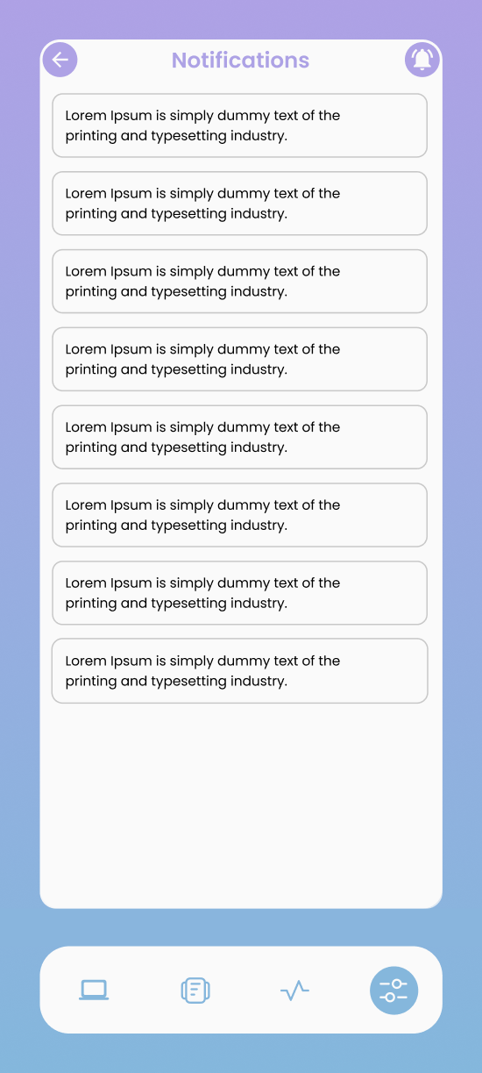

**Summary:** It is the side menu where the settings, communication and exit buttons are located.

**Actor:** Users & Admins

**Trigger:** Settings, Communication and Exit Buttons

**Precondition:** Users and admins must be logged in and click the sidebar button in the upper right corner.

#### Basic Sequence:

1. User and admin click the sidebar button to open the sidebar menu.
2. Three buttons are encountered. These buttons are settings, communication and exit buttons.
3. The user who wants to log in to the settings page or the admin settings button, the user who wants to enter the contact page or

the admin contact button, the user who wants to log out should click the logout button.

**Exception**: Sidebar menu button may not be clicked.

**Post Condition:** None.

**Priority:** High

**Assumptions:** Member and all admins must be connected to the internet.

#### 4.2.2.1.7 Settings Page

#### 

**Summary:** This is the page that offers the opportunity to change the user name, e-mail, password, date of birth and registration information entered for social media accounts.

**Actor:** Users&Admins

**Trigger:** Gmail and Facebook buttons

**Precondition:** Users and admins must be logged in and click the sidebar button in the upper right corner. After that, it should open the settings page by clicking the settings button.

#### Basic Sequence:

1. To edit the user name, the person's user name must be clicked.
2. To edit e-mail, click on the e-mail section of the person.
3. To edit the password, the person's password must be clicked on.
4. To arrange a birthday, the person's birthday must be clicked on.
5. Facebook or gmail buttons can be clicked for social media links.

Exception: Sidebar menu button may not be clicked.

**Post Condition:** None **Priority:** Medium **Assumptions:** None

## 4.3 REQUIREMENTS MATRIX

|  |  |  |  |  |  |  |  |  |  |
| --- | --- | --- | --- | --- | --- | --- | --- | --- | --- |
|  | **FR1** | **FR2** | **FR3** | **FR4** | **FR5** | **FR6** | **FR7** | **FR8** | **FR9** |
| **Login** | **1** | **0** | **0** | **0** | **0** | **0** | **0** | **0** | **1** |
| **Register** | **0** | **0** | **0** | **0** | **0** | **0** | **0** | **0** | **1** |
| **Connect Computer** | **1** | **0** | **0** | **1** | **1** | **0** | **0** | **0** | **0** |
| **Upgrade** | **0** | **0** | **1** | **1** | **0** | **0** | **0** | **0** | **0** |
| **Add New Computer** | **0** | **1** | **1** | **1** | **0** | **0** | **0** | **0** | **0** |
| **Payment System** | **0** | **0** | **0** | **1** | **0** | **0** | **0** | **0** | **0** |
| **Add money to account** | **0** | **0** | **0** | **0** | **0** | **0** | **0** | **1** | **0** |
| **Contact** | **0** | **0** | **0** | **0** | **0** | **1** | **0** | **0** | **0** |

* 1. **CONCLUSION**

ThinCloud Project centralizes the computer systems (Desktop, Mobile, Laptop) that may exist in an organization in a single cloud-based center; It aims to enable organizations to access the entire information architecture via a remote data center with only a network client board (ThinCloud) without purchasing a computer and server system, and to manage all their operations over this system. The system aims to provide the visitor with the option to register and provide basic information about the project about the login interface. The interface will change depending on whether the user is registered or not. There will also be an interface related to pricing and sessions options. Apart from these, there will also be an interface where we can see the hardware features of the computer we are currently using and increase or decrease these features.

ThinCloud, as the next cloud-connected and integrated system of the existing 'Thin-Client' and 'Zero-Client' systems, is an advanced step and project in this technology. . The Mobile Application Tier of the ThinCloud Cloud Computing Client Project centralizes the computer systems that may exist in an organization in a single cloud-based center, going beyond traditional computing to see virtual computing and cloud computing with a mobile interface. Ensuring the continuity of the ThinCloud Cloud Computing Client Project with the Mobile Application design will be a new technological step and will make the life of the users a little easier. The use of Flutter technology in mobile application development is essential for software developers.

The mobile application step of the Thincloud system, the software running on the ThinCloud Client, the Cloud Over Management Platform Software that provides ThinCloud management, the ThinCloud Mobile Interface Software that allows the ThinClouds to be managed independently of the device, and the ThinCloud, which allows this process to be done on local computers and to serve the systems on independent or local servers Hypervisor systems include ThinCloud HV Software. These software are systems that allow users to run and manage computer architecture and processes directly from the cloud.

# REFERENCES

* + 1. Thin Clients Clearly Explained, Joseph T Sinclair, 2000.
    2. Understanding Thin-client/server Computing, Joel P. Kanter,1998.
    3. Zero client device with multi-boot capability supporting multiple zero client protocols, Publication of US20120317180A1
    4. Mobil Uygulama Geliştirme, Cihan Ürtekin, 1. Baskı,Seçkin Yayıncılık,2021.
    5. Professional Mobile Application Development by Tarkeshwar Barua, Ruchi Doshi, et al., Dec 16, 2020.
    6. A Distributed, Decoupled System for Losslessly Streaming Dynamic Light Probes to Thin Clients Michael Stengel
    7. Wang, Y.H.; and Wu, I.C. (2009). Achieving high and consistent rendering performance of java AWT/Swing on multiple platforms. Software-Practice and Experience, 39(7), 701- 736.
    8. Aspri, M.; Tsagkatakis, G.; and Tsakalides, P. (2020). Distributed training and inference of deep learning models for multi-modal land cover classification. Remote Sensing, 12(17), 1-21.
    9. Teemu Kämäräinen, Matti Siekkinen, Jukka Eerikäinen, and Antti YläJääski. 2018. CloudVR: Cloud accelerated interactive mobile virtual reality. In Proceedings of the 26th ACM international conference on Multimedia. 1181–1189
    10. Asian Journal of Technology & Management Research [ISSN: 2249 –0892] Vol. 04 – Issue: 02 (Jul - Dec 2014)
    11. . Rabi Prasad Padhy , Manas Ranjan Patra , Suresh Chandra Satapathy , , “ Cloud

Computing: Security Issues and Research Challenges”, IRACST.

* + 1. Virtual cloud computing provider for mobile devices: <https://dl.acm.org/doi/abs/10.1145/1810931.1810937>
    2. An overview of virtual and cloud computing: <https://www.emerald.com/insight/content/doi/10.1108/10650751011073607/full/html>
    3. Cloud Computing: <https://ieeexplore.ieee.org/abstract/document/6405648>
    4. Virtual cloud computing provider for mobile devices: https://ieeexplore.ieee.org/abstract/document/786118411

**MOODBOARDS**

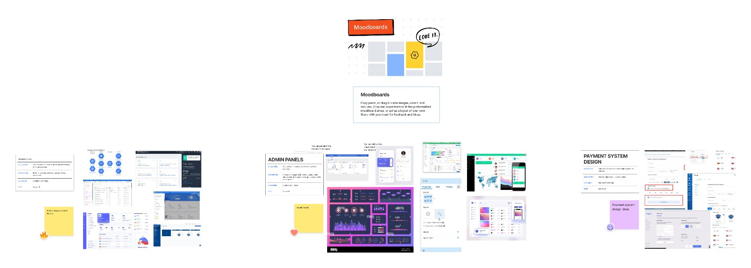

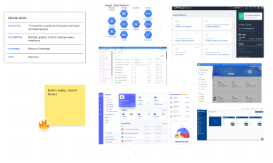1-)

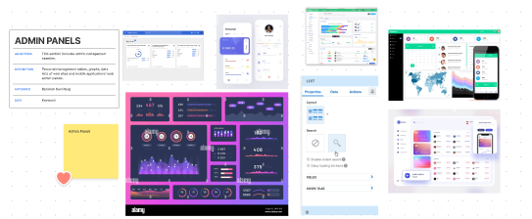2-)

3-)

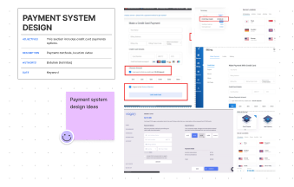

LİNK : <https://www.figma.com/file/jyWyj0feI2W2WbriDY7Pyf/Mood_Boards?node-id=0%3A1>,

**Empathy Map**

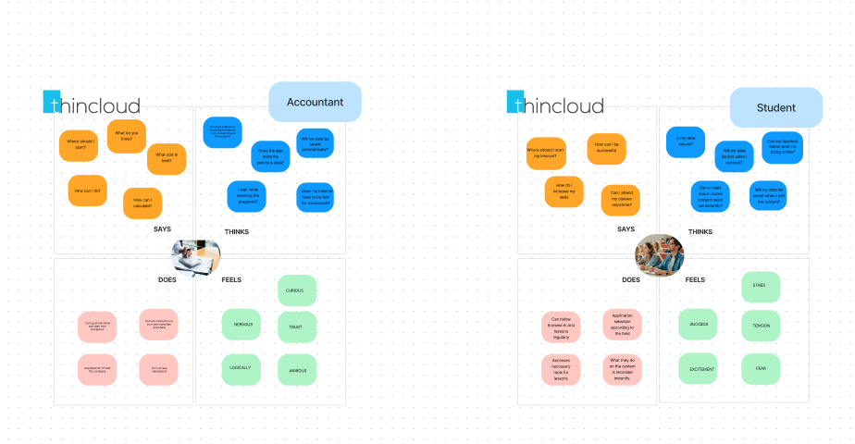

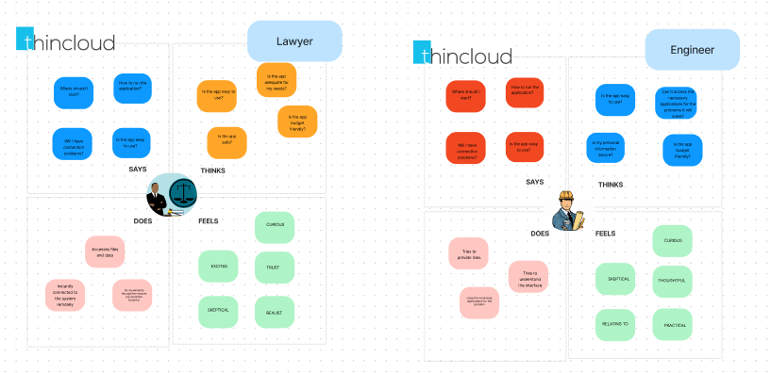

**LİNK :** [**https://www.figma.com/file/1pYgSTXeP86ZpKTiCCzgMC/Empathy-Map?node-id=0%3A1**](https://www.figma.com/file/1pYgSTXeP86ZpKTiCCzgMC/Empathy-Map?node-id=0%3A1)

**Information Arcitecture**

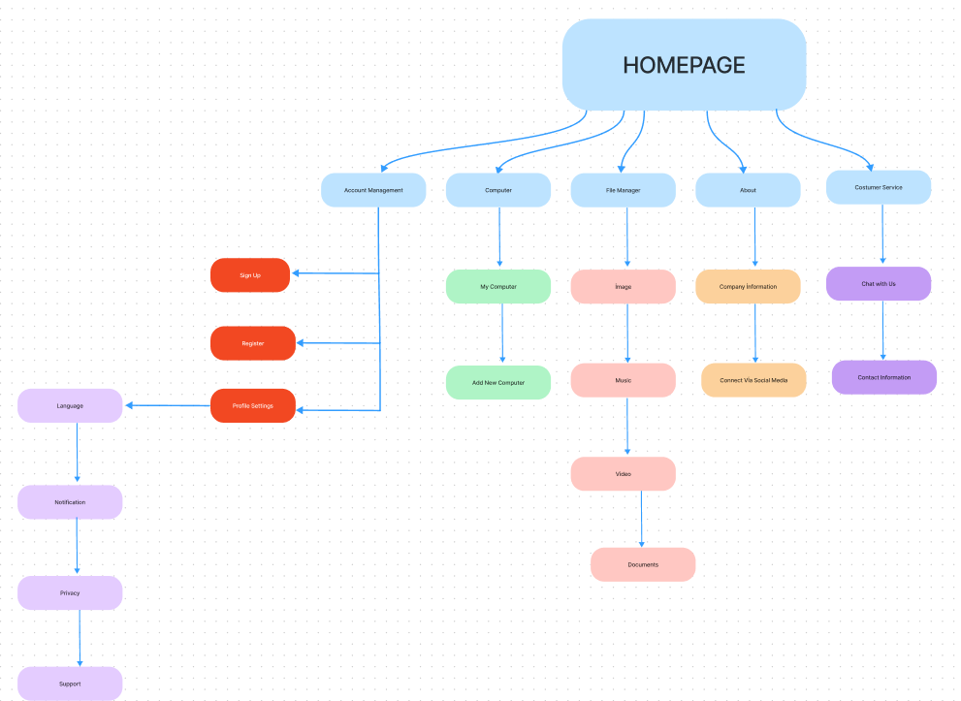

**LINK :** [**https://www.figma.com/file/3jSRhKhJhEXSYdIDYka5CX/Information-Arcitecture?node-id=0%3A1**](https://www.figma.com/file/3jSRhKhJhEXSYdIDYka5CX/Information-Arcitecture?node-id=0%3A1)

# TASK DISTRUBUTION

|  |  |  |
| --- | --- | --- |
| **Prof. Dr. Ahmet COŞAR** | Advisor |  |
| **Betül HAYKIR** | Team Leader | 1. Main Findings of Literature Review 2. Introduction of SRS 3. Functional Requirements(Use Case Diagram and Use Case Tables) 4. Architectural Design of SDD 5. Task distribution to group members 6. Completion of revisions of files (introduction, conclusion, abstracts, etc.) and system uploads 7. Back-end design 8. Mood Boards 9. Information Arhitecture |
| **Batuhan DEMİRBAĞ** | Team Member | 1. Main Findings of Literature Review 2. Introduction of SDD 3. Functional Requirements(Use Case Diagram and Use Case Tables) 4. Architectural Design of SDD 5. Front-end design 6. Back-end design 7. Empathy maps 8. User Journery 9. Information Arhitecture 10. Mood Boards |
| **Burak YAVUZ** | Team Member | 1. The Similar Applications to ThinCloud Project 2. Software System Attributes of SRS 3. Functional Requirements(Use Case Diagram and Use Case Tables) 4. Architectural Design of SDD 5. User Interface Design 6. Front-end design 7. UML design 8. User Journery 9. Test plan result 10. Mood Boards |
| **Cem GÜVENBAŞ** | Team Member | 1. The Similar Applications to ThinCloud Project 2. Overall Description of SRS 3. Functional Requirements(Use Case Diagram and Use Case Tables) 4. Requirements Matrix 5. Front-end design 6. UML design 7. Test plan result |