**Software Design Document (SDD)**

**Lie Detection Using Speech Processing Techniques**

1. Introduction

This document provides a detailed description of the software design for the "Lie Detection Using Speech Processing Techniques" project. The system focuses on analyzing acoustic, prosodic, and emotional features to detect deception. This document elaborates on the project's purpose, scope, and components while emphasizing technical details and architectural decisions.

The project offers a roadmap to guide the development team and stakeholders in managing the complexities of integrating speech analysis and machine learning. It combines advanced technology and software architecture to provide an effective solution for detecting deceptive behavior.

1.1 Purpose

The purpose of this document is to detail the design and architectural choices of the "Lie Detection Using Speech Processing Techniques" project and provide guidance throughout the development process. The system focuses on the integration of components, the use of technical tools, and the establishment of a scalable infrastructure. This document addresses the following key objectives:

* Establishing a comprehensive framework for system design.
* Providing a clear roadmap for the engineering team.
* Aligning stakeholders’ understanding of the project.

1.2 Definitions

This section defines key technical terms and concepts frequently used in the document:

|  |  |
| --- | --- |
| **Term** | **Definition** |
| **Lie Detection** | The process of identifying deception by analyzing speech features. |
| **Speech Processing** | Techniques used to analyze and extract features from speech signals. |
| **CNN (Convolutional Neural Network)** | A deep learning model used to analyze structured data such as speech. |
| **LSTM (Long Short-Term Memory)** | A type of neural network effective for sequential data like audio. |
| **Librosa** | A Python library for audio analysis and feature extraction. |
| **TensorFlow/PyTorch** | Frameworks used for building and training machine learning models. |
| **Deceptive Speech Corpus** | A dataset designed for research in speech-based deception detection. |

2. System Overview

This project is designed to detect deceptive behavior by analyzing speech features. The system combines advanced speech processing techniques and machine learning methodologies to provide an effective solution.

2.1 System Components

The system consists of the following key components:

* **Speech Preprocessing Module:**
  + Uses Librosa for audio cleaning, segmentation, and extraction of acoustic features.
* **Machine Learning Module:**
  + Analyzes extracted features using traditional ML models (SVM) and deep learning architectures (CNN, LSTM).
* **Web-Based Interface:**
  + Provides a user-friendly platform for uploading audio, analyzing results, and offering graphical visualizations.
* **Visualization Tools:**
  + Offers graphical representations of speech patterns (e.g., pitch fluctuations, stress markers) contributing to the analysis.

2.2 System Interaction

The system components interact as follows:

1. **Audio Input:** Users upload audio files or provide real-time recordings.
2. **Preprocessing:** Audio files are cleaned, and key features are extracted after noise removal.
3. **Model Analysis:** Extracted features are analyzed using models to classify results as "truthful" or "deceptive."
4. **Result Display:** Analysis results are presented with visualized reports.

2.3 Key Technologies and Tools

* **Programming Language:** Python
* **Libraries:** Librosa, TensorFlow, PyTorch
* **Databases:** PostgreSQL for storing analysis results.
* **Frameworks:** Flask (backend) and TensorFlow Serving (for model deployment).
* **Deployment:** Docker for platform-independent and portable infrastructure.

2.4 System Objectives

* Provide accurate and fast solutions for lie detection.
* Prioritize data privacy and user confidentiality.
* Ensure a scalable infrastructure for multiple users and increased data loads.

3. System Design

This section provides a comprehensive description of the system architecture, its components, and how they interact to fulfill the functional requirements outlined in the SRS.

3.1 Architectural Design

### **3.1.1 System Architecture Overview**

The system is composed of three main components:

1. **Mobile App (Frontend)**:
   * Provides an interface for users to interact with the system.
   * Allows users to upload audio files, record real-time audio, and view analysis results.
2. **Server (Backend)**:
   * Acts as the intermediary between the mobile app and the machine learning model.
   * Handles user authentication, audio file processing, and data storage.
   * Invokes the machine learning model for analysis and returns results to the frontend.
3. **Machine Learning Model**:
   * Hosted on the server, trained to analyze speech patterns and classify them as truthful or deceptive.
   * Processes audio features such as pitch, prosody, and emotional markers to generate results.
4. **Database**:
   * Stores user data, audio files, and analysis results securely.

### **3.1.2 Architecture Diagram**

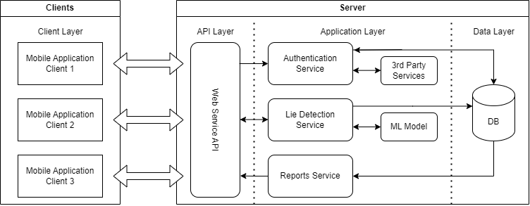

3.2 Class Diagram

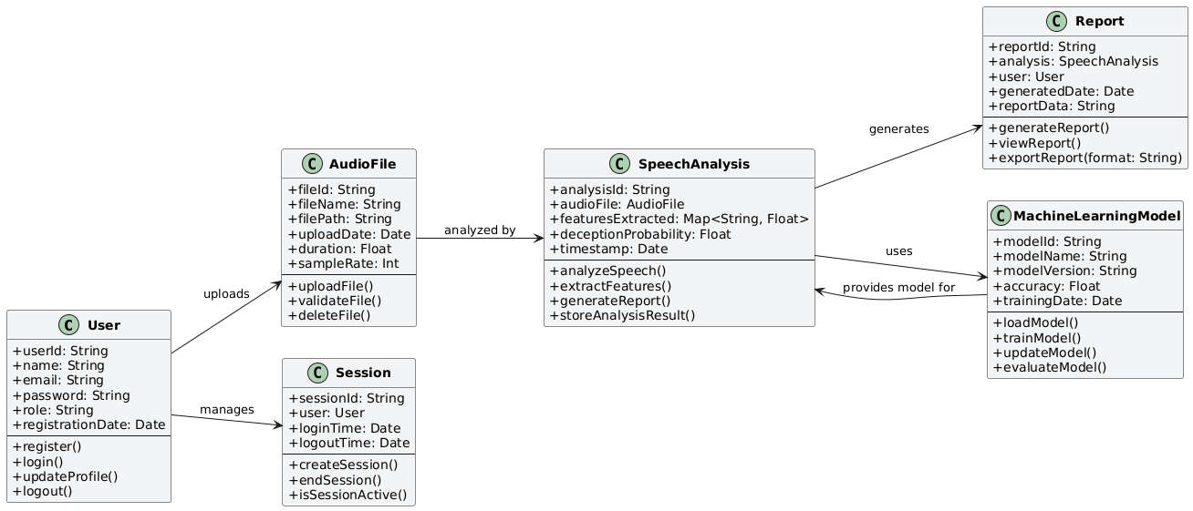

3.3 System Modelling

### **3.3.1 Lie Detection**

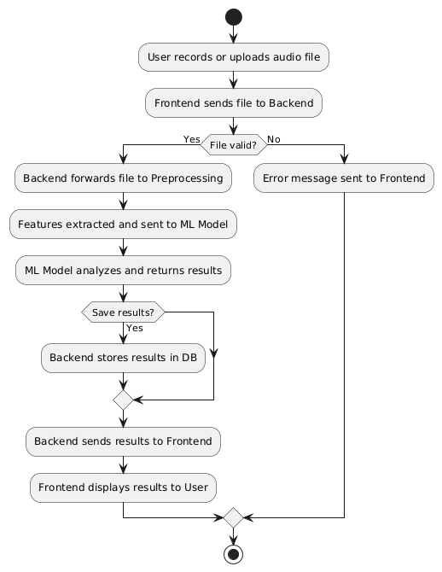

Activity Diagram 1

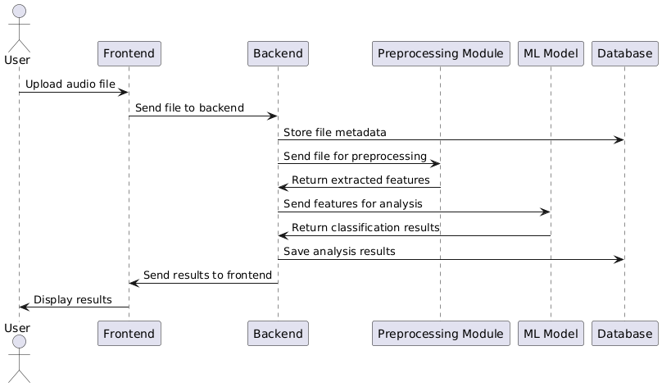

Sequence Diagram 1

### **3.3.2 Authentication**

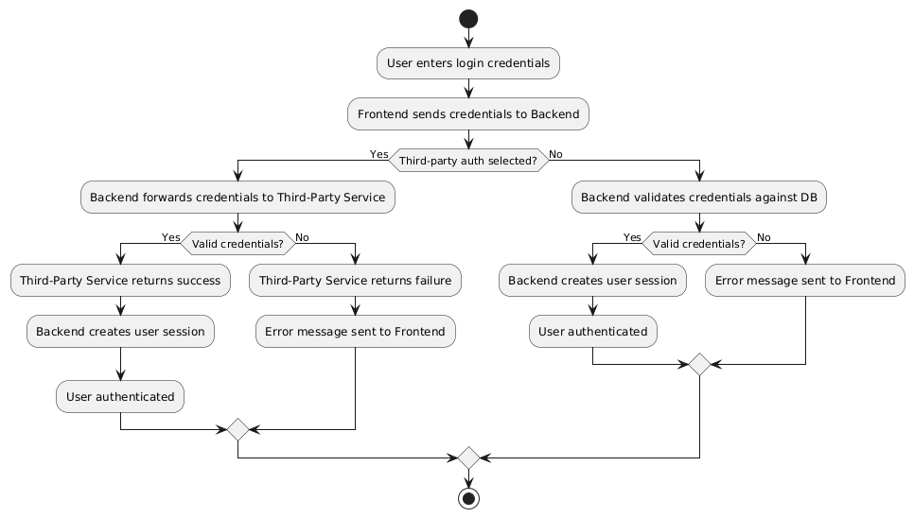

Activity Diagram 2

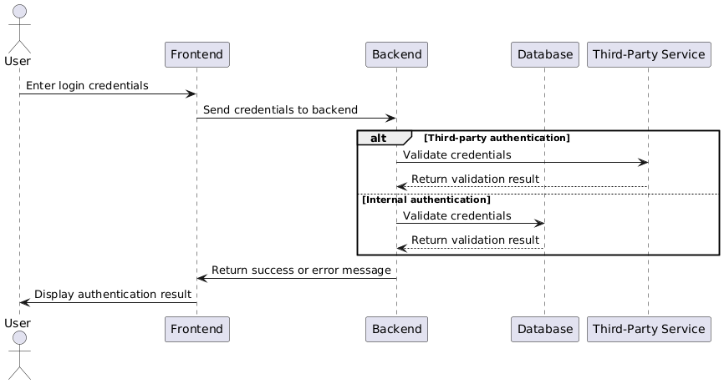

Sequence Diagram 2

4. Interface Design

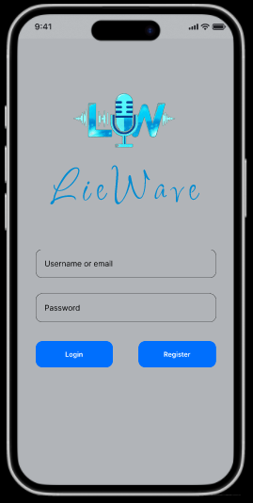

Login Screen Lie Detection Screen