|  |  |  |
| --- | --- | --- |
| amblem | **ÇANKAYA UNIVERSITY**  **Software Engineering Department** |  |

**SENG 491 – 492 Graduation Project**

**Software Requirements**

**Specification**

**SenseAI**

**Ece Heval Ünal**

**Mustafa Tozman**

**Özge Alkan**

**Sadrettin Anıl Karaçay**

**Zeliha Aybüke Baştürk**

**Version 1.2**

Table of Contents

1 Introduction 1

1.1 Purpose 1

1.2 Scope 1

1.3 Definitions, acronyms, and abbreviations 2

1.4 References 2

1.5 Overview 2

1.6 Version History 3

2 Overall description 3

2.1 Product perspective 3

2.1.1 System interfaces 3

2.1.2 User interfaces 3

2.1.3 Hardware interfaces 4

2.1.4 Software interfaces 4

2.1.5 Communication interfaces 5

2.1.6 Memory constraints 5

2.1.7 Operations 6

2.1.8 Site adaptation requirements 6

2.2 Product functions 7

2.3 User characteristics 7

2.4 Constraints 7

2.5 Assumptions and dependencies 8

2.6 Apportioning of requirements 8

3 Specific Requirements 9

3.1 External Interface Requirements 9

3.1.1 User interfaces 9

3.1.2 Hardware interfaces 14

3.1.3 Software interfaces 14

3.1.4 Communications interfaces 14

3.2 Functional Requirements 14

3.2.1 SenseAI users 17

3.2.2 Admin 23

3.3 Performance requirements 27

3.4 Logical database requirements 27

3.5 Design constraints 28

3.5.1 Standards compliance 28

3.6 Software system attributes 28

3.6.1 Reliability 28

3.6.2 Availability 28

3.6.3 Security 28

3.6.4 Maintainability 29

3.6.5 Portability 29

4 References 29

# Introduction

## Purpose

The purpose of this Software Requirements Specification (SRS) is to provide a comprehensive overview of the functional and non-functional requirements for the **SenseAI** project. This document serves as a foundational guide for the design, development, and deployment of the application. It ensures all stakeholders have a shared understanding of the system's objectives and specifications while reducing ambiguity and promoting consistency during the project's lifecycle.

The primary audience for this SRS includes:

* **Development Team:** To implement the features and functionality outlined in the requirements.
* **Project Stakeholders:** To ensure the application aligns with business objectives and user needs.
* **Quality Assurance Team:** To validate that the system meets the specified requirements.
* **End-User Representatives:** To provide feedback and confirm the application addresses their expectations.
* **Future Developers/Maintainers:** To understand the original design and purpose for updates or maintenance.

This document is designed to be accessible and useful for both technical and non-technical stakeholders.

## Scope

The software product to be developed is **SenseAI**, a mobile psychology chatbot application designed to analyze emotional states and assist users in managing their mental well-being.

**What SenseAI will do:**

* **Camera Integration:** Analyze facial expressions to interpret the user’s emotional state.
* **Speech-to-Text (STT):** Convert user speech to text for processing by the AI.
* **Heart Rate Monitoring:** Retrieve BPM data from connected smartwatches for additional mood analysis. (Google Fit will be utilised to achieve this)
* **Chatbot Support:** Provide AI-driven conversational support to guide users through mental wellness strategies.
* **Recommendations:** Offer personalized activities or content based on user mood and inputs.

**What SenseAI will not do:**

* SenseAI will not replace professional therapy sessions.

**Application Benefits and Goals:**SenseAI is targeted at individuals seeking a convenient, AI-powered companion for mental health support. It aims to:

* Improve accessibility to basic mental wellness tools.
* Provide emotional feedback and personalized suggestions.
* Leverage non-invasive biometric data to enhance user experience.
* Deliver a user-friendly interface for seamless interaction.
* Ensure data security and user privacy.

## Definitions, acronyms, and abbreviations

|  |  |
| --- | --- |
| Term | Description |
| CBT | Cognitive Behavioral Therapy |
| AI | Artificial Intelligence |
| NLP | Natural Language Processing |
| CNN | Convolutional Neural Network |
| DBMS | Database Management System |
| SRS | Software Requirements Specification |
| HA | High Availability |

## References

See 4. References section.

## Overview

This SRS contains a comprehensive explanation of the system's functional and non-functional requirements and interfaces. It describes the features and capabilities SenseAI will provide, outlines system design constraints, assumptions, and dependencies to guide development.

This SRS is separated into different sections to increase readability, these sections include:

**Overall description (Section 2)**

A section for general description of the product and product perspective.

**Specific Requirements (Section 3)**

A section for describing both functional and non-functional requirements, design constraints, and software interfaces.

**References (Section 4)**

The section containing the articles in which we determined our requirements and the documents that helped us create our report.

## Version History

|  |  |  |
| --- | --- | --- |
| 1.0 | Initial Release | 15.10.2024 |
| 1.1 | Corrections and additions have been made | 06.11.2024 |
| 1.2 | Added interfaces and remaining descriptions | 30.11.2024 |

# Overall description

## Product perspective

This project aims to develop a multi-modal psychology chatbot that analyzes users' emotional states and contexts and helps people with a psychological guideline. This chatbot will perform emotional analysis using biometric data obtained from voice, facial expressions and wearable devices (e.g. smart watches) and provide personalized feedback. Users can use this application when they need instant support, check their old data and perform emotional state analysis. The application can be authenticated with the authentication API. Users' previous conversations will be deleted after a certain period of time in the database.

### System interfaces

**User Interface:** The interface through which users interact with the chatbot. This interface receives input from the user, such as voice, facial expressions, biometric data, and text input.

**Voice Recognition Interface:** Analyzes the user's voice commands and emotional tone.

**Image Processing Interface:** A system interface that analyzes the user's facial expressions.

**Biometric Data Interface:** An interface that analyzes the biometric data the user receives from wearable devices (e.g. smart watches).

**API Interfaces:** An interface that analyzes both historical and real time data from the user and provides instant feedback and suggestions by enabling the chatbot to integrate with external services (emotion analysis, biometric data collection, etc.). It is required for the client and server to communicate, allowing real-time data exchange and feedback. It ensures that requests sent by the client (user's device) are properly handled and processed by the server, which then returns appropriate responses to enrich the user experience.

**Database Interface:** An interface where user data is stored and queried.

### User interfaces

* The interfaces in the system should be designed to be user-friendly, guiding and easy to use.
* The login screen should be large enough to enter the username and password and should be adaptable to different screens. There should be no elements that will make it difficult for the user to click on a field or impair the readability of the interface.
* The buttons that the user will click on to select the desired data type on the homepage should be large enough and the fonts should be readable.
* The home screen should provide users with easy access to the new chat, previous chats and the user page.
* The menu structure should be intuitive so that users can easily access the information they need. The main menu should provide users with quick access to the desired section.
* Warning messages should provide clear and direct information to the user.
* The interface should allow users to perform functions quickly and effectively.
* The steps required for any operation should be minimized. Unnecessary complexity should be avoided and a user should be able to easily use this application with an average of 5 minutes of training.
* The interfaces should be designed in a way that the user can easily remember how to use the application.
* The application shall provide support for Dark Mode on both Android and iOS platforms. Dark Mode should be available as an optional interface theme for users who prefer a darker, more visually comfortable interface. This feature will automatically respect the device's system-wide theme settings (if enabled) and allow the user to toggle between Light and Dark modes from within the app settings.
* The application shall ensure that the user interface (UI) remains consistent and responsive (e.g. enabling screen rotation) across different screen sizes, resolutions, and platforms (Android and iOS). The design will be adaptive, ensuring that the app provides an optimal and consistent user experience regardless of whether the user is on a phone, tablet, or other device.

### Hardware interfaces

This application is a mobile app and will be coded for Android. However, supported updates for IOS will be added later.

### Software interfaces

**Operating System (OS):** The application is built using the Flutter framework and relies on Android and iOS as the primary operating systems. The minimum required versions are Android 10 (API level 29) for Android devices and iOS 13.0 for iOS devices. These versions ensure that the application can access modern system APIs needed for biometric data, voice recognition, image processing, and other critical features. These OS versions also support improved privacy controls, security enhancements, and compatibility with Flutter plugins necessary for device functionalities.

**User Interface:** This is the interface where users interact with the chatbot. This interface receives various inputs from the user, such as voice, facial expressions, biometric data, and text input. It will be developed to have a user-friendly design, so that users can easily communicate with the chatbot.

**Voice Recognition Interface:** This is an interface that analyzes the user's voice commands and emotional tone. This interface ensures that voice commands are correctly perceived and that user emotions are extracted from the tone of voice. Real-time processing of the user's voice is a critical component for instant responses.

**Image Processing Interface:** This is a system interface that analyzes the user's facial expressions. This interface processes the necessary image data to determine the user's emotional state using face recognition and emotion analysis technologies. Real-time face recognition and emotion detection play an important role in the chatbot providing personalized feedback to the user.

**Biometric Data Interface(Google Fit):** An interface that analyzes biometric data received from wearable devices (e.g. smartwatches). This interface collects and interprets information such as heart rate, stress levels, and other health data. Integration of biometric data allows for more accurate feedback by providing a deeper understanding of the user's emotional state.

**API Interfaces:** An interface that analyzes data from users and provides feedback and recommendations. This interface is used to provide sentiment analysis, biometric data collection, and integration with other external services. API interfaces enhance the functionality of the chatbot, enriching the user experience. It is required for the client and server communication.

**Database Interface:** An interface where user data is stored and queried. This interface securely stores users' past sentiments, interactions, and other important information, and provides quick access when needed. The database interface is critical for managing and analyzing user data.

### Communication interfaces

The system will use secure and efficient methods for communication between its components. Firebase will handle real-time data updates and ensure everything is synced quickly across devices. Google Authentication API will securely handle user sign-ins and Google Fit API will help capture biometric data like heart rate. The system will also use RESTful APIs to make connecting the app to the backend simple and scalable.

The device should have access to a stable internet connection, Wi-Fi, or mobile data, to use all the functionalities.

### Memory constraints

* The SenseAI app should require a minimum of 2 GB of RAM for optimal performance.
* Facial recognition and speech-to-text functionality require real-time processing, which can consume significant memory resources. While modern mobile devices have 4 GB or more of RAM, setting 2 GB as the minimum ensures compatibility with a broad range of devices.
* Users might run the app alongside other applications. Allocating enough memory ensures smooth operation without crashes or significant lag.
* The app should require approximately 100 MB of available storage space for installation and operation.
* Previous queries will be kept in the database and will not be deleted unless the user is deleted. It will be used to analyze the query before and after.

### Operations

* Users can register and log in to the system.
* Users can choose what type of query to send (text, image, audio, and biometric data).
* Users can change the data they entered when registering.
* Users can access and delete previous chats.
* The system shall support user authentication via an external authentication API to secure user accounts.
* Users can start new query at any time.
* Users can choose the type of query to send before initiating the emotional analysis process.
* The system will allow users to update or delete the information entered during registration.
* The system shall provide error handling and feedback to the users when a problem arises (e.g., data format issues or network connectivity).
* Users will be notified if they exceed the character limit for text inputs or try to upload unsupported files.
* The system will analyze and process multiple types of inputs (biometric, audio, image) and provide real-time emotional feedback based on those inputs.
* Users will be able to view and analyze historical data through past chats.
* The system will offer multilingual support in future versions, starting with English as the primary language.
* The application will manage user data in compliance with privacy laws, ensuring secure storage and processing of sensitive information.
* Users can search for previous queries with the name given by AI or change the given name.
* Users can update their mood in the profile section, see the last query access time, and the title of the last query they spoke to.

### Site adaptation requirements

The application will be developed for both iOS and Android platforms, with Android as the primary target.

## Product functions

* The system will analyze the users' emotional state and provide real-time feedback.
* The system should comply with ethical standards while providing advice on mental health and should be sensitive to the needs of the users.
* Users can log in to the system by registering.
* Users can send text, image, audio and biometric query.
* The user should be able to choose what type of data to send from the homepage.
* Users can start new query whenever they want and access and delete old query from the user page.
* With the user-friendly interface, the user's interface will be easy to learn and remember with the use of the application.
* Wearable devices or existing health applications will be used for biometric data integration.
* The application will perform emotional analysis through multi-modal inputs such as voice, facial expressions, and biometric data collected from wearable devices like smartwatches.
* The system will analyze user responses using quantifiable metrics, such as numerical or statistical analysis, to derive insights about the mental state of the user. These insights will not be shared directly with the user but will inform the system's logic to provide personalized and contextually relevant responses back to the user.

## User characteristics

The intended users of SenseAI are primarily individuals seeking therapeutic assistance through a digital platform. Users are expected to have a general understanding of using mobile applications. No specific educational background is required; however, the app will be designed to cater to users with diverse educational levels, from high school students to professionals.

Given the nature of SenseAI as a mental support app using AI, users may have varying levels of comfort with AI interactions. Some users may feel hesitant or cautious about AI’s ability to understand emotional context. Consequently, the app will prioritize transparent communication about data handling, privacy, and the limitations of AI responses to build user trust and enhance user comfort.

## Constraints

* The size and image resolution of the videos that users will send will be determined later by the developer team and will have certain limits. Users who try to add data with an unsupported feature will be shown an appropriate warning message.
* The text received from users will have a character limit that will be determined later. Users who exceed the limit will be shown a warning message appropriate for the error.
* User data must be stored and processed in accordance with data privacy laws.
* Users' previous AI chats will continue to be kept in the database for a period to be determined during development.
* 95% of the responses returned to the user should be under 1 minute.
* In the first stage, 5 users will be supported simultaneously, and this number will be increased later according to hardware.
* The app size should be under 150 mb.
* Previous query titles that users change cannot exceed 100 characters.

## Assumptions and dependencies

* **User permissions**: Permissions such as camera and microphone access are assumed to be allowed by the user.
* **User Device Specifications:** The characteristics of the devices that users use to access the software can affect the performance of the application. For example, optimization requirements may arise for devices with lower hardware specifications. The mobile devices are assumed to have working camera microphone and touch screen. Also users are assumed to be familiar with basic smart device interactions.
* **Network Conditions:** Users' internet connection speeds and network conditions can affect the performance of the software. Conditions such as longer response times or data loss for low-bandwidth connections may require reconsideration of the requirements.
* **Audio and Visual Quality:** The audio and video quality delivered to users can significantly impact the user experience. Inadequate audio or video quality can make communication difficult to understand and can reduce the effectiveness of the application. Therefore, the requirements should be updated to ensure high-quality audio and video streaming.

## Apportioning of requirements

* **Additional Emotion Recognition Modes:** Additional emotion recognition modes (e.g. stress management or relaxation techniques) added to better understand the user’s mood.
* **More Integration Options:** A wider range of integrations with different wearable devices. For example, connection with more brands and models of smartwatches or fitness trackers.
* **Enhanced UI Features:** Added more customization options in the UI design to enhance the user experience.
* **Multilingual Support:** Added multilingual support features to enable the app to be used in different languages.

# Specific Requirements

## External Interface Requirements

### User interfaces

This section will describe the logical characteristics of each interface in the system. The section will include wireframes to better describe the interface.

#### 3.1.1.1 Sign Up

On the Sign Up page, users will register to the system with an e-mail address and a password they will specify. E-mail and password are mandatory fields on this page. With ”Google” sign users can login with their google account. Users must click the "Sign Up" button to complete their registration to the system. (Figure 2)

#### 3.1.1.2 Login/Sign In

The Login page is for users to access the system through their existing accounts. The required fields for this page are e-mail and password. With ”Google” sign users can login with their google account. After the fields are provided, users can click the “Log In” button to access the system. With “Remember Me” button users can access their account without sign in process. (Figure 1)

#### 3.1.1.3 Chat History

In this interface, users can access, delete and update their previous queries. Each query is kept with its date and title. Users can search for old queries with the search icon. They can add new queries with the "+" button. (Figure 5)

#### 3.1.1.4 Profile

Users can update their mood in the profile section, see the last query access time and the title of the last query they talked about. They can start a new query with the "Start conversation" button. They can also access the settings page, chat section and profile page via the corresponding buttons. (Figure 6)

#### 3.1.1.5 Settings

On this page, users can go to account settings, share the application URL, manage notifications, access privacy policy, terms & conditions and log out. They can go back to the previous page with the button on the top left. Users can access the chat section and profile page with the buttons below. (Figure 9)

#### 3.1.1.6 Admin

When the admin clicks on the "Review User Record" button, they can search for a user by ID or Username with the search button in the window that opens. Users are listed according to the search. The admin selects the user to see the record. They can see ID, username, e-mail, last access date, query contents and log in/log out activities. They can see the queries of the users with the "query contents" button, the "log in/log activity history screen opens. They select a user for controlling from the list that appears. Admin can make the user an admin, block them or manage access. Admin can go to the settings page with the button on the top right. (Figure 7)

#### 3.1.1.7 Home Page

Users can go to the previous query page with the "Chat history" button, write their own thoughts in the "My Inbox" section, access the settings page with the icon at the top left, and access the chat section and profile page with the buttons at the bottom. (Figure 3)

#### 3.1.1.8 Chat Page

On this page, users send queries to the system and receive answers. Users can select the query type they will send with the paperclip icon at the top, and switch to dark mode with the icon next to it. They can go to the previous page. (Figure 4)

#### 3.1.1.9 Forgot Password

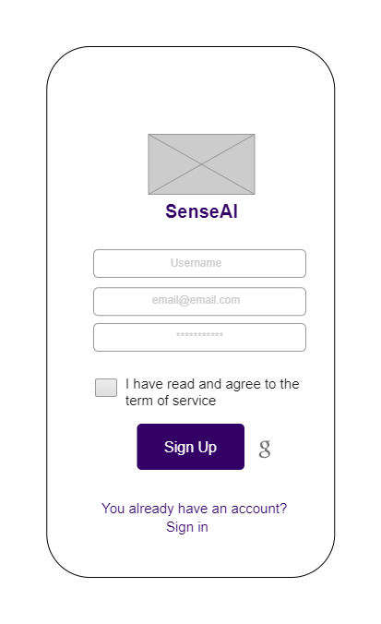If the user clicks on the "forgot password" button, the system directs them to a page where they will write the e-mail that will reset the password. If they enter a valid e-mail, the user should be directed to the page where they will determine the new password. They should click on the "Submit Password" button to save the new password. (Figure 8)

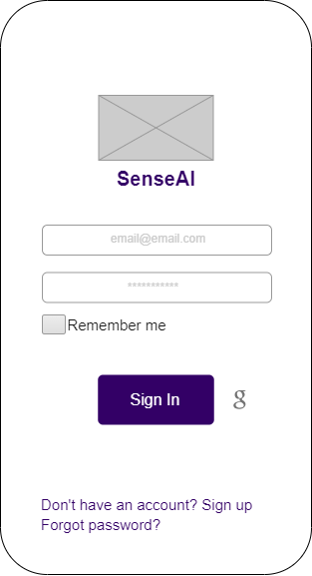

Figure 2 Sign up page

Figure 1 Login page

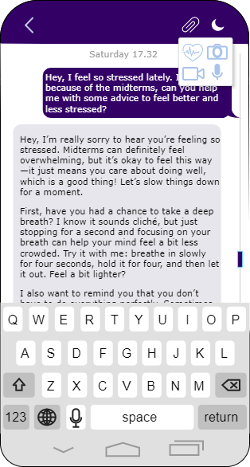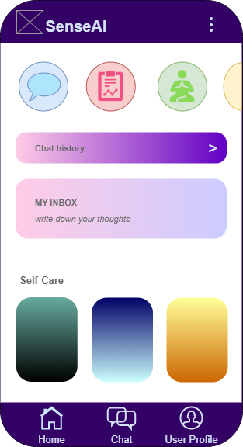

Figure 4 AI chat page

Figure 3 Main page

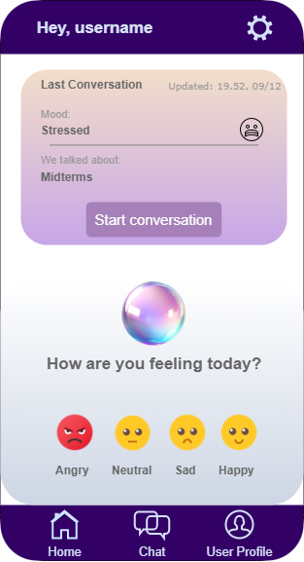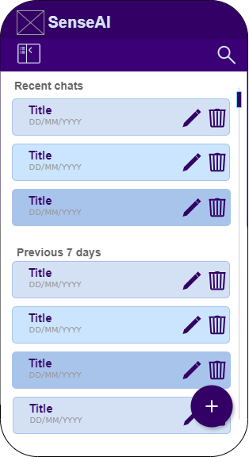

Figure 6 User profile page

Figure 5 Chat history page

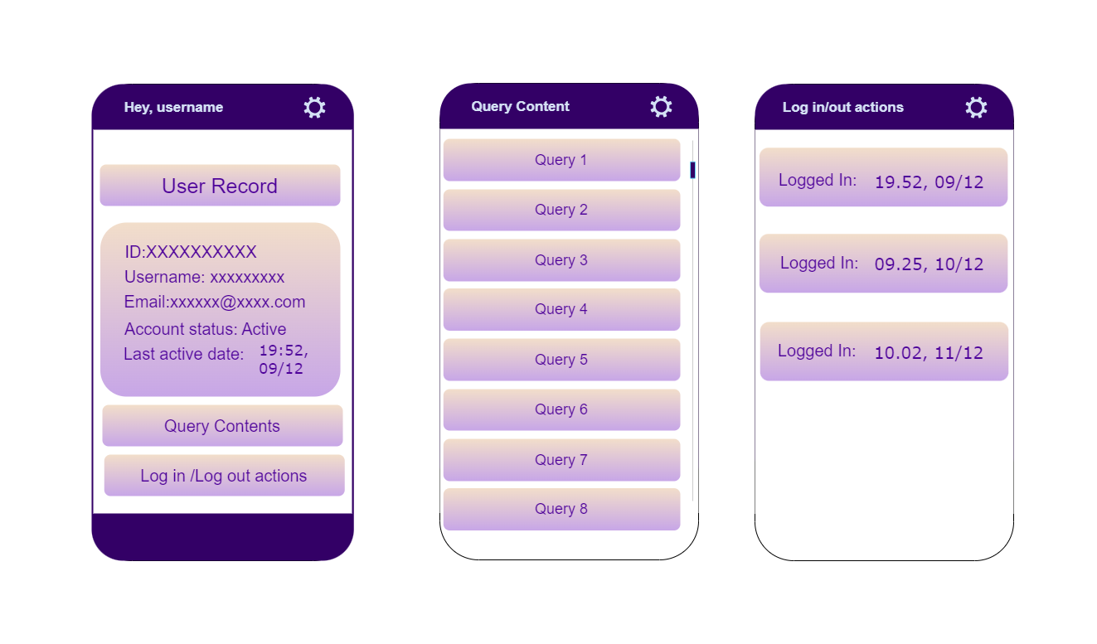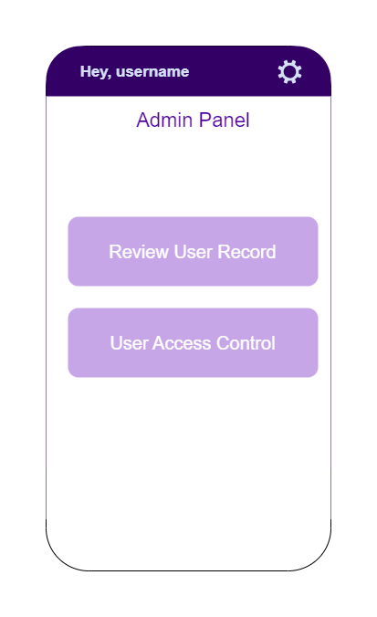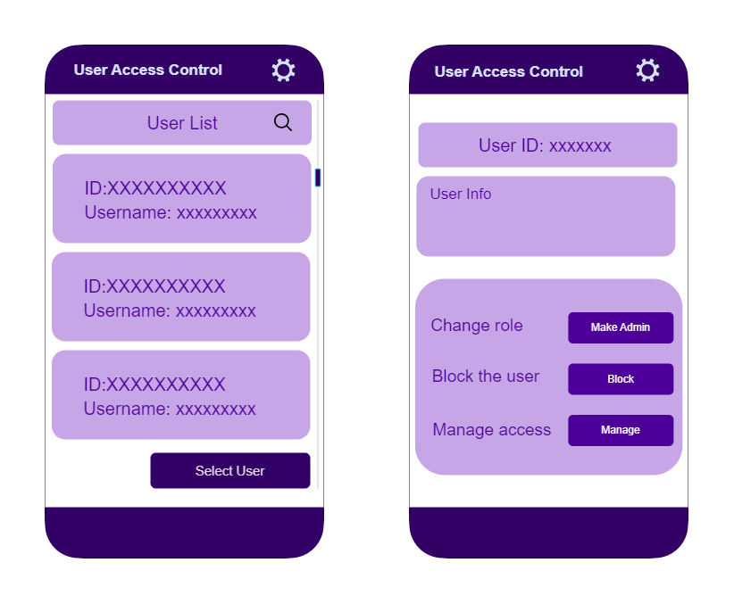metin, ekran görüntüsü, yazı tipi içeren bir resim

Açıklama otomatik olarak oluşturuldu

Figure 7 Admin pages

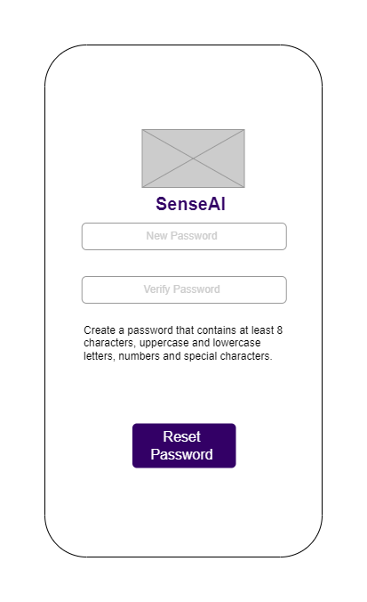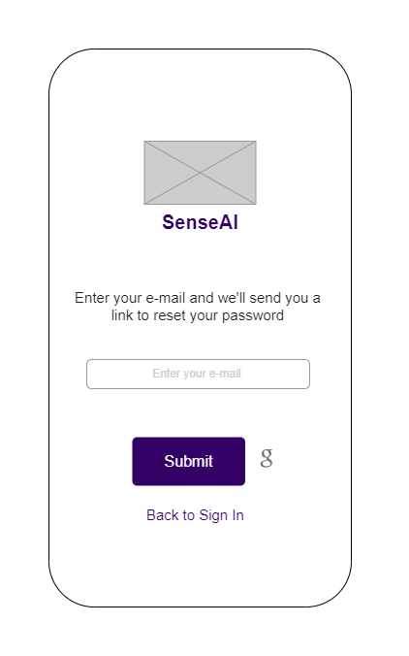

Figure 8 Forgot password pages

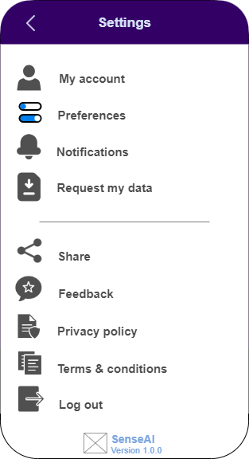

Figure 9 Settings page

### Hardware interfaces

#### 3.1.2.1 Input Devices

* Touchscreen: SenseAI should support touch input on the mobile device’s touchscreen for user interactions such as tapping and swiping.
* Microphone: The devices that users use should support microphone input for inputs sent via voice.
* Camera: Camera should be supported for inputs received from users’ facial expressions.
* Sensor: Smartwatch input should be supported for inputs received from users’ watches.

#### 3.1.2.2 Output Devices

Display: SenseAI should be able to render the user interface on the mobile device's screen, utilizing the available screen resolution and aspect ratio.

#### 3.1.2.3 Network Connectivity

SenseAI will require access to the device's internet connection to communicate with external services.

### Software interfaces

Software Interfaces will have the features mentioned in the 2.1.4 Software Interfaces section.

### Communications interfaces

Communication Interface will have the features mentioned in the 2.1.5 Communication Interfaces section.

## Functional Requirements

In this section, the functional requirements for the SenseAI project will be defined by the system features and the main services provided by the product. Below is the requirement list and use case diagram showing the users and their operations at a high level.

* The system shall analyze the user's emotional state and provide feedback.
* The system shall comply with ethical standards when providing mental health advice and shall be sensitive to users' needs.
* The system shall allow users to register and log in to the application.
* The system shall enable users to send data via text, images, audio, and biometric data.
* The user shall be able to choose what type of query to send from the homepage.
* Users shall be able to start new AI chats and access or delete old chats from their history page.
* The system shall allow users to update and delete the information entered during registration.
* Wearable devices or existing health applications will be used for biometric data integration.
* The system shall be free initially and then charge for premium features. The users shall be able to access some advanced functionalities through in-app purchases or subscriptions.
* The system shall provide a user-friendly interface that is easy to learn and remember. The interface should also have an appealing color palette.
* The system shall guide users to ensure images are taken in sufficient lighting and at appropriate angles to maintain data quality for accurate sentiment analysis.
* Users shall be able to choose dark mode/light mode.
* Users shall be able to search past queries by title and change the query name from history.
* The system shall clearly convey the problem to the users when an error occurs and allow recovery.
* The system shall support user authentication via an external authentication API to secure access to personal data and previous interactions, safeguarding user privacy.
* The system shall initially support the English language, with potential for multilingual expansion in the future.
* The system shall provide a warning message in cases where users send videos and photos that exceed the size or texts exceed the character limit.

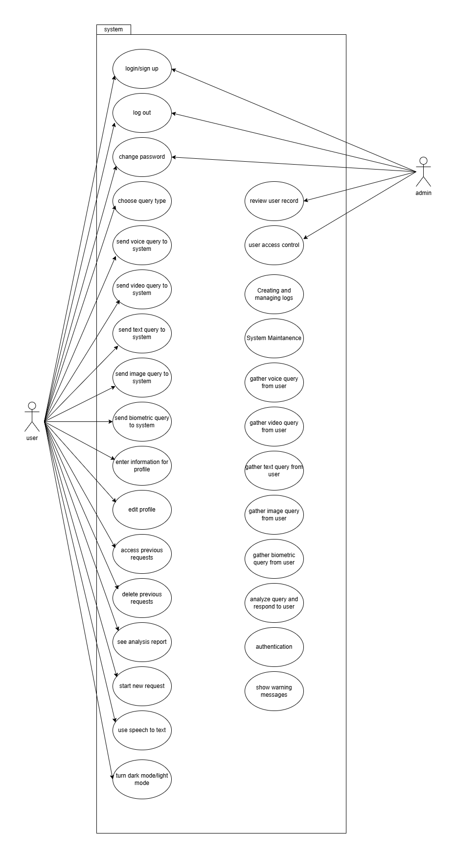

Figure 10 Use Case Diagram

### SenseAI users

#### Logging in

##### Introduction/Purpose of feature

The Logging In feature allows authorized users to securely access the SenseAI application and their personalized data. This feature serves as an entry point to ensure data privacy, personalized experience, and user accountability. The system should let users stay logged in once login is successfully completed.

##### Stimulus/Response sequence

1. System: Check if user logged in before
2. System: Direct to landing page if user logged in
3. System: Else, show login screen with text fields for e-mail and password
4. User: Fills in account info
5. User: Tap login
6. System: Check account credentials and direct user to landing page if correct
7. System: Else show error

##### Associated functional requirements

REQ-1:Users should be able to login with their google accounts.

REQ-2: Users should be able to sign up by inputting their email and a password.

REQ-3: Users should be able to log out whenever they want

REQ-4: Logged in users should stay logged in unless they logged out (closing the app should not log out the users). The login screen should be skipped for already logged in users.

metin, diyagram, çizgi, plan içeren bir resim

Açıklama otomatik olarak oluşturuldu

Figure 11 Login/Sign Up Activity Diagram

#### Forgot password

##### Introduction/Purpose of feature

The system shall allow users to securely update their passwords to maintain account security and protect their personal information. This feature ensures that users can regularly update their credentials or recover access in case of a potential breach.

##### Stimulus/Response sequence

1. System: Display a "Change Password" option in the account settings.
2. User: Taps on the "Change Password" option.
3. System: Prompt the user to input their current password and the new password twice for confirmation.
4. User: Enters the current password and the new password.
5. System: Validates the current password and checks if the new password meets the required security criteria (e.g., length, character mix).
6. System: If validation passes, update the password and confirm the change to the user.
7. System: If validation fails, display an error message and prompt the user to try again.

##### Associated functional requirements

REQ-1: The system must verify the user’s current password before allowing the password to be updated.

REQ-2: The new password must meet defined security standards, including minimum length, inclusion of special characters, and exclusion of easily guessable patterns.

REQ-3: The system should send a confirmation email or notification upon successful password change.

REQ-4: The feature must block repeated use of the last X passwords for additional security.

REQ-5: If the password change attempt fails multiple times, the system must temporarily lock the account to prevent unauthorized access.

#### Sign up

##### Introduction/Purpose of feature

The system shall provide new users with a secure and user-friendly way to create an account. This feature ensures the onboarding process is seamless while verifying the user's identity and maintaining system integrity.

##### Stimulus/Response sequence

1. System: Display a "Sign Up" form with fields for required information (e.g., email, password, name).
2. User: Fills out the required information and submits the form.
3. System: Validate the input data for accuracy and completeness (e.g., valid email format, strong password).
4. System: Check if the email is already associated with an existing account.
5. System: If validation passes, create a new user account and send a confirmation email or message to the provided address.
6. System: If validation fails, display an error message and prompt the user to correct the input.

##### Associated functional requirements

REQ-1: The system must ensure that email addresses are unique and not already in use.

REQ-2: Passwords must meet security criteria, including minimum length, inclusion of special characters, and resistance to dictionary attacks.

REQ-3: The system should require users to verify their email address by sending a confirmation link or code.

REQ-4: The system must encrypt sensitive user data, such as passwords, during storage and transmission.

REQ-5: The system should provide error messages that guide users in correcting any issues with their input (e.g., “Email already in use” or “Password is too weak”).

REQ-6: The feature must comply with data privacy regulations by securely handling user-provided information.

REQ-7: Optional fields for user profile information (e.g., phone number, date of birth) should be clearly marked and not mandatory for account creation.

#### Sending text for analysis

##### Introduction/Purpose of feature

The system shall allow users to input text for emotion and sentiment analysis, enabling SenseAI to interpret emotional cues within user responses. By processing the input, SenseAI’s analysis module will detect underlying emotions (e.g., happiness, sadness, anger) and overall sentiment (positive, negative, neutral).

##### Stimulus/Response sequence

1. System: Show textbox for input
2. User: Enter input.
3. User: Taps "Send" button.
4. System: Validates text input and sends it to the model for analysis with other input types (if exists).
5. System: Displays loading indicator.
6. Model: Processes the input.
7. System: Receives analysis results, saves it to the database and the device.
8. System: Displays results to the user.

##### Associated functional requirements

REQ-1: Chatting with ai should look and feel like the users are chatting with a friends on an app. e.g. both input and output text should be visible as text bubbles and the screen should be vertically scrollable.

REQ-2: The device's keyboard should not obstruct the previous text while writing new inputs.

#### Using voice as input

##### Introduction/Purpose of feature

The system shall allow users to input audio by processing the audio through text-to-speech conversion. It shall also take audio input and analyze it to return a response to the user.

##### Stimulus/Response sequence

1. System: Show microphone icon for input
2. User: Taps the icon
3. User:Speaks to the microphone.
4. System: Detects speech and uses TTS (text to speech) and converts it to text input.
5. System: Validates input and sends it to the model for analysis with other input types (if exists).
6. System: Displays loading indicator.
7. Model: Processes the input.
8. System: Receives analysis results, saves it to the database and the device.
9. System: Displays results to the user.

##### Associated functional requirements

REQ-1: Transcript of the user’s input should be added to the input textbox, ready to be sent.

#### Sending image for analysis

##### Introduction/Purpose of feature

The system shall allow users to input photos using their smart devices for analysis, enabling SenseAI to process the images and extract actionable insights, such as object recognition, emotional tone assessment, or visual patterns, to enhance the overall analysis process.

##### Stimulus/Response sequence

1. System: Show image icon for input
2. User: Taps the icon.
3. System: Enables the front camera for taking a photo
4. User: Takes a photo.
5. System: Validates input and sends it to the model for analysis with other input types (if exists).
6. System: Displays loading indicator.
7. Model: Processes the input.
8. System: Receives analysis results, saves it to the database and the device.
9. System: Displays results to the user.

##### Associated functional requirements

REQ-1: Users should be able to take photos without exiting the app.

#### Sending heartbeat info for analysis

##### Introduction/Purpose of feature

The system shall enable SenseAI to receive and analyze users' heartbeat information to assess emotional or physical states. This analysis will take into account the user’s age, as age-related differences can impact heart rate norms and interpretations. By factoring in age, SenseAI can more accurately identify deviations from typical heartbeat patterns, helping to gauge stress, anxiety, or relaxation levels.

##### Stimulus/Response sequence

1. System: Display option for biometric data input.
2. User: Either check or uncheck the option
3. System**:** Check if the user has checked or unchecked the option for biometric data input. If checked, proceed; if unchecked, skip the biometric data retrieval step.
4. System**:** Check if Google Fit API is successfully connected to the user’s account (is the user authenticated on Google Fit?).
5. System**:** Check if the required biometric data (BPM) is available in Google Fit. If data is unavailable or incomplete, prompt the user to provide manual input or skip this step.
6. System: Access today’s google fit information(BPM) of the user and send it to the model along with other input type (if exists)
7. System: Displays loading indicator.
8. Model: Processes the input.
9. System: Receives analysis results, saves it to the database and the device.
10. System: Displays results to the user.

##### Associated functional requirements

REQ-1: The system should be able to access the latest heartbeat info from the user’s google fit account.

REQ-2: The users should be only able to use this input option if they have a google fit account linked. If no account is linked the option should be grayed out. And tapping it should show a text bubble telling users they need to link their google fit accounts.

REQ-3: If an error occurs while retrieving info or if no data exists, the app should inform the user about the error.

#### Viewing previous analysis (history)

##### Introduction/Purpose of feature

The system shall provide users with access to a history feature, allowing them to view previous analyses and insights generated by SenseAI. This history will include past sentiment, emotion analyses from text, heartbeat, and image inputs, enabling users to track trends and changes over time. By offering a historical view, SenseAI aims to support users in understanding their emotional patterns and progress

##### Stimulus/Response sequence

1. System**:** Display option to view past analysis results
2. User**:** Selects the option to view previous analysis.
3. System**:** Checks if the user has any stored analysis results in the database or device.

* If results are found, proceed.
* If no results are found, display a message such as "No previous analysis available.”

1. System**:** Retrieves and displays a list of previous analysis results.
2. User**:** Selects a specific past analysis entry to view detailed results.
3. System**:** Displays the selected analysis details, including insights, graphs, and any other relevant data.
4. User**:** Optionally, chooses to delete or update past analysis results (if allowed by the system).
5. System**:** If the user deletes or updates, confirms action and updates the database accordingly.
6. System**:** displays the updated history of deletion.

##### Associated functional requirements

REQ-1: History of previous interactions should be displayed with dates.

REQ-2: Users should be able to view the history chronologically ordered.

REQ-3: Users should be able to delete previous talks.

REQ-4: The system should provide a search or filter option, allowing users to find specific past interactions based on keywords or date ranges.

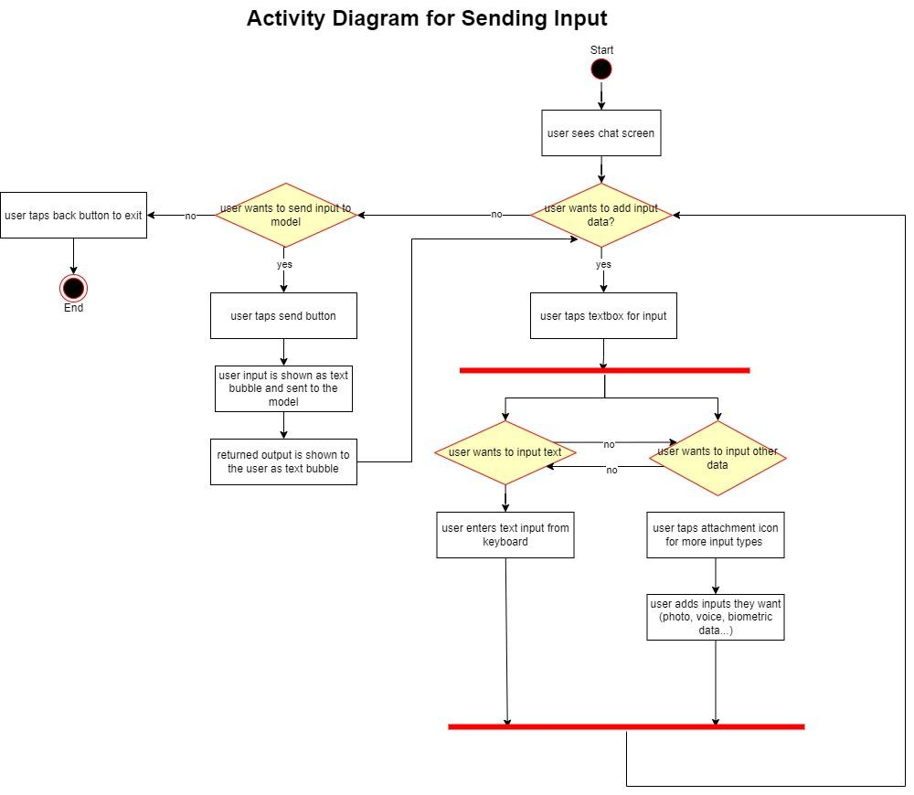

Figure 12 Sending Input Activity Diagram

### Admin

#### 3.2.2.1 Logging in

The Logging In feature allows admins to securely access the SenseAI application and their personalized data. This feature serves as an entry point to ensure data privacy, personalized experience, and user accountability. The system should let users stay logged in once login is successfully completed.

##### Stimulus/Response sequence

1. System: Check if user logged in before
2. System: Direct to landing page if user logged in
3. System: Else, show login screen with text fields for email and password
4. User: Fills in account info
5. User: Tap login
6. System: Check account credentials and direct user to landing page if the user is admin
7. System: Else show error

##### Associated functional requirements

REQ-1: The system must securely authenticate the admin's credentials using industry-standard encryption methods.

REQ-2: The system should store a secure session token to keep the admin logged in until the session expires or the admin logs out manually.

REQ-3: If the user has previously logged in and their session is active, the system should skip the login screen and redirect them directly to the landing page.

REQ-4: Invalid login attempts should trigger appropriate error messages (e.g., "Invalid email or password") without exposing sensitive information.

REQ-5: The system must enforce a retry limit to prevent brute-force login attempts and temporarily lock the account after exceeding the limit.

REQ-6: The login feature must validate that the user has an admin role before granting access to the admin dashboard or personalized data.

REQ-7: A "Forgot Password" option should be available to help admins recover access in case of credential loss.

#### Forgot password

##### Introduction/Purpose of feature

The system shall allow users to securely update their passwords to maintain account security and protect their personal information. This feature ensures that users can regularly update their credentials or recover access in case of a potential breach.

##### Stimulus/Response sequence

1. System: Display a "Change Password" option in the account settings.
2. User: Taps on the "Change Password" option.
3. System: Prompt the user to input their current password and the new password twice for confirmation.
4. User: Enters the current password and the new password.
5. System: Validates the current password and checks if the new password meets the required security criteria (e.g., length, character mix).
6. System: If validation passes, update the password and confirm the change to the user.
7. System: If validation fails, display an error message and prompt the user to try again.

##### Associated functional requirements

REQ-1: The system must verify the user’s current password before allowing the password to be updated.

REQ-2: The new password must meet defined security standards, including minimum length, inclusion of special characters, and exclusion of easily guessable patterns.

REQ-3: The system should send a confirmation email or notification upon successful password change.

REQ-4: The feature must block repeated use of the last X passwords for additional security.

REQ-5: If the password change attempt fails multiple times, the system must temporarily lock the account to prevent unauthorized access.

#### Sign up

##### Introduction/Purpose of feature

The system shall provide new users with a secure and user-friendly way to create an account. This feature ensures the onboarding process is seamless while verifying the user's identity and maintaining system integrity.

##### Stimulus/Response sequence

1. System: Display a "Sign Up" form with fields for required information (e.g., email, password, name).
2. User: Fills out the required information and submits the form.
3. System: Validate the input data for accuracy and completeness (e.g., valid email format, strong password).
4. System: Check if the email is already associated with an existing account.
5. System: If validation passes, create a new user account and send a confirmation email or message to the provided address.
6. System: If validation fails, display an error message and prompt the user to correct the input.

##### Associated functional requirements

REQ-1: The system must ensure that email addresses are unique and not already in use.

REQ-2: Passwords must meet security criteria, including minimum length, inclusion of special characters, and resistance to dictionary attacks.

REQ-3: The system should require users to verify their email address by sending a confirmation link or code.

REQ-4: The system must encrypt sensitive user data, such as passwords, during storage and transmission.

REQ-5: The system should provide error messages that guide users in correcting any issues with their input (e.g., “Email already in use” or “Password is too weak”).

REQ-6: The feature must comply with data privacy regulations by securely handling user-provided information.

REQ-7: Optional fields for user profile information (e.g., phone number, date of birth) should be clearly marked and not mandatory for account creation.

#### 

#### 3.2.2.4 Review user record

##### 3.2.2.4.1 Introduction/Purpose of feature

This feature enables admins to access and manage detailed records of individual users, including their activities, queries, and biometric or manual inputs. It supports efficient monitoring and accountability while ensuring user data privacy and system transparency.

##### 3.2.2.4.2 Stimulus/Response sequence

1. System: Display a list of user records in the admin panel, with options to search and filter users.
2. Admin: Search for or filter the user list to locate a specific user ID,username and select the user record.
3. System: Retrieve and display the selected user's record with the following sections:

* Personal Information:
  + Username, email address, user ID, account status (active/inactive).
* System Interaction Logs:
  + User’s login/logout actions, connection status.
  + The last active date and time on the application.
* Query History:
  + A chronological list of all queries submitted by the user:
    - Query content.
    - Submission date and time.
    - Results or error messages returned for the query.
    - Query status (completed, failed, pending).
* Biometric Data:
  + Latest biometric data (e.g., BPM) if the user is connected to Google Fit.
  + Connection status: "Connected" or "Not Connected."
* Linked Services:
  + Status of connections with external services like Google Fit.

1. System: Display a confirmation dialog for each selected action.
2. Admin: Confirm or cancel the action.
3. System: Execute the action, display a record.

##### 3.2.2.4.3 Associated functional requirements

REQ-1: The system must provide an interface for searching, filtering, and viewing user records.

REQ-2: The user's query history must be displayed in detail, including query content, results, timestamps, and statuses.

REQ-3: Biometric data should only be displayed if the user is connected to an external service like Google Fit.

REQ-4: All admin actions must be logged with action type, timestamp, and admin identity for auditing purposes.

REQ-5: User details can only be edited or deleted by authorized admins.

REQ-6: The query history must support search and filter functionality for efficient review.

REQ-7: The system must maintain separate logs for user and admin activities.

#### 3.2.2.5 User access control

##### 3.2.2.5.1 Introduction/Purpose of feature

This feature allows admins to manage and regulate user access within the system. It enables the assignment of roles, permission settings, and account status management, ensuring that users can only access the resources and actions appropriate to their role. This is critical for maintaining security, privacy, and operational efficiency within the application.

##### 3.2.2.5.2 Stimulus/Response sequence

1. System: Search users with options to search, filter, and sort by roles, permissions, or activity status (active/inactive).  
   Admin: Select a specific user from the list to review or modify their access permissions.  
   System: Retrieve and display the selected user’s access details.
2. Admin: Closes an account, changes access permissions, or changes the role of another account.
3. System: Display a confirmation dialog summarizing the changes.
4. Admin: Confirm or cancel the action.  
   System: Execute the changes, update the user’s record in the database, and display a success or error message.

##### 3.2.2.5.3 Associated functional requirements

REQ-1 The system must provide a unified dashboard for searching, filtering, and managing user access.

REQ-2 Changes to roles, permissions, or account statuses must show their impact clearly before confirmation.

REQ-3 The system must maintain an audit log of all actions performed, including timestamps, changes, and admin details.

REQ-4 Account status changes should have safeguards (e.g., warnings) to prevent unintentional lockouts.

REQ-5 Permissions and roles should be manageable independently to ensure granular control over access.

## Performance requirements

* The application shall be available 24/7 to ensure accessibility at any time.
* 95% of system responses to user requests shall be completed within 1 minute to ensure timely feedback.
* The system shall initially support up to 5 simultaneous users, with scalability to support more users as the application matures and a more advanced hardware is provided.
* The system shall handle multimodal data types, including text, images, audio, and biometric data.
* Users who engage with audio and video functionalities shall use compatible devices to ensure smooth data transmission and processing.

## Logical database requirements

The system must ensure 24/7 availability of the database without any interruption or service interruption. The database will be backed up daily to ensure uninterrupted accessibility of the database in the event of hardware or software failure, to ensure data integrity and to support disaster recovery procedures. Users' past queries will be stored in the database indefinitely until the user deletes them.

## Design constraints

The server's processor power, RAM and storage capacity should not negatively affect the performance of the Chatbot as the number of users increases. The device should support microphone, camera, smart watch, touchscreen features.

### Standards compliance

#### Material Design Guidelines

Sense AI’s user interface will be designed in accordance with Google’s Material Design Principles to provide a consistent, modern, and user-friendly experience. Material Design provides a comprehensive guide to visual design, motion, and interaction principles that enhance usability and add aesthetic appeal. This design approach makes it easy for users to interact naturally with the chatbot, while providing a professional and reliable interface standard.

## Software system attributes

### Reliability

A chatbot system that provides psychological support is critical in terms of reliability. The system must provide a sustainable service without losing users' past conversations and analyses. Therefore, regular data backup mechanisms will be implemented. In addition, continuous tests will be conducted to minimize system errors and provide uninterrupted service.

### Availability

The system should be available 24/7 and include recovery and restart mechanisms for disaster recovery situations. High availability (HA) infrastructure will be used to minimize user waiting time.

### Security

Users’ personal data and chat content must be protected against both accidental and malicious access. Security measures will include:

* Use of reliable cryptographic algorithms (e.g. AES-256) to encrypt data,
* Two-factor authentication for user logins,
* Role-based access control to ensure only authorized individuals can access sensitive data,
* Regular verification processes to ensure data integrity.

### Maintainability

The chatbot will be developed in a modular structure. Each function will be in a separate module and these modules can be updated or changed independently when necessary. Thanks to the object-oriented design, it will be easy to expand the chatbot by adding new features or improving existing features. The system should allow automatic updates to be installed remotely via the Google Play Store and Apple App Store without requiring user intervention. Updates should not disrupt the user experience and should ensure the integrity and security of the data. The system will apply Over-the-Air (OTA) updates to keep the system up to date via the Google Play Store and Apple App Store.

### Portability

The mobile application that offers psychological support will be developed in a way that it can work seamlessly on different mobile devices and operating systems (iOS, Android). In this direction:

* Platform-dependent codes will be minimized,
* Tools that provide cross-platform compatibility will be used in the development process,
* It will be optimized to meet the requirements of mobile application stores,
* Its compatibility with various screen sizes and resolutions will be tested.
* This approach will ensure that the application offers a seamless user experience on different devices.

# References

|  |  |
| --- | --- |
| [1] | Software Engineeering Department, "Graduation Projects," SENG, [Online]. Available: https://seng.cankaya.edu.tr/graduation-projects/. [Accessed 28 June 2024]. |

[2] H. Lian, C. Lu, S. Li, Y. Zhao, C. Tang, and Y. Zong, "A Survey of Deep Learning-Based Multimodal Emotion Recognition: Speech, Text, and Face," *Entropy*, vol. 25, no. 10, pp. 1440, 2023. doi: 10.3390/e25101440

[3] Archana Sharma, Anuradha Saxena, Ashok Kumar, ve Divyansh Singh, "Depression Detection Using Multimodal Analysis with Chatbot Support," *2023 IEEE International Conference on Computational Intelligence and Data Science (ICCIDS)*, Chennai, Hindistan, 2023, ss. 1-6, doi: 10.1109/ICCIDS56901.2023.10489080

[4] S. Wang, Z. Zhang, B. Chen, Z. Zhang, W. Fang, and J. Pan, "Multimodal Emotion Recognition Based on Facial Expressions, Speech, and EEG," *IEEE Transactions on Affective Computing*, vol. 13, no. 1, pp. 142-154, Jan.-March 2022, doi: 10.1109/TAFFC.2021.10026861.

[5] J. Yan, P. Li, C. Du, K. Zhu, X. Zhou, Y. Liu, and J. Wei, "Multimodal Emotion Recognition Based on Facial Expressions, Speech, and Body Gestures," *Electronics*, vol. 13, no. 18, p. 3756, Sep. 2024, doi: 10.3390/electronics13183756.