|  |  |  |
| --- | --- | --- |
| amblem | **ÇANKAYA UNIVERSITY**  **Software Engineering Department** |  |

**SENG 491 – 492 Graduation Project**

**Software Design**

**Description**

**SenseAI**

**Ece Heval Ünal**

**Mustafa Tozman**

**Özge Alkan**

**Sadrettin Anıl Karaçay**

**Zeliha Aybüke Baştürk**

**Version 1.1**

Table of Contents

1 Introduction 1

1.1 Purpose 1

1.2 Scope 1

1.3 Definitions, acronyms, and abbreviations 1

1.4 References 1

1.5 Overview 1

1.6 Version History 1

2 Architecture 1

2.1 Clients 2

2.1.1 Mobile Phones 2

2.1.2 Tablets 2

2.1.3 Personal Computers 2

2.2 Application Server 2

2.3 Database Server 2

3 User Interface 2

3.1 Screen 1 3

3.2 Screen 2 3

3.3 … 3

4 High Level Design 3

4.1 Module 1 4

4.2 Module 2 4

4.3 Module ... 4

5 Low Level Design 4

5.1 Module 1 5

5.2 Module 2 5

5.3 Module … 5

6 Database Design 5

6.1 E-R Diagram 5

6.2 Tables 5

6.2.1 Table 1 5

6.2.2 Table 2 5

6.2.3 Table … 5

7 References 6

# Introduction

## Purpose

The purpose of this Software Requirements Specification (SRS) is to provide a comprehensive overview of the functional and non-functional requirements for the **SenseAI** project. This document serves as a foundational guide for the design, development, and deployment of the application. It ensures all stakeholders have a shared understanding of the system's objectives and specifications while reducing ambiguity and promoting consistency during the project's lifecycle.

The primary audience for this SRS includes:

* **Development Team:** To implement the features and functionality outlined in the requirements.
* **Project Stakeholders:** To ensure the application aligns with business objectives and user needs.
* **Quality Assurance Team:** To validate that the system meets the specified requirements.
* **End-User Representatives:** To provide feedback and confirm the application addresses their expectations.
* **Future Developers/Maintainers:** To understand the original design and purpose for updates or maintenance.

This document is designed to be accessible and useful for both technical and non-technical stakeholders.

## Scope

The software product to be developed is **SenseAI**, a mobile psychology chatbot application designed to analyze emotional states and assist users in managing their mental well-being.

**What SenseAI will do:**

* **Camera Integration:** Analyze facial expressions to interpret the user’s emotional state.
* **Speech-to-Text (STT):** Convert user speech to text for processing by the AI.
* **Heart Rate Monitoring:** Retrieve BPM data from connected smartwatches for additional mood analysis. (Google Fit will be utilised to achieve this)
* **Chatbot Support:** Provide AI-driven conversational support to guide users through mental wellness strategies.
* **Recommendations:** Offer personalized activities or content based on user mood and inputs.

**What SenseAI will not do:**

* SenseAI will not replace professional therapy sessions.

**Application Benefits and Goals:**SenseAI is targeted at individuals seeking a convenient, AI-powered companion for mental health support. It aims to:

* Improve accessibility to basic mental wellness tools.
* Provide emotional feedback and personalized suggestions.
* Leverage non-invasive biometric data to enhance user experience.
* Deliver a user-friendly interface for seamless interaction.

Ensure data security and user privacy

## Definitions, acronyms, and abbreviations

|  |  |
| --- | --- |
| Term | Description |
| AI Modal | Artificial Intelligence Modal |
| IOS | iPhone Operating System |
| IP | Internet Protocol Address |
| OS | Operating System |
| RAM | Random Access Memory |
| SSD | Solid State Disk |

## References

See 7. References section.

## Overview

This document details the design and development process of a software or system. Below are summaries of the topics covered in each section:

**Architecture (Section 2)**

This section outlines the overall architecture of the system. It describes the architectural components, structures on the client and server sides, and how these components interact with each other. The main components of the system and their interconnections are detailed.

**User Interface (Section 3)**

The user interface design is explained in this section. The design of different screens and the functionalities they provide are discussed. Interface components and the interaction methods used to improve user experience are described.

**High Level Design (Section 4)**

This section provides a high-level design of the system. The structures and functions of the main modules are discussed in broad terms. The basic roles of each module, their functions, and the relationships between the modules are summarized.

**Low Level Design (Section 5)**

This section delves into the detailed design of each module. It explains how each module operates, including the algorithms used and the data flows. Technical details of each module are provided.

**Database Design (Section 6)**

This section explains the database design. It provides information on the database structure, relationships, tables, and how the database will be organized. Entity-relationship diagrams, tables, and their relationships are detailed.

**References (Section 7)**

The final section lists all the sources and references cited throughout the document. It includes technical documents, libraries, and other relevant materials used.

## Version History

Provide a table of table of changes to this document

|  |  |  |
| --- | --- | --- |
| **Version No** | **Description of change** | **Date** |
| 1.0 | Initial Release | 16.12.2024 |
| 1.1 | Diagrams added | 25.12.2024 |

# Architecture

## Clients

### Mobile Phones

**Minimum Requirements:**

* OS: Android 10.0 or iOS 13.0 and above.
* RAM: Minimum 2 GB (recommended 4 GB or more).
* Storage: At least 150 MB available space.
* Network: Active internet connection (Wi-Fi or 4G/5G recommended).

### Tablets

• **Minimum Requirements:**

* OS: Android 10.0 (Oreo) or iOS 13.0 and above.
* RAM: Minimum 2 GB (recommended 4 GB or more).
* Storage: At least 150 MB available space.
* Network: Active internet connection (Wi-Fi or 4G/5G recommended).

## Application Server

• **Minimum Requirements:**

* OS: Ubuntu 20.04 LTS or Windows Server 2019.
* CPU: Quad-core processor.
* RAM: Minimum 8 GB.
* Storage: At least 500 GB available space.
* Network: High-speed internet connection with static IP.

## Database Server

• **Minimum Requirements:**

* OS: Ubuntu 20.04 LTS or Windows Server 2019.
* CPU: Quad-core processor.
* RAM: Minimum 16 GB.
* Storage: At least 1 TB SSD.
* Network: High-speed internet connection.

# User Interface

## Login Page

|  |  |
| --- | --- |
| Title | SenseAI |
| E-mail Field | Field where the user will enter his/her e-mail address. Accepts data only in e-mail format. |
| Password Field | The field where the user will enter the password. The characters are displayed hiddenly. |
| Remember Me Checkbox | Provides the option for the user to remember their login information. |
| Sign In Button | The main action button that allows the user to log in. |
| Google Login Icon | Icon that allows you to log in with a Google account. |
| Sign Up Link | Referral link for user to create account |
| Forgot Password Link | Allows the user to go to the reset screen when they forget their password. |

## Sign Up Page

|  |  |
| --- | --- |
| Title | SenseAI |
| Username Field | Textbox for entering the user's username. |
| E-mail Field | Field where the user will enter his/her e-mail address. Accepts data only in e-mail format. |
| Password Field | The field where the user will enter the password. The characters are displayed hiddenly. |
| Checkbox | Checkbox labeled *"I have read and agree to the term of service"*. Users must check this box before signing up. |
| Sign Up Button | Main button for account creation, highlighted in purple. |
| Google Sign-Up Button | Secondary button with Google icon for signing up via Google authentication. |
| Sign In Link | Text link for existing users to navigate to the login page. Label: *"You already have an account? Sign in"* |

|  |  |
| --- | --- |
| Title | SenseAI |
| Chat History Section | Button with text and a right arrow for accessing previous chat sessions. Label: *"Chat history"*. |
| My Inbox Section | Button with text for accessing a note-taking feature. Placeholder: *"Write down your thoughts"*. |
| Self-Care | A section displaying gradient-colored cards/buttons representing various self-care activities or tools. |
| Home Button | Tab with a home icon for navigating to the main page. |
| Chat Button | Tab with a chat bubble icon for accessing chat page. |
| User Profile Button | Tab with a user icon for see account details. |
| 3 Dots Button | Tab with 3 dots icon for managing account. |

## Main Page

|  |  |
| --- | --- |
| Date and time | Shows last conversation time. |
| Paperclip Button | Shows the options for the type of data to be sent. |
| Moon Button | Button that changes dark mode/light mode. |
| Heart Rhythm Button | Chatbot allows biometric data collection. |
| Camera Button | Chatbot allows to get photo data. |
| Video Button | Chatbot allows to get video data. |
| Microphone Button | Receives voice data from the user for the text-to-speech feature. |
| Purple Speech Bubble | Shows the query sent by the user to the chatbot. |
| Gray Speech Bubble | Shows the answers the chatbot returns to the user. |
| Keyboard | Used to receive text data from the user. |
| Back Button | Redirects to the previous page. |

## AI Chat Page

|  |  |
| --- | --- |
| Title | SenseAI |
| Sub-Title | Recent chats |
| Title(in box) | Shows the title of the chat. |
| Date | Shows the chat’s date. |
| Pen Button | Edit the chat. |
| Bin Button | Delete the chat. |
| Search Button | Search the chat from the chats. |
| Sub-Title | Previous 7 days |
| Plus Button | Redirects to the chat page to add a new chat. |
| Back Button | Redirects previous page. |

## Chat History Page

|  |  |
| --- | --- |
| Title | Hey,[username] |
| Sub-Title | Last Conversation |
| Date and time | Shows the last conversation date and time. |
| Sub-Title | Mood |
| Mood Field | Shows mood type. |
| Mood Icon | Shows mood icon. |
| Sub-Title | We talked about. |
| Chat name field | Shows the lastest chat title. |
| Start Conversation Title | Tab for start new chat. |
| Sub-Title | How are you feeling today? |
| Mood Icons | User select for the day mood. |
| Home Button | Tab with a home icon for navigating to the main page. |
| Chat Button | Tab with a chat bubble icon for accessing chat page. |
| User Profile Button | Tab with a user icon for see account details. |
| Wheel Button | Tab with wheel icon for manage account. |

## User Profile Page

## Admin Pages

|  |  |
| --- | --- |
| Title | Hey,[username] |
| Sub-Title | Admin Panel |
| Wheel Button | Tab with wheel icon for manage account. |
| Review User Record | Shows users record page to admin. |
| User Access Control Button | Shows user access control page to admin. |

### User Record Page

|  |  |
| --- | --- |
| Title | User List |
| User Fields | Shows users as a list. |
| Search Button | Admin searchs users with ID or username. |
| Select User Button | Tab the one of user then tab to this button for select the user. |
| Wheel Button | Tab with wheel icon for manage account. |

|  |  |
| --- | --- |
| Title | Hey,[username] |
| Sub-Title | User Record |
| Record Field | Shows the record informations of user to admin. |
| Query Contents | Redirected query content page. |
| Log in/Log out actions | Redirected log in/out actions page. |
| Wheel Button | Tab with wheel icon for manage account. |

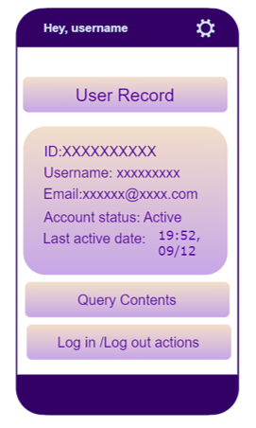

|  |  |
| --- | --- |
| Title | Query Content |
| Query Botton | Shows the queries to admin. Tab to see information about query. |
| Wheel Button | Tab with wheel icon for manage account. |

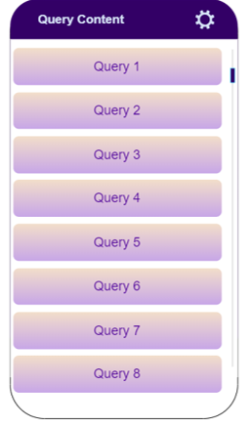

|  |  |
| --- | --- |
| Title | Log in/out actions |
| Logged in/out Fields | Shows the login/out information of user to admin. |
| Date and time | Shows users log in/out information to admin. |
| Wheel Button | Tab with wheel icon for manage account. |

### User Access Control Page

|  |  |
| --- | --- |
| Title | User List |
| User Fields | Shows users as a list. |
| Search Button | Admin searches users with ID or username. |
| Select User Button | Tab the one of user then tab to this button for select the user. |
| Wheel Button | Tab with wheel icon for manage account. |

|  |  |
| --- | --- |
| Title | User Access Control |
| User ID Field | Shows user’s ID information. |
| User Info Field | Shows the information of user. |
| Sub-Title | Change Role |
| Make Admin Button | Tab to button form changing user role. |
| Sub-Title | Block the user. |
| Block Button | Tab to block the user. |
| Sub-Title | Manage Access |
| Manage Button | Tab to manage accessing of user. |
| Wheel Button | Tab with wheel icon for manage account. |

## Forgot Password Pages

|  |  |
| --- | --- |
| Title | SenseAI |
| Explanation Part | Explanation for directing user. |
| E-mail Field | Field where the user will enter his/her e-mail address. Accepts data only in e-mail format. |
| Submit Button | Submit for e-mail address. |
| Back to Sign In Link | Redirected user Sign In Page. |
| Google Sign-Up Button | Secondary button with Google icon for signing up via Google authentication. |

|  |  |
| --- | --- |
| Title | SenseAI |
| New Password Field | Field where the user will enter new password. |
| Verify Password Field | Field where the user will verify new password. |
| Reset Password Button | Button for resetting password. |
| Explanation Part | Explain the new password constraints. |

## Settings Page

BURAYA TABLO EKLENECEK

# High Level Design

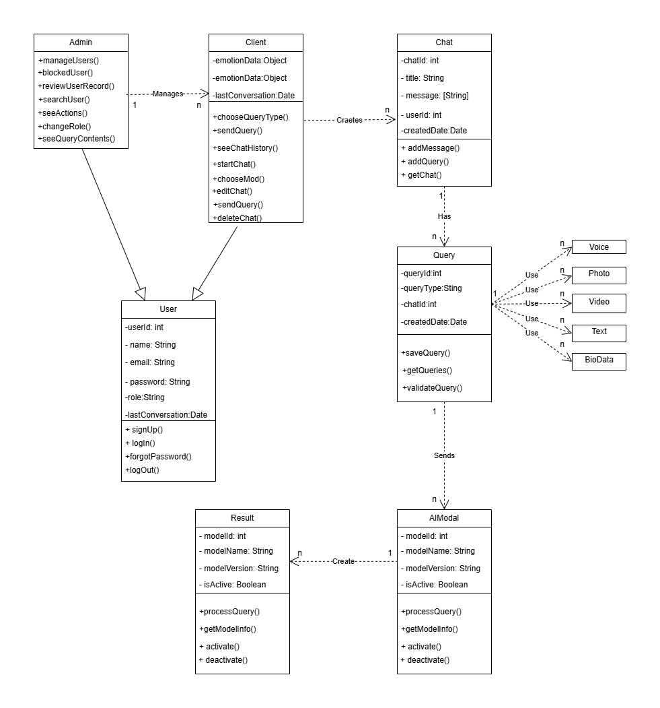

## Module 1

Brief Description.

## Module 2

Brief Description.

## Module ...

# Low Level Design

## Module 1

## Module 2

## Module 3

# Database Design

Provide an E-R diagram and a description of each table.

## E-R Diagram

## Tables

### Table 1

List all the attributes of the table and provide the characteristics of each attribute (Key, Type, size, etc.)

### Table 2

List all the attributes of the table and provide the characteristics of each attribute (Key, Type, size, etc.)

### Table …

# References

The resources used to produce this document should be listed here and referenced in the relevant text of this document

|  |  |
| --- | --- |
| [1] | Software Engineeering Department, "Graduation Projects," SENG, [Online]. Available: https://seng.cankaya.edu.tr/graduation-projects/. [Accessed 28 June 2024]. |