|  |  |  |
| --- | --- | --- |
| amblem | **ÇANKAYA UNIVERSITY**  **Software Engineering Department** |  |

**SENG 491 – 492 Graduation Project**

**Software Design**

**Description**

**SenseAI**

**Ece Heval Ünal**

**Mustafa Tozman**

**Özge Alkan**

**Sadrettin Anıl Karaçay**

**Zeliha Aybüke Baştürk**

**Version 1.2**

Table of Contents

1 Introduction 1

1.1 Purpose 1

1.2 Scope 1

1.3 Definitions, acronyms, and abbreviations 1

1.4 References 2

1.5 Overview 2

1.6 Version History 2

2 Architecture 3

2.1 Clients 3

2.1.1 Mobile Phones / Tablets 3

2.2 Minimum Requirements: 3

2.3 Application Server 3

2.4 Database Server 3

3 User Interface 4

3.1 Login Page 4

3.2 Sign up Page 5

3.3 Main Page 6

3.4 AI Chat Page 7

3.5 Chat History Page 8

3.6 User Profile Page 9

3.7 Admin Pages 9

3.7.1 Admin Panel 9

3.7.2 User Record Page 10

3.7.3 Query Page 11

3.7.4 Log Information Page 11

3.7.5 User Access Control Page 12

3.7.6 Configuration Page 13

3.8 Forgot Password Pages 14

3.9 Settings Page 15

4 High Level Design 16

4.1 Server Module 17

4.2 AIModel Module: 17

4.3 Chat Management Module 17

4.4 Profile Management Module 17

4.5 Authentication Module 17

4.6 Client App Module 17

4.7 Chat Manager Module 18

5 Low Level Design 18

5.1 Authentication Module 18

5.2 Chat Manager Module 19

5.3 Profile Management Module 20

6 Database Design 20

6.1 E-R Diagram 20

6.2 Tables 21

6.2.1 User 21

6.2.2 Report 21

6.2.3 MoodEntry 22

6.2.4 Session 22

6.2.5 ChatMessage 22

6.2.6 Device 22

6.2.7 Data 23

7 References 23

# Introduction

## Purpose

The purpose of this Software Design Document (SDD) is to provide a comprehensive and detailed description of the architecture, design, and implementation approach for the SenseAI project. The SDD serves as a blueprint to ensure that all stakeholders have a clear understanding of the system’s structure, its components, and their interactions.

This document is intended for:

* **Development Team:** To implement the features and functionality outlined in the requirements.
* **Project Stakeholders:** To review and validate the proposed design.
* **Quality Assurance Team:** To understand the system design for testing purposes.
* **End-User Representatives:** To provide feedback and confirm the application addresses their expectations.
* **Project Managers**: To ensure the design aligns with project objectives.
* **Future Developers/Maintainers:** To understand the original design and purpose for updates or maintenance.

This document is designed to be accessible and useful for both technical and non-technical stakeholders.

## Scope

This SDD outlines the design of the SenseAI system, which aims to facilitate mood tracking, data analysis, and session-based communication.

The document will cover:

* The overall system architecture.
* Detailed descriptions of system components and their interactions.
* Data models and storage mechanisms.
* Interfaces and dependencies.
* Non-functional requirements, such as performance and scalability.

The SDD will not include:

* Detailed implementation code.
* End-user documentation or training materials.

The intended audience includes developers, testers, project managers, and stakeholders who are involved in the project lifecycle.

## Definitions, acronyms, and abbreviations

|  |  |
| --- | --- |
| Term | Description |
| AI Model | Artificial Intelligence Model |
| IOS | iPhone Operating System |
| IP | Internet Protocol Address |
| OS | Operating System |
| RAM | Random Access Memory |
| SSD | Solid State Disk |

## References

*Software Design Description (SDD) IEEE 1016-2009*, 2017. [Online]. Available: https://cengproject.cankaya.edu.tr/wp-content/uploads/sites/10/2017/12/SDD-ieee-1016-2009.pdf. [Accessed: Dec. 27, 2024].

## Overview

This document details the design and development process of a software or system. Below are summaries of the topics covered in each section:

**Architecture (Section 2):** This section outlines the overall architecture of the system. It describes the architectural components, structures on the client and server sides, and how these components interact with each other. The main components of the system and their interconnections are detailed.

**User Interface (Section 3):** The user interface design is explained in this section. The design of different screens and the functionalities they provide are discussed. Interface components and the interaction methods used to improve user experience are described.

**High Level Design (Section 4):** This section provides a high-level design of the system. The structures and functions of the main modules are discussed in broad terms. The basic roles of each module, their functions, and the relationships between the modules are summarized.

**Low Level Design (Section 5):** This section delves into the detailed design of each module. It explains how each module operates, including the algorithms used and the data flows. Technical details of each module are provided.

**Database Design (Section 6)**: This section explains the database design. It provides information on the database structure, relationships, tables, and how the database will be organized. Entity-relationship diagrams, tables, and their relationships are detailed.

**References (Section 7):** The final section lists all the sources and references cited throughout the document. It includes technical documents, libraries, and other relevant materials used.

## Version History

|  |  |  |
| --- | --- | --- |
| **Version No** | **Description of change** | **Date** |
| 1.0 | Initial Release | 16.12.2024 |
| 1.1 | Updated activity diagrams | 22.12.2024 |
| 1.2 | Last version | 27.12.2024 |

# Architecture

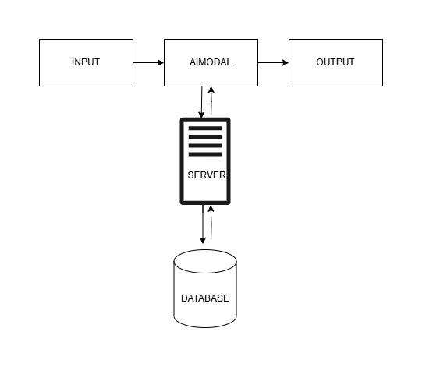

*Figure 1 Hardware Diagram*

## Clients

### Mobile Phones / Tablets

## ****Minimum Requirements:****

* **OS: Android 10.0 or iOS 13.0 and above**
* **RAM: 4 GB minimum (6 GB or more recommended for better performance)**
* **Storage: 200 MB of available space (additional space may be required for user data and media)**
* **Network: Active internet connection (Wi-Fi or 4G/5G recommended for reliable performance)**

## Application Server

**Minimum Requirements:**

* OS: Ubuntu 20.04 LTS or Windows 10/11 (Desktop versions)
* CPU: Dual-core processor (Intel i3/Ryzen 3 or higher)
* RAM: 8 GB minimum (16 GB recommended for smooth operation)
* Storage: 50 GB available space (SSD for better performance)
* Network: Standard internet connection (at least 20-50 Mbps)

## Database Server

**Minimum Requirements:**

* OS: Ubuntu 20.04 LTS or Windows 10/11
* CPU: Dual-core processor (Intel i3/Ryzen 3 or higher)
* RAM: 8 GB minimum (16 GB recommended)
* Storage: 256 GB SSD (for fast read/write operations)
* Network: Standard internet connection (at least 20-50 Mbps).

# User Interface

## Login Page

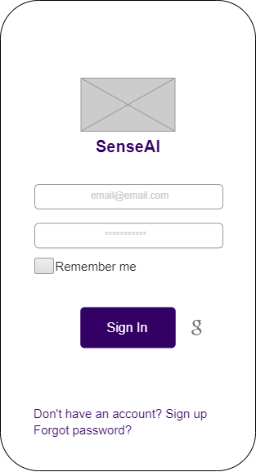

*Figure 2 Login Page*

|  |  |
| --- | --- |
| Title | SenseAI |
| E-mail Field | Field where the user will enter his/her e-mail address. Accepts data only in e-mail format. |
| Password Field | The field where the user will enter the password. The characters are displayed hiddenly. |
| Remember Me Checkbox | Provides the option for the user to remember their login information. |
| Sign In Button | The main action button that allows the user to log in. |
| Google Login Icon | Icon that allows you to log in with a Google account. |
| Sign Up Link | Referral link for user to create account |
| Forgot Password Link | Allows the user to go to the reset screen when they forget their password. |

## Sign up Page

*Figure 3 Sign up Page*

|  |  |
| --- | --- |
| Title | SenseAI |
| Username Field | Textbox for entering the user's username. |
| E-mail Field | Field where the user will enter his/her e-mail address. Accepts data only in e-mail format. |
| Password Field | The field where the user will enter the password. The characters are displayed hiddenly. |
| Checkbox | Checkbox labeled *"I have read and agree to the term of service"*. Users must check this box before signing up. |
| Sign Up Button | Main button for account creation, highlighted in purple. |
| Google Sign-Up Button | Secondary button with Google icon for signing up via Google authentication. |
| Sign In Link | Text link for existing users to navigate to the login page. Label: *"You already have an account? Sign in"* |

## Main Page

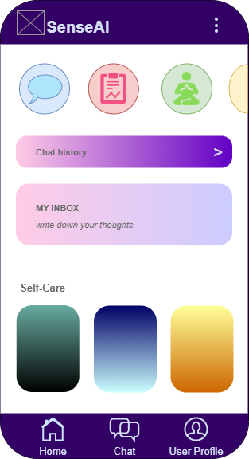

*Figure 4 Main Page*

|  |  |
| --- | --- |
| Title | SenseAI |
| Chat History Section | Button with text and a right arrow for accessing previous chat sessions. Label: *"Chat history"*. |
| My Inbox Section | Button with text for accessing a note-taking feature. Placeholder: *"Write down your thoughts"*. |
| Self-Care | A section displaying gradient-colored cards/buttons representing various self-care activities or tools. |
| Home Button | Tab with a home icon for navigating to the main page. |
| Chat Button | Tab with a chat bubble icon for accessing chat page. |
| User Profile Button | Tab with a user icon for see account details. |
| 3 Dots Button | Tab with 3 dots icon for managing account. |

## AI Chat Page

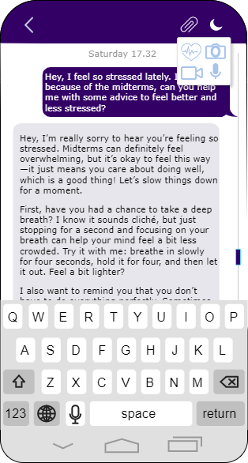

*Figure 5 AI Chat Page*

|  |  |
| --- | --- |
| Date and time | Shows last conversation time. |
| Paperclip Button | Shows the options for the type of data to be sent. |
| Moon Button | Button that changes dark mode/light mode. |
| Heart Rhythm Button | Chatbot allows biometric data collection. |
| Camera Button | Chatbot allows to get photo data. |
| Video Button | Chatbot allows to get video data. |
| Microphone Button | Receives voice data from the user for the text-to-speech feature. |
| Purple Speech Bubble | Shows the query sent by the user to the chatbot. |
| Gray Speech Bubble | Shows the answers the chatbot returns to the user. |
| Keyboard | Used to receive text data from the user. |
| Back Button | Redirects to the previous page. |

## Chat History Page

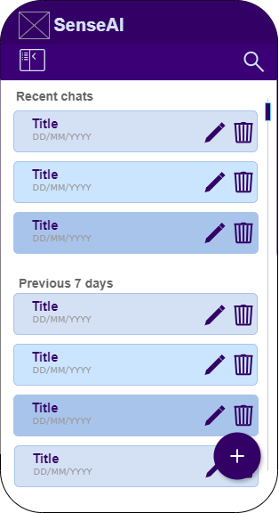

*Figure 6 Chat History Page*

|  |  |
| --- | --- |
| Title | SenseAI |
| Sub-Title | Recent chats |
| Title (in box) | Shows the title of the chat. |
| Date | Shows the chat’s date. |
| Pen Button | Edit the chat. |
| Bin Button | Delete the chat. |
| Search Button | Search the chat from the chats. |
| Sub-Title | Previous 7 days |
| Plus Button | Redirects to the chat page to add a new chat. |
| Back Button | Redirects to the previous page. |

## User Profile Page

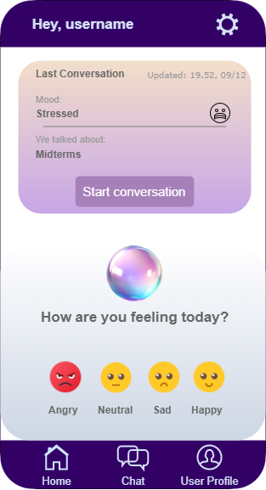

*Figure 7 User Profile Page*

|  |  |
| --- | --- |
| Title | Hey, [username] |
| Sub-Title | Last Conversation |
| Date and time | Shows the last conversation date and time. |
| Sub-Title | Mood |
| Mood Field | Shows mood type. |
| Mood Icon | Shows mood. |
| Sub-Title | We talked about. (Shows the latest chat topic) |
| Chat name field | Shows the latest chat title. |
| Start Conversation Title | Tab for start new chat. |
| Sub-Title | How are you feeling today? |
| Mood Icons | Users select mood for the day. |
| Home Button | Tab with a home icon for navigating to the main page. |
| Chat Button | Tab with a chat bubble icon for accessing chat page. |
| User Profile Button | Tab with a user icon for see account details. |
| Settings Button | Tab for managing account. |

## Admin Pages

### Admin Panel

*Figure 8 Admin Panel Page*

|  |  |
| --- | --- |
| Title | Hey, [username] |
| Sub-Title | Admin Panel |
| Settings Button | Tab for managing account. |
| Review User Record | Shows users records to admin. |
| User Access Control Button | Shows user access control page to admin. |

### User Record Page

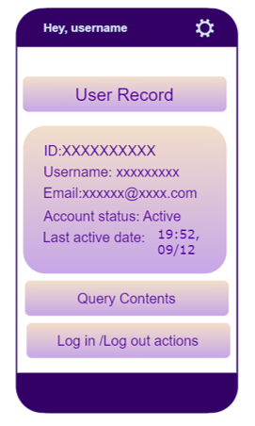

*Figure 9 User Record Page*

|  |  |
| --- | --- |
| Title | Hey, [username] |
| Sub-Title | User Record |
| Record Field | Shows the recorded information of user to admin. |
| Query Contents | Redirected query content page. |
| Log in/Log out actions | Redirected log in/out actions page. |
| Settings Button | Tab for managing account. |

### Query Page

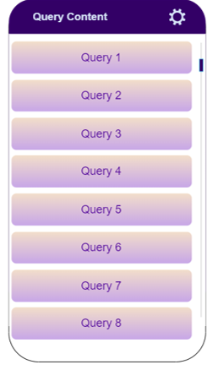

*Figure 10 Query Page*

|  |  |
| --- | --- |
| Title | Query Content |
| Query Botton | Shows the queries to admin. Tab to see information about query. |
| Settings Button | Tab for managing account. |

### Log Information Page

*Figure 11 Log Information Page*

|  |  |
| --- | --- |
| Title | Log in/out actions |
| Logged in/out Fields | Shows the login/out information of user to admin. |
| Date and time | Shows users log in/out information to admin. |
| Settings Button | Tab for managing account. |

### User Access Control Page

*Figure 12 User List Page*

|  |  |
| --- | --- |
| Title | User List |
| User Fields | Shows users as a list. |
| Search Button | Admin searches users with ID or username. |
| Select User Button | Tab the one of user then tab to this button for select the user. |
| Settings Button | Tab for managing account. |

*Figure 13 Access Control Page*

|  |  |
| --- | --- |
| Title | User Access Control |
| User ID Field | Shows user’s ID information. |
| User Info Field | Shows the information of user. |
| Sub-Title | Change Role |
| Make Admin Button | Tab to button form changing user role. |
| Sub-Title | Block the user. |
| Block Button | Tab to block the user. |
| Sub-Title | Manage Access |
| Manage Button | Tab to manage accessing of user. |
| Settings Button | Tab for managing account. |

### Configuration Page

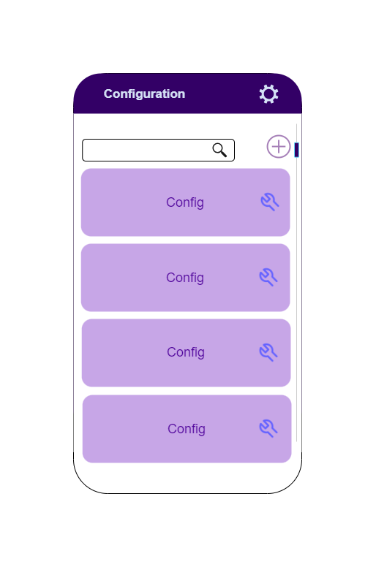

*Figure 14 Admin Configuration Page*

|  |  |
| --- | --- |
| Title | Configuration |
| Search Bar | Allows searching configurations. |
| Add Button | Allows adding new configurations. |
| Configuration Box | Opens configuration detail popup. |
| Edit Button | Allows editing the configuration. |
| Settings Button | Tab for managing account. |

## Forgot Password Pages

*Figure 15 Entering E-mail Address Page*

|  |  |
| --- | --- |
| Title | SenseAI |
| Explanation Part | Explanation for directing user. |
| E-mail Field | Field where the user will enter his/her e-mail address. Accepts data only in e-mail format. |
| Submit Button | Submit for e-mail address. |
| Back to Sign in Link | Redirected user Sign in Page. |
| Google Sign-Up Button | Secondary button with Google icon for signing up via Google authentication. |

*Figure 16 New Password Page*

|  |  |
| --- | --- |
| Title | SenseAI |
| New Password Field | Field where the user will enter new password. |
| Verify Password Field | Field where the user will verify new password. |
| Reset Password Button | Button for resetting password. |
| Explanation Part | Explain the new password constraints. |

## Settings Page

*Figure 17 Settings Page*

|  |  |
| --- | --- |
| Title | Settings |
| My Account Button | With this button user can see their account. |
| Preferences Button | With this button users can manage preferences. |
| Notifications Button | With this button users can manage notification preferences. |
| Request my data Button | Used to obtain user information. |
| Share Button | Copies the link to share the app. |
| Feedback Button | With this button users can rate the system. |
| Privacy Policy Button | Contains information regarding the use of personal data. |
| Terms & conditions Button | Shows the terms of use of the service. |
| Log out Button | With this button users can log out the system. |

# High Level Design

*Figure 18 Module Diagram*

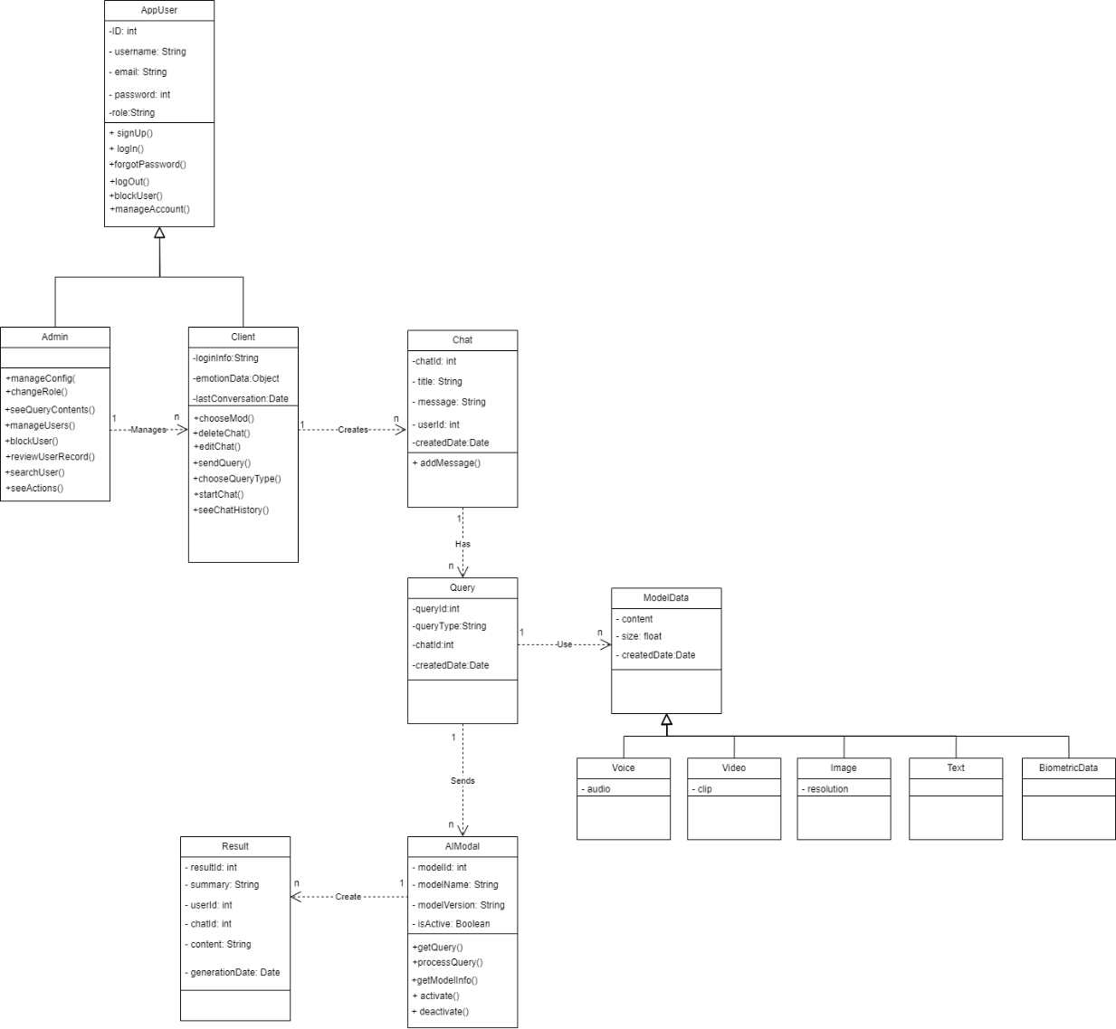

*Figure 19 Class Diagram*

## Server Module

The Server module provides the core backend infrastructure that runs the entire system. It handles HTTP requests and manages data communication between the client and server. Additionally, it provides real-time messaging services using technologies like socket.io. The server coordinates the overall operation of the application and works in integration with other modules to fulfill user requests. Data from users is processed through the server and appropriate responses are sent back to the user.

## AIModel Module:

The AIModel module is an artificial intelligence model that generates responses to user messages. This model works with a specific AI algorithm to analyze each incoming query and generate the most accurate response. AIModel can be customized based on the AI model used in the project and can continuously evolve based on user interactions. This module plays a critical role in ensuring that the conversation occurs in a meaningful and natural way.

## Chat Management Module

The Chat Management module is responsible for managing the chats that users have. This module ensures that chat histories are stored, messages are organized and sorted. Each message is stored with details like which user it belongs to and which chat session it is associated with. This module is critical for providing users with access to previous chats, ensuring a more comprehensive and consistent conversation history.

## Profile Management Module

The Profile Management module manages the editing and updating of user profiles. User information is stored and can be edited here. This module allows users to manage all information related to their accounts.

## Authentication Module

The Authentication module handles the authentication process of users. This module ensures a secure authentication process when users log in or create a new account. Typically, token-based authentication is used to manage each user’s access level. The Authentication module is crucial for maintaining the security of the system.

## Client App Module

The Client App module is the interface where the user interacts with the chatbot. This module typically works as a web or mobile application, enabling users to chat using text, voice, images, and other media types. The Client App captures the messages typed by users, sends them to the server, and displays the responses from the server. The user interface (UI) and user experience (UX) are optimized to provide a friendly and engaging conversation experience. In this module, users receive responses generated by the AIModel and continue their interactions with the chatbot.

## Chat Manager Module

The Chat Manager module is responsible for handling the type of queries sent during a chat session. It allows users to select the type of query (such as text, photo, video, etc.) they want to send. This module ensures that the correct processing is applied based on the selected query type, enabling flexible interaction with the chatbot. This module is also responsible for displaying the output to the user.

# Low Level Design

## Authentication Module

This diagram explains the user's registration and login to the system.

*Figure 20 Authentication Activity Diagram*

## Chat Manager Module

It is a module where the type of query that the user will send is determined. The modules and steps selected by the user are shown in the diagrams below.

*Figure 21 Chat Activity Diagram*

## Profile Management Module

The steps that users take to change their account properties are shown in the diagram below.

*Figure 22 Settings Activity Diagram*

# Database Design

## E-R Diagram

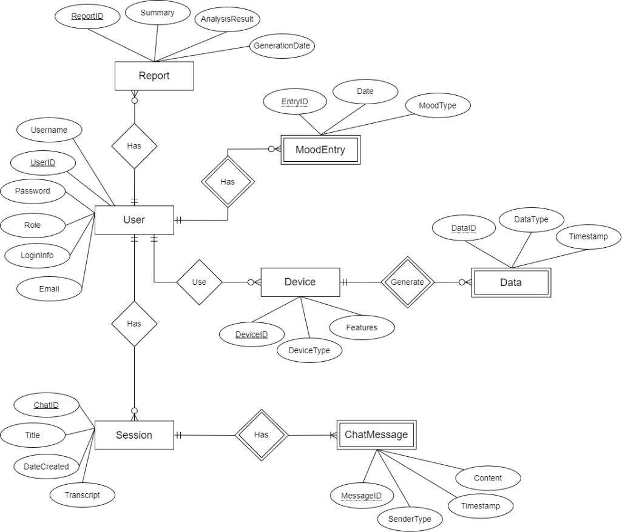

*Figure 23 ERD (Entity-Relationship Diagram)*

## Tables

### User

**Attributes:**

1. **UserID**: Primary Key, Integer, Unique identifier for each user.
2. **Username**: String, the name chosen by the user.
3. **Password**: String, Encrypted password for the user.
4. **Role**: String, The role of the user (e.g., Admin, User).
5. **LoginInfo**: String, Information about the user's login records.
6. **Email**: String, User's email address.

### Report

**Attributes:**

1. **ReportID**: Primary Key, Integer, Unique identifier for each report.
2. **Summary**: String, A summary of the report.
3. **AnalysisResult**: String, the analysis result included in the report.
4. **GenerationDate**: Date, The date the report was generated.
5. **UserID**: Foreign Key, Integer, References the User table.

### MoodEntry

**Attributes:**

1. **EntryID**: Partial Key, Integer, Unique identifier for each mood entry.
2. **Date**: Date, the date the mood entry was recorded.
3. **MoodType**: String, The type of mood (e.g., Happy, Sad).
4. **UserID**: Foreign Key, Integer, References the User table.

### Session

**Attributes:**

1. **ChatID**: Primary Key, Integer, Unique identifier for each session.
2. **Title**: String, The title of the session.
3. **DateCreated**: Date, the date the session was created.
4. **Transcript**: Text, The transcript of the session.
5. **UserID**: Foreign Key, Integer, References the User table.

### ChatMessage

**Attributes:**

1. **MessageID**: Partial Key, Integer, Unique identifier for each chat message.
2. **Content**: Text, The content of the message.
3. **Timestamp**: DateTime, the time the message was sent.
4. **SenderType**: String, Type of sender (e.g., User, System).
5. **ChatID**: Foreign Key, Integer, References the Session table.

### Device

**Attributes:**

1. **DeviceID**: Primary Key, Integer, Unique identifier for each device.
2. **DeviceType**: String, The type of device (e.g., Wearable, Smartphone).
3. **Features**: String, Features of the device.
4. **UserID**: Foreign Key, Integer, References the User table.

### Data

**Attributes:**

1. **DataID**: Partial Key, Integer, Unique identifier for each data entry.
2. **DataType**: String, The type of data (e.g., Sensor Data, Analysis Data).
3. **Timestamp**: DateTime, the time the data was generated.
4. **DeviceID**: Foreign Key, Integer, References the Device table.

# References

|  |  |
| --- | --- |
| [1] | Software Engineering Department, "Graduation Projects," SENG, [Online]. Available: https://seng.cankaya.edu.tr/graduation-projects/. [Accessed 28 June 2024]. |