System Design and Architecture

This part gives the high-level modular architecture of the AI-Powered Web Research Assistant with a more focus on the way the system extracts updated information on the web and generates an evidence-based response. The design is intended to be a pipeline consisting of autonomous modules that are coordinated by a centralized orchestrator to achieve a separation of concerns, resilience to partial failures, and scalability in the future.

Figure 4.1 shows a representation of the interaction of the key elements of user input to final output. On the high-level, the user enters a query to the UI, the backend coordinates simultaneous access to outside resources, gathered material is purged and normalised, and the LLM generates a final response along with sources and credibility cues.

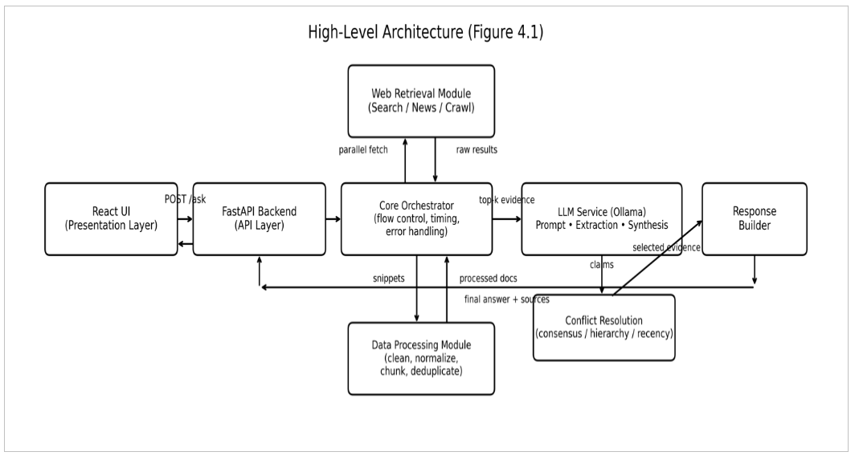

Main Components

1) Presentation Layer (React UI)
* Takes the user queries and gives the final answer.
* Listing supporting sources (URLs / domains) and any indicators or credibility (where applicable).
* Interacts with the backend through one API endpoint (e.g., /ask).

2) API Layer (FastAPI Backend)
* Offers the system as a web service.
*Answers requests and sends formatted JSON response to the UI.
*forwards the request to the Core Orchestrator.

3) Core Orchestrator
* The main coordinator in charge of the complete cycle of request (timing, flow control, error handling).
* Concurrently starts retrieval work, implements timeouts, and makes fallbacks in the event of dependency failure.
* Makes sure that the LLM never works in the absence of evidence by using control over the processed documents that are presented to the LLM.

4) Web Retrieval Module
* Makes asynchronous calls to third parties (e.g. search APIs, news APIs, or direct crawling where appropriate).
* Provides raw snippets/pages together with rudimentary metadata (URL, title, domain, date when available).
* Manages rate limits and retries on the perimeter with external services.

5) Data Processing Module
* Parses crude HTML/JSON snippets (stripping boilerplate, navigation text, adverts, etc.).
Normalizes content into a uniform internal form and divides it into small manageable units.
* Generates (near) duplicate documents and formats them to be used in downstream ranking and by LLM.

6) LLM Service (Ollama)
* Prompting and using a locally-hosted LLM for three inference-based tasks :
* Prompt Generation (query rewriting / retrieval prompting support),
* Extraction (locating candidate claims/facts of evidence),
* Synthesis (creating an end product, evidence-based answer).

7) Conflict Resolution + Response Builder
* Aggregates derives claims and clusters conflicting statements.
* Uses conflict resolution principles (e.g., consistency of sources, source credibility, recency).
* Gives the final response and a well-organized list of references/sources to be transparent.

High-Level Request Flow (shown in Figure 4.1)
1. The user types a query by using the React UI.
2. The query request is forwarded to the FastAPI backend (/ask) by the UI.
3. The Core Orchestrator initiates the Web Retrieval Module to retrieve concurrently results of various sources.
4. The Retrieved Content is passed to the Data Processing Module where it is cleaned, normalized, chunked and deduplicated.
5. The extracted and synthesized evidence will be sent to the LLM Service.
6. Conflict resolving picks up the most plausible evidence and Response Builder packages the final answer.
7. The backend sends the end solution and sources (and optional credibility signals) to the UI.

Principles of Design Captured by the High-Level Architecture

* Modularity: Each module is a single responsibility, and thus, it is easy to update during subsequent stages.
Evidence-first answering The LLM is applied as a reasoning/synthesis component to the retrieved evidence and not a source of knowledge by itself.
* Robustness: Fallbacks is used to make sure that the system can react even in cases where there are some external sources out of commission.
* Transparency: The user does not only get an answer but is also given the sources that were used to build it.

4.2 Module Breakdown
In this section, the fundamental components of the system are defined, and the separation of responsibilities among the components is explained. The design is done in a modular way to allow the system to be easier to maintain, test, and extend in subsequent iterations.

4.2.1 Core Orchestrator
Purpose: Handles the entire request cycle, and is in control of all the modules and makes sure the system provides a response in a reliable manner.
Inputs:
* User query (string)
* User parameters (max sources, time budget, etc.), optional.
Outputs:
* Final answer text
* Source list (citations)
* Metadata (e.g. timing, retrieval statistics) are optional.
Key Responsibilities:
* Authorizes and authenticates the query being hit.
* Makes parallel Web Retrieval calls and imposes timeouts.
Result retrieved by Data Processing Module.
* Choses best evidence to proceed to the LLM Service.
* Calls dispute resolution preceding ultimate response format.
* Implements fallback mechanisms in cases of external failure.
Failure Handling (examples):
* Failure of retrieval or retrieval of insufficient evidence: returns a partial answer with a result of limited evidence.
Otherwise in case of failure of the LLM: produces extractive output (top evidence snippets + sources) as a fallback.

4.2.2 LLM Service (Ollama)
Purpose: Infers local LLM to convert evidence to structured claims and its final answer.
Inputs:
* Processed evidence chunks
* System prompts (extraction/synthesis prompts)
Outputs:
* Claims/facts that have been extracted (structured)
* Ultimate synthesized solution (evidence-based)
Key Responsibilities:
* Extraction: Recovers candidate claims/facts out of the cleaned evidence.
* Synthesis: Generates a coherent final solution based on the available evidence.
* Makes sure that answers are grounded by making use of evidence given.
Failure Handling (examples):
* Inference times out: halve the size of input (fewer chunks) and restart again.
* In case output of model is not structured: It is time to apply output formatting constraints and re-synthesize.

4.2.3 Web Retrieval Module
Purpose: Retrieves recent data on external web.
Inputs:
* Search query (it may be rewritten)
* Retrieval settings (max result, domains, time limit)
Outputs:
* Raw results (snippets/pages)
* Metadata (URL, title, domain, date of publication where it exists)
Key Responsibilities:
* Makes asynchronous search/news APIs and crawling endpoint calls.
** Multiple sources are used to obtain aggregates to minimize bias and enhance coverage.
* Processes rate limits, retries, and simple filtering (e.g. duplicate URLs).
Failure Handling (examples):
* Rate limiting: linear back off and retries.
* Empty results: query rewrite (light rewrite), and restart.

4.2.4 Data Processing Module
Purpose: Processes raw web results into clean and consistent evidence, and can be used to rank and use in LLM reasoning.
Inputs:
* Raw metadata and HTML/JSON snippets.
Outputs:
* Cleaned text
* Metadata-containing chunked documents.
* Deduplicated evidence set
Key Responsibilities:
* Eliminates boilerplate (navigation, advertisements, irrelevant content).
Encodes and formats text normally.
* Breaks extensive content into pieces to fit the LLM context window.
Removes duplicates of similar contents and poor quality snippets.
Failure Handling (examples):
* In case of a failure on parsing: save the original snippet as back-up text (bare minimum cleaning).
* When the content is excessive: chunk more aggressively and retain only the resulted parts.

4.2.5 Response Builder and Conflict Resolution.
Purpose: Clears up conflicting assertions and generates the final response to be displayed to the user including sources.
Inputs:
* Extracted claims
Chunks of evidence (as well as source metadata).
Outputs:
* Final answer citation/source(s) (URLs/domains)
* Non-compulsory credibility indicators.
Key Responsibilities:
Grounds of disagreement: Groups make claims which refer to the same statement and disagree.
Chooses evidence based on heuristic such as:
* Cross-source agreement (consensus)
Weights representing source reputation (hierarchy)
* Recency (timeline)
* Prepares the final response in an understandable format (answer + sources).
Failure Handling (examples):
* In case of no possibility to solve conflicts: surfaces both sides and expressly notes doubt.
* When evidence irregular: issues a style output in the form of insufficient evidence using the best available sources.

4.3 Data Flow Diagram
Figure 4.3 gives the flow of the system end-to-end data flow handling a web query by a user with highlight (i) parallel web retrieval, (ii) evidence processing and top-k selection, and (iii) conflict-aware answer generation.
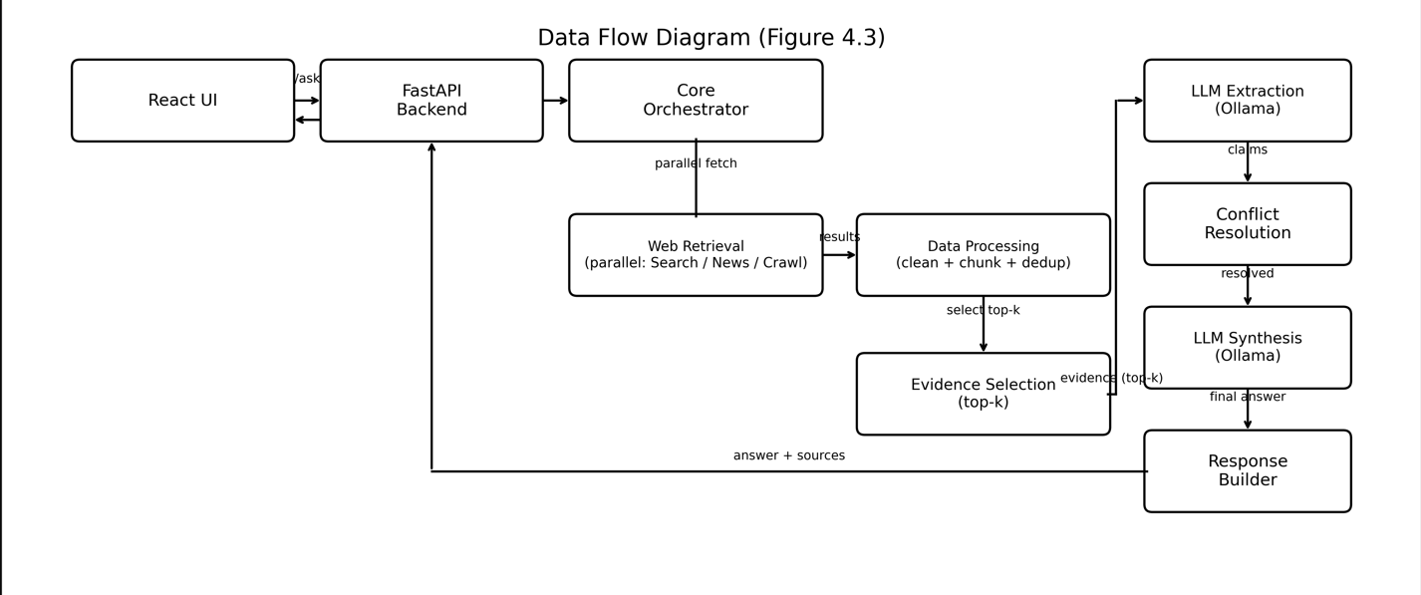
A React UI is used to send a user query to a FastAPI back-end. The Core Orchestrator is involved in parallel retrieval, processing of evidence, extracting claims, resolving conflicts, and completing synthesis. The system provides the ultimate answer with the source supports.
Step-by-step Request Flow (in Figure 4.3)
1. Through the React UI, the user provides a question.
2. The query is passed to the Fast API back-end endpoint (/ask).
3. The Core Orchestrator initiates the workflow and initiates the Web Retrieval module to retrieve results concurrently (e.g., search/news/crawl).
4. The content retrieved is sent to Data Processing module where it is cleaned and chunked.
5. The system picks up the most relevant evidence (top-k) to remain within the context and quality constraints.
6. The LLM Extraction step recognizes the candidate claims/facts out of the evidence chosen.
7. CR groups disbelieve conflicting assertions and chooses the most plausible evidence by signal (e.g., consensus/recency).
8. The LLM Synthesis step produces a final response based on the solved evidence.
9. Response Builder does the formatting and gives answer + sources to the backend, which is shown in the UI.
Reliability Notes
* The orchestrator implements temporal pauses and may give a partial answer to failure of some of the retrieval sources.
* In the case of insufficient evidence or evidence that is quite contradicting, the answer can clearly show that it is uncertain and give the most relevant resources.

4.4 Technology Rationale (Phase-Based and Revisable)
This section captures the existing technology decision to implement the Phase-1 (MVP). Such decisions are not considered final, but rather they are chosen so that one can develop quickly and have an end-to end prototype that works. According to the evaluation findings, performance limits, and feedback of the instructor, the stack may be changed in Phase-2.
Selection Criteria
The stack has been selected according to:
* Rapid prototyping and integration rate.
* Parallel retrieval and evidence-first pipeline support.
* Simple operational environment of a student project.
* Capability to replace parts subsequently without re-compiling the entire system (modularity)
Backend: Python + FastAPI
Why: API development speed and powerful support of parallel web retrieval, which needs asynchronous workflows.
Modifiable in Phase-2: in case the API layer is required to be changed or augmented (e.g., with more caching/queueing or alternative service architecture) then that can be done without modifying the pipeline.
LLM Integration: Ollama (Local LLM Service)
Why: is a cheap, locally testable LLM service that can be used to extract/synthesize evidence retrieved.
To be revisited in Phase-2: the LLM is interchangeable with a hosted provider or another local model based on quality/latency constraints. The interface has not changed (Extraction + Synthesis).
Frontend: React
Why: Fast UI iteration and a rich/strong ecosystem to build a responsive interface.
Phase-2: UI framework modifiable, though not likely to be needed: The UI can be modified, though mostly these changes are manageable within React.
Data Access: API Search/News + Crawling (Optional).
Why: provides access to current information on query time and multiple source retrieval.
Updatable in Phase-2: the selection of the sources and their retrieval strategy may be revised according to the availability, rate limits, and reliability.
Phase-2 Revision Plan (Why and how may change)
During Phase-2, changes will be motivated by:
* Retrieval level (coverage, relevance)
* Stability and latency (timeouts, rate limits)
* Grounding (reduction of hallucinations) and quality of answers.
* Maintenance and implementation effort.
To reinforce this, the system has already defined module boundaries such that, whenever one part should be changed (e.g., the LLM backend or retrieval layer), the entire architecture does not need to be redesigned.

4.5 Data Structure
This section determines the internal structured data format that is to be used to represent the retrieved content, extracted claims, and supporting evidence, and the final output. The MVP data model is meant to be easy to understand, trackable, and to develop in small parts allowing any of the parts to be updated during Phase-2 without altering the general pipeline.

4.5.1 Design Goals
* Evidence-first representation: the ultimate solution is based on retrieved chunks of evidence.
* Traceability: every claim may be linked to a number of evidence pieces and sources.
* Modularity: retrieval, processing, and LLM are data exchange components using a stable schema.

4.5.2 Core Entities (MVP)
The core entities used in the system are as follows:
Source
* Representation of the source of information.
* Common fields: sourceid,url,domain, title, optional publishedat.
Chunk
* Preprocessed piece of evidence text.
Examples Typical fields: chunkid, sourceid, text, optional retrievedat.
Claim
A statement of evidence-based candidate.
d Standard fields: claimid, text, evidencechunkids[].
Credibility (lightweight in MVP)
* Simple store of confidence score and short justification signals.
* Conventional fields: claimid, score (0-1), signals[].
Conflict Group (optimal in MVP)
Groups with similar claims but of different opinion refer to the same topic.
* Standard types: groupid, claimids[], selectedclaimid.
Final Response
* Final user-facing output.
* Common fields: answer_text, citations[] (references to claims and/or sources).
*
Figure 4.5. Data Structure Schema. The schema illustrates the process of source generation of evidence chunks, the manner in which claims are produced out of chunks, and the manner in which credibility / conflict management promotes the final response where cites are made.

