INFLATION AND THE COST OF LIVING IN ZAMBIA (2020–2026)
An Analysis of Food Prices, Exchange Rate Dynamics
and Household Purchasing Power
INDEPENDENT ECONOMIC RESEARCH ARTICLE
SECOND DRAFT
November 2026
Prepared using publicly available data from ZamStats, the Bank of Zambia
and the Jesuit Centre for Theological Reflection.
Canan Phiri

Abstract
This article examines Zambia’s inflation and cost-of-living experience between January 2020 and October 2026, focusing on consumer prices, food and non-food inflation, exchange-rate movements and the cost of a basic household basket. It draws on monthly Consumer Price Index (CPI) observations published by the Zambia Statistics Agency (ZamStats), exchange-rate data from the Bank of Zambia (BoZ), and selected Lusaka Basic Needs and Nutrition Basket (BNNB) estimates published by the Jesuit Centre for Theological Reflection (JCTR). The CPI data indicate that the all-items price index increased by approximately 128.9% between January 2020 and October 2026. Food prices increased by about 154.5%, compared with 98.8% for non-food prices. At the same time, annual headline inflation declined from 11.9% in October 2025 to 6.3% in October 2026. The Kwacha also appreciated against the US dollar during much of 2025, while the JCTR basket remained higher in June 2026 than in June 2025. These findings illustrate the distinction between a declining inflation rate and a lower cost of living. The article treats the observed exchange-rate and inflation movements as associations rather than evidence of causation, and recognises that the CPI and JCTR basket measure different aspects of price and household expenditure.
Keywords: Zambia; inflation; Consumer Price Index; food prices; exchange rate; cost of living; household welfare.
JEL classifications: E31, E52, F31, O55.

1. Introduction
Inflation matters because it changes what households can buy with a given income and affects the costs faced by firms and government. In a small, open economy such as Zambia, domestic prices are also exposed to external conditions through imported consumer goods, fuel, intermediate inputs and movements in the exchange rate. Research on Zambia identifies exchange-rate movements, imported prices, energy costs and food-supply conditions as important influences on inflation, although their relative importance varies across periods and CPI components (Roger, Smith, & Morrissey, 2019; Chipili, 2022).
A fall in the inflation rate does not mean that the general price level has fallen. Inflation measures the rate of change in prices over a period; the price level reflects the accumulated effect of price changes over time. When inflation declines, prices may continue to rise, but at a slower rate. Whether households experience an improvement in living standards therefore depends not only on current inflation, but also on the prices they face and how their incomes change. This distinction is central to the present analysis.
This article examines Zambia’s inflation experience from January 2020 to October 2026. It considers three questions: (i) how headline, food and non-food inflation evolved; (ii) what relationship can be observed between exchange-rate movements and domestic inflation; and (iii) how selected household basket estimates compare with the broader inflation picture. The analysis is descriptive and exploratory. It does not seek to identify causal effects or estimate a structural model of inflation.

2. Data and Approach
The analysis combines three sources. First, monthly CPI component indices and annual headline inflation observations are drawn from the Zambia Statistics Agency’s (ZamStats) The Monthly, Volume 256 (July 2024) and Volume 283 (October 2026), including Annex 1, Tables 1.1 and 1.3. The assembled CPI series covers January 2020 to October 2026 and contains 82 monthly observations. The source indices are reported on the published index base. For comparison over time, each component is also rebased by the author to January 2020 = 100.
Second, monthly average Kwacha/US dollar mid-rates are taken from the Bank of Zambia’s Statistics Fortnightly, Volume 33, Issue No. 2, Table 02. The consistent monthly series available for this analysis covers January 2024 to December 2025. A January 2026 period-average observation appears in Table 01A, but it is not treated as directly continuous with the Table 02 monthly-average mid-rate series.
Third, selected Lusaka Basic Needs and Nutrition Basket (BNNB) observations are taken from statements published by the Jesuit Centre for Theological Reflection (JCTR). The BNNB estimates the monthly cost of a defined set of food and non-food necessities for a reference household of five people. It is used here as a complementary indicator of household expenditure requirements, not as an alternative measure of national consumer-price inflation. The selected observations include June 2025 and January, June, August and September 2026. They are not a complete monthly series.
Food and non-food year-on-year inflation rates are calculated as the percentage change in the respective CPI component index over 12 months. Month-on-month rates are calculated as the percentage change from the preceding month. Cumulative price changes are calculated from the component index values between January 2020 and October 2026. Rebased indices are calculated by dividing each monthly component index by its January 2020 value and multiplying by 100. All calculations are descriptive; no missing observations have been interpolated.
The analysis has several limitations. The CPI observations were transcribed from official statistical publications and should be interpreted in light of the source-series checks documented in the accompanying data workbook. The exchange-rate series is shorter than the CPI series, while the JCTR observations are selected months rather than a fully reconstructed monthly series. The analysis is therefore descriptive: it identifies patterns and associations but does not estimate causal effects or a formal exchange-rate pass-through model.

3. Zambia’s Inflation Experience
The CPI series shows that the general price level rose substantially during the period under review. The all-items CPI increased from 246.72 in January 2020 to 564.62 in October 2026. When rebased to January 2020 = 100, this corresponds to an index of 228.9, or a cumulative increase of approximately 128.9%. The implication is that the representative basket captured by the CPI became considerably more expensive over the period, even though the annual rate of inflation eased towards the end of the series.
Annual headline inflation declined from 11.9% in October 2025 to 6.3% in October 2026, a reduction of 5.6 percentage points. This is a substantial moderation in the pace of price increases. It should not, however, be read as a fall in the price level. The CPI index continued to rise over the period, and the October 2026 bulletin records a slight increase in headline inflation from 6.1% in September to 6.3% in October (ZamStats, 2026). The distinction between disinflation and deflation is important: disinflation means prices are rising more slowly, whereas deflation means the general price level is falling.
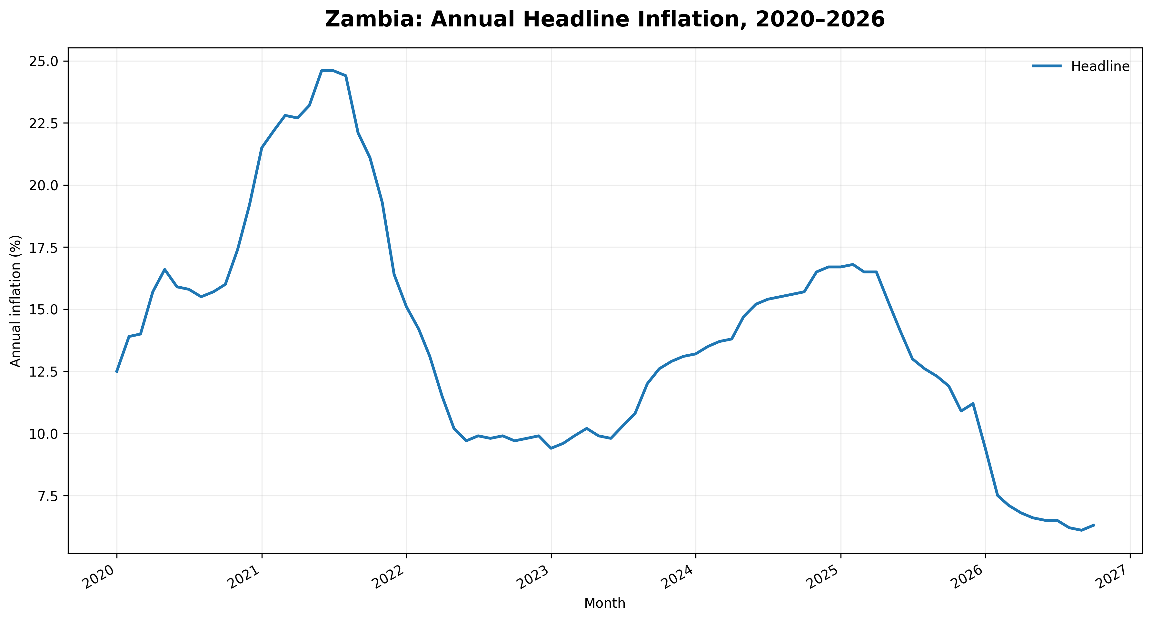
Figure 1. Zambia’s annual headline inflation, January 2020–October 2026. Source: ZamStats; author’s compilation.
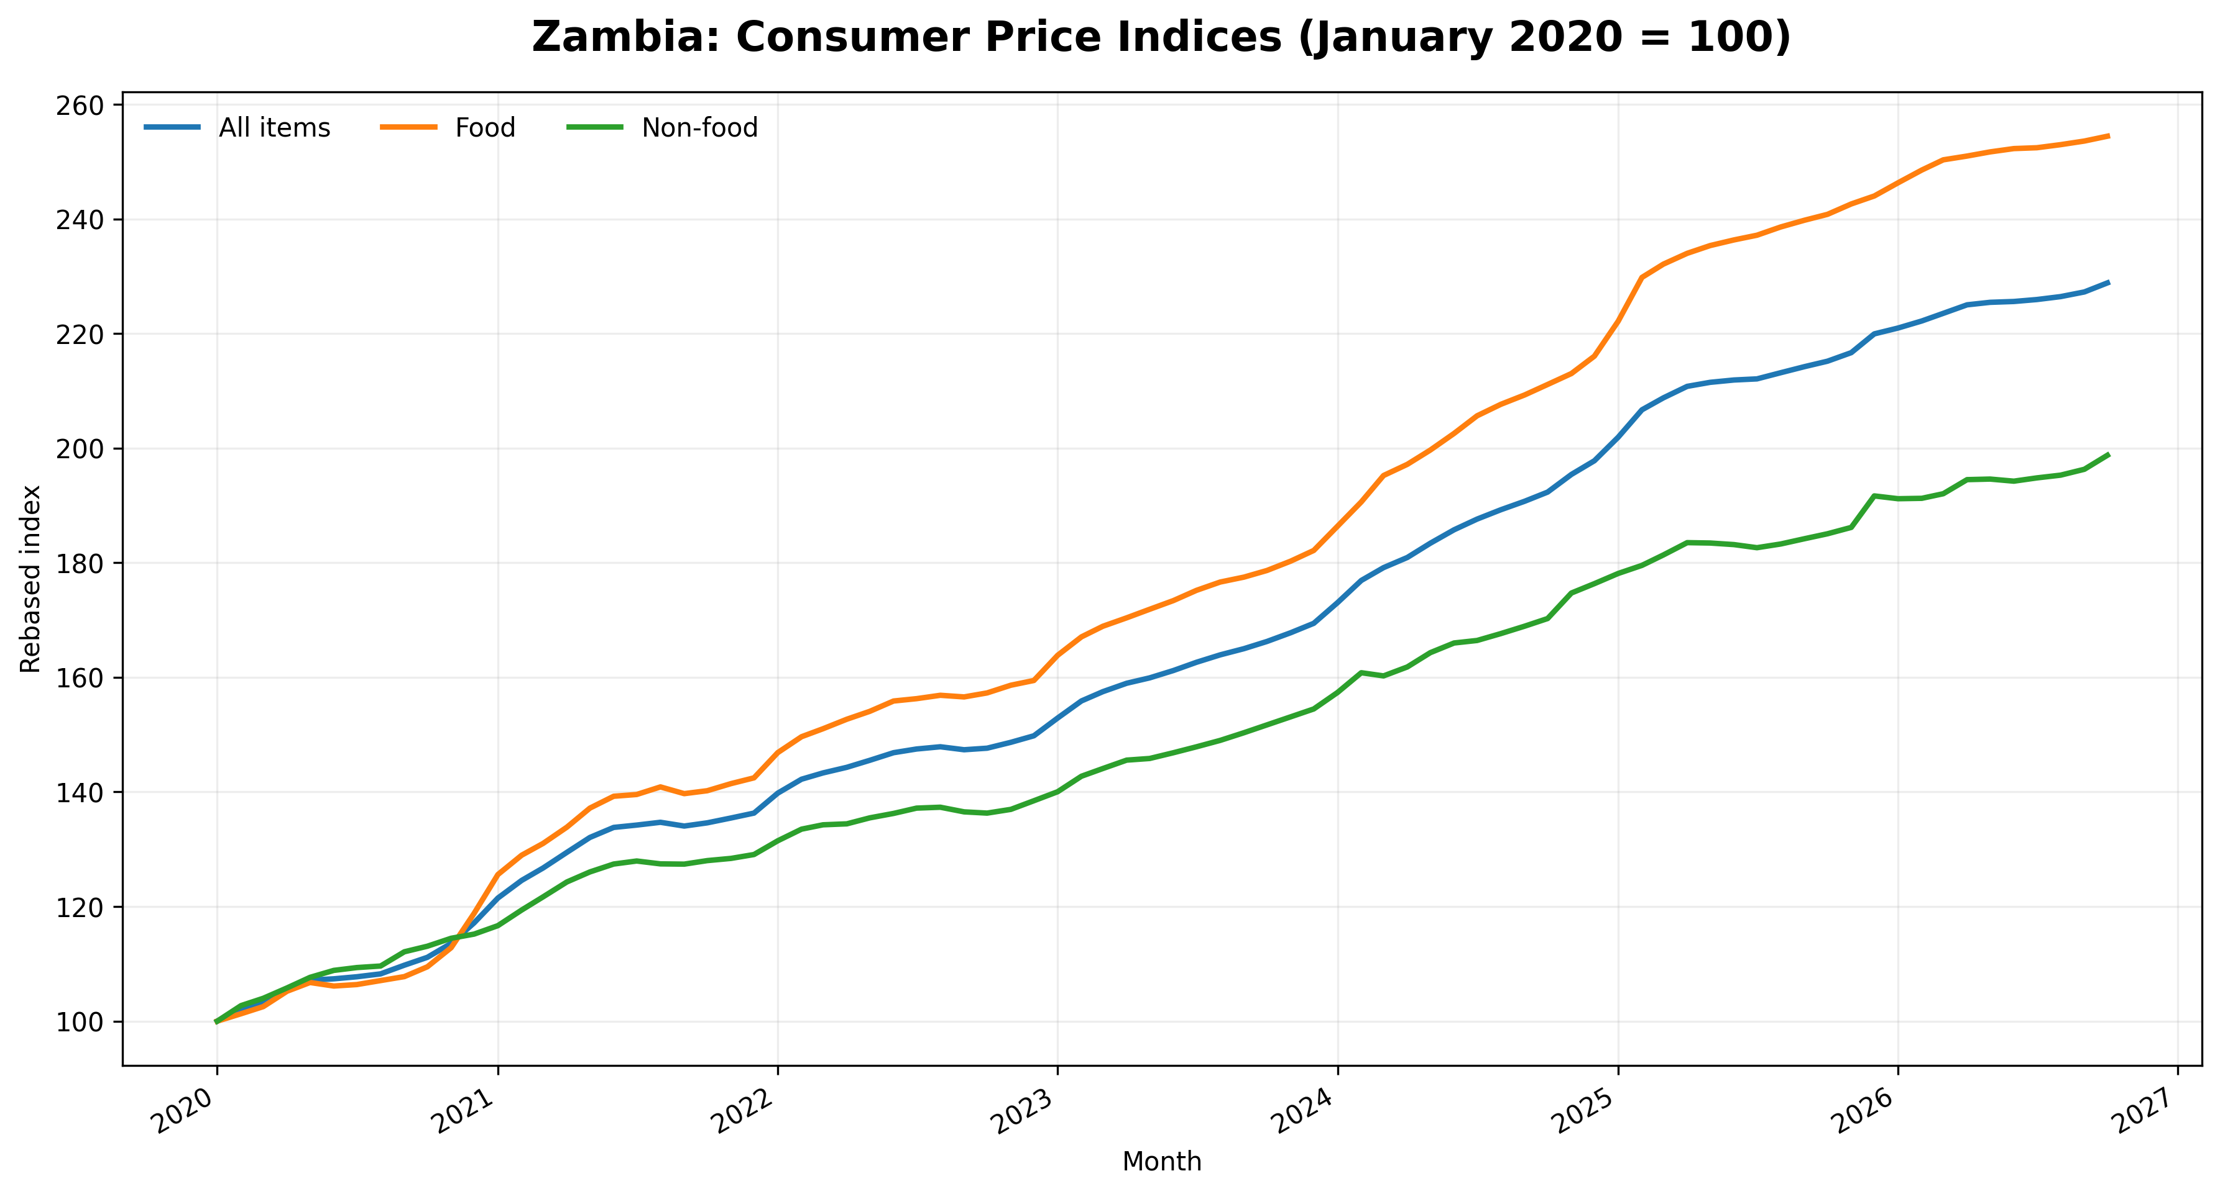
Figure 2. All-items, food and non-food CPI rebased to January 2020 = 100. Source: ZamStats; author’s calculations.
Measure | Jan 2020 index | Oct 2026 index (Jan 2020=100) | Cumulative change
All-items CPI | 100.0 | 228.9 | 128.9%
Food CPI | 100.0 | 254.5 | 154.5%
Non-food CPI | 100.0 | 198.8 | 98.8%

Table 1. Cumulative change in consumer price indices, January 2020 – October 2026. Rebased indices and cumulative changes are author calculations.
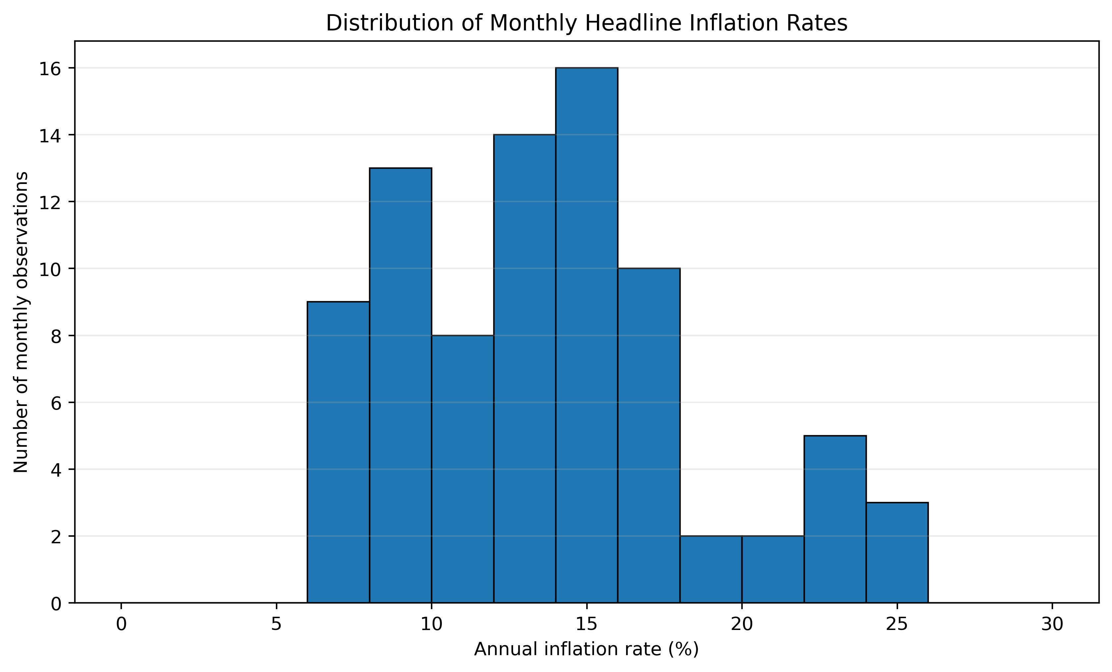
Figure 3. Frequency distribution of monthly headline year-on-year inflation observations, Jan 2020 – Oct 2026. Source: ZamStats; author calculations.

4. Food and Non-food Price Movements
The component indices show that food prices increased more rapidly than non-food prices over the full period. Between January 2020 and October 2026, the food CPI rose by approximately 154.5%, compared with 98.8% for the non-food CPI. The difference matters because food is a major item in household budgets, although the share varies by location and income. ZamStats’ 2022 Living Conditions Monitoring Survey reports that food accounted for 56.4% of household expenditure in rural areas and 34.7% in urban areas (ZamStats, 2025). The national CPI basket also assigns a substantial weight to food and non-alcoholic beverages. These figures should not be conflated: CPI weights and household expenditure shares are related but are not identical measures.
Recent annual rates, however, show a change in the relative pattern. In October 2025, the derived food inflation rate was approximately 14.1% and non-food inflation was 8.7%. By October 2026, food inflation had eased to 5.7%, while non-food inflation stood at 7.4%. The October 2026 ZamStats bulletin similarly notes that the headline increase from September was mainly associated with non-food items, including fuels, accommodation services and passenger transport by road (ZamStats, 2026).
The cumulative and recent-period comparisons describe different aspects of the same price experience. The cumulative index records how much prices have risen since January 2020; the annual inflation rate records how quickly prices changed over the latest 12 months. Food prices therefore remain much higher relative to their January 2020 level even though food inflation had slowed to 5.7% by October 2026. At the same time, non-food inflation was 7.4%, above the food rate. This component-level variation is one reason headline inflation alone cannot show which expenses are currently placing the greatest pressure on different households. The pattern is consistent with research on Zambia that finds distinct drivers and different exchange-rate responses across food and non-food prices (Roger et al., 2019; Chipili, 2022).
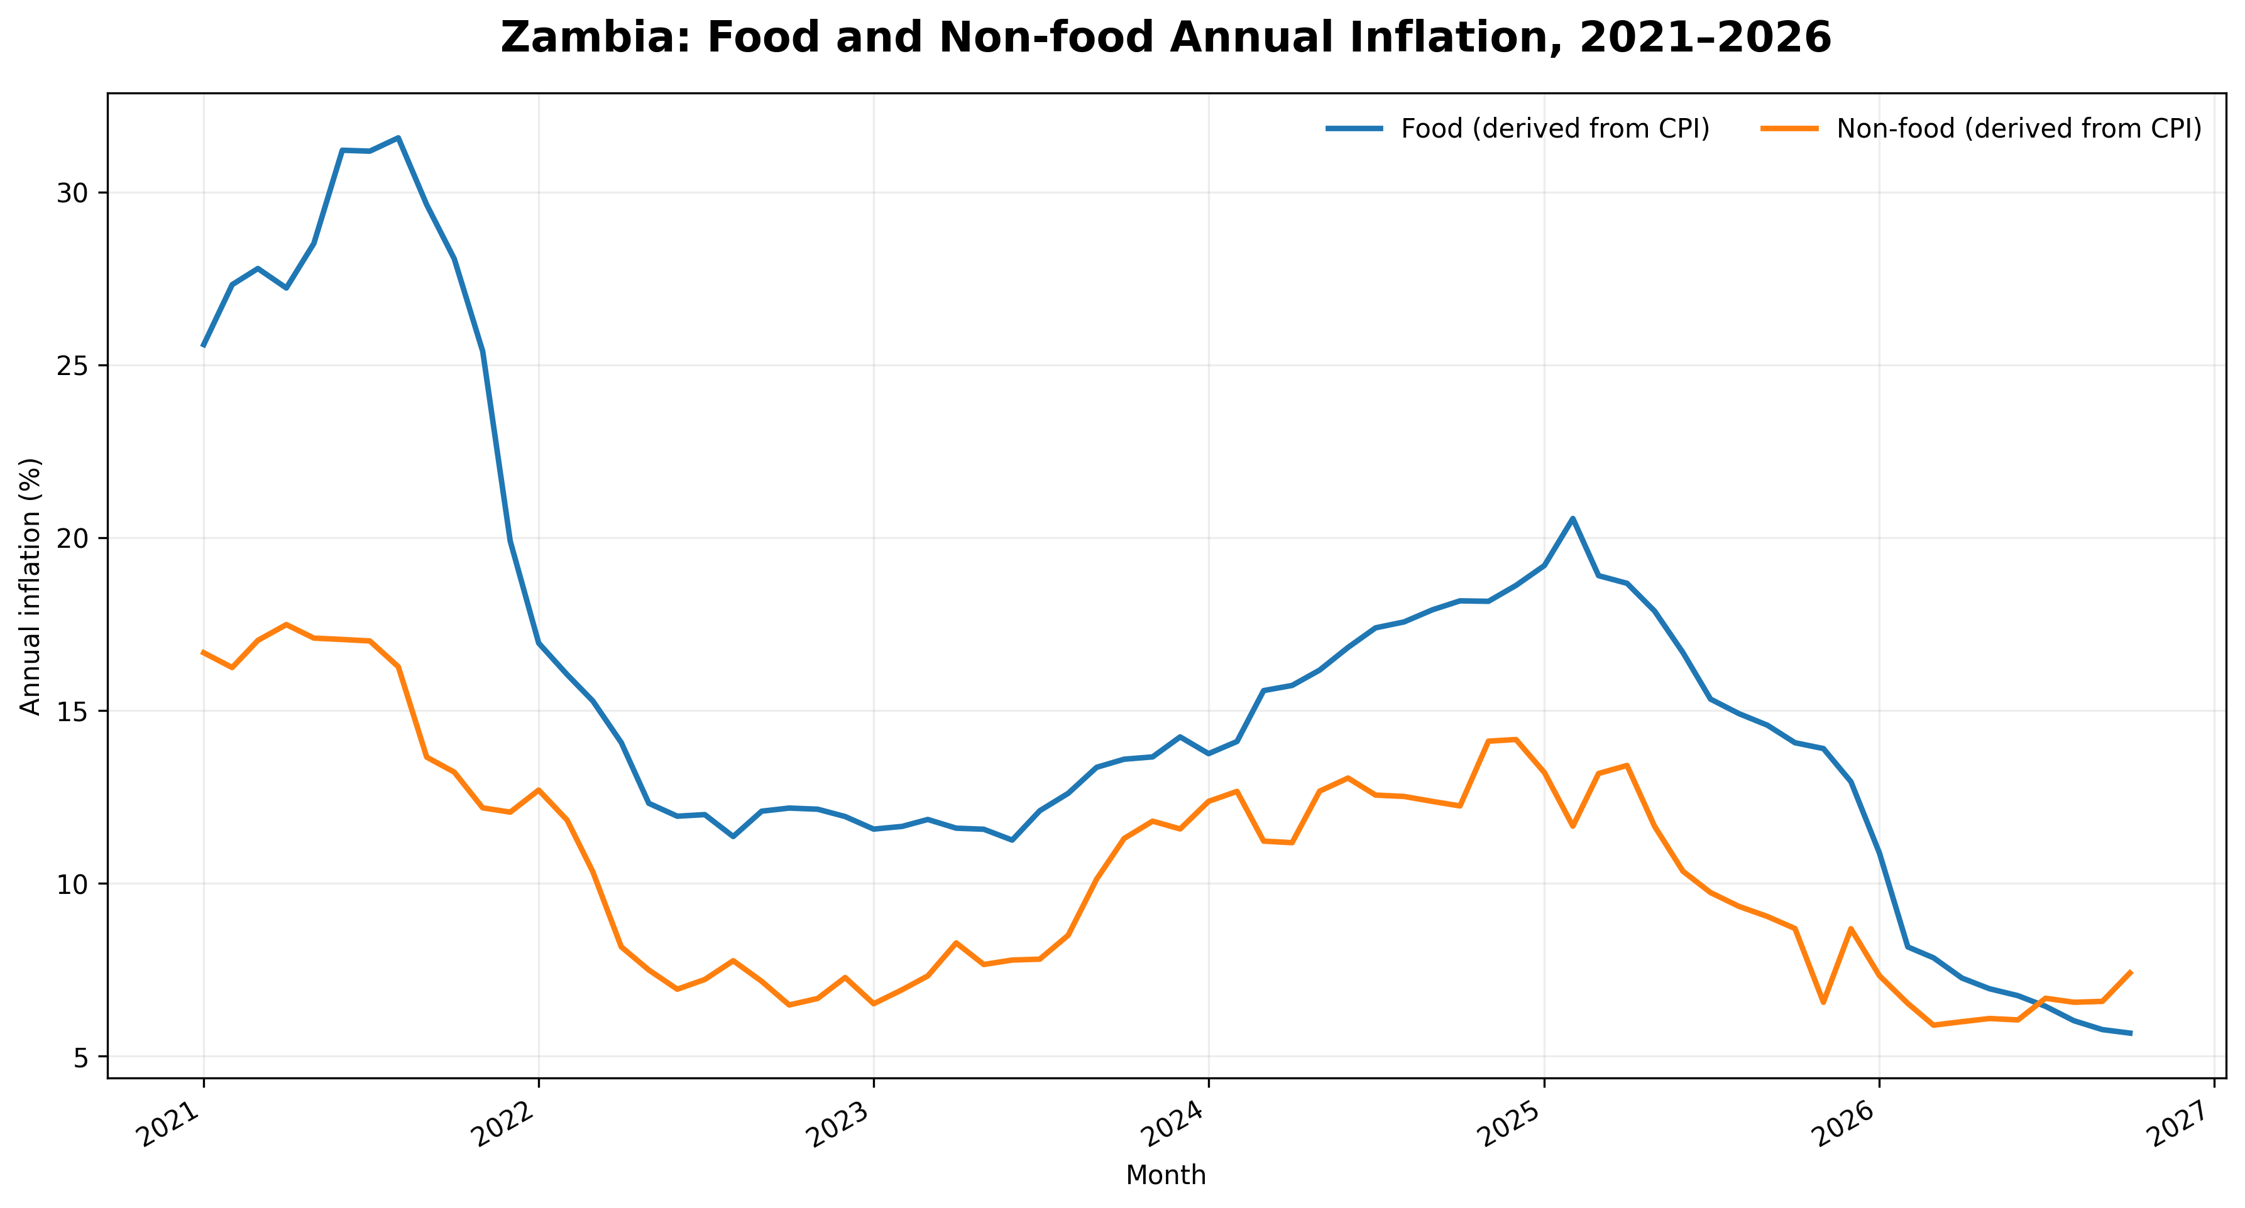
Figure 4. Annual food and non-food inflation, calculated from CPI component indices. Source: ZamStats; author’s calculations.
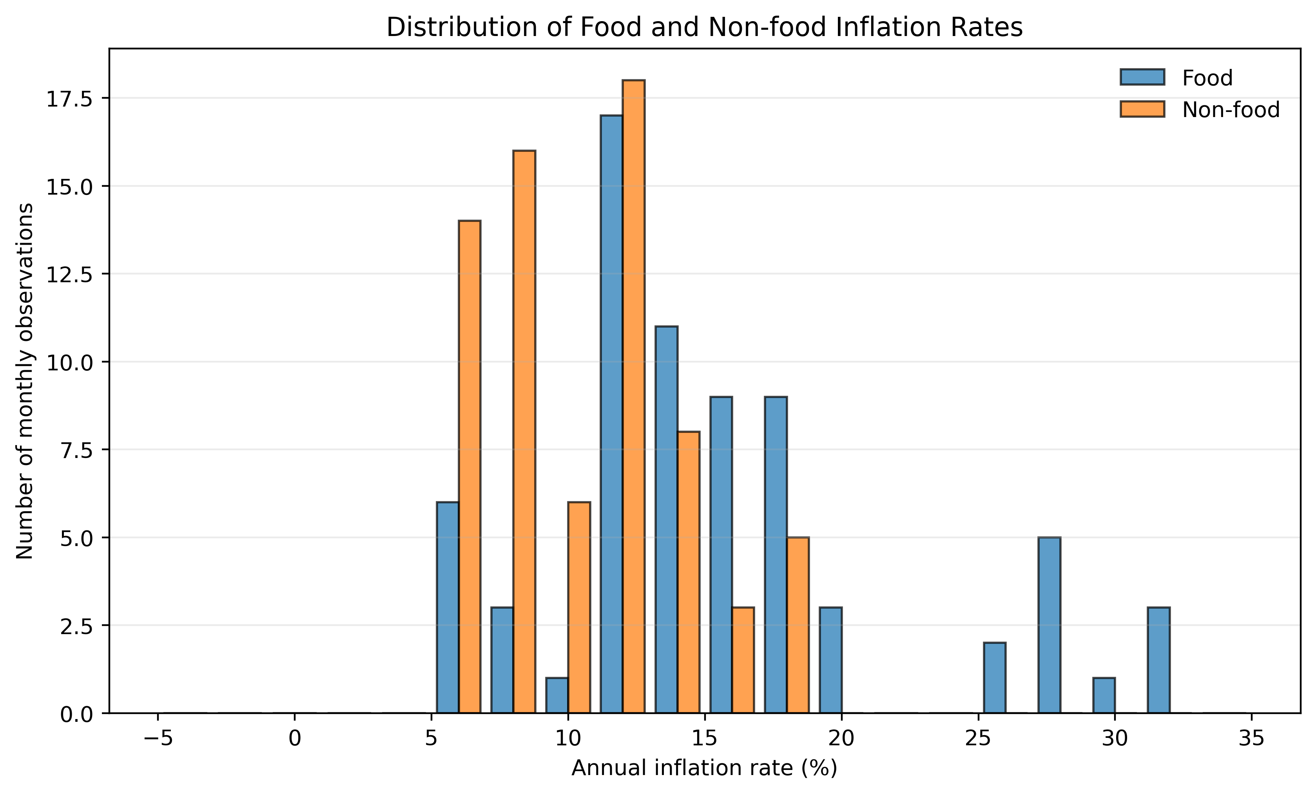
Figure 5. Frequency distributions of derived food and non-food year-on-year inflation rates. Source: ZamStats; author calculations.
Note: Histograms summarise the frequency distribution of the monthly derived year-on-year rates; they do not show the timing of inflation changes. Food and non-food rates are calculated from the corresponding CPI indices.

5. Exchange Rate Dynamics and Inflation
The Bank of Zambia data show a notable strengthening of the Kwacha during 2025. The monthly average mid-rate moved from K28.69 per US dollar in March 2025 to K22.84 in December 2025. Since the exchange rate is expressed as Kwacha per US dollar, a decline in the quoted rate represents an appreciation of the Kwacha. The endpoint movement represents an appreciation of approximately 20.4% using the percentage change in the quoted rate.
The period of exchange-rate appreciation coincided with a reduction in annual inflation. This is economically plausible because a weaker Kwacha can raise the domestic-currency cost of imported consumer goods and production inputs, while an appreciation can reduce some of those costs. Evidence from Zambia supports the existence of exchange-rate pass-through, although estimates suggest that it is incomplete, persistent and asymmetric: depreciation may have a larger effect on consumer prices than appreciation (Roger et al., 2019; Chinyemba, 2021; Fandamu et al., 2023). The exchange-rate movement observed in 2025 may therefore have eased some imported cost pressures, but the descriptive data used here cannot isolate its contribution to the decline in inflation.
This comparison should not be interpreted as evidence that Kwacha appreciation caused the fall in inflation. Domestic food supply, seasonal agricultural conditions, energy prices, monetary policy, demand conditions and changes in administered prices may also influence consumer prices. Moreover, exchange-rate pass-through can occur with a lag and may differ between food and non-food items. The available monthly exchange-rate series is limited to 2024–2025 for the consistent Table 02 measure. A longer, consistently defined series and a multivariate econometric framework would be needed to estimate the size and timing of pass-through.
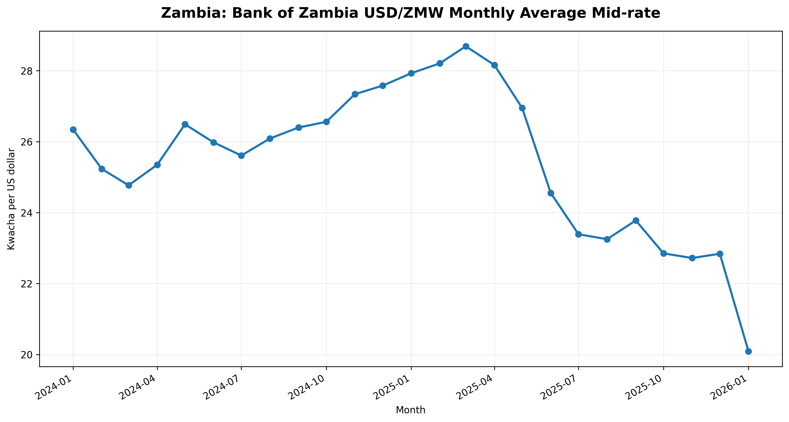
Figure 6. Bank of Zambia Kwacha/US dollar exchange-rate observations. Note: January 2026 is from Table 01A and is not strictly comparable with the Table 02 monthly-average series.
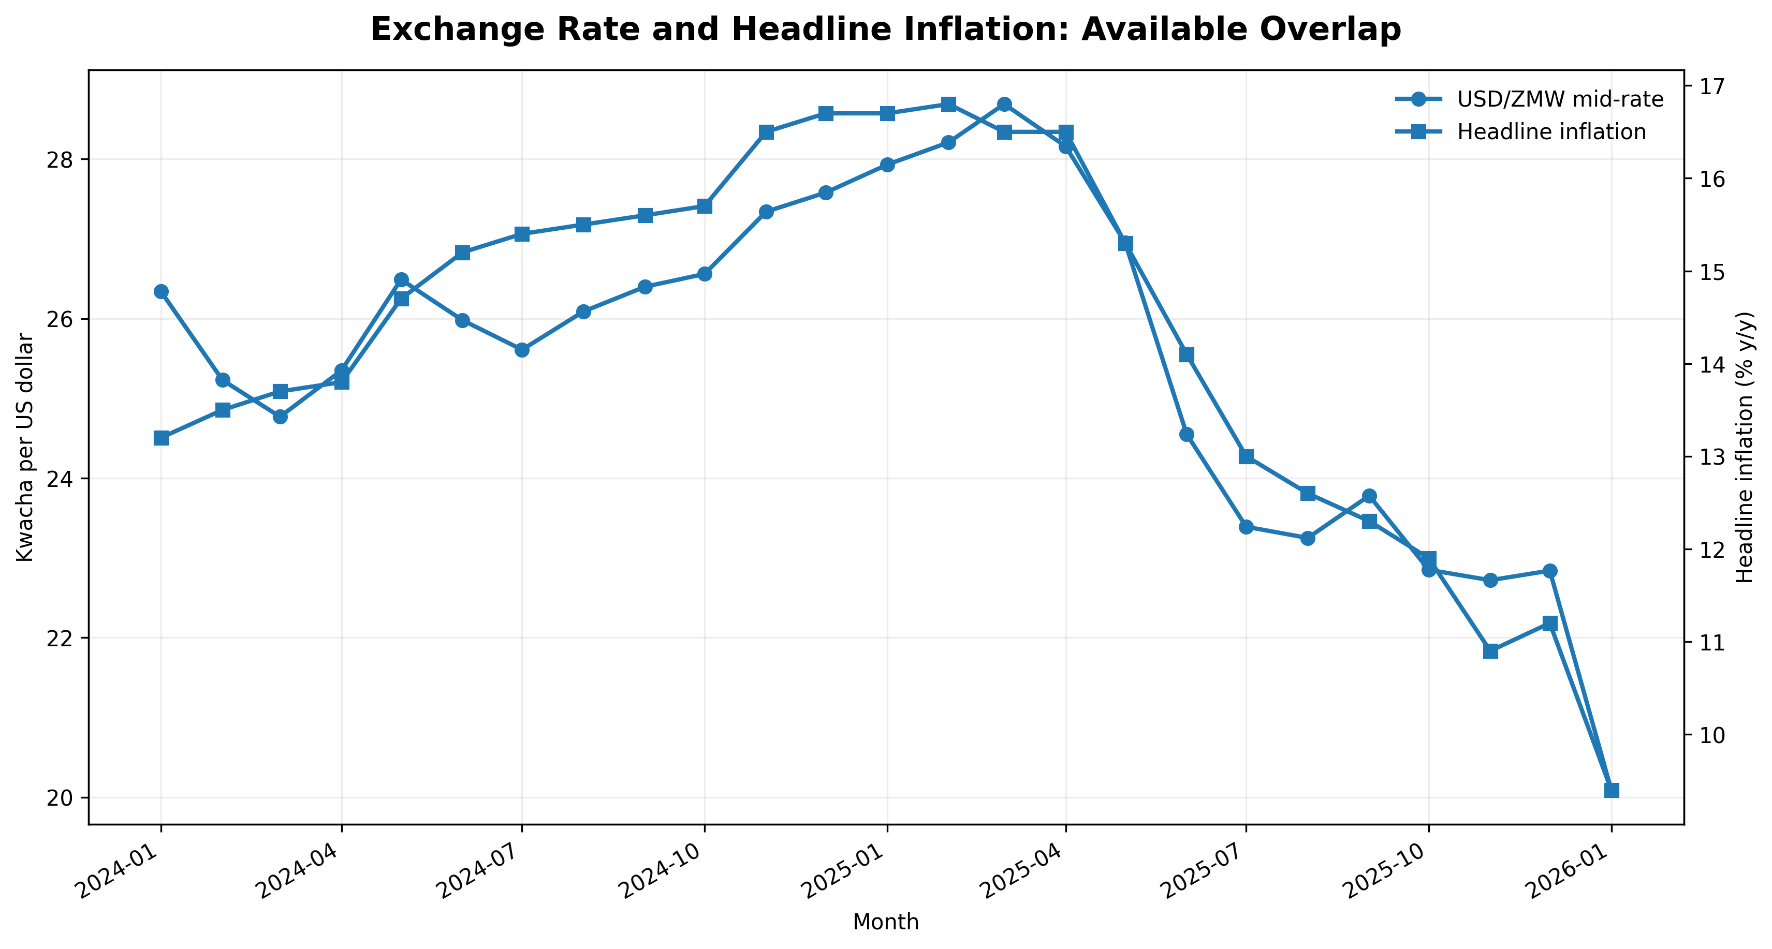
Figure 7. Exchange-rate and headline inflation movements over the available overlap. Dual-axis visual comparison; not evidence of causation.
Period | USD/ZMW rate | Interpretation
March 2025 | K28.69 | Higher Kwacha cost per US dollar
December 2025 | K22.84 | Lower Kwacha cost per US dollar
Change | −20.4% | Kwacha appreciation over the endpoint comparison

Table 2. Selected Bank of Zambia monthly average USD/ZMW mid-rates. A negative percentage change in the quoted ZMW-per-USD rate indicates Kwacha appreciation.
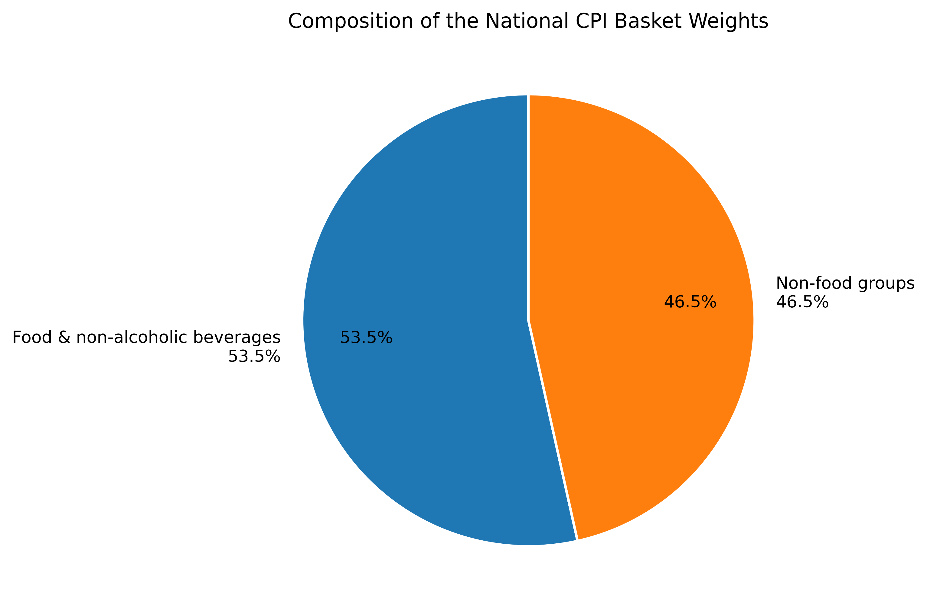
Figure 8. CPI basket weight composition. Source: ZamStats, October 2026, Table 1.

6. Household Cost of Living: JCTR Evidence
The JCTR Lusaka Basic Needs and Nutrition Basket (BNNB) provides a household-level complement to the national CPI. A basic-needs basket is a priced list of goods and services considered necessary to meet a household’s essential consumption requirements. JCTR’s BNNB estimates the monthly cost of specified food and non-food necessities for a reference family of five. It is a cost estimate for that defined basket and location, rather than a measure of the average expenditure of every household. JCTR reported a Lusaka basket cost of K12,112.88 in June 2026, compared with K11,763.38 in June 2025. This was an annual increase of K349.50, or approximately 3.0% (JCTR, 2026).
The June 2026 statement also reported that the basket had increased by K747.88 between January and June 2026. This occurred while annual headline inflation eased from 11.2% in December 2025 to 6.5% in June 2026. The two measures are not contradictory. The inflation rate compares the CPI with its level 12 months earlier, while the BNNB amount records the cost of purchasing the specified basket in a particular month. A household can therefore face a higher monthly bill even as the annual rate of inflation declines.
Monthly changes in the basket can also be substantial. JCTR reported that the Lusaka basket declined from K12,000.94 in August 2026 to K11,399.64 in September 2026, a reduction of K601.30. The September statement attributed the decrease mainly to lower prices for selected food items, including vegetables, bananas, kapenta, Irish potatoes and roller mealie meal, although some essential non-food items increased (JCTR, 2026). This illustrates how movements in a limited number of frequently purchased items can affect the monthly cost of a basic-needs basket.
The BNNB and CPI should not be treated as interchangeable. The CPI tracks price changes across a broad, weighted basket intended to represent consumption patterns, whereas the JCTR BNNB reports the cost of a specified set of necessities for a reference household in particular locations. Their composition, weights, coverage and collection methods differ. In addition, the basket cost alone does not measure affordability. To assess affordability or changes in real purchasing power, the basket would need to be compared with household earnings, wages or disposable income over the same period.
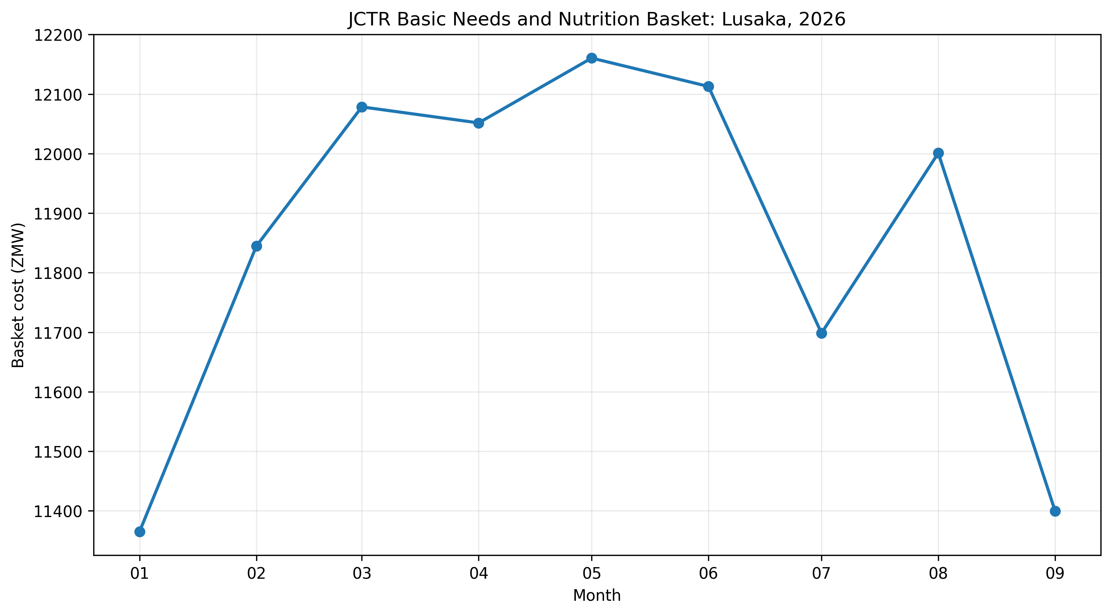
Figure 9. Selected monthly JCTR Lusaka BNNB observations in 2026. Source: JCTR; author’s compilation. Selected observations only.
Observation | Basket cost (ZMW) | Change / context
June 2025 | K11,763.38 | Annual comparison baseline
January 2026 | K11,365.00 | Start of 2026 comparison
June 2026 | K12,112.88 | +K747.88 since January
August 2026 | K12,000.94 | Before September decline
September 2026 | K11,399.64 | −K601.30 month on month

Table 3. Selected Lusaka BNNB observations. Source: JCTR monthly statements.
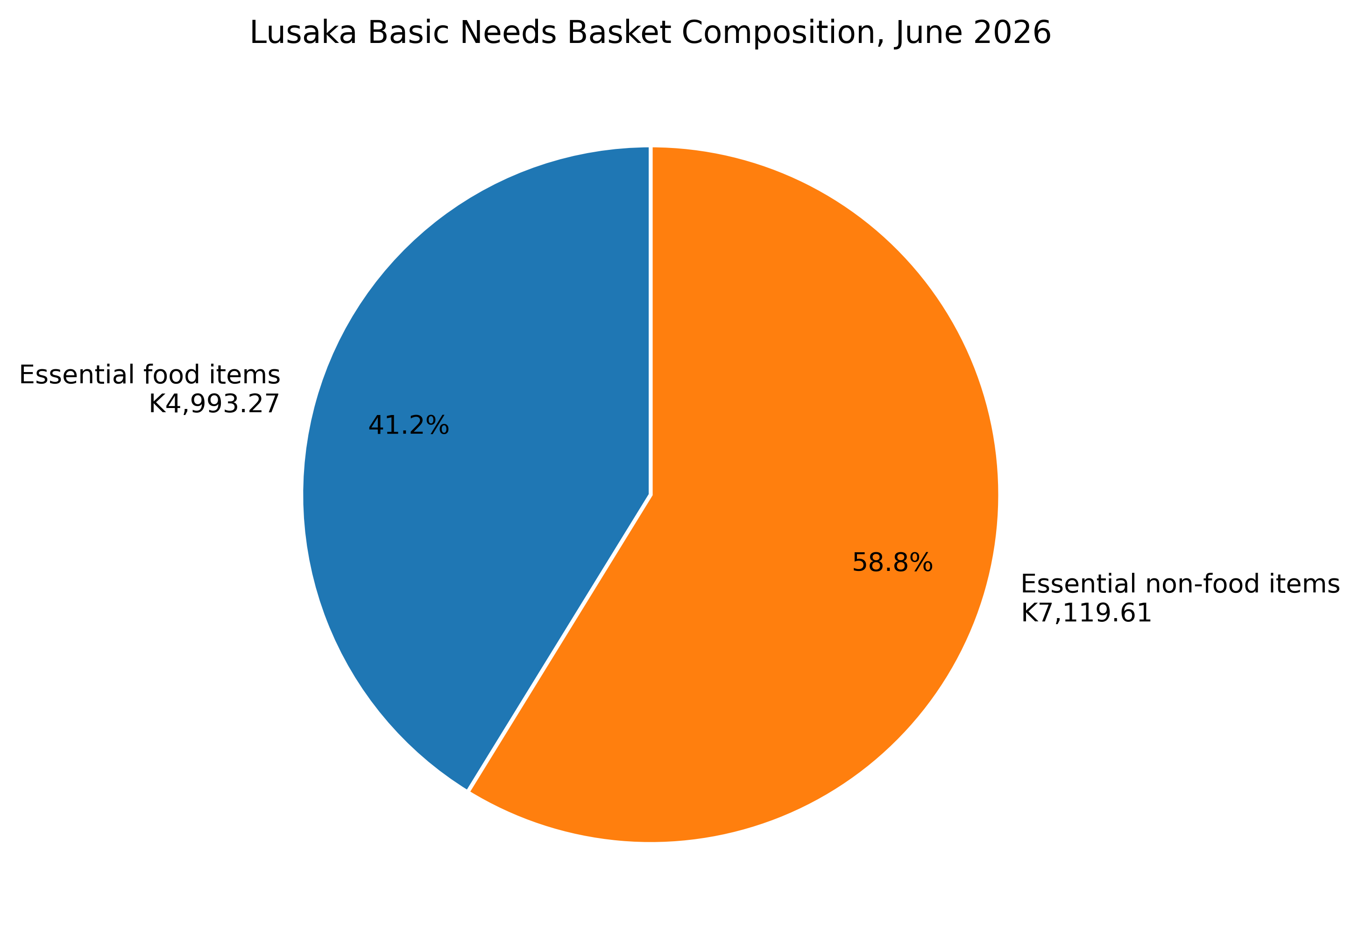
Figure 10. Food and non-food components of the Lusaka BNNB, June 2026. The food amount is calculated as the total basket less the JCTR-reported non-food subtotal.

7. Discussion and Economic Implications
Three findings emerge from the analysis. First, Zambia’s consumer price level rose substantially between January 2020 and October 2026, even though annual inflation had moderated by the end of the period. Second, food prices recorded the largest cumulative increase, but the latest annual comparison shows non-food inflation above food inflation. Third, the JCTR basket remained more expensive in June 2026 than in June 2025, illustrating that a lower national inflation rate does not necessarily reduce the monthly amount a household must spend on basic necessities.
The distinction between the inflation rate and the price level has direct implications for household purchasing power. If nominal earnings remain unchanged while prices rise, the quantity of goods and services that income can buy falls. When inflation slows, the erosion of purchasing power becomes less rapid; it is not automatically reversed. Households may therefore continue to feel the effects of earlier price increases, particularly where wages, pensions or informal-sector earnings have not adjusted sufficiently. This is especially relevant for households with limited capacity to substitute away from essential food and transport expenditure.
Food prices deserve particular attention. The CPI results show a larger cumulative increase in food than in non-food prices, while household expenditure data indicate that food absorbs a larger share of budgets in rural areas than in urban areas. A food-price shock can consequently have a disproportionate effect on households that purchase much of their food in the market and have little room to reduce other essential spending. Improving agricultural productivity, storage, transport links and market access can help reduce supply disruptions and seasonal price volatility. These measures are not substitutes for macroeconomic stability; they address the domestic supply conditions that also shape the cost of living.
The exchange-rate findings add an external dimension to the analysis. Kwacha appreciation can reduce the local-currency cost of imported goods and inputs, but the extent and speed of the benefit reaching consumers depend on the degree of pass-through, inventory costs, competition and domestic distribution margins. Zambia-specific studies find that pass-through is incomplete and asymmetric, with depreciation shocks generally exerting a stronger effect than appreciation shocks (Roger et al., 2019; Fandamu et al., 2023). It would therefore be premature to expect a period of currency appreciation to produce an immediate or proportionate fall in retail prices. The present data show a concurrent movement, not a causal estimate.
The central policy issue is thus not simply whether inflation has returned to a lower rate, but whether household incomes can keep pace with the accumulated cost of essential consumption. Monitoring inflation alongside wages, employment, household expenditure and the cost of basic-needs baskets would provide a more complete picture of welfare. For policymakers, the findings point to the value of sustaining macroeconomic stability while strengthening domestic food supply chains and protecting the purchasing power of households most exposed to food and essential-service costs. These are complementary priorities: stable prices support planning and investment, while stronger household incomes determine whether families can afford the goods and services whose prices are being stabilised.

8. Conclusion
This article examined Zambia’s inflation and cost-of-living experience from January 2020 to October 2026. The all-items CPI rose by approximately 128.9% over the period, with food prices increasing by 154.5% and non-food prices by 98.8%. Annual headline inflation, by contrast, declined to 6.3% in October 2026. The findings show why these measures should be read together: inflation slowed, but the accumulated price increases remained in place.
The Kwacha appreciated during much of 2025, alongside a period of declining inflation, while the JCTR basket remained higher in June 2026 than a year earlier. These patterns are consistent with easing price pressures but do not establish causation or prove that household affordability improved. The evidence supports a clear conclusion: disinflation is an important step towards stability, but it does not by itself restore lost purchasing power. That depends on sustained price stability, reliable food supply and growth in real household incomes.
The central conclusion is that improved inflation indicators do not automatically translate into an affordable cost of living. Sustained price stability, stronger domestic food systems, stable macroeconomic conditions and growth in household incomes are all important to translating lower inflation into improved living standards. [Improve on the conclusion, make it a bit more solid, convincing and a bit shorter with impact]

References
Bank of Zambia. (2026). Statistics Fortnightly, Volume 33, Issue No. 2. Tables 01A and 02. https://www.boz.zm/StatisticsFortnightly2026Vol33IssueNo_2.pdf
Jesuit Centre for Theological Reflection. (2025). June 2025 Basic Needs and Nutrition Basket Statement. https://www.jctr.org.zm/en/june-2025-basic-needs-and-nutrition-basket-statement/
Jesuit Centre for Theological Reflection. (2026). June 2026 Basic Needs and Nutrition Basket Statement. https://jctr.org.zm/en/june-2026-basic-needs-and-nutrition-basket-statement/
Jesuit Centre for Theological Reflection. (2026). September 2026 Basic Needs and Nutrition Basket Statement. https://www.jctr.org.zm/en/september-2026-basic-needs-and-nutrition-basket-statement/
Roger, L., Smith, G., & Morrissey, O. (2019). Exchange rate and inflation dynamics in a resource rich setting: The case of Zambia. South African Journal of Economics, 87(4), 490–514. https://doi.org/10.1111/saje.12236
Fandamu, H., Ndulo, M., Mudenda, D., & Fandamu, M. (2023). Asymmetric exchange rate pass through to consumer prices: Evidence from Zambia. Foreign Trade Review, 58(4), 504–523. https://doi.org/10.1177/00157325221143886
Zambia Statistics Agency. (2024). The Monthly, Volume 256, July 2024. Annex 1, Tables 1.1 and 1.3. https://www.zamstats.gov.zm/wp-content/uploads/2024/07/Vol-256-of-2024-The-Monthly-July.pdf
Zambia Statistics Agency. (2026). The Monthly, Volume 283, October 2026. Annex 1, Tables 1.1 and 1.3. https://www.zamstats.gov.zm/wp-content/uploads/2026/10/Vol-283-of-2026-The-Monthly-October.pdf
Chipili, J. M. (2022). Inflation dynamics in Zambia. African Economic Research Consortium, Research Paper 484. https://publication.aercafricalibrary.org/handle/123456789/3299
Chinyemba, K. (2021). Exchange rate pass-through to domestic consumer prices in Zambia. University of Zambia. https://dspace.unza.zm/handle/123456789/7298
Zambia Statistics Agency. (2025). 2022 Living Conditions Monitoring Survey Report. Chapter 11: Consumption Expenditure. https://www.zamstats.gov.zm/wp-content/uploads/2025/07/2022-LCMS-Report.pdf

