BOISDUR_exercise3

Loading the data
# Load required packages
pacman::p_load(
devtools,
quanteda,
quanteda.corpora,
udpipe,
textclean,
stm,
dplyr,
ggrepel,
tidyr,
tidytext,
stringi,
ggplot2,
topicmodels,
topicdoc,
stminsights,
install = TRUE
)
# Load the UN General Debate Corpus
data("data_corpus_ungd2017",
package = "quanteda.corpora")
un <- data_corpus_ungd2017
rm(data_corpus_ungd2017)
# Remove missing observations
un <- un |>
convert(to = "data.frame") |>
drop_na(continent, gdp_per_capita)
# Check the number of statements
nrow(un)
[1] 187

Text preprocessing
un <- un |>
mutate(
text.clean = stri_trans_general(
text,
id = "Any-Latin;Latin-ASCII"
),
text.clean = tolower(text.clean),
text.clean = replace_curly_quote(text.clean),
text.clean = replace_contraction(text.clean),
text.clean = gsub("[[:digit:]]+", " ", text.clean),
text.clean = gsub("[[:space:]]+", " ", text.clean),
text.clean = trimws(text.clean)
)

Lemmatization
# Download and load the English language model
eng <- udpipe_download_model(language = "english-gum")
ud_eng <- udpipe_load_model(eng$file_model)
# Annotate and lemmatize the statements
un.df.trip <- udpipe_annotate(
x = un$text.clean,
object = ud_eng
) |>
as_tibble() |>
anti_join(stop_words, by = c("lemma" = "word")) |>
select(doc_id, lemma) |>
filter(!grepl("[[:punct:]]+", lemma)) |>
count(doc_id, lemma)

Document-term matrix
# DTM
un.dtm <- un.df.trip |>
cast_dfm(
document = doc_id,
term = lemma,
value = n
) |>
dfm_trim(
min_docfreq = 0.1,
max_docfreq = 0.9,
docfreq_type = "prop"
)
# Check the dimensions
dim(un.dtm)
[1] 187 1205

Partie I : Latent Dirichlet Allocation

Question 1 : Estimate ten LDA models
# Convert the DFM for topicmodels
un_lda_dtm <- quanteda::convert(
un.dtm,
to = "topicmodels"
)
# Set seed for reproducibility
set.seed(2026)
# Define the number of topics
k_values <- seq(2, 20, by = 2)
# Estimate the ten models
lda_models <- lapply(k_values, function(k) {
topicmodels::LDA(
un_lda_dtm,
k = k,
method = "Gibbs",
control = list(
seed = 2026,
burnin = 500,
iter = 1500,
thin = 100
)
)
})
names(lda_models) <- paste0("K", k_values)
names(lda_models)
[1] "K2" "K4" "K6" "K8" "K10" "K12" "K14" "K16" "K18" "K20"

Question 2 : Semantic Coherence and Exclusivity
# Calculate semantic coherence and exclusivity
diagnostics <- lapply(seq_along(k_values), function(i) {
model <- lda_models[[i]]
coherence <- topicdoc::topic_coherence(
model,
un_lda_dtm,
top_n_tokens = 10
)
exclusivity <- topicdoc::topic_exclusivity(
model,
top_n_tokens = 10,
excl_weight = 0.7
)
data.frame(
K = k_values[i],
semantic_coherence = mean(coherence),
exclusivity = mean(exclusivity)
)
}) |>
dplyr::bind_rows()
print(diagnostics)
K semantic_coherence exclusivity
1 2 -15.38701 9.053551
2 4 -21.64192 9.128793
3 6 -25.31842 9.389327
4 8 -24.30143 9.454055
5 10 -29.73894 9.543991
6 12 -30.21745 9.627330
7 14 -31.05498 9.635476
8 16 -33.42327 9.721799
9 18 -32.85819 9.724833
10 20 -34.15950 9.736637
# Plot semantic coherence and exclusivity
ggplot(
diagnostics,
aes(
x = semantic_coherence,
y = exclusivity
)
) +
geom_point(size = 3, color = "steelblue") +
ggrepel::geom_text_repel(
aes(label = paste0("K = ", K)),
size = 3.5,
box.padding = 0.5,
point.padding = 0.3,
max.overlaps = Inf,
seed = 2026
) +
labs(
title = "Semantic Coherence and Exclusivity of LDA Models",
subtitle = "UN General Debate Corpus (2017)",
x = "Mean Semantic Coherence",
y = "Mean Exclusivity"
) +
theme_minimal()
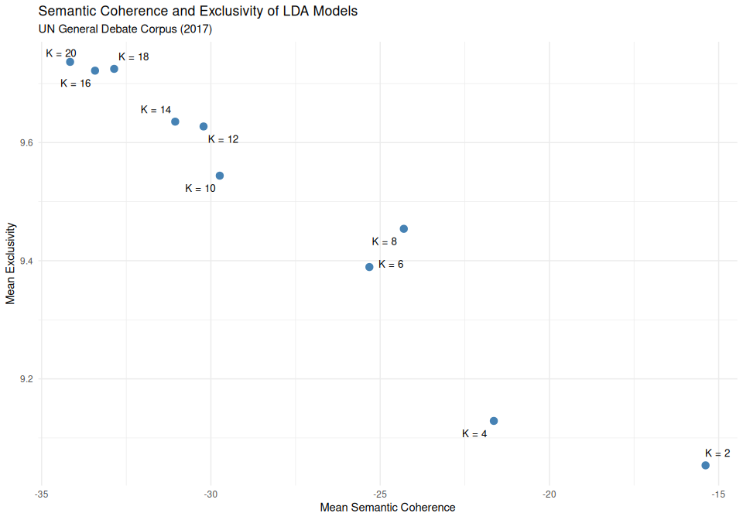
The scatterplot reveals a trade-off between semantic coherence and exclusivity. Models with fewer topics tend to exhibit higher semantic coherence but lower exclusivity, whereas models with more topics show greater exclusivity at the expense of semantic coherence.
I selected the eight-topic solution (K = 8), which provides a reasonable compromise between these two measures, with a mean semantic coherence of −24.30 and a mean exclusivity of 9.45. Compared with models containing fewer topics, it offers greater topic differentiation, while avoiding the substantial decline in semantic coherence observed in models with larger numbers of topics.

Question 3 : Topic interpretation
# Retrieve the selected 8-topic model
final_lda <- lda_models[["K8"]]
# Extract topic-word probability distributions
beta_matrix <- posterior(final_lda)$terms
# Extract the 10 most probable lemmas per topic
top_lemmas <- as.data.frame(beta_matrix) |>
mutate(topic = row_number()) |>
pivot_longer(
cols = -topic,
names_to = "lemma",
values_to = "probability"
) |>
group_by(topic) |>
slice_max(
order_by = probability,
n = 10,
with_ties = FALSE
) |>
ungroup() |>
mutate(topic = paste0("Topic ", topic))
# Display the results
print(top_lemmas, n = 80)
# A tibble: 80 × 3
topic lemma probability
<chr> <chr> <dbl>
1 Topic 1 african 0.0381
2 Topic 1 agreement 0.0180
3 Topic 1 union 0.0174
4 Topic 1 situation 0.0169
5 Topic 1 central 0.0152
6 Topic 1 fight 0.0135
7 Topic 1 regard 0.0132
8 Topic 1 reform 0.0129
9 Topic 1 council 0.0127
10 Topic 1 commitment 0.0125
11 Topic 2 republic 0.0286
12 Topic 2 human 0.0259
13 Topic 2 political 0.0203
14 Topic 2 economic 0.0166
15 Topic 2 national 0.0153
16 Topic 2 session 0.0153
17 Topic 2 issue 0.0142
18 Topic 2 dialogue 0.0137
19 Topic 2 president 0.0129
20 Topic 2 process 0.0122
21 Topic 3 agenda 0.0238
22 Topic 3 goal 0.0202
23 Topic 3 ensure 0.0174
24 Topic 3 council 0.0168
25 Topic 3 cooperation 0.0158
26 Topic 3 reform 0.0148
27 Topic 3 implementation 0.0147
28 Topic 3 regional 0.0146
29 Topic 3 commitment 0.0143
30 Topic 3 action 0.0142
31 Topic 4 terrorism 0.0228
32 Topic 4 region 0.0193
33 Topic 4 humanitarian 0.0178
34 Topic 4 resolution 0.0172
35 Topic 4 solution 0.0149
36 Topic 4 conflict 0.0131
37 Topic 4 stability 0.0116
38 Topic 4 refugee 0.0115
39 Topic 4 community 0.0110
40 Topic 4 call 0.0108
41 Topic 5 human 0.0302
42 Topic 5 time 0.0224
43 Topic 5 woman 0.0201
44 Topic 5 future 0.0200
45 Topic 5 conflict 0.0185
46 Topic 5 share 0.0177
47 Topic 5 strong 0.0168
48 Topic 5 common 0.0135
49 Topic 5 protect 0.0130
50 Topic 5 bring 0.0130
51 Topic 6 climate 0.0392
52 Topic 6 change 0.0356
53 Topic 6 island 0.0225
54 Topic 6 planet 0.0160
55 Topic 6 caribbean 0.0152
56 Topic 6 life 0.0141
57 Topic 6 government 0.0141
58 Topic 6 ocean 0.0134
59 Topic 6 call 0.0130
60 Topic 6 hurricane 0.0126
61 Topic 7 government 0.0289
62 Topic 7 economic 0.0255
63 Topic 7 poverty 0.0195
64 Topic 7 cent 0.0156
65 Topic 7 goal 0.0155
66 Topic 7 economy 0.0151
67 Topic 7 national 0.0134
68 Topic 7 create 0.0134
69 Topic 7 social 0.0127
70 Topic 7 life 0.0124
71 Topic 8 nuclear 0.0232
72 Topic 8 war 0.0224
73 Topic 8 korea 0.0176
74 Topic 8 north 0.0163
75 Topic 8 president 0.0149
76 Topic 8 weapon 0.0149
77 Topic 8 time 0.0134
78 Topic 8 seek 0.0115
79 Topic 8 threat 0.0109
80 Topic 8 power 0.0100
# Visualize the 10 most probable lemmas per topic
ggplot(
top_lemmas,
aes(
x = reorder_within(lemma, probability, topic),
y = probability
)
) +
geom_col(fill = "steelblue") +
coord_flip() +
scale_x_reordered() +
facet_wrap(
~ topic,
scales = "free",
ncol = 2
) +
labs(
title = "Top 10 Most Probable Lemmas by Topic",
subtitle = "Eight-topic LDA Model - UN General Debate 2017",
x = "Lemma",
y = "Probability"
) +
theme_minimal()
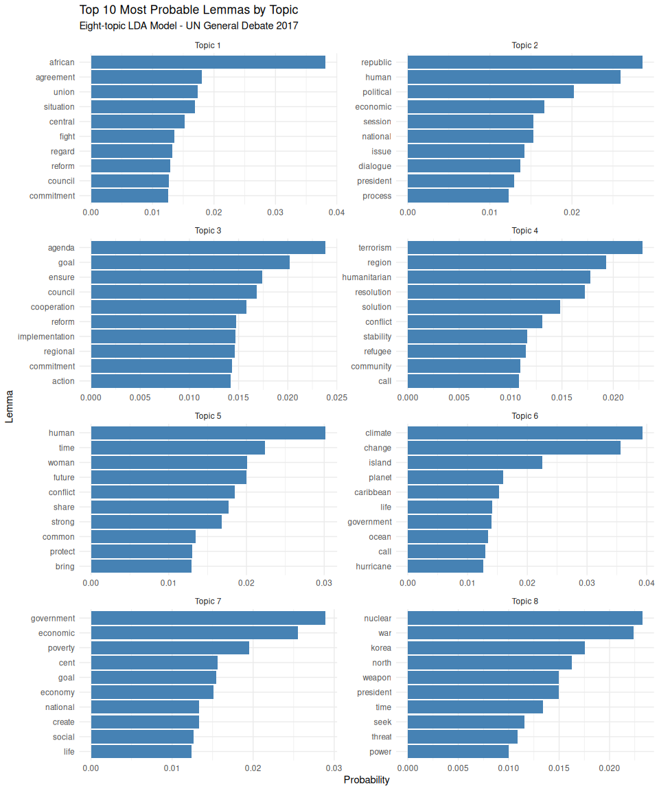
The eight-topic LDA model identifies several thematic dimensions within the 2017 UN General Debate speeches. Based on the ten most probable lemmas, I assigned the following labels:
Topic | Label
Topic 1 | African Union and Regional Affairs
Topic 2 | National Politics and Governance
Topic 3 | Multilateral Cooperation and Institutional Reform
Topic 4 | Terrorism and Humanitarian Crises
Topic 5 | Human Security and Protection
Topic 6 | Climate Change and Caribbean Vulnerability
Topic 7 | Economic Development and Poverty Reduction
Topic 8 | North Korean Nuclear Threat
Some topics are more clearly interpretable than others. Topics 6 and 8, for instance, contain highly specific vocabulary related to climate change and North Korean nuclear threats, respectively. By contrast, Topics 2, 3, and 5 contain more general terms, making their substantive interpretation less straightforward. Their labels should therefore be considered tentative.

Question 4 : Downstream Analyses
The document-topic probability distributions could be used to compare diplomatic priorities across countries and continents. For instance, we could examine whether Caribbean countries devote a greater proportion of their speeches to climate change (Topic 6) than countries from other regions.
These probabilities could also be used in regression analyses to investigate whether GDP per capita is associated with the prevalence of topics such as economic development and poverty reduction (Topic 7).
Finally, document-topic probabilities could help identify speeches strongly associated with a particular topic, such as the North Korean nuclear threat (Topic 8), for further qualitative analysis. Topic-word probabilities could complement this analysis by identifying the vocabulary most characteristic of each topic.

Partie 2 : Structural Topic Modeling

Question 1 : Estimating a Six-Topic Structural Topic Model
# Align metadata with the document-term matrix
rownames(un) <- paste0("doc", 1:nrow(un))
un <- un[rownames(un.dtm), ]
# Verify alignment
identical(rownames(un), rownames(un.dtm))
[1] TRUE
# Convert the DFM to STM format
un_stm <- quanteda::convert(
un.dtm,
to = "stm"
)
# Estimate the six-topic STM model
set.seed(2026)
un.model <- stm(
documents = un_stm$documents,
vocab = un_stm$vocab,
K = 6,
prevalence = ~ gdp_per_capita + continent,
data = un,
init.type = "Spectral",
seed = 2026,
verbose = FALSE
)
# Display the model summary
summary(un.model)
A topic model with 6 topics, 187 documents and a 1205 word dictionary.
Topic 1 Top Words:
Highest Prob: nuclear, korea, weapon, conflict, council, north, human
FREX: korea, north, nuclear, weapon, korean, ukraine, treaty
Lift: north, korea, ukraine, missile, korean, nuclear, disarmament
Score: north, korea, ukraine, nuclear, korean, weapon, missile
Topic 2 Top Words:
Highest Prob: israel, resolution, region, terrorism, palestinian, government, humanitarian
FREX: israel, palestinian, arab, iran, occupation, palestine, territory
Lift: israel, jerusalem, arab, occupation, muslim, palestinian, iran
Score: israel, arab, iran, palestinian, jerusalem, occupation, yeman
Topic 3 Top Words:
Highest Prob: government, human, life, poverty, woman, economic, cent
FREX: poverty, cent, drug, education, democracy, woman, child
Lift: divide, happy, drug, love, feel, wealth, corruption
Score: divide, government, poverty, quality, drug, happy, democracy
Topic 4 Top Words:
Highest Prob: cooperation, european, terrorism, future, time, region, political
FREX: european, europe, migration, common, civilization, multilateralism, china
Lift: civilization, european, europe, strick, contrary, perspective, answer
Score: civilization, european, europe, syrian, central, minority, ethnic
Topic 5 Top Words:
Highest Prob: african, agenda, republic, national, implementation, commitment, session
FREX: african, implementation, regard, session, central, union, agenda
Lift: sudan, malus, sahel, sahara, ababa, african, africa
Score: sudan, african, malus, sahel, central, libya, union
Topic 6 Top Words:
Highest Prob: climate, change, island, caribbean, ocean, hurricane, pacific
FREX: island, pacific, ocean, caribbean, hurricane, climate, disaster
Lift: pacific, irma, maria, island, ocean, fiji, hurricane
Score: pacific, island, ocean, irma, caribbean, hurricane, climate

Question 2 : Interpreting STM Topics
labelTopics(un.model)
Topic 1 Top Words:
Highest Prob: nuclear, korea, weapon, conflict, council, north, human
FREX: korea, north, nuclear, weapon, korean, ukraine, treaty
Lift: north, korea, ukraine, missile, korean, nuclear, disarmament
Score: north, korea, ukraine, nuclear, korean, weapon, missile
Topic 2 Top Words:
Highest Prob: israel, resolution, region, terrorism, palestinian, government, humanitarian
FREX: israel, palestinian, arab, iran, occupation, palestine, territory
Lift: israel, jerusalem, arab, occupation, muslim, palestinian, iran
Score: israel, arab, iran, palestinian, jerusalem, occupation, yeman
Topic 3 Top Words:
Highest Prob: government, human, life, poverty, woman, economic, cent
FREX: poverty, cent, drug, education, democracy, woman, child
Lift: divide, happy, drug, love, feel, wealth, corruption
Score: divide, government, poverty, quality, drug, happy, democracy
Topic 4 Top Words:
Highest Prob: cooperation, european, terrorism, future, time, region, political
FREX: european, europe, migration, common, civilization, multilateralism, china
Lift: civilization, european, europe, strick, contrary, perspective, answer
Score: civilization, european, europe, syrian, central, minority, ethnic
Topic 5 Top Words:
Highest Prob: african, agenda, republic, national, implementation, commitment, session
FREX: african, implementation, regard, session, central, union, agenda
Lift: sudan, malus, sahel, sahara, ababa, african, africa
Score: sudan, african, malus, sahel, central, libya, union
Topic 6 Top Words:
Highest Prob: climate, change, island, caribbean, ocean, hurricane, pacific
FREX: island, pacific, ocean, caribbean, hurricane, climate, disaster
Lift: pacific, irma, maria, island, ocean, fiji, hurricane
Score: pacific, island, ocean, irma, caribbean, hurricane, climate
The six-topic STM model reveals several thematic dimensions of the 2017 UN General Debate speeches. Based on the highest-probability, FREX, and lift terms, I propose the following interpretations:
Topic 1 — Nuclear Security and International Conflicts. The prominence of terms such as nuclear, korea, weapon, and missile suggests a focus on nuclear proliferation and international security. The presence of ukraine and disarmament also indicates broader geopolitical tensions.
Topic 2 — Middle Eastern Conflicts. Terms such as israel, palestinian, iran, occupation, and jerusalem suggest that this topic captures regional conflicts in the Middle East, particularly the Israeli-Palestinian conflict.
Topic 3 — Social Welfare and Domestic Development. The combination of poverty, education, woman, child, and democracy points to socioeconomic development, social welfare, and domestic governance. However, the diversity of these terms suggests a relatively broad thematic category.
Topic 4 — European and International Cooperation. The presence of european, cooperation, migration, and multilateralism suggests discussions of European affairs and international relations. References to terrorism and syrian indicate that security and migration issues may also contribute to this topic, making its interpretation less straightforward.
Topic 5 — African Regional Affairs. Terms such as african, union, sahel, sudan, and libya suggest a focus on African regional politics, institutional cooperation, and political challenges across the continent.
Topic 6 — Climate Change and Island Vulnerability. The prominence of climate, island, caribbean, pacific, and hurricane, alongside references to Irma and Maria, indicates a focus on climate change, natural disasters, and the particular vulnerability of island states.
Overall, Topics 1, 2, 5, and 6 appear relatively well-defined, while Topics 3 and 4 contain more heterogeneous vocabulary. Their interpretation therefore requires greater caution.

Question 3 : Effects of GDP per Capita on Topic Prevalence
# Estimate covariate effects on Topics 3 and 6
library(stminsights)
set.seed(2026)
un.effs <- estimateEffect(
c(3, 6) ~ gdp_per_capita + continent,
stmobj = un.model,
metadata = un,
uncertainty = "Global"
)
# Display regression results
summary(un.effs)
Call:
estimateEffect(formula = c(3, 6) ~ gdp_per_capita + continent,
stmobj = un.model, metadata = un, uncertainty = "Global")
Topic 3:
Coefficients:
Estimate Std. Error t value Pr(>|t|)
(Intercept) 2.387e-01 3.101e-02 7.697 8.74e-13 ***
gdp_per_capita 7.890e-08 1.043e-06 0.076 0.93981
continentAmericas 4.952e-02 5.117e-02 0.968 0.33447
continentAsia -7.507e-02 4.665e-02 -1.609 0.10930
continentEurope -1.599e-01 5.457e-02 -2.930 0.00383 **
continentOceania -1.760e-01 6.475e-02 -2.718 0.00720 **
---
Signif. codes: 0 '***' 0.001 '**' 0.01 '*' 0.05 '.' 0.1 ' ' 1
Topic 6:
Coefficients:
Estimate Std. Error t value Pr(>|t|)
(Intercept) 7.452e-02 2.649e-02 2.814 0.00544 **
gdp_per_capita -7.054e-07 9.433e-07 -0.748 0.45553
continentAmericas 2.727e-01 4.651e-02 5.862 2.12e-08 ***
continentAsia -2.770e-03 3.931e-02 -0.070 0.94391
continentEurope 7.397e-03 4.702e-02 0.157 0.87517
continentOceania 5.454e-01 6.211e-02 8.781 1.20e-15 ***
---
Signif. codes: 0 '***' 0.001 '**' 0.01 '*' 0.05 '.' 0.1 ' ' 1
# Extract predicted topic prevalence by GDP per capita
gdp.effects <- stminsights::get_effects(
estimates = un.effs,
variable = "gdp_per_capita",
type = "continuous"
) |>
mutate(
Topic = case_when(
as.character(topic) == "3" ~
"Social Welfare and Domestic Development",
as.character(topic) == "6" ~
"Climate Change and Island Vulnerability"
)
) |>
arrange(Topic, value)
# Display the results
head(gdp.effects)
# A tibble: 6 × 6
value proportion topic lower upper Topic
<dbl> <dbl> <fct> <dbl> <dbl> <chr>
1 292 0.0743 6 0.0222 0.123 Climate Change and Island Vulnerability
2 1341. 0.0736 6 0.0215 0.123 Climate Change and Island Vulnerability
3 2389. 0.0729 6 0.0203 0.122 Climate Change and Island Vulnerability
4 3438. 0.0721 6 0.0191 0.122 Climate Change and Island Vulnerability
5 4486. 0.0714 6 0.0184 0.122 Climate Change and Island Vulnerability
6 5535. 0.0706 6 0.0174 0.121 Climate Change and Island Vulnerability
# Plot predicted topic prevalence by GDP per capita
ggplot(
gdp.effects,
aes(
x = value,
y = proportion,
color = Topic,
fill = Topic
)
) +
geom_ribbon(
aes(ymin = lower, ymax = upper),
alpha = 0.15,
color = NA
) +
geom_line(linewidth = 1) +
labs(
title = "GDP per Capita and Predicted Topic Prevalence",
subtitle = "UN General Debate Corpus (2017)",
x = "GDP per Capita",
y = "Predicted Topic Prevalence",
color = "Topic",
fill = "Topic"
) +
theme_minimal()
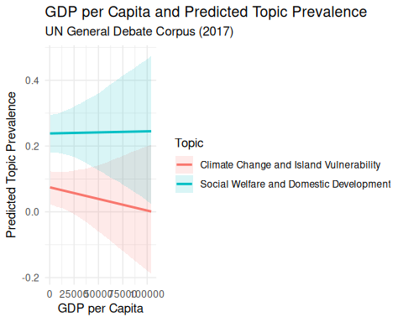
The plot suggests different patterns in predicted topic prevalence across GDP per capita. Topic 3 (Social Welfare and Domestic Development) remains relatively stable, with a predicted prevalence of approximately 0.24. In contrast, Topic 6 (Climate Change and Island Vulnerability) shows a slight downward trend as GDP per capita increases.
However, neither association is statistically significant (p = 0.940 for Topic 3 and p = 0.456 for Topic 6). The relatively wide confidence intervals, particularly at higher GDP levels, further suggest uncertainty in these estimates.
Interestingly, the regression results indicate significant differences across continents. In particular, the predicted prevalence of Topic 6 is higher for countries in the Americas and Oceania compared with Africa, controlling for GDP per capita. This suggests that geographical context may be more strongly associated with the prominence of climate-related issues in UN speeches than national economic wealth.

Question 4 : Topic Prevalence Across Continents
# Estimate effects for Topics 3 and 5
set.seed(2026)
un.effs.continent <- estimateEffect(
c(3, 5) ~ gdp_per_capita + continent,
stmobj = un.model,
metadata = un,
uncertainty = "Global"
)
# Extract predicted topic prevalence by continent
un.continent.effects <- get_effects(
un.effs.continent,
variable = "continent",
type = "pointestimate"
) |>
mutate(Topics = case_when(
as.character(topic) == "5" ~ "Africa",
as.character(topic) == "3" ~ "National Welfare"
))
# Plot predicted topic prevalence
un.continent.effects |>
ggplot(aes(x = value, y = proportion, color = value)) +
geom_errorbar(
aes(ymin = lower, ymax = upper),
alpha = 0.5,
width = .5
) +
geom_point() +
labs(x = "") +
guides(color = "none") +
labs(y = "Predicted Topic Prevalence") +
facet_wrap(~Topics)
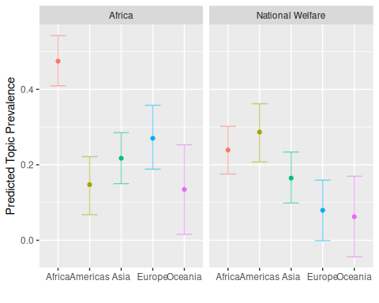
The plot reveals substantial geographical differences in predicted topic prevalence.
Topic 5 (Africa) is considerably more prevalent in speeches from African countries (approximately 0.47) than from other continents. This suggests that African states devote a greater proportion of their speeches to regional political and institutional issues. The relatively limited overlap between confidence intervals reinforces this geographical distinction.
Topic 3 (National Welfare) displays a different pattern. Its predicted prevalence is highest in the Americas (approximately 0.29) and Africa (0.24), while Europe and Oceania exhibit substantially lower values. However, the overlapping confidence intervals indicate greater uncertainty regarding some of these differences.
Overall, these results suggest that geographical context is associated with the thematic priorities expressed in UN General Debate speeches, even after accounting for GDP per capita.

On Your own

Question 1 : Topic Selection and Interpretation
I selected Topic 2, which I label “Middle Eastern Conflicts and Geopolitical Tensions”.
The highest-probability terms, including israel, resolution, terrorism, palestinian, and humanitarian, suggest a focus on political conflicts and humanitarian issues in the Middle East. The FREX and lift terms provide a more specific interpretation, with words such as occupation, palestine, jerusalem, arab, and iran pointing particularly to the Israeli-Palestinian conflict and broader regional tensions.
Overall, this topic appears to capture diplomatic discussions surrounding territorial disputes, regional security, and humanitarian challenges in the Middle East.

Question 2 : Identifying the Three Most Representative Speeches
# Extract the three speeches with the highest Topic 2 prevalence
top_thoughts <- findThoughts(
model = un.model,
texts = un$text,
topics = 2,
n = 3
)
# Extract document indices
top_indices <- top_thoughts$index[[1]]
# Create a summary table
top_speeches <- data.frame(
Rank = 1:3,
Document = rownames(un)[top_indices],
Country = un$country[top_indices],
Topic_Prevalence = round(
un.model$theta[top_indices, 2],
3
)
)
# Display the results
print(top_speeches)
Rank Document Country Topic_Prevalence
1 1 doc141 Palestinian Territories 0.992
2 2 doc146 Saudi Arabia 0.960
3 3 doc183 Yemen 0.955

Question 3 : Reading the Three Selected UN Speeches
selected_speeches <- data.frame(
Country = un$country[top_indices],
Text = un$text[top_indices]
)

Question 4 : Evaluating the Topic Label
The label “Middle Eastern Conflicts and Geopolitical Tensions” broadly aligns with the three selected speeches. The model successfully identifies a shared focus on regional conflicts, security, and international relations. However, a closer reading reveals important differences in their political priorities. The Palestinian speech primarily focuses on Israeli occupation, sovereignty, and the two-state solution, while Saudi Arabia addresses several regional crises, including Yemen, Iran, and Qatar. The Yemeni speech emphasizes the country’s internal conflict, humanitarian crisis, and reconstruction efforts. Although the model captures their common geopolitical vocabulary, it overlooks these distinct national perspectives and the specific political arguments developed by each speaker. This illustrates the limitations of topic modeling in capturing the nuances of diplomatic discourse.

