PROPERTY OF MCTV DIGITAL · DO NOT REMOVE Cannon Chevrolet Buick Cadill… OXF-BFEC78 bfec78d2-aeac-4aa4-a316-1d0a65eff9d2 Questions? 601-201-8202 | portal@mctvofms.com 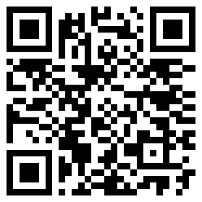 |  | PROPERTY OF MCTV DIGITAL · DO NOT REMOVE Cannon Collision Center OXF-FEE15B fee15bc3-046e-45fb-a0ef-e2bdf591d589 Questions? 601-201-8202 | portal@mctvofms.com 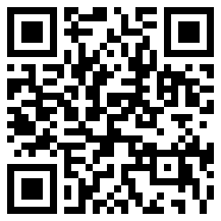
PROPERTY OF MCTV DIGITAL · DO NOT REMOVE Casa Mexicana of Oxford OXF-F58A32 f58a32f0-9555-436d-a633-1b238ecf97a6 Questions? 601-201-8202 | portal@mctvofms.com 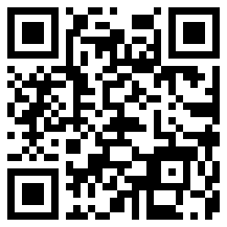 |  | PROPERTY OF MCTV DIGITAL · DO NOT REMOVE Built Different Fitness OXF-118168 118168ee-f876-4799-a16b-d87d4917f540 Questions? 601-201-8202 | portal@mctvofms.com 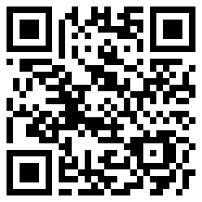
PROPERTY OF MCTV DIGITAL · DO NOT REMOVE Nail E! OXF-5B0A3A 5b0a3a8a-84e9-4a62-bf3c-bda67aae32d3 Questions? 601-201-8202 | portal@mctvofms.com 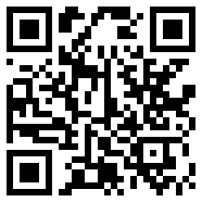 |  | PROPERTY OF MCTV DIGITAL · DO NOT REMOVE Nail E! OXF-BB967D bb967db7-e7a0-4c63-805b-1999aa8703e5 Questions? 601-201-8202 | portal@mctvofms.com 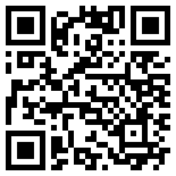
PROPERTY OF MCTV DIGITAL · DO NOT REMOVE LandShark Seafood & Catfish OXF-8D3D54 8d3d548a-2369-4fbc-852c-e552258b8415 Questions? 601-201-8202 | portal@mctvofms.com 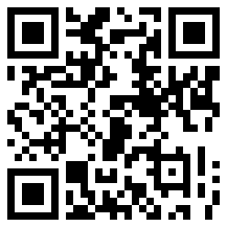 |  | PROPERTY OF MCTV DIGITAL · DO NOT REMOVE RedMed Urgent Clinic of Oxfor… OXF-485AF1 485af1c6-c9a6-4f9b-a28d-3d307465b0ac Questions? 601-201-8202 | portal@mctvofms.com 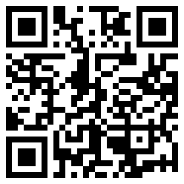
PROPERTY OF MCTV DIGITAL · DO NOT REMOVE Rebel Body Fitness OXF-8D1802 8d1802b5-8ced-4785-a5b1-90ab759d697b Questions? 601-201-8202 | portal@mctvofms.com 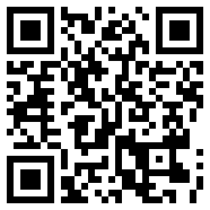 |  | PROPERTY OF MCTV DIGITAL · DO NOT REMOVE Bep Haus OXF-667F1E 667f1e3f-92a1-4b54-bd5f-de6f39049e95 Questions? 601-201-8202 | portal@mctvofms.com 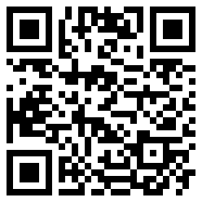

PROPERTY OF MCTV DIGITAL · DO NOT REMOVE B's Hickory Smoke BBQ OXF-ECEA20 ecea20f5-9ddb-4f4c-a4b3-a249536494d5 Questions? 601-201-8202 | portal@mctvofms.com 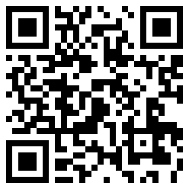 |  | PROPERTY OF MCTV DIGITAL · DO NOT REMOVE Oxford Super Tan OXF-F35B67 f35b6766-f3fb-420d-a278-e09a97976356 Questions? 601-201-8202 | portal@mctvofms.com 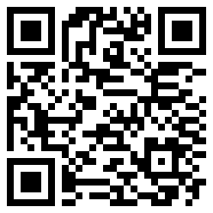
PROPERTY OF MCTV DIGITAL · DO NOT REMOVE James Food Center Post Office OXF-BF648A bf648afe-3003-4f39-a2b5-855a77ee5754 Questions? 601-201-8202 | portal@mctvofms.com 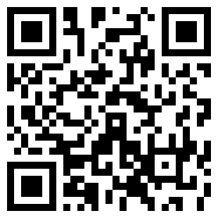 |  | PROPERTY OF MCTV DIGITAL · DO NOT REMOVE Magnolia Wine & Spirits OXF-C190DC c190dca0-0170-4f82-909b-c53f6b000467 Questions? 601-201-8202 | portal@mctvofms.com 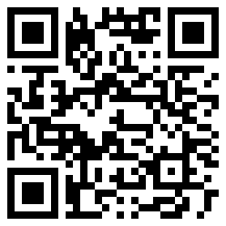
PROPERTY OF MCTV DIGITAL · DO NOT REMOVE Oxford T-Shirt Co. OXF-9A4D91 9a4d91cc-e23e-4b6e-9022-ce53904139fc Questions? 601-201-8202 | portal@mctvofms.com 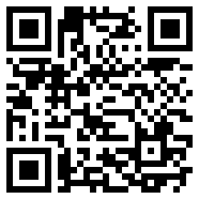 |  | PROPERTY OF MCTV DIGITAL · DO NOT REMOVE MARATHON South Lamar OXF-D4987F d4987fd8-0477-4510-90ae-e84fcd8b4e3e Questions? 601-201-8202 | portal@mctvofms.com 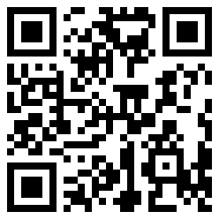
PROPERTY OF MCTV DIGITAL · DO NOT REMOVE Texaco lamar express OXF-418D52 418d52b0-f93a-415c-aa58-2eb879075add Questions? 601-201-8202 | portal@mctvofms.com 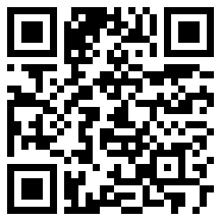 |  | PROPERTY OF MCTV DIGITAL · DO NOT REMOVE Oxford Dental OXF-B0F11C b0f11ca1-c12a-4e07-addb-c3d56d47ba6b Questions? 601-201-8202 | portal@mctvofms.com 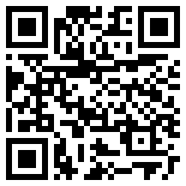
PROPERTY OF MCTV DIGITAL · DO NOT REMOVE Revive Wellness of Oxford OXF-8C6070 8c6070e7-e2b8-45b5-a0d0-419522254894 Questions? 601-201-8202 | portal@mctvofms.com 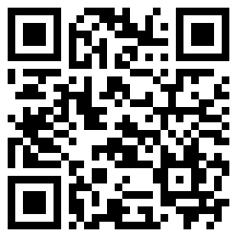 |  | PROPERTY OF MCTV DIGITAL · DO NOT REMOVE Booth's Barbeque and Yard OXF-EFA5B2 efa5b248-7b66-4465-b4b0-dcceedd4878b Questions? 601-201-8202 | portal@mctvofms.com 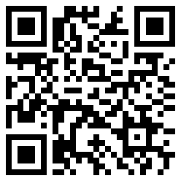

PROPERTY OF MCTV DIGITAL · DO NOT REMOVE The Children's Dental Center OXF-1A7152 1a7152cb-c481-4eec-ae26-dd080e1aefe6 Questions? 601-201-8202 | portal@mctvofms.com 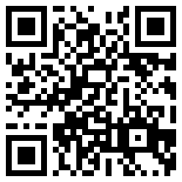 |  | PROPERTY OF MCTV DIGITAL · DO NOT REMOVE Internal Medicine Associates… OXF-25F416 25f416e8-2408-4fec-9540-4d2136e435d6 Questions? 601-201-8202 | portal@mctvofms.com 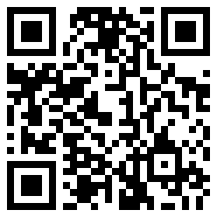
PROPERTY OF MCTV DIGITAL · DO NOT REMOVE Internal Medicine Associates… OXF-6386F1 6386f195-a0a9-4424-a9b0-4227a2b5cf25 Questions? 601-201-8202 | portal@mctvofms.com 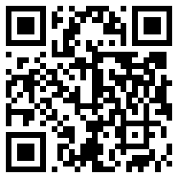 |  | PROPERTY OF MCTV DIGITAL · DO NOT REMOVE Right Track Medical Group - O… OXF-22004B 22004bc1-fc0a-479c-83c3-96d0bffc45a3 Questions? 601-201-8202 | portal@mctvofms.com 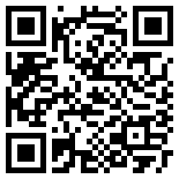
PROPERTY OF MCTV DIGITAL · DO NOT REMOVE Right Track Medical Group - O… OXF-24E683 24e68330-6677-480c-a9a7-a0aa9db72760 Questions? 601-201-8202 | portal@mctvofms.com 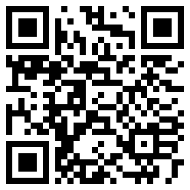 |  | PROPERTY OF MCTV DIGITAL · DO NOT REMOVE Right Track Medical Group - O… OXF-907E02 907e02c1-61df-405a-9008-73b21268559d Questions? 601-201-8202 | portal@mctvofms.com 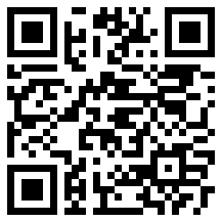
PROPERTY OF MCTV DIGITAL · DO NOT REMOVE Mississippi Asthma & Allergy… OXF-CABE69 cabe6939-b6b5-4801-af24-81613ebabaaf Questions? 601-201-8202 | portal@mctvofms.com 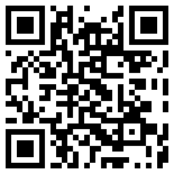 |  | PROPERTY OF MCTV DIGITAL · DO NOT REMOVE Amara Salon & Aesthetics OXF-AAEA40 aaea40fb-d108-41c9-b6db-a41797cecea2 Questions? 601-201-8202 | portal@mctvofms.com 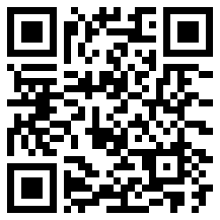
PROPERTY OF MCTV DIGITAL · DO NOT REMOVE Amara Salon & Aesthetics OXF-E4872B e4872bda-b614-4236-8cd2-eff8ea1de3b1 Questions? 601-201-8202 | portal@mctvofms.com 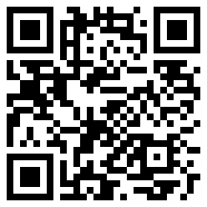 |  | PROPERTY OF MCTV DIGITAL · DO NOT REMOVE Sip Oxford OXF-9E965A 9e965a78-f182-48c9-8c33-6098e3cbf176 Questions? 601-201-8202 | portal@mctvofms.com 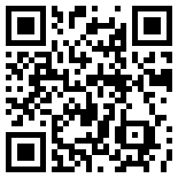

PROPERTY OF MCTV DIGITAL · DO NOT REMOVE Nail Thology OXF-3CD425 3cd42501-0fcf-4260-b8ce-9de0eb1d4f52 Questions? 601-201-8202 | portal@mctvofms.com 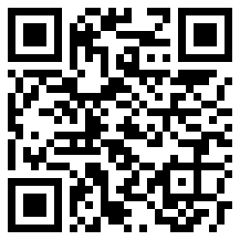 |  | PROPERTY OF MCTV DIGITAL · DO NOT REMOVE Nail Thology OXF-54DC08 54dc0814-b0a8-4418-aefe-e418b2e3610f Questions? 601-201-8202 | portal@mctvofms.com 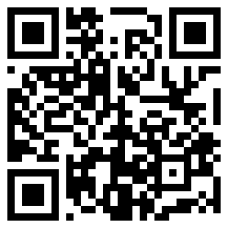
PROPERTY OF MCTV DIGITAL · DO NOT REMOVE Party in the Sip OXF-5B7A57 5b7a57fc-4530-407e-91a0-22375992b42f Questions? 601-201-8202 | portal@mctvofms.com 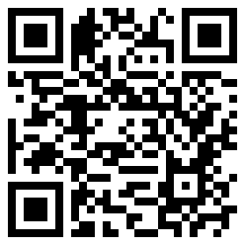 |  | PROPERTY OF MCTV DIGITAL · DO NOT REMOVE Luxe Styling Studio OXF-A3DF63 a3df6329-122c-4c6c-946a-f5dab2441100 Questions? 601-201-8202 | portal@mctvofms.com 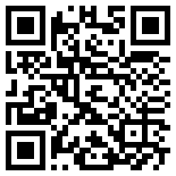
PROPERTY OF MCTV DIGITAL · DO NOT REMOVE 4 Corner's Chevron (Chicken O… OXF-6D893B 6d893b82-5c11-4c96-8096-87aec7780963 Questions? 601-201-8202 | portal@mctvofms.com 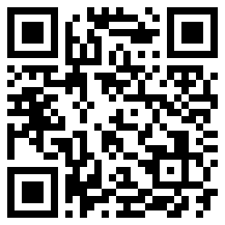 |  | PROPERTY OF MCTV DIGITAL · DO NOT REMOVE The Velvet Ditch - Sports bar… OXF-D3C25D d3c25de4-12c8-41e9-a294-300f95e4692f Questions? 601-201-8202 | portal@mctvofms.com 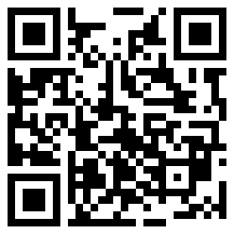
PROPERTY OF MCTV DIGITAL · DO NOT REMOVE Element Hair Studio OXF-761015 761015e3-b041-40ff-8627-277cade4aa8b Questions? 601-201-8202 | portal@mctvofms.com 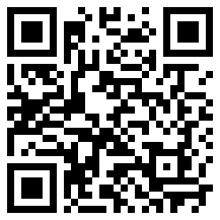 |  | PROPERTY OF MCTV DIGITAL · DO NOT REMOVE Finch & Kelly OXF-EC0495 ec049549-343d-44c7-bb52-a5e4077c34c3 Questions? 601-201-8202 | portal@mctvofms.com 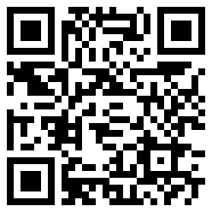
PROPERTY OF MCTV DIGITAL · DO NOT REMOVE Rafters Music and Food OXF-247CE2 247ce23f-a85b-4f34-8606-ae8d4d45b6ff Questions? 601-201-8202 | portal@mctvofms.com 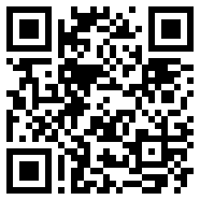 |  | PROPERTY OF MCTV DIGITAL · DO NOT REMOVE Uno Mas Tacos y Tequila Jacks… OXF-7E0448 7e0448ba-1560-4c49-8fc7-ccd025de0db4 Questions? 601-201-8202 | portal@mctvofms.com 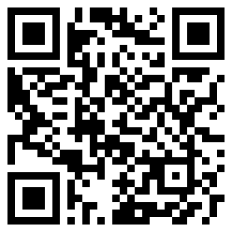

PROPERTY OF MCTV DIGITAL · DO NOT REMOVE Rebel Yell Rooftop Bar OXF-A9E2DB a9e2dbba-3df9-4ce8-9a73-75316fc4e898 Questions? 601-201-8202 | portal@mctvofms.com 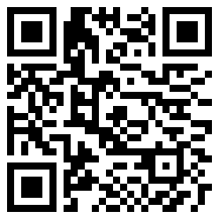 |  | PROPERTY OF MCTV DIGITAL · DO NOT REMOVE Rainbow Cleaners OXF-BDC179 bdc179f3-7b5d-4341-a30a-94fa1794f2f2 Questions? 601-201-8202 | portal@mctvofms.com 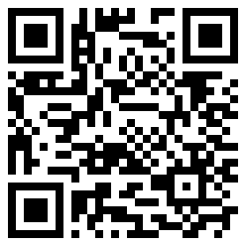
PROPERTY OF MCTV DIGITAL · DO NOT REMOVE The Blind Pig Pub OXF-975C0F 975c0fbd-515b-48e7-8e58-3f0b15563444 Questions? 601-201-8202 | portal@mctvofms.com 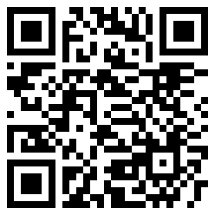 |  | PROPERTY OF MCTV DIGITAL · DO NOT REMOVE The Oxford Growler OXF-A55FBD a55fbde5-5fa8-4889-a12f-08c1ae561a7f Questions? 601-201-8202 | portal@mctvofms.com 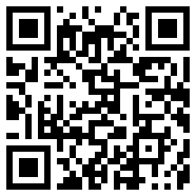
PROPERTY OF MCTV DIGITAL · DO NOT REMOVE Rosati's Pizza OXF-44A07F 44a07ff4-2393-4c4d-8f31-eca7d72b8e73 Questions? 601-201-8202 | portal@mctvofms.com 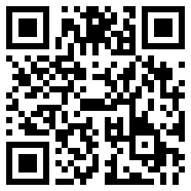 |  | PROPERTY OF MCTV DIGITAL · DO NOT REMOVE El Charro Cocina & Cantina OXF-AA5BB8 aa5bb861-927a-4818-9592-210a05cabab7 Questions? 601-201-8202 | portal@mctvofms.com 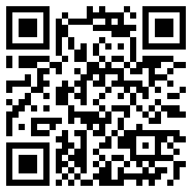
PROPERTY OF MCTV DIGITAL · DO NOT REMOVE Southern Coop OXF-645CFB 645cfb39-ac06-4c37-8a3f-5225f0199016 Questions? 601-201-8202 | portal@mctvofms.com 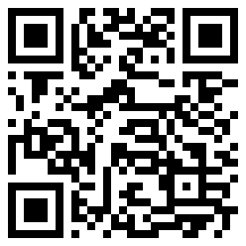 |  | PROPERTY OF MCTV DIGITAL · DO NOT REMOVE Stouts Carpet & Flooring OXF-AB13DC ab13dcdb-abba-4d74-8210-40bd9362e4df Questions? 601-201-8202 | portal@mctvofms.com 