PROPERTY OF MCTV DIGITAL · DO NOT REMOVE Magnolia Dermatology: Columbu… STK-54D607 54d60714-0a4f-4bc1-b86c-f852705872b5 Questions? 601-201-8202 | portal@mctvofms.com 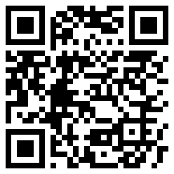 |  | PROPERTY OF MCTV DIGITAL · DO NOT REMOVE Elm Lake Golf Course STK-2BADA0 2bada09c-f24d-419a-926c-695beb2a81b7 Questions? 601-201-8202 | portal@mctvofms.com 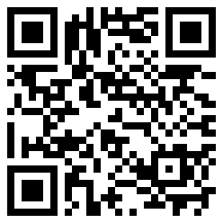
PROPERTY OF MCTV DIGITAL · DO NOT REMOVE Elm Lake Golf Course STK-A086F5 a086f5f2-c7f4-4033-9ace-e185f4324644 Questions? 601-201-8202 | portal@mctvofms.com 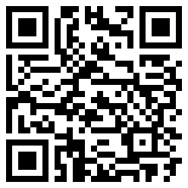 |  | PROPERTY OF MCTV DIGITAL · DO NOT REMOVE Mississippi Ice Daiquiri Shop STK-30A1C1 30a1c1ff-17ee-408e-bc3b-416a173c83fc Questions? 601-201-8202 | portal@mctvofms.com 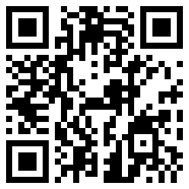
PROPERTY OF MCTV DIGITAL · DO NOT REMOVE Two Brothers Smoked Meats STK-3FF395 3ff3957e-96a4-4be0-9c1e-8b815a2d6a45 Questions? 601-201-8202 | portal@mctvofms.com 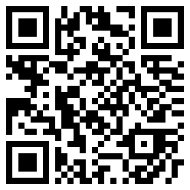 |  | PROPERTY OF MCTV DIGITAL · DO NOT REMOVE Two Brothers Smoked Meats STK-480CD3 480cd3bf-b29c-49a3-a0ac-5dc312cb7d0d Questions? 601-201-8202 | portal@mctvofms.com 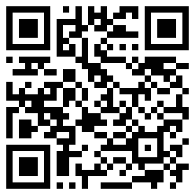
PROPERTY OF MCTV DIGITAL · DO NOT REMOVE Two Brothers Smoked Meats STK-F80705 f8070576-d2bc-4efe-bbd9-bf67697cff57 Questions? 601-201-8202 | portal@mctvofms.com 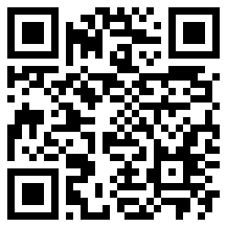 |  | PROPERTY OF MCTV DIGITAL · DO NOT REMOVE Arepas Coffee & Bar STK-D020AB d020abfc-9dcd-4f2a-b3ea-5c0957f4620f Questions? 601-201-8202 | portal@mctvofms.com 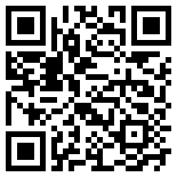
PROPERTY OF MCTV DIGITAL · DO NOT REMOVE Uno Mas Tacos y Tequila Stark… STK-58ECE6 58ece69d-59a4-4f14-8947-b81857e417c4 Questions? 601-201-8202 | portal@mctvofms.com 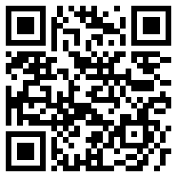 |  | PROPERTY OF MCTV DIGITAL · DO NOT REMOVE Uno Mas Tacos y Tequila Stark… STK-7E6EEA 7e6eeadd-c01c-49ec-8725-5b993c1a5966 Questions? 601-201-8202 | portal@mctvofms.com 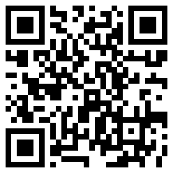

PROPERTY OF MCTV DIGITAL · DO NOT REMOVE Uno Mas Tacos y Tequila Stark… STK-979297 97929713-fc1e-4420-86e5-ec408898c8f4 Questions? 601-201-8202 | portal@mctvofms.com 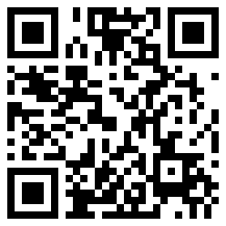 |  | PROPERTY OF MCTV DIGITAL · DO NOT REMOVE Cellars Wine & Spirits STK-B03AD6 b03ad644-bb90-4d6b-99d0-89c87bea1fa7 Questions? 601-201-8202 | portal@mctvofms.com 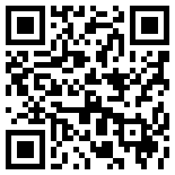
PROPERTY OF MCTV DIGITAL · DO NOT REMOVE Copy Cow STK-E1F259 e1f259cc-282d-4147-9d00-192002253de2 Questions? 601-201-8202 | portal@mctvofms.com 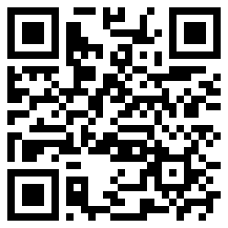 |  | PROPERTY OF MCTV DIGITAL · DO NOT REMOVE 39759 Nutrition STK-D6C61D d6c61d7f-5208-4770-9119-ae7a5cdc5c34 Questions? 601-201-8202 | portal@mctvofms.com 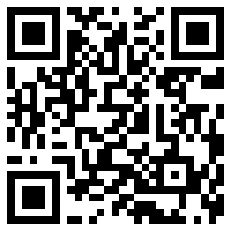
PROPERTY OF MCTV DIGITAL · DO NOT REMOVE Legends Hair Salon STK-098E2B 098e2b5b-dc4d-4a87-82c0-0979affb0340 Questions? 601-201-8202 | portal@mctvofms.com 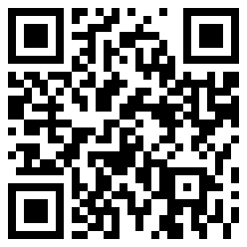 |  | PROPERTY OF MCTV DIGITAL · DO NOT REMOVE Bennett Home Furniture & More STK-E602D2 e602d214-2b23-4ec7-aa87-2dec022aebde Questions? 601-201-8202 | portal@mctvofms.com 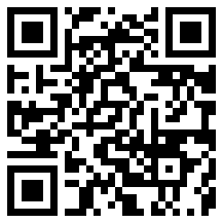
PROPERTY OF MCTV DIGITAL · DO NOT REMOVE Umi Japanese Steakhouse & Sus… STK-35F831 35f83164-0f3e-4ff8-a88c-26078155e472 Questions? 601-201-8202 | portal@mctvofms.com 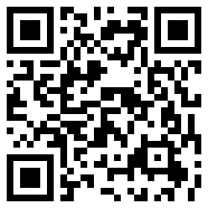 |  | PROPERTY OF MCTV DIGITAL · DO NOT REMOVE Starkville Veterinary Hospital STK-86C961 86c961cd-0633-4e9a-be53-a097803f3605 Questions? 601-201-8202 | portal@mctvofms.com 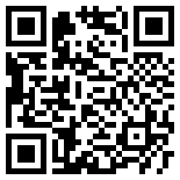
PROPERTY OF MCTV DIGITAL · DO NOT REMOVE Oktibbeha County Co-op STK-57F565 57f565b5-a303-44a8-ac62-c6c5e700be87 Questions? 601-201-8202 | portal@mctvofms.com 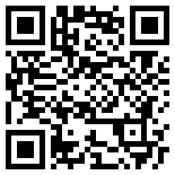 |  | PROPERTY OF MCTV DIGITAL · DO NOT REMOVE Skate Odyssey Inc STK-BD9917 bd991793-f574-4130-b2a6-623538382b6c Questions? 601-201-8202 | portal@mctvofms.com 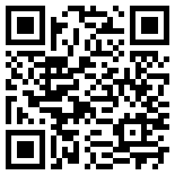

PROPERTY OF MCTV DIGITAL · DO NOT REMOVE The Breakfast Club STK-CD41A5 cd41a58c-6344-44da-abe3-f53e1f41d924 Questions? 601-201-8202 | portal@mctvofms.com 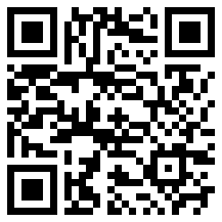 |  | PROPERTY OF MCTV DIGITAL · DO NOT REMOVE BJ's Family Pharmacy STK-E4EF80 e4ef805d-027d-4e94-9229-728e1899831f Questions? 601-201-8202 | portal@mctvofms.com 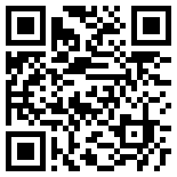
PROPERTY OF MCTV DIGITAL · DO NOT REMOVE Right Track Medical Group - S… STK-05E766 05e76657-ce0a-4061-8ceb-60048a4de0aa Questions? 601-201-8202 | portal@mctvofms.com 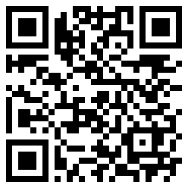 |  | PROPERTY OF MCTV DIGITAL · DO NOT REMOVE Right Track Medical Group - S… STK-61724F 61724faf-00fa-4855-a41a-2e70cc0db4d6 Questions? 601-201-8202 | portal@mctvofms.com 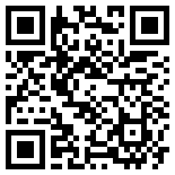
PROPERTY OF MCTV DIGITAL · DO NOT REMOVE Revive Wellness Clinic - Star… STK-0A2F33 0a2f33d1-e8d4-4e3e-a0b9-00cc7ecb1cf1 Questions? 601-201-8202 | portal@mctvofms.com 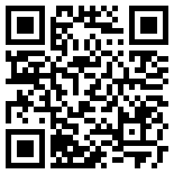 |  | PROPERTY OF MCTV DIGITAL · DO NOT REMOVE Montgomery's Jewelry STK-F13B5F f13b5f62-7507-442c-9bf7-f369c9b29240 Questions? 601-201-8202 | portal@mctvofms.com 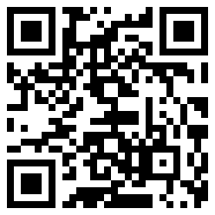
PROPERTY OF MCTV DIGITAL · DO NOT REMOVE starkvegas pawnshop STK-5B8818 5b8818e6-fe17-4935-b39b-c72dfefaca43 Questions? 601-201-8202 | portal@mctvofms.com 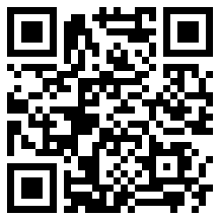 |  | PROPERTY OF MCTV DIGITAL · DO NOT REMOVE Mississippi Asthma & Allergy… STK-9E030F 9e030f38-1a6c-4500-bbaf-3b9d0c4369d6 Questions? 601-201-8202 | portal@mctvofms.com 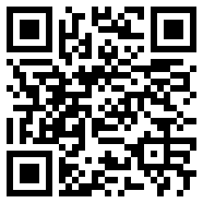
PROPERTY OF MCTV DIGITAL · DO NOT REMOVE Cannon Chevrolet GMC of West… STK-98CA3E 98ca3ef5-67b7-4136-b013-40a8b1233628 Questions? 601-201-8202 | portal@mctvofms.com 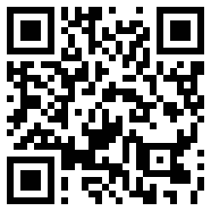 |  | PROPERTY OF MCTV DIGITAL · DO NOT REMOVE Little Magnolia Gifts & Appar… STK-CABDED cabded9f-6044-421e-ba92-bc6e5789da95 Questions? 601-201-8202 | portal@mctvofms.com 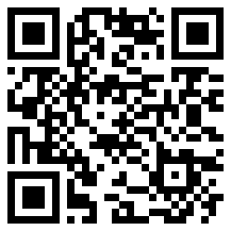

PROPERTY OF MCTV DIGITAL · DO NOT REMOVE Lucky Nails & Spa STK-B45538 b45538c7-433f-4a48-a436-14ee505f7900 Questions? 601-201-8202 | portal@mctvofms.com 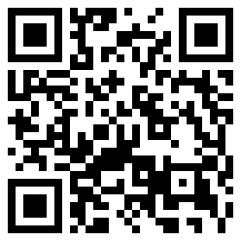 |  | PROPERTY OF MCTV DIGITAL · DO NOT REMOVE William Wells Tire & Auto STK-449794 4497944d-5741-4b58-ad87-e808c0e9fac2 Questions? 601-201-8202 | portal@mctvofms.com 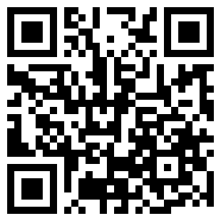
PROPERTY OF MCTV DIGITAL · DO NOT REMOVE Hobies Tiki Dawgs & Daqs STK-F89F84 f89f8478-6a0d-47e9-b5a1-3f7a38f37e44 Questions? 601-201-8202 | portal@mctvofms.com 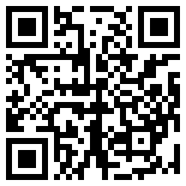 |  | PROPERTY OF MCTV DIGITAL · DO NOT REMOVE Skate Zone STK-2E859E 2e859e1f-76b9-436c-b741-b6201b72ed14 Questions? 601-201-8202 | portal@mctvofms.com 