ES043

**PUSH-UP EXERCISE COUNTER**

**SOH WEI KIAT 4A1**

HWA CHONG INSTITUTION

**MENTOR: DR SANGIT SASIDHAR**

DEPARTMENT OF ELECTRICAL ENGINEERING (NUS)

**ABSTRACT**

Push-ups are a physical exercise performed in a prone position by raising and lowering the body using the arms. It is a basic exercise commonly seen in military physical trainings and punishments.

Push-up counters are made in order to accurately record the number of push-ups done by a person and to help a person monitor the progress of his training. Existing push-up counters use infrared technology or compression-based technology to count the number of push-ups done by the user. However, there are some flaws that exist in current push-up counting devices.

As such, this project aims to design and build a push-up counter, using Arduino, which would be wearable and have increased capabilities. This project improves on existing push-up counters by measuring the posture of the user doing the push-up. This is achieved through using a small device at the lower back of the user to measure the angle of his back.

Arduino is an open-source electronics platform based on easy-to-use hardware and software. Arduino can sense the environment by receiving inputs from sensors, and respond accordingly, through sound or light signals. Arduino can be programmed to perform tasks through writing codes using the Arduino Integrated Design Environment.

**CASE STUDIES**

Case studies of existing push-up counters are done in order to identify inaccuracies present in counting push-ups.

IPPT/Fist method:  
  
This method of counting push-ups requires the tester (person recording the push-ups) to place his fist on the ground below of the center of the participant’s (person doing the push-ups) chest when doing push-ups. The participant’s chest has to touch the tester’s fist for a push-up to be valid.

As the sizes of a fist varies with testers, inaccuracies in results may arise as the distance the participant has to lower his chest changes.

Furthermore, this method requires 2 people (participant & tester). If a person does push-ups alone and counts his push-ups, his results might not be accurate as he might not have done valid push-ups throughout.

Push-up counter devices:

These devices record push-ups by being placed on the ground under the center of the person’s chest.

Inaccuracies result from the devices being unable to detect the posture of the person, a person may not always have to do push-ups correctly for the device to record it as valid. For example, a person’s back may not be straight when doing push-ups, which might make it easier for the person to do push-ups.  
  
Push-up counter mobile applications:

Push-up counters also come in the form of mobile applications. The mobile applications make use of the infrared proximity sensors on the phone to record push-ups. By constantly sensing the light levels of its surrounding, it can determine if a person has completed a push-up.

When placed in different light conditions, its ability to accurately record push-ups is limited as the surrounding light intensity fluctuates and does not accurately display the distance.

**SOLUTION DESIGN**

|  |  |
| --- | --- |
| Arduino Uno R3 | 1 |
| Ultrasonic Sensor HC-SR04 | 1 |
| Passive Buzzer | 1 |
| Liquid Crystal Display (LCD) | 1 |
| Flex Sensor | 1 |
| Light Emitting Diode (LED) | 1 |
| Power Source | 1 |
| Wire | 15 |

Arduino Uno R3  
Arduino is an open-source electronics platform based on easy-to-use hardware and software. Arduino boards can read inputs - light on a sensor, a finger on a button, or a Twitter message - and turn it into an output - activating a motor, turning on an LED, publishing something online. [1]  
Through the Arduino Integrated Design Environment (IDE), users can configure the Arduino board to serve different purposes.

Ultrasonic Sensor HC-SR04  
The Ultrasonic Sensor detects the distance of the closest object in front of the sensor (from 3 cm up to 400 cm). It works by sending out a burst of ultrasound and listening for the echo when it bounces off an object. [2] The ultrasonic sensor measures the time it takes for the ultrasound to bounce off the nearest object. Using this information, we can find the distance between the ultrasonic sensor and the ground using the formula Distance = Speed of Sound*Time/2

Passive Buzzer  
The buzzer produces a sound of varying pitch when a current is passed through it. It is used to indicate when the user can begin pushups and counts pushups

Liquid Crystal Display (LCD)  
The LCD displays the number of pushups done

Flex Sensor  
This flex sensor is a variable resistor like no other. The resistance of the flex sensor increases as the body of the component bends. [3] By measuring the current that flows through the flex sensor, Arduino can measure the degree of how bent the flex sensor is. This is used to check whether the user’s back is straight when doing push ups.

Light Emitting Diode (LED)  
Light is emitted when current passes through it in a forward-bias. Photons are given off as electrons move from the n-type to the p-type. As the electrons finish moving, photons are given off. The LED is used to indicate that the user is ready to do pushups.

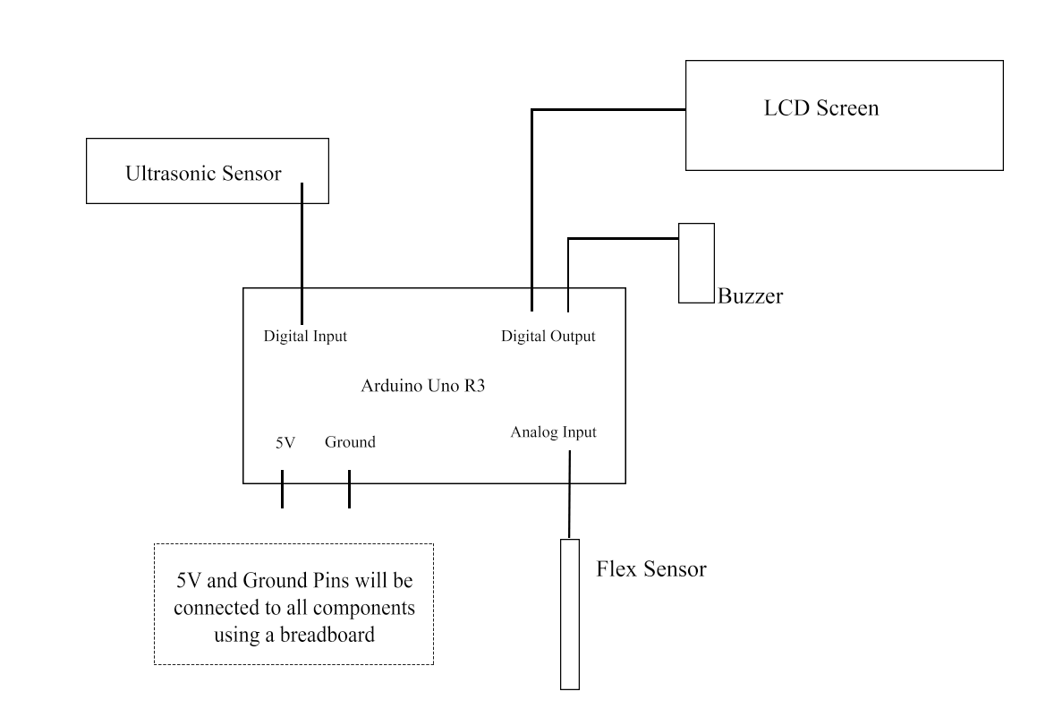

Figure I Circuit Diagram

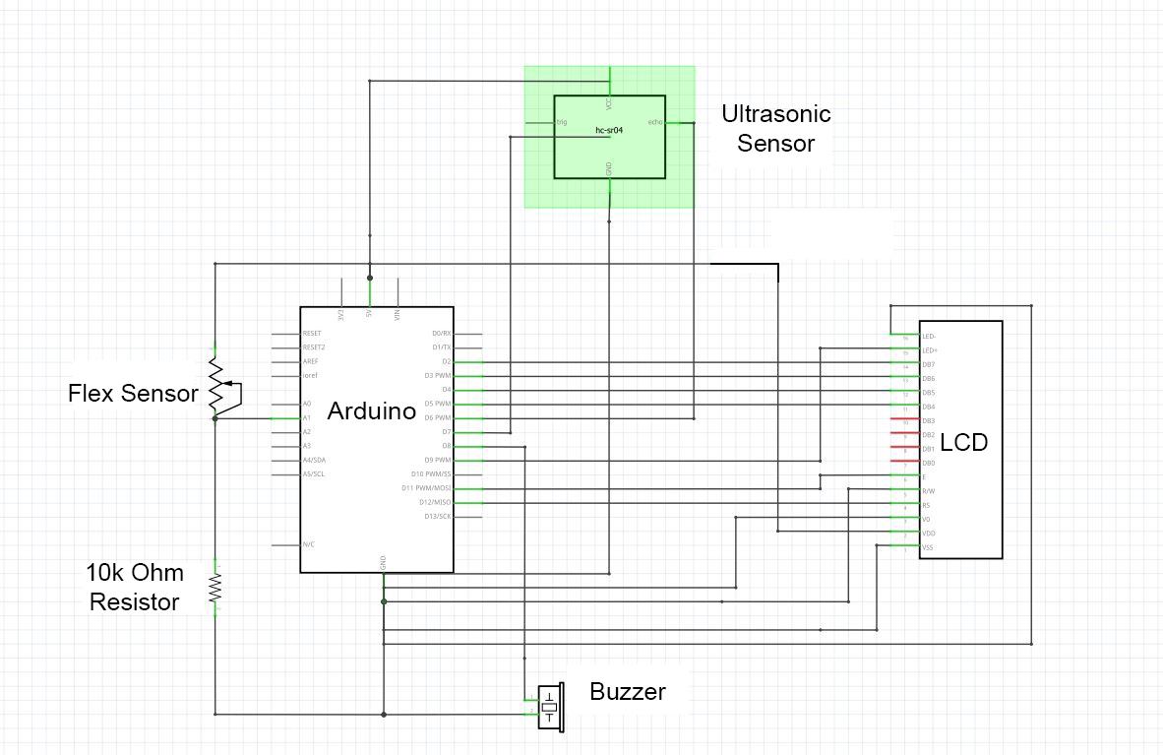

Figure II Schematics

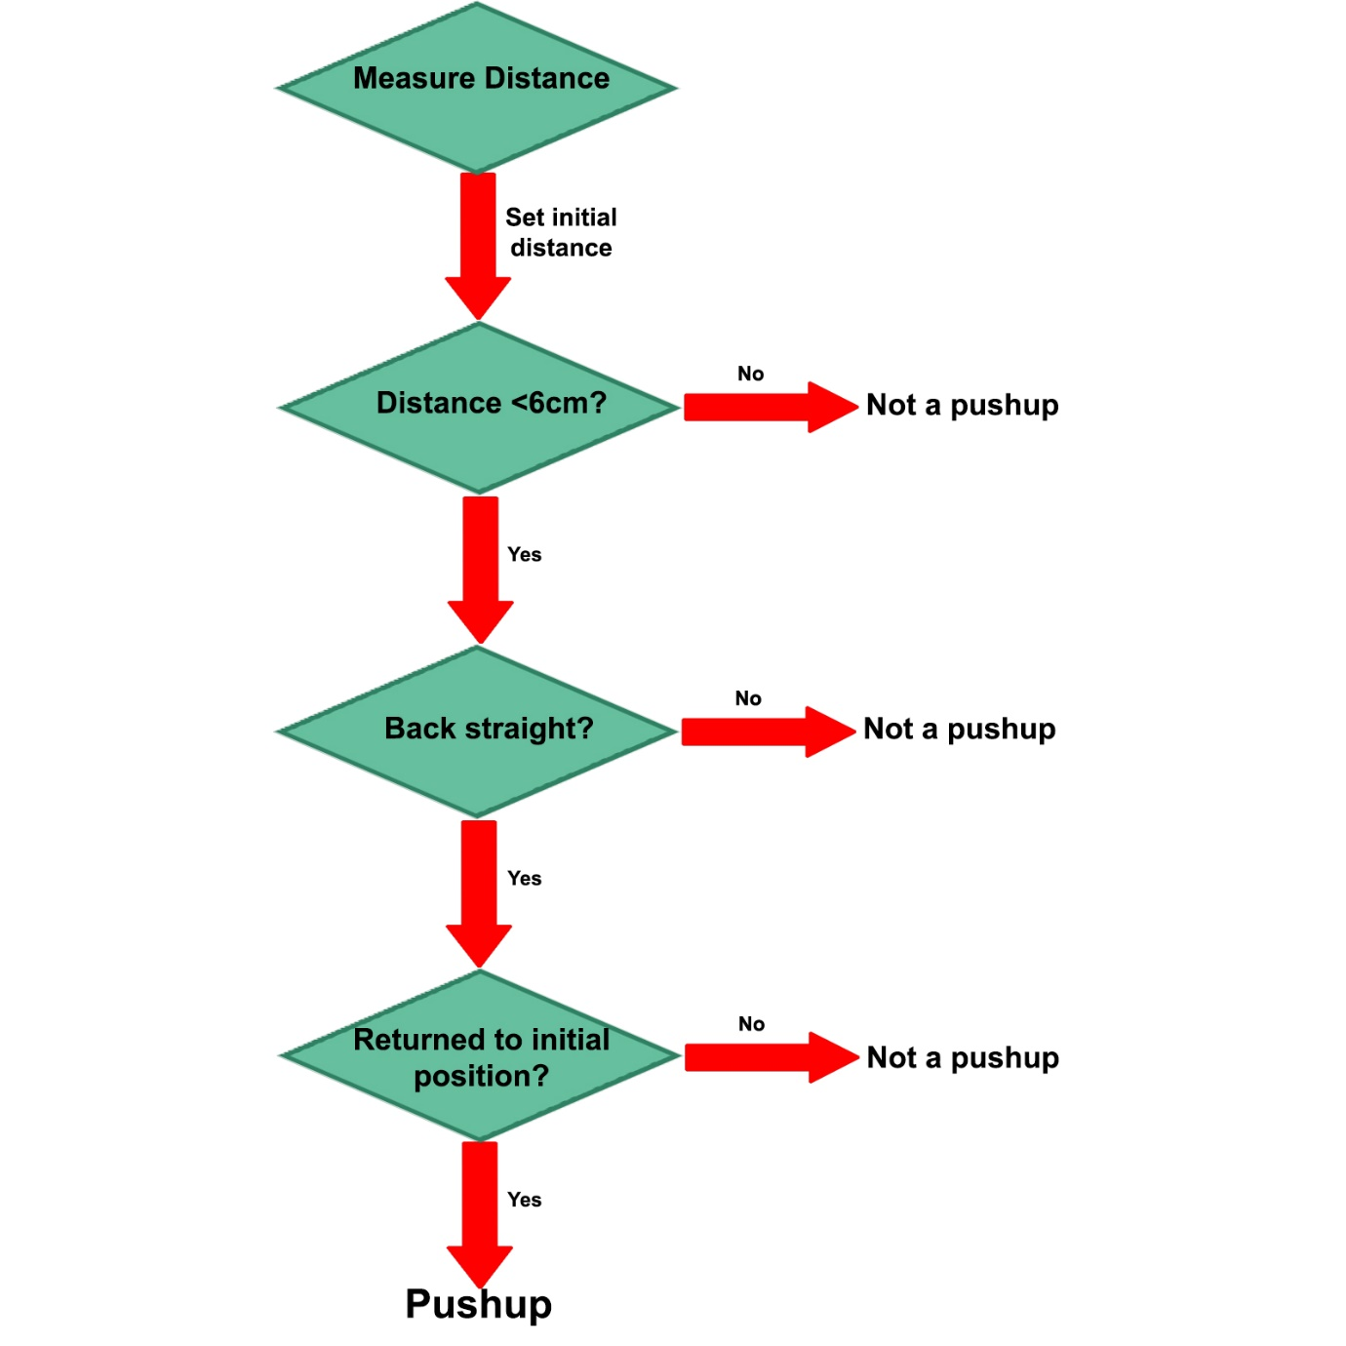

Figure III Logic Tree

Arduino Program  
The process in which the counter measures a pushup can be divided into 3 stages: Setup, ‘Down’ Phase, ‘Up’ Phase.

In the setup phase, the Pushup Exercise Counter has a delay of 5 seconds for the user to get ready. The ultrasonic sensor located on the user’s chest will then record the average initial distance (of 99 readings) between the user’s chest and the ground. When the initial distance is determined, the buzzer will beep twice, and the LED will light up.

In the ‘Down’ Phase, the Pushup Exercise Counter actively checks for the distance between the user’s chest and the ground. If the distance if measured to be under 6cm, it will then check whether the user’s back is straight. If both conditions are met, the user is recognized to have his arm bent to a satisfactory extent and should extend his arms next.

In the ‘Up’ Phase, the Pushup Exercise Counter actively checks whether the distance between the user’s chest and the ground has returned to his initial position. If the user has reached the initial position, he/she is considered to have done 1 successful pushup and the buzzer will beep once. The LCD will update his current Pushups.

The Pushup Exercise Counter automatically stops when it recognizes that the user is standing up. This is done by recording for consistent high readings from the ultrasonic sensor.

**RESULTS & DISCUSSION**

Final Product  
The final product is based on the design of suspenders. The user would fasten a belt across his/her hip to secure the pushup counter.



Figure IV Pushup Counter



Figure V Front View (Worn)



Figure VI Back View (Worn)



Figure VII Usage

**CONCLUSION**

Extent of success

Future plans  
The Pushup Counter can be further developed to record other exercises. The ultrasound sensor and flex sensor can allow it to record sit-ups and “Superman” exercise. Improvements can also be made to send the counter data (using Bluetooth) into an integrated phone application that tracks the user’s exercise.

**REFERENCES**

Arduino - Introduction. (n.d.). Retrieved from <https://www.arduino.cc/en/Guide/Introduction>

Arduino - Ping. (n.d.). Retrieved from <https://www.arduino.cc/en/Tutorial/Ping>

Flex Sensor 2.2". (n.d.). Retrieved from <https://learn.sparkfun.com/tutorials/flex-sensor-hookup-guide>

**ACKNOWLEDGEMENTS**

We would like to acknowledge and show our immense gratitude to the following people, without whom it was impossible to complete our project

Our external mentor, Dr Sangit Sasidhar for his vital support and assistance. He was patient with us and explained in detail concepts we did not understand fully.

Our external mentor, Dr Arthur Tay for providing the opportunity for us to embark on this project. We are grateful for this learning experience which has allowed us to venture into Engineering

The lab staff at the National University of Singapore (NUS) for providing the necessary equipment and expertise.

Our school mentor, Mr. Sim Mong Chea, for his guidance along this journey. He helped us in clarifying our doubts and checked our work consistently to ensure that we were progressing steadily.