ES043

**PUSH-UP EXERCISE COUNTER**

**SOH WEI KIAT 4A1**

HWA CHONG INSTITUTION

**MENTOR: DR SANGIT SASIDHAR**

DEPARTMENT OF ELECTRICAL ENGINEERING (NUS)

**ABSTRACT**

Push-ups are a physical exercise performed in a prone position by raising and lowering the body using the arms. It is a basic exercise commonly seen in military physical trainings and punishments.

Push-up counters are made in order to accurately record the number of push-ups done by a person and to help a person monitor the progress of his training. Existing push-up counters use infrared technology or compression-based technology to count the number of push-ups done by the user. However, there are some flaws that exist in current push-up counting devices.

As such, this project aims to design and build a push-up counter, using Arduino, which would be wearable and have increased capabilities. This project improves on existing push-up counters by measuring the posture of the user doing the push-up. This is achieved through using a small device at the lower back of the user to measure the angle of his back.

Arduino is an open-source electronics platform based on easy-to-use hardware and software. Arduino can sense the environment by receiving inputs from sensors, and respond accordingly, through sound or light signals. Arduino can be programmed to perform tasks through writing codes using the Arduino Integrated Design Environment.

**CASE STUDIES**

We examine several existing push-up counters to identify their inaccuracies in counting push-ups.

IPPT/Fist method:  
This method of counting push-ups requires the tester (person recording the push-ups) to place his fist on the ground below of the center of the participant’s (person doing the push-ups) chest when doing push-ups. The participant’s chest must touch the tester’s fist for a push-up to be considered valid.

As the sizes of a fist varies with testers, inaccuracies in results may arise as the distance the participant has to lower his chest changes.

Furthermore, this method requires 2 people (participant & tester). If a person does push-ups alone and counts his push-ups, his results might not be accurate as he may not have done valid push-ups throughout.

Compression-Referenced Push-up counter devices:

Typically, such a device is placed on the ground parallel below the user’s chest. The device will record a push-up count whenever the person’s chest compresses the pressure plate of the device.

One shortcoming of this device is that it is not able to validate the posture of the person who is doing the push-ups. Push-ups with unacceptable postures can be counted. For example, a person’s back may not be straight when doing push-ups, which makes it easier for the person to do push-ups.

Push-up counter mobile applications:

Push-up counters also come in the form of mobile applications. The mobile applications make use of the infrared proximity sensors on the phone to record push-ups. By constantly sensing the light levels of its surrounding, it counts a pushup whenever the user’s chest is near the phone.

When placed in different light conditions, its ability to accurately record push-ups is limited as the surrounding light intensity fluctuates and the infrared proximity sensor is unable to pick up push-ups.

**SOLUTION DESIGN**

In order to build a push-up counter which only counts a push-up only when the user’s chest is descended to 6-cm off the ground **and** when the user’s back is straightened, we propose the following design.

|  |  |
| --- | --- |
| Arduino Uno R3 | 1 |
| Ultrasonic Sensor HC-SR04 | 1 |
| Passive Buzzer | 1 |
| 4-Digit Display | 1 |
| Flex Sensor | 1 |
| Light Emitting Diode (LED) | 1 |
| 6xAA Battery Holder | 1 |

Arduino Uno R3  
Arduino is an open-source electronics platform based on easy-to-use hardware and software. Arduino boards can read inputs - light on a sensor, a finger on a button, or a Twitter message - and turn it into an output - activating a motor, turning on an LED, publishing something online. [1]  
Through the Arduino Integrated Design Environment (IDE), users can configure the Arduino board to serve different purposes.

Ultrasonic Sensor HC-SR04  
The Ultrasonic Sensor detects the distance of the closest object in front of the sensor (from 3 cm up to 400 cm). It works by sending out a burst of ultrasound and listening for the echo when it bounces off an object. [2] The ultrasonic sensor measures the time it takes for the ultrasound to bounce off the nearest object. Using this information, we can find the distance between the ultrasonic sensor and the ground using the formula 

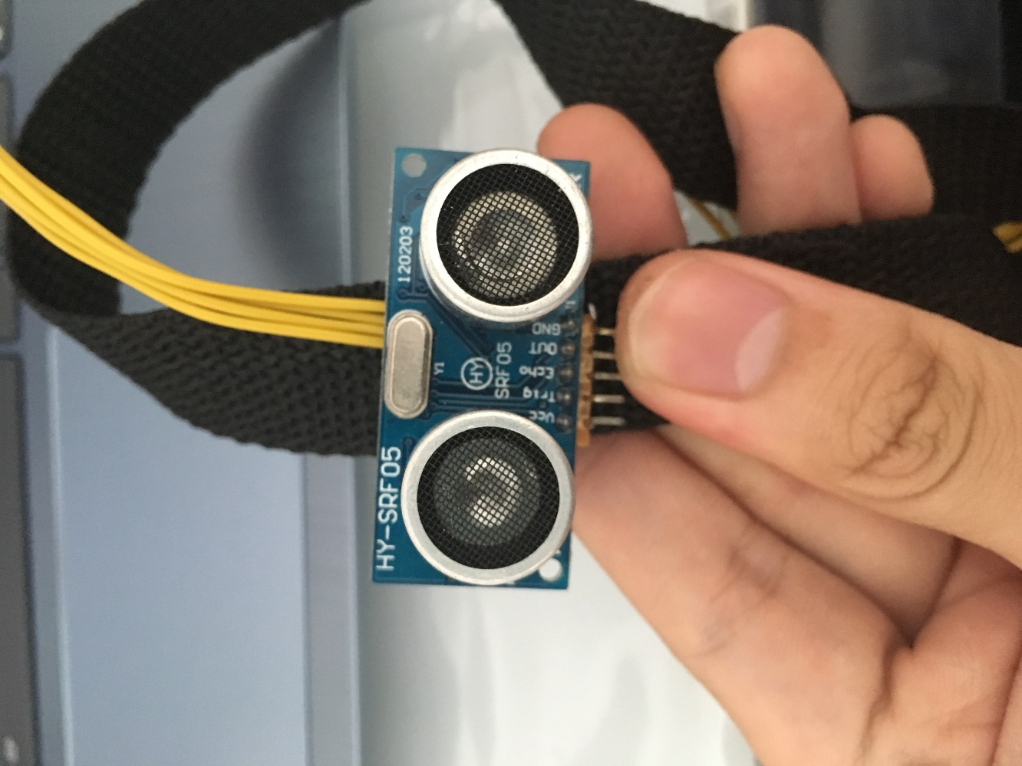

Figure I Ultrasonic Sensor  
Used to measure the distance between the chest and the ground

Passive Buzzer  
The buzzer produces a sound of varying pitch when a current is passed through it. It is used to indicate when the user can begin push-ups and counts push-ups.

4-Digit Display  
The 4-Digit Display displays the number of pushups done.

Flex Sensor  
This flex sensor is a variable resistor. The resistance of the flex sensor increases as the body of the component bends. [3] By measuring the current that flows through the flex sensor, Arduino can measure the degree of how bent the flex sensor is. This is used to check whether the user’s back is straightened when doing push ups.

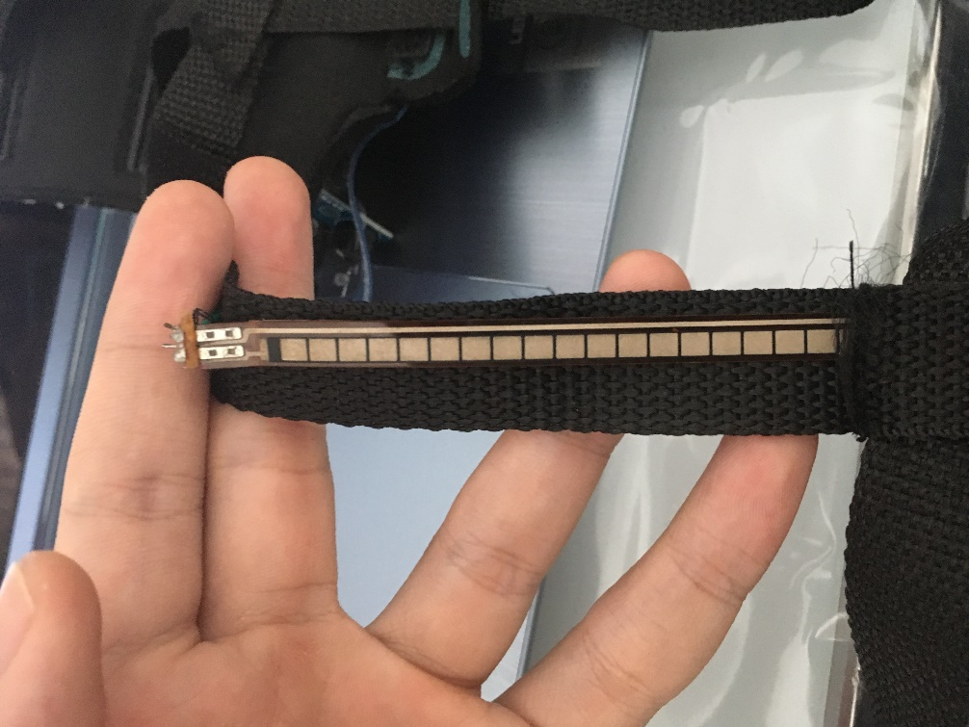

Figure II Flex Sensor  
Used to measure the straightness of the back

Light Emitting Diode (LED)  
The LED lights up to indicate that the push-up counter is calibrated.

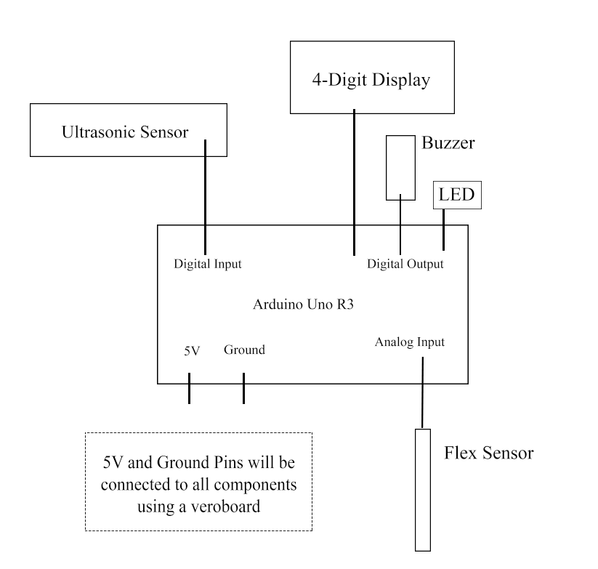

Figure III Circuit Diagram  
All the components are connected to the Arduino Uno

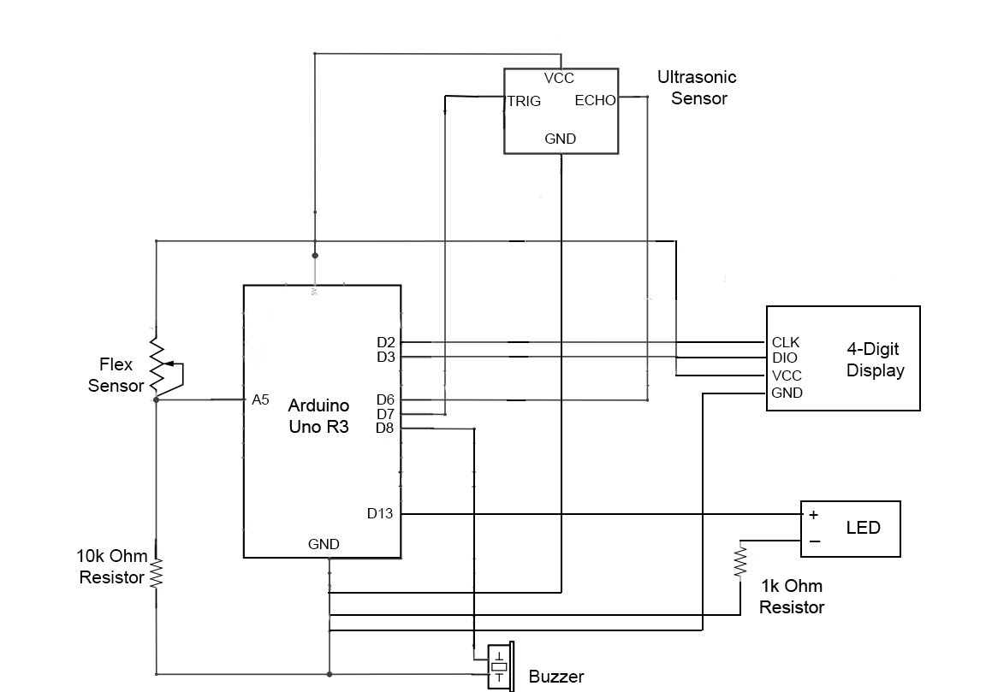

Figure IV Schematics of the full diagram  
The wiring for the push-up counter is shown above, including input and output pins

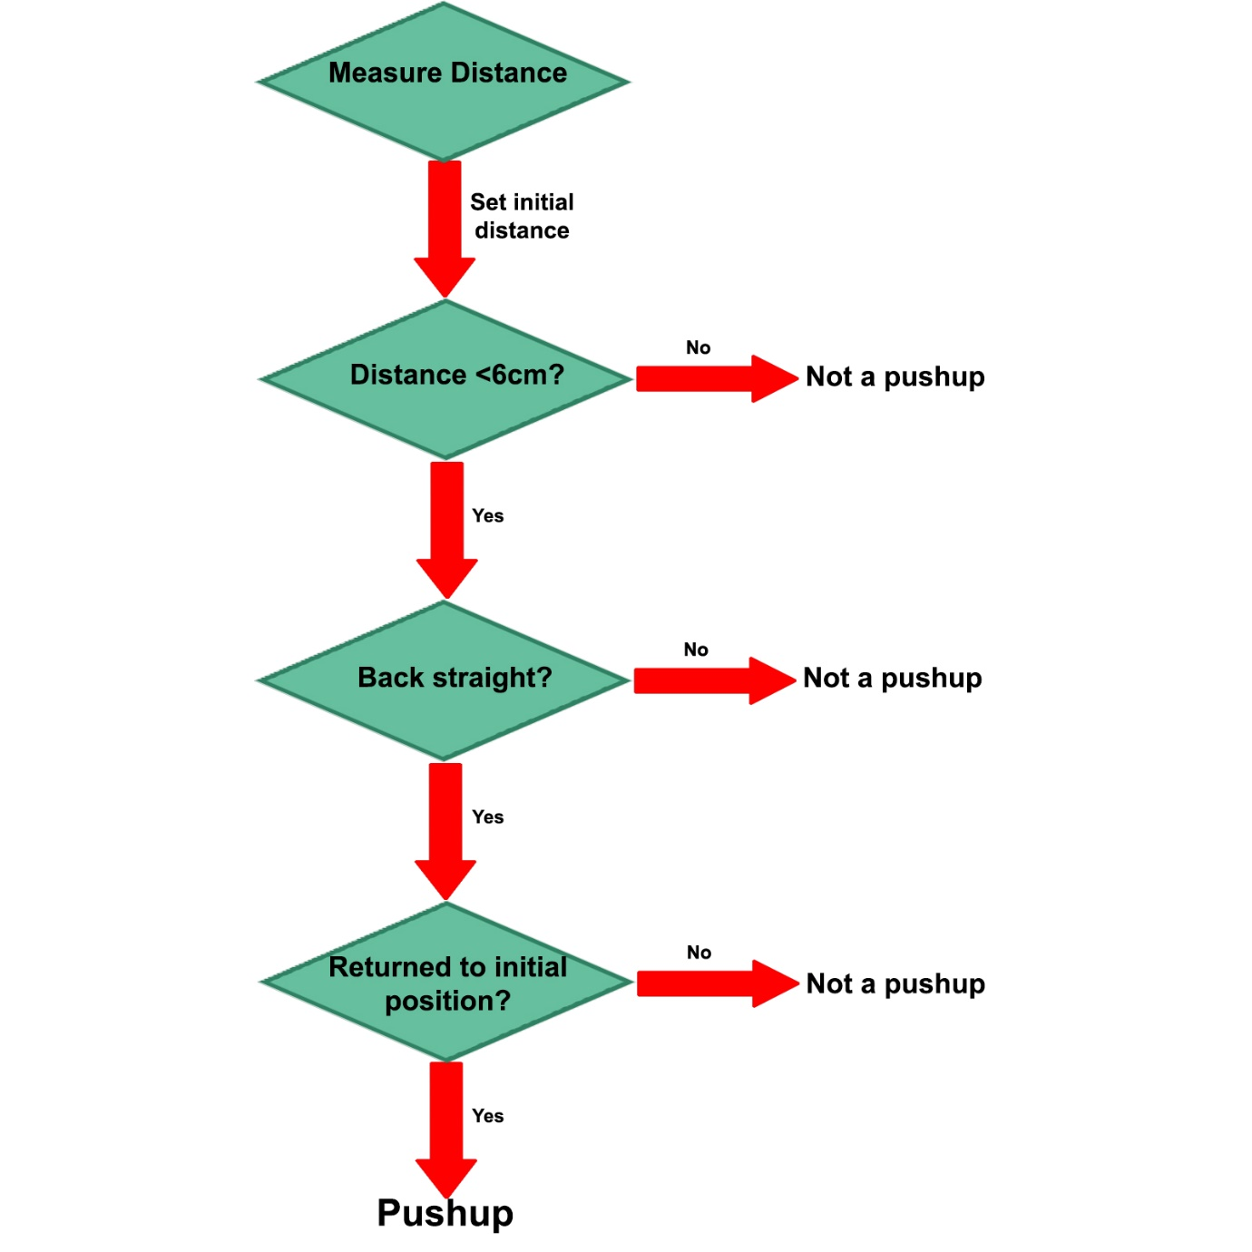

Figure V Logic Tree, a skeleton of the code behind the push-up counter

Arduino Program  
The process in which the counter measures a pushup can be divided into 3 stages: Setup, ‘Down’ Phase, ‘Up’ Phase.

In the setup phase, the Push-up Exercise Counter has a delay of 5 seconds for the user to get ready. The ultrasonic sensor located on the user’s chest will then record the average initial distance (of 99 readings) between the user’s chest and the ground. When the initial distance is determined, the buzzer will beep twice, and the LED will light up.

In the ‘Down’ Phase, the Push-up Exercise Counter actively checks for the distance between the user’s chest and the ground. If the distance if measured to be under 6-cm, it will then check whether the user’s back is straight. If both conditions are met, the user is recognized to have his arm bent to a satisfactory extent and should extend his arms next.

In the ‘Up’ Phase, the Push-up Exercise Counter actively checks whether the distance between the user’s chest and the ground has returned to his initial position. If the user has reached the initial position, he/she is considered to have done one successful push-up and the buzzer will beep once. The LCD will update his current Push-ups.

The Push-up Exercise Counter automatically stops when it recognizes that the user is standing up. This is done by recording for consistent high readings from the ultrasonic sensor.

**RESULTS & DISCUSSION**

Final Product  
The final product is based on the design of a harness. The user would fasten a belt across their chest and waist to secure the push-up counter.

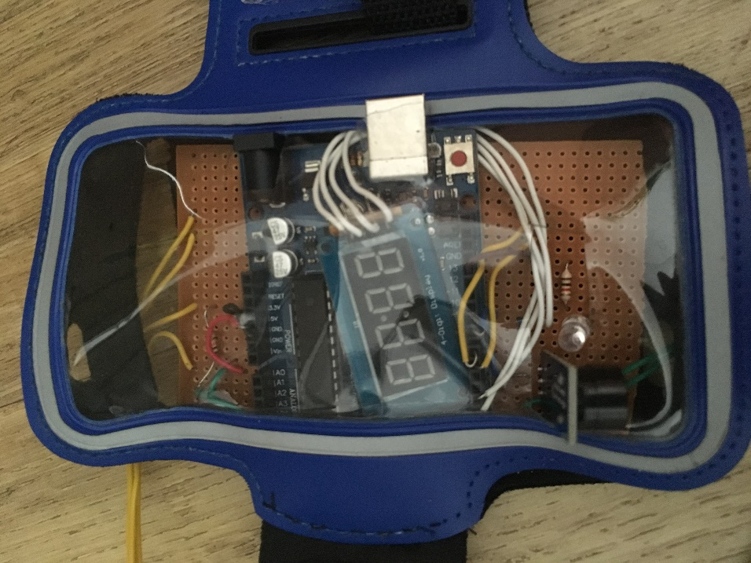

Figure VI Pushup Counter, the LED lights up when the user is ready to do push-ups  
The buzzer sounds whenever the user is ready to do push-ups, or that one push-up was done

Figure I Front View (Worn), only the ultrasound is found on the front of the person’s chest, this is to  
ensure that the ultrasound is as near to the chest as possible, increasing accuracy of ultrasonic sensor.

Figure II Back View (Worn), the flex sensor is located at the lower back while the main circuit  
is at the upper back of the user, to even the weight of the counter.

**CONCLUSION**

Extent of success

The project has successfully created a prototype that incorporates the designed solution. The ultrasonic sensor sends and receives around 30 readings per second, allowing the push-up counter to continue recording data accurately even if the user does push-ups at a faster pace. The wearable push-up counter is also adjustable to suit users of different body sizes and is lightweight so that it would not result in too much weight on the user and affect the number of push-ups he can complete.

Future plans  
The Push-up Counter can be further developed to record other exercises. The ultrasound sensor and flex sensor can allow it to record sit-ups and “Superman” exercise. Improvements can also be made to send the counter data (using Bluetooth) into an integrated phone application that tracks the user’s exercise.

**REFERENCES**

Arduino - Introduction. (n.d.). Retrieved from <https://www.arduino.cc/en/Guide/Introduction>

Arduino - Ping. (n.d.). Retrieved from <https://www.arduino.cc/en/Tutorial/Ping>

Flex Sensor 2.2". (n.d.). Retrieved from <https://learn.sparkfun.com/tutorials/flex-sensor-hookup-guide>

**ACKNOWLEDGEMENTS**

We would like to acknowledge and show our immense gratitude to the following people, without whom it was impossible to complete our project

Our external mentor, Dr Sangit Sasidhar for his vital support and assistance. He was patient with us and explained in detail concepts we did not understand fully.

Our external mentor, Dr Arthur Tay for providing the opportunity for us to embark on this project. We are grateful for this learning experience which has allowed us to venture into Engineering

The lab staff at the National University of Singapore (NUS) for providing the necessary equipment and expertise.

Our school mentor, Mr. Sim Mong Chea, for his guidance along this journey. He helped us in clarifying our doubts and checked our work consistently to ensure that we were progressing steadily.