## horizontal line

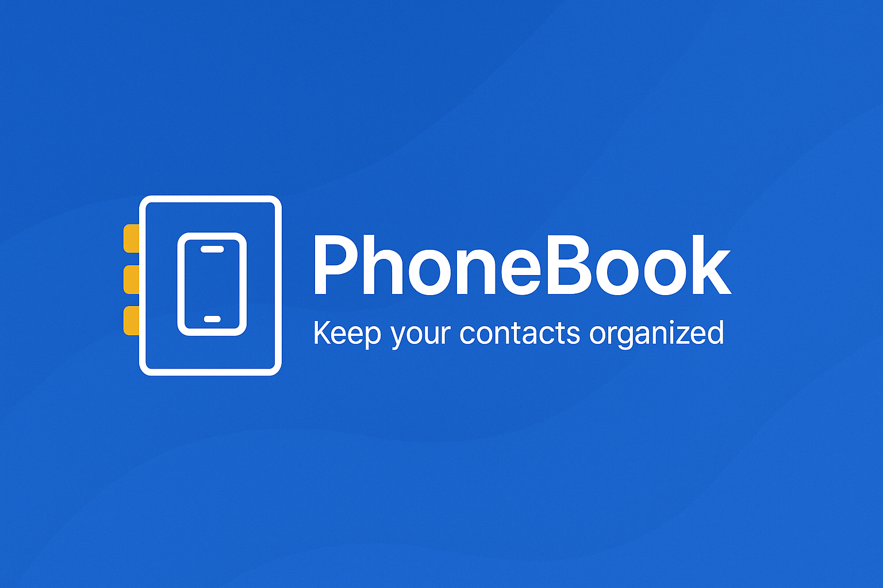

PhoneBook

09.07.2025

**────────────────────────────────────**

Project Abstract and Report

Suhail Hamie Gumbwa

Jonathan Jensen Svein

Oren Tyrus Jeremiah

Thomas Evarist Lugusi

Rashid Soud Abdallah

4DC1-A

Diploma Computer Engineering

Marwadi University

# Overview

**PhoneBook** is a web-based contact management application designed to help users to securely store, organize, and manage their personal and professional contact information. Built using the Django web framework, the system provides an intuitive interface for users to perform standard operations such as adding, editing, viewing, and deleting contacts. The application incorporates authentication to ensure that user data is private and accessible only to the authorized account holder. By taking advantage of the modern design principles and a structured backend, PhoneBook offers a clean, responsive, and user-friendly experience suitable for both individual use and small teams.

# Goals

The primary objective of the **PhoneBook** project is to develop a simple, secure, user-friendly and efficient web application for managing contact information. The specific goals of the project include:

* Enable users to create, read, update, and delete (CRUD) contacts within a secure environment.
* Implement user authentication to ensure that contact data is private and account-specific.
* Design a clean, responsive user interface using modern front-end tools like CSS.
* Apply Django best practices in application architecture and project structure.
* Organize contact records with essential fields such as name, phone number, email, and address.
* Ensure data validation, error handling, and proper feedback throughout the user journey.
* Deploy the application to a cloud platform to allow access across devices.

# Specifications

* **Frontend**: Django Templates with CSS for responsive UI
* **Backend**: Django Framework (Python 3.8+)
* **Database**: SQLite (Development) / PostgreSQL (Deployment)
* **Authentication**: Django built-in authentication system
* **Deployment Platform**: AWS EC2 (Free Tier)
* **Environment Management**: Virtualenv + .env configuration
* **Version Control**: Git + GitHub
* **Static Files Handling**: Managed with Django’s collectstatic system
* **Operating System**: Windows (development environment)

# Milestones

**System Architecture**

**Technology Stack**

* **Language:** Python 3.8+
* **Web Framework:** Django
* **Frontend:** HTML, CSS, Bootstrap 5
* **Database:** SQLite / PostgreSQL
* **Auth:** Django Auth
* **Version Control:** Git + GitHub
* **Hosting:** AWS EC2

**Features**

* User registration, login and logout
* Add, edit, view, and delete contacts
* Responsive UI design for for browser
* Contact search functionality
* User specific data isolation (each user sees only their own contacts)
* Structured error and success messages

**User roles**

* **Registered User**
  + Authentication (register, login and logout)
  + Access only their own contacts
  + Full CRUD capabilities (Create, Read, Update, Delete)
  + Ability to update their profile
* **Admin** (superuser)  
  + Full access to all user data (via Django Admin Panel)
  + Manage users and perform system-level operations

**UI/UX**

(add screen shots pictures of User Interface)

**Security Consideration**

* Passwords hashed using Django's secure built-in system
* CSRF protection enabled on all forms
* User access limited to their own data
* Environment variables used to store secrets (.env not committed to GitHub)

**Testing**

**Deployment**

**Challenges and Limitations**

**Future Enhancements**

1. Add contact image upload feature
2. Enable on app call methods (voice call)
3. Enable contact messaging
4. Implement full-text search and filters
5. Add pagination for large contact lists
6. Create mobile-first PWA (Progressive Web App)
7. Database change to Postgresql
8. Role-based access control for team use

**Conclusion**

The PhoneBook project demonstrates the practical application of Django in building a structured, full-featured web application. It emphasizes secure user data handling, clean UI/UX design, and modern development best practices. This project serves as a solid foundation for future development and can be extended into a scalable contact management system for individuals.