Team 04

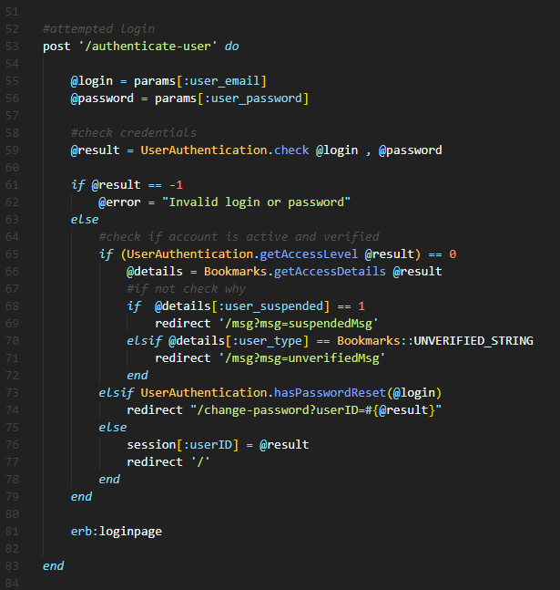

Figure 1 Snippet A (bookmark-site.rb)

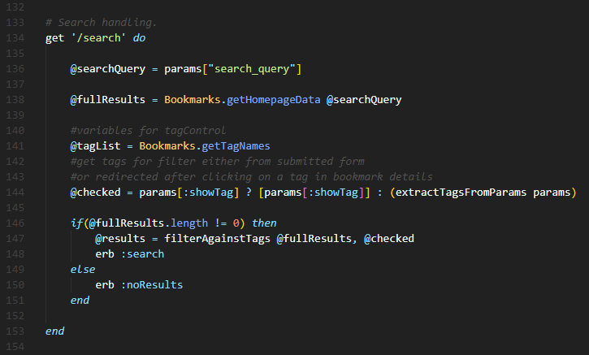

Figure 2 Snippet B (bookmark-site.rb)

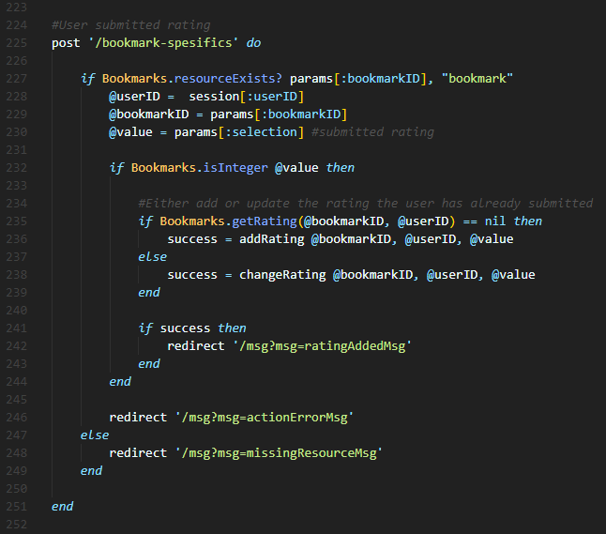

Figure 3 Code Snippet C (bookmark-site.rb) 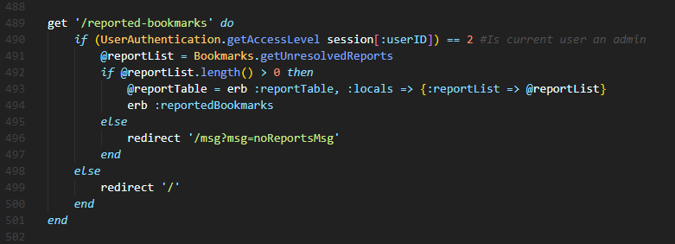

Figure 4 Code Snippet D (bookmark-site.rb)

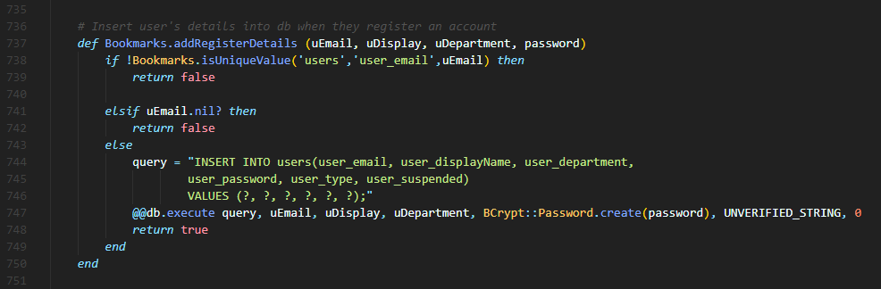

Figure 5 Snipped E (ruby-scripts/database-model.rb)

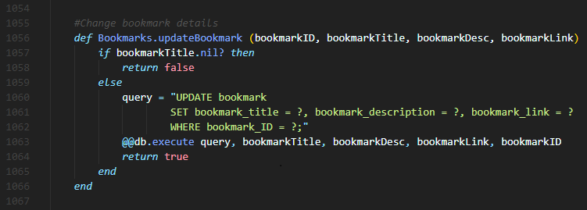

Figure 6 Snippet F (ruby-scripts/database-model.rb)

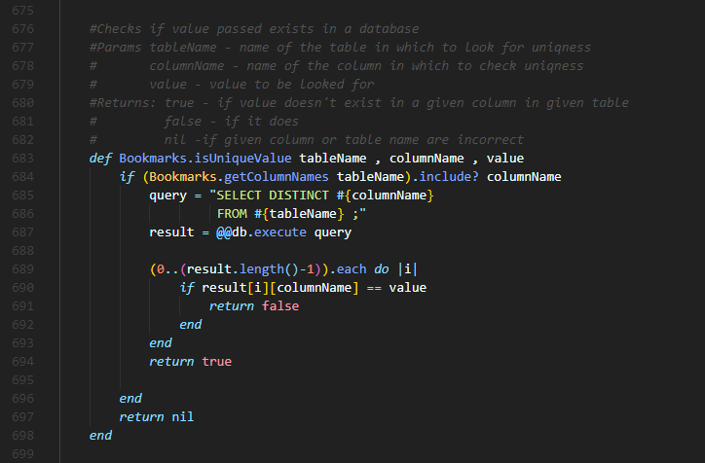

Figure 7 Snippet G (ruby-scripts/database-model.rb)

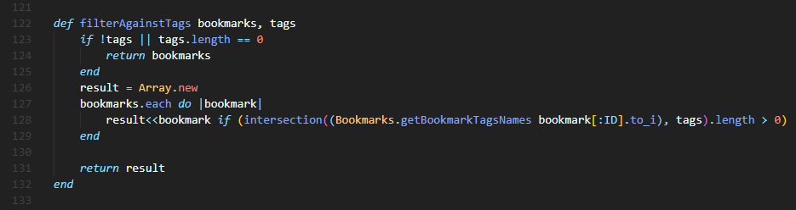

Figure 8 Snippet H (ruby-scripts/support-functions.rb)