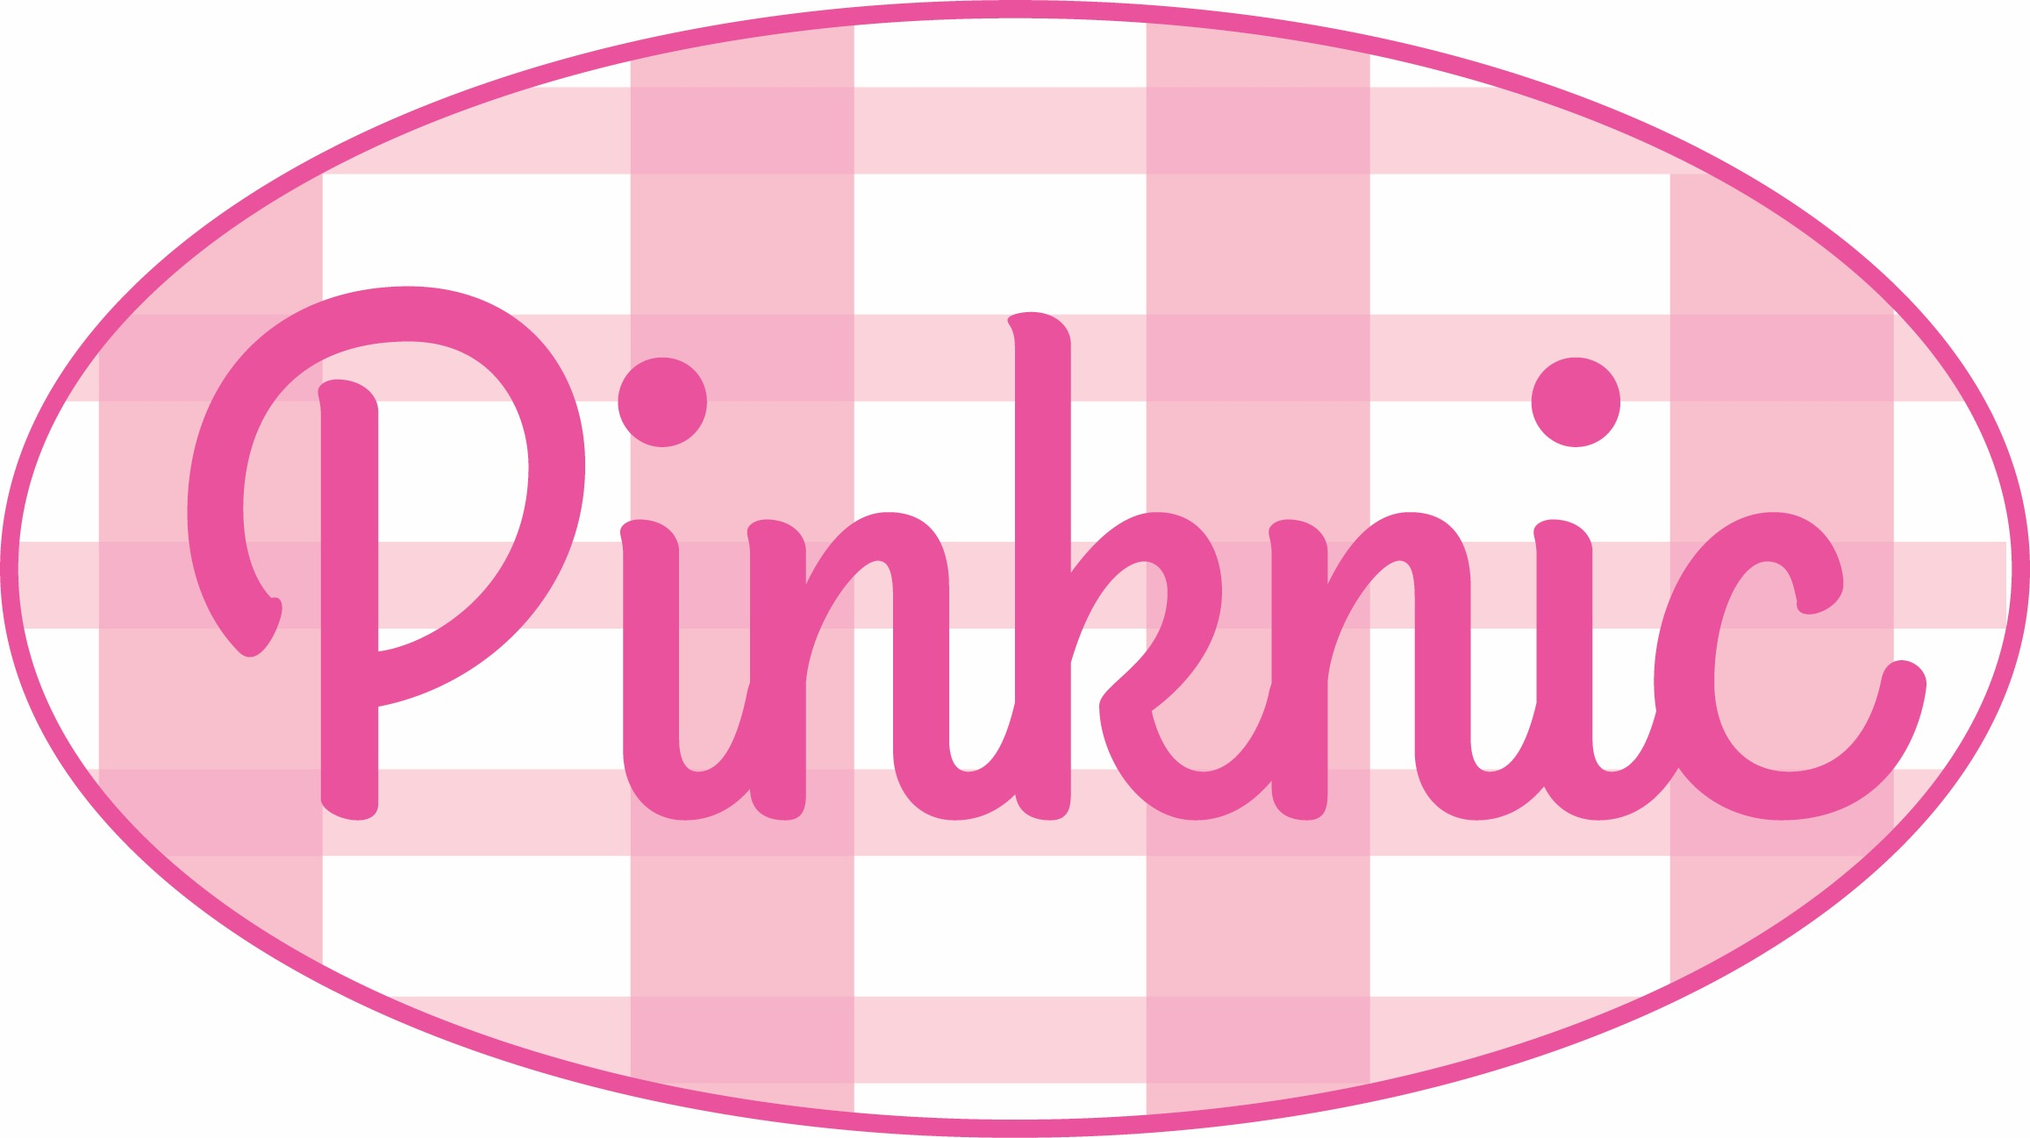

Pinknic!, a celebration for the Lesbian, Gay, Bisexual and Transgender community.We will be holding our first event on for our 6th year with an anticipated attendance in excess of 12,000 people.

We are proud to provide a diverse range of entertainment including live music, comedy, cabaret and performance art. We are currently searching for Sheffield and Britain’s finest talent and emerging artists. If you would like the opportunity to showcase your talents to the thousands of pride goers, please complete the attached application form and send to [sheffieldprideacts@live.co.uk](mailto:sheffieldprideacts@live.co.uk) attaching any samples of your work and supporting information.

We regret that due to the volume of applications received we may not be able to acknowledge receipt or provide feedback to all applicants.

Kath Housley

**LGBT Chair**

**Pinkinc 2018**

**ACTS & PERFORMERS**

**APPLICATION FORM 2017**

OUR NEXT EVENT: **Pinknic 2018** WILL TAKE PLACE ON **SATURDAY 14h JULY 2018**

FOR MORE INFO ON THE EVENT AND WHAT SPACES ARE AVAILABLE ETC PLEASE SEE FAQS SECTION BELOW.

TO MAKE A PROPOSAL PLEASE COMPLETE THE APPLICATION PROCESS BELOW. IF YOU ARE SUCCESSFUL WE WILL CONTACT YOU IN APRIL WHEN WE START TO SELECT WORK. **PROPOSAL DEADLINE 30th APRIL 2017.**

|  |
| --- |
| TO MAKE A PROPOSAL  COMPLETE THE DETAILS BELOW AND EMAIL THEM TO [chair@lgbtsheffield.co.uk](mailto:chair@lgbtsheffield.co.uk?subject=)  ATTACH ANY SUPPORTING INFORMATION TO THE EMAIL (IE PHOTOGRAPHS, VIDEOS, AUDIO FILES)  NOTE: FILES SHOULD BE NO LARGER THAN 200MB PER UPLOAD (IDEALLY A SMALLER FILE IS BETTER AS IT'S QUICKER TO UPLOAD)  IF THE SUPPORTING MATERIAL IS OF A LARGE SIZE YOU CAN EITHER POINT US IN THE DIRECTION OF AN ONLINE HOST, E.G. YOUTUBE, VIMEO OR ANOTHER WEBSITE, OR ALTERNATIVELY A POSTAL ADDRESS CAN BE PROVIDED ON REQUEST TO SEND US THE MATERIAL ON A DVD/CD. |

PLEASE NOTE:

UNFORTUNATELY WE CANNOT ACCEPT PROPOSAL FORMS BY POST. EACH PROPOSAL MUST BE SUBMITTED ON A SEPARATE EMAIL. THERE IS NO LIMIT TO THE AMOUNT OF PROPOSALS YOU CAN MAKE.

PROPOSALS MUST HAVE SUPPORTING MATERIAL (I.E. PHOTOS, VIDEO, MP3S) ATTACHED (OR SENT BY POST BY ARRANGEMENT).

IF THE WORK PROPOSED HAS NOT YET BEEN REALISED, PLEASE ATTACH MEDIA THAT REFLECTS YOUR WORK.

BY SENDING US IMAGES YOU ARE AGREEING TO US USING THEM ON OUR WEBSITE AND FOR PUBLICITY, IF YOUR WORK IS SELECTED.

|  |  |
| --- | --- |
| CONTACT NAME |  |
| EMAIL |  |
| PHONE |  |
| ADDRESS |  |
| WEBSITE(S) |  |
| ARTIST(S) NAME(S) (for publicity purposes) |  |
| CITY OF RESIDENCE(S) |  |
| PROPOSED ACT / DISPLAY |  |
| TYPE OF ACT / DISPLAY | e.g. Dance / Singer / Group / Comedy / DJ Set  2D/3D Artwork / Video / Performance art etc. |
| GENRE OF PERFORMANCE / WORK | e.g. Dance / Pop / Rock / RnB / Jazz / Acoustic /  Painting / Sculpture / Interactive etc. |
| PREFERED AREA TO PERFORM / DISPLAY | [ ] Main Stage  [ ] Cabaret Tent  [ ] Dance Tent  [ ] Womens / Trans / Alternative Stage  [ ] Main Park  [ ] Other (please specify)  [ ] Any of the above |
| LENGTH OF ACT (performing artists only) |  |
| SIZE OF DISPLAY (2D/3D visual artists) |  |
| PLEASE GIVE DETAILS OF WHERE YOU HAVE PERFORMED / DISPLAYED BEFORE (if applicable) |  |
| WILL THE PERFORMANCE / DISPLAY BE A PREMIERE OF NEW MATERIAL (If yes, please state City / UK / World) |  |
| MINIMUM STAGE / FLOOR SIZE (3D / performing artists only) |  |
| TECHNICAL REQUIREMENTS (if any) |  |
| ACCESS / OTHER SPECIAL REQUIREMENTS (if any) |  |
| ARTIST STATEMENT (Max 200 words for publicity) |  |
| WORK DESCRIPTION (What you intend to do/show) |  |
| PRESS QUOTES / COVERAGE (provide links if available) |  |
| HAVE YOU PREVIOUSLY ATTENDED SHEFFIELD OR SOUTH YORKSHIRE PRIDE ? |  |
| HAVE YOU PREVIOUSLY PERFORMED AT SHEFFIELD / SOUTH YORKSHIRE PRIDE ? |  |
| PLEASE GIVE DETAILS OF ANY OTHER PRIDE / EQUALITY / FUNDRAISER EVENTS YOU HAVE PERFORMED / DISPLAYED WORK AT (if any) |  |
| PLEASE GIVE ANY OTHER INFORMATION YOU FEEL RELEVANT IN SUPPORT OF YOUR APPLICATION |  |

|  |
| --- |
| **PINKNIC** is a not for profit community event which is free to attend and is funded by donations, fund-raising events and grant applications. We therefore are not able to pay artists fees and proposing artists should be aware of this. Subject to funding we may be able to reimburse / contribute towards travel costs, this will be confirmed prior to the date if it is available. All production costs are met by us.  **PINKNIC** offers an opportunity to showcase work at a high profile event with an anticipated 3000+ visitors. The event is promoted through an extensive marketing campaign both in print and online.  **PINKNIC** hopes to be able to act as a stepping stone for emerging artists. We're fully aware that not being able to offer fees / expenses to everyone involved does mean that PINKNIC is not for everyone. However many participating artists (both emerging and established) apply each year because they've enjoyed being part of the experience and want to be involved again.  PINKNIC is always looking for volunteers to help out in many ways both before and during the event. For example by fundraising, stewarding, helping set up marquees, being part of the stage crew or filming / photographing the event. There are many opportunities for getting involved no matter what your skills are, so please don't hesitate to email us if you feel you could help out and be part of the event in any way possible. |

**FAQS / ADDITIONAL INFORMATION**

**WHAT TYPE OF ACTS / DISPLAYS CAN BE PROPOSED FOR THE EVENT ?**

We have a number of spaces available for artists across the festival. In addition to Music / Dance / DJ performances we also welcome proposals for displays by 2D/3D visual displays, comedy and other interactive performance. If you are unsure please submit your proposal and we will see if we have a suitable space for you. Feel free to email us with any queries you may have.

**WHAT AREAS CAN I PERFORM IN ?**

The main performance space.

**WHAT ACTS CAN'T YOU ACCEPT ?**

We are unable to accept acts involving fire and jiggling with weaponry (and definitely not both!). We will not accept performances of a discriminatory / offensive nature. If you have specific concerns about any element of your proposed performance / display please contact us to discuss.

**WHEN WILL I FIND OUT IF MY APPLICATION HAS BEEN SUCCESSFUL ?**

We will be confirming the line up in April and will contact all applicants and let them know one way or another if they have been successful.

**WHAT DO ARTISTS GET IN RETURN FOR THEIR PERFORMANCE ?**

Although we are unable to pay fees, artists have the opportunity to showcase their work to an anticipated attendance in excess of 3000+ people and to be included in associated event publicity.

All artists are also able to have any merchandise / CDs/DVDs / gig tickets etc. sold on the main performance stage.

**I HAVE PREVIOUSLY PERFORMED AT PINKINC OR APPLIED AND BEEN UNSUCCESSFUL CAN I APPLY AGAIN ?**

Yes to both. Although we will try to give preference to first time applicants to give everyone a good opportunity and keep the performances new and fresh each year, we will also be happy to welcome back popular acts from previous years.

There are many reasons we may not have accepted a previous application; please feel free to reapply this year.

**CAN I CHOOSE WHAT TIME I PERFORM ?**

The stage management will decide upon the line up order most suitable to the event and confirm your allocated time slot for your performance. Performances will take place at the main event between Midday and 6pm. If there are specific times you cannot perform please state this on your application and we will endeavour to work around this.

**HOW DO YOU SELECT PERFORMERS ?**

We will take into account a number of factors including the diversity of different acts; the quality of the proposed performances, suitability to our target audience, supporting local and emerging artists while allowing the event to benefit from the range of talent nationwide etc. There is no exact criteria other than the small number of restricted acts listed above.

We are unlikely to have the same act repeated in different areas / times across the festival. However if you have two or more different applications e.g. you are a comedian or visual artist who also sings in a band, we are happy to accept applications for both.