Saved for later

Your place for things you have saved.

1. [](https://slb.percipio.com/books/73325ea3-8b9c-403e-9e22-3d323b076ece)

BOOK

[**Kafka Streams in Action: Real-time Apps and Microservices with the Kafka Streams API**](https://slb.percipio.com/books/73325ea3-8b9c-403e-9e22-3d323b076ece)

Book

Kafka Streams in Action teaches you everything you need to know to implement stream processing on data flowing into  
your Kafka platform, allowing you to focus on getting more from your data without sacrificing time or effort. Foreword b...No more description.

Not Started

4h 5m4hours 5minutes

Everyone

Aug 2018

by William P. Bejeck Jr.

37 likes

37

37 likes



1. [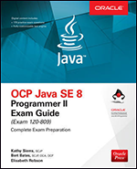](https://slb.percipio.com/books/9cabbd2a-bac1-4399-afe5-c8326436c4df)

BOOK

[**OCP Java SE 8 Programmer II Exam Guide (Exam 1Z0-809)**](https://slb.percipio.com/books/9cabbd2a-bac1-4399-afe5-c8326436c4df)

Book

A Complete, Integrated Study System for OCP Exam 1Z0-809 Study for the OCP Java SE 8 Programmer II exam using this  
effective exam preparation guide from Oracle Press. Written by a team of experts, including two developers of the origin...No more description.

Not Started

14h 50m14hours 50minutes

Everyone

May 2018

by Kathy Sierra, Bert Bates, Elisabeth Robson

27 likes

27

27 likes



1. [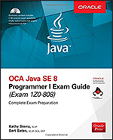](https://slb.percipio.com/books/5e8c4341-6d38-4d1c-9d7d-13aba025d06e)

BOOK

[**OCA Java SE 8 Programmer I Exam Guide (Exams 1Z0-808)**](https://slb.percipio.com/books/5e8c4341-6d38-4d1c-9d7d-13aba025d06e)

Book

Up-to-date coverage of every topic on the Java 8 SE Programmer I exam Prepare for the OCA Java SE 8 Programmer I  
exam using this effective self-study system from Oracle Press. Written by developers of the original Sun Certified Java Pr...No more description.

Not Started

6h 51m6hours 51minutes

Everyone

May 2017

by Kathy Sierra, Bert Bates

44 likes

44

44 likes



1. [](https://slb.percipio.com/books/0cd35994-1f53-443d-84c6-9c864c79c270)

BOOK

[**How to Become an IT Architect**](https://slb.percipio.com/books/0cd35994-1f53-443d-84c6-9c864c79c270)

Book

This one-of-a-kind new resource introduces IT architecture to professionals looking for guidance to embark on the  
successful path to become an IT architect. This book defines the various types of IT architecture in the industry and highl...No more description.

Not Started

4h 58m4hours 58minutes

Everyone

Oct 2016

by Cristian Bojinca

30 likes

30

30 likes



1. [](https://slb.percipio.com/books/1db69950-f28f-11e6-b0e2-0242c0a80804)

BOOK

[**Ace the Programming Interview: 160 Questions and Answers for Success**](https://slb.percipio.com/books/1db69950-f28f-11e6-b0e2-0242c0a80804)

Book

Programmers are in demand, but to land the job, you must demonstrate knowledge of those things expected by today's  
employers. This guide sets you up for success. Not only does it provide 160 of the most commonly asked interview quest...No more description.

Not Started

6h 7m6hours 7minutes

Everyone

Jun 2013

by Edward Guiness

10 likes

10

10 likes



1. [](https://slb.percipio.com/books/2b2a4674-1a59-402b-87ba-24ee09c7b7b1)

BOOK

[**Kafka in Action**](https://slb.percipio.com/books/2b2a4674-1a59-402b-87ba-24ee09c7b7b1)

Book

Master the wicked-fast Apache Kafka streaming platform through hands-on examples and real-world projects. In Kafka in  
Action you will learn: Understanding Apache Kafka conceptsSetting up and executing basic ETL tasks using Kafka Conne...No more description.

Started

4h 23m4hours 23minutes

Everyone

Jan 2022

by Dylan Scott, Viktor Gamov, Dave Klein

17 likes

17

17 likes



1. [](https://slb.percipio.com/books/0b6b7328-864e-444c-acbd-c604b0811edf)

BOOK

[**Deep-Dive Terraform on Azure**](https://slb.percipio.com/books/0b6b7328-864e-444c-acbd-c604b0811edf)

Book

Get started with the foundations of Infrastructure as Code and learn how Terraform can automate the deployment and  
management of resources on Azure. This book covers all of the software engineering practices related to Terraform and I...No more description.

Started

2h 42m2hours 42minutes

Everyone

Sep 2021

by Ritesh Modi

28 likes

28

28 likes



1. [](https://slb.percipio.com/books/75aac080-bcfc-4a38-989d-0b1c34923c6b)

BOOK

[**Infrastructure Automation with Terraform: Automate and Orchestrate Your Infrastructure with Terraform Across AWS and Microsoft Azure**](https://slb.percipio.com/books/75aac080-bcfc-4a38-989d-0b1c34923c6b)

Book

TAGLINE Use Terraform and Jenkins to implement Infrastructure as Code and Pipeline as Code across multi-cloud  
environments KEY FEATURES Step-by-step guidelines for managing infrastructure across multiple cloud platforms.Exp...No more description.

Started

3h 36m3hours 36minutes

Everyone

May 2022

by Mitesh Soni, Ankita Patil

23 likes

23

23 likes



1. [](https://slb.percipio.com/books/eda9a756-f752-4738-86e7-55cb5e30ec45)

BOOK

[**Secure by Design**](https://slb.percipio.com/books/eda9a756-f752-4738-86e7-55cb5e30ec45)

Book

As a developer, you need to build software in a secure way. But you can't spend all your time focusing on security. The  
answer is to use good design principles, tools, and mindsets that make security an implicit result - it's secure by design. ...No more description.

Started

7h 59m7hours 59minutes

Everyone

Sep 2019

by Dan Bergh Johnsson, Daniel Deogun, Daniel Sawano

5 likes

5

5 likes



1. [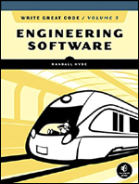](https://slb.percipio.com/books/3d97b33e-90d6-419a-bd30-72892338c89e)

BOOK

[**Write Great Code: Engineering Software, Volume 3**](https://slb.percipio.com/books/3d97b33e-90d6-419a-bd30-72892338c89e)

Book

Engineering Software, the third volume in the landmark Write Great Code series by Randall Hyde, helps you create  
readable and maintainable code that will generate awe from fellow programmers. The field of software engineering may ...No more description.

Started

5h 43m5hours 43minutes

Everyone

Aug 2020

by Randall Hyde

5 likes

5

5 likes



1. [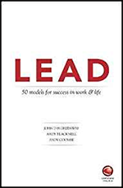](https://slb.percipio.com/books/be5de38b-2ec7-46ef-a9b9-91b43858d06c)

BOOK

[**LEAD: 50 Models for Success in Work & Life**](https://slb.percipio.com/books/be5de38b-2ec7-46ef-a9b9-91b43858d06c)

Book

LEAD will develop you as a leader in a dynamic way that goes to the heart of your purpose and dreams. It takes you well  
beyond traditional, fixed planning processes, which are out of date as soon as the ink dries, or the temporary ‘high’ of a le...No more description.

Not Started

1h 58m1hours 58minutes

Everyone

Oct 2018

by John D H Greenway, Andy Blacknell, Andy Coombe

6 likes

6

6 likes



1. [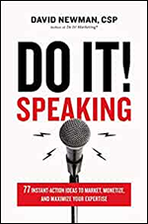](https://slb.percipio.com/books/9abd245f-0010-438c-8333-ff633a093f22)

BOOK

[**Do It! Speaking: 77 Instant-Action Ideas to Market, Monetize, and Maximize Your Expertise**](https://slb.percipio.com/books/9abd245f-0010-438c-8333-ff633a093f22)

Book

Discover the principles, practices, and insider secrets of paid professional speaking success in 77 instant-access  
“microchapters” that will help you market your smarts, monetize your message, and dramatically expand your reach and r...No more description.

Started

2h 56m2hours 56minutes

Everyone

Jan 2020

by David Newman

11 likes

11

11 likes



1. [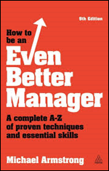](https://slb.percipio.com/books/2375f930-f30c-11e6-bb29-0242c0a80506)

BOOK

[**How to be an Even Better Manager: A Complete A-Z of Proven Techniques and Essential Skills, Ninth Edition**](https://slb.percipio.com/books/2375f930-f30c-11e6-bb29-0242c0a80506)

Book

This ninth edition of How to be an Even Better Manager covers over 60 essential topics across the three key areas in which  
any manager needs to be competent: managing people; managing activities and processes; and managing and developing...No more description.

Started

4h 48m4hours 48minutes

Everyone

Apr 2014

by Michael Armstrong

10 likes

10

10 likes



1. [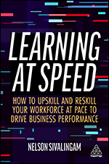](https://slb.percipio.com/books/e30aba41-c553-49dc-b11e-1bdd86c34f31)

BOOK

[**Learning at Speed: How to Upskill and Reskill your Workforce at Pace to Drive Business Performance**](https://slb.percipio.com/books/e30aba41-c553-49dc-b11e-1bdd86c34f31)

Book

The world is changing fast, but are you? Do you know where the skills gaps are in your organization? Do you know how to  
fill these gaps? Most importantly, can you make the necessary changes quickly enough to succeed? Learning at Speed is ...No more description.

Not Started

3h 12m3hours 12minutes

Everyone

Jun 2022

by Nelson Sivalingam

3 likes

3

3 likes



1. [](https://slb.percipio.com/books/69b122f1-307d-4844-8551-8f4e3981ede4)

BOOK

[**Computational Thinking: The MIT Press Essential Knowledge Series**](https://slb.percipio.com/books/69b122f1-307d-4844-8551-8f4e3981ede4)

Book

An introduction to computational thinking that traces a genealogy beginning centuries before the digital computer. A few  
decades into the digital era, scientists discovered that thinking in terms of computation made possible an entirely new w...No more description.

Started

2h 36m2hours 36minutes

Everyone

May 2019

by Peter J. Denning, Matti Tedre

10 likes

10

10 likes



1. [](https://slb.percipio.com/books/5ac8096b-e4d6-4c25-b89d-531901f05c68)

BOOK

[**Computational Thinking: A Beginner's Guide to Problem-Solving and Programming**](https://slb.percipio.com/books/5ac8096b-e4d6-4c25-b89d-531901f05c68)

Book

Computational thinking is a timeless, transferable skill that enables you to think more clearly and logically, as well as a way  
to solve specific problems. Beginning with the core ideas of computational thinking, with this book you'll build up an und...No more description.

Started

4h 44m4hours 44minutes

Everyone

Aug 2017

by Karl Beecher

23 likes

23

23 likes



1. [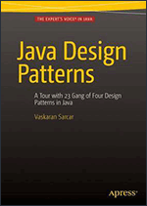](https://slb.percipio.com/books/5623e0e0-f3de-11e6-bb2f-0242c0a80b05)

BOOK

[**Java Design Patterns: A Tour of 23 Gang of Four Design Patterns in Java**](https://slb.percipio.com/books/5623e0e0-f3de-11e6-bb2f-0242c0a80b05)

Book

Java

Learn how to implement design patterns in Java: each pattern in Java Design Patterns is a complete implementation and  
the output is generated using Eclipse, making the code accessible to all. The examples are chosen so you will be able to a...No more description.

Started

1h 5m1hours 5minutes

Everyone

Dec 2015

by Vaskaran Sarcar

23 likes

23

23 likes



1. [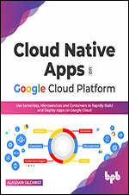](https://slb.percipio.com/books/5531fc7d-bf04-4bb7-8729-4112edbf18eb)

BOOK

[**Cloud Native Apps on Google Cloud Platform: Use Serverless, Microservices and Containers to Rapidly Build and Deploy Apps on Google Cloud**](https://slb.percipio.com/books/5531fc7d-bf04-4bb7-8729-4112edbf18eb)

Book

Step-by-step guide for developing cloud native apps on GCP powered by hands-on interactive learning KEY FEATURES  
Cutting-edge coverage on Google Cloud Build, Cloud Run, GKE, Kubectl and Anthos.Includes tutorials and exercises to le...No more description.

Not Started

6h 5m6hours 5minutes

Everyone

Apr 2022

by Alasdair Gilchrist

4 likes

4

4 likes



1. [](https://slb.percipio.com/books/22bd8ff1-b4aa-4c62-ae0e-4bd7de8ca638)

BOOK

[**Google Cloud Certified Professional Cloud Architect Study Guide, Second Edition**](https://slb.percipio.com/books/22bd8ff1-b4aa-4c62-ae0e-4bd7de8ca638)

Book

An indispensable guide to the newest version of the Google Certified Professional Cloud Architect certification The newly  
revised Second Edition of the Google Cloud Certified Professional Cloud Architect Study Guide delivers a proven and eff...No more description.

Not Started

8h 19m8hours 19minutes

Everyone

Mar 2022

by Dan Sullivan

27 likes

27

27 likes



1. [](https://slb.percipio.com/books/e6ee7a50-3f1f-433c-bb59-f8977dfb3a22)

BOOK

[**Google Cloud Certified Professional Cloud Architect All-in-One Exam Guide**](https://slb.percipio.com/books/e6ee7a50-3f1f-433c-bb59-f8977dfb3a22)

Book

Everything you need to succeed on the Google Cloud Certified Professional Cloud Architect exam in one accessible study  
guide Boost your confidence as you prepare for the Google Cloud (GCP) Certified Professional Cloud Architect exam wit...No more description.

Not Started

6h 31m6hours 31minutes

Everyone

Feb 2021

by Iman Ghanizada

62 likes

62

62 likes



1. [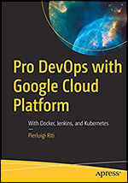](https://slb.percipio.com/books/3fe946a4-783c-4b4b-823d-0526fc88c6b5)

BOOK

[**Pro DevOps with Google Cloud Platform: With Docker, Jenkins, and Kubernetes**](https://slb.percipio.com/books/3fe946a4-783c-4b4b-823d-0526fc88c6b5)

Book

Use DevOps principles with Google Cloud Platform (GCP) to develop applications and services. This book builds chapter by  
chapter to a complete real-life scenario, explaining how to build, monitor, and maintain a complete application using Dev...No more description.

Not Started

3h 24m3hours 24minutes

Everyone

Oct 2018

by Pierluigi Riti

29 likes

29

29 likes



1. [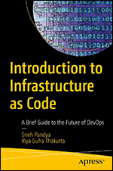](https://slb.percipio.com/books/04d1db3d-9644-42da-b9bf-f81f152ae871)

BOOK

[**Introduction to Infrastructure as Code: A Brief Guide to the Future of DevOps, 1st Edition**](https://slb.percipio.com/books/04d1db3d-9644-42da-b9bf-f81f152ae871)

Book

Get inspired to explore the depths of the DevOps field. In today’s rapidly transforming world, Infrastructure as Code (IaC)  
has emerged as an effective approach to maintain, scale, and deploy software systems. This book offers a mixture of foun...No more description.

Not Started

2h 17m2hours 17minutes

Everyone

Nov 2022

by Sneh Pandya, Riya Guha Thakurta



1. [](https://slb.percipio.com/books/b81ba322-ec3d-415b-b41f-d79863109f1a)

BOOK

[**Terraform in Action**](https://slb.percipio.com/books/b81ba322-ec3d-415b-b41f-d79863109f1a)

Book

By treating your infrastructure as a codeable application, you can instantaneously create and launch new components and  
respond efficiently to changes in demand and other use requirements. Terraform in Action introduces the Infrastructure-...No more description.

Started

4h 55m4hours 55minutes

Everyone

May 2021

by Scott Winkler

49 likes

49

49 likes



1. [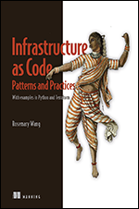](https://slb.percipio.com/books/cf8216a0-5e66-457a-901d-c250ab56db59)

BOOK

[**Infrastructure as Code, Patterns and Practices: With examples in Python and Terraform**](https://slb.percipio.com/books/cf8216a0-5e66-457a-901d-c250ab56db59)

Book

Use Infrastructure as Code (IaC) to automate, test, and streamline infrastructure for business-critical systems. In  
Infrastructure as Code, Patterns and Practices you will learn how to: Optimize infrastructure for modularity and isolate d...No more description.

Not Started

6h 35m6hours 35minutes

Everyone

Aug 2022

by Rosemary Wang

7 likes

7

7 likes



1. [](https://slb.percipio.com/books/9ec3c7c4-e04b-4652-9c70-c32dafd1ae18)

BOOK

[**Web Security for Developers: Real Threats, Practical Defense**](https://slb.percipio.com/books/9ec3c7c4-e04b-4652-9c70-c32dafd1ae18)

Book

Website security made easy. This book covers the most common ways websites get hacked and how web developers can  
defend themselves. The world has changed. Today, every time you make a site live, you're opening it up to attack. A first...No more description.

Not Started

3h 50m3hours 50minutes

Everyone

Jun 2020

by Malcolm McDonald

2 likes

2

2 likes



1. [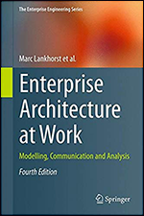](https://slb.percipio.com/books/824b974b-9d14-4242-a96f-1ac48952dcae)

BOOK

[**Enterprise Architecture at Work: Modelling, Communication and Analysis, Fourth ed.**](https://slb.percipio.com/books/824b974b-9d14-4242-a96f-1ac48952dcae)

Book

Lankhorst and his co authors present ArchiMate 3.0, enterprise modelling language that captures the complexity of  
architectural domains and their relations and allows the construction of integrated enterprise architecture models. They ...No more description.

Started

6h6hours

Everyone

Mar 2017

by Marc Lankhorst

31 likes

31

31 likes



1. [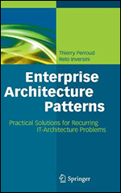](https://slb.percipio.com/books/f5da1130-f2f4-11e6-b0e2-0242c0a80804)

BOOK

[**Enterprise Architecture Patterns**](https://slb.percipio.com/books/f5da1130-f2f4-11e6-b0e2-0242c0a80804)

Book

Every enterprise architect faces similar problems when designing and governing the enterprise architecture of a medium to  
large enterprise. Design patterns are a well-established concept in software engineering, used to define universally applic...No more description.

Not Started

5h 26m5hours 26minutes

Everyone

Jul 2013

by Thierry Perroud, Reto Inversini

20 likes

20

20 likes



1. [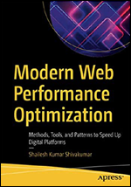](https://slb.percipio.com/books/db3af58a-bfdd-4828-956b-774befa06cee)

BOOK

[**Modern Web Performance Optimization: Methods, Tools, and Patterns to Speed Up Digital Platforms**](https://slb.percipio.com/books/db3af58a-bfdd-4828-956b-774befa06cee)

Book

Web-based platforms have become vehicles for enterprises to realize their digital strategy and are key to positive user  
engagement. The performance of these platforms can make the difference between an effective sale and a negative revie...No more description.

Not Started

4h 39m4hours 39minutes

Everyone

Nov 2020

by Shailesh Kumar Shivakumar

6 likes

6

6 likes



1. [](https://slb.percipio.com/books/129d82c0-f1a1-11e6-b696-0242c0a80a09)

BOOK

[**You've Got To Be Kidding!: How to Keep Your Job Without Losing Your Integrity**](https://slb.percipio.com/books/129d82c0-f1a1-11e6-b696-0242c0a80a09)

Book

What to do when you're caught in the middle of an ethical dilemma at work In today's super-stressed workplace, an  
ethical dilemma can come at you when you least expect it. Here's how to do the right thing without losing your integrity ...No more description.

Not Started

5h 16m5hours 16minutes

Everyone

Jun 2011

by Nan DeMars

16 likes

16

16 likes



1. [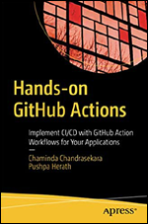](https://slb.percipio.com/books/6f7f8995-7884-4390-8786-3617286e57e5)

BOOK

[**Hands-on GitHub Actions: Implement CI/CD with GitHub Action Workflows for Your Applications**](https://slb.percipio.com/books/6f7f8995-7884-4390-8786-3617286e57e5)

Book

Implement continuous integration/continuous delivery (CI/CD) workflows for any application you develop through GitHub  
Actions. This book will give you an in-depth idea of implementation patterns, solutions for different technology builds, gu...No more description.

Not Started

1h 5m1hours 5minutes

Everyone

Feb 2021

by Chaminda Chandrasekara, Pushpa Herath

21 likes

21

21 likes



1. [](https://slb.percipio.com/books/3bf4e268-cc81-40ed-b7c9-5ae732c18b7b)

BOOK

[**Sales Genius: 40 Insights from the Science of Selling**](https://slb.percipio.com/books/3bf4e268-cc81-40ed-b7c9-5ae732c18b7b)

Book

The fast-track MBA in sales Imagine having instant access to the world's smartest thinking on sales - and being shown  
exactly what to do to guarantee that you get your own selling right, every time. Sales Genius makes it easy to apply wha...No more description.

Not Started

3h 39m3hours 39minutes

Everyone

Nov 2015

by Graham Jones

1 like

1

1 like



1. [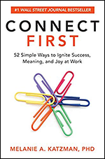](https://slb.percipio.com/books/5ed734ba-402b-4a86-8b26-411aafce2e89)

BOOK

[**Connect First: 52 Simple Ways to Ignite Success, Meaning, and Joy at Work**](https://slb.percipio.com/books/5ed734ba-402b-4a86-8b26-411aafce2e89)

Book

A renowned business psychologist, advisor, and consultant to the world’s leading companies reveals the key to greater  
success, meaning, and joy at work Technology has enabled us to be more interconnected today than ever before. So wh...No more description.

Not Started

4h 56m4hours 56minutes

Everyone

Oct 2019

by Melanie A. Katzman

10 likes

10

10 likes



1. [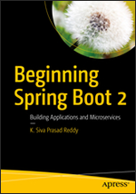](https://slb.percipio.com/books/efc9ff96-fc02-4179-a09d-bb23e1067509)

BOOK

[**Beginning Spring Boot 2: Applications and Microservices with the Spring Framework**](https://slb.percipio.com/books/efc9ff96-fc02-4179-a09d-bb23e1067509)

Book

Learn Spring Boot and how to build Java-based enterprise, web, and microservice applications with it. In this book, you'll  
see how to work with relational and NoSQL databases, build your first microservice, enterprise, or web application, and e...No more description.

Not Started

3h 7m3hours 7minutes

Everyone

Sep 2017

by K. Siva Prasad Reddy

66 likes

66

66 likes



1. [](https://slb.percipio.com/books/55c537b4-8819-4767-a23b-d016e5e6ad35)

BOOK

[**Spring in Action, Sixth Edition**](https://slb.percipio.com/books/55c537b4-8819-4767-a23b-d016e5e6ad35)

Book

If you need to learn Spring, look no further than this widely beloved and comprehensive guide! Fully revised for Spring 5.3,  
and packed with interesting real-world examples to get your hands dirty with Spring. In Spring in Action, 6th Edition you...No more description.

Not Started

7h 32m7hours 32minutes

Everyone

Mar 2022

by Craig Walls

27 likes

27

27 likes



1. [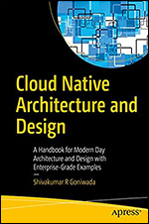](https://slb.percipio.com/books/27230109-a3af-4fa1-87c0-9488f97d712e)

BOOK

[**Cloud Native Architecture and Design**](https://slb.percipio.com/books/27230109-a3af-4fa1-87c0-9488f97d712e)

Book

Cloud Native Architecture and Design begins by explaining the fundamentals of cloud-native architecture and services,  
what cloud principles and patterns to use, and details of designing a cloud-native element. The book progresses to cover...No more description.

Not Started

8h 43m8hours 43minutes

Everyone

Oct 2021

by Shivakumar R Goniwada

18 likes

18

18 likes



1. [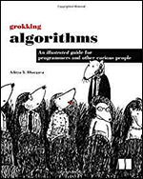](https://slb.percipio.com/books/2c1d629b-735b-4529-9e8c-a2140809f3d9)

BOOK

[**Grokking Algorithms: An Illustrated Guide for Programmers and Other Curious People**](https://slb.percipio.com/books/2c1d629b-735b-4529-9e8c-a2140809f3d9)

Book

Summary Grokking Algorithms is a fully illustrated, friendly guide that teaches you how to apply common algorithms to the  
practical problems you face every day as a programmer. You'll start with sorting and searching and, as you build up your s...No more description.

Not Started

2h 14m2hours 14minutes

Everyone

May 2016

by Aditya Y. Bhargava

30 likes

30

30 likes



1. [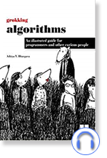](https://slb.percipio.com/audiobooks/e6a8fb9f-7d54-4d15-986c-3f2578ca9d4e)

AUDIOBOOK

[**Grokking Algorithms: An Illustrated Guide for Programmers and Other Curious People**](https://slb.percipio.com/audiobooks/e6a8fb9f-7d54-4d15-986c-3f2578ca9d4e)

Audiobook

Grokking Algorithms is a friendly guide that teaches you how to apply common algorithms to the practical problems you  
face every day as a programmer. You'll start with sorting and searching and, as you build up your skills in thinking algorith...No more description.

Not Started

3h 46m 43s3hours 46minutes 43seconds

Everyone

by Aditya Bhargava

7 likes

7

7 likes



1. [](https://slb.percipio.com/books/bd5d26db-b0ec-49b1-b606-bfc564470eb5)

BOOK

[**Grokking Streaming Systems: Real-time event processing**](https://slb.percipio.com/books/bd5d26db-b0ec-49b1-b606-bfc564470eb5)

Book

A friendly, framework-agnostic tutorial that will help you grok how streaming systems work—and how to build your own!  
In Grokking Streaming Systems you will learn how to: Implement and troubleshoot streaming systemsDesign streaming s...No more description.

Not Started

2h 28m2hours 28minutes

Everyone

Apr 2022

by Ning Wang, Josh Fischer

3 likes

3

3 likes



1. [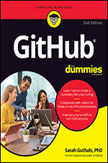](https://slb.percipio.com/books/92c8739d-0cfa-4202-8ead-5a4b3c0f3a12)

BOOK

[**GitHub For Dummies, 2nd Edition**](https://slb.percipio.com/books/92c8739d-0cfa-4202-8ead-5a4b3c0f3a12)

Book

Get more out of your coding with GitHub For today’s coders, GitHub is a must. The world’s largest software development  
platform, GitHub helps developers store, track, and collaborate on software projects. In this easy-to-follow Dummies gui...No more description.

Not Started

4h 9m4hours 9minutes

Everyone

Feb 2023

by Sarah Guthals

1 like

1

1 like



1. [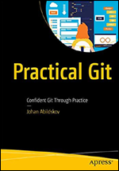](https://slb.percipio.com/books/3f4e2517-1ae5-43bc-a877-340d820438a7)

BOOK

[**Practical Git: Confident Git Through Practice**](https://slb.percipio.com/books/3f4e2517-1ae5-43bc-a877-340d820438a7)

Book

Practice your Git skills using exercises in your own environment. This book introduces concepts in an abstract visual way,  
and then enforces this learning through exercises - the Git katas. You will start with basic interactions such as commits an...No more description.

Not Started

2h 26m2hours 26minutes

Everyone

Nov 2020

by Johan Abildskov

24 likes

24

24 likes



1. [](https://slb.percipio.com/books/87b3f5b9-184c-4d9d-9dde-805c99361816)

BOOK

[**Rise of Generative AI and ChatGPT: Understand How Generative AI and ChatGPT are Transforming and Reshaping the Business World**](https://slb.percipio.com/books/87b3f5b9-184c-4d9d-9dde-805c99361816)

Book

Generative AI and ChatGPT have the potential to transform industries and society by improving efficiency, enhancing  
creativity, and enabling more personalized experiences. If you are someone who is looking to stay ahead of the curve in t...No more description.

Started

2h 43m2hours 43minutes

Everyone

Mar 2023

by Utpal Chakraborty, Soumyadeep Roy, Sumit Kumar

18 likes

18

18 likes



1. [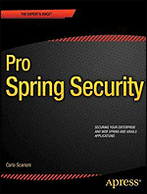](https://slb.percipio.com/books/f9b2dc40-f1fc-11e6-b33f-0242c0a80c08)

BOOK

[**Pro Spring Security**](https://slb.percipio.com/books/f9b2dc40-f1fc-11e6-b33f-0242c0a80c08)

Book

Security is a key element in the development of any non-trivial application. The Spring Security Framework provides a  
comprehensive set of functionalities to implement industry-standard authentication and authorization mechanisms for Ja...No more description.

Not Started

5h 22m5hours 22minutes

Everyone

Mar 2013

by Carlo Scarioni

14 likes

14

14 likes



1. [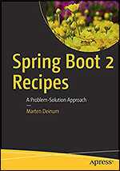](https://slb.percipio.com/books/60f059d7-1b11-4523-8524-b421482fda0f)

BOOK

[**Spring Boot 2 Recipes: A Problem-Solution Approach**](https://slb.percipio.com/books/60f059d7-1b11-4523-8524-b421482fda0f)

Book

Solve all your Spring Boot 2 problems using complete and real-world code examples. When you start a new project, you’ll  
be able to copy the code and configuration files from this book, and then modify them for your needs. This can save you ...No more description.

Not Started

2h 55m2hours 55minutes

Everyone

Nov 2018

by Marten Deinum

16 likes

16

16 likes



1. [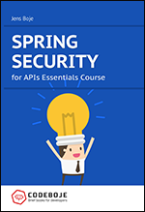](https://slb.percipio.com/books/df53b5ca-efe3-4db3-ab4f-cc00438ba495)

BOOK

[**Spring Security for APIs Essentials Course**](https://slb.percipio.com/books/df53b5ca-efe3-4db3-ab4f-cc00438ba495)

Book

Want to secure your Spring Boot based API now? You know that securing your API is essential and the one-stop-solution  
in a Spring-based API is Spring Security. Spring Security can solve almost all problems you are facing with security in an A...No more description.

Not Started

43m43minutes

Everyone

Jan 2019

by Jens Boje

10 likes

10

10 likes



1. [](https://slb.percipio.com/books/fe86d3a7-b5cb-4133-be25-ba2b8f1d79fd)

BOOK

[**Spring Security in Action**](https://slb.percipio.com/books/fe86d3a7-b5cb-4133-be25-ba2b8f1d79fd)

Book

Spring Security in Action shows you how to prevent cross-site scripting and request forgery attacks before they do  
damage. You’ll start with the basics, simulating password upgrades and adding multiple types of authorization. As your sk...No more description.

Not Started

8h 17m8hours 17minutes

Everyone

Oct 2020

by Laurenţiu Spilcă

22 likes

22

22 likes



1. [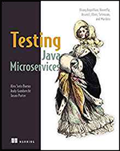](https://slb.percipio.com/books/f7c02326-eef1-4a46-9165-2d7e1cb92e2c)

BOOK

[**Testing Java Microservices: Using Arquillian, Hoverfly, AssertJ, JUnit, Selenium, and Mockito**](https://slb.percipio.com/books/f7c02326-eef1-4a46-9165-2d7e1cb92e2c)

Book

Summary Testing Java Microservices teaches you to implement unit and integration tests for microservice systems running  
on the JVM. You'll work with a microservice environment built using Java EE, WildFly Swarm, and Docker. You'll learn ho...No more description.

Not Started

4h 5m4hours 5minutes

Everyone

Aug 2018

by Alex Soto Bueno, Andy Gumbrecht, Jason Porter

13 likes

13

13 likes



1. [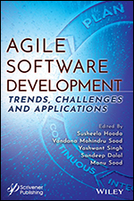](https://slb.percipio.com/books/50acac72-6988-420a-a562-2eeac119d982)

BOOK

[**Agile Software Development: Trends, Challenges and Applications**](https://slb.percipio.com/books/50acac72-6988-420a-a562-2eeac119d982)

Book

AGILE SOFTWARE DEVELOPMENT A unique title that introduces the whole range of agile software development  
processes from the fundamental concepts to the highest levels of applications such as requirement analysis, software tes...No more description.

Not Started

5h 54m5hours 54minutes

Everyone

Feb 2023

by Susheela Hooda, Vandana Mohindru Sood, Yashwant Singh...



1. [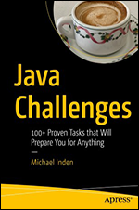](https://slb.percipio.com/books/2ece2049-de69-4892-b539-c4e8cf06f3ff)

BOOK

[**Java Challenges: 100+ Proven Tasks that Will Prepare You for Anything**](https://slb.percipio.com/books/2ece2049-de69-4892-b539-c4e8cf06f3ff)

Book

Expand your knowledge of Java with this entertaining learning guide, which features 100+ exercises and programming  
challenges. Java Challenges will prepare you for your next exam or job interview, and covers many practical topics, such a...No more description.

Started

7h 47m7hours 47minutes

Everyone

Dec 2021

by Michael Inden

3 likes

3

3 likes



1. [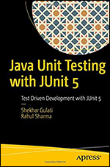](https://slb.percipio.com/books/5a2c646a-a878-4e67-8177-bb69296be921)

BOOK

[**Java Unit Testing with JUnit 5: Test Driven Development with JUnit 5**](https://slb.percipio.com/books/5a2c646a-a878-4e67-8177-bb69296be921)

Book

Explore the new way of building and maintaining test cases with Java test driven development (TDD) using JUnit 5. This  
book doesn't just talk about the new concepts, it shows you ways of applying them in TDD and Java 8 to continuously d...No more description.

Completed

1h 55m1hours 55minutes

Everyone

Nov 2017

by Shekhar Gulati, Rahul Sharma

56 likes

56

56 likes



1. [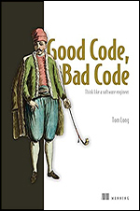](https://slb.percipio.com/books/00f342b2-ef68-4044-a879-e3eeb9f48610)

BOOK

[**Good Code, Bad Code**](https://slb.percipio.com/books/00f342b2-ef68-4044-a879-e3eeb9f48610)

Book

Practical techniques for writing code that is robust, reliable, and easy for team members to understand and adapt.  
Summary In Good Code, Bad Code you’ll learn how to: Think about code like an effective software engineerWrite functi...No more description.

Not Started

6h 48m6hours 48minutes

Everyone

Jul 2021

by Tom Long

13 likes

13

13 likes



1. [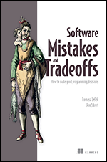](https://slb.percipio.com/books/51898751-ac35-4484-99c2-5e5647504b27)

BOOK

[**Software Mistakes and Tradeoffs: How to make good programming decisions**](https://slb.percipio.com/books/51898751-ac35-4484-99c2-5e5647504b27)

Book

Optimize the decisions that define your code by exploring the common mistakes and intentional tradeoffs made by expert  
developers. In Software Mistakes and Tradeoffs you will learn how to: Reason about your systems to make intuitive and ...No more description.

Started

7h 59m7hours 59minutes

Everyone

Apr 2022

by Jon Skeet, Tomasz Lelek

11 likes

11

11 likes



1. [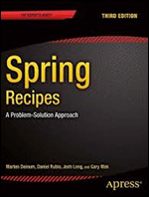](https://slb.percipio.com/books/84592f50-f31c-11e6-ad5d-0242c0a80607)

BOOK

[**Spring Recipes: A Problem-Solution Approach, Third Edition**](https://slb.percipio.com/books/84592f50-f31c-11e6-ad5d-0242c0a80607)

Book

Spring Recipes: A Problem-Solution Approach, Third Edition builds upon the best-selling success of the previous editions  
and focuses on the latest Spring Framework features for building enterprise Java applications. This book provides code re...No more description.

Not Started

11h 33m11hours 33minutes

Everyone

Nov 2014

by Gary Mak, Josh Long, Daniel Rubio...

16 likes

16

16 likes



1. [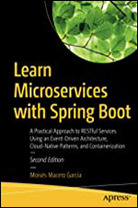](https://slb.percipio.com/books/0547d4bf-fb59-45ef-a907-677da0b54011)

BOOK

[**Learn Microservices**](https://slb.percipio.com/books/0547d4bf-fb59-45ef-a907-677da0b54011)

Book

Build Java-based microservices architecture using the Spring Boot framework by evolving an application from a small  
monolith to an event-driven architecture composed of several services. This revised book follows an incremental approac...No more description.

Started

54m54minutes

Everyone

Aug 2018

by Moisés Macero García



1. [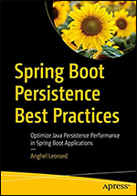](https://slb.percipio.com/books/42b027ff-d85b-4d9c-8347-29d9000f302d)

BOOK

[**Spring Boot Persistence Best Practices: Optimize Java Persistence Performance in Spring Boot Applications**](https://slb.percipio.com/books/42b027ff-d85b-4d9c-8347-29d9000f302d)

Book

This book is a collection of developer code recipes and best practices for persisting data using Spring, particularly Spring  
Boot. The book is structured around practical recipes, where each recipe discusses a performance case or performance-r...No more description.

Not Started

9h 1m9hours 1minutes

Everyone

Apr 2020

by Anghel Leonard

14 likes

14

14 likes



1. [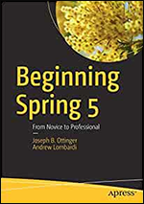](https://slb.percipio.com/books/6ffbbc79-77c5-44d9-bfaa-235e5c14cafa)

BOOK

[**Beginning Spring 5: From Novice to Professional**](https://slb.percipio.com/books/6ffbbc79-77c5-44d9-bfaa-235e5c14cafa)

Book

Get started with Spring Framework 5 and its ecosystem, with a guide to the working practices in modern development.  
Authors Joseph Ottinger and Andrew Lombardi will teach you how to use the Spring Framework to build Java-based appl...No more description.

Not Started

4h 8m4hours 8minutes

Everyone

Sep 2019

by Joseph B. Ottinger, Andrew Lombardi

12 likes

12

12 likes



1. [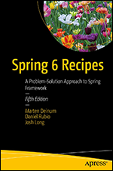](https://slb.percipio.com/books/6a87d63f-b91b-47f2-b92d-d304e51b1ba7)

BOOK

[**Spring 6 Recipes: A Problem-Solution Approach to Spring Framework, 5th Edition**](https://slb.percipio.com/books/6a87d63f-b91b-47f2-b92d-d304e51b1ba7)

Book

This in-depth Spring-based Java developer code reference has been updated and now solves many of your Spring  
Framework 6 problems using reusable, complete and real-world working code examples. Spring 6 Recipes (5th Edition) n...No more description.

Not Started

9h 46m9hours 46minutes

Everyone

Apr 2023

by Josh Long, Daniel Rubio, Marten Deinum



1. [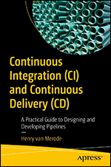](https://slb.percipio.com/books/d6746f1e-2fff-47a5-aa5e-862b6de4c0d6)

BOOK

[**Continuous Integration (CI) and Continuous Delivery (CD): A Practical Guide to Designing and Developing Pipelines**](https://slb.percipio.com/books/d6746f1e-2fff-47a5-aa5e-862b6de4c0d6)

Book

Use continuous Integration (CI) and continuous delivery (CD) to improve the speed of software delivery. This book presents  
a game changer—how to use pipelines to automate the software delivery process. The theories about CI/CD are much th...No more description.

Not Started

4h 18m4hours 18minutes

Everyone

Mar 2023

by Henry van Merode



1. [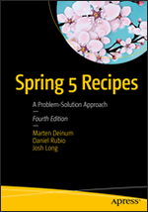](https://slb.percipio.com/books/d01a9354-c677-4392-8661-562aa1ac5283)

BOOK

[**Spring 5 Recipes: A Problem-Solution Approach, Fourth Edition**](https://slb.percipio.com/books/d01a9354-c677-4392-8661-562aa1ac5283)

Book

Solve all your Spring 5 problems using complete and real-world code examples. When you start a new project, you’ll be  
able to copy the code and configuration files from this book, and then modify them for your needs. This can save you a g...No more description.

Not Started

11h 12m11hours 12minutes

Everyone

Oct 2017

by Josh Long, Daniel Rubio, Marten Deinum

9 likes

9

9 likes



1. [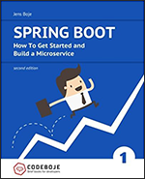](https://slb.percipio.com/books/824d8001-f88b-45b2-87a7-bf6383c4b73d)

BOOK

[**Spring Boot: How to Get Started and Build a Microservice, Second Edition**](https://slb.percipio.com/books/824d8001-f88b-45b2-87a7-bf6383c4b73d)

Book

From Zero Spring Experience to Building Your First Microservice with Spring Boot 2 Learn to build your first microservice  
with Spring Boot. Together we will write a production-ready microservice with a REST API in just a few hours. All starting...No more description.

Started

59m59minutes

Everyone

Oct 2017

by Jens Boje

16 likes

16

16 likes



1. [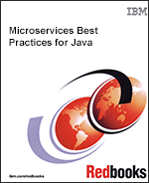](https://slb.percipio.com/books/49ac2820-0abf-11e7-a383-0242c0a80c04)

BOOK

[**Microservices Best Practices for Java**](https://slb.percipio.com/books/49ac2820-0abf-11e7-a383-0242c0a80c04)

Book

Microservices is an architectural style in which large, complex software applications are composed of one or more smaller  
services. Each of these microservices focuses on completing one task that represents a small business capability. These ...No more description.

Not Started

2h 9m2hours 9minutes

Everyone

Mar 2017

by Michael Hofmann, Erin Schnabel, Katherine Stanley

37 likes

37

37 likes



1. [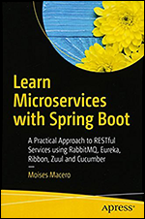](https://slb.percipio.com/books/7fd8b390-f292-499b-8a06-faab982dc5fd)

BOOK

[**Learn Microservices with Spring Boot: A Practical Approach to RESTful Services Using RabbitMQ, Eureka, Ribbon, Zuul and Cucumber**](https://slb.percipio.com/books/7fd8b390-f292-499b-8a06-faab982dc5fd)

Book

Build a microservices architecture with Spring Boot, by evolving an application from a small monolith to an event-driven  
architecture composed of several services. This book follows an incremental approach to teach microservice structure, te...No more description.

Not Started

3h 8m3hours 8minutes

Everyone

Dec 2017

by Moises Macero

53 likes

53

53 likes



1. [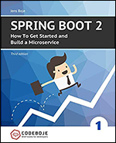](https://slb.percipio.com/books/1515a62c-5264-4f19-8cb6-89dbe6b1d5af)

BOOK

[**Spring Boot 2: How to Get Started and Build a Microservice, Third Edition**](https://slb.percipio.com/books/1515a62c-5264-4f19-8cb6-89dbe6b1d5af)

Book

From Zero Spring Experience to Building Your First Microservice with Spring Boot 2 Learn to build your first microservice  
with Spring Boot. Together we will write a production-ready microservice with a REST API in just a few hours. All starting...No more description.

Not Started

1h 3m1hours 3minutes

Everyone

Sep 2019

by Jens Boje

13 likes

13

13 likes



1. [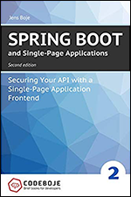](https://slb.percipio.com/books/f50d3770-72cf-451e-aa24-a8119a465405)

BOOK

[**Spring Boot and Single-Page Applications: Securing Your API with a Single-Page Application Frontend, Second Edition**](https://slb.percipio.com/books/f50d3770-72cf-451e-aa24-a8119a465405)

Book

Learn to integrate your Spring Boot application with a single-page application securely in an actionable and hands-on  
approach within just a few hours! In this custom-tailored learning plan you get a head start and learn 4 commonly used w...No more description.

Not Started

35m35minutes

Everyone

Sep 2019

by Jens Boje

7 likes

7

7 likes



1. [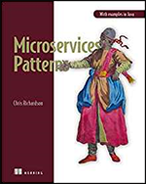](https://slb.percipio.com/books/8a74ccea-f809-4f79-a901-4a1c1f69a9c5)

BOOK

[**Microservices Patterns**](https://slb.percipio.com/books/8a74ccea-f809-4f79-a901-4a1c1f69a9c5)

Book

Summary Microservices Patterns teaches enterprise developers and architects how to build applications with the  
microservice architecture. Rather than simply advocating for the use the microservice architecture, this clearly-written gu...No more description.

Not Started

8h 32m8hours 32minutes

Everyone

Oct 2018

by Chris Richardson

73 likes

73

73 likes



1. [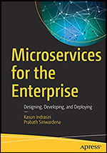](https://slb.percipio.com/books/dbcc5ee5-eeee-4dbf-8441-426043fb2936)

BOOK

[**Microservices for the Enterprise: Designing, Developing, and Deploying**](https://slb.percipio.com/books/dbcc5ee5-eeee-4dbf-8441-426043fb2936)

Book

Understand the key challenges and solutions around building microservices in the enterprise application environment. This  
book provides a comprehensive understanding of microservices architectural principles and how to use microservices in r...No more description.

Not Started

5h 31m5hours 31minutes

Everyone

Nov 2018

by Prabath Siriwardena, Kasun Indrasiri

25 likes

25

25 likes



1. [](https://slb.percipio.com/books/8b9f1fe9-0084-482e-ae9c-4055d84fb298)

BOOK

[**Microservices Security in Action**](https://slb.percipio.com/books/8b9f1fe9-0084-482e-ae9c-4055d84fb298)

Book

Microservices Security in Action teaches you how to address microservices-specific security challenges throughout the  
system. This practical guide includes plentiful hands-on exercises using industry-leading open-source tools and examples ...No more description.

Not Started

9h 59m9hours 59minutes

Everyone

Jul 2020

by Prabath Siriwardena, Nuwan Dias

12 likes

12

12 likes



1. [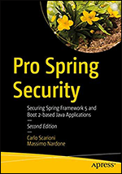](https://slb.percipio.com/books/8fe85fc4-cb83-468b-a31a-ba24cf0a379c)

BOOK

[**Pro Spring Security: Securing Spring Framework 5 and Boot 2-based Java Applications, Second Edition**](https://slb.percipio.com/books/8fe85fc4-cb83-468b-a31a-ba24cf0a379c)

Book

Build and deploy secure Spring Framework and Spring Boot-based enterprise Java applications with the Spring Security  
Framework. This book explores a comprehensive set of functionalities to implement industry-standard authentication an...No more description.

Started

3h 57m3hours 57minutes

Everyone

Nov 2019

by Carlo Scarioni, Massimo Nardone

6 likes

6

6 likes



1. [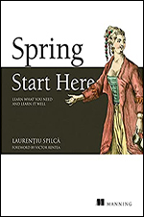](https://slb.percipio.com/books/7abf7e48-afa5-4e62-b7cb-ad3b6a34bd2c)

BOOK

[**Spring Start Here**](https://slb.percipio.com/books/7abf7e48-afa5-4e62-b7cb-ad3b6a34bd2c)

Book

Quickly master the massive Spring ecosystem with this focused, hands-on guide that teaches you exactly what you need  
to know. In Spring Start Here, you will learn how to: Build web applications with SpringManage application objects with ...No more description.

Not Started

6h 22m6hours 22minutes

Everyone

Nov 2021

by Laurentiu Spilca

35 likes

35

35 likes



1. [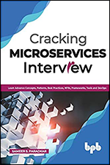](https://slb.percipio.com/books/89a7da73-ec1b-4f07-9a11-1ac692e5be2d)

BOOK

[**Cracking Microservices Interview: Learn Advance Concepts, Patterns, Best Practices, NFRs, Frameworks, Tools and DevOps**](https://slb.percipio.com/books/89a7da73-ec1b-4f07-9a11-1ac692e5be2d)

Book

Gold mine of microservices interview Questions & Answers for aspirants and domain experts Key Features More than 200  
questions in 5 domains including a chapter on patterns, practices, and NFRsExtended coverage from architecture, design,...No more description.

Completed

2h2hours

Everyone

Jan 2020

by Sameer S. Paradkar

16 likes

16

16 likes



1. [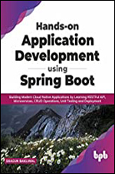](https://slb.percipio.com/books/26654270-8d53-43de-bd2f-8d066b374d7a)

BOOK

[**Hands-on Application Development using Spring Boot**](https://slb.percipio.com/books/26654270-8d53-43de-bd2f-8d066b374d7a)

Book

Spring is an excellent framework for developing both web and cloud-native applications. This book on application  
development using Spring Boot simplifies the process of writing boilerplate code for complex software. It allows develop...No more description.

Not Started

2h 58m2hours 58minutes

Everyone

Oct 2021

by Shagun Bakliwal

43 likes

43

43 likes



1. [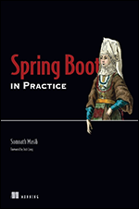](https://slb.percipio.com/books/3b16e6e3-0b4d-4689-8f08-0f088ae29e4a)

BOOK

[**Spring Boot in Practice**](https://slb.percipio.com/books/3b16e6e3-0b4d-4689-8f08-0f088ae29e4a)

Book

Go beyond the basics with Spring Boot! This practical guide presents dozens of relevant scenarios in a convenient  
problem-solution-discussion format. In Spring Boot in Practice you will learn: Spring Boot’s features from an expert’s per...No more description.

Not Started

8h 19m8hours 19minutes

Everyone

Jul 2022

by Somnath Musib

19 likes

19

19 likes



1. [](https://slb.percipio.com/books/0c76abe0-f400-11e6-bb29-0242c0a80506)

BOOK

[**Pro Spring Boot**](https://slb.percipio.com/books/0c76abe0-f400-11e6-bb29-0242c0a80506)

Book

Pro Spring Boot is your authoritative hands-on practical guide for increasing your Spring Framework-based enterprise Java  
and cloud application productivity while decreasing development time using the Spring Boot productivity suite of tools. I...No more description.

Not Started

4h 4m4hours 4minutes

Everyone

May 2016

by Felipe Gutierrez

42 likes

42

42 likes



1. [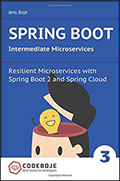](https://slb.percipio.com/books/a7f6bf70-9c5e-4166-addf-25d0813dac3d)

BOOK

[**Spring Boot Intermediate Microservices: Resilient Microservices with Spring Boot 2 and Spring Cloud**](https://slb.percipio.com/books/a7f6bf70-9c5e-4166-addf-25d0813dac3d)

Book

Learn to build a resilient microservice infrastructure using proven patterns with Spring Boot 2 and Spring Cloud Resilience  
and fault tolerance are a must, or your system will fall apart. Our guides give you brief lessons on a single topic to get yo...No more description.

Not Started

34m34minutes

Everyone

Nov 2017

by Jens Boje

41 likes

41

41 likes



1. [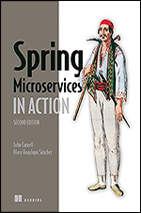](https://slb.percipio.com/books/f3dc0381-a28e-4a30-8482-a2167dfa31db)

BOOK

[**Spring Microservices in Action, Second Edition**](https://slb.percipio.com/books/f3dc0381-a28e-4a30-8482-a2167dfa31db)

Book

Spring Microservices in Action, Second Edition teaches you to build microservice-based applications using Java and Spring.  
Summary By dividing large applications into separate self-contained units, Microservices are a great step toward reducin...No more description.

Not Started

6h 16m6hours 16minutes

Everyone

May 2021

by John Carnell, Illary Huaylupo Sánchez

28 likes

28

28 likes



1. [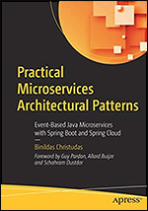](https://slb.percipio.com/books/c4e4a438-b7f3-4fea-b046-1136c1139cc7)

BOOK

[**Practical Microservices Architectural Patterns: Event-Based Java Microservices with Spring Boot and Spring Cloud**](https://slb.percipio.com/books/c4e4a438-b7f3-4fea-b046-1136c1139cc7)

Book

Take your distributed applications to the next level and see what the reference architectures associated with microservices  
can do for you. This book begins by showing you the distributed computing architecture landscape and provides an in-de...No more description.

Started

8h 50m8hours 50minutes

Everyone

Jun 2019

by Binildas Christudas

52 likes

52

52 likes



1. [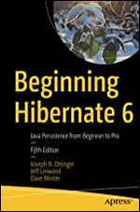](https://slb.percipio.com/books/5b1eaf2b-e361-42b9-94b1-57f055345b6e)

BOOK

[**Beginning Hibernate 6**](https://slb.percipio.com/books/5b1eaf2b-e361-42b9-94b1-57f055345b6e)

Book

Get started with Hibernate, an open source Java persistence layer and gain a clear introduction to the current standard for  
object-relational persistence in Java. This updated edition includes the new Hibernate 6.0 framework which covers new ...No more description.

Not Started

5h 17m5hours 17minutes

Everyone

Oct 2021

by Jeff Linwood, Dave Minter, Joseph B. Ottinger

6 likes

6

6 likes



1. [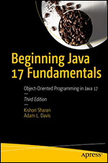](https://slb.percipio.com/books/cbadb50e-7809-44a2-abce-95b0749f6256)

BOOK

[**Beginning Java 17 Fundamentals: Object-Oriented Programming in Java 17, 3rd Edition**](https://slb.percipio.com/books/cbadb50e-7809-44a2-abce-95b0749f6256)

Book

Learn the fundamentals of the Java 17 LTS or Java Standard Edition version 17 Long Term Support release, including basic  
programming concepts and the object-oriented fundamentals necessary at all levels of Java development. Authors Kishor...No more description.

Not Started

19h 18m19hours 18minutes

Everyone

Nov 2021

by Kishori Sharan, Adam L. Davis

7 likes

7

7 likes



1. [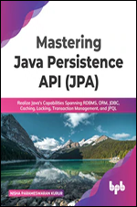](https://slb.percipio.com/books/b96e5c80-993a-4fb4-a3c1-fd2d58496fda)

BOOK

[**Mastering Java Persistence API (JPA): Realize Java's Capabilities Spanning RDBMS, ORM, JDBC, Caching, Locking, Transaction Management, and JPQL**](https://slb.percipio.com/books/b96e5c80-993a-4fb4-a3c1-fd2d58496fda)

Book

Filled with sample case study, exercises, commonly faced issues/solutions, and important interview questions, this book is  
surely going to help developers to expand their skills in JPA. KEY FEATURES Covers every JPA capability with detailed e...No more description.

Not Started

3h 34m3hours 34minutes

Everyone

Mar 2022

by Nisha Parameswaran Kurur

1 like

1

1 like



1. [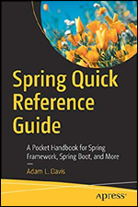](https://slb.percipio.com/books/0991bce7-4d90-4e84-a64c-3f1eda58720f)

BOOK

[**Spring Quick Reference Guide: A Pocket Handbook for Spring Framework, Spring Boot, and More**](https://slb.percipio.com/books/0991bce7-4d90-4e84-a64c-3f1eda58720f)

Book

Quickly gain the insight necessary to address a multitude of Java-based Spring Framework and Spring Boot coding  
challenges using this succinct reference guide. Short, focused code examples will help you master many of the Spring ele...No more description.

Not Started

1h 46m1hours 46minutes

Everyone

Sep 2020

by Adam L. Davis

23 likes

23

23 likes



1. [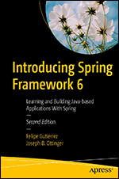](https://slb.percipio.com/books/bd334209-a5a6-4c4f-93ff-fb96792b6b7a)

BOOK

[**Introducing Spring Framework 6: Learning and Building Java-based Applications With Spring, 2nd Edition**](https://slb.percipio.com/books/bd334209-a5a6-4c4f-93ff-fb96792b6b7a)

Book

Spring Framework 6 remains - by far - the leading de-facto "out of the box" practical Java meta application development  
framework for building complex enterprise, cloud-native applications as well as web applications and microservices. Intro...No more description.

Not Started

2h 11m2hours 11minutes

Everyone

Dec 2022

by Joseph B. Ottinger, Felipe Gutierrez

1 like

1

1 like



1. [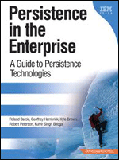](https://slb.percipio.com/books/cf78c940-f1ab-11e6-a556-0242c0a80509)

BOOK

[**Persistence in the Enterprise: A Guide to Persistence Technologies**](https://slb.percipio.com/books/cf78c940-f1ab-11e6-a556-0242c0a80509)

Book

Persistence in the Enterprise is a unique, up-to-date, and objective guide to building the persistence layers of enterprise  
applications. Drawing on their extensive experience, five leading IBM Web development experts carefully review the issu...No more description.

Not Started

6h 32m6hours 32minutes

Everyone

May 2008

by et al., Roland Barcia

1 like

1

1 like



1. [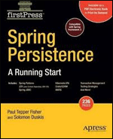](https://slb.percipio.com/books/a33fea30-f335-11e6-bb29-0242c0a80506)

BOOK

[**Spring Persistence: A Running Start**](https://slb.percipio.com/books/a33fea30-f335-11e6-bb29-0242c0a80506)

Book

This firstPress title gets readers rolling with the various fundamental Spring Framework Java Persistence concepts and  
offerings, as well as proven design patterns for integrating Spring Persistence functionality for complex and transaction–...No more description.

Not Started

2h 37m2hours 37minutes

Everyone

Feb 2009

by Paul Tepper Fisher, Solomon Duskis

9 likes

9

9 likes



1. [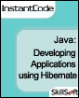](https://slb.percipio.com/books/3d1d1ea0-f04f-11e6-9877-0242c0a80506)

BOOK

[**Java InstantCode: Developing Applications Using Hibernate**](https://slb.percipio.com/books/3d1d1ea0-f04f-11e6-9877-0242c0a80506)

Book

Java

Learn how to create applications using Hibernate. Including how you can create persistence classes and map these classes  
to the relational database table, and how to create, store, and retrieve persistent objects in and from the database.

Not Started

2h 50m2hours 50minutes

Everyone

Sep 2005

19 likes

19

19 likes



1. [](https://slb.percipio.com/books/9a4fb970-f1cb-11e6-b33f-0242c0a80c08)

BOOK

[**Professional Hibernate**](https://slb.percipio.com/books/9a4fb970-f1cb-11e6-b33f-0242c0a80c08)

Book

What is this book about? This book is written for professional Java developers who already understand how to build  
server-side Java applications. The book assumes no previous experience with Hibernate, though readers should have a g...No more description.

Not Started

6h6hours

Everyone

Sep 2004

by Joseph D. Gradecki, Eric Pugh

187 likes

187

187 likes



1. [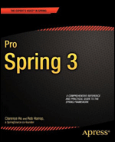](https://slb.percipio.com/books/5332d6c0-f041-11e6-87f4-0242c0a80606)

BOOK

[**Pro Spring 3**](https://slb.percipio.com/books/5332d6c0-f041-11e6-87f4-0242c0a80606)

Book

The agile, lightweight, open-source Spring Framework continues to be the de facto leading enterprise Java application  
development framework for today's Java programmers and developers. It works with other leading open-source, agile an...No more description.

Not Started

13h 2m13hours 2minutes

Everyone

Apr 2012

by Clarence Ho, Rob Harrop

72 likes

72

72 likes



1. [](https://slb.percipio.com/books/11a22070-efac-11e6-be4a-0242c0a80906)

BOOK

[**Pro Hibernate 3**](https://slb.percipio.com/books/11a22070-efac-11e6-be4a-0242c0a80906)

Book

Pro Hibernate 3 is the first book to offer complete coverage of the open source lightweight Hibernate 3 and its new  
features. Authors Dave Minter and Jeff Linwood discuss the new persistence layer and share design tips and best practic...No more description.

Not Started

3h 48m3hours 48minutes

Everyone

Jun 2005

by Jeff Linwood, Dave Minter

5 likes

5

5 likes



1. [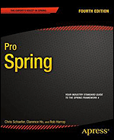](https://slb.percipio.com/books/924620e0-f30e-11e6-ad5d-0242c0a80607)

BOOK

[**Pro Spring, Fourth Edition**](https://slb.percipio.com/books/924620e0-f30e-11e6-ad5d-0242c0a80607)

Book

Pro Spring updates the perennial bestseller with the latest that the Spring Framework 4 has to offer. Now in its fourth  
edition, this popular book is by far the most comprehensive and definitive treatment of Spring available. With Pro Spring...No more description.

Not Started

10h 5m10hours 5minutes

Everyone

Aug 2014

by Rob Harrop, Clarence Ho, Chris Schaefer

11 likes

11

11 likes



1. [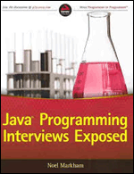](https://slb.percipio.com/books/0a1cedd0-f2d6-11e6-b0e2-0242c0a80804)

BOOK

[**Java Programming Interviews Exposed**](https://slb.percipio.com/books/0a1cedd0-f2d6-11e6-b0e2-0242c0a80804)

Book

Java

If you are a skilled Java programmer but are concerned about the Java coding interview process, this real-world guide can  
help you land your next position Java is a popular and powerful language that is a virtual requirement for businesses mak...No more description.

Completed

5h 56m5hours 56minutes

Everyone

Feb 2014

by Noel Markham

118 likes

118

118 likes



1. [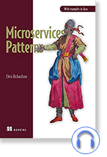](https://slb.percipio.com/audiobooks/8917fc38-3cf7-4ba3-85d2-bb9ea4d4adae)

AUDIOBOOK

[**Microservices Patterns: With Examples in Java**](https://slb.percipio.com/audiobooks/8917fc38-3cf7-4ba3-85d2-bb9ea4d4adae)

Audiobook

Microservices Patterns teaches you how to develop and deploy production-quality microservices-based applications. This  
invaluable set of design patterns builds on decades of distributed system experience, adding new patterns for writing ser...No more description.

Started

18h 28m 36s18hours 28minutes 36seconds

Everyone

by Chris Richardson

10 likes

10

10 likes



1. [](https://slb.percipio.com/audiobooks/d20fe8a8-9d2a-4148-b294-afff62f6cd7c)

AUDIOBOOK

[**Supertrends in Technology: 50 Things You Need to Know About the Future**](https://slb.percipio.com/audiobooks/d20fe8a8-9d2a-4148-b294-afff62f6cd7c)

Audiobook

Supertrends: 50 Things You Need to Know About the Future is about how efficient futurists work and how we can expect  
the world to evolve in terms of demographics, general economics, technologies, business models, resources, environment...No more description.

Not Started

11h 20m 51s11hours 20minutes 51seconds

Everyone

by Lars Tvede

7 likes

7

7 likes



1. [](https://slb.percipio.com/audiobooks/f9988ac9-abf6-4dd1-a642-4f57c9def2a5)

AUDIOBOOK

[**Design Thinking for Dummies**](https://slb.percipio.com/audiobooks/f9988ac9-abf6-4dd1-a642-4f57c9def2a5)

Audiobook

Design thinking is not just the property of graphic designers. This approach to creating solutions by thinking from the  
customer perspective can lead to new and innovative ideas that old methods could not approach. Design Thinking for Du...No more description.

Not Started

10h 21m 55s10hours 21minutes 55seconds

Everyone

by Christian Muller-Roterberg

50 likes

50

50 likes



1. [](https://slb.percipio.com/audiobooks/7fa7e6df-0999-492b-9c7c-dd460b9c486c)

AUDIOBOOK

[**HBR's 10 Must Reads on Design Thinking**](https://slb.percipio.com/audiobooks/7fa7e6df-0999-492b-9c7c-dd460b9c486c)

Audiobook

Use design thinking for competitive advantage. This audiobook will inspire you to: understand the transformative potential  
of design thinking; proceed from idea to product at lightning speed; iterate with rapid customer feedback; fail small and ...No more description.

Not Started

5h 52m 2s5hours 52minutes 2seconds

Everyone

by Harvard Business Review

84 likes

84

84 likes



1. [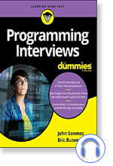](https://slb.percipio.com/audiobooks/52e525f3-09ef-4600-963d-cace58ae6023)

AUDIOBOOK

[**Programming Interviews For Dummies**](https://slb.percipio.com/audiobooks/52e525f3-09ef-4600-963d-cace58ae6023)

Audiobook

Programming jobs are on the rise, and the field is predicted to keep growing, fast. Landing one of these lucrative and  
rewarding jobs requires more than just being a good programmer. Programming Interviews for Dummies explains the skill...No more description.

Not Started

7h 26m 2s7hours 26minutes 2seconds

Everyone

by Eric Butow, John Sonmez

2 likes

2

2 likes



1. [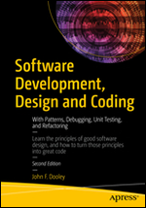](https://slb.percipio.com/books/66115e1a-976d-4c54-8625-042b3a01d5e5)

BOOK

[**Software Development, Design and Coding: With Patterns, Debugging, Unit Testing, and Refactoring, Second Edition**](https://slb.percipio.com/books/66115e1a-976d-4c54-8625-042b3a01d5e5)

Book

Learn the principles of good software design, and how to turn those principles into great code. This book introduces you to  
software engineering ― from the application of engineering principles to the development of software. You'll see how to ...No more description.

Completed

7h 21m7hours 21minutes

Everyone

Nov 2017

by John F. Dooley

15 likes

15

15 likes



1. [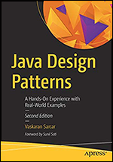](https://slb.percipio.com/books/c13b4d66-caeb-4b91-8db9-987fc3d2cf2d)

BOOK

[**Java Design Patterns: A Hands-On Experience with Real-World Examples, Second Edition**](https://slb.percipio.com/books/c13b4d66-caeb-4b91-8db9-987fc3d2cf2d)

Book

Get hands-on experience implementing 26 of the most common design patterns using Java and Eclipse. In addition to  
Gang of Four (GoF) design patterns, you will also learn about alternative design patterns, and understand the criticisms of...No more description.

Not Started

3h 54m3hours 54minutes

Everyone

Dec 2018

by Vaskaran Sarcar

20 likes

20

20 likes



1. [](https://slb.percipio.com/books/10e0375e-8b45-4795-a608-4bbeb041d01a)

BOOK

[**API Design Patterns**](https://slb.percipio.com/books/10e0375e-8b45-4795-a608-4bbeb041d01a)

Book

API Design Patterns lays out a set of design principles for building internal and public-facing APIs. Summary A collection of  
best practices and design standards for web and internal APIs. In API Design Patterns you will learn: Guiding principles f...No more description.

Not Started

9h 6m9hours 6minutes

Everyone

Jun 2021

by JJ Geewax

15 likes

15

15 likes



1. [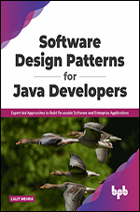](https://slb.percipio.com/books/862b4912-1578-449e-b32b-98481e0bcdba)

BOOK

[**Software Design Patterns for Java Developers**](https://slb.percipio.com/books/862b4912-1578-449e-b32b-98481e0bcdba)

Book

Practice Design Patterns to Enrich and Streamline Software Development Key Features Classify design patterns into three  
broad categories.Deep dive into design patterns with individual chapters covering them in detail.Understand design patte...No more description.

Started

2h 31m2hours 31minutes

Everyone

Nov 2021

by Lalit Mehra

5 likes

5

5 likes



1. [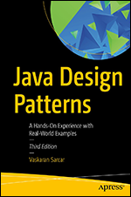](https://slb.percipio.com/books/54f7e799-142c-4b69-b2b1-7a7a63684f1c)

BOOK

[**Java Design Patterns: A Hands-On Experience with Real-World Examples, Third Edition**](https://slb.percipio.com/books/54f7e799-142c-4b69-b2b1-7a7a63684f1c)

Book

Use the step-by-step approach of this book to learn and implement design patterns in real-world applications. It focuses on  
classical design patterns with Java 17 and Eclipse (2021-09). In addition to Gang of Four (GoF) design patterns, the book ...No more description.

Started

6h 8m6hours 8minutes

Everyone

May 2022

by Vaskaran Sarcar

6 likes

6

6 likes



1. [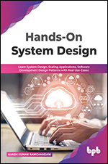](https://slb.percipio.com/books/847285d0-1c4d-46b0-a0ce-f4ee1aa8e791)

BOOK

[**Hands-On System Design: Learn System Design, Scaling Applications, Software Development Design Patterns with Real Use-Cases**](https://slb.percipio.com/books/847285d0-1c4d-46b0-a0ce-f4ee1aa8e791)

Book

The ultimate guide to ace your system designing interviews. KEY FEATURES Provides step-by-step solutions to  
real-world problems related to system design and development.Includes detailed explanations of each OOPs idea and de...No more description.

Completed

2h 40m2hours 40minutes

Everyone

Mar 2022

by Harsh Kumar Ramchandani

15 likes

15

15 likes



1. [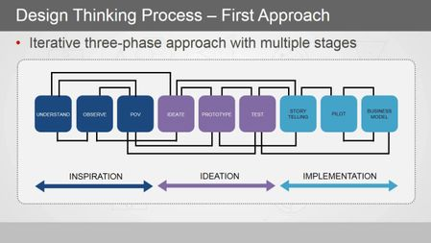](https://slb.percipio.com/courses/f511dda0-23bd-11e8-8db9-e5266c8595ba)

COURSE

[**Design Thinking for Microservices**](https://slb.percipio.com/courses/f511dda0-23bd-11e8-8db9-e5266c8595ba)

Course

Microservices

Discover how we can adopt design thinking process to identify an approach of leveraging the collective expertise to build  
solutions.

Started

56m 30s56minutes 30seconds

Intermediate

Mar 2018

153 likes

153

153 likes



* [**License Agreement**](https://documentation.skillsoft.com/en_us/privacy/skillsoft_license_agreement.htm)
* [**Privacy Policy**](https://documentation.skillsoft.com/en_us/privacy/skillsoft_privacy_policy.htm)
* [**Help**](https://slb.percipio.com/help)

© Copyright 2023 Skillsoft Ireland Limited - All rights reserved.

*PMBOK, PMI, PMP, CAPM, PMI-ACP, PgMP, PMI-RMP and PMI-SP are trademarks of the Project Management Institute, Inc.*

Powered byPercipio

Percipio Playlist details - Saved for later