**Pertemuan 8 : CRUD(BAGIAN 2)**

**Tugas 8 : WEB PENGIRIMAN BARANG VIA KAPAL**

|  |  |
| --- | --- |
| **Nama / Nim** | **:I Putu Radith Sabiandika Pratama** |
| **Kelas** | **:**D |
| **Pengajar** | **:**2218092 Raden Adityo Priyo Harjuno |

* 1. **Tujuan**

1. Praktikan dapat memahami struktur dasar CRUD (BAGIAN 2)
2. Praktikan dapat memahami tag tag dasar CRUD (BAGIAN 2)
3. Praktikan dapat membuat halaman web menggunakan CRUD (BAGIAN 2)
   1. **Alat dan Bahan**
4. Laptop/pc
5. Modul Praktikum Web 2024
6. TextEditor (Visual Studio Code / Sublime Text)
   1. **Langkah-langkah**
7. Membuat CRUD pada Tabel User
8. Membuat File User.php

|  |
| --- |
| <!DOCTYPE html>  <html lang="en" dir="ltr">  <head>  <meta charset="UTF-8" />  <link rel="icon" href="../assets/icon.png" />  <link rel="stylesheet" href="../../css/admin.css" />  <!-- Boxicons CDN Link -->  <link href="https://unpkg.com/boxicons@2.0.7/css/boxicons.min.css" rel="stylesheet" />  <meta name="viewport" content="width=device-width, initial-scale=1.0" />  <title>Nusantara Admin | Tabel User</title>  </head>  <body>  <div class="sidebar">  <div class="logo-details">  <i class="bx bx-category"></i>  <span class="logo_name">Cargo Nusantara</span>  </div>  <ul class="nav-links">  <li>  <a href="../admin.php" class="active">  <i class="bx bx-grid-alt"></i>  <span class="links_name">Dashboard</span>  </a>  </li>  <li>  <a href="../categories/categories.php">  <i class="bx bx-box"></i>  <span class="links_name">Categories</span>  </a>  </li>  <li>  <a href="../user/user.php">  <i class="bx bx-list-ul"></i>  <span class="links_name">user</span>  </a>  </li>  <li>  <a href="../logout.php">  <i class="bx bx-log-out"></i>  <span class="links_name">Log out</span>  </a>  </li>  </ul>  </div>  <section class="home-section">  <nav>  <div class="sidebar-button">  <i class="bx bx-menu sidebarBtn"></i>  </div>  <div class="profile-details">  <span class="admin_name">Nusantara Admin</span>  </div>  </nav>  <div class="home-content">  <h3>user</h3>  <button type="button" class="btn btn-tambah">  <a href="user-cetak.php">cetak report</a>  </button>  <table class="table-data">  <thead>  <tr>  <th>Nama</th>  <th>Email</th>  <th scope="col" style="width: 20%">Action</th>  </tr>  </thead>  <tbody>  <?php  include '../../koneksi.php';  $sql = "SELECT * FROM user";  $result = mysqli_query($koneksi, $sql);  if (mysqli_num_rows($result) == 0) {  echo "  <tr>  <td colspan='5' align='center'>  Data Kosong  </td>  </tr>  ";  }  while ($data = mysqli_fetch_assoc($result)) {  echo "  <tr>  <td>$data[kontainer]</td>  <td >  <a class='btn-edit' href=categories-edit.php?id=$data[id]>  Edit  </a> |  <a class='btn-delete' href=categories-hapus.php?id=$data[id]>  Hapus  </a>  </td>  </tr>  ";  }  ?>  </tbody>  </table>  </div>  </section>  <script>  let sidebar = document.querySelector(".sidebar");  let sidebarBtn = document.querySelector(".sidebarBtn");  sidebarBtn.onclick = function() {  sidebar.classList.toggle("active");  if (sidebar.classList.contains("active")) {  sidebarBtn.classList.replace("bx-menu", "bx-menu-alt-right");  } else sidebarBtn.classList.replace("bx-menu-alt-right", "bx-menu");  };  </script>  </body>  </html> |

1. membuat file user-proses.php

|  |
| --- |
| <?php  include '../../koneksi.php';  if(isset($_POST['edit'])) {  $id = $_POST['id'];  $nama = $_POST['nama'];  $email = $_POST['email'];  $sql = "UPDATE user SET nama = '$nama',email = '$email' WHERE id = $id ";  if(mysqli_query($koneksi, $sql)) {  echo "  <script>  alert('Data Categories Berhasil Diubah');  window.location = 'user.php';  </script>  ";  }else {  echo "  <script>  alert('Terjadi Kesalahan');  window.location = 'user-edit.php';  </script>  ";  }  }elseif(isset($_POST['hapus'])) {  $id = $_POST['id'];  $sql = "SELECT * FROM user WHERE id = $id";  $result = mysqli_query($koneksi, $sql);  $row = mysqli_fetch_assoc($result);    $sql = "DELETE FROM user WHERE id = $id";  if(mysqli_query($koneksi, $sql)) {  echo "  <script>  alert('Data user Berhasil Dihapus');  window.location = 'user.php';  </script>  ";  }else {  echo "  <script>  alert('Data user Gagal Dihapus');  window.location = 'user.php';  </script>  ";  }  }else {  header('location: user.php');  } |

1. membuat file simpan-signup.php

|  |
| --- |
| <?php  // koneksi database  include 'koneksi.php';  // menangkap data yang di kirim dari form  $username = $_POST['username'];  $password = md5($_POST['password']);  $email = $_POST['email'];  // menginput data ke database  mysqli_query($koneksi,"INSERT into user values('','$username','$email','$password')");  // mengalihkan halaman kembali ke index.php  header("location:login.php");  ?> |

1. membuat file user-edit.php

|  |
| --- |
| <?php  include '../../koneksi.php';  $id = $_GET['id'];  if(!isset($_GET['id'])) {  echo "  <script>  alert('Tidak ada ID yang Terdeteksi');  window.location = 'user.php';  </script>  ";  }  $sql = "SELECT * FROM user WHERE id = '$id'";  $result = mysqli_query($koneksi, $sql);  $data = mysqli_fetch_assoc($result);  ?>  <!DOCTYPE html>  <html lang="en">  <head>  <meta charset="UTF-8" />  <link rel="icon" href="../assets/icon.png" />  <link rel="stylesheet" href="../../css/admin.css" />  <!-- Boxicons CDN Link -->  <link  href="https://unpkg.com/boxicons@2.0.7/css/boxicons.min.css"  rel="stylesheet" />  <meta name="viewport" content="width=device-width, initial-scale=1.0" />  <title>Nusantara Admin | user Entry</title>  </head>  <body>  <div class="sidebar">  <div class="logo-details">  <i class="bx bx-category"></i>  <span class="logo_name">Nusantara</span>  </div>  <ul class="nav-links">  <li>  <a href="../admin.php">  <i class="bx bx-grid-alt"></i>  <span class="links_name">Dashboard</span>  </a>  </li>  <li>  <a href="../categories/categories.php" class="active">  <i class="bx bx-box"></i>  <span class="links_name">categories</span>  </a>  </li>  <li>  <a href="../tabeluser/user.php">  <i class="bx bx-list-ul"></i>  <span class="links_name">user</span>  </a>  </li>  <li>  <a href="../logout.php">  <i class="bx bx-log-out"></i>  <span class="links_name">Log out</span>  </a>  </li>  </ul>  </div>  <section class="home-section">  <nav>  <div class="sidebar-button">  <i class="bx bx-menu sidebarBtn"></i>  </div>  <div class="profile-details">  <span class="admin_name">Nusantara Admin</span>  </div>  </nav>  <div class="home-content">  <h3>Input user</h3>  <div class="form-login">  <form  action="user-proses.php"  method="post"  enctype="multipart/form-data"  >  <input type="hidden" name="id" value="<?= $data['id'] ?>">  <label for="nama">Edit User</label>  <input  class="input"  type="text"  name="nama"  id="nama"  placeholder="nama"  value="<?= $data['nama'] ?>"  />  <input type="hidden" name="id" value="<?= $data['id'] ?>">  <input  class="input"  type="text"  name="email"  id="email"  placeholder="email"  value="<?= $data['email'] ?>"  />  <button type="submit" class="btn btn-simpan" name="edit">  Edit  </button>  </form>  </div>  </div>  </section>  <script>  let sidebar = document.querySelector(".sidebar");  let sidebarBtn = document.querySelector(".sidebarBtn");  sidebarBtn.onclick = function () {  sidebar.classList.toggle("active");  if (sidebar.classList.contains("active")) {  sidebarBtn.classList.replace("bx-menu", "bx-menu-alt-right");  } else sidebarBtn.classList.replace("bx-menu-alt-right", "bx-menu");  };  </script>  </body>  </html> |

1. membuat file user-hapus.php

|  |
| --- |
| <?php  include '../../koneksi.php';  $id = $_GET['id'];  if(!isset($_GET['id'])) {  echo "  <script>  alert('Tidak ada ID yang Terdeteksi');  window.location = 'user.php';  </script>  ";  }  $sql = "SELECT * FROM user WHERE id = '$id'";  $result = mysqli_query($koneksi, $sql);  $data = mysqli_fetch_assoc($result);  ?>  <!DOCTYPE html>  <html lang="en">  <head>  <meta charset="UTF-8" />  <link rel="icon" href="../assets/icon.png" />  <link rel="stylesheet" href="../../css/admin.css" />  <!-- Boxicons CDN Link -->  <link  href="https://unpkg.com/boxicons@2.0.7/css/boxicons.min.css"  rel="stylesheet" />  <meta name="viewport" content="width=device-width, initial-scale=1.0" />  <title>Nusantara Admin | user Entry</title>  </head>  <body>  <div class="sidebar">  <div class="logo-details">  <i class="bx bx-category"></i>  <span class="logo_name">Nusantara</span>  </div>  <ul class="nav-links">  <li>  <a href="../admin.php">  <i class="bx bx-grid-alt"></i>  <span class="links_name">Dashboard</span>  </a>  </li>  <li>  <a href="../categories/categories.php" class="active">  <i class="bx bx-box"></i>  <span class="links_name">categories</span>  </a>  </li>  <li>  <a href="../transaction/transaction.php">  <i class="bx bx-list-ul"></i>  <span class="links_name">Transaction</span>  </a>  </li>  <li>  <a href="../logout.php">  <i class="bx bx-log-out"></i>  <span class="links_name">Log out</span>  </a>  </li>  </ul>  </div>  <section class="home-section">  <nav>  <div class="sidebar-button">  <i class="bx bx-menu sidebarBtn"></i>  </div>  <div class="profile-details">  <span class="admin_name">Nusantara Admin</span>  </div>  </nav>  <div class="home-content">  <h3>Hapus user</h3>  <div class="form-login">  <h4>Ingin Menghapus Data ?</h4>  <form  action="user-proses.php"  method="post"  enctype="multipart/form-data"  >  <input type="hidden" name="id" value="<?= $data['id'] ?>">  <button type="submit" class="btn" name="hapus" style="margin-top: 50px;">  Yes  </button>  <button type="submit" class="btn" name="tidak">  No  </button>  </form>  </div>  </div>  </section>  <script>  let sidebar = document.querySelector(".sidebar");  let sidebarBtn = document.querySelector(".sidebarBtn");  sidebarBtn.onclick = function () {  sidebar.classList.toggle("active");  if (sidebar.classList.contains("active")) {  sidebarBtn.classList.replace("bx-menu", "bx-menu-alt-right");  } else sidebarBtn.classList.replace("bx-menu-alt-right", "bx-menu");  };  </script>  </body>  </html> |

1. Membuat Widget
2. Tambahkan di bagian home-content, pada file Admin.php

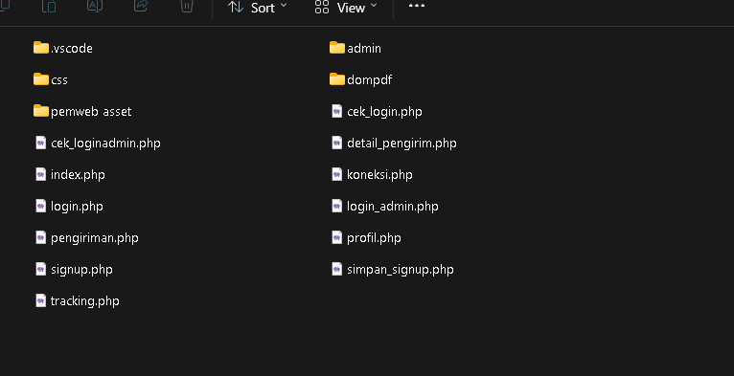

1. \Tambahkan kode javascript pada file Admin.php

|  |
| --- |
| <script>  let sidebar = document.querySelector(".sidebar");  let sidebarBtn = document.querySelector(".sidebarBtn");  sidebarBtn.onclick = function() {  sidebar.classList.toggle("active");  if (sidebar.classList.contains("active")) {  sidebarBtn.classList.replace("bx-menu", "bx-menu-alt-right");  } else sidebarBtn.classList.replace("bx-menu-alt-right", "bx-menu");  };  function myFunction() {  const months = ["Januari", "Februari", "Maret", "April", "Mei",  "Juni", "Juli", "Agustus", "September",  "Oktober", "November", "Desember"  ];  const days = ["Minggu", "Senin", "Selasa", "Rabu", "Kamis",  "Jumat", "Sabtu"  ];  let date = new Date();  jam = date.getHours();  tanggal = date.getDate();  hari = days[date.getDay()];  bulan = months[date.getMonth()];  tahun = date.getFullYear();  let m = date.getMinutes();  let s = date.getSeconds();  m = checkTime(m);  s = checkTime(s);  document.getElementById("date").innerHTML = `${hari}, ${tanggal} ${bulan} ${tahun}, ${jam}:${m}:${s}`;  requestAnimationFrame(myFunction);  }  function checkTime(i) {  if (i < 10) {  i = "0" + i;  }  return i;  } |

1. Membuat Widget
2. Membuat user-cetak

|  |
| --- |
| <?php  include('../../koneksi.php');  require_once("../../dompdf/autoload.inc.php");  use Dompdf\Dompdf;  $dompdf = new Dompdf();  $query = mysqli_query($koneksi, "SELECT * FROM user");  $html = '<center><h3>Data User</h3></center><hr/><br>';  $html .= '<table border="1" width="100%">  <tr>  <th>No</th>  <th>Nama</th>  <th>Email</th>  </tr>';  $no = 1;  while ($user = mysqli_fetch_array($query)) {  $html .= "<tr>  <td>" . $no . "</td>  <td>" . $user['nama'] . "</td>  <td>" . $user['email'] . "</td>  </tr>";  $no++;  }  $html .= "</table>";  $dompdf->loadHtml($html);  // Setting ukuran dan orientasi kertas  $dompdf->setPaper('A4', 'potrait');  // Rendering dari HTML Ke PDF  $dompdf->render();  // Melakukan output file Pdf  $dompdf->stream('laporan-transaksi.pdf');  ?> |

1. Bukti Instal Composer

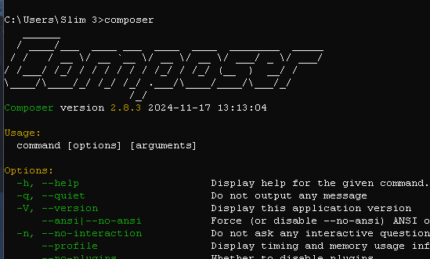

Gambar 1.1 TampilanCMD Composer