https://github.com/adam-p/markdown-here/wiki/Markdown-Cheatsheet#headers

The Engineering Notebook

Site to buy custom engineering notebook: <http://www.bookfactory.com/engineering-notebooks/engineering-notebooks.html>

Introduction

As you probably guessed, the Excellence Award is the most prestigious award given in the VEX Robotics Competition. It encompasses driver ability, skills ranking, as well as documentation. A proper engineering notebook is key to success of any team, and there are many guidelines to follow to earn a full score on the Design Award Rubric (see Resource 2). With that being said, let’s get started with the formula to create the engineering notebook.

General Guidelines

The first thing judges look for is organization. To start off on a good note, be sure to accurately update the table of contents, being sure that the title, page number, and date matches with the actual source. While handwriting is not the greatest worry in a team, having legible penmanship is a must when writing the engineering notebook. Remember, you want to make it easier on the judges to understand, and scribbles won’t serve you that justice. Prior to writing in the notebook, be sure to create a shared document to type out what will be included in the notebook. Review and edit the passage before commencing in writing the information. You want to make as little errors as possible. However, if there is an error, cross out the mistake with one, solid, horizontal line streaking across the source of inaccuracy. A giant scribble could disrupt your organization. Writing content in black ink is the most viable option for the engineering notebook. However, if your notebook calls for various levels of classification (such as defining team roles or drawing the engineering process), it is okay to use different colors, as long as they are uniform throughout the book. Finally, as a rule of thumb, do not procrastinate on your work. A proper engineering notebook will take a lot of time commitment, and the role of scribe agrees to spending that amount of time to ensure the team’s success. Take your time on the process, be strategic, and your team will be successful. And with that, let’s begin with the descriptions of the engineering notebook.

The Team

Many teams have a page or two dedicated to describing the team. To begin, introduce the team makeup. How many people are there? What is the age range? What school do you attend? The basic information. Then, go on to discuss the history of the team. Which VRC games has the team participated in? What were the results (no need to be very detailed here; think low-level, such as “went undefeated in ___ year”). Finally, discuss community outreach. Many organizations fail to include community outreach in their teams, making it a go-to piece to mention at the end of your team description. Overall, the page or two of team description should entirely encompass the team dynamic, history, and qualities of the team on a generic level.

Team Bios

Shortly after the team description comes the team biographies. It is advised that each team member writes their own biography, so there isn’t a sense of monotony when the judges read over the bios. Advise each team member to write a biography of 100-150 words. The format of a successful biography goes as follows. Introduce with a greeting, like “Hello, my name is ___ and I am a ___ year member of team 5776_.” Discuss your enjoyment of robotics, and, if possible, tie your interests back to some instances in your childhood that further demonstrate your passion for robotics. It is also a good idea to mention how you fit in with the team, and how the team has changed you. Describe what you thought you were going to get out of robotics versus what you received (good experiences only, hopefully). To leave you with one last note, one practice our team did was write the name of the member at the top of the page, and list their role on the team next to the name. Each role was written in a different color, which was uniform across all team members’ names (“programmer” was green, “builder” was purple, etc.). This can help in organization, as well as help the judges understand the team composition.

Game Description

While the mechanics and programming may remain relatively similar throughout seasons, the game description is something that is bound to change for every competition year. This page allows the judges to acknowledge that your team understands the objective of the game, as well as what you’re wrapping your strategy around. My tip for this section: state the obvious. For example, in the 2017-2018 game In The Zone, one could say that it is a game played on a 144 by 144 inch field that contains 80 cones. Then, go on to describe the objective of the game, as well as the point values for each game object. Be sure to include some generalized rules as well (for example a restriction on game object capacity). Finally, you can conclude with the standard that allows an alliance to win the match.

Strategy

Though it is not a specific component explicitly stated in the Design Award Rubric, judges enjoy the unique thought process of teams pertaining to a certain game. For this reason, the strategy section makes its way into this guideline document. Whether it be calculations to find the optimal scoring strategy or even a certain autonomous route, dedicate a section in your notebook to thoroughly discuss the strategy involved in your team’s success. For example, in the game In The Zone (2017-2018), there were many outlets to score points. To find the most efficient game strategy, a points table was created to measure the return on investment each game object brings. This allowed us to judge the most important field elements that could earn us the higher scores in the shortest amount of time possible, to maximize our final point value. This is just one example from one game in the past. However, judges typically value observing the thought process of a team when they participate in matches. Any calculations or match routines could always help you.

Meeting Logs

By now, about 20 pages of your notebook has been filled with valuable information. However, the bulk of the notebook comes from meeting logs. Now, it is too much to ask for every single meeting entry, as teams can total over 200 meetings within a given season. To combat this issue, the team must identify the noteworthy meetings, where a significant change/decision was made during their progression (good or bad). These meeting logs may encompass mechanical changes (switching from a four-bar lift to an R4B6B), programming alterations (using PID to control the drive distance as opposed to time based), or strategy modification (preference of one game object over another). Whatever it may be, the meeting logs are the only way you can display your hard work to the judges. Each entry should encompass one change at a time (one day to fix the lift, another day to elaborate on autonomous program). Be sure to include detailed descriptions of how the meeting started, what problem was encountered, the various designs considered, the finalized implementation, and the rationale behind it. In other words, **elaborate on the engineering process in your works**. Yes, I put that in bold, because I cannot describe how important the engineering process is to your team’s success (see Reference 3). Finally, include pictures in your meeting logs. Whether it be hand drawn or printed, include annotations as to the names of each part, as well as the various orientations of the part at hand.

Tournament Analysis

One aspect in the engineering notebook many teams lack is a reflection after every tournament. As per the engineering process, we learn from our past. There will always be memorable moments and mistakes that every team will encounter at tournaments, and judges want to see what these instances are, as well as what you take from them. For your analysis, begin with a summary of the tournament, detailing the general gist of what occurred at the tournament. Include common feelings throughout the tournament, standings, and awards. In the next section, highlight moments that went well in the tournament, and why you would want to continue them in further tournaments. Maybe your team’s robot needed no mechanical alteration. This is a noteworthy aspect that should be highlighted in the section. Be sure to elaborate on why these events brought you fortune, and what you can do in the next tournament to achieve such a feat again. The third section in your tournament analysis could be (yup, you guessed it) any shortcomings that your team encountered in the tournament. Be sure to describe what went wrong, how it affected the performance, and how your team could build off upon these misfortunes. Judges crave learning, so be sure to highlight this in every part of your reflection. The final part recommended for the tournament analysis is further implementations. Maybe there could be a change in regime for how your tournament roles could be addressed. Or a new mechanical design strategy your team could try out. Whatever it may be, be sure to describe them in this section. Remember to justify your implementations with the learning experience from past successes and failures.

Code

One part of the Design Award Rubric is the inclusion of code. Judges understand that there are thousands of lines of code that help the robot operate in competition. Within the engineering notebook, at least one important file is required to earn a competitive score for the Excellence Award. However, just stapling the code to the notebook is not enough. There should be accurate documentation describing the purpose of essential functions. Similarly, be sure to write down where this piece of code will be used in your robot. Coming back to the example of In The Zone (sorry for the repetition, this game has so many examples), one essential function was called “autostack,” which executed a series of programs to grab a cone, raise the lift and place it on a stack. Describing the importance and use of the printed-out function could positively impact your performance.

Closing Remarks

I want to close off this document by stating that the information above is all suggestion. However, these strategies have worked to win several awards in the past, including the Think, Design, and Excellence Awards. Though this is not a perfect formula to guarantee success, following this guideline could help achieve higher level awards in tournaments. With that being said, the entire engineering notebook process is very arduous, and can take long nights if one procrastinates. Be sure to space out your time, and type out ideas prior to writing to ensure great quality in your works. I am sure you will do great, so here’s to a successful season!

*Useful notebook tips:* [*https://www.vexforum.com/index.php/30394-notebook-tips*](https://www.vexforum.com/index.php/30394-notebook-tips)

*Using drawings in the notebook:* [*https://www.vexforum.com/index.php/29891-pictures-vs-drawings-for-notebook*](https://www.vexforum.com/index.php/29891-pictures-vs-drawings-for-notebook)

*NBN worlds winning notebook:* [*https://www.roboticseducation.org/documents/2016/11/vrc-engineering-notebook-team-1575a.pdf*](https://www.roboticseducation.org/documents/2016/11/vrc-engineering-notebook-team-1575a.pdf)

*Resource 1: Couple of websites from Vexforums (a great resource) that may provide useful tips in making the engineering notebook*

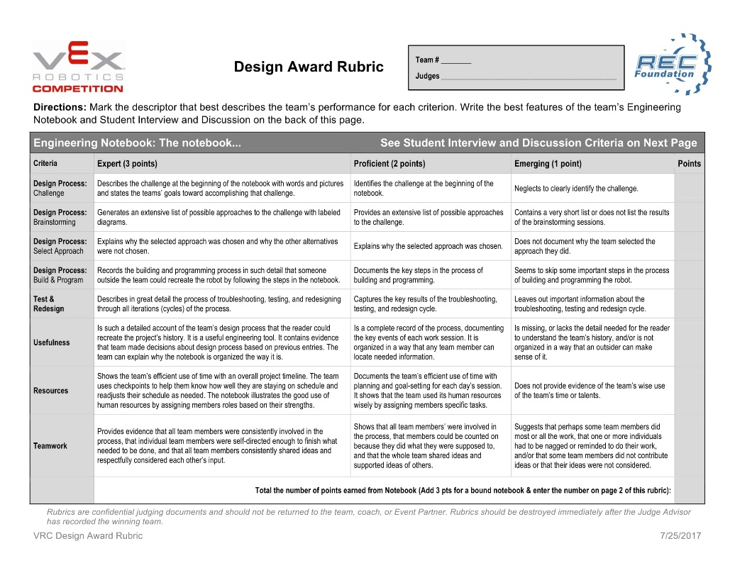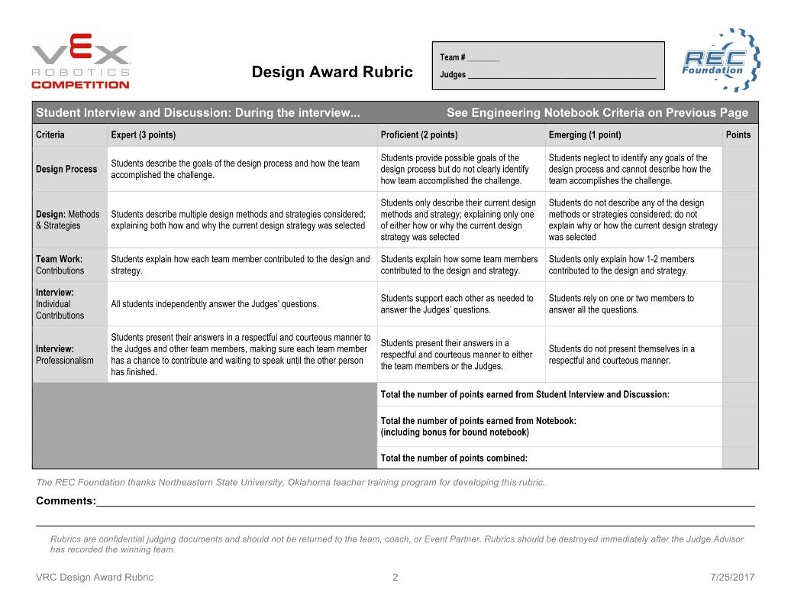

*Resource 2: The rubric judges use to grade teams for the Excellence Award. This is called the Design Award Rubric, since the runner up to the Excellence Award is the Design Award. As you can see, it encompasses all aspects of performance, including competition ranking, skills ranking, teamwork, and documentation.*

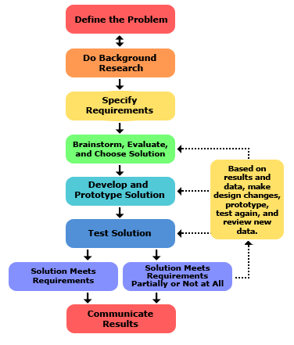

*Resource 3: The engineering process is a common, yet powerful tool teams use to aid them in efficient and effective building. Though some may deem it as tedious , when done properly, it ensures that all parts of the robot function at their best state. Beyond high school robotics, engineers in the industrial world follow a similar (if not the same) process when creating the complex, intricate machinery. Above is a picture of the general engineering process, though it goes by different processes (all having the same general idea).*