Quick start

The following described:

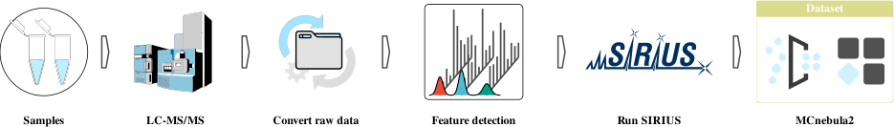

### 1. Samples

It may be a sample of any mixture of small molecule compounds, such as animal metabolites, plant metabolites, drug samples, etc.

### 2. LC-MS/MS

For the workflow, SIRIUS has many restrictive [**Prerequisites**](https://boecker-lab.github.io/docs.sirius.github.io/prerequisites/) that prevent its generalization to the analysis of any mass spectrometry data. Fortunately, your data as least will not be rejected by one vote as long as they meet the following two characteristics:

* High mass accuracy data
* Data-Dependent Acquisition (DDA) Mode.

### 3. Convert raw data

GNPS Server provides detailed instructions and services regarding data conversion. [Click here](https://ccms-ucsd.github.io/GNPSDocumentation/fileconversion/).

If you are on Windows and have a lot of data to convert, then downloading locally and using MSconvert might be the best option. [Click here](https://proteowizard.sourceforge.io/download.html)

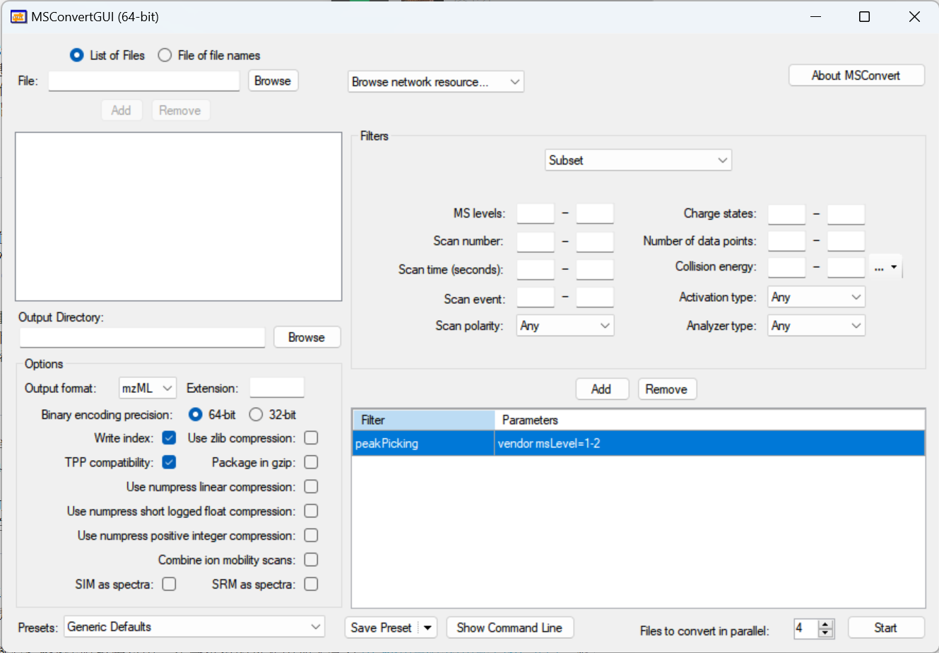

If you were not on Windows, installing the docker to perform MSconvert is an option. [massconverter of TidyMass](https://book.tidymass.org/massconverter.html) provides a way in R to perform MSconvert with docker.

### 4. Feature detection

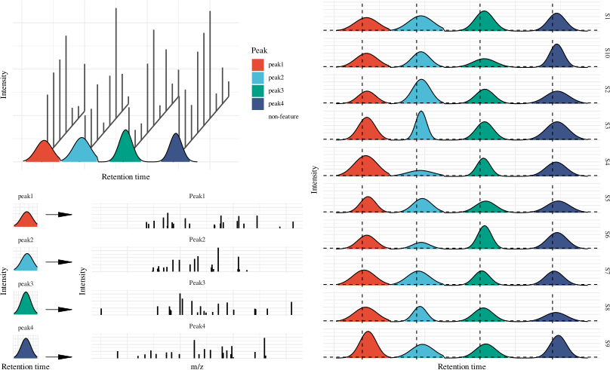

Feature Detection is a kind of algorithm for detecting peaks from EIC plots, and most mass spectrometry processing tools have a similar function. Users can implement this process with any tool, but to access the MCnebula workflow, .mgf (long list file containing MS/MS information) and .csv files (Feature quantification table) are required for output. The following are some examples of the four implementations of Feature Detection with output of .mgf files and .csv:

#### 4.1 (Option 1) With MZmine

[MZmine](http://mzmine.github.io/) is a flexible deployment software for processing LC-MS data, providing a range of algorithms that can be freely combined to process LC-MS data according to user needs; its high degree of flexibility makes it potentially difficult to use.



MZmine has gone through several version changes and now MZmine3 is available. Unfortunately, our next example still uses version 2.53; since we did a test application with our Waters data when the original MZmine3 was released, only to find that errors occurred during data import, we are not sure if the latest version of MZmine3 has resolved this issue.

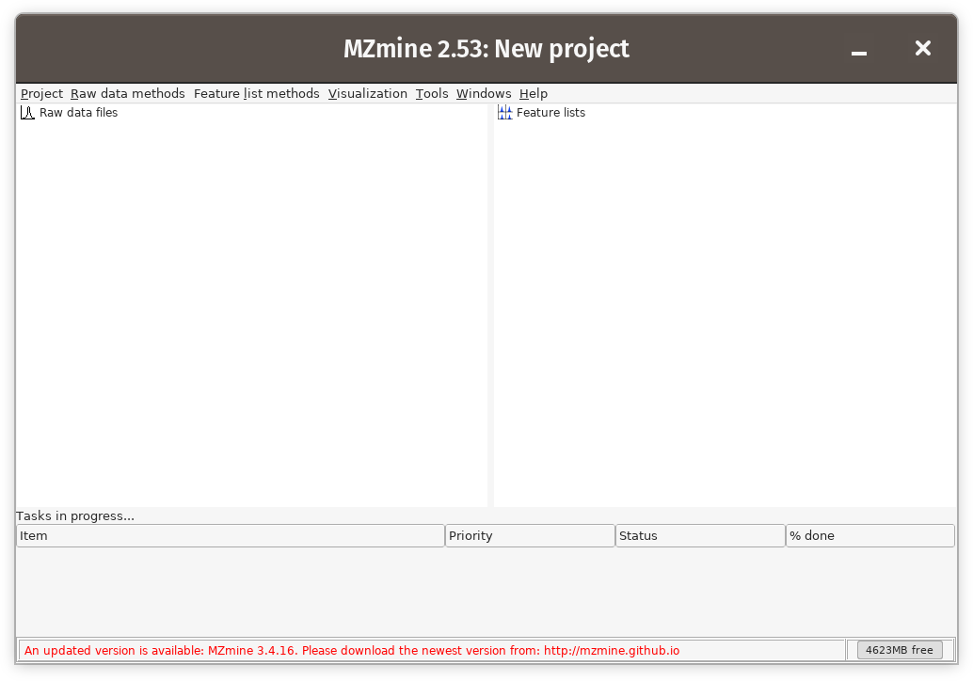

**Download MZmine with version 2.53**. [Click here](https://github.com/mzmine/mzmine2/releases/tag/v2.53)

The **Guidance in GNPS** provides a step by step description about MZmine for feature detection. [Click here](https://ccms-ucsd.github.io/GNPSDocumentation/featurebasedmolecularnetworking-with-mzmine2/)

Using batch mode of MZmine is the most convenient way to repeat a given process and parameters. We have provided some batch schema files (.xml) for MZmine2 for example. Click here

**Note** that different instruments and conditions may produce very different data, so it is a necessary step to pre-study your own data and customize the parameters when performing batch mode; ignore the parameter settings for the main steps, at least when applying these demo batch mode files, you will need to modify the input specified files and the output file names.

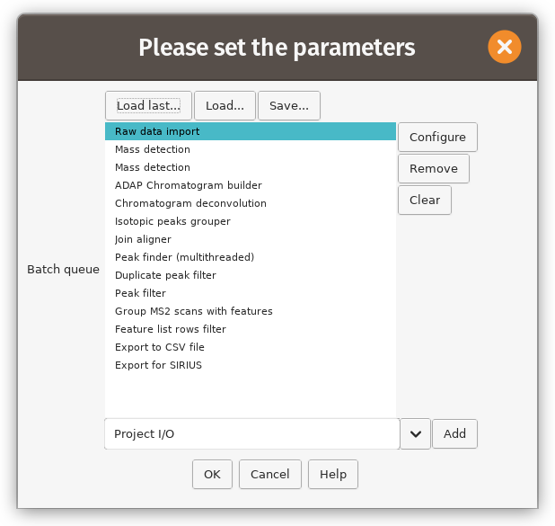

##### 4.1.1 Demo XML for batch mode

* [Waters Qtof (with output step)](https://github.com/Cao-lab-zcmu/MZmine2_bachModeXML/blob/master/waters_with_output.xml)
* [Waters Qtof](https://github.com/Cao-lab-zcmu/MZmine2_bachModeXML/blob/master/waters.xml)
* [Thermo Orbitrap](https://github.com/Cao-lab-zcmu/MZmine2_bachModeXML/blob/master/thermo.xml)

#### 4.2 (Option 2) With XCMS

Preparing…

#### 4.3 (Option 3) With OpenMS

Preparing…

#### 4.4 (Option …) Any tools

You can use any tool to export a list containing MS/MS information and .csv. However, please **Note that** please convert the list of MS/MS information into a format that matches the [SIRIUS input](https://boecker-lab.github.io/docs.sirius.github.io/io/#input).

### 5. Run SIRIUS

[SIRIUS](https://bio.informatik.uni-jena.de/software/sirius/) is a java-based software framework for the analysis of LC-MS/MS data of metabolites and other’ small molecules of biological interest’ …

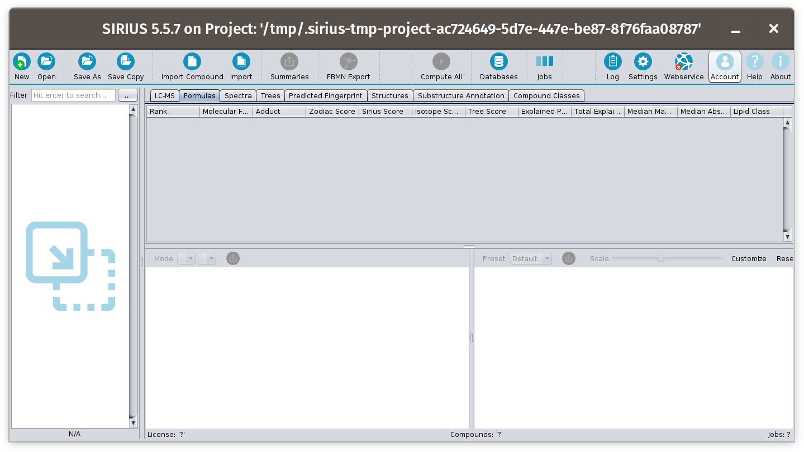

#### 5.1 Sign up for use

Now, users must register to access from the SIRIUS network services (free for academic use) (sign up and login in the GUI).

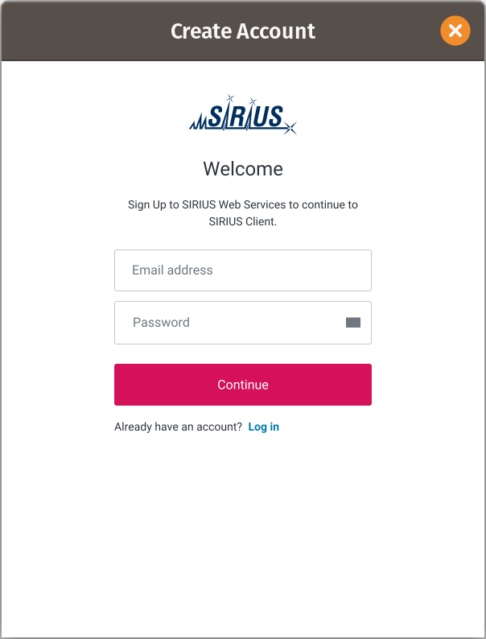

#### 5.2 Import .mgf

The .mgf file is obtained from the processing of the Feature Detection in the previous step, which records the basic information of the MS/MS. By dragging M into the GUI of SIRIUS, the data will be imported successfully. For command line mode, please refer to: [Click here](https://boecker-lab.github.io/docs.sirius.github.io/quick-start/#command-line-interface)

The following is the content of a demo .mgf:

BEGIN IONS  
FEATURE_ID=1  
PEPMASS=532.30509842717  
CHARGE=+1  
MSLEVEL=1  
532.30509842717 100  
532.305646812001 100  
533.309001652001 27.0393207318305  
END IONS  
  
BEGIN IONS  
FEATURE_ID=gnps1  
PEPMASS=532.30509842717  
CHARGE=+1  
RTINSECONDS=  
MSLEVEL=2  
153.8885 148  
181.8 74  
334.8798 1881  
360.7695 139  
514.1035 120  
451.17258 18.81  
END IONS

#### 5.3 Activate modules

Activate SIRIUS, ZODIAC, CSI:FingerID and CANOPUS for computation. (If necessary, adjust the parameters)

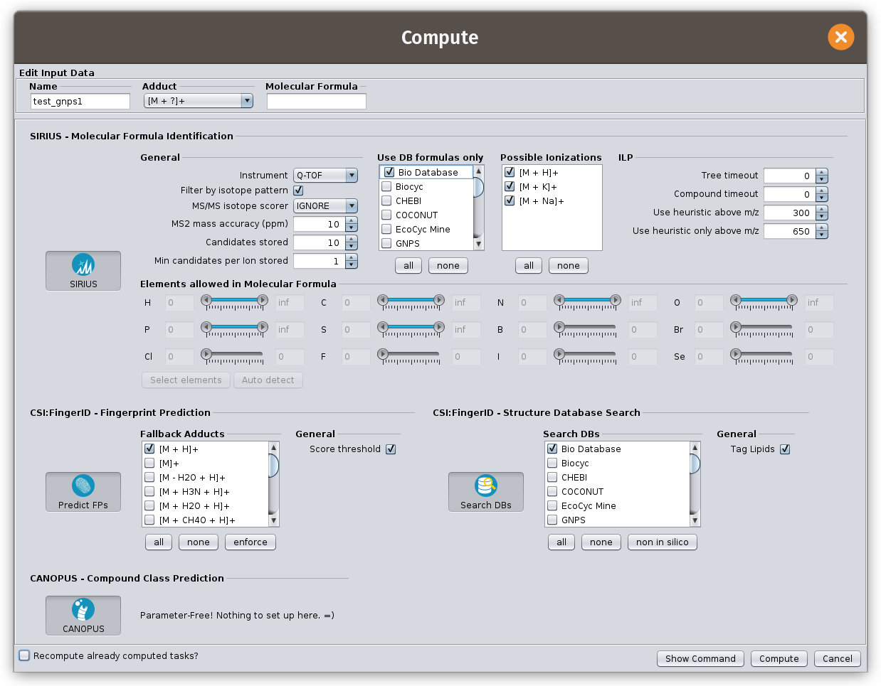

#### 5.4 Write summaries

It may take hours or even an evening to calculate the LC-MS/MS data set containing thousands of Features. When it is over, write a summary.

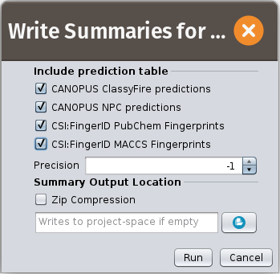

### 6. MCnebula2

Now, let’ s get started with the R package MCnebula2!

### The `path` is where your SIRIUS project saved.  
path <- "."  
mcn <- mcnebula()  
mcn <- initialize_mcnebula(mcn, "sirius.v5", path)

<<< [Workflow](/docs/workflow/) >>>