LAB 5 – Stored procedures and Triggers
Create database and insert data to store information of employees as following:
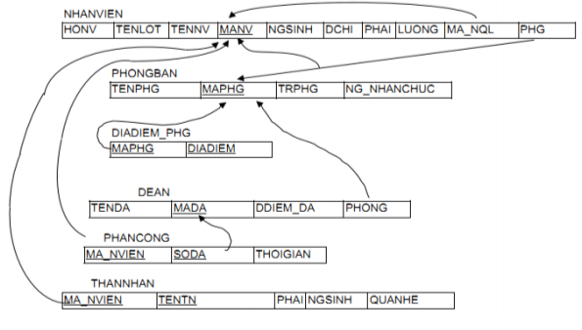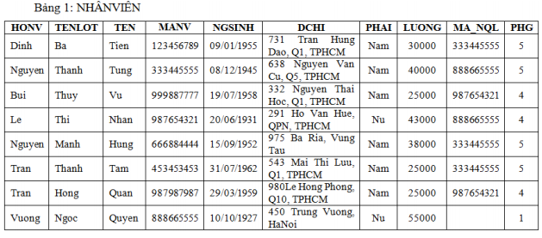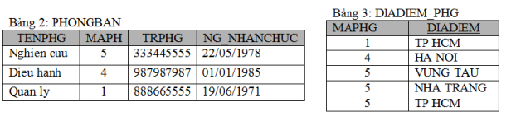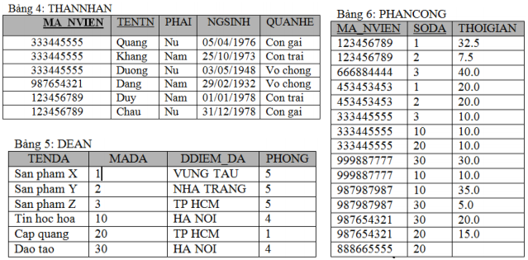
- Write store procedures to do bellow tasks: (SPs were named SP_[number])
- List all employees whose salary is greater than the input parameter.
- List all information of employees (code, name, entered date, supervisor’s id, supervisor’s name) that were employed from s to f. S and f are date value that were been input parameters.
- List all employees in the department that whose code is input parameter.
- List all employees that do not have supervisor.
- List all information about employees, include: name, code, working times in months to now.
- List all information about departments, include: code, name of department, number of employees of department.
- List all employees (code, name, salary) whose salary more than the average salary of the department that they work in.
- List N employees that have the highest salary. N is the input parameter.
- Increase 10% for salary of all employees in the city A. A is the input parameter.
- Delete all no personnel departments.

- Write triggers to ensure:
- The average salary of each department must be fewer than 50000.
- The salary of the head of each department must be greater than or equal to salary of all employees in this department.
- The different between average salary of employees in HCM and HN must fewer than 10000.
- There is not group that have more than five employees that are in the same family.
- The different between number of male and female employees must fewer than 10%.

