 | MINISTRY OF EDUCATION AND TRAINING

FPT UNIVERSITY
Capstone Project Document
Sketch2Life: Collaborative Creative Learning with AI for Children

Sketch2Life
Group Members | Đỗ Cao Đạt | SE193713 | Leader, Fullstack  Phạm Tấn Hiếu | SE184252 | BE2  Vũ Chí Bảo | SE182733 | FE  Lý Anh Khoa | SE182682 | BE1
Supervisor | Lâm Hữu Khánh Phương
Ext Supervisor | N/A
Capstone Project code | FA26SE225 (inferred)

Ho Chi Minh City, October 2026

Table of Contents
Table of Contents 2
Acknowledgement 3
Definitions and Acronyms 4
I. Project Introduction 4
1. Overview 4
2. Product Background 5
3. Existing Systems and Current Baseline 5
4. Business Opportunity 5
5. Software Product Vision 6
6. Project Scope and Limitations 6
7. Stakeholders and Classroom Setting 7
8. Product Boundary and Success Evidence 7
II. Project Management Plan 7
1. Overview 7
2. Management Approach 8
3. Project Deliverables 9
4. Responsibility Assignments 10
5. Project Communications 11
6. Configuration Management 11
7. Detailed Work Breakdown and Estimate 12
8. Relative Schedule, Dependencies and Gates 13
9. Deliverable Register 13
10. Risk Register and Response 15
11. Process, Quality and Team Communication 16
12. Training and Responsibility Assignments 16
13. Configuration, Tools and Deployment Controls 17
III. Software Requirements Specification 17
1. Product Overview 17
2. User Requirements 18
3. Functional Requirements 19
4. Requirement Appendix 22
5. Complete Product Module and Actor Model 23
6. Full Use Case Catalog UC-001 to UC-038 24
7. Logical Data Dictionary and Invariants 25
8. Business Rules and Authorization 26
9. Exceptions and Recovery Outcomes 27
IV. Software Design Description 27
1. System Design 27
2. Database Design 27
3. Detailed Design 28
5. Current, Target and Integration Architecture 30
6. Technology, Third-Party Services and Environments 31
7. API, Event and Service Contract Families 32
8. Logical Data Model and Physical Database Inventory 34
9. Main State Models and Current Enum Mapping 35
10. Activity Diagrams for the Four Main Workflows 36
11. Security, Privacy and Data Lineage 37
12. Runtime, Rollback and Failure Handling 37
V. Software Testing Documentation 38
1. Scope of Testing 38
2. Test Strategy 38
3. Test Plan 38
4. Test Cases 39
5. Test Reports 39
6. Expanded Verification Strategy and Case Register 40
7. Test Levels, Environments and Evidence 45
8. Test Data, CI and Acceptance Thresholds 45
9. Historical Test Reports and Limits 46
VI. Project Tracking 46
1. Source and Branch Snapshot 46
2. Work Status 46
3. Open Decisions and Gaps 47
5. Current Workstream and Integration Status 48
6. Owner Decisions and Closure Conditions 50
7. Branch, Change and Evidence Record 50
References 50
Appendix D. Editable Draw.io Diagram Gallery 52
Appendix E. Current Delivery, Proposed Next Work and Unknowns 97
E1. Current workflow status 97
E2. Near-term filter for owner review 98
E3. Submission and planning unknowns 99

Acknowledgement
The team acknowledges the academic supervision of Lâm Hữu Khánh Phương and the work contributed by the four registered members. This report presents the current source evidence and the target classroom specification for Review 2.

Definitions and Acronyms
Acronym | Definition
AI | Artificial Intelligence
API | Application Programming Interface
ADR | Architecture Decision Record
BE | Backend
CI | Continuous Integration
ERD | Entity Relationship Diagram
FR | Functional Requirement
NFR | Non-Functional Requirement
QR | Quick Response code
SRS | Software Requirements Specification
SDD | Software Design Description
TBD | To be determined
UC | Use Case
UI | User Interface
UAT | User Acceptance Testing
Modal | Selected AI hosting platform; deployment configuration TBD

I. Project Introduction
Sketch2Life is a collaborative classroom learning system for children ages 3–12. The product connects individual and shared drawing to Teacher-led knowledge, reviewed AI suggestions, class activities and descriptive reflection. The registration v1.2 is the scope authority; the codebase is evidence of implementation only and does not reduce or prove the full target scope.

1. Overview

1.1 Project Information
Field | Value
Project | Sketch2Life: Collaborative Creative Learning with AI for Children
Abbreviation | Sketch2Life
Project reference | TBD; selected registration v1.2 leaves the project-code field blank. Do not infer from filename.
Class | TBD; blank in the selected registration.
Registration period | September 2026 to March 2027
Document snapshot | Review source examined on local dev before the current authorized publication commit; dirty source tree and untagged baseline. Not a course release tag.
Review tag | review-2: absent; BM02 is an untagged draft and this task does not create a tag.
Repository | https://github.com/CaoDat-2410/Sketch2Life

1.2 Project Team
Member | Code | Role / ownership
Đỗ Cao Đạt | SE193713 | Leader; fullstack and cross-surface acceptance
Phạm Tấn Hiếu | SE184252 | BE2; AI and learning-media services
Vũ Chí Bảo | SE182733 | FE; Child Android surface
Lý Anh Khoa | SE182682 | BE1; classroom API and persistence
Supervisor: Lâm Hữu Khánh Phương. The registration’s Class field is empty; no class value is inferred.

2. Product Background
The registered problem is that classroom drawing can capture children’s ideas but often leaves collaboration, reliable contribution history, age-appropriate guidance, and follow-up activity outside one coherent session. Sketch2Life links those actions under Teacher control. Drawing similarity is not the learning goal. AI may help explore a child’s idea, but it cannot replace the child’s work or act as an assessment authority.

3. Existing Systems and Current Baseline
No named external competitor or classroom system was evidenced in the supplied registration. The report therefore describes the current project baseline rather than making an unsupported comparative market claim. The codebase contains a FastAPI backend, a durable classroom persistence slice, legacy/demo compositions and three separate UI applications. Current UI services rely on fixtures or stubs; branch presence and component tests do not show end-to-end integration.
Surface / component | Current source evidence | Current limitation
Child | apps/child-ui; Expo SDK 55, React Native 0.83.10 | FEAT-060 local join, refresh, reconnect/replay and acknowledged-stroke paths; check passed 18 suites/26 tests. Mocked UI checks; no DB-backed FE-to-BE acceptance or device run.
Teacher | apps/teacher-ui; React + Vite | Local class/lobby/roster/group/turn/stage and observation paths; check passed 3 suites/6 tests. No PostgreSQL-backed UI workflow acceptance.
Super Admin | apps/admin-ui; React + Vite | Local Firebase/BE1 role gate and class list/create path exist; live Firebase login and deployment authorization are not evidenced.
Backend | FastAPI classroom/demo compositions, PostgreSQL adapters and module-owned migrations | Focused local BE1 checks pass; four PostgreSQL cases skipped without BE1_TEST_DATABASE_URL. Nine Alembic heads have no approved consolidated install/rollback plan.
AI hosting | Modal selected by owner | No configured/deployed product profile, live call, production storage profile, latency or capacity result is evidenced; values remain TBD.

4. Business Opportunity
The product aims to support one-school classroom pilots for children from 36 through 155 completed months, grouped into experience bands 3–5, 6–8 and 9–12. The target capacity is one class of up to 40 children; it is a planning target, not a measured load result. The opportunity is a teacher-managed flow that joins expressive drawing, safe review, collaborative participation and practical off-screen learning while preserving consent and provenance.

5. Software Product Vision
Children explore and explain ideas through drawing and shared classroom activity; Teachers guide each group, control the pace, review AI and media, and record observations; the system preserves accepted work and access history so the classroom can continue safely after interruption.

6. Project Scope and Limitations
In scope | Explicit limitation / not established
Child Android app; Teacher Desktop; Super Admin Console | Separate surfaces exist; local WF-01/WF-02 wiring is checked independently but database-backed integrated release is not demonstrated.
Managed child profiles, class/group/session management and QR/session-code admission | A child does not have a separate login account. Detailed capability/identity contracts remain proposed.
Personal/shared drawing, AI suggestion review, gallery, knowledge/video, off-screen activities, reflection and progress | WF-01/WF-02 local paths do not close PostgreSQL/device acceptance. WF-03/WF-04 remain gated by FEAT-057 and runtime/data policy decisions.
Consent, purpose-scoped access, audit, retention and recovery | School process, jurisdiction and data-class-specific retention require further sign-off; session/artwork default is 90 days after session end.
Parent portal, payments, public social features, ranking and diagnosis | Not in the supplied registration scope; do not infer these features from legacy code.

7. Stakeholders and Classroom Setting
The primary setting is a teacher-led classroom pilot at one school, with one class targeting up to 40 unique admitted children. The number 40 is a product planning target, not a measured load limit. A connected device may serve more than one participant, so the capacity measure is unique admitted children, not sockets or tablets.
Stakeholder | Need | Decision / boundary
Child participant | Express an idea, draw alone or together, request optional support, explore reviewed media and do an off-screen activity. | Uses a Teacher-managed profile; no independent login; may hide or decline an AI suggestion.
Teacher | Prepare class, manage groups and pace, review content and observe learning. | Acts only within current school/class assignment; final review and session decisions remain explicit.
School / representative | Collect and govern legal-representative permission and classroom participation. | School collects consent; authorized Teacher/Admin records evidence and purpose; jurisdiction and verification process remain open.
Super Admin | Manage adult accounts, policies, approved content, data requests and service health. | Administrative role alone does not authorize reading child content or establish consent.
AI/media workers | Prepare typed candidate analysis or media derivatives. | Backend-owned service; outputs are untrusted until validation and exact Teacher review.

8. Product Boundary and Success Evidence
The product combines three surfaces and one backend boundary: Child Android, Teacher Desktop, Super Admin Console, and a FastAPI modular backend. The product succeeds only when a complete classroom workflow preserves child agency, contribution history, age-appropriate review, durable state and off-screen learning. A screen mock, endpoint inventory, local unit test or AI output alone does not prove the workflow.
Outcome | Evidence required before claiming it
Classroom participation | Valid managed-profile admission, teacher-controlled group/session transitions, and denial of wrong-class or unauthorized requests.
Creative collaboration | Accepted operations have durable receipts, correct contributor context, replay/reconnect behavior and no silent overwrite.
Safe AI assistance | Pinned source, typed result, safety/freshness checks, exact-version Teacher review and recorded Child choice.
Reviewed learning | Exact knowledge/video and activity versions have review, audience, failure disposition and outcome lineage.
Responsible data handling | Effective purpose checks, scoped access, audit, class-specific retention, export/delete and copy/purge evidence.

II. Project Management Plan
The team plans work around four product work packages and keeps that dependency view separate from individual sprint allocation. The 15-week relative plan and preliminary person-day estimates are proposals requiring group and supervisor confirmation; calendar anchors remain TBD within the registered September 2026–March 2027 period.

1. Overview

1.1 Scope and Estimation
Work package | Primary outputs | Effort / status
WP1 Product, classroom learning and evaluation | Approved requirements, age-band interaction, safety review, test protocol | Planned; estimates to be agreed with supervisor
WP2 Backend and classroom services | Adult identity, class/profile/consent, sessions/groups, permissions, persistence/recovery | In progress in source slices; not yet verified end to end
WP3 AI and learning media | Vision, separate sketch suggestions, review gates, knowledge/video and provenance | Source modules and contracts exist; Modal runtime deployment TBD
WP4 Product surfaces and integration | Child Android, Teacher Desktop, Super Admin workflows and cross-surface acceptance | Prototype surfaces exist; fixture/stub integration gap remains

1.2 Project Objectives
Objective | Target measure | Evidence required
Preserve child agency and Teacher decision gates | 100% of test cases block pending/unapproved AI or video from Child playback | Negative authorization tests and version-specific approval cases
Support classroom collaboration and recovery | 40 synthetic clients for the pilot target; accepted operation is retrievable after restart | Load profile, durable-ack and restart/reconnect results; not yet measured
Deliver scoped product surfaces | Child, Teacher and Admin complete assigned workflows against versioned backend contracts | Staging end-to-end run; not yet available
Protect child data | Consent/purpose and retention policy checked before protected processing; 90-day default for session/artwork | Policy tests and purge evidence; other data classes TBD

1.3 Project Risks
Risk | Impact | Control / owner
Fixture-backed UI surfaces do not yet consume a shared versioned contract | Integration defects may appear after screen completion | Publish contract, map API owners, run cross-surface acceptance; Đạt
Nine independent Alembic heads lack one verified deployment order | A fresh environment may not reach the same schema as individual feature tests | Agree schema ownership and migration orchestration before staging; Khoa
Modal is selected without deployment/model/GPU/latency details | AI availability, cost and response time remain unbounded | Complete provider profile and acceptance test before product claims; Hiếu

2. Management Approach
Use short, reviewed feature increments with an explicit feature plan, acceptance criteria, approval and evidence folder. Domain rules stay framework-independent; interfaces depend inward; persistence and provider integrations implement application-owned ports. Cross-feature interaction uses versioned contracts. A code change is not accepted as a product claim until the named tests and evidence exist.

2.1 Project Process

Figure 1. The four workflow activity diagrams are in Appendix D, Figures D41–D44.
The dependency roadmap identifies what must exist before a workflow can be integrated. Parallel team assignments remain an independent planning view; do not assume that one member owns the entire backend, infrastructure, E2E suite or complete Android app by default.

2.2 Quality Management
• Every feature has measurable acceptance criteria and feature-local evidence.
• Run the relevant unit, contract and integration suite in CI; record failures and scope rather than reporting a global pass.
• Keep migration and API changes reviewed against source contracts and actual database constraints.
• Use synthetic fixtures in development. Do not commit credentials, real child data or provider secrets.
• Run the repository security validator before each commit or push; no commit or push is made by this document task.

2.3 Training Plan
Topic | Participants | Evidence
Child-centered age-adaptive interaction and classroom facilitation | All members; supervisor review | Reviewed screen/workflow acceptance
FastAPI, API contracts, migrations and recovery | BE owners and integrator | Contract test and migration review
Provider safety, job states, review provenance and Modal deployment | BE2 and integrator | Provider configuration record and no-secret deployment evidence
Privacy, school consent, audit and retention | All members | Approved school procedure and policy test cases

3. Project Deliverables
Deliverable | Status / evidence
Reports 1–5 and Project Tracking consolidated report | This document; editable DOCX, diagrams in repository
BM01 Design Brief | Separate document with sections 0–8 and Appendix A
Versioned SRS/SDD and editable diagrams | SRS v3.3/B28 is the current requirements baseline; all fifteen B19.4 lifecycle registries and WF-01–WF-04 activity diagrams are represented in the editable Rev10 Draw.io master and report appendix.
Child / Teacher / Admin applications and backend | Local FEAT-060 implementation is documented; WF-01/WF-02 remain unaccepted against PostgreSQL/devices; WF-03/WF-04 and live services are gated.
Test evidence | Historical FEAT-060 checks: Child 18 suites/26 tests; Teacher 3 suites/6 tests; backend 22 passed and four PostgreSQL cases skipped. No tests rerun for this documentation task.
Release tag and deployment profile | review-2 tag absent; Firebase, Modal, object storage, staging and rollback settings are not evidenced.

3.1 Project Schedule and Time Plan
Relative weeks follow the SEP490 sample sequence. Exact calendar start/end dates and official due dates must be confirmed; the standalone Report 2 contains dependencies and output gates. Status labels describe current evidence, not forecast completion.
Relative window | Work / output gate | Lead | Current status
W1 / 1 wk | Initiation and project setup: Report 1, initial plan, risk baseline | Đạt; all members | Drafts exist; Review 2 disposition and official project/class code remain TBD.
W2-W3 / 2 wks | Planning and requirements: Registration baseline, SRS, traceability, backlog | Đạt; all members | SRS v3.3/B28 and Rev10 diagram set are present; contracts/migration order and Review 2 acceptance remain open.
W4-W5 / 2 wks | Software design: SDD, architecture, ERD, state/activity diagrams, contracts | Khoa; Đạt | FEAT-060 local WF-01/WF-02 code/checks exist; DB/device acceptance not proven.
W6-W7 / 2 wks | Iteration 1: classroom foundation: Class/profile/session/admission vertical slice with tests | Khoa; Đạt; Bảo | Local drawing/reconnect paths exist; durable two-device/device-network acceptance not proven.
W8-W9 / 2 wks | Iteration 2: drawing and collaboration: Canvas, contribution context, reconnect/recovery slice | Bảo; Khoa; Đạt | WF-03/WF-04 gated by FEAT-057, provider/storage configuration and consent/retention decisions.
W10-W11 / 2 wks | Iteration 3: AI, content and activities: Reviewed sketch/media/activity workflows and tests | Hiếu; Đạt; Bảo | Planned; N1–N4/N7 gates remain, and staging, privacy, recovery and capacity evidence is absent.
W12-W13 / 2 wks | System verification and defect correction: E2E, security/privacy, recovery and performance receipts | Đạt; all members | Not started; course calendar and deployment/rollback owner TBD.
W14 / 1 wk | Transition preparation: User guides, deployment/rollback runbook, UAT readiness | All members | Not started; official dates and release/tag approval TBD.
W15 / 1 wk | Final package and defense preparation: Updated reports, reproducible demo, final package | All members | Not started; course dates TBD

4. Responsibility Assignments
Member | Owned parts (2–3) | Main workflow
Vũ Chí Bảo (SE182733) | Child Android screens; drawing/join interactions; child-surface UI acceptance | WF-02 Draw and recover collaborative canvas
Đỗ Cao Đạt (SE193713) | Cross-surface integration; requirements/traceability; acceptance coordination | WF-04 Teacher-led content and learning close
Phạm Tấn Hiếu (SE184252) | AI job/provider boundary; sketch review and learning media; safety/result provenance | WF-03 Review AI sketch suggestion
Lý Anh Khoa (SE182682) | Classroom HTTP/API; persistence and migrations; session/recovery contracts | WF-01 Prepare and admit classroom session

5. Project Communications
Use the project repository for versioned requirements, plans, architecture decisions, tests and review evidence. Use the team’s agreed meeting channel for sprint coordination and record decisions in repository ADR/feature records. Escalate scope, consent, child-safety and deployment decisions to the supervisor/owner before implementation. The specific meeting cadence is not evidenced and remains for the team to set.

6. Configuration Management

6.1 Document Management
Keep the official registration and supplied school templates unchanged. The five supplied Draw.io files remain unchanged; Mermaid is retained only for the authorized lifecycle/activity diagrams, imported as editable pages into the Rev10 Draw.io master. Record hashes and evidence in FEAT-058.

6.2 Source Code Management
Source repository: https://github.com/CaoDat-2410/Sketch2Life. Review evidence was gathered on the local dev source before this authorized publication commit; `review-2` remains absent and this report is not a tagged-baseline run. The source tree contained a large ahead-of-origin history and uncommitted changes at the time of review.

6.3 Tools and Infrastructure
Area | Current / selected | Target or open setting
Child client | Expo SDK 55; React Native 0.83.10 | Android confirmed; device matrix TBD
Teacher/Admin web | React 19; Vite 8; TypeScript | Desktop browser; support matrix TBD
Backend | FastAPI; SQLAlchemy; Alembic | Durable classroom ports; migration order TBD
Adult identity | Firebase Authentication only | Storage, Firestore and Realtime Database prohibited
AI hosting | Modal selected | App/model/GPU/endpoint/region/scale/timeout/budget TBD
DevOps / AI tools | GitHub and CI scripts; Codex assisted cleanup/docs | Tag review-2 and staging/prod/rollback TBD; humans own decisions

7. Detailed Work Breakdown and Estimate
The WBS decomposes the registered product into implementable packages. The estimate totals 252 preliminary person-days. Category totals are planning allocations, not actual effort or confirmed capacity. Complexity guides refinement; the owner and team must re-estimate from available hours and accepted contracts before baselining.
WBS | Work package | Complexity | Effort
1 | Classroom and session management | Work package subtotal | 46 person-days
1.1 | Class, profile, enrollment and consent administration | Complex | 16 person-days
1.2 | QR/session-code admission and participant verification | Medium | 10 person-days
1.3 | Teacher-led session stages, groups and progress | Complex | 20 person-days
2 | Collaborative drawing | Work package subtotal | 40 person-days
2.1 | Personal/shared canvas and age-adapted tools | Complex | 22 person-days
2.2 | Contribution attribution, save, reconnect and recovery | Complex | 18 person-days
3 | AI and reviewed learning media | Work package subtotal | 48 person-days
3.1 | Contextual sketch suggestions, Teacher review and child response | Complex | 24 person-days
3.2 | Knowledge/video authoring, versioning and approval | Complex | 24 person-days
4 | Activities and learning records | Work package subtotal | 30 person-days
4.1 | Off-screen activity selection, adaptation and outcome | Medium | 14 person-days
4.2 | Reflection, portfolio and descriptive progress observations | Medium | 16 person-days
5 | Product surfaces | Work package subtotal | 54 person-days
5.1 | Child Android application workflows | Complex | 22 person-days
5.2 | Teacher Desktop workflows | Complex | 18 person-days
5.3 | Super Admin Console workflows | Medium | 14 person-days
6 | Cross-cutting platform and verification | Work package subtotal | 34 person-days
6.1 | Adult identity, scoped access, audit and retention controls | Complex | 16 person-days
6.2 | API/data integration, migration coordination, test and acceptance | Complex | 18 person-days
TOTAL | All product work packages | Proposed baseline | 252 person-days

8. Relative Schedule, Dependencies and Gates
The 15-week sequence follows the school sample's phases. It is relative to kickoff within the registered September 2026–March 2027 envelope. Exact dates, course milestones and member availability were not supplied; every window remains a proposal until the supervisor confirms the calendar.
Window | Stage | Depends on | Lead | Output gate | Current status
W1 / 1 wk | Initiation and project setup | Kickoff / scope baseline | Đạt; all members | Report 1, initial plan, risk baseline | Drafts exist; Review 2 disposition and official project/class code remain TBD.
W2-W3 / 2 wks | Planning and requirements | W1 | Đạt; all members | Registration baseline, SRS, traceability, backlog | SRS v3.3/B28 and Rev10 diagram set are present; contracts/migration order and Review 2 acceptance remain open.
W4-W5 / 2 wks | Software design | W2-W3 | Khoa; Đạt | SDD, architecture, ERD, state/activity diagrams, contracts | FEAT-060 local WF-01/WF-02 code/checks exist; DB/device acceptance not proven.
W6-W7 / 2 wks | Iteration 1: classroom foundation | W4-W5; API contract | Khoa; Đạt; Bảo | Class/profile/session/admission vertical slice with tests | Local drawing/reconnect paths exist; durable two-device/device-network acceptance not proven.
W8-W9 / 2 wks | Iteration 2: drawing and collaboration | W6-W7 | Bảo; Khoa; Đạt | Canvas, contribution context, reconnect/recovery slice | WF-03/WF-04 gated by FEAT-057, provider/storage configuration and consent/retention decisions.
W10-W11 / 2 wks | Iteration 3: AI, content and activities | W8-W9; provider decision | Hiếu; Đạt; Bảo | Reviewed sketch/media/activity workflows and tests | Planned; N1–N4/N7 gates remain, and staging, privacy, recovery and capacity evidence is absent.
W12-W13 / 2 wks | System verification and defect correction | W6-W11; staging + migration rehearsal | Đạt; all members | E2E, security/privacy, recovery and performance receipts | Not started; course calendar and deployment/rollback owner TBD.
W14 / 1 wk | Transition preparation | W12-W13 exit gate | All members | User guides, deployment/rollback runbook, UAT readiness | Not started; official dates and release/tag approval TBD.
W15 / 1 wk | Final package and defense preparation | W14 | All members | Updated reports, reproducible demo, final package | Not started; course dates TBD

9. Deliverable Register
No. | Deliverable | Window | Status / evidence boundary
1 | Project Introduction and initial Project Management Plan | W1 | Initial draft exists in the Review 2 package; instructor dates TBD.
2 | SRS, requirement traceability and project tracking baseline | W2-W3 | Registration v1.2 controls; review/approval remains pending.
3 | SDD, architecture, Logical ERD and editable diagrams | W4-W5 | Current design draft; database migration order remains an open gate.
4 | Software Package 1: classroom foundation and automated tests | W6-W7 | Proposed milestone; do not claim end-to-end acceptance before evidence.
5 | Software Package 2: collaborative drawing and recovery | W8-W9 | Proposed milestone; API/UI integration is an explicit exit check.
6 | Software Package 3: AI/media/activity workflows | W10-W11 | Modal selected; model/GPU/endpoint/budget and provider acceptance TBD.
7 | System test, security/privacy review and defect closure | W12-W13 | Planned; staging and one-class capacity target must be measured.
8 | User guides, deployment/rollback, UAT and final package | W14-W15 | Official dates and release/tag approval TBD.

10. Risk Register and Response
ID | Risk | Effect | Response | Owner | Gate
R-01 | DB acceptance is blocked by migration and contract gates | No repeatable PostgreSQL FE-to-BE proof; four DB cases were skipped. | Keep N1–N3 in order; review lineage/contracts and run isolated synthetic acceptance. | Owner/operator TBD | Before database acceptance
R-02 | Device and network recovery are unaccepted | QR/deep-link, restart, reconnect and concurrent-client defects may remain. | Keep N4 after or alongside DB acceptance; define device matrix and recovery criteria. | Owner TBD | Before end-to-end claim
R-03 | Child-data lifecycle is incomplete | Consent, derivative copies, deletion and backup expiry are not fully evidenced. | Keep N7 as a pre-pilot gate; synthetic data only until approved. | Policy/legal owner TBD | Before child-data pilot
R-04 | AI/media services are not configured for product use | No production Modal or artifact storage profile; WF-03/WF-04 have adoption gates. | Defer N5/N6; approve contracts/runtime/budget before live checks. | Provider/service owner TBD | Before AI/media acceptance
R-05 | 40-child target and candidate NFRs are unmeasured | No fixed workload, latency, error or cost profile is registered. | Defer N9 until N3/N6; do not change the join policy into a hard cap. | Measurement owner TBD | After runtime profile
R-06 | Age/safety review workload | Content or tool may be unsuitable for an age band or class setting. | Retain age-banded review, Teacher gate and explicit reject/recall path. | Feature owner TBD | Before content release
R-07 | Scope metadata and calendar are unconfirmed | Registration code/class are blank; delivery capacity and dates are not accepted. | Retain TBD and the relative schedule proposal until official records are confirmed. | Project owner / supervisor | Before submission
R-08 | State/contract drift across modules | SRS B19.4 target registries exceed currently accepted wire-state mappings. | Review all lifecycle diagrams against contracts and transition tests; maintain forward-only stages until OD07 is resolved. | Feature owners TBD | Before integration freeze

11. Process, Quality and Team Communication
Control |  | Project rule
Process |  | Feature-based iterative delivery: backlog item → testable acceptance → feature plan/approval → vertical slice → review/CI → integration evidence → weekly adaptation. This is not a declaration of formal Scrum.
Scope baseline |  | The supplied registration v1.2 is the authority. A requirement change updates its linked SRS, SDD, tests, schedule and BM01; after Review 2, scope is frozen by the course commitment.
Estimate method |  | The 252 person-day WBS is a bottom-up planning proposal using relative complexity and task decomposition. It excludes no hidden vendor spend and is not a time sheet; team capacity and calendar dates were not supplied.
Schedule method |  | 15 relative weeks use the SEP490 phase sequence inside September 2026–March 2027. Dependencies are gates, not dates; the official course calendar must be inserted before the baseline is approved.
Exit gates |  | Do not enter staging until contracts and migration order are agreed. Do not use child data until school-mediated consent, purpose, retention, deletion and research controls are approved. Do not claim AI acceptance before the Modal profile and tests exist.
Quality ownership |  | Requirement owner writes acceptance criteria; feature owner supplies unit/contract evidence; integrator checks cross-surface behavior; team reviews CI weekly. Blocked evidence is recorded as blocked rather than passed.
Capacity and cost |  | Availability by member, paid service budget and Modal spending cap are TBD. No paid provider call or production spend is included in this estimate.
Event | Participants |  | Purpose | Cadence | Record
Weekly feature and schedule review | All four members; supervisor when available |  | Inspect shipped evidence, blockers, estimate/schedule variance and next work | Weekly; exact day TBD | Team meeting + repository issue/feature record; publish decisions
Pull-request / CI review | Author, relevant owner and integrator |  | Review contract, tests, security and acceptance criteria | Every PR; CI on each change | GitHub PR/checks; require owner review and passing required checks
Scope, child-safety, data or provider decision | Team + project owner/supervisor |  | Resolve decisions that affect registered scope, consent or paid services | Before implementation or external call | Repository ADR/approval record; do not rely on chat-only implicit state

12. Training and Responsibility Assignments
Training | Participants | Window | Completion evidence
Child safety, consent, privacy and descriptive assessment | All members | W1-W3; refresh before any child study | Required before any real child data or recruitment
Versioned API contracts, PostgreSQL migrations and recovery | Khoa, Đạt; supporting members | W4-W7 | Review contract and migration rehearsal evidence
AI job lifecycle, safety gates and Modal deployment controls | Hiếu, Đạt; supporting members | W8-W11 after profile approval | No live provider call before model/GPU/budget approval
Cross-platform acceptance testing and CI evidence | All members | W6-W13 | Each member can run tests for their owned workflow
Work / workflow |  |  |  | Đạt | Hiếu | Bảo | Khoa
Project planning and weekly tracking |  |  |  | D | S | S | S
Registration, SRS and requirement traceability |  |  |  | D | S | S | R
System architecture and API contract integration |  |  |  | R | S | I | D
Class/session APIs, persistence and migrations |  |  |  | S | S | I | D
Child, Teacher and Admin user-interface surfaces |  |  |  | R | I | D | S
AI sketch, knowledge/video and result provenance |  |  |  | R | D | S | S
Cross-surface integration and acceptance coordination |  |  |  | D | R | S | S
Privacy, consent, audit and retention controls |  |  |  | R | S | I | D
Unit/contract/CI evidence for owned features |  |  |  | S | D | R | R
WF-01 Prepare and admit classroom session |  |  |  | S | I | S | D
WF-02 Join, draw and recover a collaborative canvas |  |  |  | S | S | D | R
WF-03 Review an AI sketch suggestion |  |  |  | R | D | S | S
WF-04 Teacher-led learning content and session close |  |  |  | D | S | R | S
Review 2 reports and project documentation |  |  |  | D | S | S | R

13. Configuration, Tools and Deployment Controls
Area | Current declaration and limitation
Database | PostgreSQL with SQLAlchemy/Alembic in current BE1 slices; nine heads reported; delivery lineage and rollback are TBD.
Database | PostgreSQL with SQLAlchemy/Alembic in current backend slices; multiple migration heads remain and deployment order is TBD.
Identity and third parties | Firebase Authentication only. Firebase Storage, Firestore and Realtime Database are prohibited.
AI hosting | Modal selected. App/function, model, GPU, endpoint, region, scale, timeout and spending cap are TBD; no deployed product endpoint is claimed.
IDE / diagramming | Microsoft Word/PDF for course reports; five supplied Draw.io sources preserved unchanged; authorized state/activity Mermaid sources imported into editable Draw.io.
Documentation | Microsoft Word/PDF for course reports; Markdown for feature plans, decisions and evidence.
Version control / CI | GitHub repository and local dev snapshot. At review time the branch was 726 commits ahead of origin/dev with a dirty tree; owner authorized normal commit/push after security validation. review-2 tag remains absent.
Project management | Feature plan/approval/evidence records plus weekly team review. GitHub Issues/Projects can hold backlog and timeline views; an active Project board is not verified.
Deployment environment | Dev source is local. Staging/production host, rollout and rollback process remain TBD; no deployment is claimed.
AI tools | Codex/ChatGPT assisted requirements, design, code/document review and drafting; team members validate every owned result and disclose use in Report 4.

III. Software Requirements Specification
This SRS expresses the registered product target and owner-confirmed refinements. It does not certify that the current branch implements each item. CONFIRMED describes scope authority; PROPOSED and TBD identify refinements that need approval. The canonical Vietnamese SRS v3.3 remains the full source of detailed rules.

1. Product Overview
The system serves one-school classroom pilots with children aged 36–155 completed months and experience bands 3–5, 6–8 and 9–12. A Teacher prepares a class session, admits children using managed profiles and QR/session code, controls group progress, and approves content. Children draw individually or collaboratively, may request an AI suggestion and may hide or decline it. The session can include gallery presentation, reviewed knowledge/video, an off-screen activity, reflection and descriptive assessment. A child has no separate login account.

1.1 Status and assumptions
Status label | Meaning in this report
Confirmed / owner-confirmed | Included product behavior from the registration or direct owner answer
Proposed | A design refinement; do not present as frozen contract or implemented behavior
TBD | Requires owner/school/provider decision before dependent implementation
Source implemented | Code exists; production, durable use and successful provider inference are not implied
Fixture/demo | Local, synthetic, mock or process-local behavior only

2. User Requirements

2.1 Actors and authorization
Actor | Goals | Authorization boundary
Child participant | Join, draw, request/view/hide/decline reviewed suggestion, share, reflect | Teacher-managed profile; session-bound participant capability is a proposed contract, not a child login
Teacher | Manage assigned classes, admit participants, direct pace, review AI/media, record observation | Assigned school/class/session scope; final decision-maker for sessions and review
Super Admin | Manage adult accounts, policy, content, consent workflow, audit and operations | Purpose-scoped and audited access; role alone does not imply access to all raw child content
School / legal representative | Provide consent and classroom context | School-mediated process; evidence, verifier and purpose record are governed by local policy
AI / media provider | Process backend-authorized jobs | No direct mobile credentials; provider output is untrusted until application policy and Teacher review

Figure 2. Use Case Overview: Appendix D, Figure D03.

2.2 Use case catalog

2.3 Detailed use case descriptions

UC-004 and UC-007 Prepare and admit
Precondition: Teacher is authorized for the class and consent policy allows the session. Main flow: Teacher selects topic/age/tools, assigns groups, opens lobby, issues QR/code, checks incoming roster requests and admits participants. Outcome: active session membership is persisted. Exception: expired code, wrong class or duplicate request is rejected and audited; session does not start without explicit Teacher action.

UC-008 and UC-013 Collaborative drawing
Precondition: admitted participant and canvas permission exist. Main flow: Child selects allowed canvas/tool, submits a versioned operation, backend validates scope/epoch/idempotency, persists accepted operation and returns durable receipt. Outcome: peers can resync from checkpoint and ordered operations. Exception: stale epoch or forbidden region is rejected; local tentative draft is not represented as accepted.

UC-019 and UC-020 Review an AI sketch
Precondition: authorized snapshot and policy permit analysis. Main flow: Child/Teacher requests support, backend captures input version, worker returns typed candidate, Teacher reviews exact sketch, then Child may view, hide or decline. Outcome: source/approval lineage is retained. Exception: unsafe/stale/failure remains unavailable; no automatic display or replacement of child strokes.

UC-026 Resolve failed video
Precondition: video generation is pending for an approved session purpose. Main flow: show truthful progress and wait; after retry budget is exhausted, present explicit Teacher choices. Outcome: Teacher selects retry, skip with disposition or end session. Exception: no auto-fallback, no silent skip and no “video complete” state for a skipped item.

UC-016 Recover session and canvas
Precondition: previously accepted state and checkpoint exist. Main flow: reconnecting client authenticates, fetches current scope/version, loads checkpoint and missing ordered operations, deduplicates receipts and resumes permitted work. Outcome: accepted work and contributor history remain. Exception: revoked or stale capability is denied; local unaccepted draft is retained as a conflict draft, not replayed automatically.

UC-038 Handle a data request
Precondition: authorized requester, purpose and scope are established. Main flow: record request, determine data classes/copies under approved retention policy, execute export/delete, record result and verify purge. Outcome: auditable disposition. Exception: unresolved legal hold or policy conflict is escalated; authorization is not inferred from a broad role alone.

3. Functional Requirements

3.1 System functional overview

Figure 3. Screen Flow: Appendix D, Figure D17.

3.1.1 Screen inventory
Surface | Screens / tasks | Authorization notes
Child Android | Join / session lobby; drawing canvas; optional AI suggestion view; gallery; reviewed knowledge/video; activity instructions; reflection/session close | Participant admission and approved content only; no child login
Teacher Desktop | Dashboard/class; profile/enrollment; session setup/lobby; group monitoring; canvas/help; AI review; gallery; content/video review; activity selection; observation/portfolio | Assigned class/school; explicit session control and version-specific review
Super Admin Console | Account/role/scope overview; content and policy review; service/job monitoring; audit and data requests | Purpose-scoped, least-privilege and audited

3.1.2 Screen authorization
Every command, subscription, query, media playback request and data export is checked at the application boundary for actor, resource, school/class/session scope, purpose and current policy version. Authentication does not by itself grant resource access. Firebase is restricted to adult Authentication in the repository; Firebase Storage, Firestore and Realtime Database are prohibited.

3.1.3 Non-screen functions
• Adult authentication and scoped capability lifecycle; class/enrollment/consent lookup.
• Session and group command validation, durable state transition, checkpoint/reconnect and audit.
• Canvas operation validation, idempotency, contribution attribution and provenance.
• AI job dispatch, moderation, stale-result rejection, Teacher review gate and child response.
• Knowledge/video versioning, truthful progress and explicit failed-video disposition.
• Activity safety/readiness check, observation/reflection/portfolio traceability.
• Retention, export/delete, audit query, redacted telemetry and incident handling.

3.1.4 Logical ERD
Logical target entities include OrganizationScope, AdultAccount, Class, StudentProfile, TeacherAssignment, Enrollment, ConsentRecord, ClassroomSession, SessionGroup, ChildParticipant, GroupMembership, DeviceConnection, CanvasDocument, CanvasOperation, CanvasSnapshot, TeacherReview, AI job/proposal, KnowledgeBundle, ReviewedVideo, ActivityDefinition/Assignment, ObservationRecord, ReflectionRecord, PortfolioEntry and AuditEvent. These are specification concepts; most are not all present as migrated classroom tables. Logical links are not declared SQL foreign keys unless the migration explicitly defines one.

3.2 Requirement catalog
The following English summaries preserve the stable FR identifiers from canonical SRS v3.3. Refinement status is copied at the requirement level; “confirmed” is not an implementation status.
ID | Requirement summary | Authority / refinement
FR001 | Enforce Child, Teacher and Super Admin permissions by resource scope | Confirmed
FR002 | Admit children by QR/session code or managed profile after Teacher verification | Confirmed
FR003 | Support one or multiple children using a shared device with session/group context | Confirmed
FR004 | Let Teachers manage assigned classes, enrollments and child profiles | Confirmed
FR005 | Verify adult identity and issue/revoke scoped participant capabilities | Proposed; Firebase Auth boundary
FR006 | Apply purpose-specific consent before policy-limited collection or AI processing | Confirmed; detailed procedure TBD
FR007 | Configure topic, age range, drawing tools, groups and session preset | Confirmed
FR008 | Create, edit and manage session groups and members | Confirmed
FR009 | Track group progress independently; one ready group does not advance the class | Confirmed
FR010 | Allow Teacher pause, resume, intervention, draft, stage advance and early end | Confirmed
FR011 | Close a session with artwork, process, comments and portfolio outcome; expose save/recovery state | Confirmed
FR012 | Move or release a child while retaining recorded artwork and contribution history | Confirmed
FR013 | Return to a stage already completed after video/off-screen work | TBD
FR065 | Offer automatic grouping in Phase 2 with Teacher review/override; criteria TBD | Confirmed capability; details TBD
FR014 | Provide personal and shared canvases with scoped drawing regions | Confirmed
FR015 | Adapt tools by age band and let Teacher configure allowed tools | Confirmed
FR016 | Show participants/help requests and protect, lock, unlock or restore canvas regions | Confirmed
FR017 | Persist canvas state and recover after reconnect without losing accepted contributions | Confirmed
FR018 | Provide author-aware operation history and scoped undo | Proposed
FR019 | Keep AI sketch content separate from child strokes and provide an unoverlaid view | Mixed: separation confirmed; view proposed
FR020 | Import image, sticker, text or starter template | TBD
FR021 | Replay drawing process and support advanced layers for older children | Confirmed capability; details proposed
FR066 | On shared device, record selected contributor for new strokes without relabeling old strokes | Owner-confirmed principle; contract proposed
FR022 | Analyze an authorized canvas snapshot with topic, age, request and Teacher feedback context | Confirmed
FR023 | Return candidate objects and uncertainty; preserve child intent and Teacher correction | Confirmed
FR024 | Accept child help request or Teacher-triggered assistance and allow cancellation | Confirmed
FR025 | Offer more than one assistance level or presentation mode | Confirmed capability; taxonomy proposed
FR026 | Require Teacher review of each pilot sketch before it reaches the child | Owner-confirmed
FR027 | Let child view, hide or decline a reviewed sketch and continue drawing | Confirmed
FR028 | Never replace child strokes or infer lack of knowledge from a pause | Confirmed
FR029 | Block unsafe output and report typed failures to Teacher | Confirmed
FR030 | Deduplicate and bound AI requests; reject results for stale snapshots | Proposed
FR031 | Let Teacher select, order, annotate and present artwork within class scope | Confirmed
FR032 | Let child preview and explain permitted artwork | Confirmed
FR033 | Version artwork sharing and enforce class/session scope | Proposed detail
FR034 | Create video or select a reviewed library item for class or child context | Confirmed
FR035 | Keep factual knowledge age-suitable and distinguish creative story detail from fact | Confirmed
FR036 | Require Teacher approval of the exact knowledge/video version before playback | Confirmed
FR037 | Show truthful video states including Generating, Ready for Review, Approved, Playing and Failed | Confirmed baseline states
FR038 | Wait while video generation is active; do not auto-fallback or skip a required stage | Confirmed
FR039 | After retry exhaustion, require Teacher to choose retry, skip or end and record disposition | Owner-confirmed; retry budget TBD
FR040 | Keep sources, script version and approval invalidation traceable across edits | Proposed
FR041 | Recommend library activities; let Teacher choose or adapt for class/group | Confirmed
FR042 | Describe activity objectives, age range, materials, steps, duration, safety and observation | Proposed detail
FR043 | Have Teacher confirm activity feasibility and materials before use | Proposed
FR044 | Save activity, reflection and off-screen evidence with session outcome | Confirmed
FR045 | Record age-aware observations and progress over time | Confirmed
FR046 | Avoid ranking children and compare progress with the child's own history | Confirmed
FR047 | Keep session, art, contribution, content, activity, reflection and comment history | Confirmed
FR048 | Export reports by permission and separate direct evidence, Teacher judgment and AI suggestion | Mixed: permission confirmed; taxonomy proposed
FR049 | Use descriptive criteria for exploration, cooperation, expression, creativity and skills | Proposed
FR050 | Do not treat unobserved behavior as lack of ability or infer psychology/intelligence from drawings | Repository constraint; report detail proposed
FR051 | Provide Teacher class dashboard, group status, help queue and controls | Confirmed
FR052 | Support reviewed presets/automation with immediate Teacher override | Confirmed
FR053 | Version preset settings for age, topic, tools, AI and session stages | Proposed detail
FR054 | Prioritize help requests and audit automated action/override | Proposed
FR055 | Manage adult accounts, roles, school/class scopes and Teacher assignments | Confirmed
FR056 | Author/review/publish/recall learning content and version AI policy | Confirmed
FR057 | Monitor service health, authorized reports, consent, audit and incidents | Confirmed
FR058 | Limit Admin access to child content by purpose and log access | Proposed access detail
FR059 | Apply consent, retention, export/delete, access control and audit rules | Confirmed
FR060 | Recover session and artwork from saved drafts/checkpoints with safe feedback | Confirmed
FR061 | Correct recognition, block unsafe content and never show pending review | Confirmed
FR062 | Prevent recalled content from use in new sessions | Confirmed
FR063 | Define offline drawing and queued approval behavior | Proposed
FR064 | Define backup/provider-copy purge and shared-canvas deletion rules | Proposed; data policy TBD

3.3 Candidate non-functional requirements
ID | Attribute | Requirement / verification
NFR01 | Age-adaptive interaction | Use age bands 3–5, 6–8 and 9–12 with adult-confirmed age context; verify screen/tool checklist per band.
NFR02 | Authorization and privacy | Reject 100% of unauthorized scope/purpose negative cases; verify no cross-class read or write.
NFR03 | AI safety and review | Zero pending, unsafe or stale AI/media versions served to Child in the negative suite; model-quality thresholds TBD.
NFR04 | Provenance | Every accepted original and derivative in test fixtures retains source/hash/version and review decision.
NFR05 | Recovery | 100% of acknowledged operations in the recovery suite are restored once after restart/reconnect; exact RPO/RTO TBD.
NFR06 | Collaboration performance | Candidate p95 durable drawing acknowledgement ≤500 ms and peer update ≤1 s at 40 synthetic children; measure before adoption, no benchmark exists.
NFR07 | Data minimization/retention | Session/artwork default 90 days after session end; other data classes, copies and legal exceptions have separate policies.
NFR08 | Operational telemetry | Operational logs redact child content and credentials; audit records remain separately queryable.
NFR09 | Bounded work | Request size, retry, rate, concurrency and job budget have explicit limits before production; thresholds TBD.
NFR10 | Versioned contracts | Cross-feature commands/events carry contract version; stale result tests reject mismatched context.
NFR11 | Development data | Development checks use synthetic fixtures and repository security validation; no real child data or secrets committed.
NFR12 | Session pacing | Teacher controls shared stage and screen/off-screen transitions; age-specific time thresholds TBD.

4. Requirement Appendix

4.1 Business rules
ID | Rule
BR01 | Children are 36–155 completed months inclusive; experience bands are 3–5, 6–8 and 9–12.
BR02 | Teacher retains final control of session stages, AI suggestions, video and activities.
BR03 | Group progress is independent; group readiness does not advance the whole class.
BR04 | Child intent is distinct from AI candidate; a child may hide/decline support.
BR05 | Pending/unsafe/stale content is never served for Child use.
BR06 | After video retry exhaustion, Teacher explicitly chooses retry/skip/end; no auto fallback.
BR07 | No ranking, diagnosis, intelligence/personality inference or treating unobserved behavior as deficiency.
BR08 | School-mediated consent and purpose-scoped access apply; session/artwork default retention is 90 days after session end.
BR09 | Firebase is Authentication-only; mobile clients do not hold AI provider/storage credentials.
BR10 | Preserve original art and record source/version/reviewer provenance for derived content.

4.2 Error and status behavior
Errors distinguish unauthorized, invalid state/version, stale AI output, unsafe content, retryable provider failure, exhausted retry, persistence failure and retained local draft. The caller never receives a success state for a rejected/uncommitted operation. Detailed error codes and HTTP mappings must be frozen in the versioned API contracts.

5. Complete Product Module and Actor Model
ID | Module | Responsibility and rules
M01 | Identity, roles and permissions | Adult authentication, verified principal, scoped authorization and capability grants.
M02 | Class and student management | Teacher assignments, managed profiles, enrollment and adult-confirmed age context.
M03 | Session lifecycle and orchestration | Teacher-controlled lobby, start, pause, resume, stage, close and recovery.
M04 | Group management | Manual grouping, membership history and independent group progress.
M05 | Collaborative drawing canvas | Personal/shared canvas, operations, turn attribution, snapshots and reconnect.
M06 | AI Vision and adaptive sketch | Contextual understanding, uncertainty, separate proposal, moderation and review.
M07 | Artwork gallery and sharing | Teacher-selected snapshot, ordering, classroom presentation and audience scope.
M08 | Knowledge and video | Knowledge sources, script/media version, generation status, exact-version review and playback.
M09 | Off-screen activity library | Reviewed age/material/safety instructions and class/group assignment.
M10 | Assessment and learning portfolio | Reflection, evidence-linked observations and non-ranking progress history.
M11 | Teacher dashboard and automation | Class/group monitoring, help queue, presets and explicit Teacher override.
M12 | Super Admin console | Adult accounts, roles, content, policies, scoped requests and operational health.
M13 | Privacy, consent and audit | School-mediated purpose evidence, data requests, retention, delete/export and audit.
M14 | Recovery and exception handling | Idempotency, stale work, reconnect, retries, typed errors and durable receipts.

6. Full Use Case Catalog UC-001 to UC-038
The catalog retains the full SRS v3.3 scope. A use case identifies the main actor and the functional requirements it elaborates; actor role never grants data access without resource, purpose and current assignment checks. Phase 2 cases remain identified as deferred rather than silently included in the pilot.
ID | Use case | Primary actor | Requirement trace
UC-001 | Adult sign-in and scoped authorization | Teacher / Super Admin | FR001, FR005
UC-002 | Manage class, child profile and enrollment | Teacher | FR004
UC-003 | Record, verify and revoke purpose consent | Authorized Teacher / Admin | FR006
UC-004 | Configure session, open Lobby and explicitly start | Teacher | FR007, FR010
UC-005 | Create and edit groups | Teacher | FR008
UC-006 | Propose automated grouping (Phase 2) | Teacher | FR065
UC-007 | Join by QR/code and Teacher admission | Child / Teacher | FR002
UC-008 | Shared tablet and turn contributor selection | Child / Teacher | FR003, FR066
UC-009 | Track independent group progress | Child / Teacher | FR009
UC-010 | Pause, resume, advance and end early | Teacher | FR010, FR013
UC-011 | Close session and save outcome | Teacher | FR011
UC-012 | Move participant or leave a group | Teacher | FR012
UC-013 | Open canvas and draw with permitted tools | Child | FR014, FR015, FR020
UC-014 | Request help, lock region and recover canvas | Child / Teacher | FR016
UC-015 | Scoped undo, history and replay | Child / Teacher | FR018, FR021
UC-016 | Disconnect, resync and recover session/canvas | Child / Teacher | FR017, FR060, FR063
UC-017 | Keep AI overlay separate from child strokes | Child / Teacher | FR019, FR028
UC-018 | Vision and confirm/correct meaning | Child / Teacher | FR022, FR023
UC-019 | Request and prepare sketch proposal | Child / Teacher | FR024, FR025, FR030
UC-020 | Moderate and review each sketch | Teacher | FR026, FR029, FR061
UC-021 | Child views, hides or declines sketch | Child | FR027
UC-022 | Gallery, presentation and scoped sharing | Teacher / Child | FR031, FR032, FR033
UC-023 | Prepare knowledge/script and select/create video | Teacher | FR034, FR035, FR040
UC-024 | Review exact video version before playback | Teacher | FR036
UC-025 | Show true video-generation state and wait | Teacher / Child | FR037, FR038
UC-026 | Choose disposition after video failure | Teacher | FR039
UC-027 | Select/edit activity and confirm safety | Teacher | FR041, FR042, FR043
UC-028 | Record off-screen participation and reflection | Child / Teacher | FR044
UC-029 | Record age-aware descriptive observation | Teacher | FR045, FR049, FR050
UC-030 | Persist history and portfolio | Teacher | FR047
UC-031 | Report progress and export under permission | Teacher | FR046, FR048
UC-032 | Monitor class dashboard and help queue | Teacher | FR051, FR054
UC-033 | Use preset, automation and Teacher override | Teacher | FR052, FR053
UC-034 | Provision, authorize and suspend accounts | Super Admin | FR055, FR058
UC-035 | Author, review, publish and recall content | Teacher / Super Admin | FR056, FR062
UC-036 | Version AI policy/configuration | Super Admin | FR056
UC-037 | Monitor, audit and handle scoped incidents | Authorized Super Admin | FR057
UC-038 | Retention, export/delete request and verify purge | Authorized actor / Admin | FR059, FR064

7. Logical Data Dictionary and Invariants
The logical model below is the target domain view from SRS v3.3. It is not a claim that every entity has already been migrated. Report 4 maps each logical area to current module schemas and flags opaque identifiers, missing deployment order and future entities.
Logical entity | Key concepts | Invariant / relationship
OrganizationScope | School boundary, identity and policy reference | A pilot target covers one school; the wider tenant topology is not frozen.
AdultAccount | Adult identity, role and status | Verified identity is separate from client-supplied role claims.
StudentProfile | Managed alias, adult-confirmed age and policy | Not a separate child login; do not infer age from artwork.
TeacherAssignment | Teacher/class scope and validity | Every Teacher action checks the current assignment.
Class / Enrollment | School class, profile membership and validity | Enrollment does not create legal-representative consent.
ConsentRecord | Subject, representative evidence, purpose and policy version | School-mediated; evidence and authority verification remain open.
ClassroomSession | Class/topic, preset version, revision and lifecycle | Teacher controls stage; close only after durable outcome handling.
SessionGroup / Membership | Independent progress and participant history | Move/leave must preserve contribution history.
ChildParticipant | Managed profile admitted to one session | The pilot does not add anonymous guest participants.
DeviceConnection | Device, participant capability and connection state | One shared device may have several participants; contributor is explicit.
CanvasDocument / Region | Personal/shared scope, epoch and region permissions | Server enforces edits and locks; UI state alone is not authority.
CanvasOperation | Operation, principal, contributor, device and sequence | Principal proves authority; contributor records the selected author context.
CanvasSnapshot | Immutable revision, hash, watermark and provenance | AI and portfolio reference source versions rather than overwrite them.
ArtworkShare | Teacher-selected snapshot, order and audience scope | No public gallery by default.
VisionObservation / MeaningConfirmation | Candidates, uncertainty, source context and correction | AI observation and confirmed child/Teacher meaning stay distinct.
AssistanceRequest / SketchProposal | Explicit trigger, support level, result version and safety | Suggestion is a derivative; Teacher review gates Child visibility.
TeacherReview / ChildResponse | Exact content version, reviewer decision and view/hide/decline | A child can decline without losing access to drawing.
KnowledgeBundle / VideoJob / ReviewedVideo | Sources, script, generation attempt, status and artifact hash | Only the exact approved version may play; failed jobs require a Teacher decision.
ActivityDefinition / Assignment | Reviewed version, age, materials, steps and safety | Teacher edits and class/group assignment keep provenance.
ObservationRecord / ReflectionRecord | Evidence, context, author and descriptive outcome | Not observed is not interpreted as a lack of ability.
PortfolioEntry | Evidence references, attribution and approved summary | Lineage distinguishes direct work, observation and AI output.
PresetVersion / ContentPublication | Effective settings and publication/recall state | Changes create versions; recalled content is excluded from new sessions.
AuditEvent / RetentionPolicy | Actor/purpose/action plus data-class lifecycle | Audit excludes raw media and credentials; class-specific durations remain open.

8. Business Rules and Authorization
Rule | Normative behavior
BR-01 | The Child has a Teacher-managed profile and no independent login.
BR-02 | Adult identity is verified by the backend; client role or class claims are never trusted.
BR-03 | A Teacher action is constrained by a current school/class assignment and resource scope.
BR-04 | Enrollment is not consent. The school collects legal-representative consent; authorized roles record evidence and allowed purpose.
BR-05 | Teacher controls session stages and each group's progress remains independent.
BR-06 | Verified principal and selected contributor are separate; turn changes apply only to new operations.
BR-07 | Original drawings are immutable; AI proposals, snapshots, edits and shared outputs are separately versioned with provenance.
BR-08 | No Child sees a pending, unsafe, stale, recalled or unreviewed AI/media version.
BR-09 | Teacher approval binds the exact content hash/version; editing invalidates prior review.
BR-10 | After video failure the Teacher explicitly retries, skips or ends; a skip is not successful playback.
BR-11 | Observation records describe observed context; absence of evidence is not an ability judgment.
BR-12 | A completion result requires a durable persistence confirmation; queued work or local draft is not completion.
BR-13 | The school pilot target is up to 40 unique admitted children; device count does not define capacity.
BR-14 | Session and artwork default retention is 90 days after session end; other data classes need separate policy.

9. Exceptions and Recovery Outcomes
Flow | Failure or exception | Required system outcome
Join | Wrong/expired code, wrong class, duplicate admission, revoked assignment or pending consent | Deny without creating access; return safe typed reason; record scoped audit event.
Drawing | Duplicate idempotency key with different body, stale epoch or unauthorized region | Reject; do not mutate the accepted canvas; client reloads current checkpoint.
Reconnect | Lost acknowledgement or sequence gap | Return durable checkpoint/sequence; replay only unacknowledged operations; deduplicate by key.
AI request | Purpose revoked, stale source, rate limit or provider unavailable | Do not start or accept stale work; preserve source snapshot; report typed pending/failure state.
AI result | Unsafe or malformed output, uncertain meaning or stale completion | Quarantine or reject result; never expose to Child before exact Teacher review.
Video | Generation retry budget exhausted | Teacher explicitly chooses retry, skip or early end; skip is not recorded as successful playback.
Session close | Durable save/outbox/persistence failure | Do not report Completed; retain recovery action and truthful incomplete outcome.
Group transfer | Member moves while operations are pending | Revoke old capability, checkpoint, preserve attribution/history, issue new scoped membership.
Data request | Deletion/export spans shared artifact or provider copy | Track each copy and dependency; protect other contributors; record incomplete external purge.
Admin access | Role is valid but purpose/resource scope is absent | Deny data access; administrative role alone is not consent or authority to read child content.

IV. Software Design Description
The accepted target composition is a classroom runtime backed by application-owned persistence and provider ports, with legacy Parent/Guide and process-local demos behind separate demo entrypoints. This section documents design direction; it does not claim the runtime was refactored or the Modal service deployed as part of the document work.

1. System Design

1.1 System overview and architecture

Figure 4. C4 System Context: Appendix D, Figure D02.

Figure 5. System Architecture: Appendix D, Figure D21.
Current source exposes a FastAPI app with BE1 classroom composition plus local/demo routers. The FEAT-059 cleanup extracted router and demo composition while preserving route/method order and app state behavior. The product target uses the durable classroom entrypoint as the primary product path and isolates old Parent/Guide/process-local demos. Child, Teacher and Admin applications remain separate packages. Their current fixture/stub services are not an integrated client contract.
For AI requests, the client calls the application backend only. Application policy validates actor, purpose, content version and request budget before a worker calls a provider adapter. Modal is selected; application name, model, GPU, endpoint, region, scaling, timeout, secret source, cost and measured latency are TBD. Lightning remains a research/test lane until a separately approved migration.

1.2 Package diagram

Figure 6. Package Diagram: Appendix D, Figure D22.
Backend packages are organized around interface adapters, application use cases and ports, domain policies, infrastructure adapters, and feature-owned contracts. Routers validate/translate transport input but should not own domain decisions or reach into another feature’s database tables.

2. Database Design

Figure 7. Supplied ERD; physical migration mapping is reported separately in Tables 38 and 43: Appendix D, Figure D20.
The BE1 core migration defines durable aggregate revisions, canvas operations, idempotency receipts, checkpoints, asset metadata, audit entries, an outbox and consumer receipts. The AI jobs branch defines durable job, attempt, command/semantic request, completion receipt, cancellation notice and outbox records. Actual foreign keys remain within each module boundary; session_id, organization_id, participant_id, target_id, result_refs and provider references are opaque identifiers unless a migration defines a physical FK.
At the inspected baseline, Alembic reports nine independent heads: the new BE1 classroom head plus eight separate feature heads. The new classroom revision chains from the existing BE1 head only; there is no approved clean all-module install/rollback path. Four PostgreSQL acceptance cases were skipped because BE1_TEST_DATABASE_URL was unset.
Schema / migration head | Purpose shown by source | Relationship note
be1_core / 20261014_0004 | Canvas operation receipts/checkpoints, aggregate revisions, audit and outbox | FKs within core migration; session and participant IDs are opaque
ai_jobs / 20261015_ai_0001 | Durable provider job and attempt lifecycle | FKs within ai_jobs; no FK into BE1 core
learning_content / 20261017_lc_0001 | Content publication records | Independent head
ai_policy / 20261018_ap_0009 | Policy, resource/copy governance and resolution records | Independent head
knowledge_video / 20261018_kv_0001; video_review / 20261018_vr_0001 | Knowledge/video lifecycle and review slices | Independent heads; deployment ordering TBD
activity_execution / 20261019_ae_0001; preset_automation / 20261019_pa_0001; video_failure / 20261019_vf_0001 | Activity, preset and failed-video disposition slices | Independent heads; do not assume cross-schema FK

3. Detailed Design

3.1 Classroom admission and persistent drawing

Figure 8. Session Sequence: Appendix D, Figures D15–D16.

3.1.1 Class and state model

Figure 9. Class Diagram: Appendix D, Figure D18.
A verified security principal and a selected child contributor are separate values. New strokes record the selected contributor for that turn; changing the device selection does not rewrite prior operation attribution. Durable acceptance means a transaction has stored the operation and returned an idempotent receipt; transport receipt or optimistic UI alone is not durable acceptance.

3.1.2 Session lifecycle

Figure 10. Session lifecycle target: Appendix D, Figures D23–D25.

3.1.3 Participant admission lifecycle

Figure 11. Participant admission lifecycle target: Appendix D, Figure D28.

3.2 AI assistance and reviewed media
AI and video work is asynchronous. An AI job records input version, policy snapshot, purpose, retry state, and typed outcome. A result can be accepted, stale or rejected; the job’s successful worker execution does not itself mean product acceptance. Teacher approval is version-specific. Any edit creates a new version and requires a new review before it is shown to a Child.

3.2.1 AI job class and state model

Figure 12. AI/media job lifecycle target: Appendix D, Figure D35.

3.2.2 Video review and playback

Figure 13. Video delivery lifecycle target: Appendix D, Figure D36.

3.2.3 Data boundaries and provenance
Data class | Owner / source of truth | Protection and lineage
Session and group state | Classroom application aggregate | Versioned commands, scoped reads, durable close/recovery
Drawing operation and checkpoint | Canvas persistence module | Operation ID, epoch, contributor context, sequence, hash/checkpoint
AI/video job and attempt | AI job / media module | Backend-only provider call, input/config version, typed failure and disposition
AI suggestion or approved media | Versioned artifact reference plus review record | Source snapshot, policy, reviewer, exact content hash/version
Consent and audit | Privacy/application policy records | Purpose, scope, decision, actor and retention; do not log raw child media/secrets

5. Current, Target and Integration Architecture
ADR-0019 records the owner-selected classroom-first durable runtime as the target product composition. The current checkout is not yet that finished product: BE1 persistence is present, but the HTTP app still includes legacy/demo routers, and the current three UI clients use fixtures or stubs. The diagram uses dashed links for proposed or unverified integration. Separate demo composition is a design target, not a claim that the cleanup has already been implemented.
Boundary | Current source | Target and constraint
Client surfaces | apps/child-ui, apps/teacher-ui, apps/admin-ui | WF-01/WF-02 have local paths and separate checks; no PostgreSQL-backed FE-to-BE or physical-device acceptance.
HTTP composition | Classroom-only and demo-only app compositions exist locally; compatibility create_app remains. | Verify release entrypoint/route set before deployment; no production entrypoint acceptance is claimed.
Application/domain | Use cases, policies, ports and versioned contracts exist in backend | Dependencies point inward; framework/provider/storage rules stay outside domain.
Persistence | PostgreSQL adapters and feature/module schemas; a new BE1 classroom migration chains from 20261014_0004. | Nine heads remain; approve supported install/upgrade/rollback path and synthetic DB acceptance.
AI worker | BE2 job/attempt/receipt slices and research adapters | Backend owns calls, secrets, idempotency, retries, stale-result checks and review gate.
External identity | Firebase Authentication adapter boundary | Adult identity only; Firebase Storage/Firestore/Realtime Database are prohibited.
AI hosting | Modal selected; no product deployment receipt | Profile values must be supplied and tested; no GPU, latency or capacity claim.

6. Technology, Third-Party Services and Environments
Area | Declared technology / service | Purpose, data and state
Child Android | apps/child-ui; Expo SDK 55, React Native 0.83.10, React 19 | Local QR/deep-link request, request refresh, reconnect/replay and acknowledged stroke append paths; mocked UI check passed 18 suites/26 tests. No DB/device E2E.
Teacher Desktop | apps/teacher-ui; React/TypeScript/Vite family | Local class/lobby/roster/group/turn/session-stage and observation paths; check passed 3 suites/6 tests. No DB-backed workflow acceptance.
Super Admin | apps/admin-ui; React/TypeScript/Vite family | Local Firebase/BE1 role gate and class list/create path exist; live adult identity and production authorization are not established.
Backend | Python 3.12 project; FastAPI, Pydantic, SQLAlchemy and Alembic | Focused local backend checks passed 22; four PostgreSQL tests skipped because BE1_TEST_DATABASE_URL is unset. Nine Alembic heads remain.
Database | PostgreSQL; module-owned Alembic schemas | BE1/core/BE2/module schemas have separate roots; release migration order remains open.
Adult identity | Firebase Authentication | Authentication only; authorization and child/class scope are backend-owned. Firebase data products are prohibited.
AI hosting | Modal selected by owner | Application/environment, endpoint, model, GPU, region, scale, timeout, secrets and spending cap TBD; no product endpoint or latency measurement.
Artifact storage / queue | Filesystem/local adapters and job/outbox slices are present | Staging/production object store, queue topology, copy inventory and rollback procedure are TBD.
Source and CI | GitHub, feature branches, local dev and repository CI/configuration | Local dev is 726 commits ahead of origin and has uncommitted files; review-2 tag does not exist.
AI-assisted work | Codex/ChatGPT for requirements, design, coding/document drafting and review assistance | Members remain accountable; synthetic data only; generated output is reviewed/tested before adoption.
No AI provider secret or endpoint belongs in a mobile app. Modal selection does not define a model license, GPU, region, scale, timeout, spending limit, endpoint shape or measured result. Firebase is authentication-only; use of Firebase data products is disallowed by repository policy. Dev is a local, unpushed checkout; staging and production hosts, secret injection, rollout and rollback are TBD.

7. API, Event and Service Contract Families
The BE1 contract inventory records 47 operations across 42 paths at its historical API snapshot. The current route composition receipt records 76 paths and 83 route/method pairs on a later uncommitted tree. These are inventories, not proof that every UI call is mounted, that every endpoint is production-ready, or that all product flows are connected.
Contract family | Operations | Current implementation boundary | Open verification
Identity / adult scope | Verify adult token; derive principal and scoped assignments | Local Firebase/BE1 role-gate path exists | Live Firebase project/login verification not evidenced
Class/profile/enrollment | Create/read assigned class, managed profile and enrollment | BE1 durable routes / PostgreSQL models and local UI paths | DB-backed UI acceptance and complete consent/age-policy gates remain open
Session / group | Configure, admit, control stages, move members and close | Local Child/Teacher connections to BE1 classroom routes | No PostgreSQL-backed FE-to-BE acceptance; state/receipt contract review remains open
Device / contributor | Issue scoped device grant and explicit turn/contributor context | BE1 device grants and durable canvas contract | Draft transition candidate; contract and transition test required
Canvas / snapshots | Submit idempotent operation, checkpoint, snapshot and recover | Core persistence ports, receipts and outbox | Draft transition candidate; contract and transition test required
AI jobs | Create job, claim attempt, record command/result and reject stale completion | BE2 job/attempt/receipt schema and adapter ports | FEAT-057 adoption gates remain; no live provider or product endpoint
Knowledge / video | Prepare content, report generation state, review exact version and disposition failure | Separate content/video modules and schemas | WF-04 integration, production storage/runtime and end-to-end acceptance open
Activity / learning record | Assign reviewed activity; record reflection, observation and portfolio evidence | Module schemas and local Teacher observation path | Cross-feature WF-04 integration and retention evidence incomplete
Governance / data request | Consent, audit, retention, export/delete and incident controls | BE1 lifecycle records plus separate policy/copy schemas | Purpose catalogue, deletion/backup policy and external-copy proof TBD
Realtime/events | Versioned outbox/event and future collaborative updates | Application-owned contract; no implicit DB coupling | Draft transition candidate; contract and transition test required
Every command should carry a versioned contract, authenticated principal, resource scope, request/operation ID and expected aggregate revision where applicable. Typed failures include authentication/authorization denial, validation, not found, conflict/stale version, consent not effective, policy block, provider unavailable and persistence failure. A worker completion is revalidated against source version and current purpose before commit.

8. Logical Data Model and Physical Database Inventory
The logical data dictionary in Report 3 is the target model. The current physical database is split into independently owned schema families. The migration register below is extracted from repository Alembic sources; it documents each revision and created tables so reviewers can compare the ERD with actual scripts. No cross-schema relationship is drawn as a physical foreign key unless the migration defines it.
Schema family | Migration file |  | Revision | Parent revision | Tables created
core | 20261014_0001_core_persistence.py |  | 20261014_0001 | None | core_aggregate_revisions, core_canvas_operations, core_idempotency_receipts, core_canvas_checkpoints, core_asset_metadata, core_audit_entries, core_outbox_events, core_outbox_consumer_receipts
be1 | 20261014_0002_be1_runtime.py |  | 20261014_0002 | "20261014_0001" | No direct create_table call
module | 20261014_0003_canvas_payload.py |  | 20261014_0003 | "20261014_0002" | No direct create_table call
be1 | 20261014_0004_be1_constraint_names.py |  | 20261014_0004 | "20261014_0003" | No direct create_table call
ai | 20261015_ai_0001_ai_jobs_schema.py |  | 20261015_ai_0001 | None | job, attempt, command_receipt, semantic_request, completion_receipt, cancellation_notice, outbox
ap | 20261017_ap_0001_policy_lifecycle.py |  | 20261017_ap_0001 | None | No direct create_table call
ap | 20261017_ap_0002_effective_scope.py |  | 20261017_ap_0002 | "20261017_ap_0001" | No direct create_table call
ap | 20261017_ap_0003_resource_ledger.py |  | 20261017_ap_0003 | "20261017_ap_0002" | No direct create_table call
ap | 20261017_ap_0004_copy_inventory.py |  | 20261017_ap_0004 | "20261017_ap_0003" | No direct create_table call
ap | 20261017_ap_0005_copy_evidence.py |  | 20261017_ap_0005 | "20261017_ap_0004" | No direct create_table call
lc | 20261017_lc_0001_content_publication.py |  | 20261017_lc_0001 | None | No direct create_table call
ap | 20261018_ap_0006_copy_operations.py |  | 20261018_ap_0006 | "20261017_ap_0005" | No direct create_table call
ap | 20261018_ap_0007_copy_delivery.py |  | 20261018_ap_0007 | "20261018_ap_0006" | No direct create_table call
ap | 20261018_ap_0008_delivery_authority.py |  | 20261018_ap_0008 | "20261018_ap_0007" | No direct create_table call
ap | 20261018_ap_0009_copy_resolution.py |  | 20261018_ap_0009 | "20261018_ap_0008" | No direct create_table call
kv | 20261018_kv_0001_knowledge_video.py |  | 20261018_kv_0001 | None | No direct create_table call
vr | 20261018_vr_0001_video_review.py |  | 20261018_vr_0001 | None | No direct create_table call
ae | 20261019_ae_0001_activity_execution.py |  | 20261019_ae_0001 | None | No direct create_table call
pa | 20261019_pa_0001_preset_automation.py |  | 20261019_pa_0001 | None | No direct create_table call
vf | 20261019_vf_0001_video_failure.py |  | 20261019_vf_0001 | None | No direct create_table call
be1 | 20261024_0005_classroom_srs_contracts.py |  | 20261024_0005 | 20261014_0004 | Additive classroom SRS contract migration; BE1 head only; not a nine-head install plan
Logical area |  | Current physical representation |  |  |  | Known limitation
Class, adult, managed profile, enrollment, consent, session, group and lifecycle requests |  | be1_core: be1_organizations, be1_adult_identities, be1_organization_assignments, be1_classrooms, be1_managed_profiles, be1_enrollments, be1_consent_records, be1_device_grants, be1_sessions, be1_session_memberships, be1_session_groups, be1_child_turns, be1_gallery_snapshots, be1_observations, be1_data_lifecycle_requests |  |  |  | Current consent is fail-closed; class-specific retention/purge and representative verification are not fully accepted.
Canvas operation and durability |  | core schema: aggregate revisions, operations, idempotency receipts, checkpoints, assets, audit, outbox and consumer receipts |  |  |  | Durable core is a bounded slice; complete real-time/client integration is not established.
AI job lifecycle |  | ai_jobs schema: job, attempt, command/result receipt and outbox records |  |  |  | Session/group identifiers are opaque; no cross-schema foreign key is inferred.
Consent/copy lifecycle and content modules |  | ap, lc, kv, vr, ae, pa and vf schema families with separate migration chains |  |  |  | No single deploy order is approved; derived-copy/provider cleanup requires evidence.
Target entities not yet represented end-to-end |  | Knowledge/story/portfolio, reviewed media, activity assignment, reporting and deletion can span isolated models/services |  |  |  | Map each canonical entity and field to an approved migration before claiming ERD/script parity.

Figure 14. Logical ERD: Appendix D, Figure D19.

9. Main State Models and Current Enum Mapping
Appendix D, Figures D23–D40, covers all fifteen SRS v3.3/B19.4 lifecycle registries in eighteen focused views, including session and device companion views. These are target models and do not prove runtime behavior. BE1 session values currently present in source are configured/lobby/active/paused/finished; mapping the full SRS lifecycle to versioned contracts remains open. The transition rows in Table 42 are draft candidates that still require owner review and tests.
Aggregate |  | Transition | Trigger |  | Verification status
ClassroomSession |  | Draft → Lobby | Teacher configures valid session |  | Proposed; needs contract and transition test
ClassroomSession |  | Lobby → Active | Teacher explicitly starts |  | Proposed; needs contract and transition test
ClassroomSession |  | Active → Paused | Teacher pauses |  | Proposed; needs contract and transition test
ClassroomSession |  | Paused → Active | Teacher resumes |  | Proposed; needs contract and transition test
ClassroomSession |  | Active → Completed | Teacher closes after save |  | Proposed; needs contract and transition test
ClassroomSession |  | Active → EndedEarly | Teacher ends early |  | Proposed; needs contract and transition test
ClassroomSession |  | Paused → EndedEarly | Teacher ends early |  | Proposed; needs contract and transition test
ParticipantMembership |  | PendingRequest → Admitted | Teacher verifies roster |  | Proposed; needs contract and transition test
ParticipantMembership |  | Admitted → GroupAssigned | Teacher assigns group |  | Proposed; needs contract and transition test
ParticipantMembership |  | GroupAssigned → Active | Session starts |  | Proposed; needs contract and transition test
ParticipantMembership |  | Active → MovedOrLeft | Teacher moves or child leaves |  | Proposed; needs contract and transition test
ParticipantMembership |  | Active → Revoked | Assignment/enrollment/consent policy revokes access |  | Proposed; needs contract and transition test
ParticipantMembership |  | MovedOrLeft → Active | Teacher re-admits under current scope |  | Proposed; needs contract and transition test
AIJob |  | queued → running | Worker claims job |  | Proposed; needs contract and transition test
AIJob |  | running → succeeded | Typed result accepted |  | Proposed; needs contract and transition test
AIJob |  | running → failed_retryable | Transient failure |  | Proposed; needs contract and transition test
AIJob |  | failed_retryable → running | Retry is eligible |  | Proposed; needs contract and transition test
AIJob |  | failed_retryable → failed_exhausted | Retry budget exhausted |  | Proposed; needs contract and transition test
AIJob |  | running → blocked_unsafe | Safety policy blocks output |  | Proposed; needs contract and transition test
AIJob |  | queued → cancelled | Authorized cancellation |  | Proposed; needs contract and transition test
AIJob |  | running → cancelled | Cancellation wins before result commit |  | Proposed; needs contract and transition test
VideoReview |  | Draft → Generating | Teacher requests generation |  | Proposed; needs contract and transition test
VideoReview |  | Generating → ReadyForReview | Generation succeeds |  | Proposed; needs contract and transition test
VideoReview |  | ReadyForReview → Approved | Teacher approves exact version |  | Proposed; needs contract and transition test
VideoReview |  | Approved → Playing | Teacher starts playback |  | Proposed; needs contract and transition test
VideoReview |  | Generating → Failed | Retry budget exhausted |  | Proposed; needs contract and transition test
VideoReview |  | Failed → Generating | Teacher explicitly retries |  | Proposed; needs contract and transition test
VideoReview |  | Failed → SkippedByTeacher | Teacher explicitly skips |  | Proposed; needs contract and transition test
VideoReview |  | Failed → EndedEarly | Teacher ends session |  | Proposed; needs contract and transition test
State model | Current code evidence |  |  | Target reconciliation
Session | Persisted BE1 wire state: configured, lobby, active, paused, finished. |  |  | Diagram Draft/Lobby/Active/Paused/Completed/EndedEarly is a target. Map configured→Lobby, finished→Completed/EndedEarly only with persisted disposition; add explicit domain contract and tests.
Membership/admission | BE1 has session membership, enrollment and device-grant states; admission is Teacher-controlled. |  |  | Separate request, roster admission, group assignment, active membership, move/leave and revoke; avoid conflating profile, participant and device identity.
AI job | BE2 job/attempt/receipt state machine is persisted in its module schema. |  |  | A successful worker job is not an approved sketch. Safety, freshness and Teacher review remain separate states.
Video | Separate knowledge, video, review and failure migrations exist. |  |  | Generation, exact-version approval, playback and retry/skip/end stay distinct.

10. Activity Diagrams for the Four Main Workflows
The four main workflows have one activity page each in Appendix D, Figures D41–D44. They show actors and business outcomes as target designs, not completed demonstrations. Editable final pages are in the Rev10 Draw.io master; Mermaid files are retained as authoring provenance only.

Figure 15. WF-01 Prepare and Admit activity: Appendix D, Figure D41.

Figure 16. WF-02 Collaborative Drawing and Recovery activity: Appendix D, Figure D42.

Figure 17. WF-03 Request and Review AI Sketch activity: Appendix D, Figure D43.

Figure 18. WF-04 Reviewed Learning and Session Close activity: Appendix D, Figure D44.

11. Security, Privacy and Data Lineage
Control | Design requirement and current status
Authentication | Verify adult identity at the backend; client role claims are not authoritative.
Authorization | Check actor, organization, class, session, group, artifact, purpose, current assignment and capability at each operation.
Child data | Use synthetic data in development. No real child media, names, credentials, tokens or service-account files in source control or AI prompts.
Consent | School collects representative consent; authorized users record evidence/purpose. Pending consent blocks child-data flows; enrollment is not consent.
AI boundary | Mobile sends application requests only; provider credentials and provider-specific APIs remain backend-only. Validate untrusted output and stale versions.
Provenance | Preserve original drawing; derived snapshot/proposal/media has immutable source reference, version, actor, reason, model/config and timestamp.
Retention and deletion | 90-day default applies to session/artwork after session end. Other data classes, backups, provider copies and exceptions need policy and purge evidence.
Audit and observability | Record scoped decisions and safe correlation IDs. Do not log raw media, full prompts, tokens, signed URLs or provider headers.

12. Runtime, Rollback and Failure Handling
The product staging/production host, runtime secrets, object store, queue, database recovery point, backup/restore rehearsal, rollout and rollback procedure are not approved. Nine Alembic heads and an additive BE1 migration are present, but no consolidated lineage is accepted. Treat local tests as local evidence only.

V. Software Testing Documentation
Testing is designed to demonstrate requirement behavior and system boundaries. The current evidence covers selected local UI checks and backend health/session/composition contracts after the FEAT-059 cleanup. It is not an end-to-end acceptance run, deployment test, load benchmark or classroom pilot.

1. Scope of Testing
In scope for planned verification: child/teacher/admin screens; session admission and group control; drawing persistence and reconnect; permission boundaries; AI/version/review gates; video generation/failure disposition; consent, retention and audit; accessibility and measurable latency/recovery objectives. Out of scope for current receipt: Modal GPU inference, staging deployment, Android device matrix, real child study, production load, and full cross-surface E2E.

2. Test Strategy

2.1 Testing Types
Type | Purpose | Technique / evidence
Unit | Domain policy, validation and state transitions | Pure input/output cases, boundary and negative cases
UI component | Visible state, choices and navigation | React Testing Library / Jest or Vitest with synthetic fixtures
Contract | Request/response/event compatibility | Schema validation, route/method snapshot and version compatibility
Integration | Persistence, outbox, workers and adapters | Disposable PostgreSQL/queue; no real provider in ordinary CI
System / acceptance | Full actor workflow and requirement acceptance | Staging cross-surface scenarios with test accounts and synthetic data
Performance / recovery | P95 latency, load, restart and reconnect | Named load profile, 40 synthetic children target, durable receipt and restore assertions

2.2 Test Levels
Level | Owner | Entry / acceptance gate
Unit / UI | Feature owner | Approved criteria and local fixtures; deterministic run
API / contract | Khoa + Hiếu; Đạt coordinates | Versioned contract accepted; auth, errors and migration behavior verified
Integrated workflow | Đạt with all surface owners | One staging build connects Child, Teacher, Admin and backend for the named workflow
System / acceptance | Whole team and supervisor | BM01 mandatory feature cases pass; no unreviewed AI/media is available to Child
Pilot evaluation | Supervisor-approved protocol | School consent and child data governance approved before recruitment

2.3 Supporting Tools
Current repository receipts use Jest/React Native Testing Library for Child, Vitest/Testing Library for Teacher and Admin, pytest for backend contracts, TypeScript builds, Expo web export, Oxlint and repository architecture/harness/security validators. PostgreSQL, queue and provider-backed environments remain separate acceptance prerequisites. No real Modal request or credentialed provider call is included in the receipt.

3. Test Plan

3.1 Human Resources
Owner | Verification responsibility
Bảo (FE) | Child screen interaction, age-band and drawing view cases
Đạt (Fullstack) | Cross-surface contract, end-to-end workflow and acceptance evidence coordination
Hiếu (BE2) | AI job lifecycle, review gate, media failure, provider contract
Khoa (BE1) | Session, authorization, persistence, migration and recovery contract

3.2 Test Environment
Local feature checks use synthetic fixtures. The CI environment must pin runtime dependencies and service versions. Staging needs a disposable database with a reviewed multi-head migration plan, isolated storage/queue, a provider sandbox or deterministic adapter, adult test accounts, generated QR/session codes and no real child data. Modal endpoint, GPU, model, secret provisioning and scale settings remain TBD.

3.3 Test Milestones
Relative window | Gate | Status
W1–W5 | Requirements, scope, design and contracts reviewed | Drafts exist; approvals and migration order open
W6–W11 | Three feature iterations with owner tests and CI | In progress; cross-surface E2E not proven
W12–W13 | Staging E2E, privacy/security, recovery and capacity verification | Planned; environment not ready
W14–W15 | User guides, rollback plan, UAT and final package | Planned; calendar dates TBD

4. Test Cases

5. Test Reports
Receipt | Result | Scope and limit
Child UI check: FEAT-059 evidence/raw/ACTIVE_UI_CHECKS.txt | 20 tests passed; typecheck, Expo web export and lint command completed | Local Child surface and fixtures; lint retains one warning; no API E2E
Teacher UI check: FEAT-059 evidence/raw/ACTIVE_UI_CHECKS.txt | 2 tests passed; build, lint and test commands completed | Local React/Vite surface
Admin UI check: FEAT-059 evidence/raw/ACTIVE_UI_CHECKS.txt | 2 tests passed; build, lint and test commands completed | Local React/Vite surface; not a production authorization assessment
Backend core suite: FEAT-059 evidence/raw/BACKEND_CORE_TESTS.txt | 9 tests passed | Health, durable session HTTP API and app composition; no full provider or multi-module DB test
Post-checks | Architecture, harness, skeleton, security validators and diff check passed | Feature-local receipts; do not establish deployment or full product readiness
Historical FEAT-060 checks on the current dirty source report Child: 18 suites/26 tests; Teacher: 3 suites/6 tests; focused backend: 22 passed, with four PostgreSQL cases skipped because BE1_TEST_DATABASE_URL is unset. These are separate local checks; mocked UI and backend tests do not prove database-backed FE-to-BE acceptance. This documentation task did not rerun application tests.

6. Expanded Verification Strategy and Case Register
The earlier TC-001–TC-061 list is a draft candidate inventory, not an approved or committed test target. Its 29-transition arithmetic predates full coverage of the fifteen B19.4 lifecycle registries. The known base is six mandatory features × three cases (18), four workflows × one case (4), and six candidate NFR rows (6): 28 planning rows. Recount legal/negative transition cases with the feature owners; final count and automation commitment remain TBD.
Case ID | Trace | Scenario / actor / owner | Setup and data | Pass condition | Execution | Actual
TC-001 | MF-01 / FR002/004 | Valid roster join (Teacher, Child; owner Khoa) | Active enrollment, valid code, effective policy | Member becomes admitted once; safe result is visible to both surfaces | Candidate target only | Not run
TC-002 | MF-01 / FR002 | Invalid/expired join code (Child; owner Khoa) | Code expired or belongs to another class | Denied; no membership/grant is written | Candidate target only | Not run
TC-003 | MF-01 / FR001/006 | Unauthorized or pending-consent join (Child, Teacher; owner Khoa) | Role, class assignment or effective consent check fails | Access denied; no child resource is served; audit is scoped | Candidate target only | Not run
TC-004 | MF-02 / FR007-013 | Teacher starts and controls a session (Teacher, Child; owner Khoa) | Configured session is in Lobby | Only explicit Teacher action changes lifecycle; state persists | Candidate target only | Not run
TC-005 | MF-02 / FR009 | Groups progress independently (Teacher, Child; owner Khoa) | Two groups are active; one reports Ready | Shared class stage does not auto-advance; other group continues | Candidate target only | Not run
TC-006 | MF-02 / FR010/013 | Invalid stage transition is rejected (Child or unauthorized adult; owner Khoa) | Wrong role or expected revision is supplied | No state change; safe conflict/authorization response | Candidate target only | Not run
TC-007 | MF-03 / FR014-021 | Personal and shared drawing (Child, Teacher; owner Bảo) | Admitted member has permitted canvas | Accepted operations update the correct scope and sequence | Candidate target only | Not run
TC-008 | MF-03 / FR003/066 | Turn attribution is immutable (Two children on shared device; owner Bảo) | Teacher changes selected contributor between operations | New operation uses new contributor; prior attribution is unchanged | Candidate target only | Not run
TC-009 | MF-03 / FR017/060 | Reconnect restores acknowledged work once (Child, Backend; owner Bảo) | Disconnect after a persisted acknowledgement | Checkpoint and sequence recover; no duplicate operation | Candidate target only | Not run
TC-010 | MF-04 / FR022-030 | Teacher approves exact AI proposal (Child, Teacher, Worker; owner Hiếu) | Synthetic safe result refers to current source snapshot | Only exact approved version becomes visible; source remains unchanged | Candidate target only | Not run
TC-011 | MF-04 / FR026/029/061 | Unsafe or stale proposal is blocked (Worker, Teacher, Child; owner Hiếu) | Result is unsafe or source version is stale | Never served to Child; status and decision remain traceable | Candidate target only | Not run
TC-012 | MF-04 / FR027/028 | Child hides or declines proposal (Child; owner Hiếu) | Teacher-approved version is available | Child choice is stored; drawing continues unchanged | Candidate target only | Not run
TC-013 | MF-05 / FR034-040 | Exact reviewed video plays (Teacher, Child, Worker; owner Hiếu) | Version is ready and approved | Teacher starts exact version; playback is recorded truthfully | Candidate target only | Not run
TC-014 | MF-05 / FR037-039 | Exhausted video failure has explicit disposition (Teacher; owner Hiếu) | Retry budget is exhausted | Teacher chooses retry, skip or end; no automatic success/skip | Candidate target only | Not run
TC-015 | MF-05 / FR036/040 | Edited/recalled version cannot reuse stale approval (Teacher, Child; owner Hiếu) | Underlying content version changes or is recalled | Old review does not authorize changed content or new audience | Candidate target only | Not run
TC-016 | MF-06 / FR041-044 | Teacher assigns reviewed activity (Teacher, Child; owner Đạt) | Activity version is suitable and reviewed | Class/group assignment starts with safety/material context | Candidate target only | Not run
TC-017 | MF-06 / FR045-050 | Observation is descriptive and evidence-linked (Teacher; owner Đạt) | Observation includes context and evidence | Portfolio keeps attribution; no peer ranking or diagnosis is created | Candidate target only | Not run
TC-018 | MF-06 / FR047/059/064 | Data request preserves lineage and audit (Authorized Teacher/Admin; owner Đạt) | Synthetic records include a shared artifact and derived copy | Each in-scope copy disposition is tracked; unrelated child data stays scoped | Candidate target only | Not run
TC-019 | WF-01 | Prepare and admit class session end-to-end (Teacher, Child, Backend; owner Khoa) | Synthetic class, profile and code | Active session and admitted membership are durable | Candidate target only | Not run
TC-020 | WF-02 | Draw, change turn and recover (Child, Teacher, Backend; owner Bảo) | Two synthetic clients and shared canvas | Accepted operations and attribution survive reconnect | Candidate target only | Not run
TC-021 | WF-03 | Request, review and respond to sketch (Child, Teacher, AI worker; owner Hiếu) | Synthetic snapshot and fixture result | Teacher review gates Child access; hide/decline recorded | Candidate target only | Not run
TC-022 | WF-04 | Review media, run activity and close (Teacher, Child, Backend; owner Đạt) | Reviewed content and synthetic activity | Outcome saves before completed state; exceptions remain truthful | Candidate target only | Not run
TC-023 | STATE / ClassroomSession | Legal transition Draft → Lobby (Authorized actor / worker; owner Khoa) | Entity is Draft; trigger: Teacher configures valid session | Transition to Lobby occurs once and is versioned/audited | Candidate target only | Not run
TC-024 | STATE / ClassroomSession | Legal transition Lobby → Active (Authorized actor / worker; owner Khoa) | Entity is Lobby; trigger: Teacher explicitly starts | Transition to Active occurs once and is versioned/audited | Candidate target only | Not run
TC-025 | STATE / ClassroomSession | Legal transition Active → Paused (Authorized actor / worker; owner Khoa) | Entity is Active; trigger: Teacher pauses | Transition to Paused occurs once and is versioned/audited | Candidate target only | Not run
TC-026 | STATE / ClassroomSession | Legal transition Paused → Active (Authorized actor / worker; owner Khoa) | Entity is Paused; trigger: Teacher resumes | Transition to Active occurs once and is versioned/audited | Candidate target only | Not run
TC-027 | STATE / ClassroomSession | Legal transition Active → Completed (Authorized actor / worker; owner Khoa) | Entity is Active; trigger: Teacher closes after save | Transition to Completed occurs once and is versioned/audited | Candidate target only | Not run
TC-028 | STATE / ClassroomSession | Legal transition Active → EndedEarly (Authorized actor / worker; owner Khoa) | Entity is Active; trigger: Teacher ends early | Transition to EndedEarly occurs once and is versioned/audited | Candidate target only | Not run
TC-029 | STATE / ClassroomSession | Legal transition Paused → EndedEarly (Authorized actor / worker; owner Khoa) | Entity is Paused; trigger: Teacher ends early | Transition to EndedEarly occurs once and is versioned/audited | Candidate target only | Not run
TC-030 | STATE / ParticipantMembership | Legal transition PendingRequest → Admitted (Authorized actor / worker; owner Khoa) | Entity is PendingRequest; trigger: Teacher verifies roster | Transition to Admitted occurs once and is versioned/audited | Candidate target only | Not run
TC-031 | STATE / ParticipantMembership | Legal transition Admitted → GroupAssigned (Authorized actor / worker; owner Khoa) | Entity is Admitted; trigger: Teacher assigns group | Transition to GroupAssigned occurs once and is versioned/audited | Candidate target only | Not run
TC-032 | STATE / ParticipantMembership | Legal transition GroupAssigned → Active (Authorized actor / worker; owner Khoa) | Entity is GroupAssigned; trigger: Session starts | Transition to Active occurs once and is versioned/audited | Candidate target only | Not run
TC-033 | STATE / ParticipantMembership | Legal transition Active → MovedOrLeft (Authorized actor / worker; owner Khoa) | Entity is Active; trigger: Teacher moves or child leaves | Transition to MovedOrLeft occurs once and is versioned/audited | Candidate target only | Not run
TC-034 | STATE / ParticipantMembership | Legal transition Active → Revoked (Authorized actor / worker; owner Khoa) | Entity is Active; trigger: Assignment/enrollment/consent policy revokes access | Transition to Revoked occurs once and is versioned/audited | Candidate target only | Not run
TC-035 | STATE / ParticipantMembership | Legal transition MovedOrLeft → Active (Authorized actor / worker; owner Khoa) | Entity is MovedOrLeft; trigger: Teacher re-admits under current scope | Transition to Active occurs once and is versioned/audited | Candidate target only | Not run
TC-036 | STATE / AIJob | Legal transition queued → running (Authorized actor / worker; owner Hiếu) | Entity is queued; trigger: Worker claims job | Transition to running occurs once and is versioned/audited | Candidate target only | Not run
TC-037 | STATE / AIJob | Legal transition running → succeeded (Authorized actor / worker; owner Hiếu) | Entity is running; trigger: Typed result accepted | Transition to succeeded occurs once and is versioned/audited | Candidate target only | Not run
TC-038 | STATE / AIJob | Legal transition running → failed_retryable (Authorized actor / worker; owner Hiếu) | Entity is running; trigger: Transient failure | Transition to failed_retryable occurs once and is versioned/audited | Candidate target only | Not run
TC-039 | STATE / AIJob | Legal transition failed_retryable → running (Authorized actor / worker; owner Hiếu) | Entity is failed_retryable; trigger: Retry is eligible | Transition to running occurs once and is versioned/audited | Candidate target only | Not run
TC-040 | STATE / AIJob | Legal transition failed_retryable → failed_exhausted (Authorized actor / worker; owner Hiếu) | Entity is failed_retryable; trigger: Retry budget exhausted | Transition to failed_exhausted occurs once and is versioned/audited | Candidate target only | Not run
TC-041 | STATE / AIJob | Legal transition running → blocked_unsafe (Authorized actor / worker; owner Hiếu) | Entity is running; trigger: Safety policy blocks output | Transition to blocked_unsafe occurs once and is versioned/audited | Candidate target only | Not run
TC-042 | STATE / AIJob | Legal transition queued → cancelled (Authorized actor / worker; owner Hiếu) | Entity is queued; trigger: Authorized cancellation | Transition to cancelled occurs once and is versioned/audited | Candidate target only | Not run
TC-043 | STATE / AIJob | Legal transition running → cancelled (Authorized actor / worker; owner Hiếu) | Entity is running; trigger: Cancellation wins before result commit | Transition to cancelled occurs once and is versioned/audited | Candidate target only | Not run
TC-044 | STATE / VideoReview | Legal transition Draft → Generating (Authorized actor / worker; owner Hiếu) | Entity is Draft; trigger: Teacher requests generation | Transition to Generating occurs once and is versioned/audited | Candidate target only | Not run
TC-045 | STATE / VideoReview | Legal transition Generating → ReadyForReview (Authorized actor / worker; owner Hiếu) | Entity is Generating; trigger: Generation succeeds | Transition to ReadyForReview occurs once and is versioned/audited | Candidate target only | Not run
TC-046 | STATE / VideoReview | Legal transition ReadyForReview → Approved (Authorized actor / worker; owner Hiếu) | Entity is ReadyForReview; trigger: Teacher approves exact version | Transition to Approved occurs once and is versioned/audited | Candidate target only | Not run
TC-047 | STATE / VideoReview | Legal transition Approved → Playing (Authorized actor / worker; owner Hiếu) | Entity is Approved; trigger: Teacher starts playback | Transition to Playing occurs once and is versioned/audited | Candidate target only | Not run
TC-048 | STATE / VideoReview | Legal transition Generating → Failed (Authorized actor / worker; owner Hiếu) | Entity is Generating; trigger: Retry budget exhausted | Transition to Failed occurs once and is versioned/audited | Candidate target only | Not run
TC-049 | STATE / VideoReview | Legal transition Failed → Generating (Authorized actor / worker; owner Hiếu) | Entity is Failed; trigger: Teacher explicitly retries | Transition to Generating occurs once and is versioned/audited | Candidate target only | Not run
TC-050 | STATE / VideoReview | Legal transition Failed → SkippedByTeacher (Authorized actor / worker; owner Hiếu) | Entity is Failed; trigger: Teacher explicitly skips | Transition to SkippedByTeacher occurs once and is versioned/audited | Candidate target only | Not run
TC-051 | STATE / VideoReview | Legal transition Failed → EndedEarly (Authorized actor / worker; owner Hiếu) | Entity is Failed; trigger: Teacher ends session | Transition to EndedEarly occurs once and is versioned/audited | Candidate target only | Not run
TC-052 | STATE / ClassroomSession | Illegal transition is rejected (Unauthorized or stale caller; owner Khoa) | Entity is in a state with no matching legal transition | State is unchanged; typed denial/conflict is returned and recorded | Candidate target only | Not run
TC-053 | STATE / ParticipantMembership | Illegal transition is rejected (Unauthorized or stale caller; owner Khoa) | Entity is in a state with no matching legal transition | State is unchanged; typed denial/conflict is returned and recorded | Candidate target only | Not run
TC-054 | STATE / AIJob | Illegal transition is rejected (Unauthorized or stale caller; owner Hiếu) | Entity is in a state with no matching legal transition | State is unchanged; typed denial/conflict is returned and recorded | Candidate target only | Not run
TC-055 | STATE / VideoReview | Illegal transition is rejected (Unauthorized or stale caller; owner Hiếu) | Entity is in a state with no matching legal transition | State is unchanged; typed denial/conflict is returned and recorded | Candidate target only | Not run
TC-056 | NFR-01 | Accepted operation acknowledgement p95 ≤500 ms at 40 synthetic clients (Backend / Child; owner Khoa) | Isolated load fixture; timer starts at submit and ends at durable acknowledgement | Measured p95 meets candidate threshold; no claimed result until run | Candidate target only | Not run
TC-057 | NFR-02 | Accepted peer update visible p95 ≤1 s at 40 synthetic clients (Child clients; owner Bảo) | Two or more isolated clients, same accepted sequence | Measured p95 meets candidate threshold; no claimed result until run | Candidate target only | Not run
TC-058 | NFR-03 | Authorization negative suite denies 100% and leaks zero records (All roles; owner Khoa) | Cross-class, wrong purpose, revoked grant and forged role fixtures | Every unauthorized request denied; response contains no protected record | Candidate target only | Not run
TC-059 | NFR-04 | Every acknowledged operation restores exactly once (Child / Backend; owner Bảo) | Restart and reconnect after durable receipt; unique operation IDs | No acknowledged op lost or duplicated; RPO/RTO remain TBD until approved | Candidate target only | Not run
TC-060 | NFR-05 | Zero pending/stale/unsafe/unapproved content served to Child (AI and content services; owner Hiếu) | Negative result/review/version fixture suite | Zero forbidden content reaches Child surface | Candidate target only | Not run
TC-061 | NFR-06 | Session/artwork data purge completes by 90 days after session end (Lifecycle worker / Admin; owner Đạt) | Clock-controlled synthetic lifecycle and copy inventory | Eligible records/copies are purged or explicit external exception is audited | Candidate target only | Not run

7. Test Levels, Environments and Evidence
Level | Coverage | Owner / environment | Evidence
Unit / domain | State invariants, age/material rules, authorization policy, idempotency and error mapping | Feature owner; synthetic fixtures | Unit test receipt and trace IDs
Adapter / persistence | PostgreSQL transaction, migration, copy inventory, outbox and restart recovery | Khoa / module owners; disposable database | Migration heads and schema verification
Contract | OpenAPI/event schema, required fields, versioning, stale-revision and negative authorization | Interface owners; generated synthetic requests | Contract suite on each PR
UI component | Screen state, fixture boundaries, accessible controls and safe error presentation | Bảo / UI owners; local fixtures | Component/unit receipt; does not prove backend integration
End-to-end | Four main workflows including expected and exception cases across surfaces | Đạt coordinates; all owners present | Staging, exact commit, synthetic seed and replayable result
Security/privacy | Cross-class access denial, consent, purpose revocation, audit redaction, export/delete and retention | Khoa / Đạt; isolated synthetic data | Threat/control case evidence before pilot
Performance/recovery | 40 unique synthetic participants, ack/update latency, reconnect, load shed and worker retry | All owners; isolated provider-free profile first | Measured p95, loss/duplication counts and resource limits
AI quality/safety | Pinned model/config, uncertainty, unsafe output, stale completion and Teacher gate | Hiếu; approved Modal profile and synthetic fixtures | Separate model-quality and workflow acceptance reports

8. Test Data, CI and Acceptance Thresholds
Development and CI use synthetic child/class/session identifiers only. Staging requires disposable PostgreSQL, an agreed migration upgrade path, isolated artifact/queue services, deterministic AI adapters or a separately approved Modal profile, scoped adult test principals and reproducible session codes. Never use production or partner data in test fixtures.
Gate | Proposed exit condition | Current status
Functional count | Draft TC-001–TC-061 inventory; known planning base is 28 rows (18 feature + 4 workflow + 6 candidate NFR). | Transition/negative-case total and automation count TBD; candidate rows are not all implemented or run.
Main workflows | Target: all four agreed workflows complete end-to-end on staging. | No full staging E2E receipt; WF-03/WF-04 remain gated.
Exception scenarios | Set after transition/negative-case review across all fifteen B19.4 registries. | Coverage denominator and result TBD.
Total pass rate | Set after the accepted test set and fixed environment are approved. | No approved denominator or baseline result.
Defects | No open Critical or High defect at Defense 1.1; accepted defect register required. | Consolidated current defect register/owner TBD.
NFRs | Run each agreed metric with a named environment and profile. | Latency, recovery and 40-child capacity remain unmeasured; N9 deferred.

9. Historical Test Reports and Limits
Receipt | Historical result | What it demonstrates | What it does not demonstrate
FEAT-047 BE1 backend, 2026-10-15 | 2,173 backend tests, six skipped; three PostgreSQL acceptance tests; local API smoke. | Bounded durable BE1 tests, status/error contracts, consent fail-closed and persistence checks on that source snapshot. | No full UI workflow, real Firebase project, staging, production or class pilot.
FEAT-057 offline BE2 seam, 2026-10-22 | Nine PostgreSQL-backed tests, zero failures/errors/skips on recorded bounded path. | A narrow synthetic BE2-07 → BE1 → BE2-08 integration seam. | No complete BE2 graph adoption, provider, deployed Modal endpoint or cross-surface acceptance.
FEAT-057 Modal CPU package, 2026-10-20 | 296 tests; 2 CPU cores / 4 GiB; no GPU inference. | Selected offline package tests ran on a Modal CPU environment in that receipt. | No GPU endpoint, model quality, product latency/capacity or live app call.
FEAT-059 local cleanup, recorded earlier | 24 UI tests and 9 backend tests; route composition snapshot 76 paths / 83 operations. | Bounded local structure-cleanup checks on a dirty working tree. | No current clean tag, all-app test suite, staging E2E or post-merge production acceptance.
The review-document task did not rerun application tests. Each receipt is historical, scoped to its recorded commit/environment, and must not be combined into a claim that the current branch passed the 61-case target.

VI. Project Tracking
This tracking view reports the document baseline and current integration gaps. It does not replace an approved sprint allocation or convert proposed milestones into commitments.

1. Source and Branch Snapshot
Ref | Source SHA | Disposition
local dev | 0a7ce768c153f2104cff930569c3eda6e484532c | Pre-publication source snapshot; current changes are being published under owner authorization. Review-2 tag remains absent.
origin/FE_UI_Child | ca3779869dfc1385cbbc7b8ca730f780386af7b2 | Included in local dev; Child Expo prototype and fixture services
origin/FE_UI_Teacher | a5c7fa84c9d05f66f6278954d2fc6b5bb4fc8f62 | Included in local dev; Teacher UI prototype
origin/FE_UI_Admin | 2bb2ab4bb7d1d09b93e566e9b519cd006984ca85 | Included in local dev; Admin UI prototype
origin/feature/be2-backend-ai-integration | aa41ed6f481a6d4a797609e588137c94a7c778d7 | Integrated into local dev; provider deployment not established
origin/feature/feat048-srs-diagram-pack | 3d8acb30e9a93339b9fc559523b77675421abd40 | Audited source branch; not used as the code baseline
origin/feature/feat018-p2t5-evaluation-harness | c345822d6b5e29367d7813781970252a8bfcd92b | Separate; not merged or cherry-picked per owner direction

2. Work Status
Work item | Status | Evidence / next gate
Requested UI/BE2 branch integration | Integrated into local dev before this authorized publication | Historical merge evidence is in FEAT-058; the `review-2` release tag is absent.
FEAT-059 structure cleanup | Local changes and bounded historical checks are recorded | Historical receipts do not prove a clean tagged release or all-app/staging acceptance.
Child/Teacher/Admin integration | WF-01/WF-02 local paths exist; WF-03/WF-04 remain gated | No DB-backed UI E2E, live adult Firebase verification or accepted cross-feature WF-03/WF-04 contract.
Modal and artifact runtime | Modal selected; product profile is not evidenced | Model/license, GPU, endpoint/auth, region, scale, timeout, secrets, artifact store and budget TBD.
Schema deploy order | Nine Alembic heads are reported | N1: delivery-path heads, clean install/upgrade and rollback approver/procedure TBD.
review-2 tag and project/class field | Tag absent; project/class remain TBD | Selected registration v1.2 leaves both fields blank; do not infer from filename.
Staging / pilot / E2E / load testing | Not evidenced as completed | Requires approved runtime, synthetic acceptance, device matrix, child-data controls and protocol.

3. Open Decisions and Gaps
• Confirm official class and project code; the class is blank and the project/class code remains TBD because the selected registration is blank.
• Freeze versioned contracts, cross-surface ownership and the production UI baseline.
• Approve migration order for nine independent Alembic heads before staging.
• Complete the Modal runtime profile and measurements; settle retention, consent and export/delete controls before pilot.

4. Release and Change Record
Snapshot: local dev@0a7ce768c153f2104cff930569c3eda6e484532c plus the reviewed dirty worktree before the current user-authorized publication commit. `review-2` was absent; this is not a tagged-baseline run.
Current source and course authorities are listed here; branch/source and template originals remain unchanged.

5. Current Workstream and Integration Status
Workstream | Present source evidence | Open gate / limitation | Owner
Registration and SRS/SDD | Draft documents trace v1.2 registration, SRS v3.3/B28, 66 FR and 38 use cases. | Review 2 decision and blank project/class confirmation remain pending. | Đạt / all
BE1 durable classroom foundation | Local routes, PostgreSQL models/adapters and BE1 migration exist; historical focused checks recorded 22 passes. | Four PostgreSQL cases skipped without BE1_TEST_DATABASE_URL; nine Alembic heads lack approved consolidated install/rollback. | Khoa named in current docs; acceptance owner TBD
BE2 AI/media | Job/attempt/receipt, content/video and worker-oriented module sources exist in local dev. | FEAT-057 adoption/finalization gates remain; no production Modal/artifact profile or accepted full workflow. | Hiếu named in current docs; acceptance owner TBD
Child Android | Local join, refresh, reconnect/replay and acknowledged-stroke paths; historical check: 18 suites/26 tests. | Mocked/local checks only; no PostgreSQL-backed FE-to-BE acceptance or physical-device run. | Bảo named in current docs; acceptance owner TBD
Teacher Desktop | Local class/lobby/roster/group/turn/stage and observation paths; historical check: 3 suites/6 tests. | No DB-backed workflow acceptance, live identity proof or full classroom E2E. | Bảo/Đạt named in current docs; acceptance owner TBD
Super Admin Console | Local Firebase/BE1 role gate and class list/create path exist. | Live adult Firebase login, production identity configuration and deployment acceptance are not evidenced. | Đạt/Bảo named in current docs; acceptance owner TBD
Database deployment | Nine Alembic heads are reported; new classroom migration chains from the existing BE1 head. | Supported all-module bootstrap, upgrade order and rollback approver/procedure TBD; keep N1 before N3. | Khoa named in current docs; migration approver TBD
Modal / AI evaluation | Modal is owner-selected as intended AI host. | Product endpoint/model/GPU/region/scale/secrets, production artifact store and budget are not configured/evidenced; N6 deferred. | Hiếu named in current docs; service owner TBD
Cross-surface verification | Historical FEAT-060 checks: Child 18 suites/26 tests, Teacher 3 suites/6 tests, backend 22 passed; four PostgreSQL cases skipped. | No staging E2E or device acceptance; 40-child target is unmeasured, not a hard cap. N3/N4 kept; N9 deferred. | Named team roles exist; accountable acceptance owner TBD

6. Owner Decisions and Closure Conditions
Decision / task | Owner | Required evidence | Target window / due
U1 — confirm project/class code | Project owner / supervisor TBD | Official source or written correction; retain TBD until confirmed. | TBD; before submission
N1 — approve migration lineage and rollback | DB approver/operator TBD | Delivery-path heads, clean install/upgrade/rollback procedure and receipt. | Before N3; calendar date TBD
N2 — review BE1 contract and security details | BE1 reviewer/owner TBD | Routes, transactions, authorization, receipts/idempotency, key lifecycle, proxy trust and throttle. | Before N3; calendar date TBD
N3 — synthetic PostgreSQL acceptance | DB operator / scenario owner TBD | Isolated DB profile; repeatable WF-01/WF-02 cases, recovery and migration evidence. | After N1/N2; date TBD
N4 — device/network acceptance | Device test owner TBD | Supported device/OS/browser matrix; QR/deep-link, restart, network-loss and recovery criteria. | After or alongside N3; date TBD
N7 — child-data lifecycle gate | Policy/legal/institutional owner TBD | Consent, purpose, retention, derivative copies, export/delete, purge, backup and audit. | Before child-data pilot; date TBD
N5/N6/N9 — deferred integration, runtime and capacity | Feature/provider/measurement owners TBD | Contract/adoption decision, approved service profile, workload and cost/latency thresholds. | After dependencies; date TBD
N8/U3/U4 — rewind, schedule and tag | Product/release/course owners TBD | Keep stage progression forward-only; rewind disabled. Confirm calendar, capacity, assignments and tag policy. | TBD; no tag created here

7. Branch, Change and Evidence Record
Document source baseline: local dev@0a7ce768c153f2104cff930569c3eda6e484532c plus the reviewed dirty worktree before this owner-authorized publication commit. The course `review-2` tag is absent and is not created by this package. Individual merge commits and branch snapshot evidence remain in FEAT-058 evidence/notes/BRANCH_MERGE_RESULT_20261023.md.
Record changes only through feature plans, decisions, approvals, commit evidence, migration receipts and rendered dossier revisions. The course's review-2 tag and Report 5 test results remain release gates; generated reports cannot replace code, SQL, CI or test evidence.

References
[1] Project registration form, Sketch2Life, version 1.2, supplied 22 October 2026. Scope authority for this Review 2 draft; form class and project code fields are blank.
[2] Collaborative Learning SRS v3.3, FEAT-039, repository artifact. Current owner-approved detailed actor, functional, data, state, API, privacy and acceptance source.
[3] Sketch2Life repository; source review used the local dev baseline and current worktree before this publication commit. The review-2 tag was absent, so BM02 is an untagged draft.
[4] ADR-0019, Classroom runtime composition and Modal hosting direction, accepted for target documentation; code implementation remains separately scoped.
[5] SWP490 Review 2 preparation guide v1.0 and BM01-BM04 forms, course-supplied October 2026.
[6] FPT University SEP490 Student Guide, Fall 2023; Report 2 Project Management Plan and sample schedule. Schedule dates in the sample are not reused.
[7] Agile Manifesto, Principles behind the Agile Manifesto, https://agilemanifesto.org/principles (accessed 23 October 2026). Used for iterative feedback only.
[8] Ken Schwaber and Jeff Sutherland, The Scrum Guide, November 2020, https://scrumguides.org/scrum-guide.html (accessed 23 October 2026). Used to distinguish feature-based cadence from formal Scrum adoption.
[9] GitHub Docs, About Projects, https://docs.github.com/en/issues/planning-and-tracking-with-projects/learning-about-projects/about-projects (accessed 23 October 2026). A configured project board is not verified.

Appendix D. Editable Draw.io Diagram Gallery
The first 22 figures reproduce the five supplied Draw.io files without changing their source. Figures D23–D40 are the fifteen SRS v3.3/B19.4 lifecycle registries with focused session/device companion views; D41–D44 provide one activity diagram for each main workflow as required by the course guide. New pages are Mermaid-to-Draw.io imports and remain editable in the Rev10 master. These are design models, not runtime acceptance evidence.

Figure D01. Business Context
Source: owner-supplied Draw.io file; source kept unchanged.
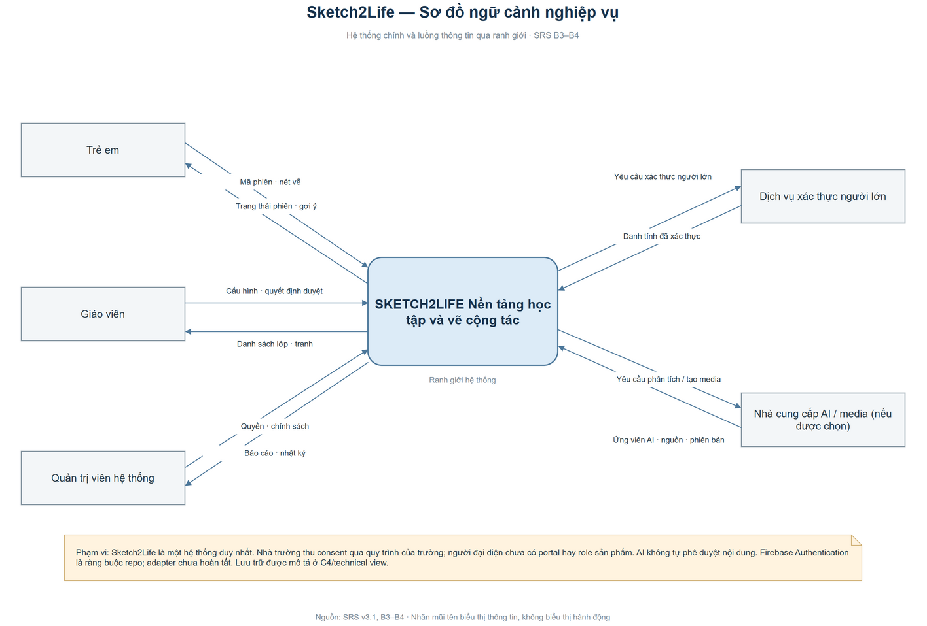

Figure D02. C4 System Context
Source: owner-supplied Draw.io file; source kept unchanged.
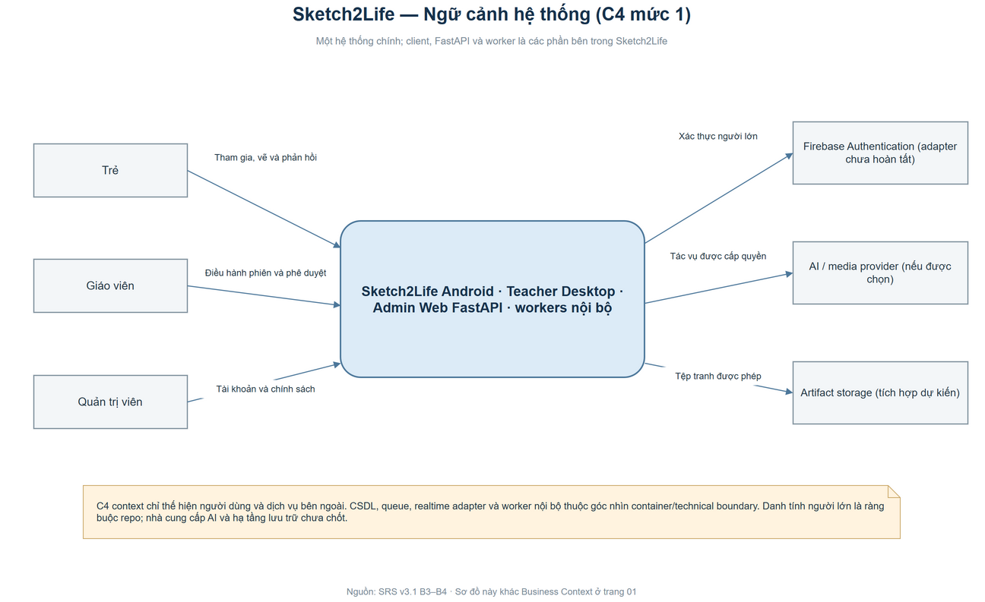

Figure D03. Use Case Overview
Source: owner-supplied Draw.io file; source kept unchanged.
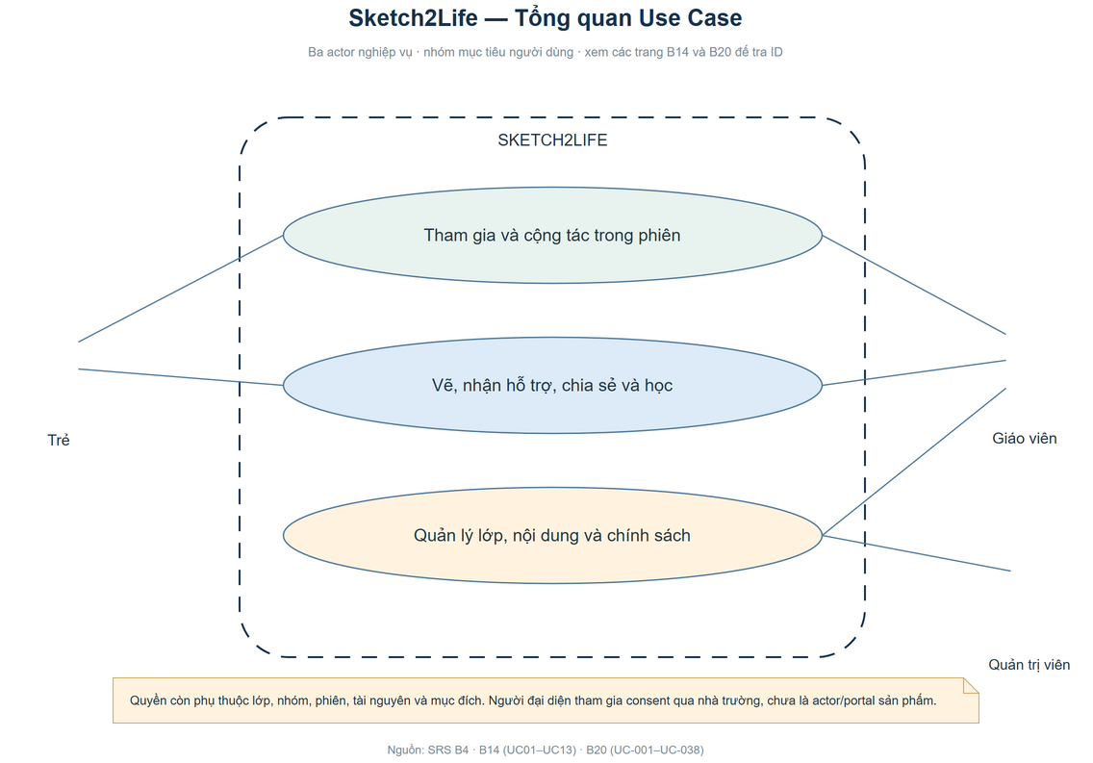

Figure D04. Use Case Details — page 2
Source: owner-supplied Draw.io file; source kept unchanged.
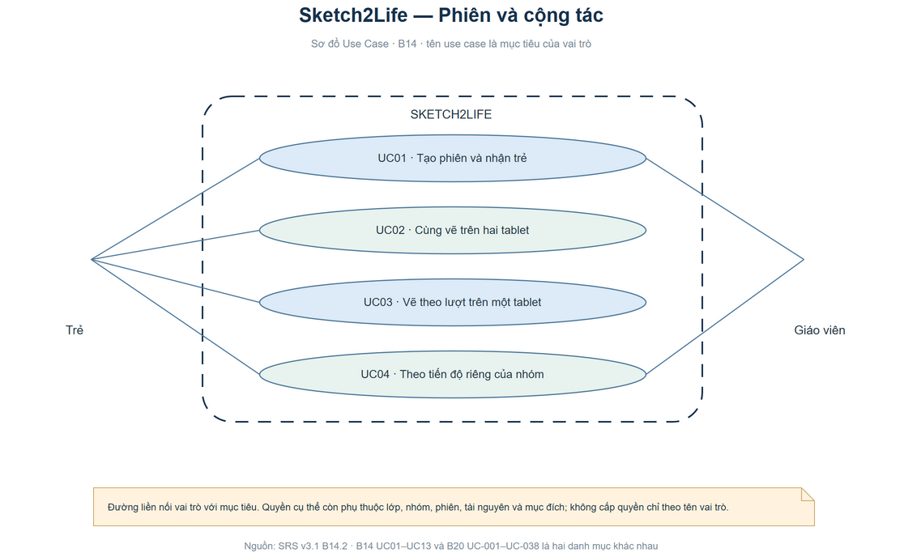

Figure D05. Use Case Details — page 3
Source: owner-supplied Draw.io file; source kept unchanged.
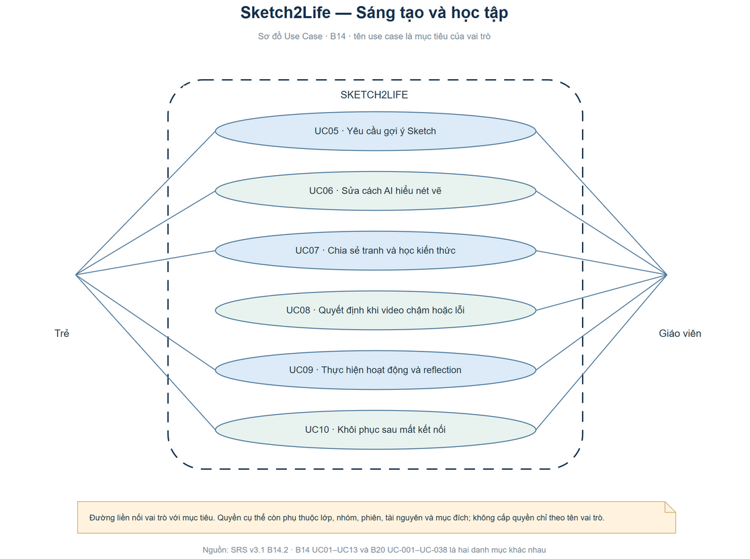

Figure D06. Use Case Details — page 4
Source: owner-supplied Draw.io file; source kept unchanged.
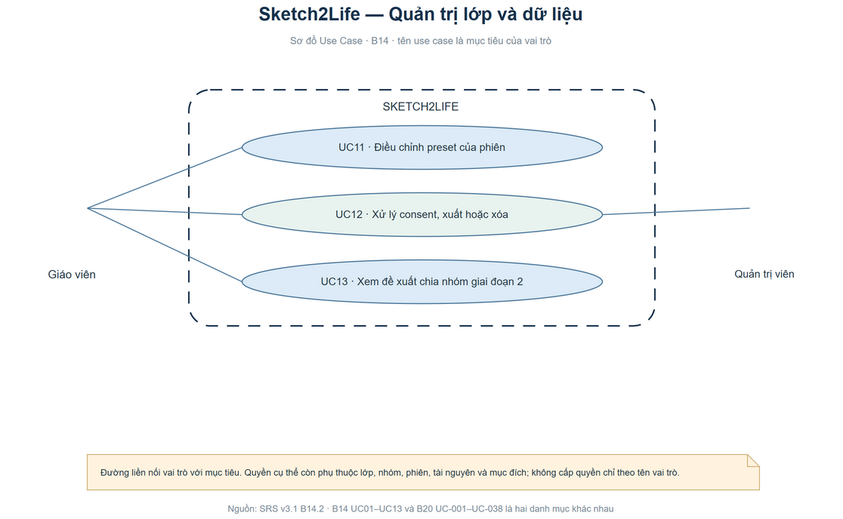

Figure D07. Use Case Details — page 5
Source: owner-supplied Draw.io file; source kept unchanged.
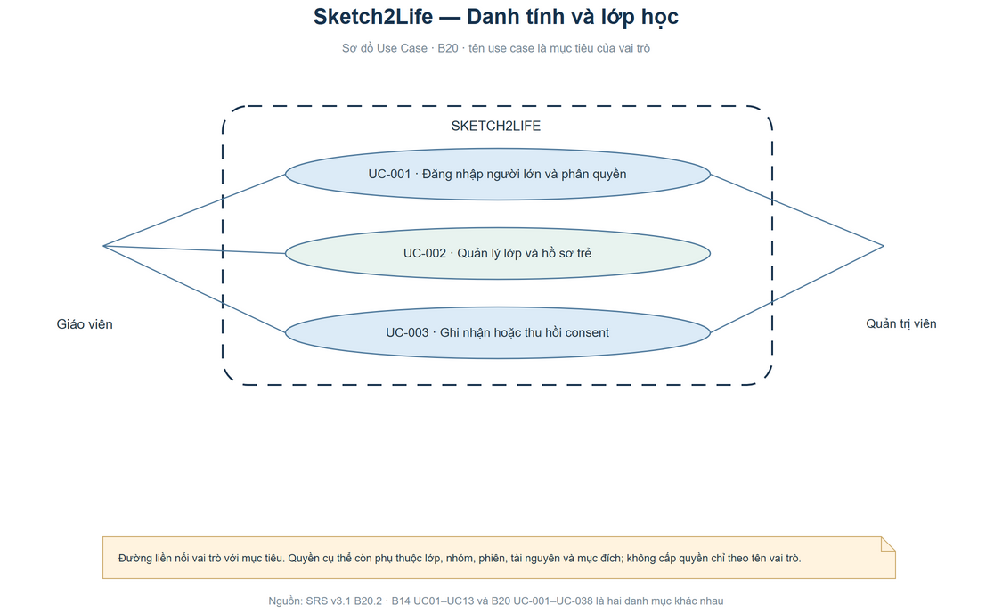

Figure D08. Use Case Details — page 6
Source: owner-supplied Draw.io file; source kept unchanged.
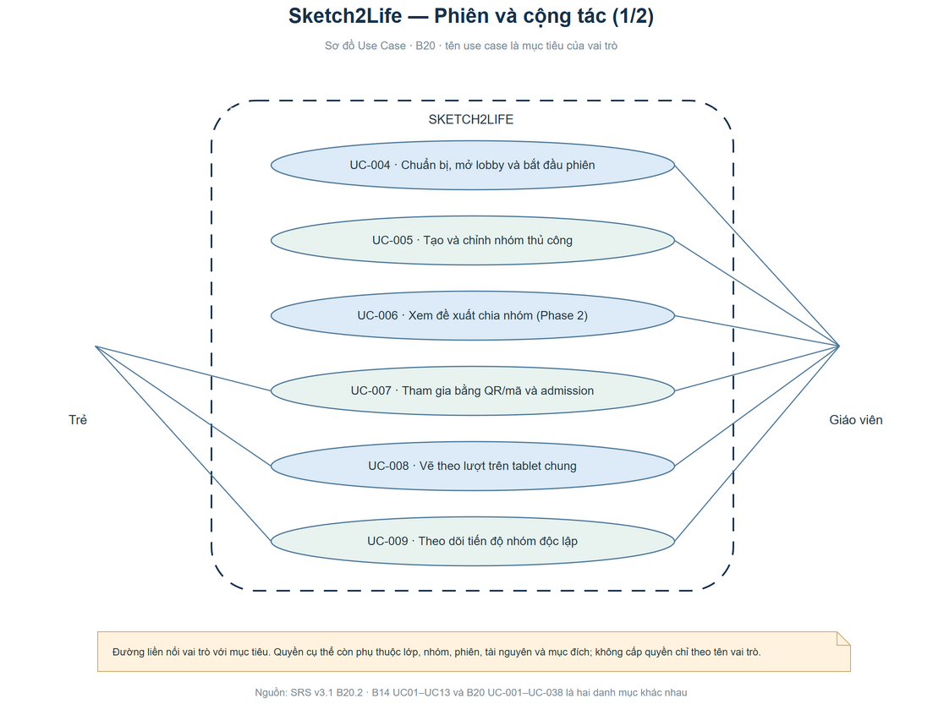

Figure D09. Use Case Details — page 7
Source: owner-supplied Draw.io file; source kept unchanged.
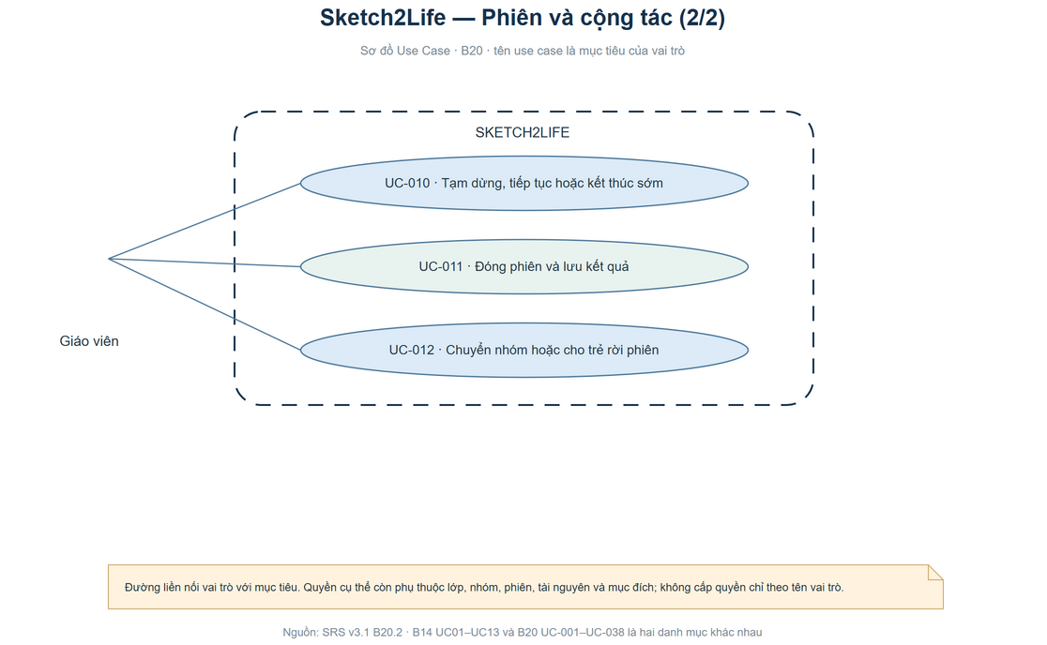

Figure D10. Use Case Details — page 8
Source: owner-supplied Draw.io file; source kept unchanged.
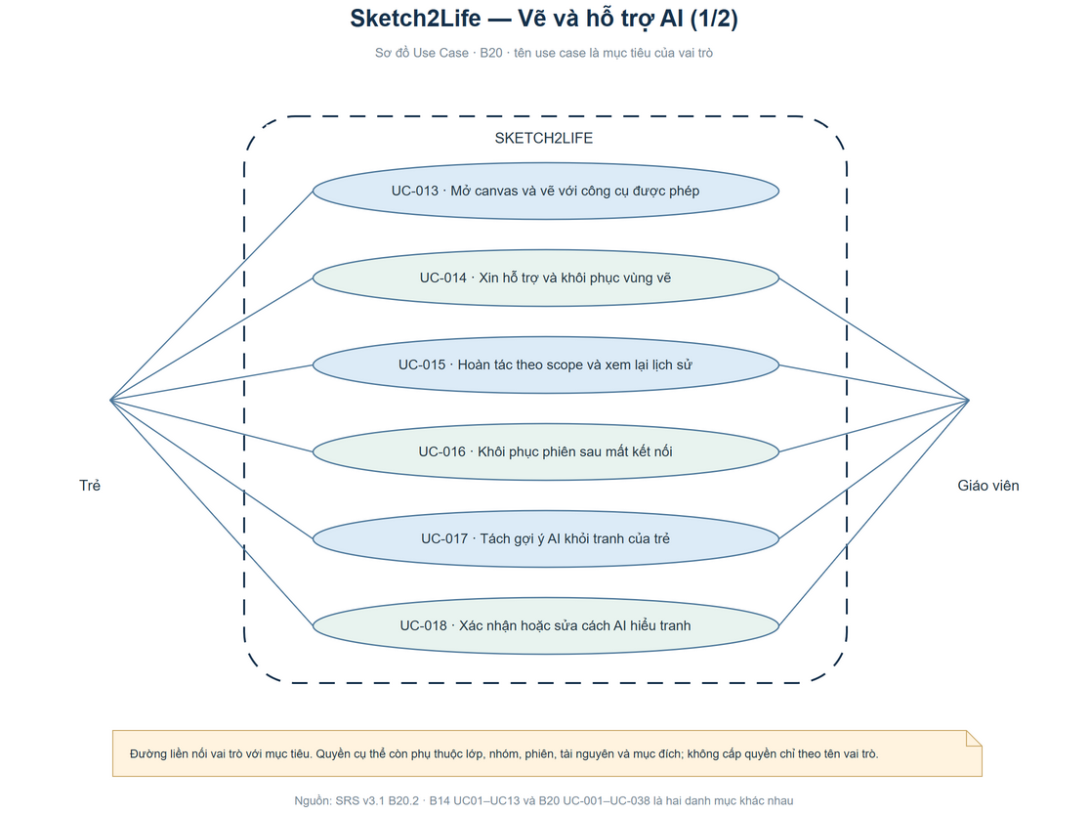

Figure D11. Use Case Details — page 9
Source: owner-supplied Draw.io file; source kept unchanged.
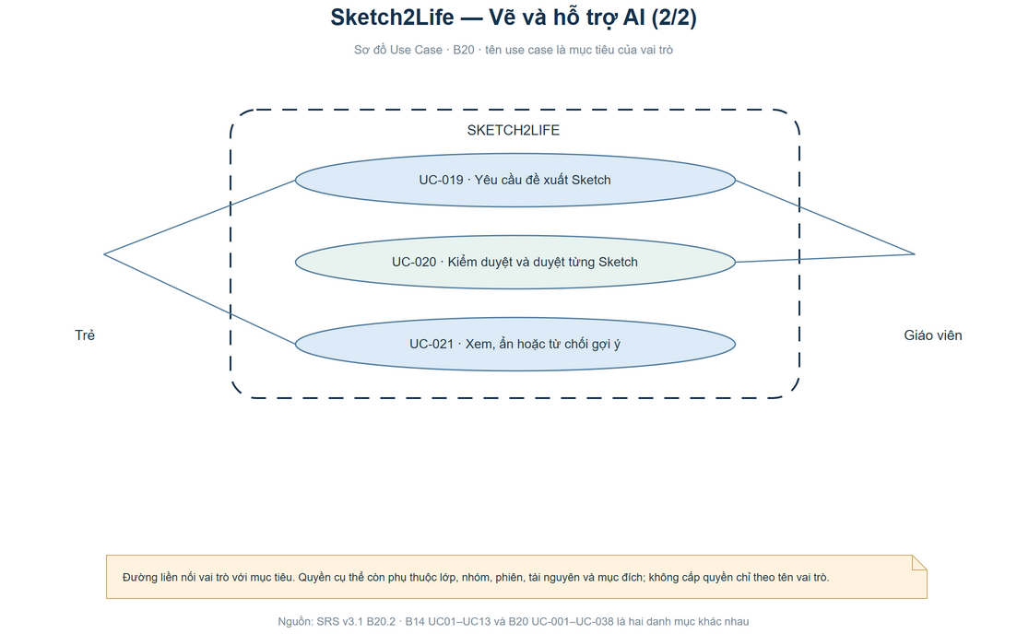

Figure D12. Use Case Details — page 10
Source: owner-supplied Draw.io file; source kept unchanged.
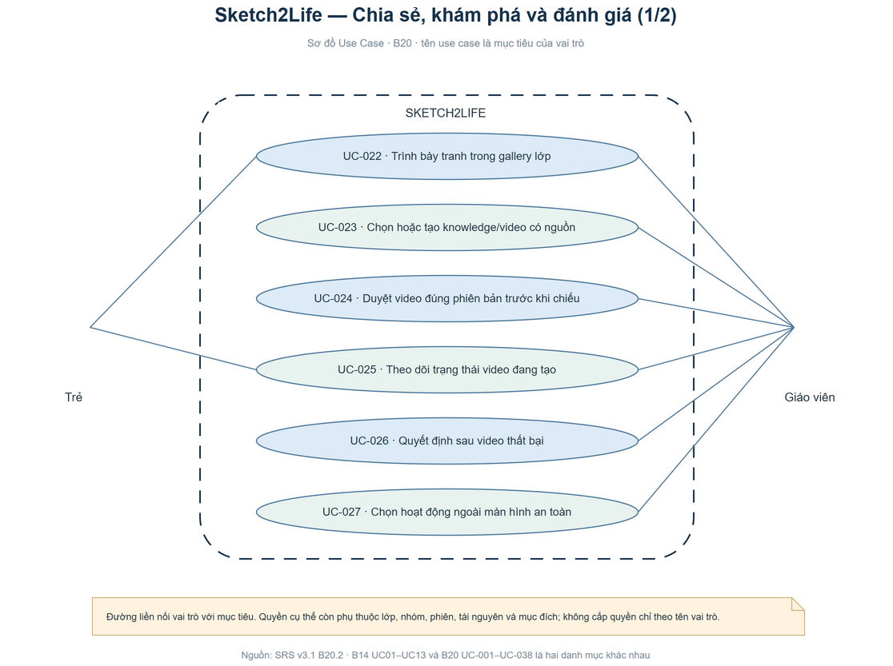

Figure D13. Use Case Details — page 11
Source: owner-supplied Draw.io file; source kept unchanged.
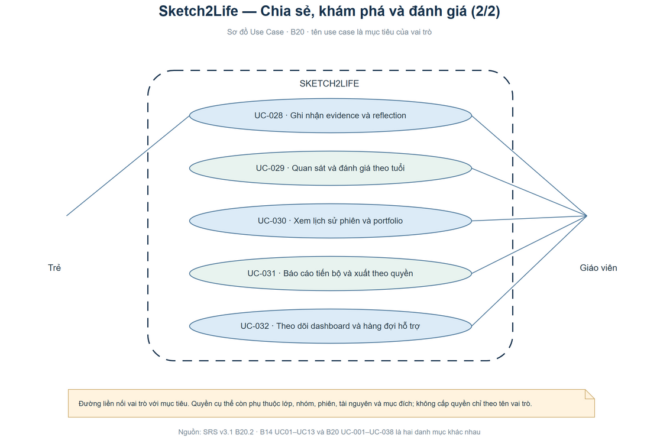

Figure D14. Use Case Details — page 12
Source: owner-supplied Draw.io file; source kept unchanged.
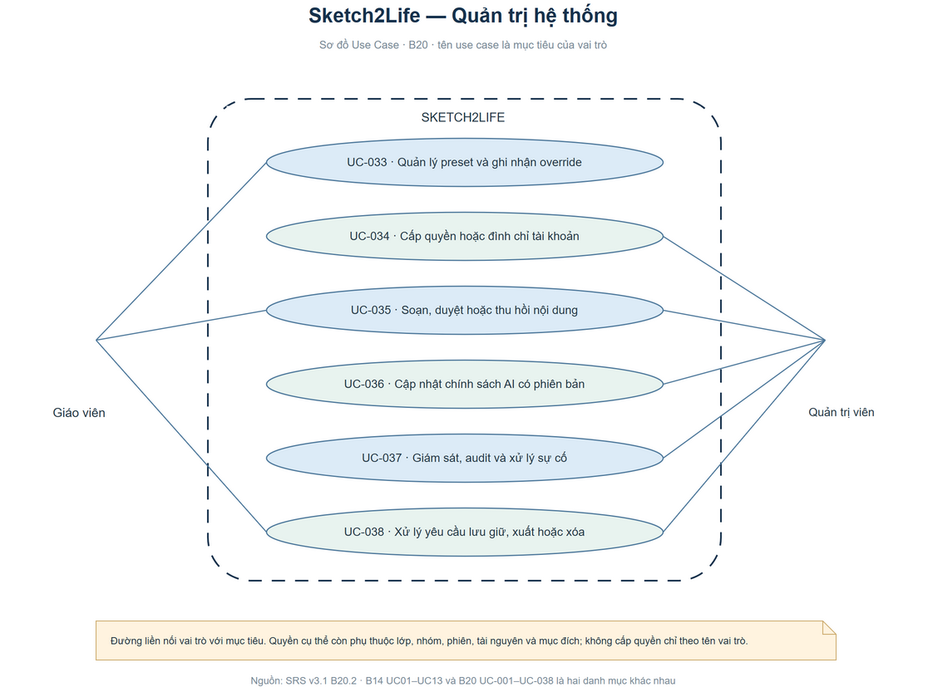

Figure D15. Main Session Sequence
Source: owner-supplied Draw.io file; source kept unchanged.
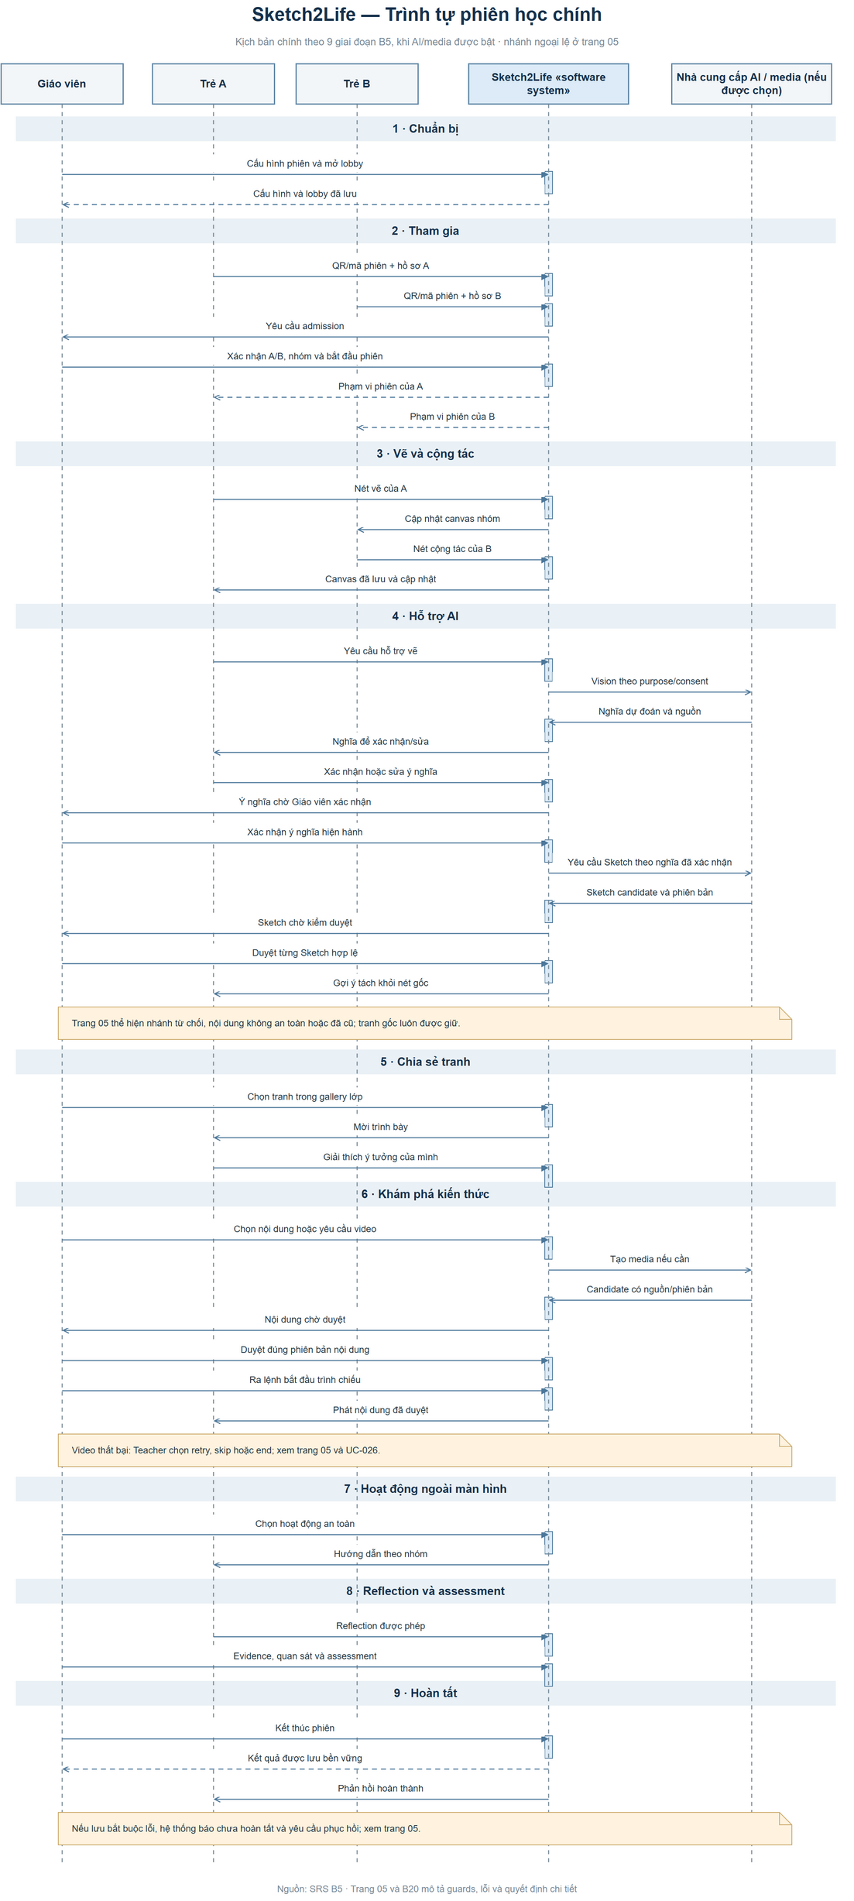

Figure D16. Detailed Session Sequence
Source: owner-supplied Draw.io file; source kept unchanged.
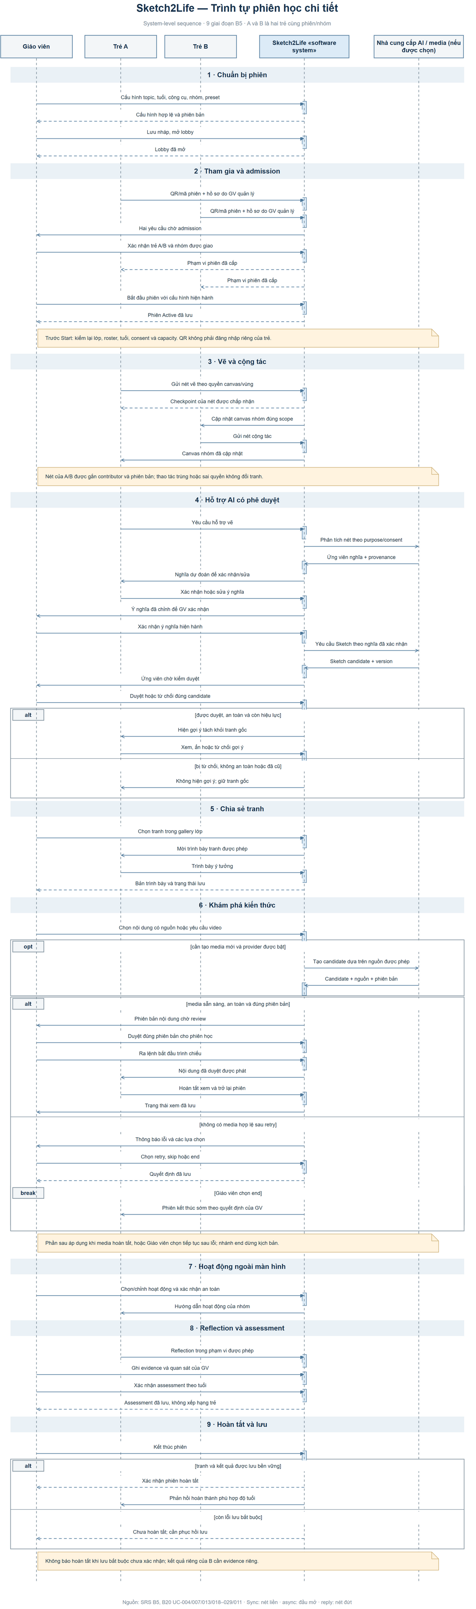

Figure D17. Screen Flow
Source: owner-supplied Draw.io file; source kept unchanged.
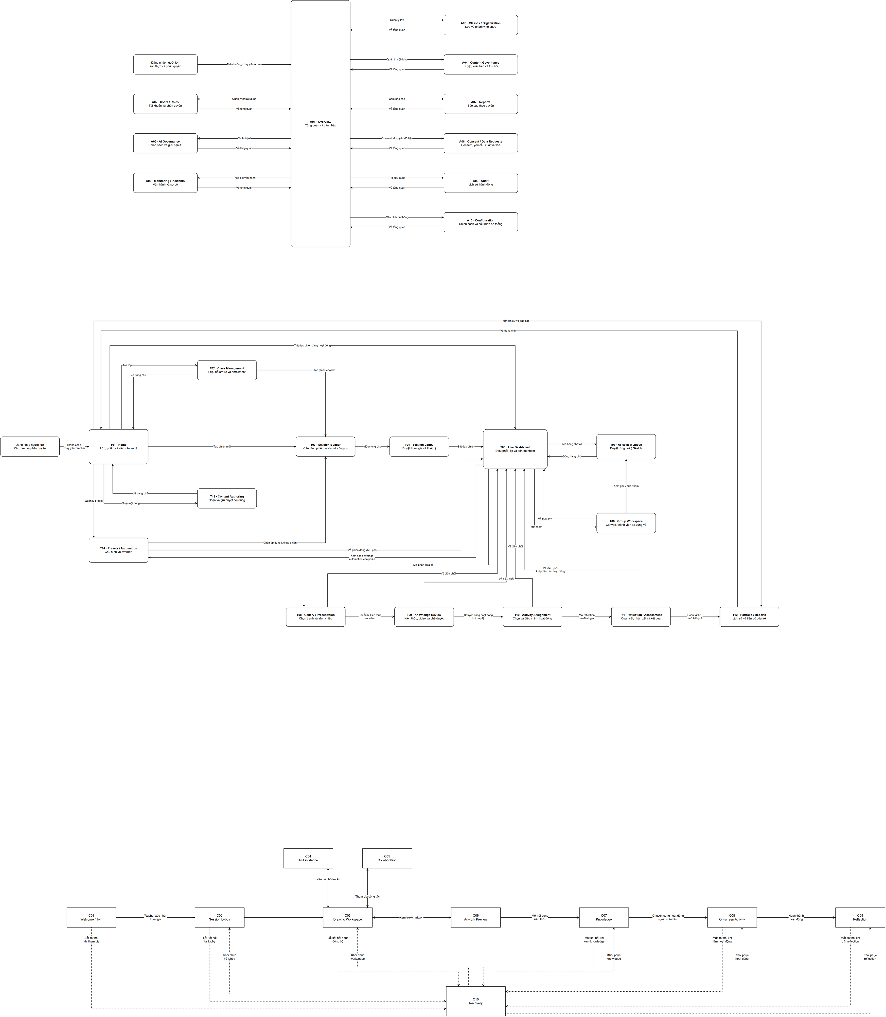

Figure D18. Class Diagram
Source: owner-supplied Draw.io file; source kept unchanged.
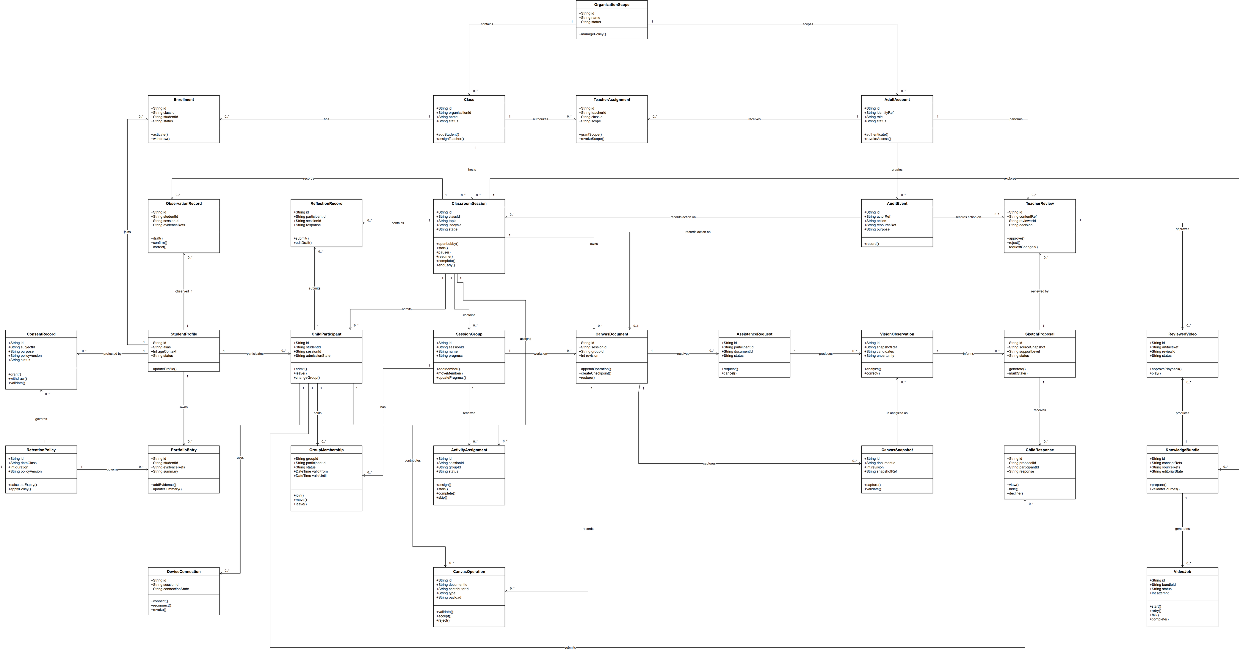

Figure D19. Logical ERD
Source: owner-supplied Draw.io file; source kept unchanged.
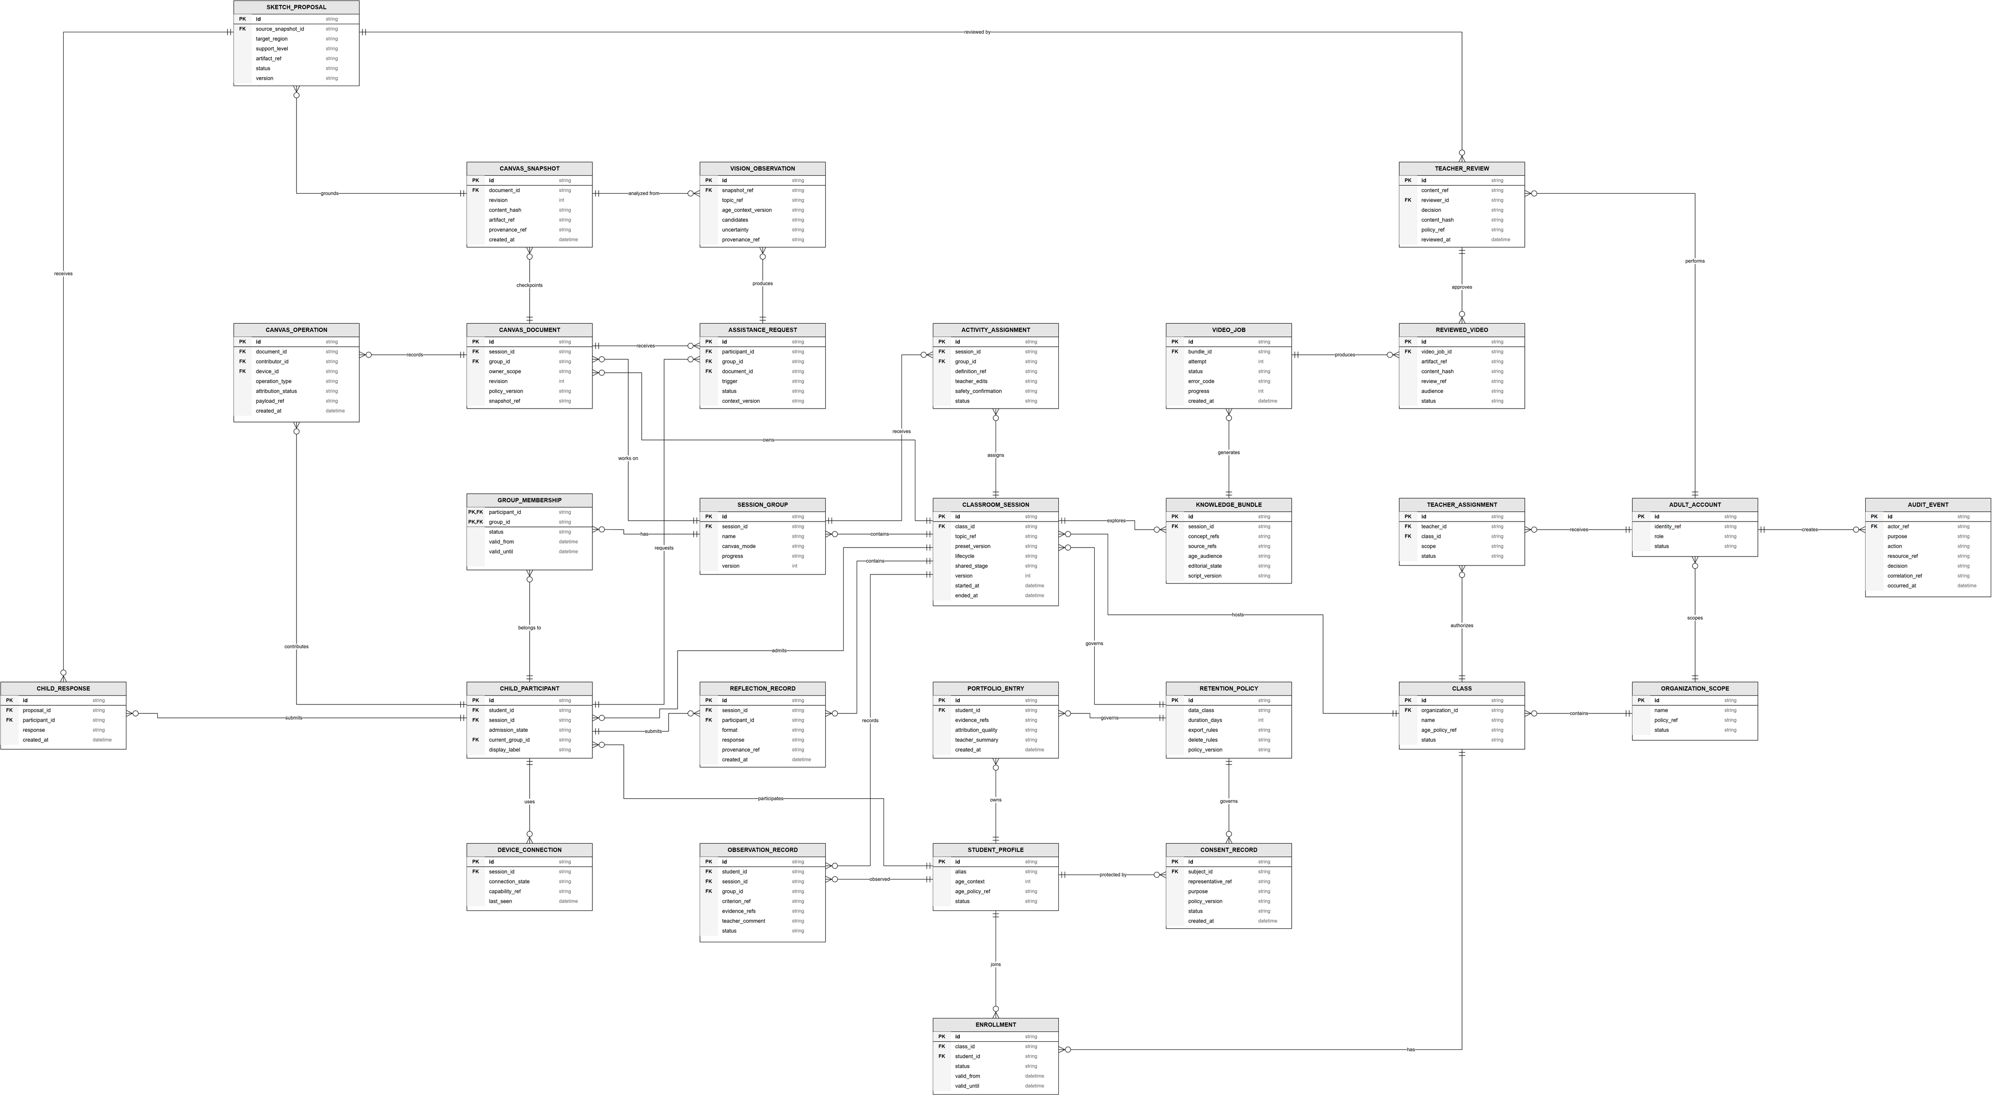

Figure D20. Khoa ERD
Source: owner-supplied Draw.io file; source kept unchanged.
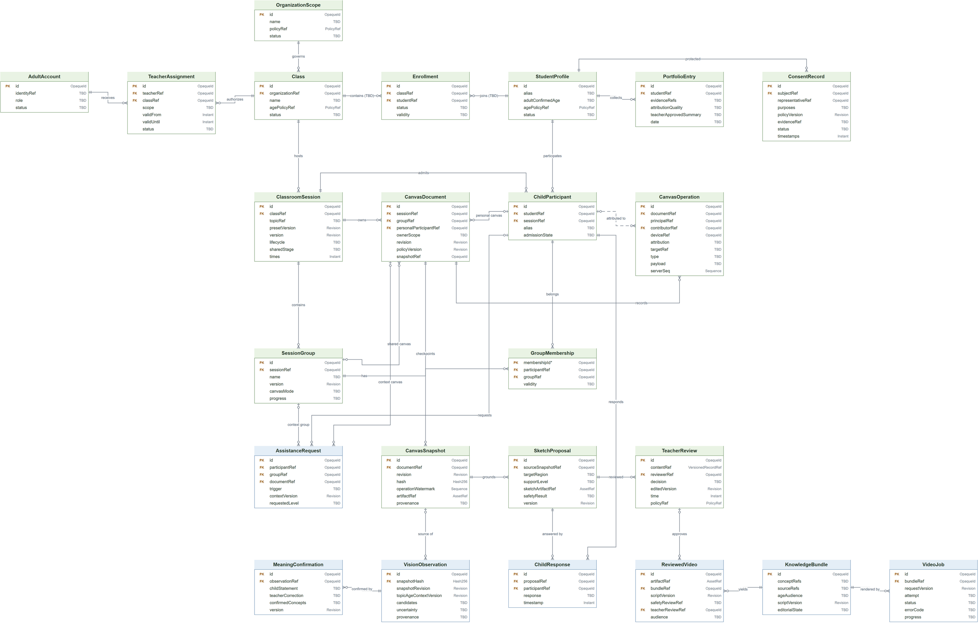

Figure D21. System Architecture
Source: owner-supplied Draw.io file; source kept unchanged.
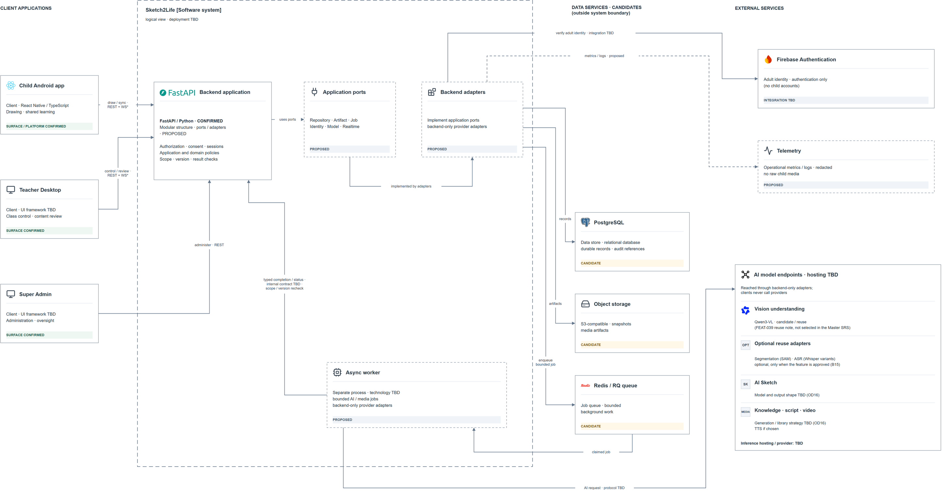

Figure D22. Package Diagram
Source: owner-supplied Draw.io file; source kept unchanged.
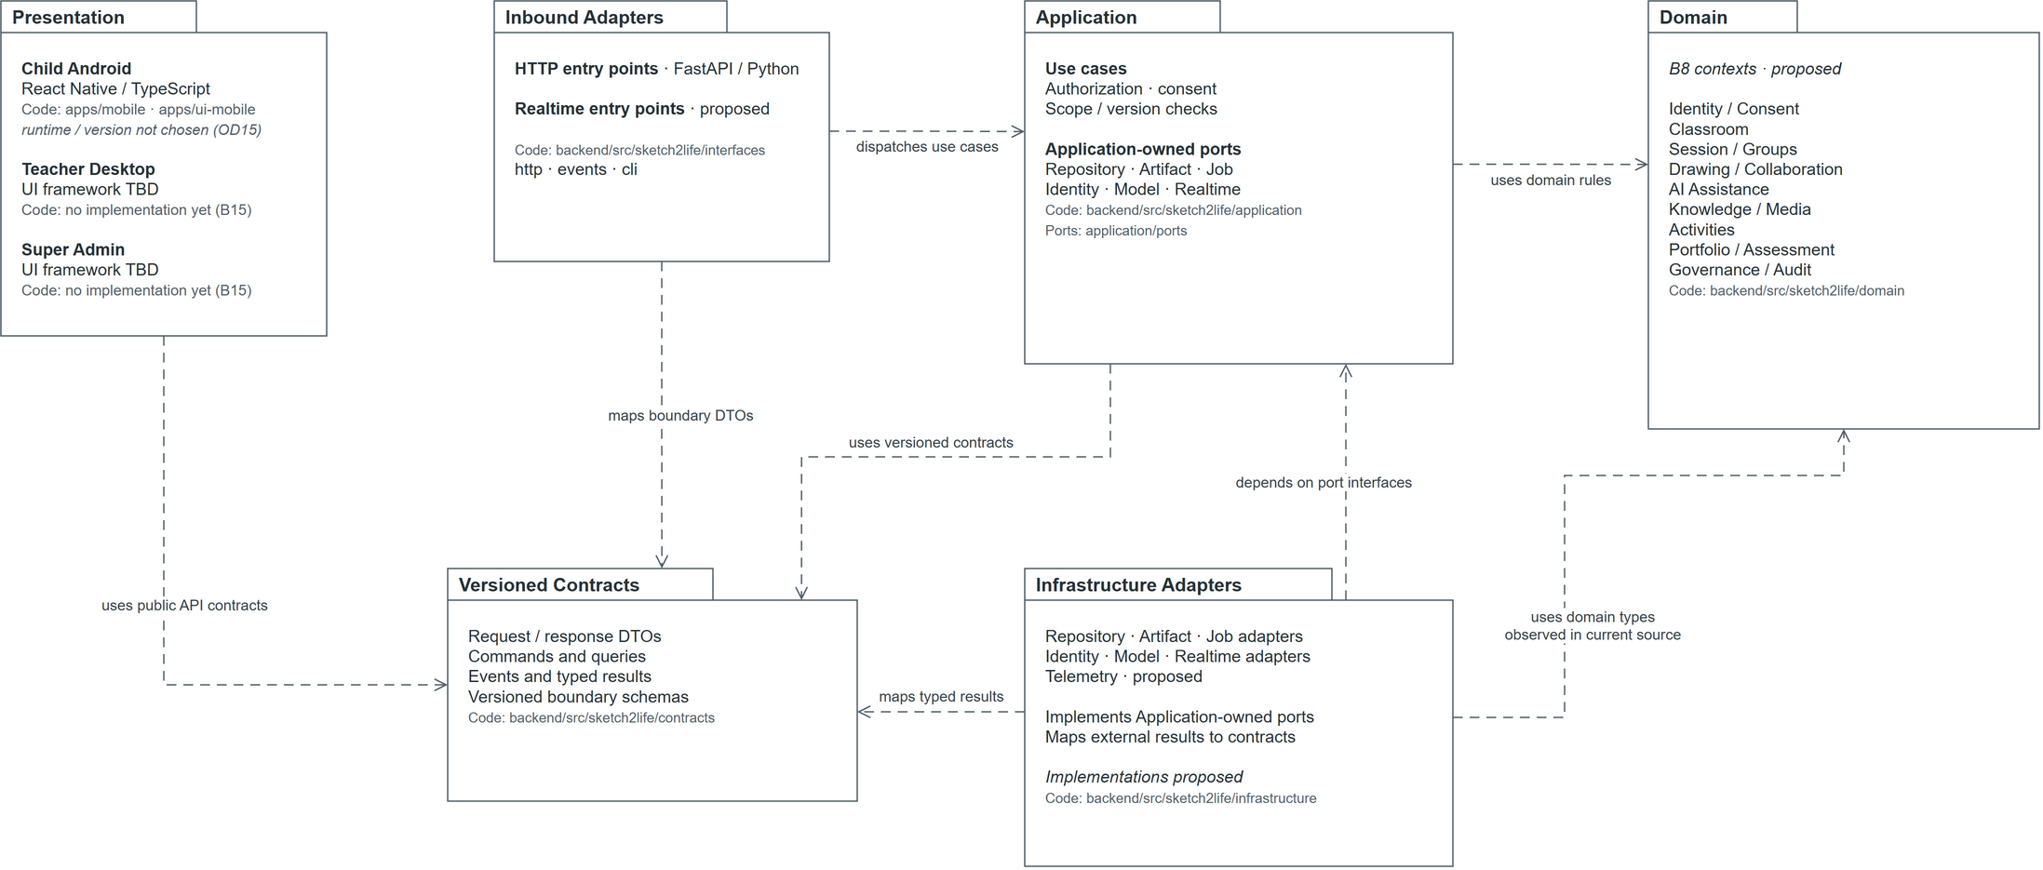

Figure D23. Session Lifecycle
Source: authorized Mermaid-to-Draw.io import; target design only.
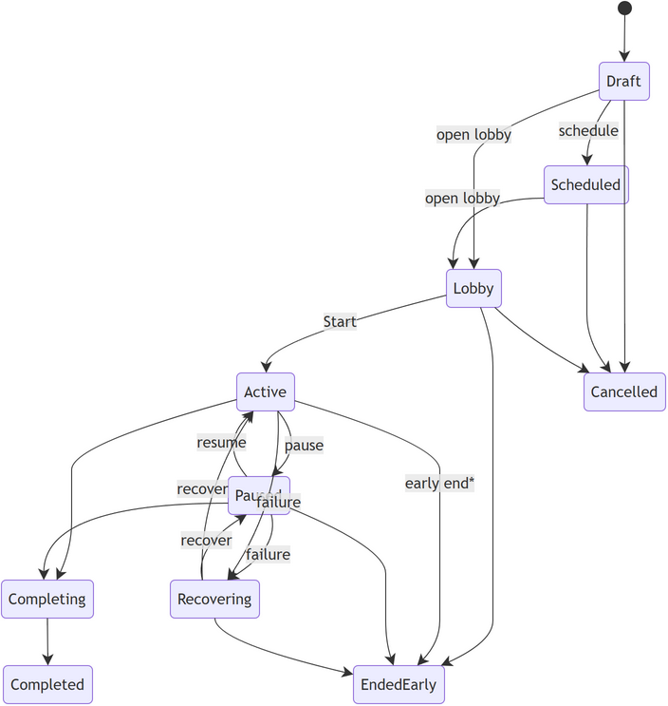

Figure D24. Session Pause and Recovery
Source: authorized Mermaid-to-Draw.io import; target design only.
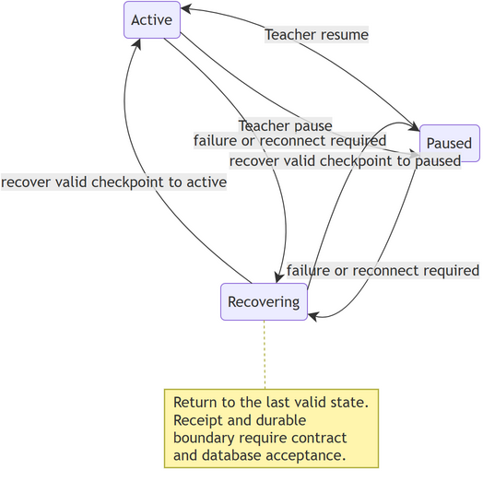

Figure D25. Session Early Termination
Source: authorized Mermaid-to-Draw.io import; target design only.
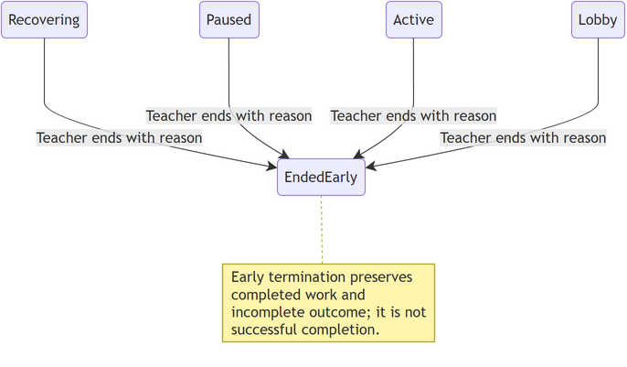

Figure D26. Shared Learning Stage
Source: authorized Mermaid-to-Draw.io import; target design only.
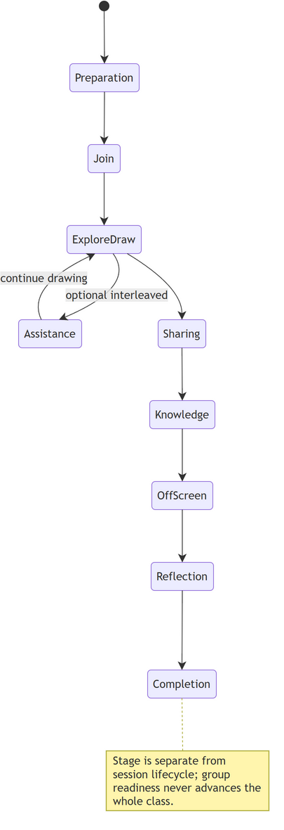

Figure D27. Group Progress
Source: authorized Mermaid-to-Draw.io import; target design only.
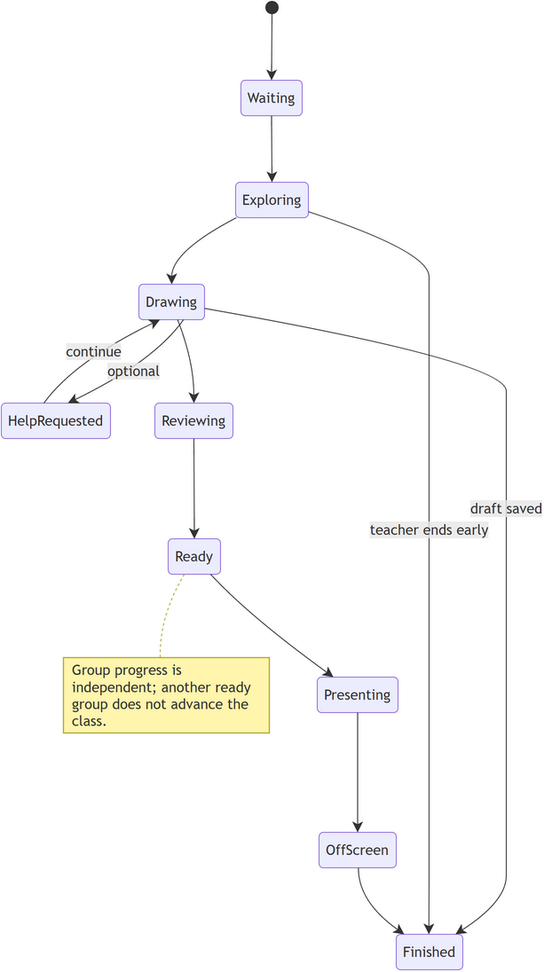

Figure D28. Participant Admission
Source: authorized Mermaid-to-Draw.io import; target design only.
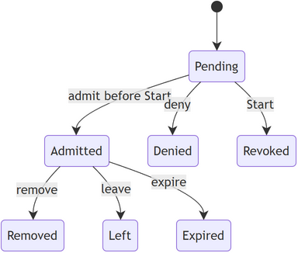

Figure D29. Device Connection
Source: authorized Mermaid-to-Draw.io import; target design only.
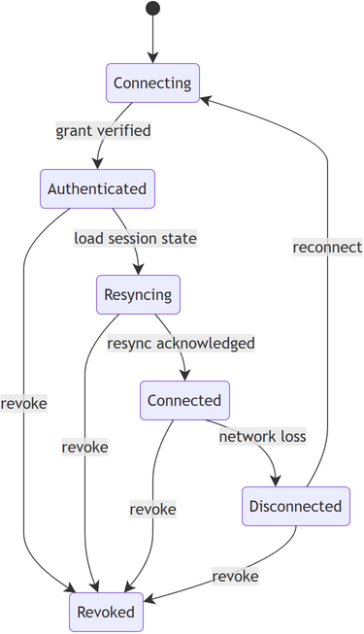

Figure D30. Device Grant Revocation
Source: authorized Mermaid-to-Draw.io import; target design only.
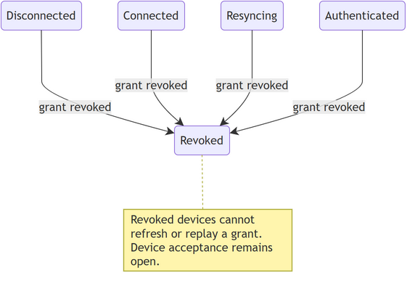

Figure D31. Draft Synchronization
Source: authorized Mermaid-to-Draw.io import; target design only.
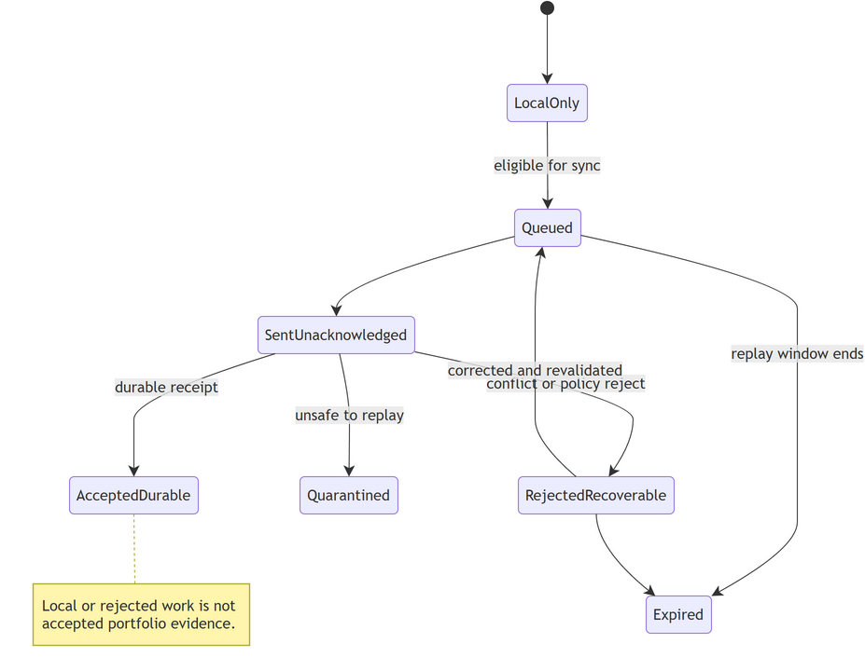

Figure D32. Sketch Pipeline
Source: authorized Mermaid-to-Draw.io import; target design only.
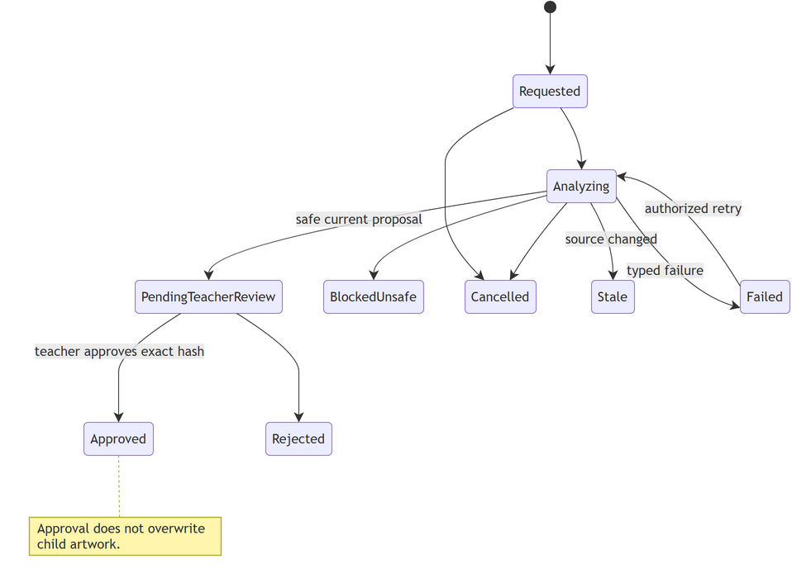

Figure D33. Child Suggestion Response
Source: authorized Mermaid-to-Draw.io import; target design only.
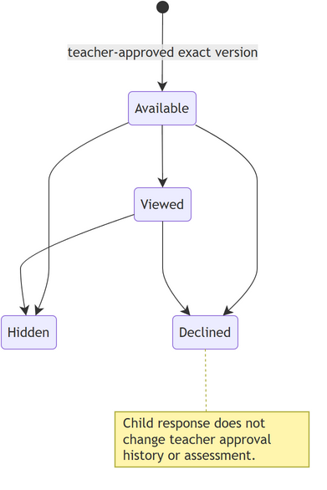

Figure D34. Knowledge Editorial
Source: authorized Mermaid-to-Draw.io import; target design only.
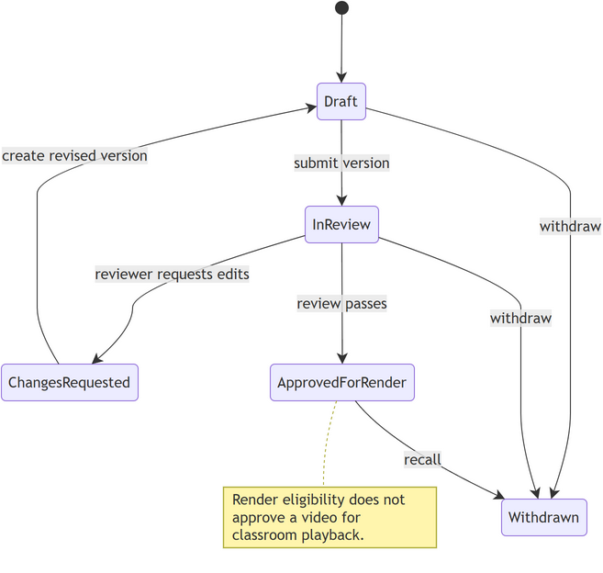

Figure D35. AI / Media Job
Source: authorized Mermaid-to-Draw.io import; target design only.
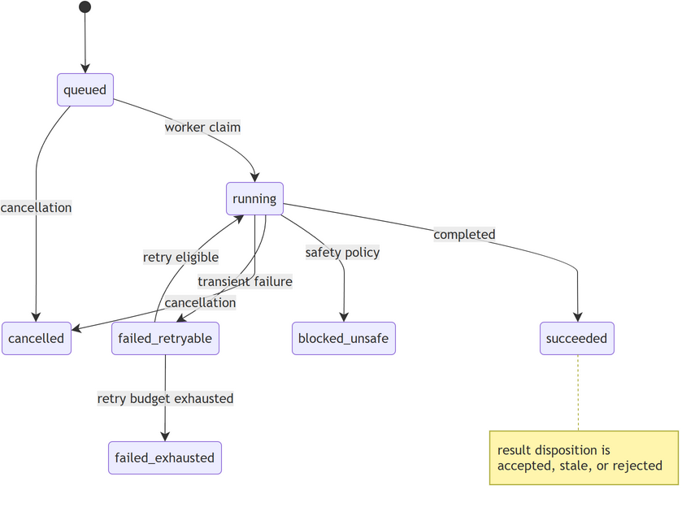

Figure D36. Video Delivery
Source: authorized Mermaid-to-Draw.io import; target design only.
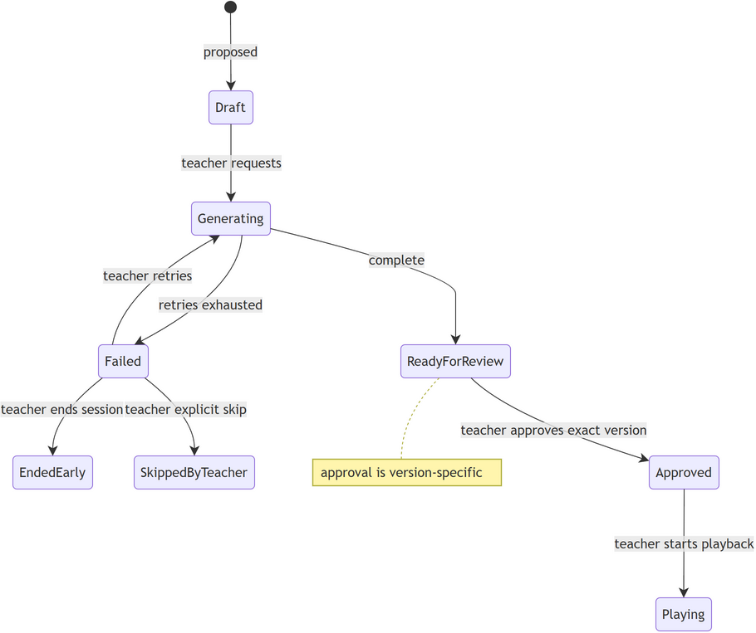

Figure D37. Activity Execution
Source: authorized Mermaid-to-Draw.io import; target design only.
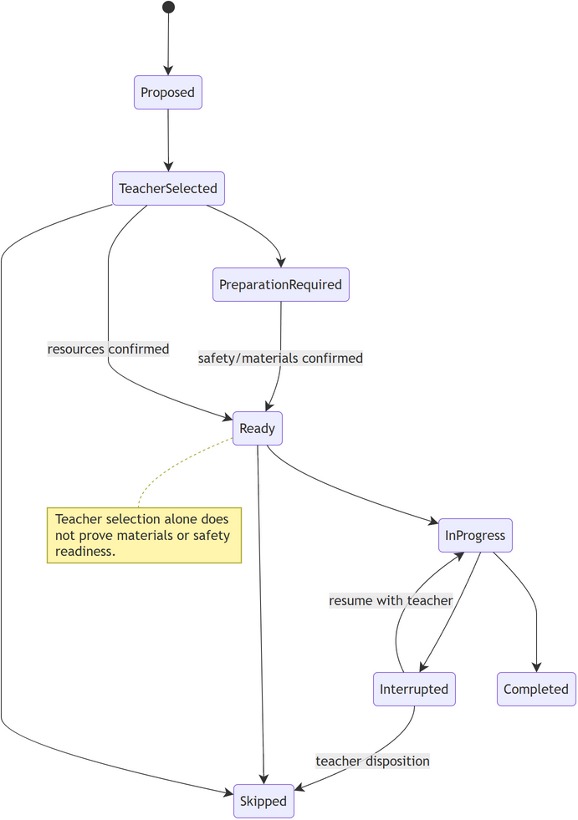

Figure D38. Observation
Source: authorized Mermaid-to-Draw.io import; target design only.
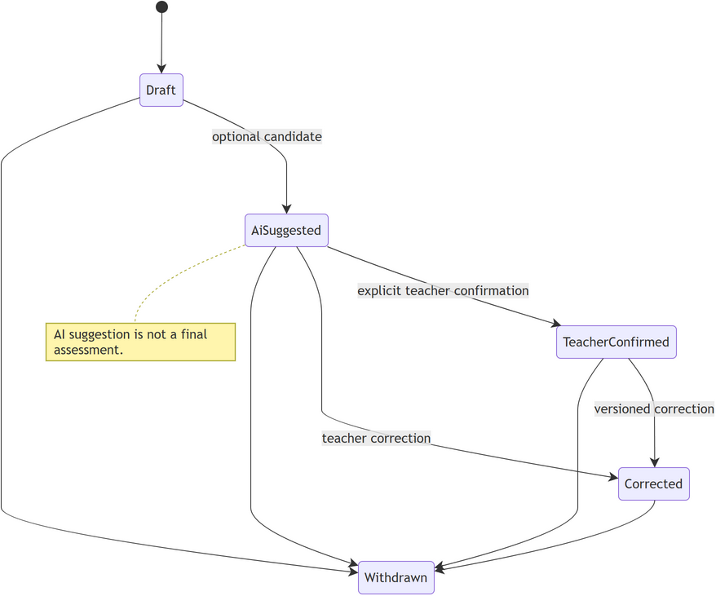

Figure D39. Content Publication
Source: authorized Mermaid-to-Draw.io import; target design only.
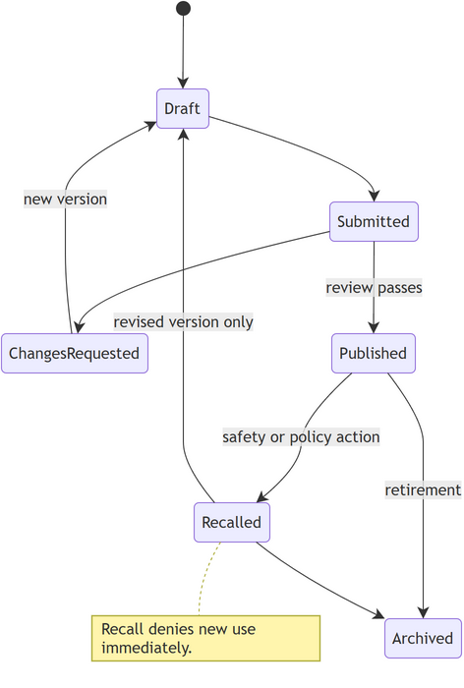

Figure D40. Data Request
Source: authorized Mermaid-to-Draw.io import; target design only.
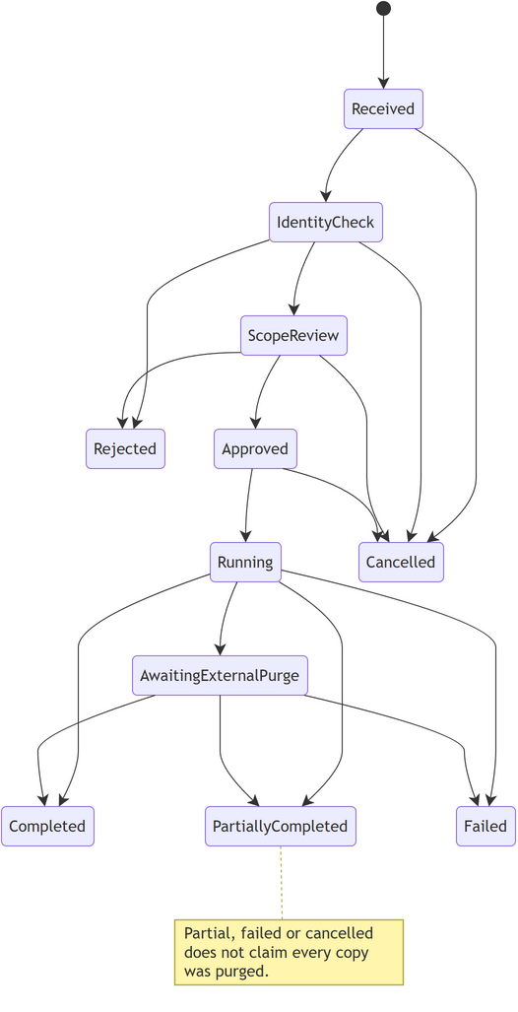

Figure D41. WF-01 Prepare and Admit
Source: authorized Mermaid-to-Draw.io import; target design only.
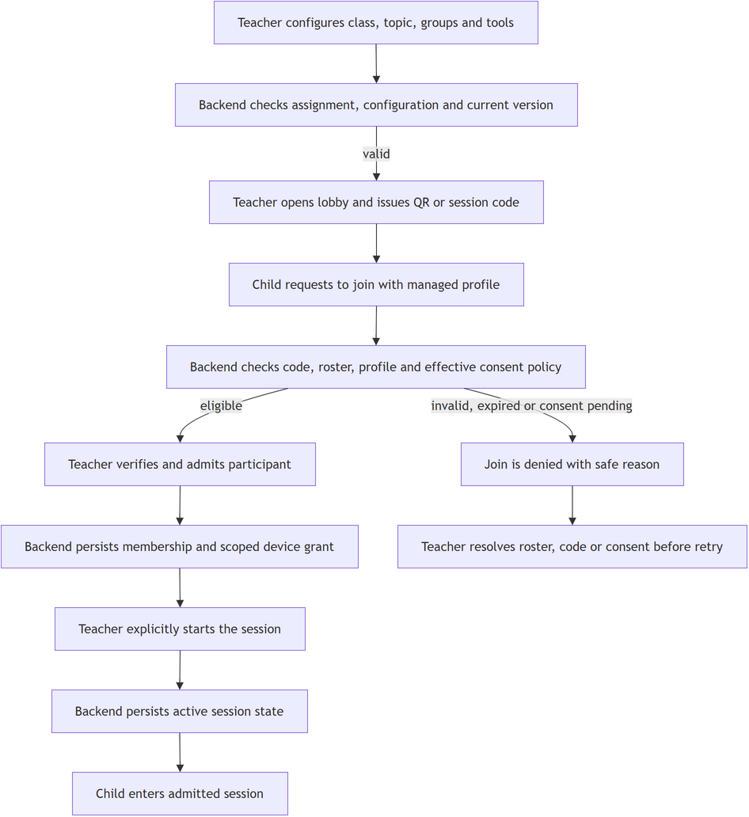

Figure D42. WF-02 Collaborative Drawing and Recovery
Source: authorized Mermaid-to-Draw.io import; target design only.
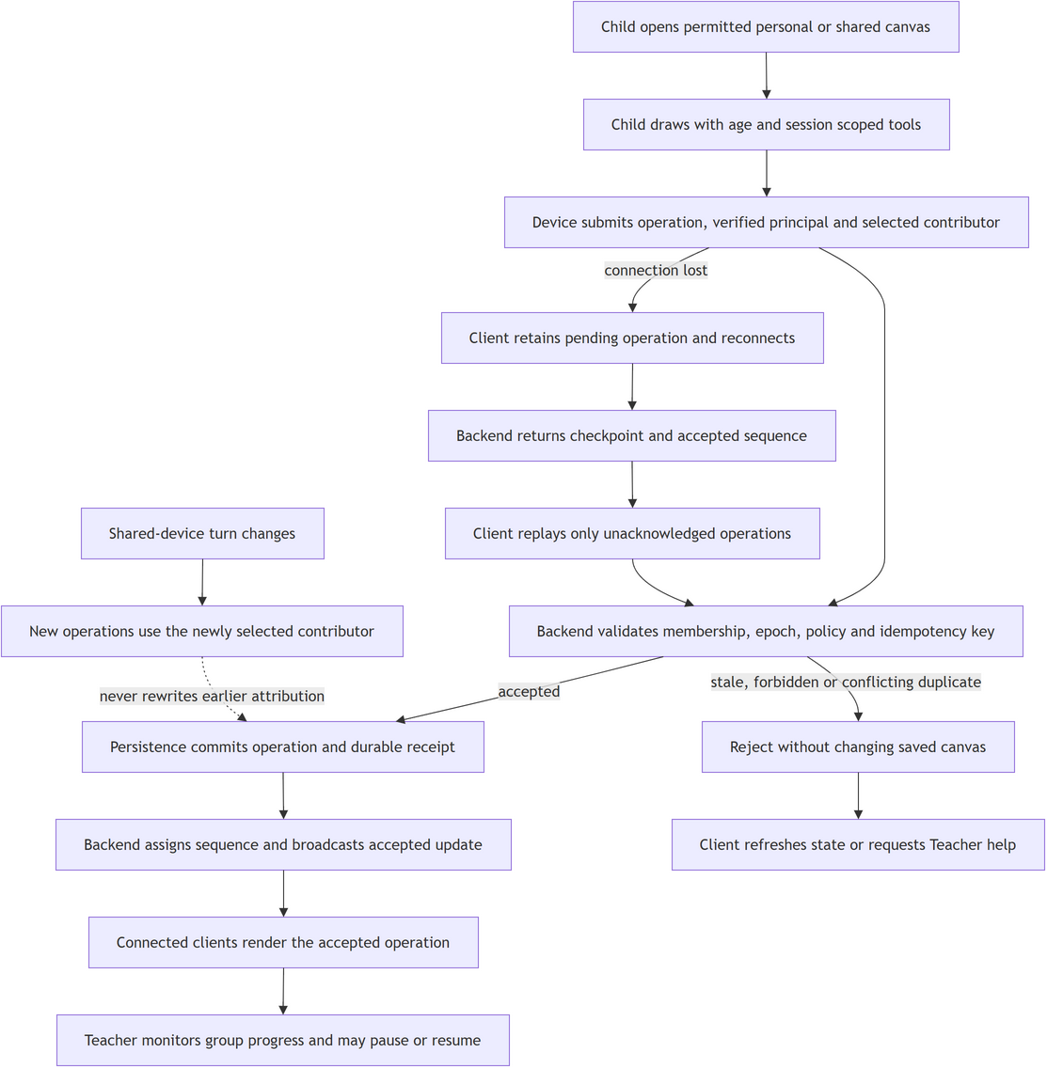

Figure D43. WF-03 Request and Review AI Sketch
Source: authorized Mermaid-to-Draw.io import; target design only.
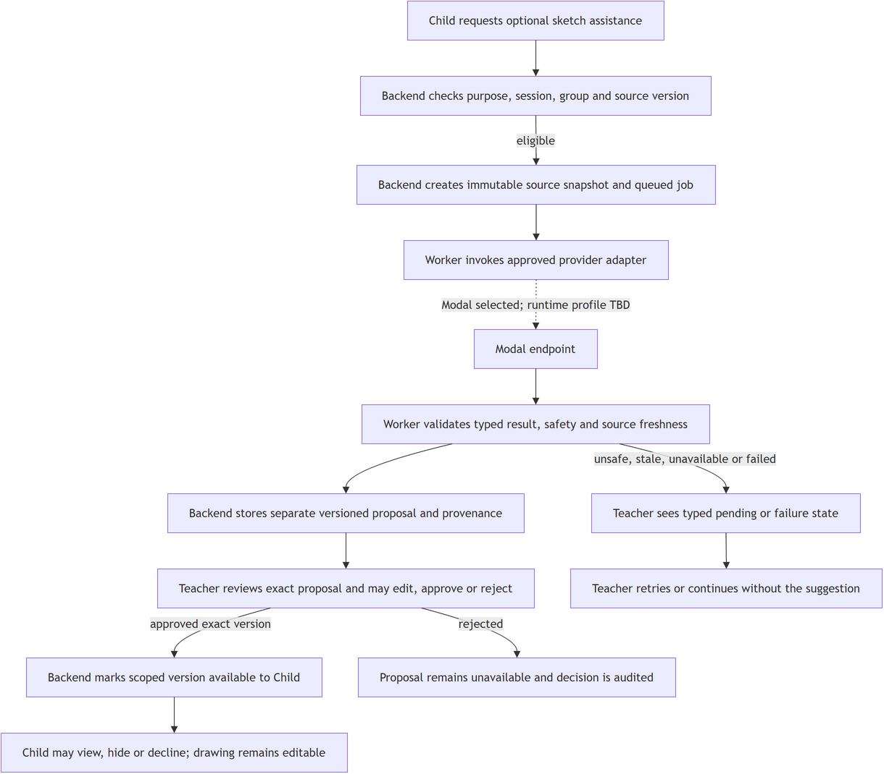

Figure D44. WF-04 Reviewed Learning and Session Close
Source: authorized Mermaid-to-Draw.io import; target design only.
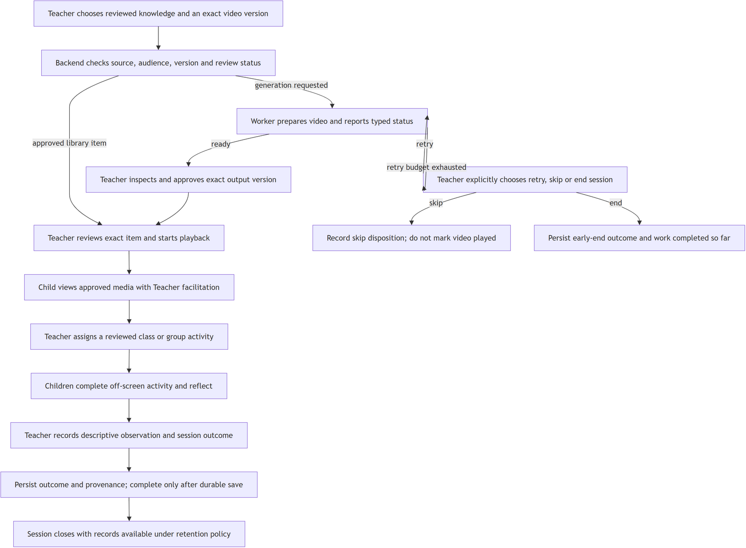

Appendix E. Current Delivery, Proposed Next Work and Unknowns
Owner-delegated dependency proposal dated 24 October 2026. Keep/Defer controls only near-term sequencing; no item is omitted from registered scope. Owners, calendar windows, thresholds, project/class code, environments and service settings stay TBD until the responsible people confirm them.

E1. Current workflow status
Workflow | Evidence-backed current status | Still unknown / not established
WF-01 — prepare and admit | Local Child/Teacher/BE1 paths for lobby, QR/code request, review, admission/revoke and Start; separate Child/Teacher checks passed. | No PostgreSQL-backed FE-to-BE acceptance; 4 DB tests skipped; no live Firebase or physical-device join evidence. Migration path and test operator TBD.
WF-02 — collaborative drawing/recovery | Local Child/Teacher wiring for acknowledged strokes, turn/group context and reconnect/replay; UI/backend checks passed separately. | No durable multi-client DB acceptance, real network/restart device run, supported-device matrix or recovery threshold.
WF-03 — AI sketch review | SRS scope retained; FEAT-057 slices remain partial/gated; no classroom integration or live Modal call evidenced. | Shared finalization/execution authority, contract version, fallback, provider profile, model, endpoint and safety review path TBD.
WF-04 — reviewed learning/video/activity/close | SRS scope retained; FEAT-057 and storage/runtime gates remain; no accepted end-to-end classroom path evidenced. | Approved content/storage contracts, retention/export/deletion path, activity/reflection lifecycle, service owner and runtime profile TBD.

E2. Near-term filter for owner review
Item / proposal | Reason and dependency | Open questions (TBD unless confirmed)
N1 — KEEP | Approve one Alembic lineage, clean install/upgrade and rollback before DB acceptance; nine heads are reported. | Which heads are in delivery path; who approves; exact clean-install and rollback procedure.
N2 — KEEP | Review BE1 routes, transactions, authorization, receipts/idempotency, join-code key lifecycle, trusted-proxy IP and cross-replica throttle; can run alongside N1. | DTO/version, guard and error mapping, key lifecycle, proxy trust, concurrency and accountable reviewer.
N3 — KEEP after N1/N2 | Run isolated synthetic PostgreSQL acceptance for WF-01/WF-02, migration, restart/recovery and rollback; four cases skipped without BE1_TEST_DATABASE_URL. | Operator/URL, DB version, isolated environment, scenarios/thresholds and evidence owner.
N4 — KEEP after or alongside N3 | Accept QR/deep-link, restart, reconnect and network-loss behavior on supported devices before end-to-end claims. | Device/OS/browser matrix, test owner, interruption scenarios and recovery criteria.
N5 — DEFER | Integrate WF-03/WF-04 only after FEAT-057 adoption gates and versioned contracts are approved; scope remains in SRS. | Card/contract version, owner, finalization/execution authority, fallback and human safety/review path.
N6 — DEFER after contract decisions | Configure Firebase, Modal and production artifact storage after contract/data boundaries and before live checks; no production profile is evidenced. | Project/tenant, storage provider/bucket/region, Modal model/GPU/endpoint, secret owner, timeout and cost ceiling.
N7 — KEEP as pre-pilot gate | Close child consent, purpose, retention, export/delete, purge and audit before real child data; synthetic DB acceptance can proceed separately. | Consent text, data classes, purge/backup rules, institutional/legal review and evidence owner.
N8 — DEFER; rewind disabled | Forward-only stage progression is valid while OD07 is unresolved; no blocker while rewind remains disabled. | Whether rewind is needed; evidence/draft preservation, guard and receipt rules if enabled.
N9 — DEFER after N3/N6 | Measure the one-class 40-child pilot target after repeatable DB/runtime exists; it is not a hard join cap. | Workload, device/network profile, latency/error thresholds, hosting/cost limits and measurement owner.

E3. Submission and planning unknowns
ID | Unknown | Disposition in this draft
U1 | Official project/class code | TBD; selected form v1.2 leaves fields blank; filename is not treated as authority.
U2 | N1–N9 near-term selection | Owner delegated the current Keep/Defer proposal; no candidate is omitted and no registered requirement is removed.
U3 | Calendar milestones, capacity, person-days and accountable owners | The existing 15-week/252 person-day figures are draft proposals; dates/capacity/assignment acceptance remain TBD.
U4 | Official BM02 tagged baseline | review-2 tag absent; this is an untagged source review. No tag is created by this task.
U5 | Treatment of deferred work | All four workflows and SRS requirements remain registered; only proposed sequencing is deferred.

