JavaScript Fundamentals – Part 1

Coding Challenge #1
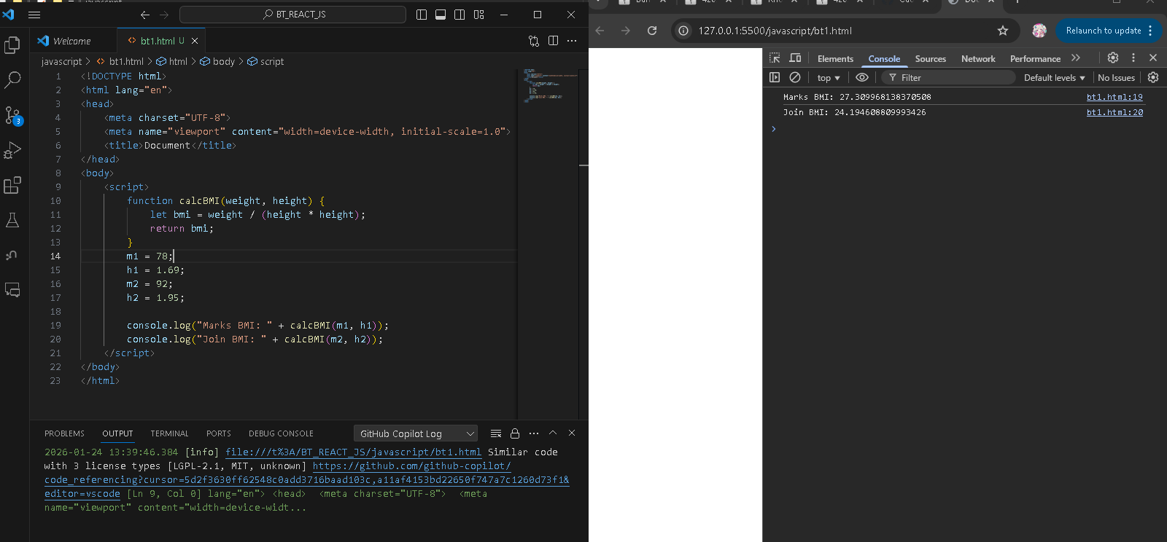

Coding Challenge #2
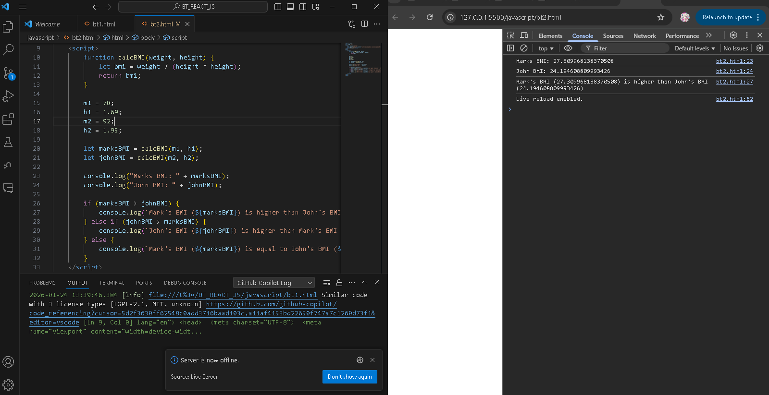

Coding Challenge #3
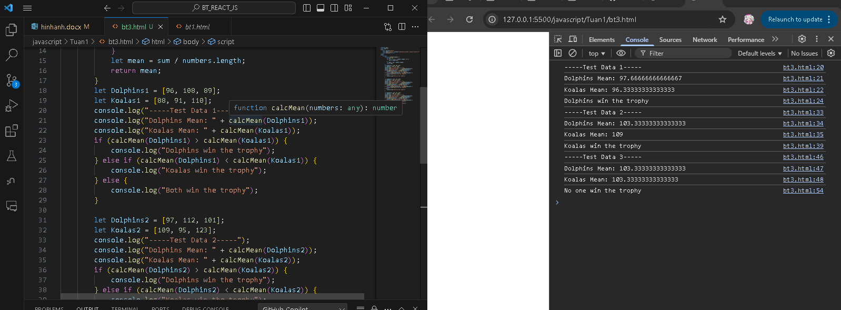

Coding Challenge #4
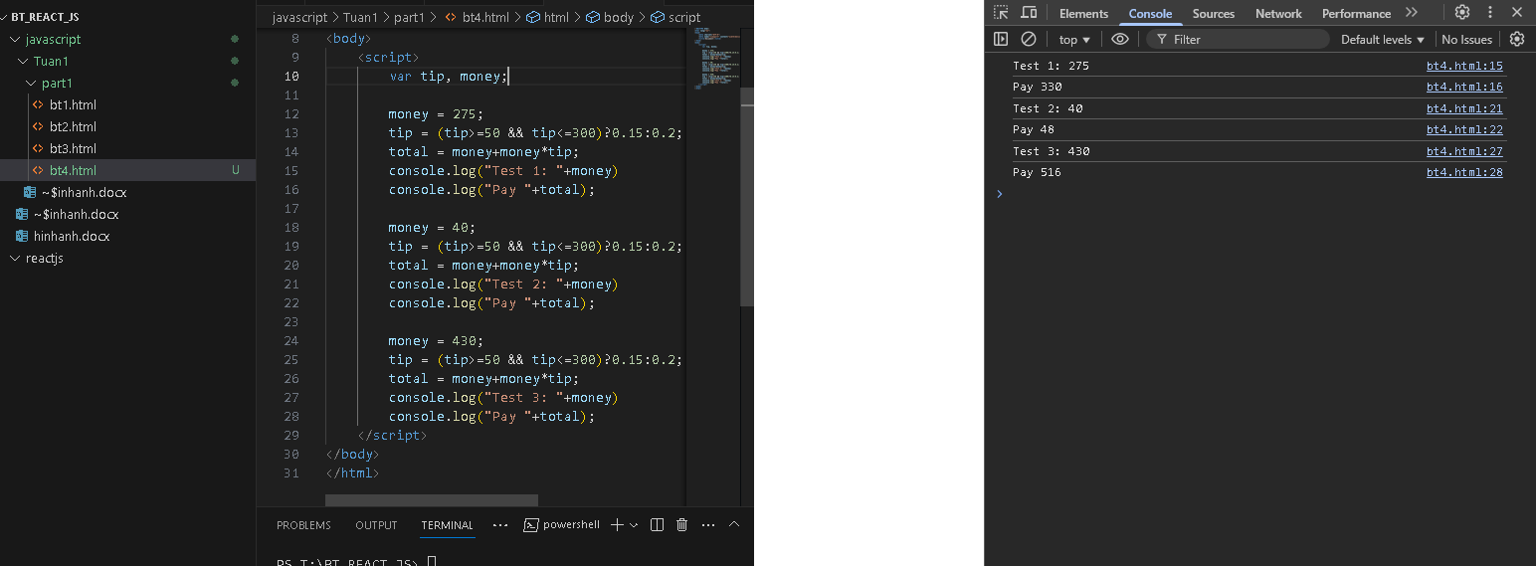

JavaScript Fundamentals – Part 2

Coding Challenge #1
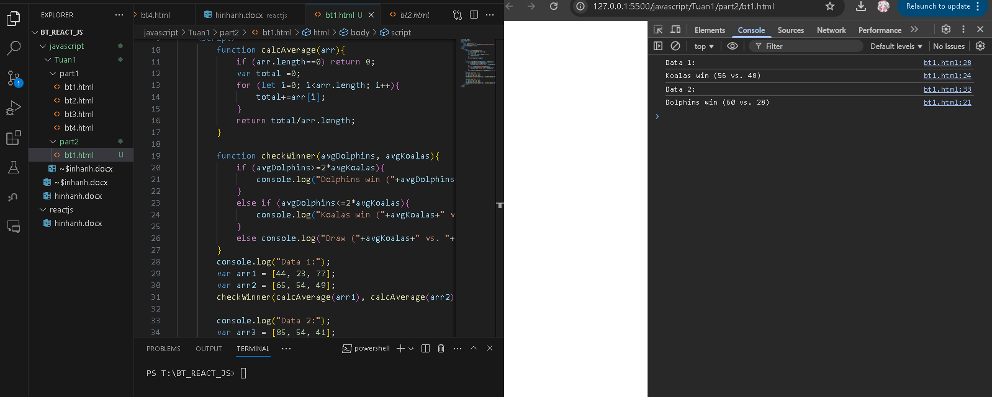

Coding Challenge #2
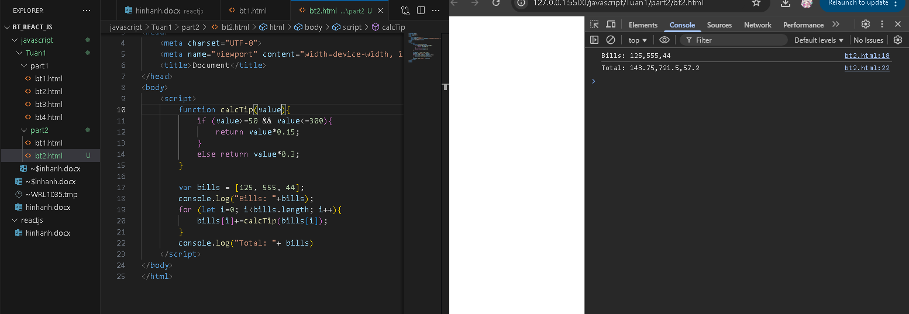

Coding Challenge #3
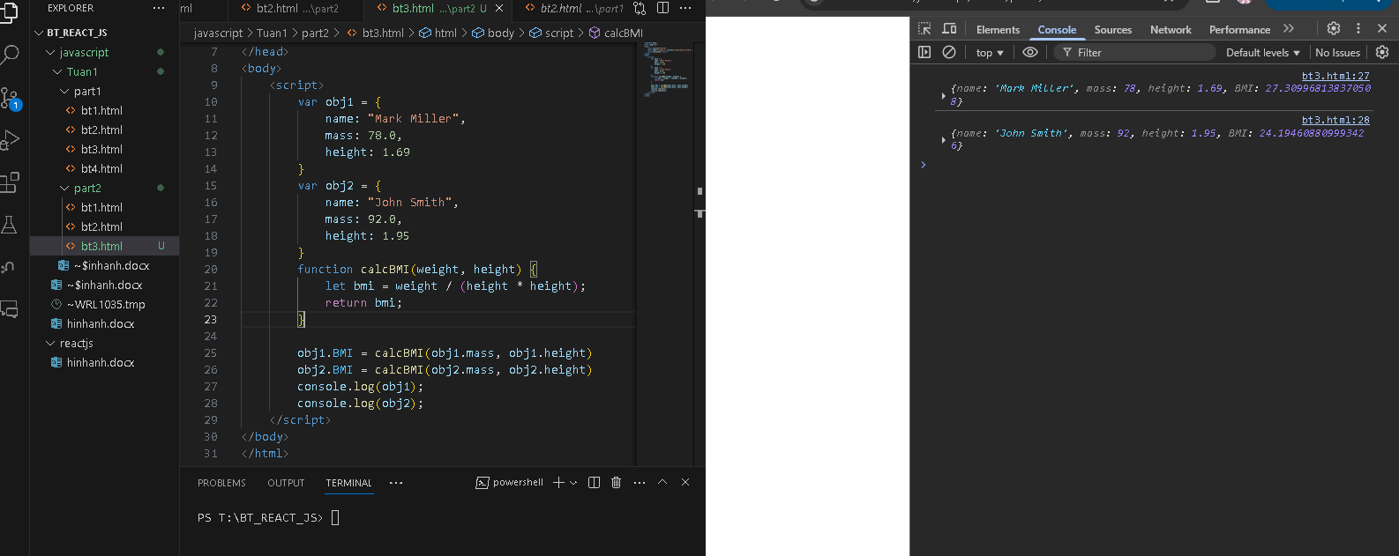

Coding Challenge #4
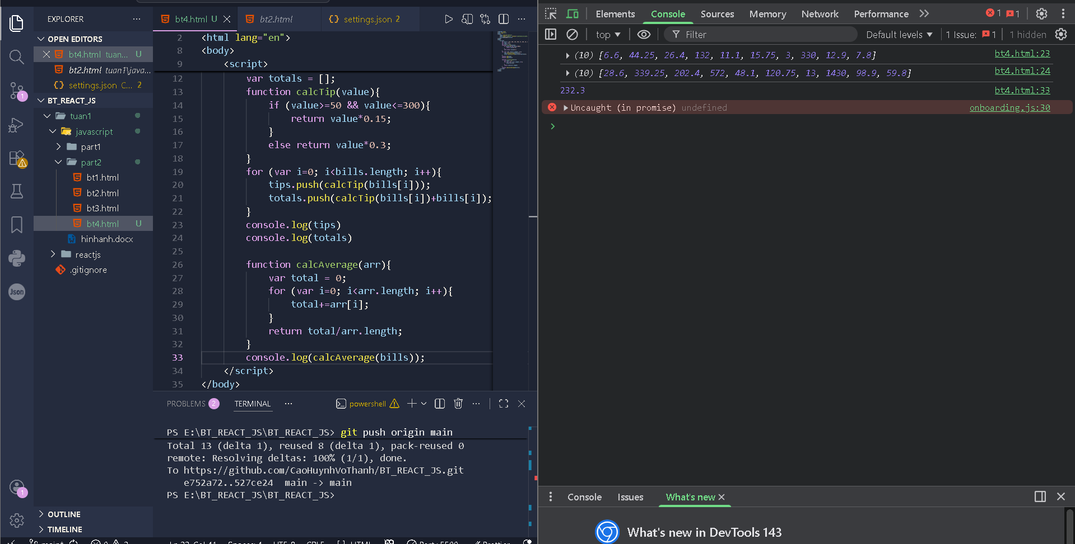

Developer Skills & Editor Setup

Coding Challenge #1
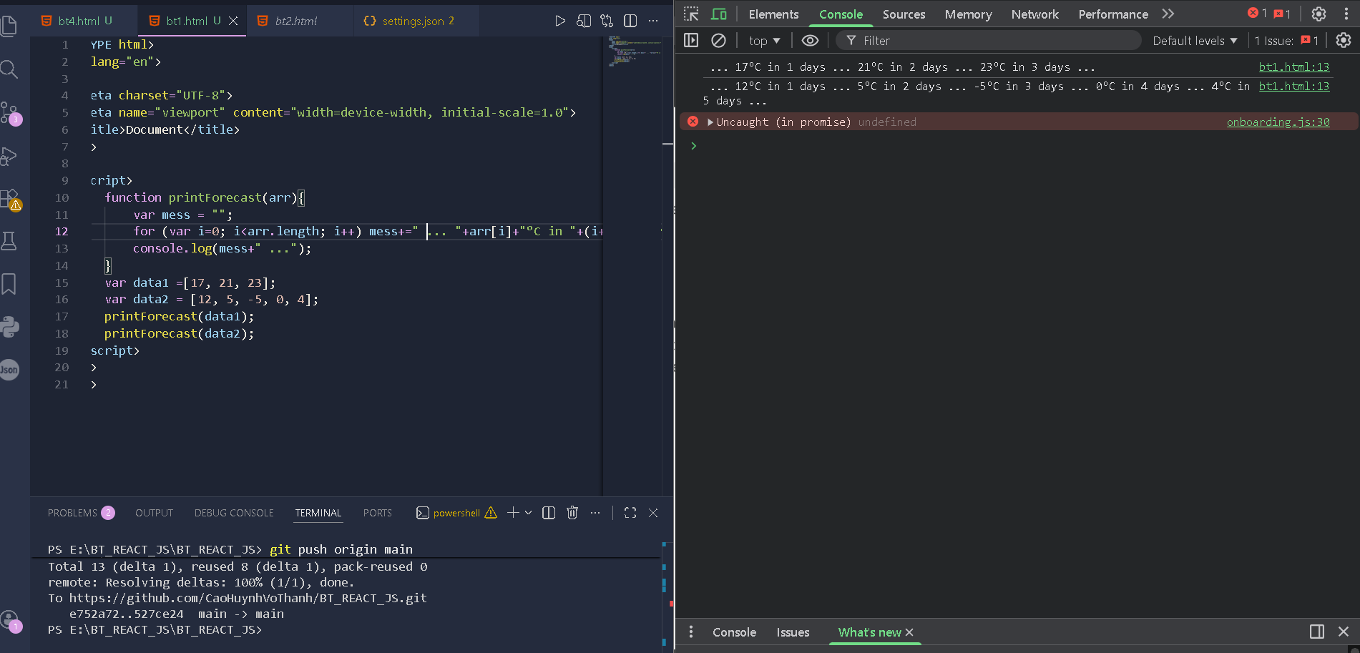

JavaScript in the Browser: DOM and Events

Coding Challenge #1
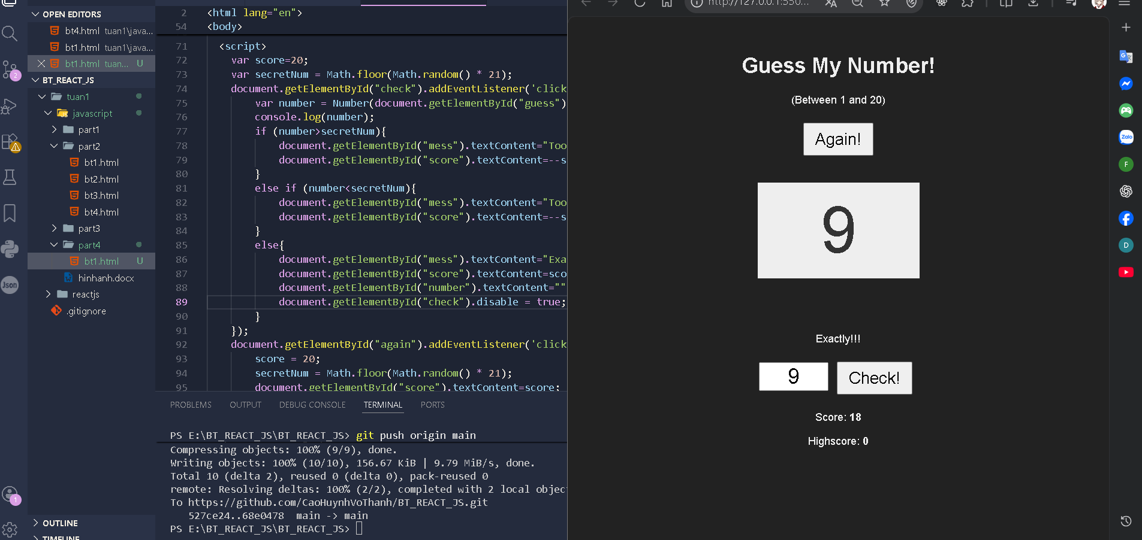
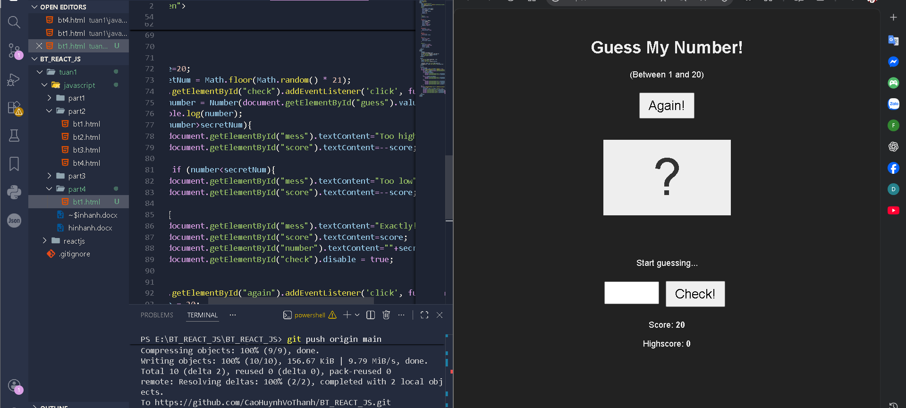

Data Structures, Modern Operators and Strings

Coding Challenge #1
